

**0113 258 1150**

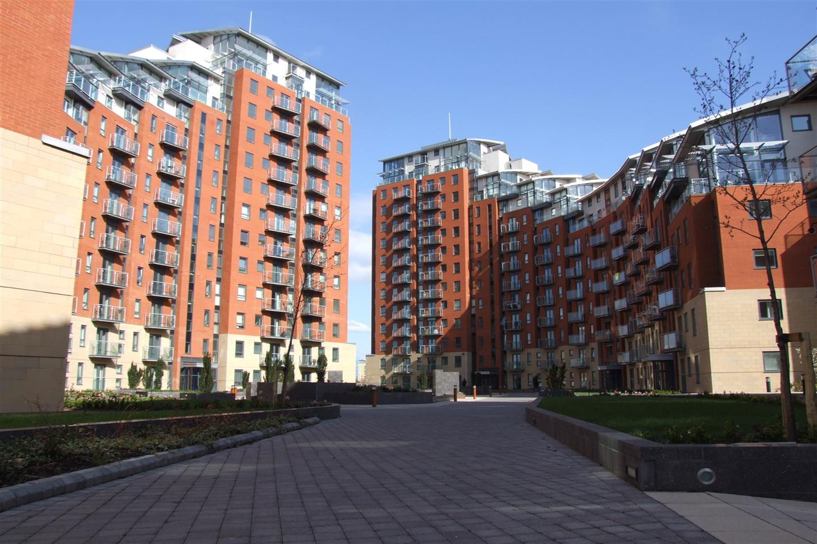



**For Sale £185,000.00**

**Faroe, City Island, Leeds**

***SPACIOUS TWO BEDROOM, TWO BATHROOM APARTMENT *** Located in this popular development, this delightful seventh floor apartment briefly comprises: entrance hall, open plan living room and kitchen with access to a balcony, two double bedrooms, En-suite shower room and house bathroom. City Island enjoys well maintained communal gardens and benefits from a balcony. early internal viewing is highly recommended. Available 3rd January 2025. deposit £1145, EPC rating C, council tax band D.

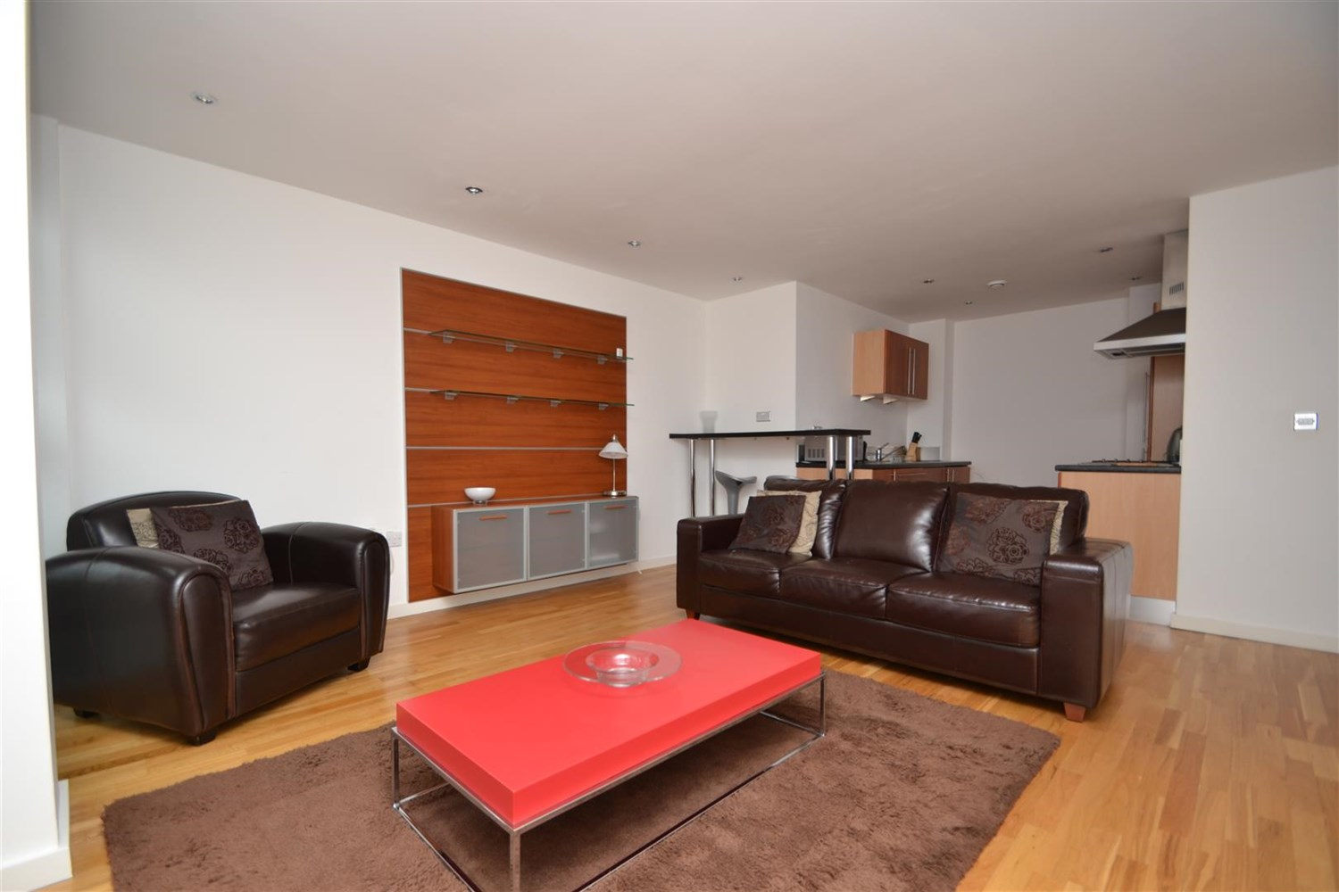

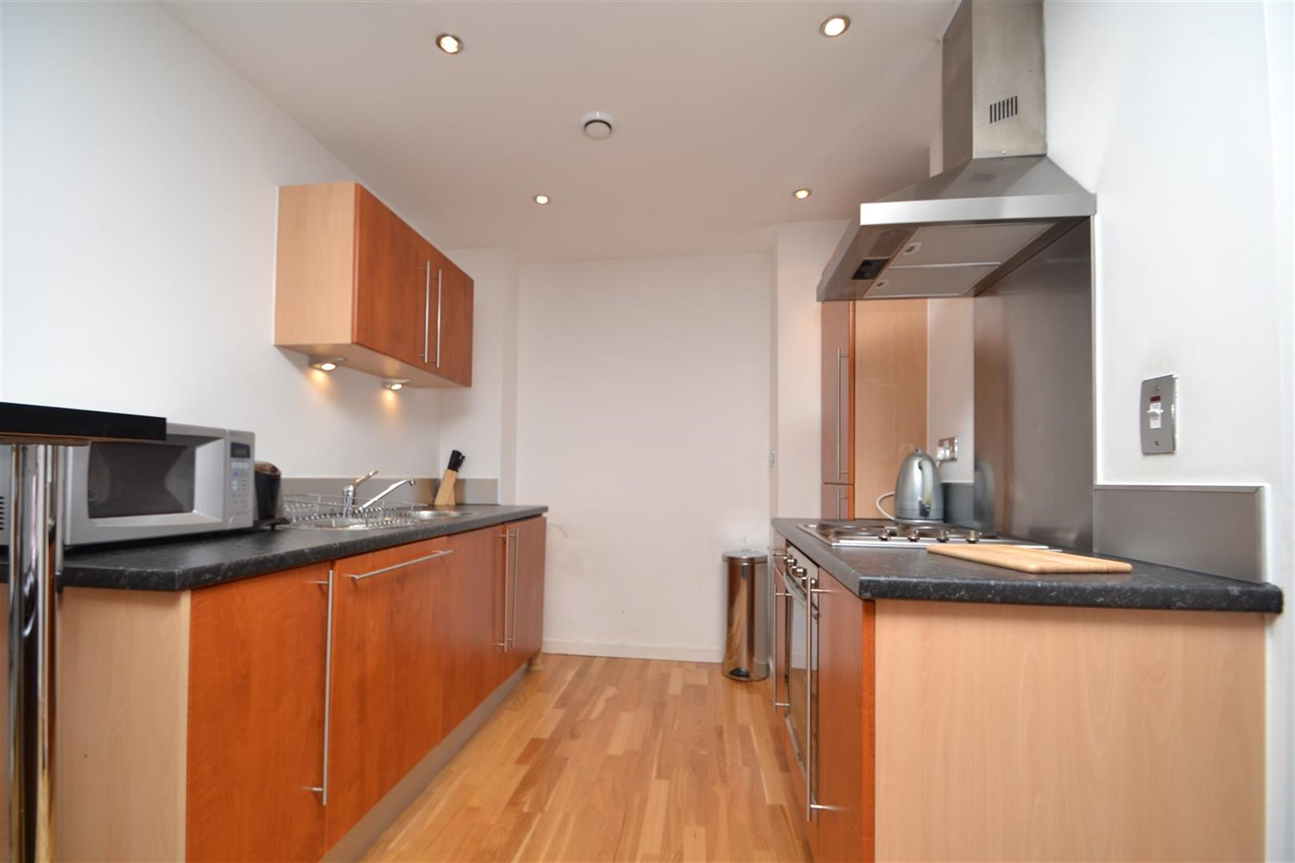

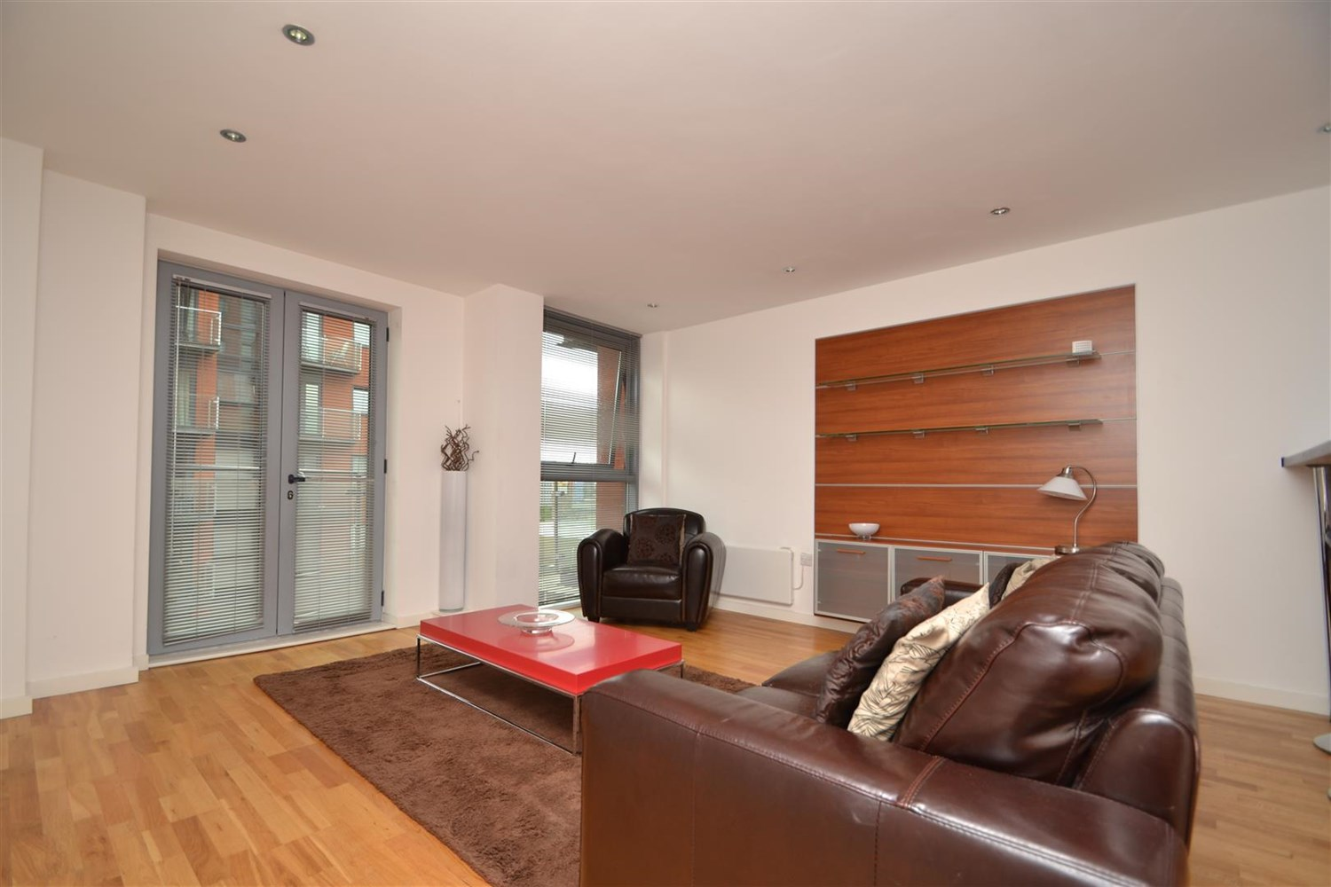

2 Bathroom(s)

0 Reception(s)

2 Bedroom(s)

00

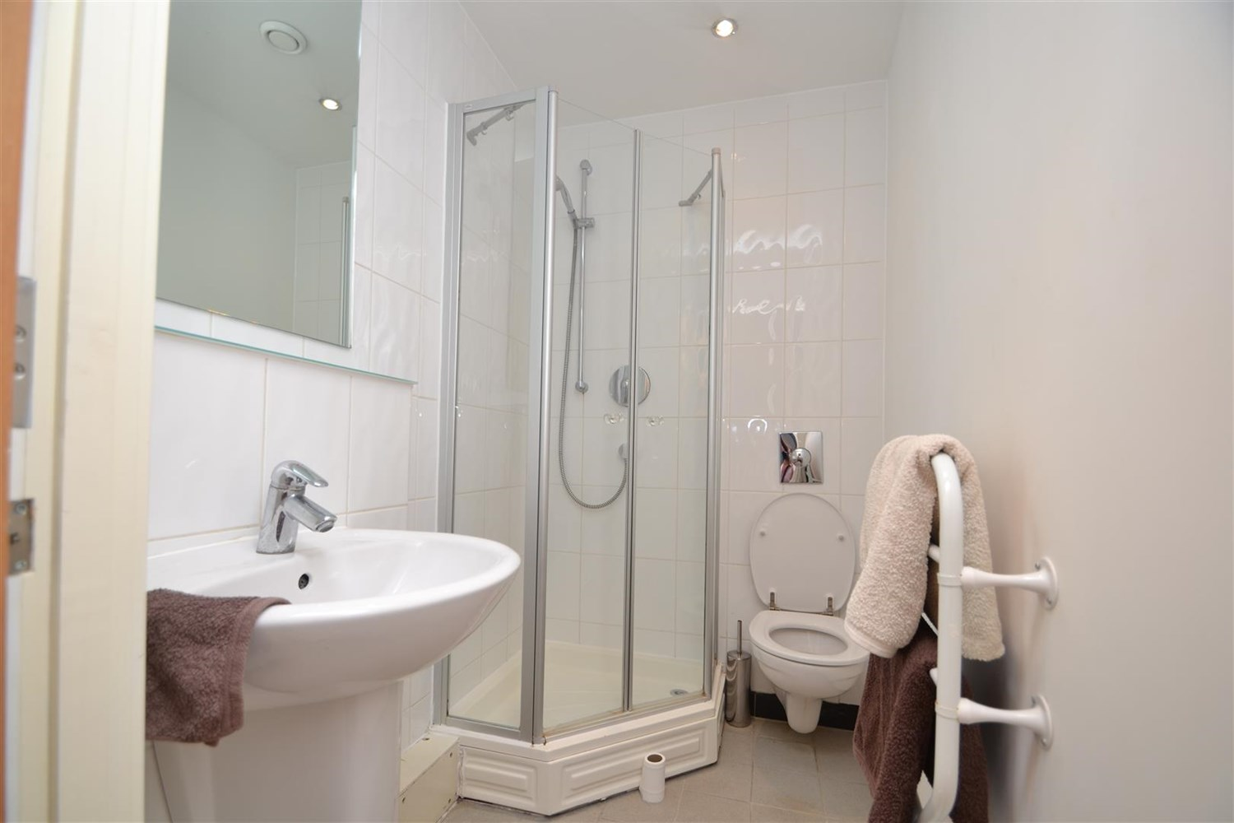

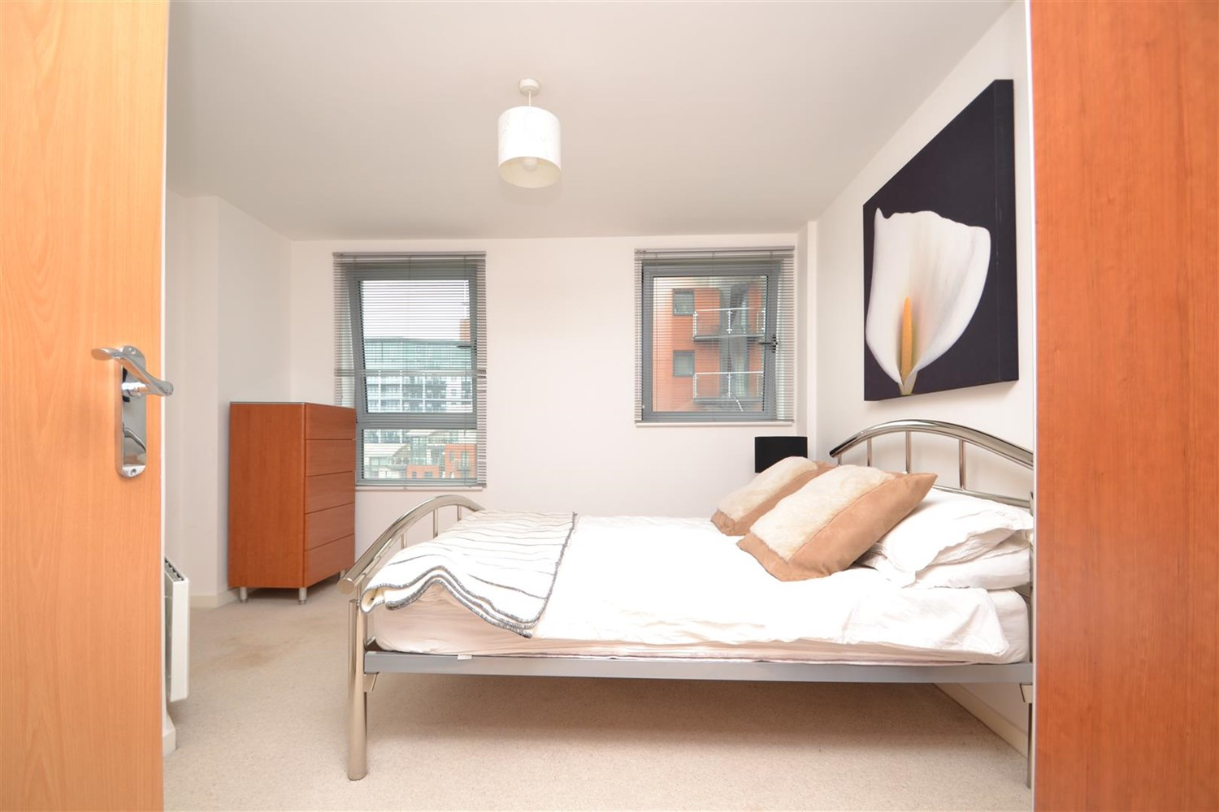

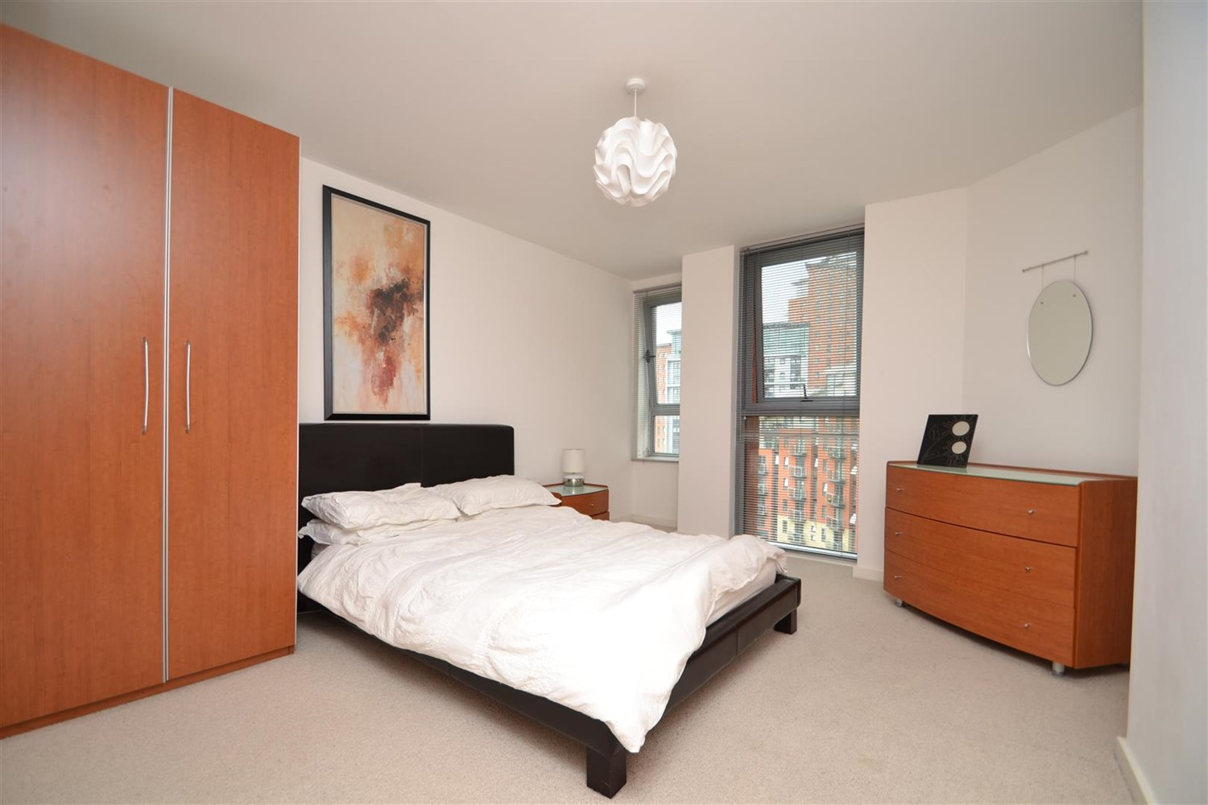

|  |
| --- |
| **Communal Entrance**  A secure private entrance with access to all floors via lift and stairs |
| **Private Entrance**  Private entrance hall with wood effect flooring and storage cupboard |
| **Open Plan Living Kitchen**  A stylish and spacious open plan living area, with video entrance phone, wood effect flooring and access to balcony. The kitchen has a breakfast bar for convenience, and briefly comprises a range of wall and base mounted units, single drainer sink unit, integrated oven, hob and extractor, washing machine, dishwasher and fridge freezer. |
| **Master Bedroom**  A spacious, carpeted room with double glazed window and electric panel radiator |
| **En-Suite Shower Room**  A three piece white suite comprising shower cubicle, low flush w.c and basin. Tiling to walls and floor and heated towel rail |
| **Bedroom 2**  Another good sized double, with double glazed window and electric panel radiator |
| **House Bathroom**  A three piece white suite comprising bath with shower over and glass shower screen, low flush WC, wash hand basin, tiling to walls and floor and heated towel rail |
| **Service Charge**  Service charge for 2024 - £2,418.35 |
| **Tenure**  Ground rent - £200 pa Lease - 999 years from 1st January 2003 |
| **Home Information**  COUNCIL TAX BAND: D EPC Rating C  Leasehold property Parking included  Broadband: Standard 16 Mbps 1 Mbps Good Superfast 201 Mbps 29 Mbps Good Ultrafast 1000 Mbps 1000 Mbps Mobile availability: EE limited coverage. Three limited coverage. O2 likely to have good coverage. Vodafone limited coverage.  Utilities: Water supplied on standard meters. Electric mains supplied on standard meters |

|  |  |
| --- | --- |
| These particulars are intended to give a fair description of the property, but their accuracy cannot be guaranteed, and they do not constitute an offer of contract. Intending purchasers must rely on their own inspection of the property. None of the above appliances/services have been tested by ourselves. We recommend purchasers arrange for a qualified person to check all appliances/services before legal commitment.  **Property Ref:** 192  **For more information, please contact**  0113 258 1150 **|** [sales@adairpaxton.co.uk](mailto:sales@adairpaxton.co.uk) **|** www.adairpaxton.co.uk |  |