

**0113 258 1150**

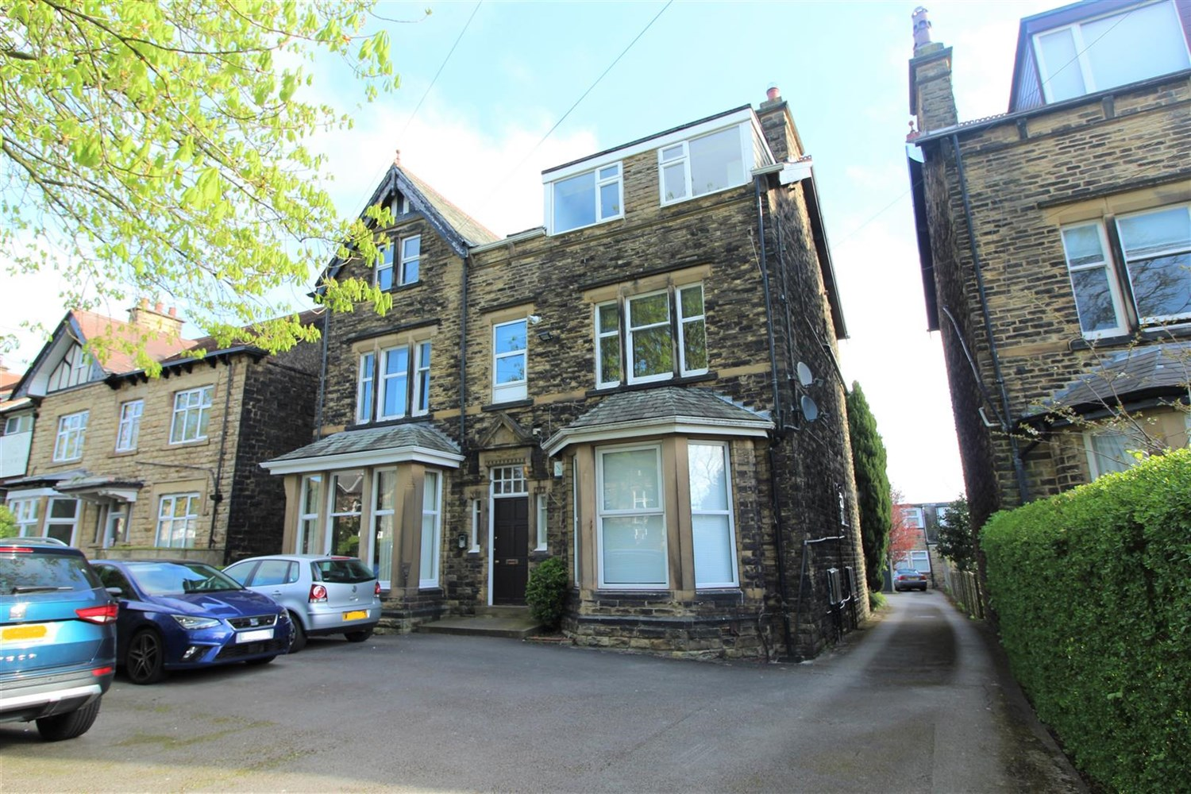



**Available to let £1,100.00pcm**

**Apt 3, 30, Street Lane, Leeds**

ADAIR PAXTON ARE DELIGHTED TO OFFER THIS LARGE TWO BEDROOM, TWO BATHROOM, FIRST FLOOR CHARACTERFUL APARTMENT WITH OFF ROAD PARKING FOR TWO VEHICLES. The property is located in a prime position on Street Lane between Roundhay Park and the shops, bars and restaurants in this popular suburb of Leeds. Comprising; entrance hallway, spacious lounge with feature fireplace, open plan kitchen/diner with appliances and feature fireplace, master bedroom with en-suite shower room and walk in wardrobe, second double bedroom and house bathroom with shower over bath. Gas central heating and off road parking for two vehicles. Furnished. Council tax band C. Bond £1265. Available 12th February.

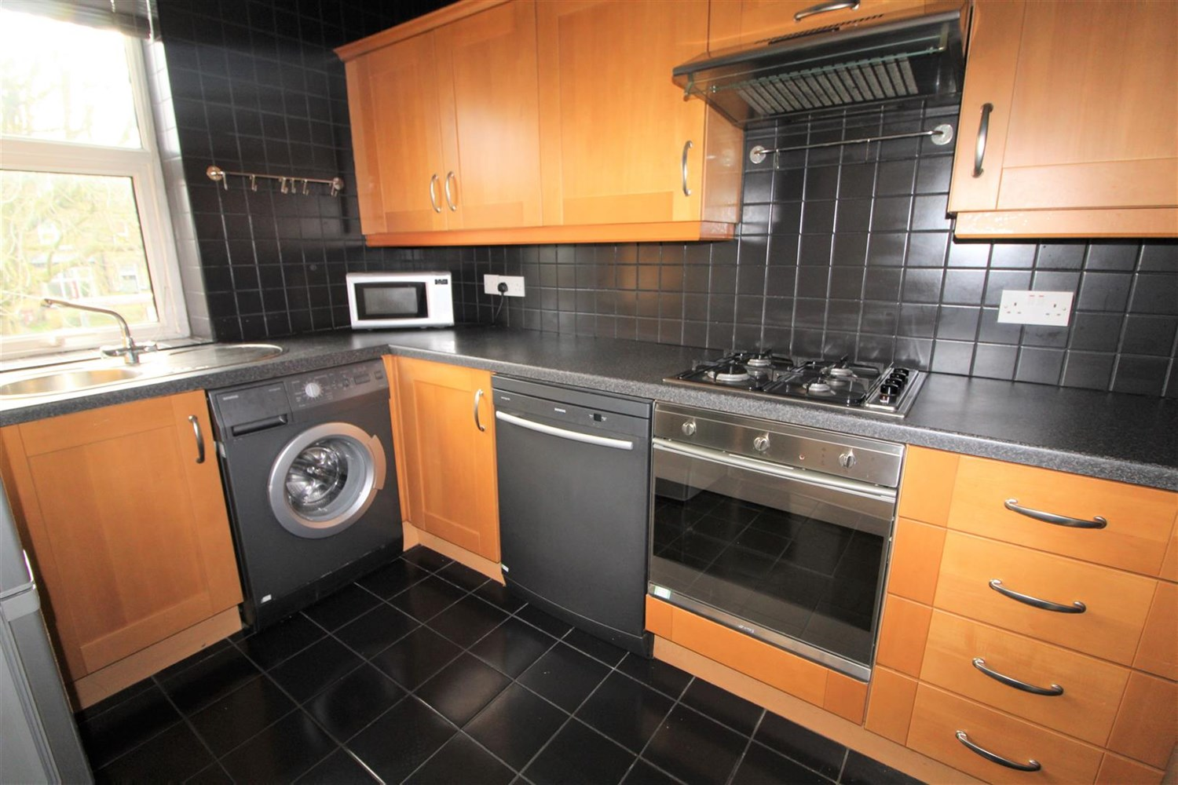

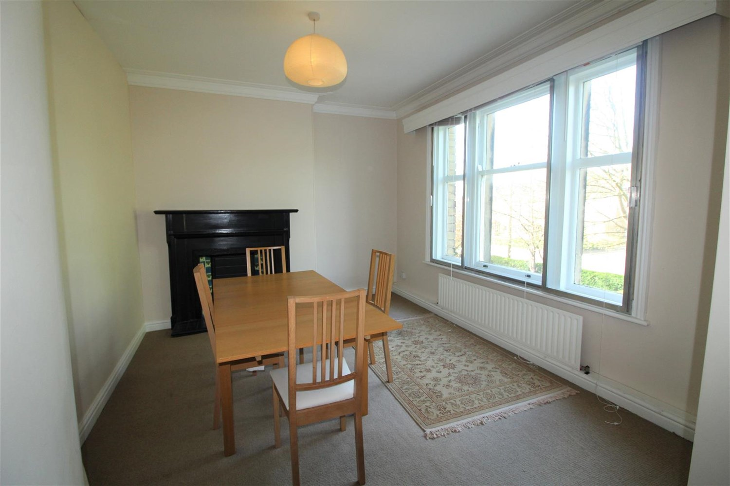

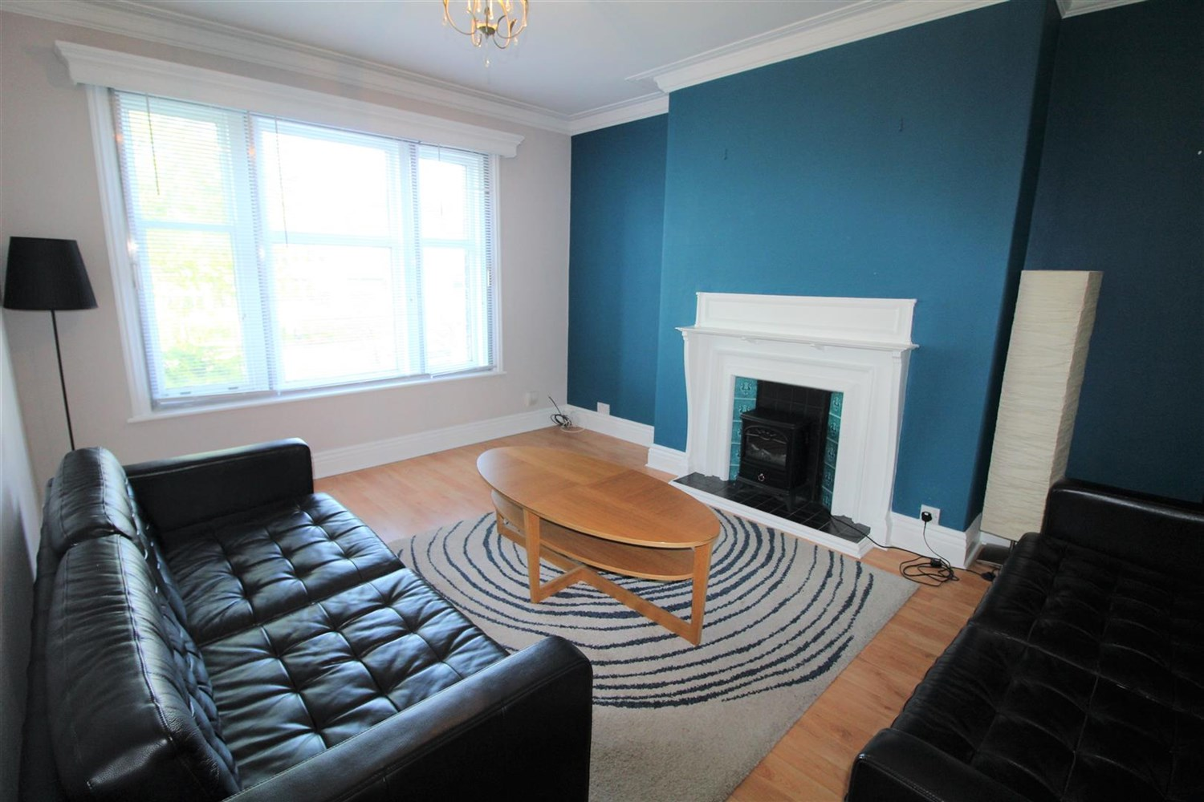

2 Bathroom(s)

2 Reception(s)

0 Bedroom(s)

00

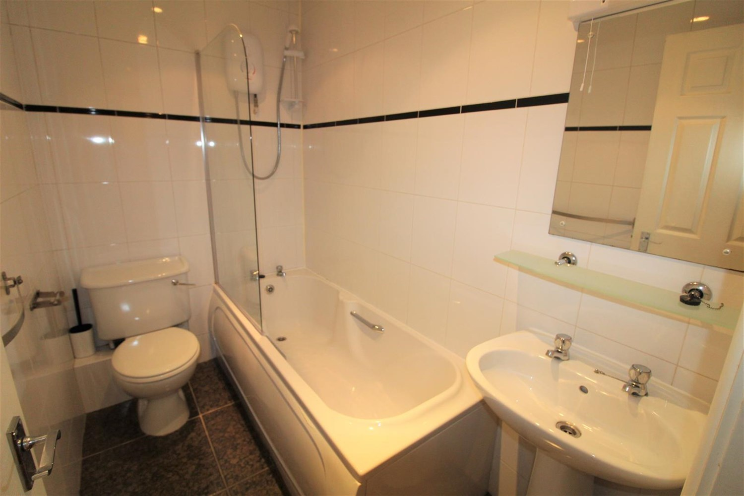

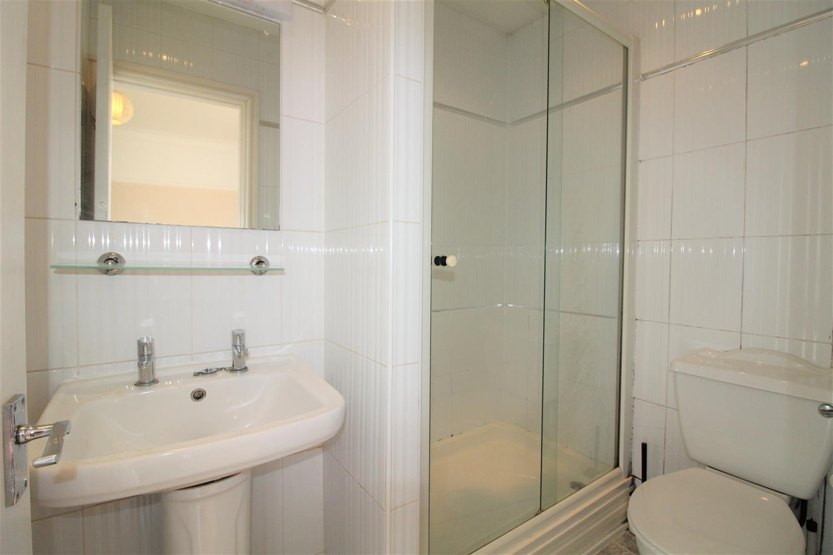

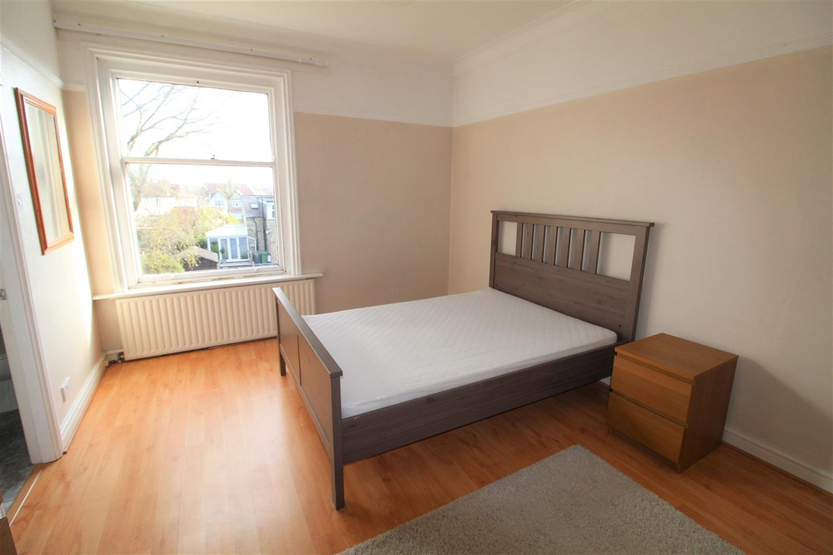

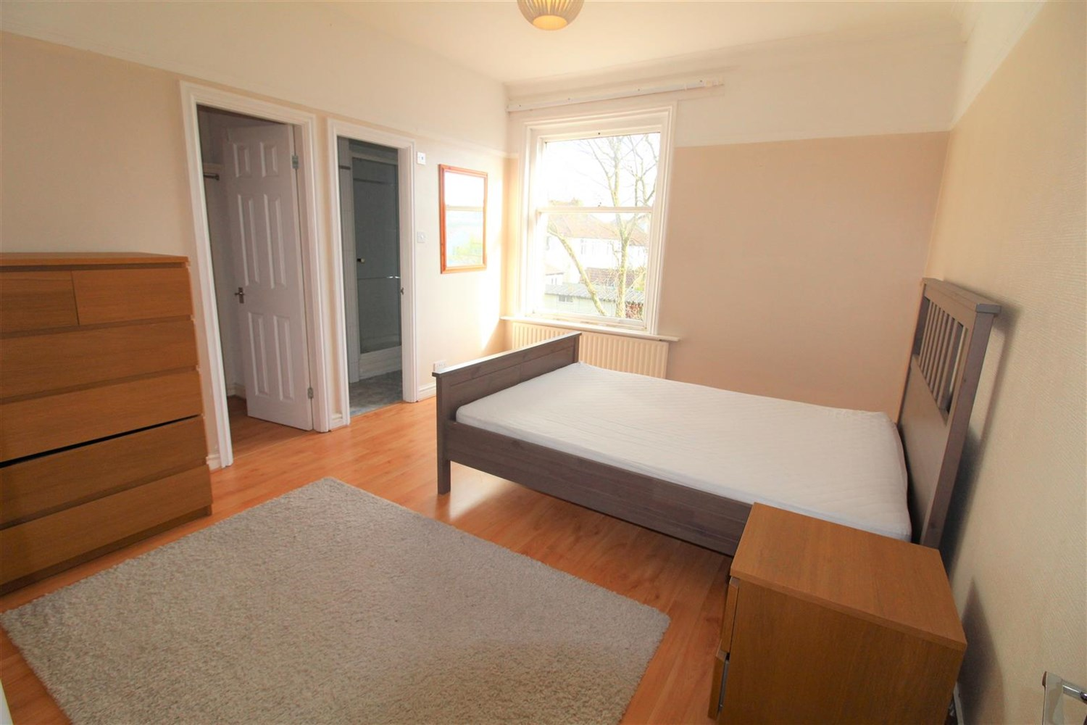

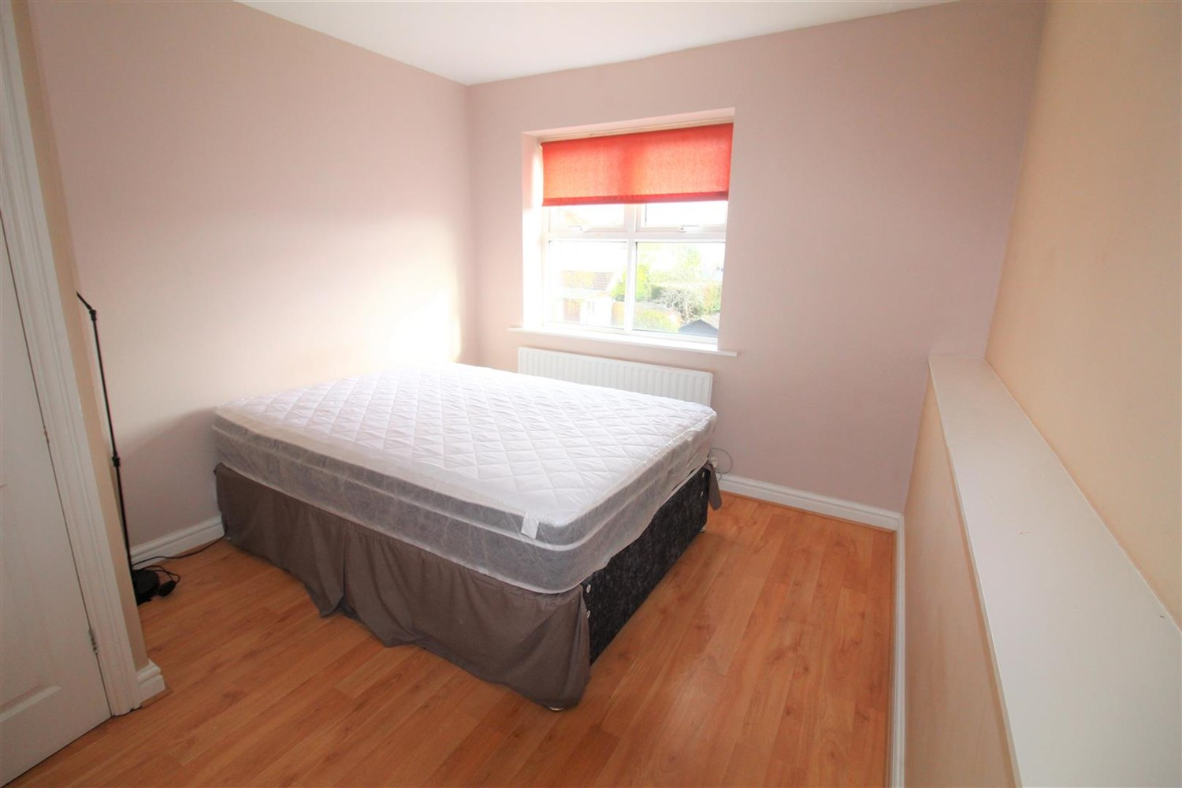

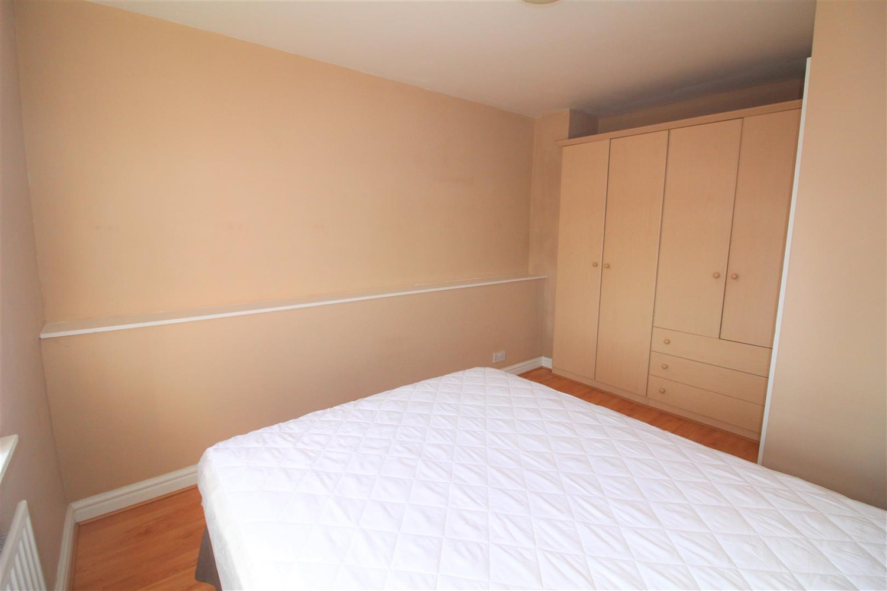

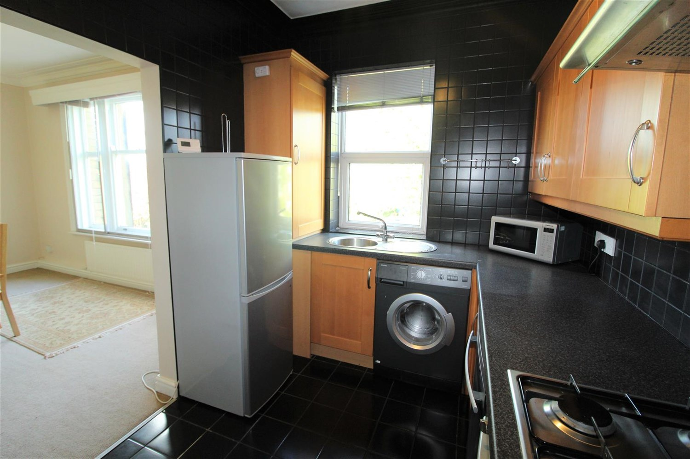

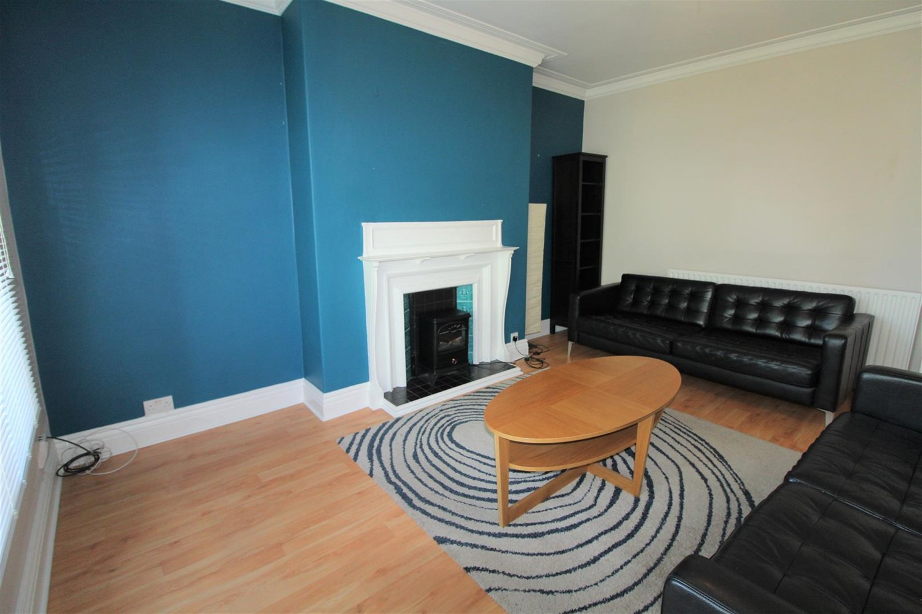

|  |
| --- |
| **Living Room**  Spacious lounge with large windows to the front. |
| **Dinning Room**  Light and airy Dining room with uPVC double glazed window to rear, gas central heating radiator. |
| **Kitchen**  Fitted with a range of wall and base units, gas cooker, free standing fridge freezer, stainless steel sink. |
| **Bedroom 1**  Large double bedroom with window to rear, gas central heating radiator. Access to walk in wardrobe and en-suite. |
| **Bedroom 2**  Double bedroom with window to rear, gas central heating radiator. |
| **En-Suite Bathroom**  Three piece bathroom suite, walk in shower cubical, hand wash basin and w/c. |
| **Bathroom**  Three piece bathroom suite compromising bath, shower over,hand wash basin and w/c. |
| **Home Information**  COUNCIL TAX BAND: C EPC Rating: D  Freehold property Parking for 2 cars.  Broadband: Standard 5 Mbps 0.6 Mbps Good Superfast 70 Mbps 20 Mbps Good Ultrafast 1000 Mbps 220 Mbps  Mobile availability: EE coverage likely. Three coverage likely. O2 coverage likely. Vodafone limited coverage.  Utilities: Water supplied on standard meters. Electric mains supplied on standard meters. Gas mains supplied on standard meters. |

|  |  |
| --- | --- |
| These particulars are intended to give a fair description of the property, but their accuracy cannot be guaranteed, and they do not constitute an offer of contract. Intending purchasers must rely on their own inspection of the property. None of the above appliances/services have been tested by ourselves. We recommend purchasers arrange for a qualified person to check all appliances/services before legal commitment.  **Property Ref:** 4520  **For more information, please contact**  0113 258 1150 **|** [lettings@adairpaxton.co.uk](mailto:lettings@adairpaxton.co.uk) **|** www.adairpaxton.co.uk |  |