

**0113 258 1150**

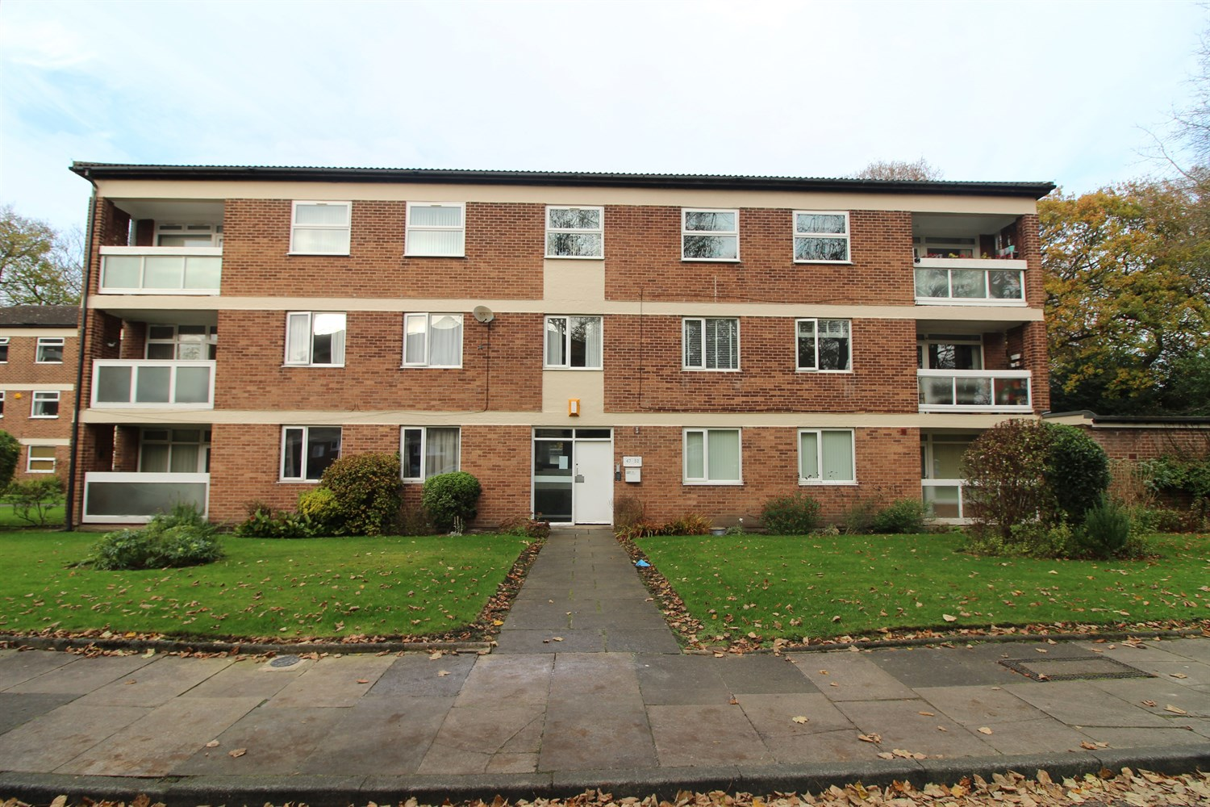



**For Sale £175,000.00**

**Foxhill Court, Weetwood**

***GROUND FLOOR TWO BEDROOM APARTMENT WITH BALCONY *** with well kept communal gardens, surrounded by fields in the sought after location of Weetwood. The property briefly comprises; Communal entrance, entrance hall, lounge with spacious balcony, kitchen, two bedrooms with built in wardrobes and a house bathroom with separate WC. The property benefits from both gas central heating and double glazing. Council tax band B. EPC rating D.

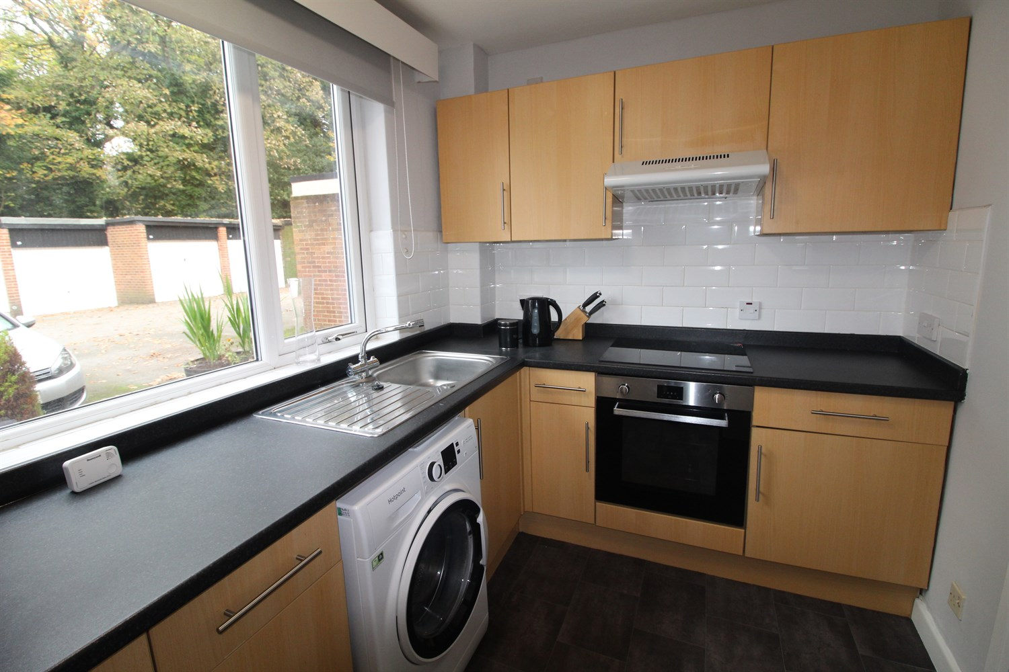

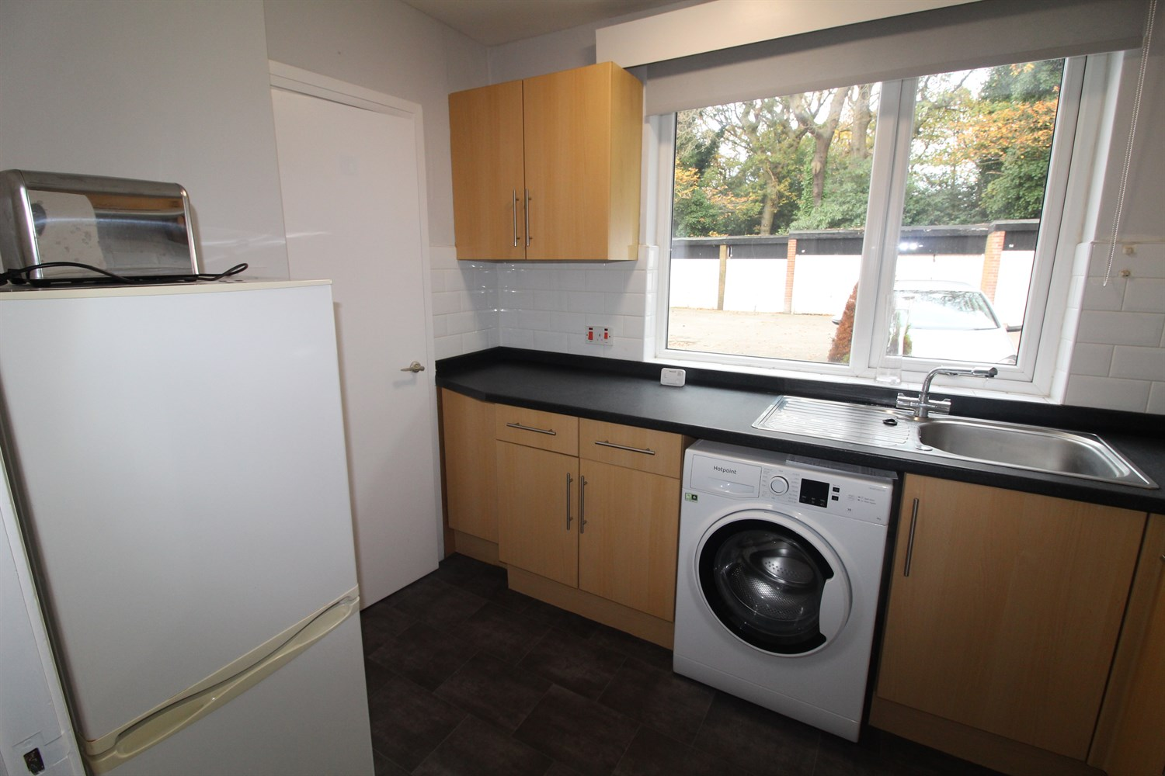

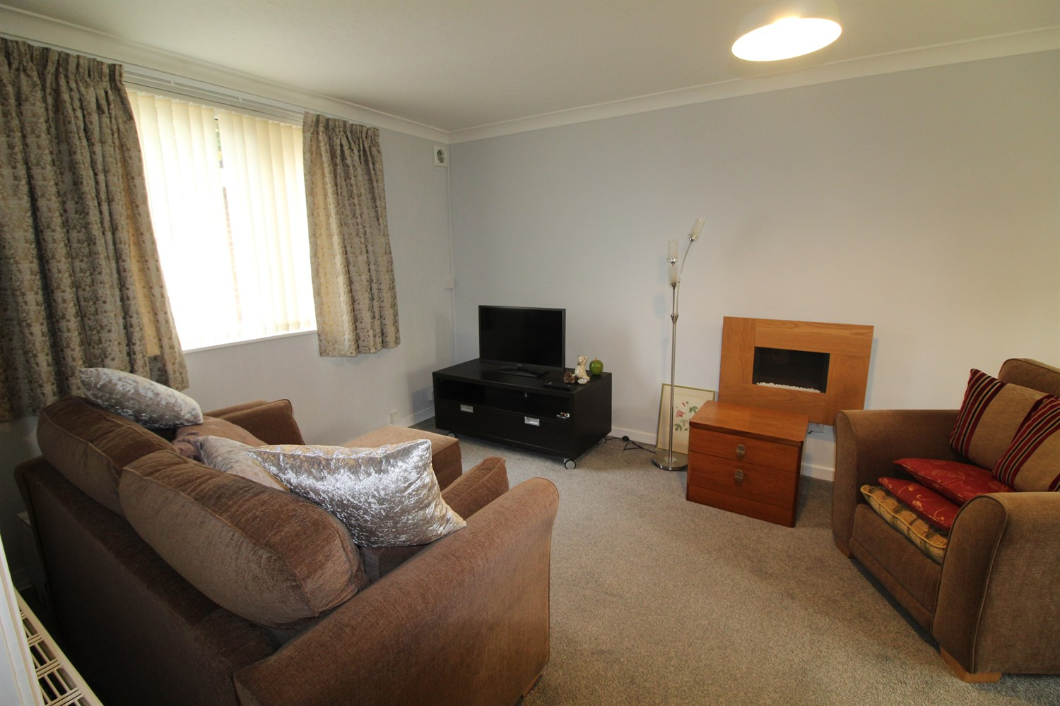

1 Bathroom(s)

1 Reception(s)

2 Bedroom(s)

00

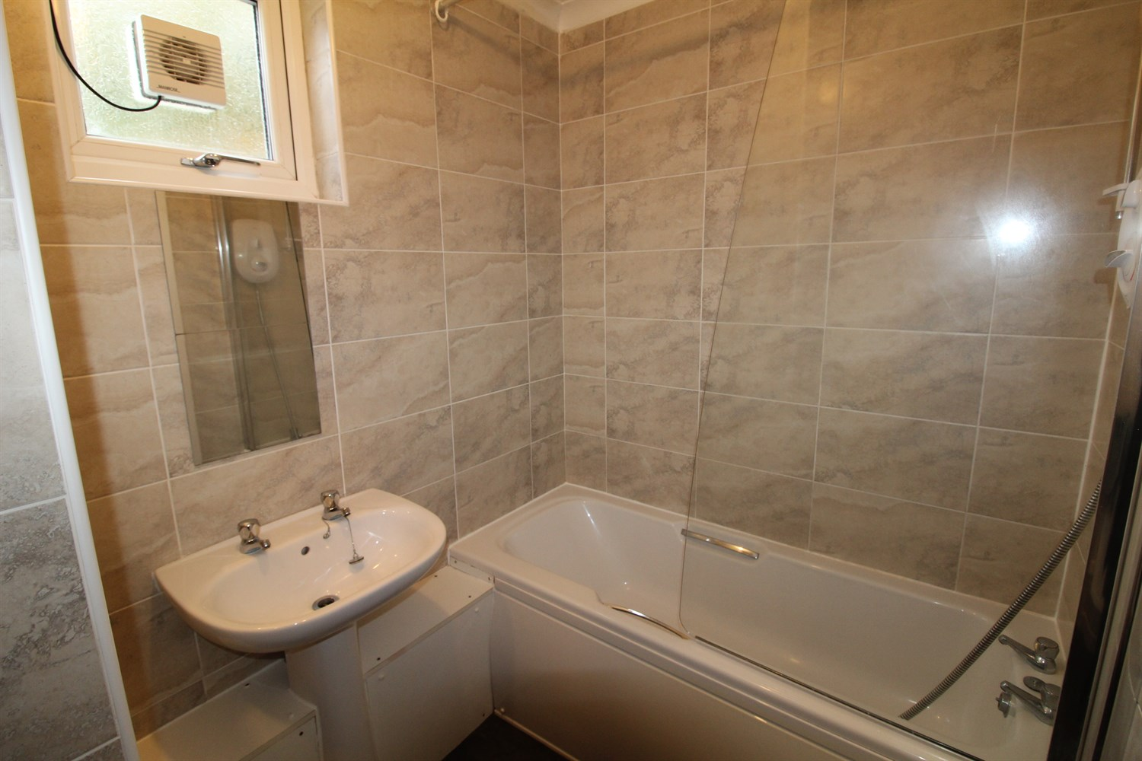

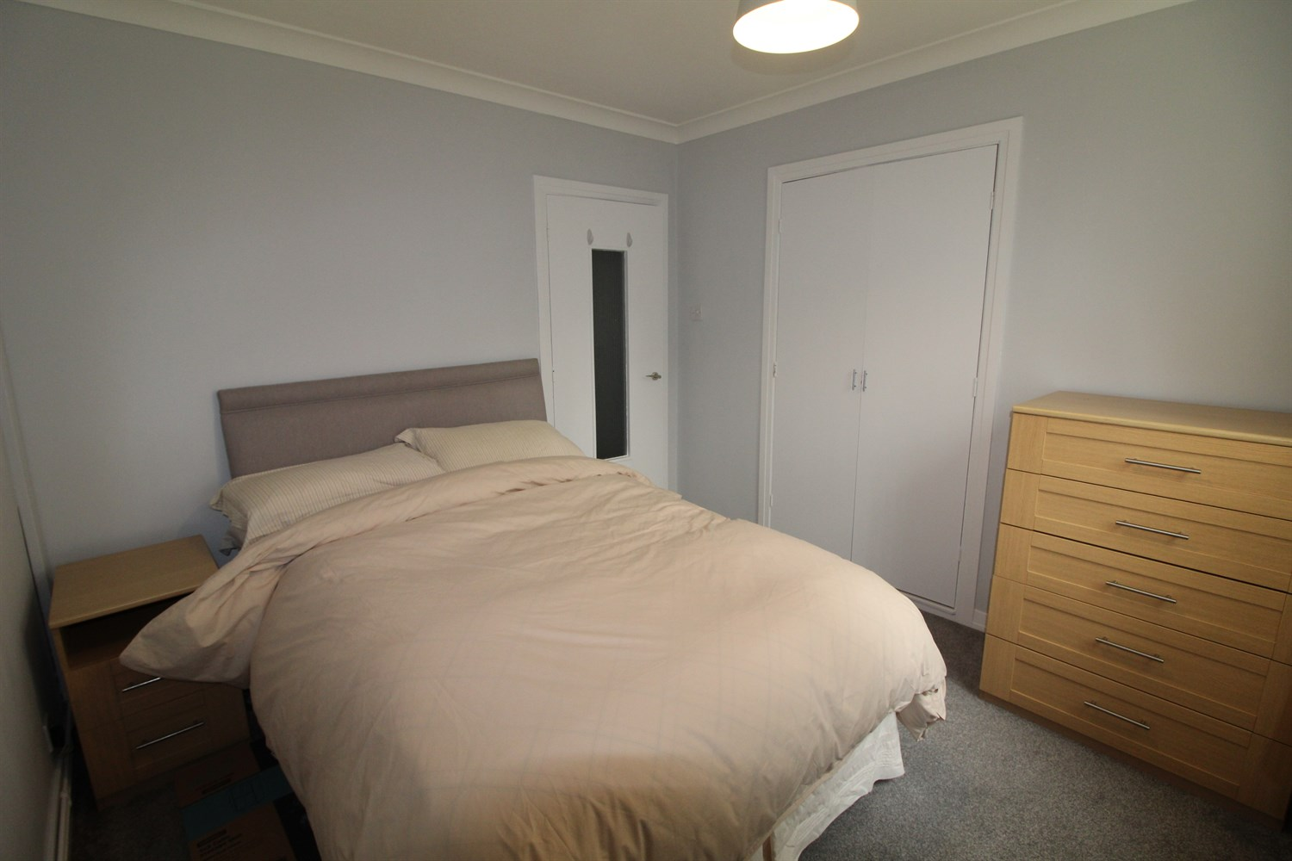

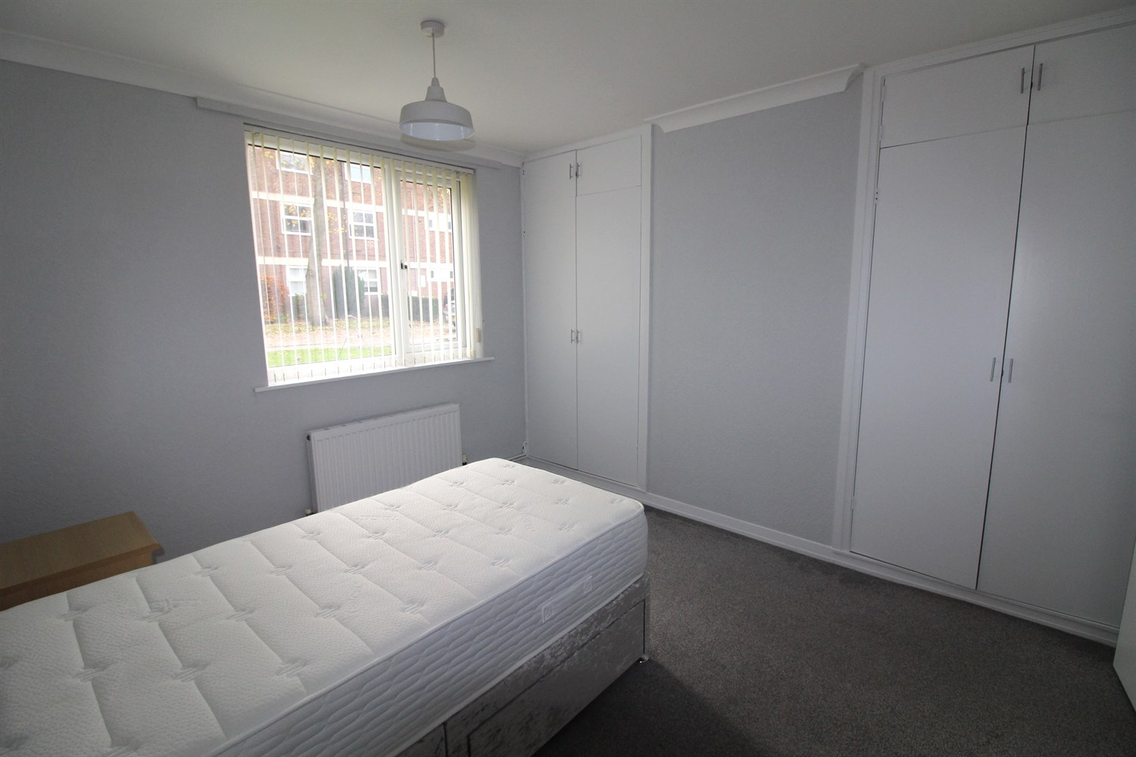

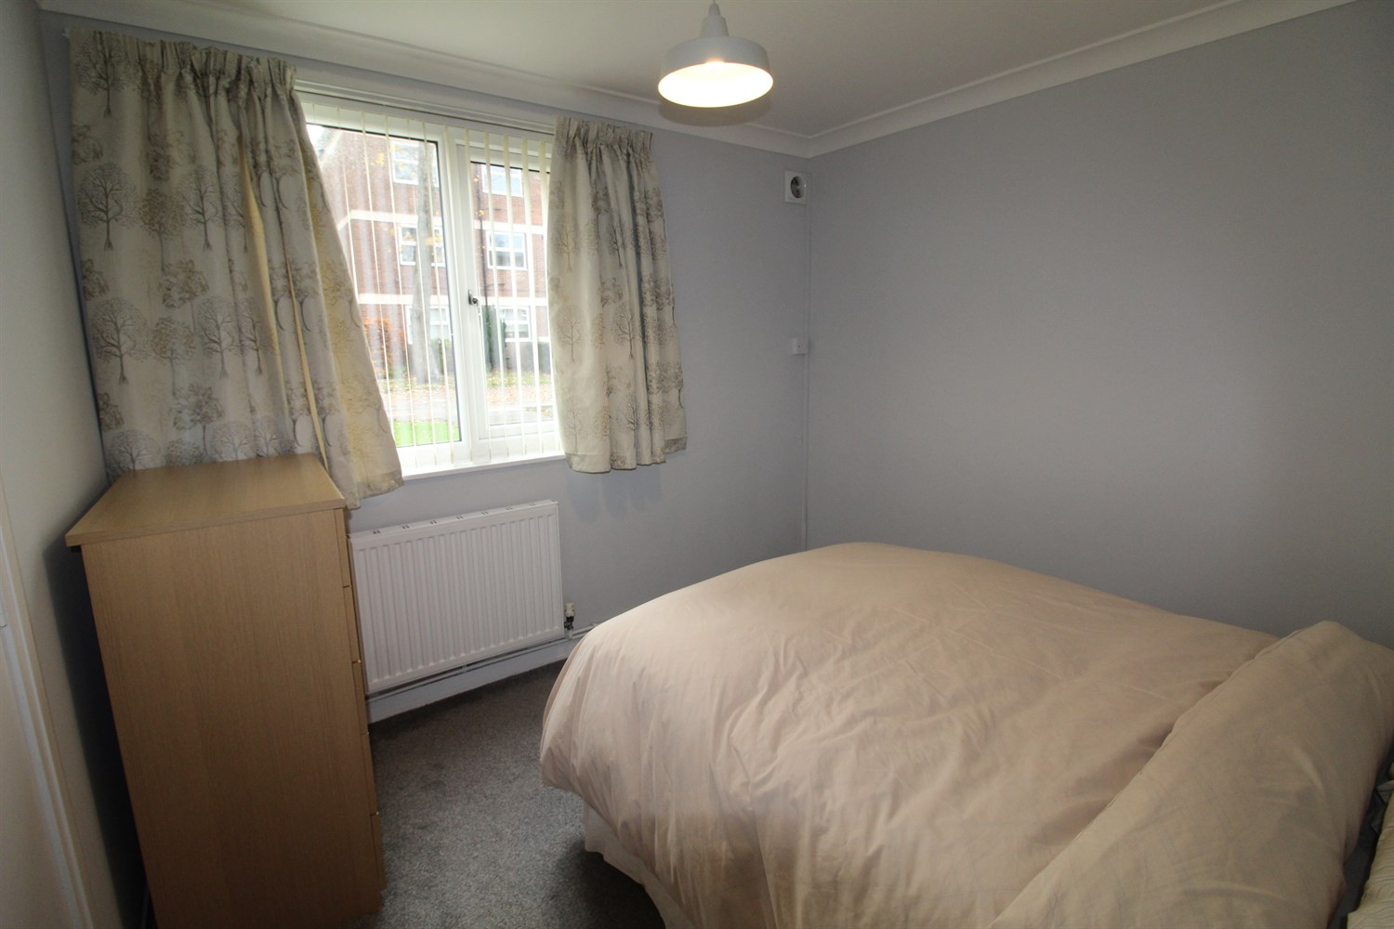

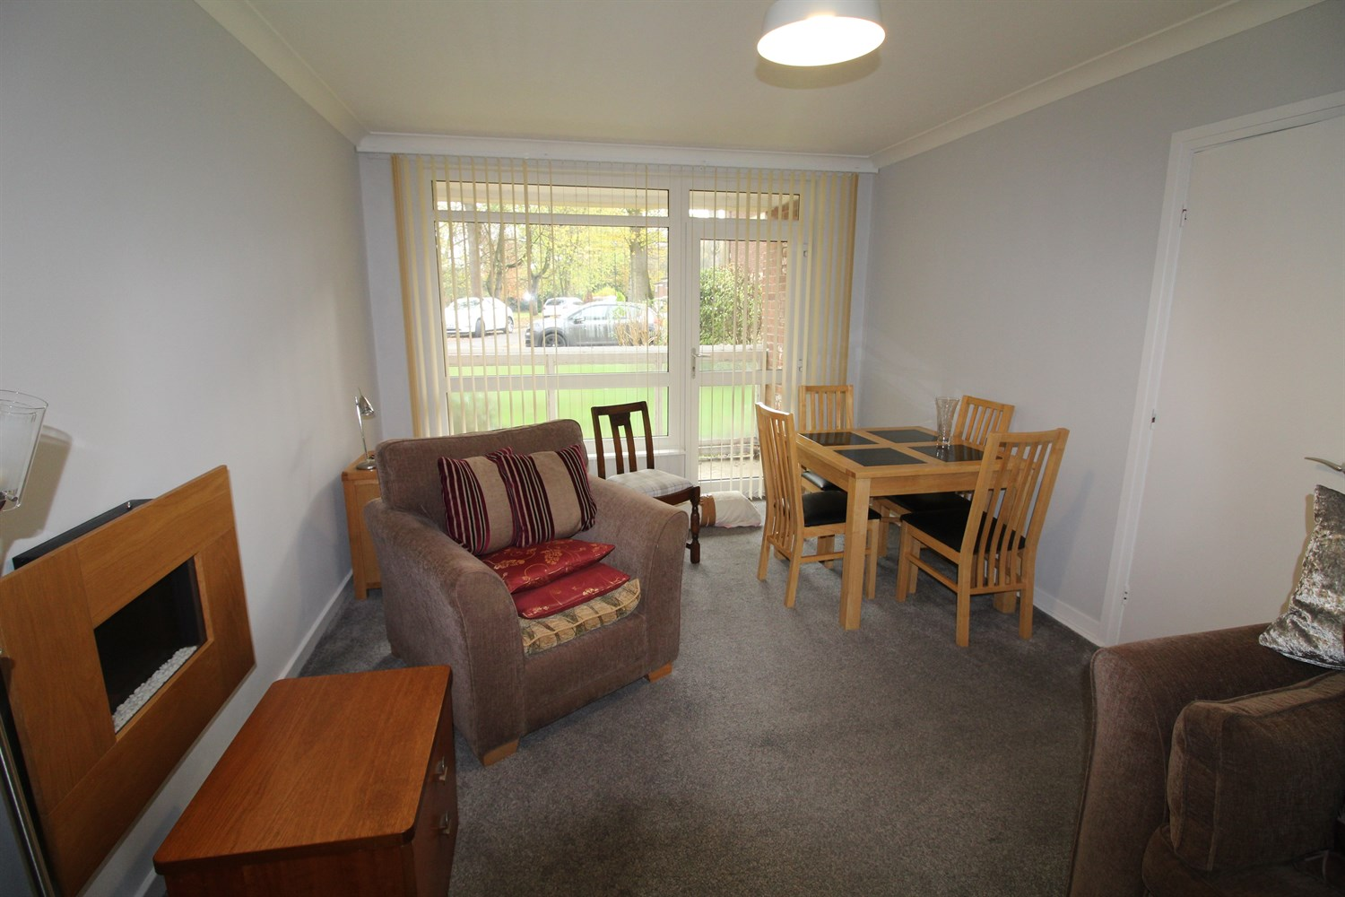

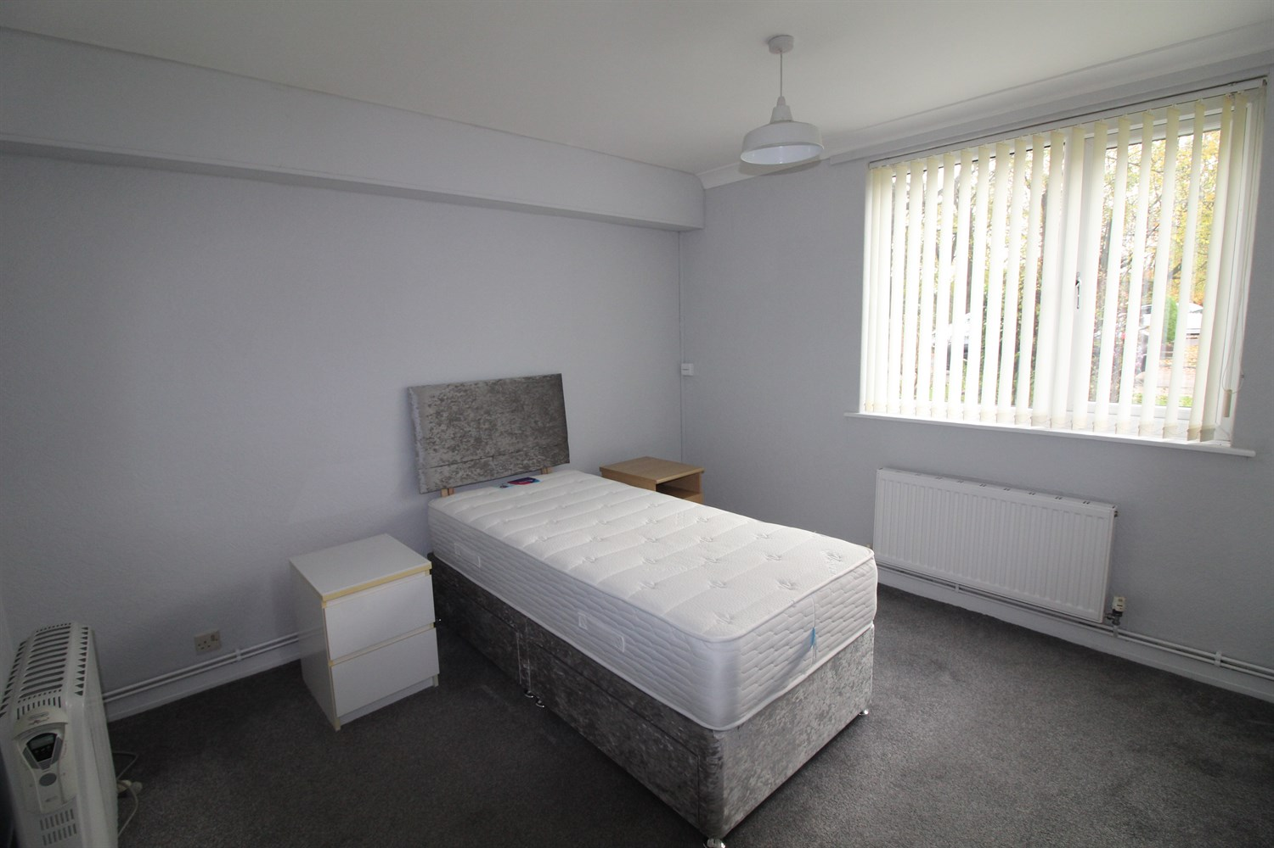

|  |
| --- |
| **Communal Entrance Hall**  Having secure keypad entry and security intercom with private entrance door and personal letter box. |
| **Private Entrance Hall**  With two storage cupboards and gas central heating radiator. Doors to all other rooms and intercom telephone. |
| **Living Room 5.49m (18'0) x 3.33m (10'11)**  With uPVC windows to the front and rear, door to balcony, wall mounted electric fire and gas central heating radiator. |
| **Kitchen 3m (9'10) x 2.11m (6'11)**  With a range of wall and base units with work surfaces over, stainless steel sink and drainer, integrated electric oven with 4-ring hob and extractor over Pantry. uPVC double glazed window. |
| **Bedroom 1 3.48m (11'5) x 3.23m (10'7)**  Good size double bedroom with fitted wardrobes. uPVC window and gas central heating radiator. |
| **Bedroom 2**  Good sized room with fitted wardrobes. UPVC window and gas central heating. |
| **Bathroom**  Two piece white suite with shower over bath and hand wash basin. uPVC frosted window. |
| **Toilet**  Separate W/C with tiled walls and floor. |
| **Parking**  On street parking. |
| **Home Information**  COUNCIL TAX BAND: C EPC Rating D  Leasehold property: On street parking   Broadband: Standard 25 Mbps 2 Mbps Good Superfast --Not available --Not available Unlikely Ultrafast 1000 Mbps 100 Mbps Mobile availability: EE limited coverage. Three limited coverage. O2 likely to have good coverage. Vodafone limited coverage.  Utilities: Water supplied on standard meters. Electric mains supplied on standard meters. Gas meters supplied on standard meters. |
| **Tenure**  Leasehold - 999 years from 1961 |
| **Service Charge**  Service charge is £400 per quarter. |

|  |  |
| --- | --- |
| These particulars are intended to give a fair description of the property, but their accuracy cannot be guaranteed, and they do not constitute an offer of contract. Intending purchasers must rely on their own inspection of the property. None of the above appliances/services have been tested by ourselves. We recommend purchasers arrange for a qualified person to check all appliances/services before legal commitment.  **Property Ref:** 4547  **For more information, please contact**  0113 258 1150 **|** [sales@adairpaxton.co.uk](mailto:sales@adairpaxton.co.uk) **|** www.adairpaxton.co.uk |  |