

**0113 258 1150**

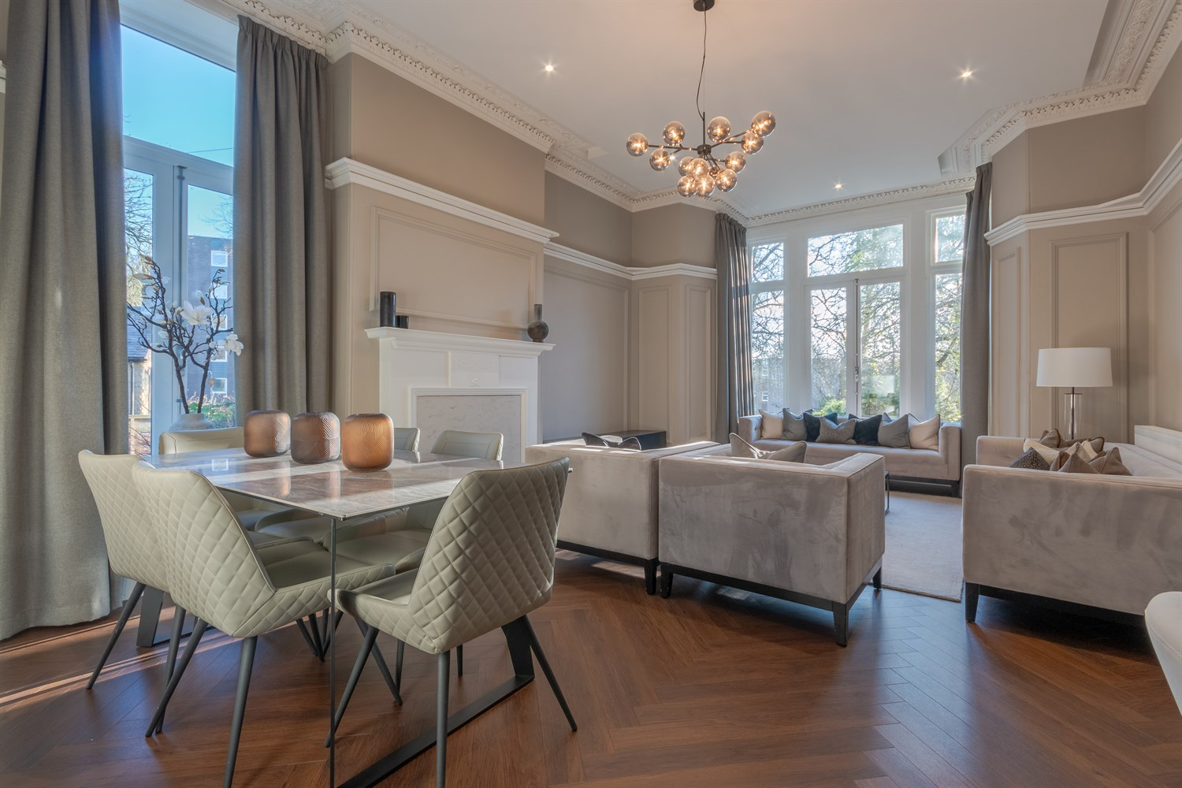



**Available to let £1,850.00pcm**

**Park Villas, Roundhay**

***SUPERB TWO BEDROOM GROUND FLOOR APARTMENT - AVAILABLE NOW*** Situated on the doorstep of Canal Gardens and leafy Roundhay Park, this stunning ground floor apartment is ready to move into and briefly comprises; entrance hall, kitchen, utility, living room, Master bedroom with en-suite shower room and second double bedroom. Externally there is off street parking. The property is a few minutes from extensive amenities on Street Lane, Oakwood and Moortown Corner including popular restaurants, cafe's, bars, designer boutiques and a variety of shops. Regular transport services are available which provide access to the city centre and surrounding areas and the outer Ring Road is also close by, providing access to the business centres of Harrogate, York and Bradford and the A1-M1 link road for those commuting further afield. Available Now, EPC rating D, council tax band D, deposit £2130.

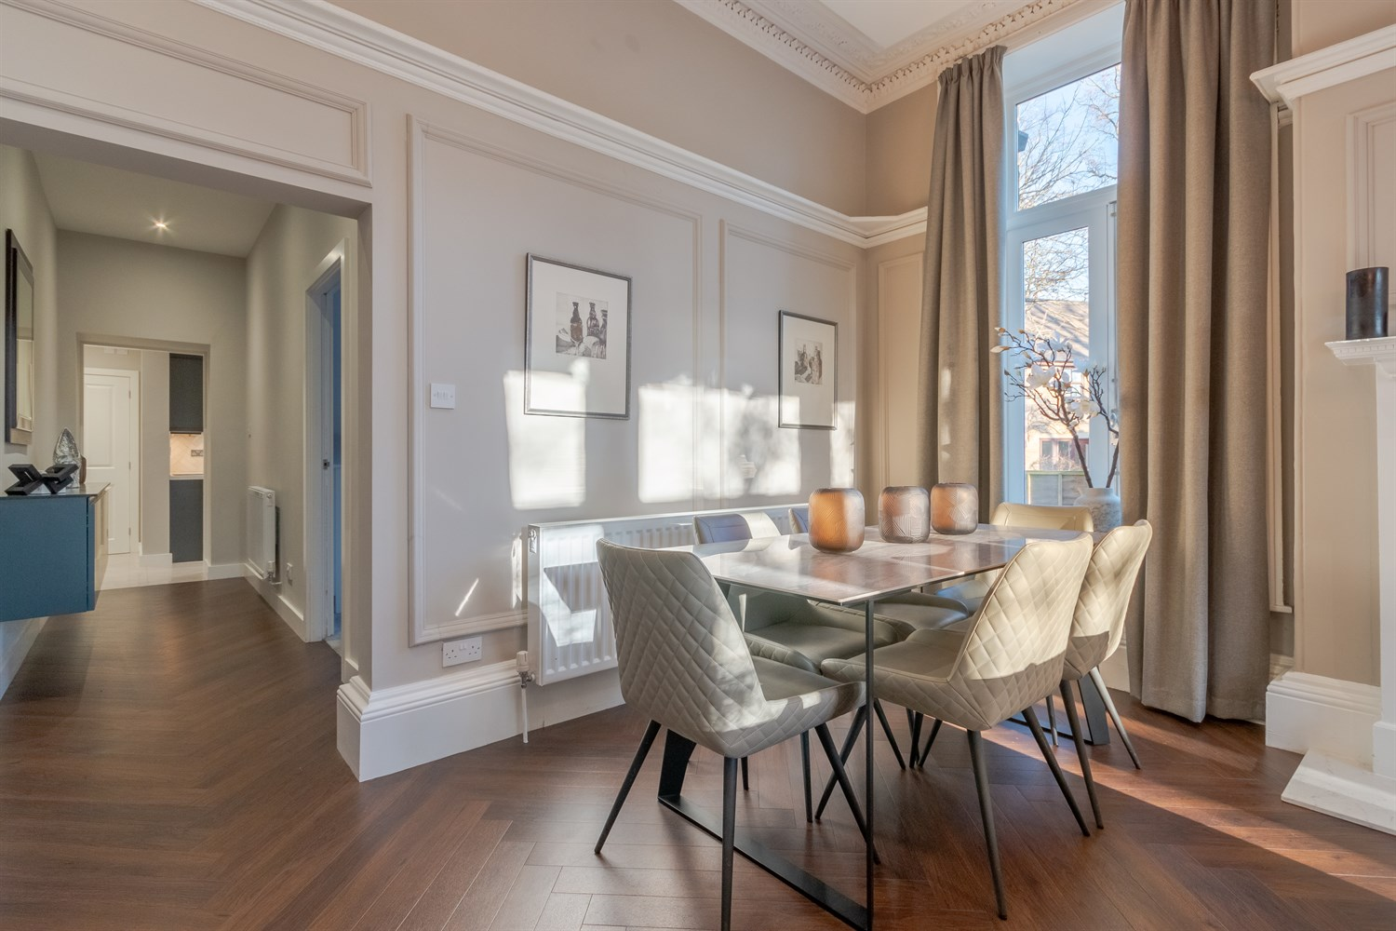

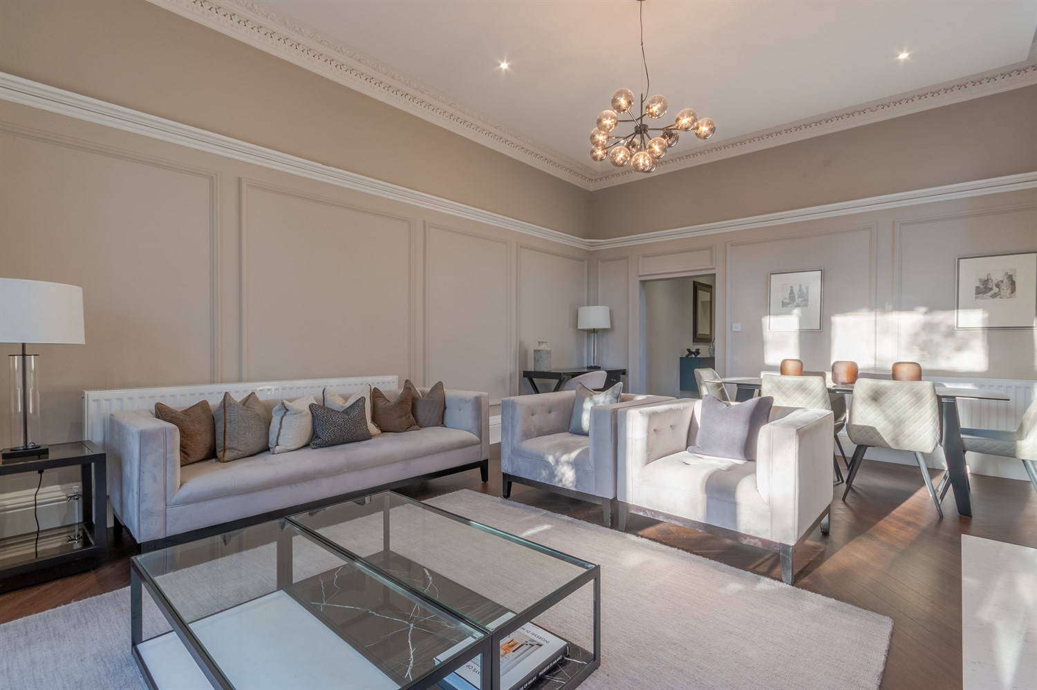

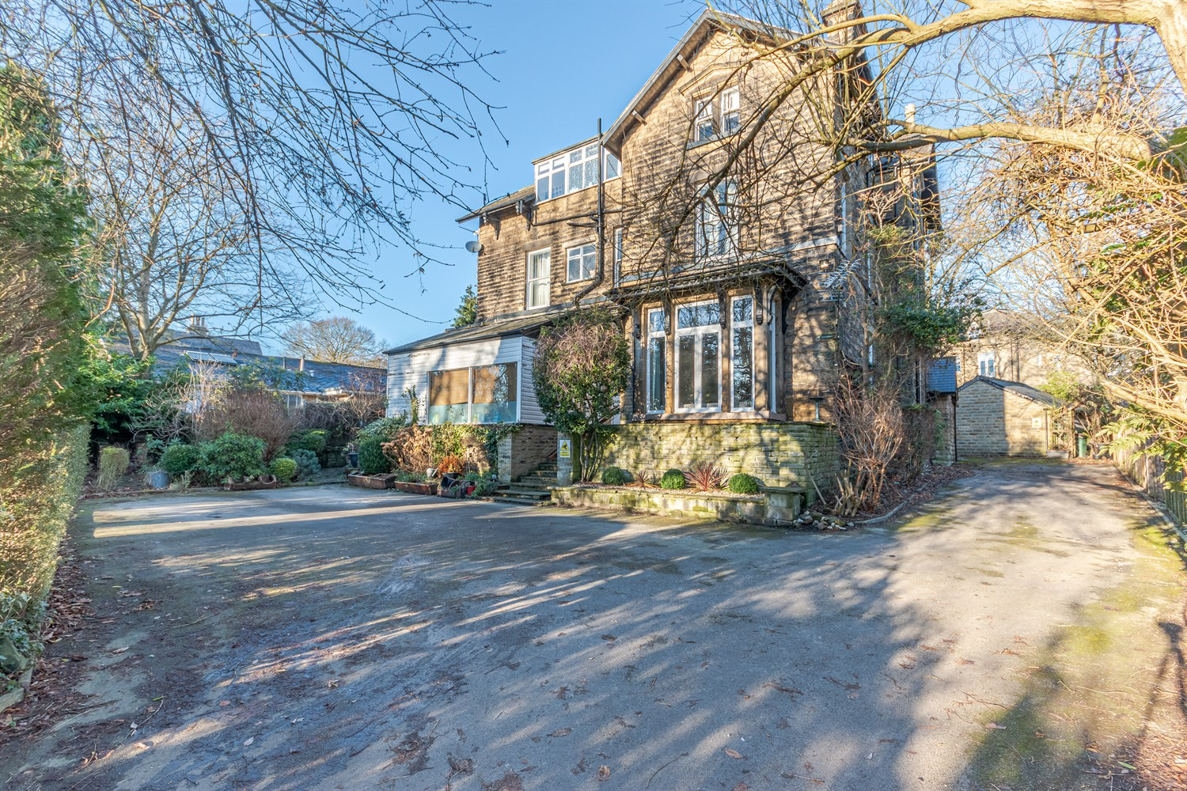

2 Bathroom(s)

1 Reception(s)

2 Bedroom(s)

00

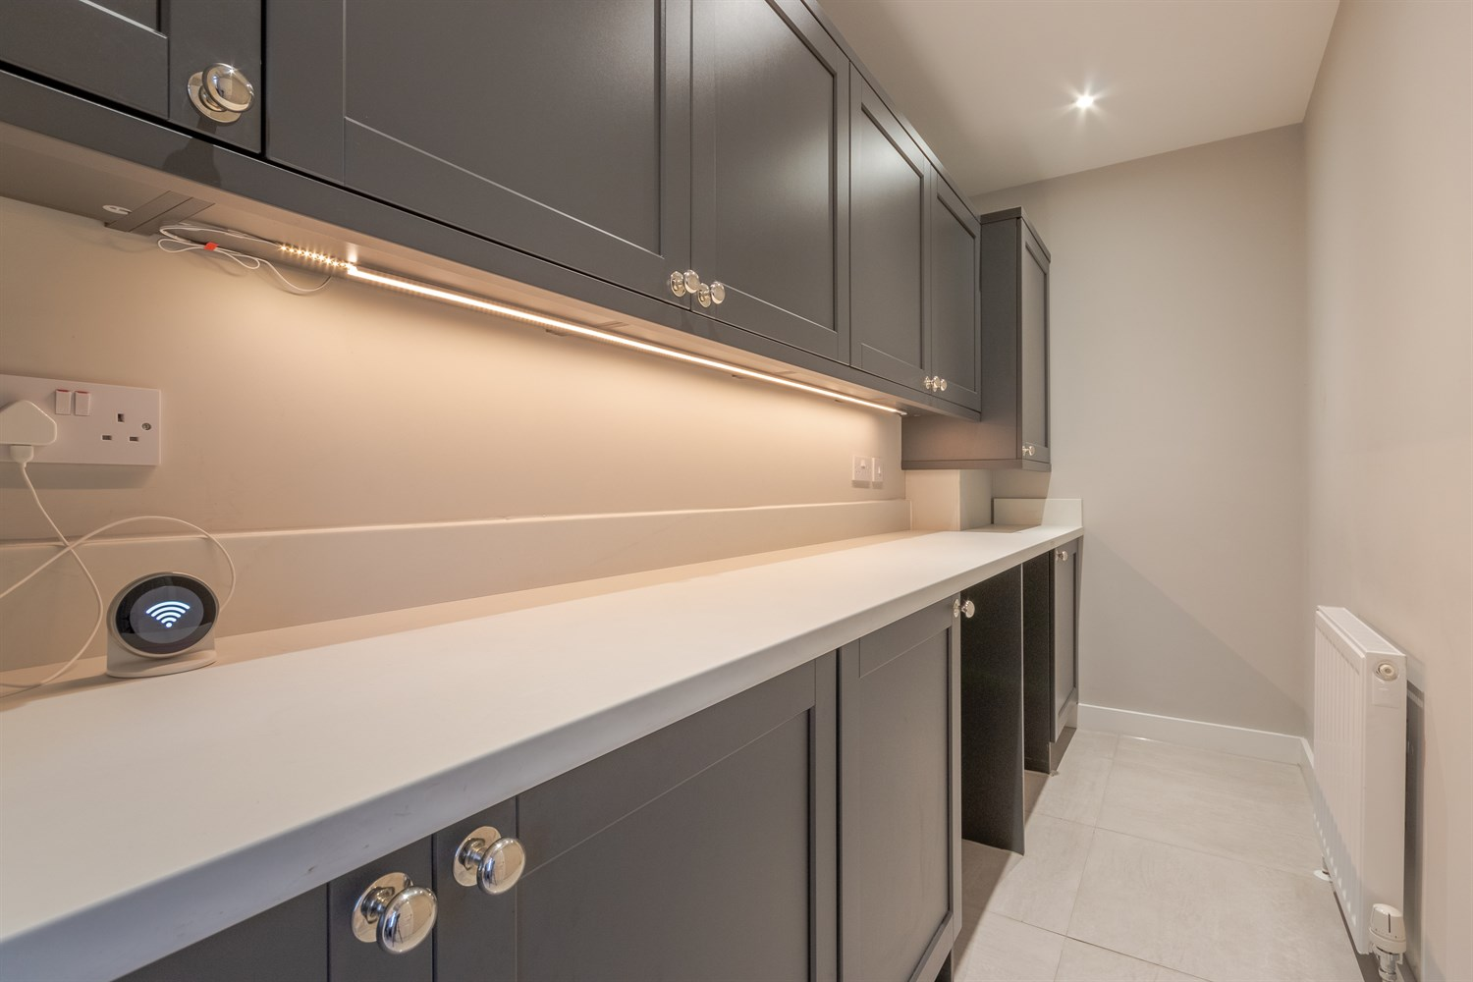

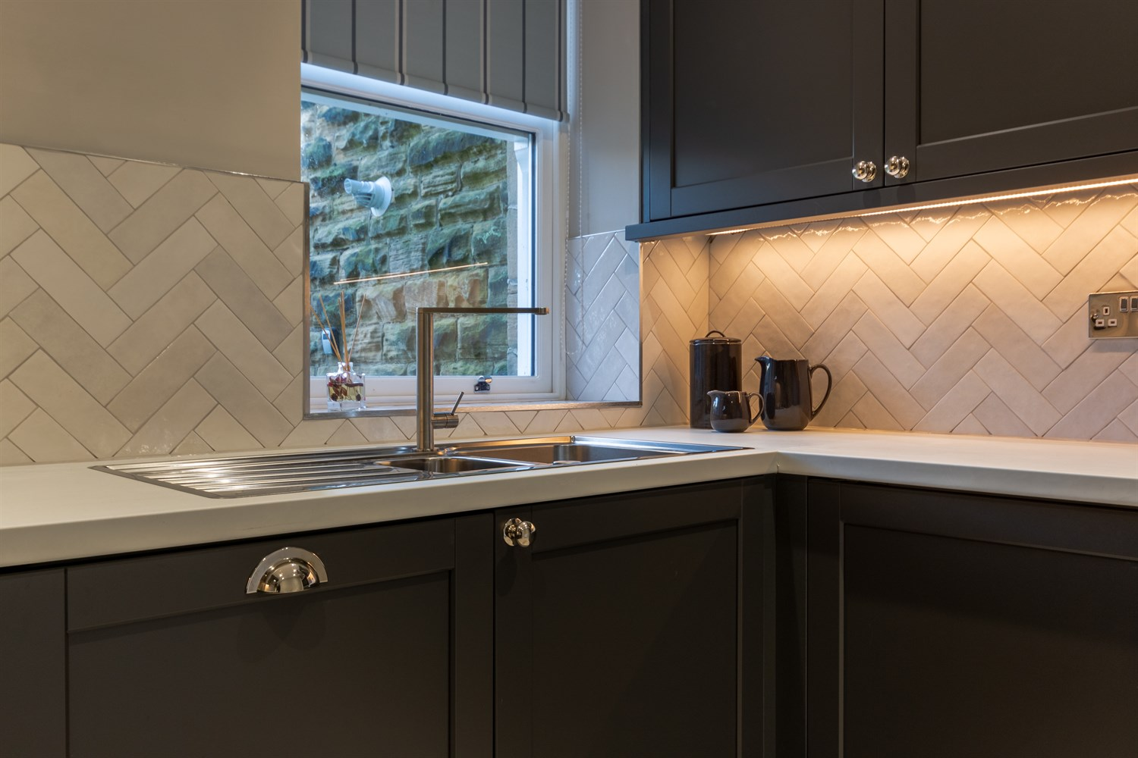

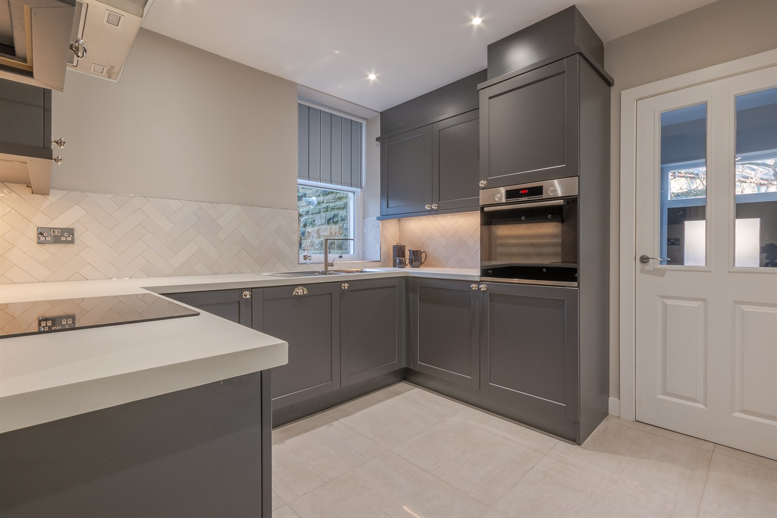

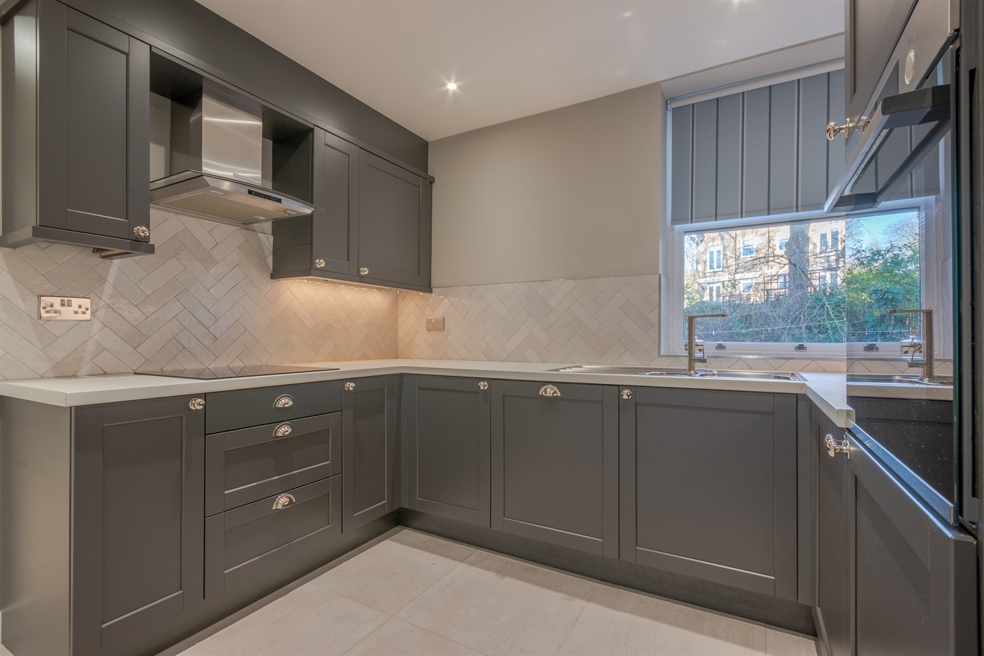

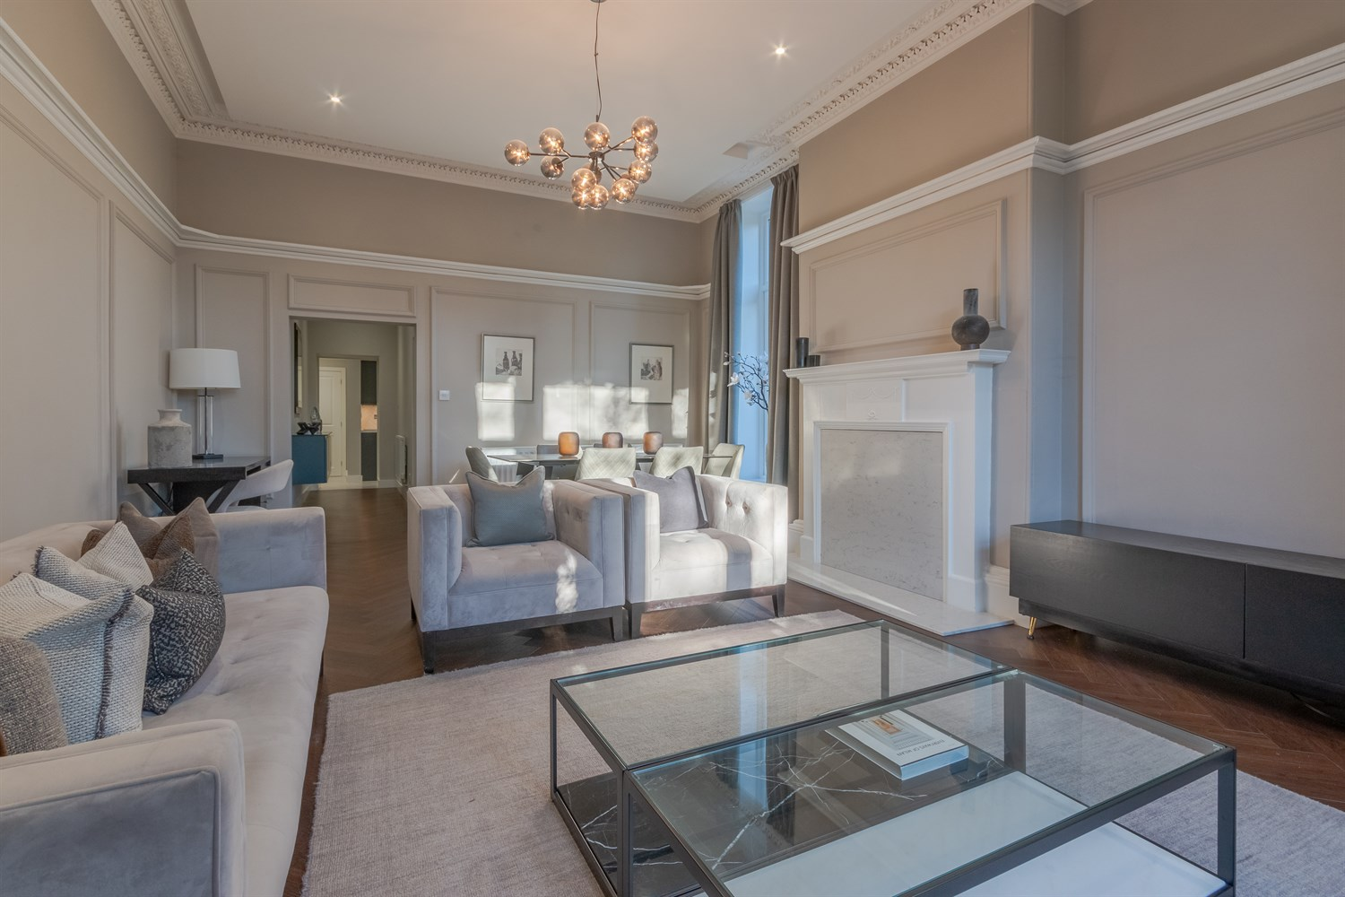

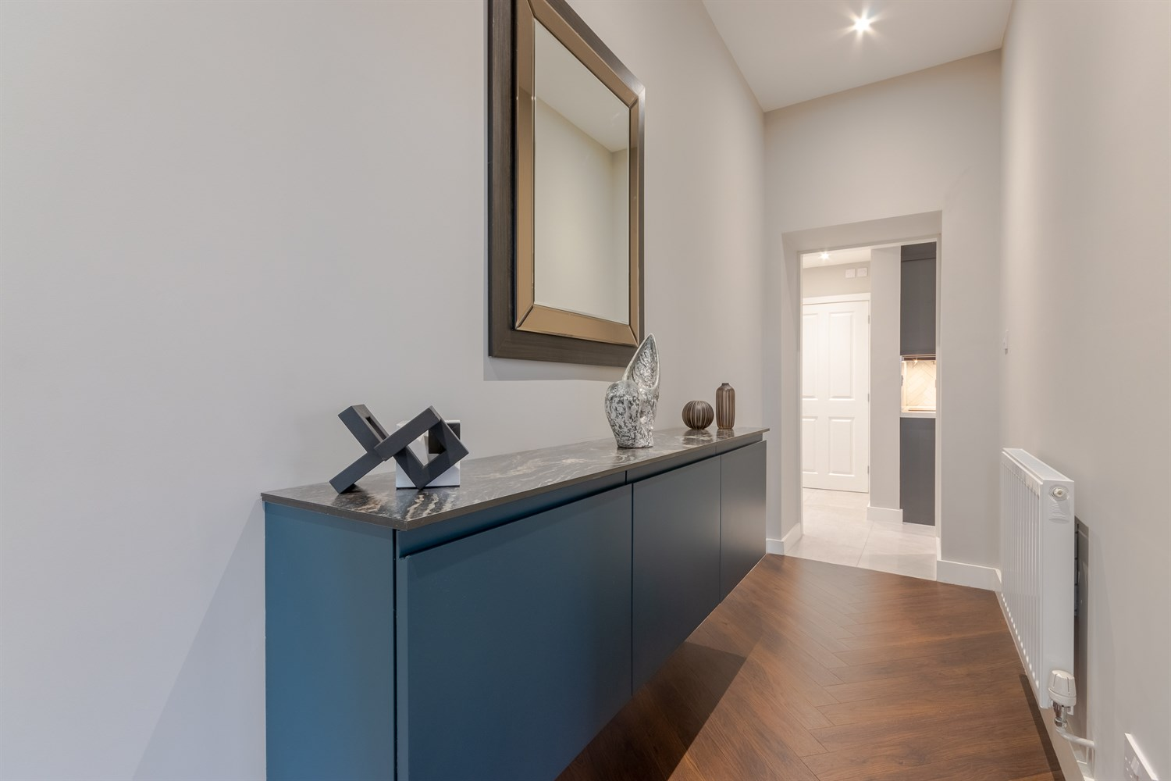

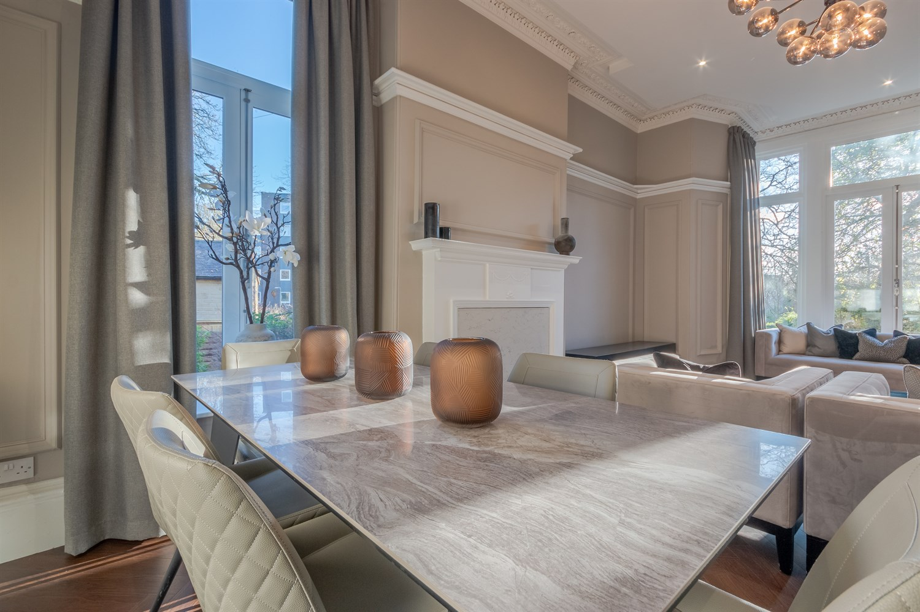

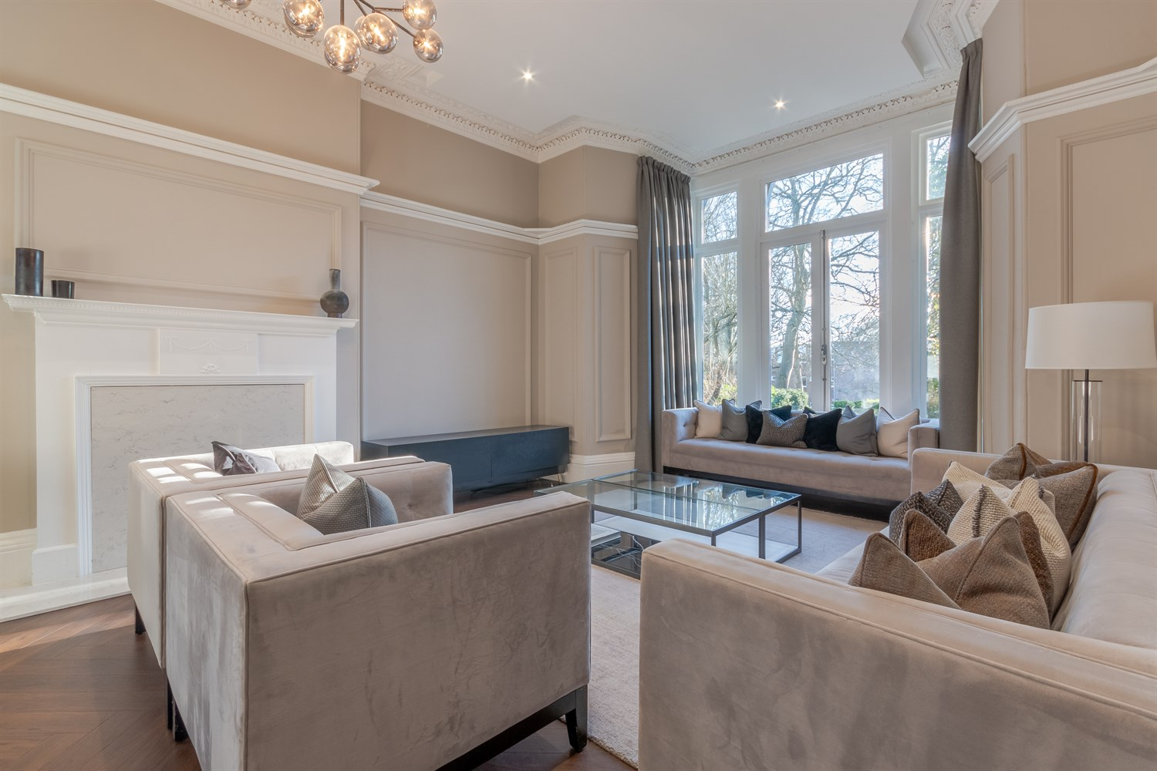

|  |
| --- |
| **Entrance Hall**  Via front entrance door. |
| **Living Room 4.54m (14'11) x 5.88m (19'3)**  Light and airy living room with high ceilings and windows to the front and side. Two gas central heating radiators. |
| **Kitchen 2.93m (9'7) x 2.83m (9'3)**  Fitted with a range of wall, base and drawer units with worktops over. 1.5 bowl stainless steel sink with mixer tap and drainer. 4-ring hob and extractor hood over. Integrated oven and dishwasher. Window to side. Inset ceiling spotlights. |
| **Utility Room**  Fitted with a range of wall, base and drawer units to match the kitchen. Space for washing machine. Gas central heating radiator. Inset ceiling spotlights. |
| **Bedroom 1 3.74m (12'3) x 4.78m (15'8)**  Master bedroom with window to rear. Gas central heating radiator. Built in wardrobes. |
| **En-Suite Shower Room**  Fitted with a three piece suite comprising; shower cubicle, WC and wash hand basin. Part tiled walls. Inset ceiling spotlights. |
| **Bedroom 2 3.42m (11'3) x 3.59m (11'9)**  Second double bedroom with window to side. Gas central heating radiator. Built in cupboard. |
| **Bathroom**  Fitted with a four piece suite comprising; shower cubicle, bath, WC and wash hand basin. Part tiled walls. Wall mounted heated towel rail. Two windows. |
| **Property Information**  COUNCIL TAX BAND: D EPC Rating: D  Leasehold property Off street Parking  Broadband: Standard 5 Mbps 0.6 Mbps Good Superfast 41 Mbps 9 Mbps Good Ultrafast 1000 Mbps 100 Mbps  Mobile availability: EE limited. Three limited. O2 likely to have voice coverage. Vodafone limited  Utilities: Water supplied on standard meters. Electric mains supplied on standard meters. Gas mains supplied on standard meters. |
| **Holding Fee**  Please note, a holding fee equivalent to one weeks rent is payable upon application. This forms part of the first months rent. |

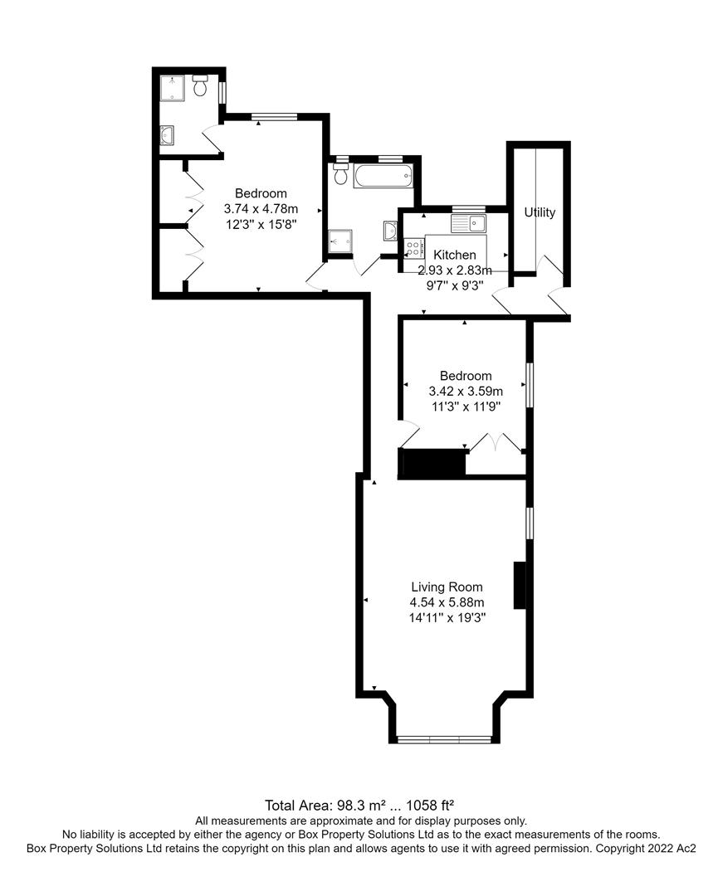

|  |  |
| --- | --- |
| These particulars are intended to give a fair description of the property, but their accuracy cannot be guaranteed, and they do not constitute an offer of contract. Intending purchasers must rely on their own inspection of the property. None of the above appliances/services have been tested by ourselves. We recommend purchasers arrange for a qualified person to check all appliances/services before legal commitment.  **Property Ref:** 4811  **For more information, please contact**  0113 258 1150 **|** [lettings@adairpaxton.co.uk](mailto:lettings@adairpaxton.co.uk) **|** www.adairpaxton.co.uk |  |