

**0113 258 1150**

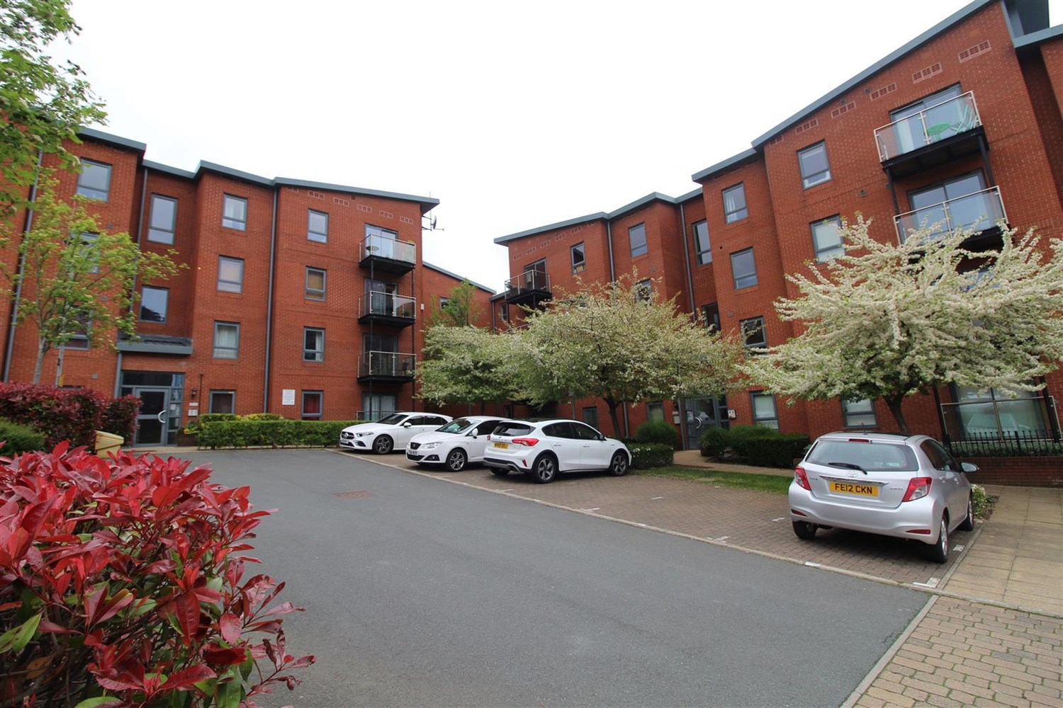



**Available to let £950.00pcm**

**Bouverie Court, LS9**

***STUNNING TWO BEDROOM GROUND FLOOR APARTMENT WITH PARKING AND EN-SUITE TO MASTER***Beautifully presented two double bedroom apartment with balcony. The apartment briefly comprises; open plan Lounge/Dining Kitchen area having patio doors which lead out onto the balcony, two double Bedrooms, master having en-suite Shower room, modern house Bathroom with shower over bath. This apartment is fully furnished to a high standard and comes with a secure, allocated parking space. Ideally located only a short distance from Leeds City centre and the nearby Clarence Dock development as well as being ideally accessible for the motorway network. Furnished. Deposit £1095. Available 16th January 2025.

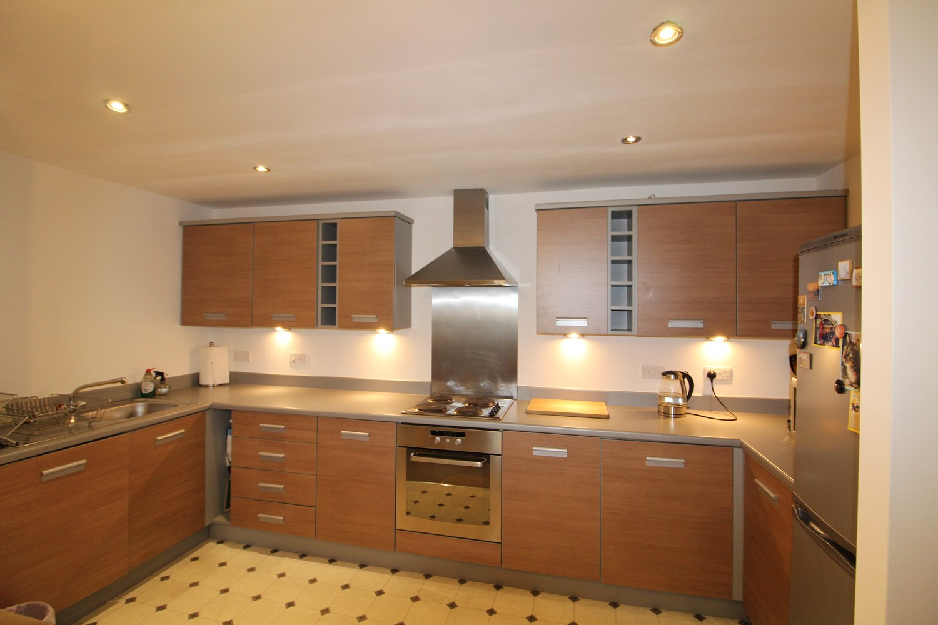

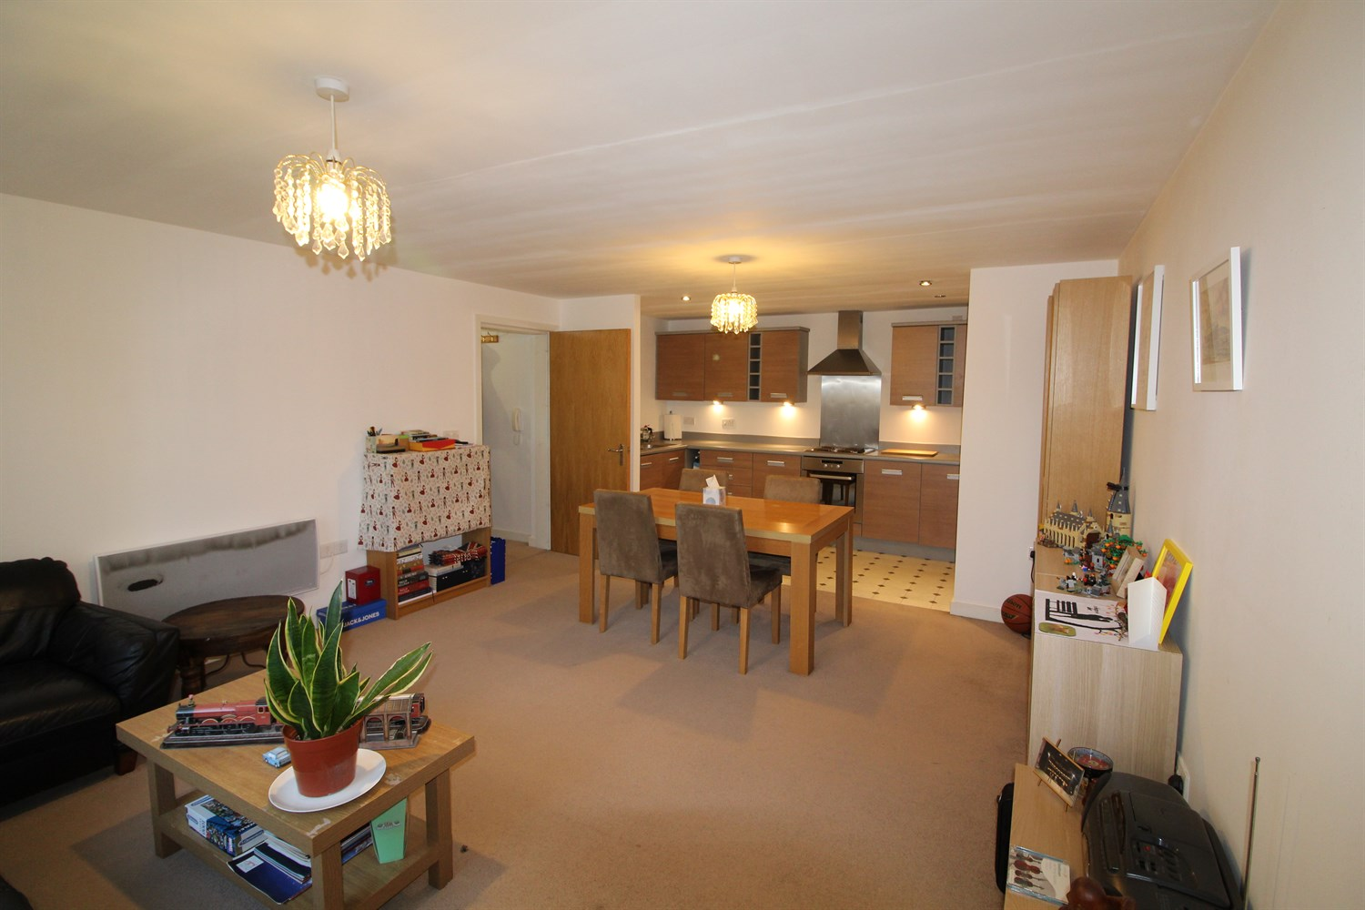

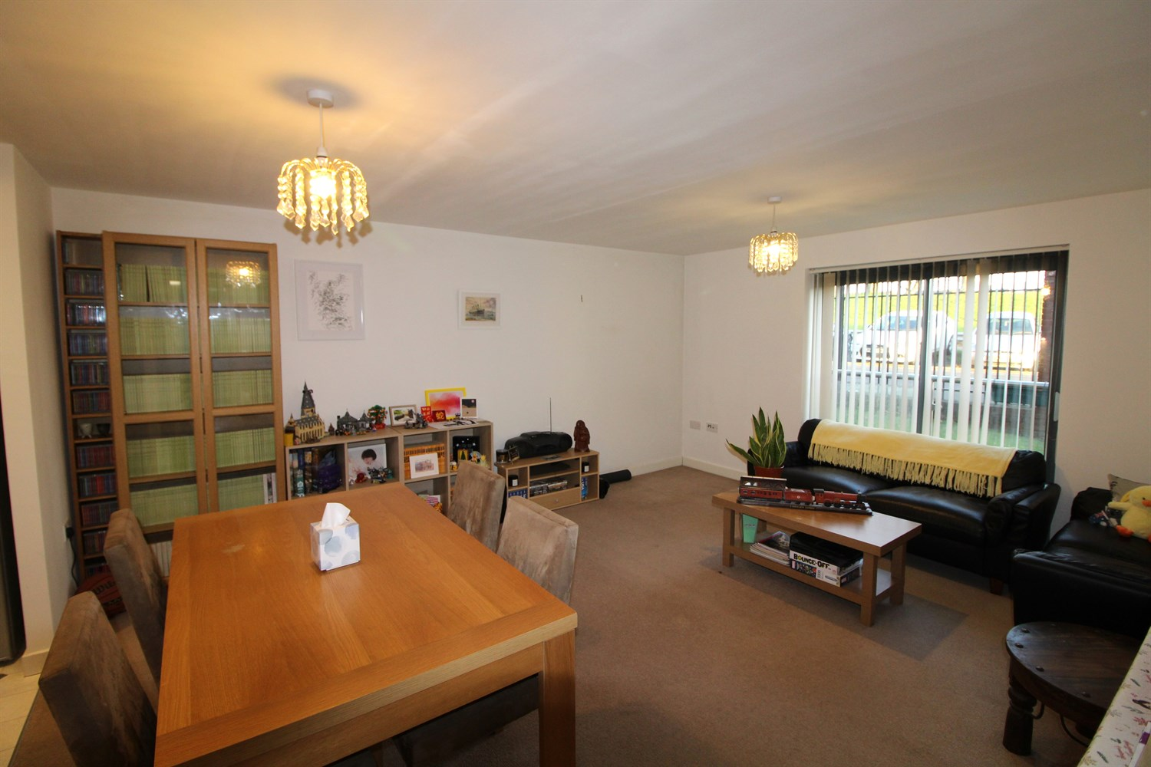

2 Bathroom(s)

1 Reception(s)

2 Bedroom(s)

00

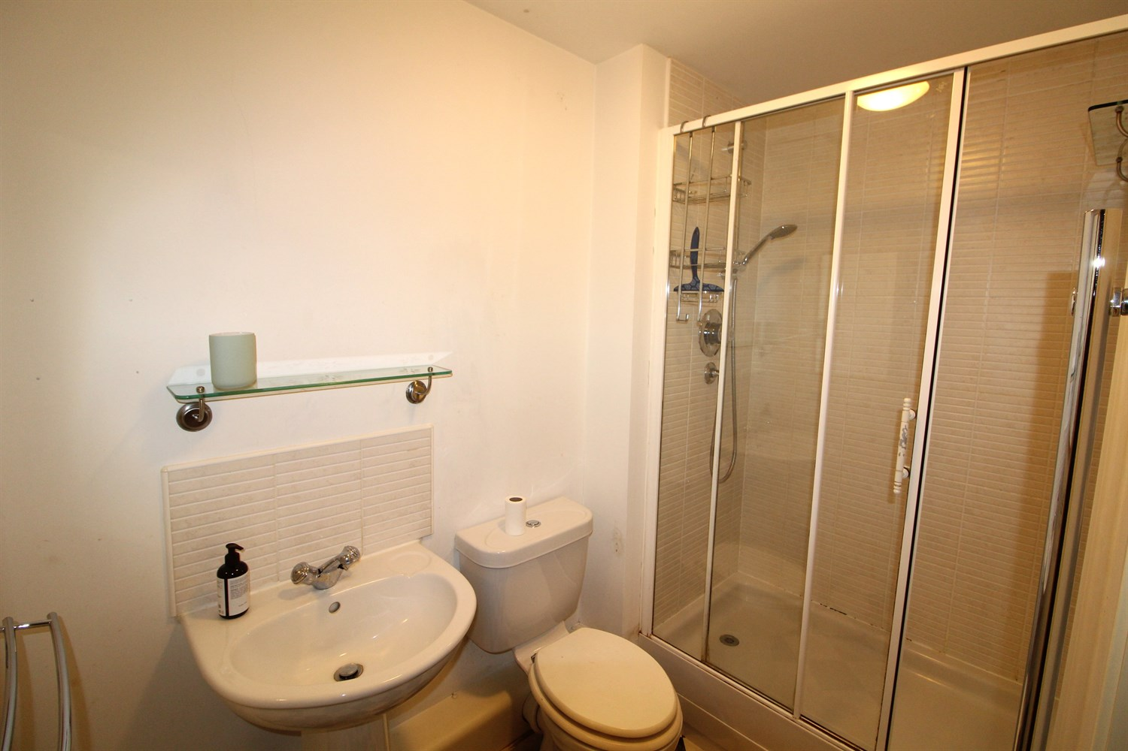

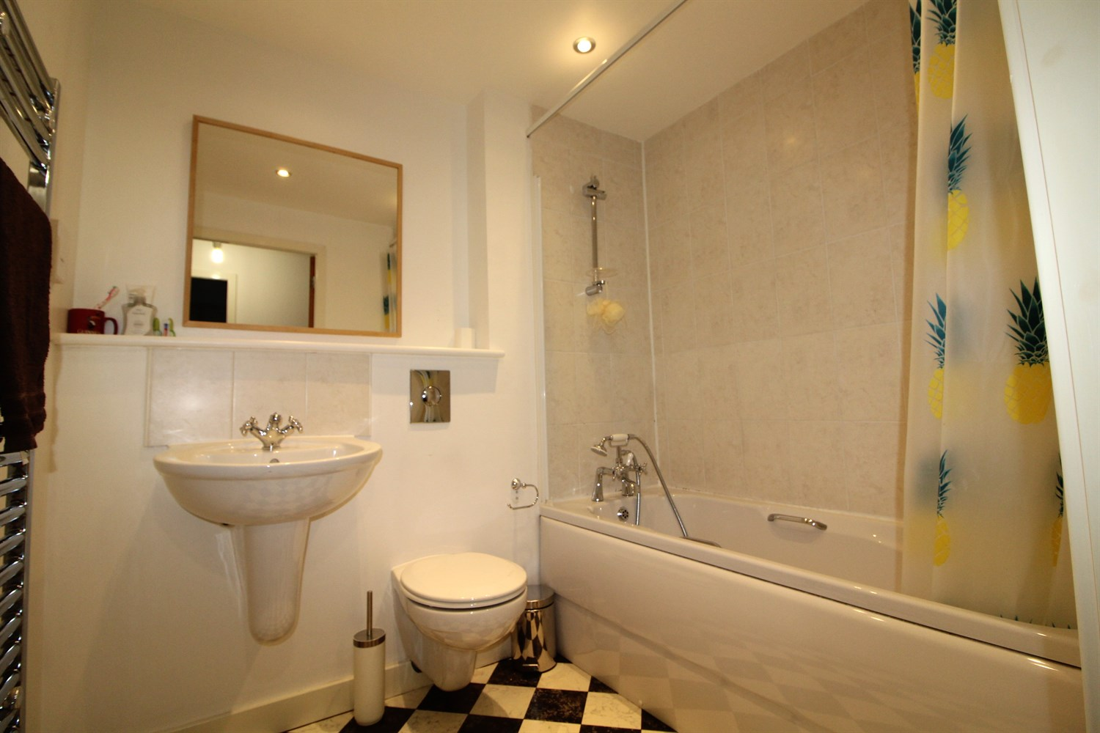

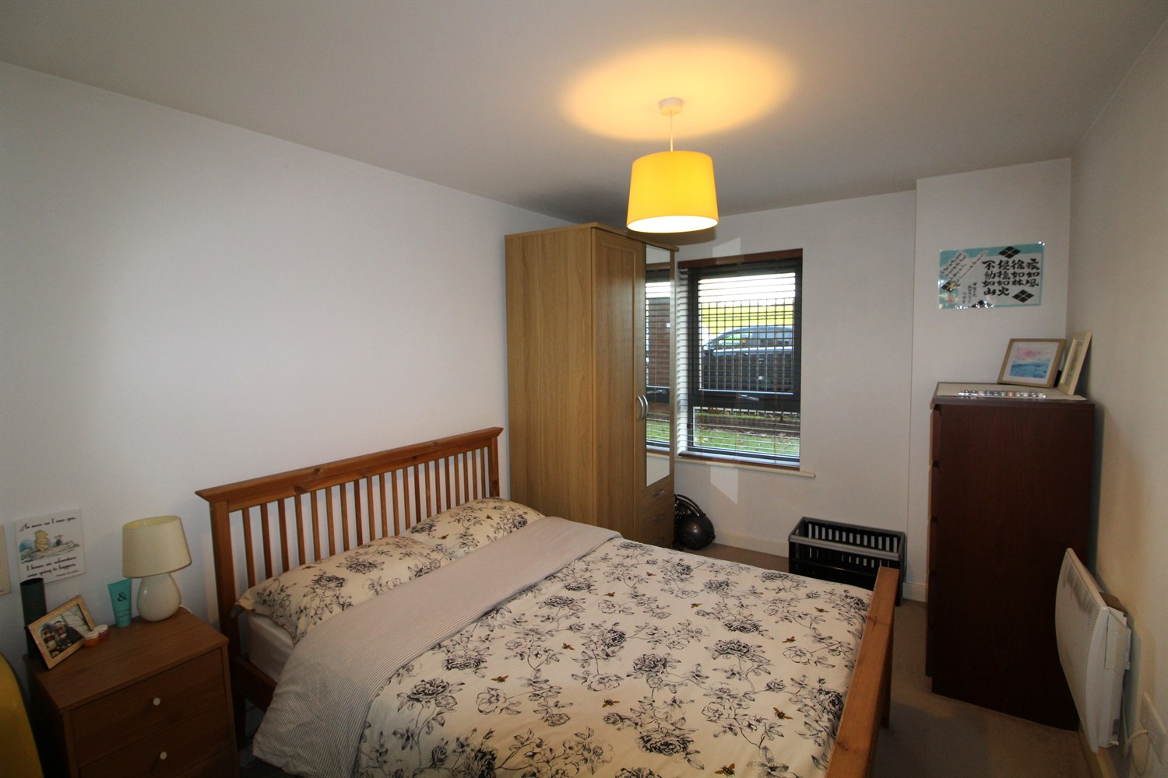

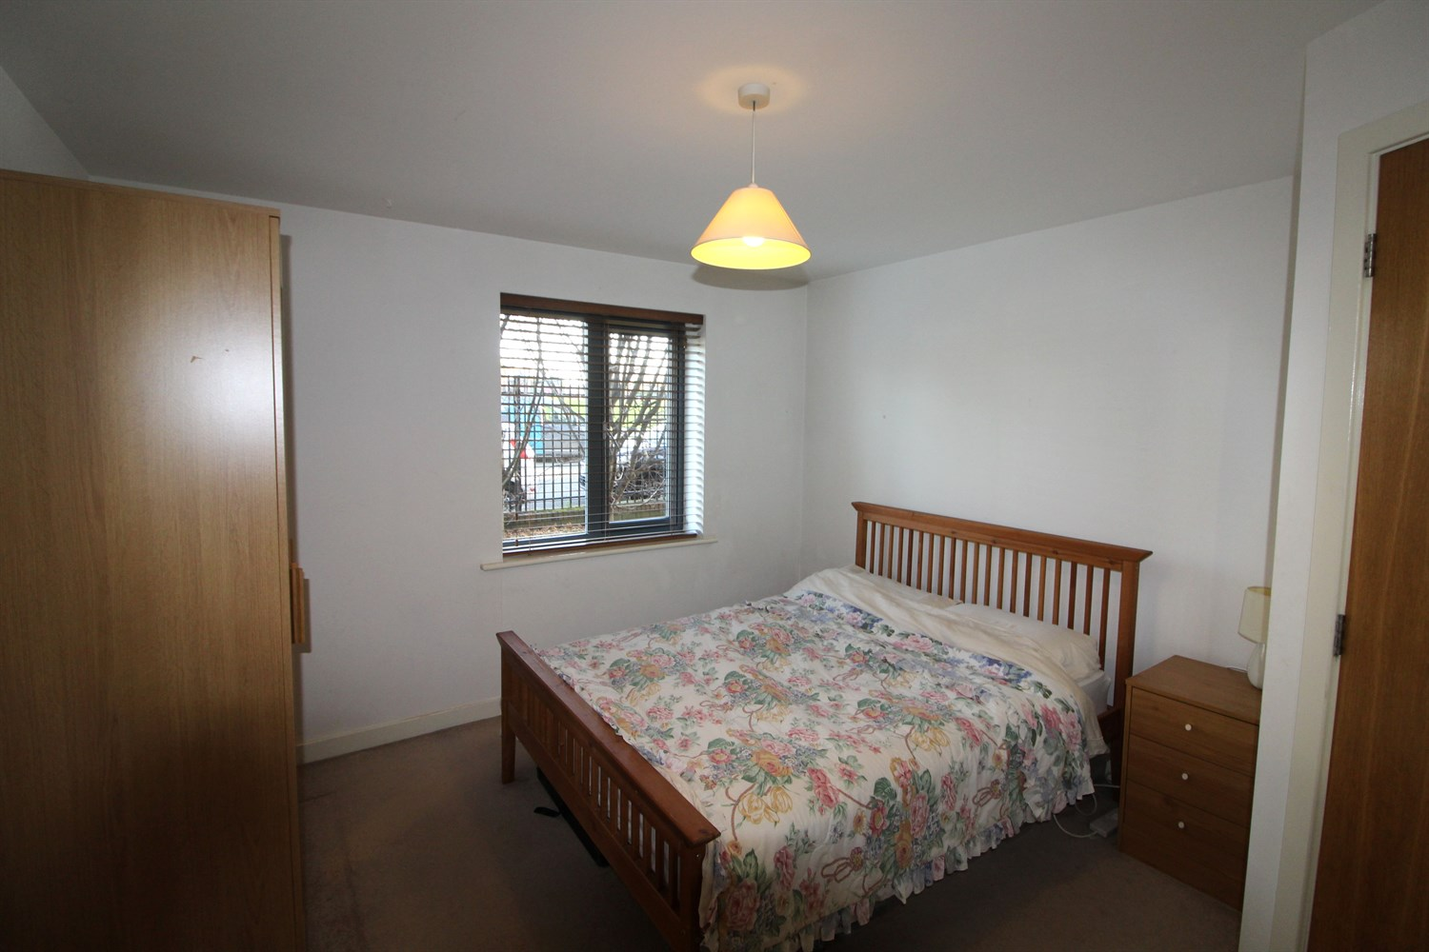

|  |
| --- |
| **Open Plan Kitchen and Living Room 6.9m (22'8) x 4.17m (13'8)**  Open plan living/dining room and kitchen with Juliet balcony . Kitchen is fitted with a range wall and base units with worktops over, electric oven and hob with extractor fan, integrated fridge freezer, stainless steel sink with mixer tap and drainer. |
| **Bedroom 1 3.31m (10'10) x 3.51m (11'6)**  Double bedroom with double glazed window and wall mounted electric radiator. |
| **Bedroom 2 2.67m (8'9) x 3.73m (12'3)**  Double bedroom with double glazed window and wall mounted electric radiator. |
| **En Suite**  Three piece suite compromising of walk in shower, w/c and hand wash basin. |
| **House Bathroom 1.85m (6'1) x 2.19m (7'2)**  Fitted with a white three piece suite compromising of bath with shower over head, shower screen, W/C, hand wash basin and a towel rail, part tiled |
| **Parking**  Allocated Parking. |
| **Home Information**  12 month Tenancy. COUNCIL TAX BAND: C EPC Rating C  Leasehold property Parking included  Broadband: Standard 8 Mbps 950.9 Mbps Good Superfast 71 Mbps 18 Mbps Good Ultrafast 1950950950 Mbps 1950950950 Mbps Mobile availability: EE limited coverage. Three likely to have good coverage. O2 likely to have good coverage. Vodafone limited coverage .  Utilities: Water supplied on standard meters. Electric mains supplied on standard meters. |

|  |  |
| --- | --- |
| These particulars are intended to give a fair description of the property, but their accuracy cannot be guaranteed, and they do not constitute an offer of contract. Intending purchasers must rely on their own inspection of the property. None of the above appliances/services have been tested by ourselves. We recommend purchasers arrange for a qualified person to check all appliances/services before legal commitment.  **Property Ref:** 4501  **For more information, please contact**  0113 258 1150 **|** [lettings@adairpaxton.co.uk](mailto:lettings@adairpaxton.co.uk) **|** www.adairpaxton.co.uk |  |