

**0113 258 1150**

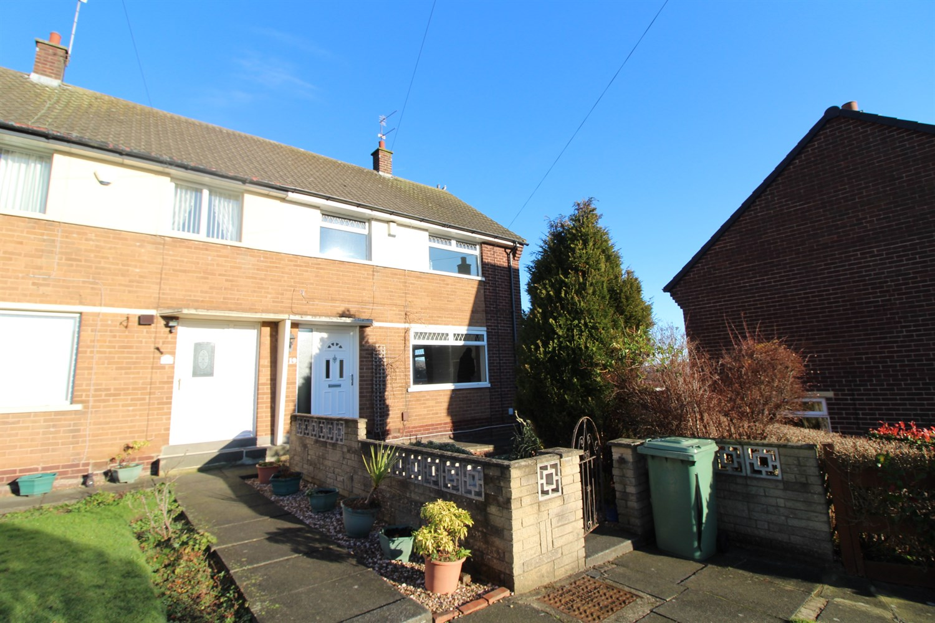



**Available to let £1,295.00pcm**

**Broadgate Lane, Horsforth**

WELL PRESENTED THREE BEDROOM HOUSE IN THE SOUGHT AFTER LOCATION OF HORSFORTH briefly comprising; Open plan lounge/diner, spacious kitchen with utility area, white goods included, oven/hob, washing machine, fridge/freezer, dishwasher, two double bedrooms and one single bedroom, small front garden and rear garden with patio area. The property also benefits from double glazing and gas central heating. On street parking.   
Unfurnished. Deposit £1490. EPC Rating D Council tax band C, Available 20th January. Sorry no pets.

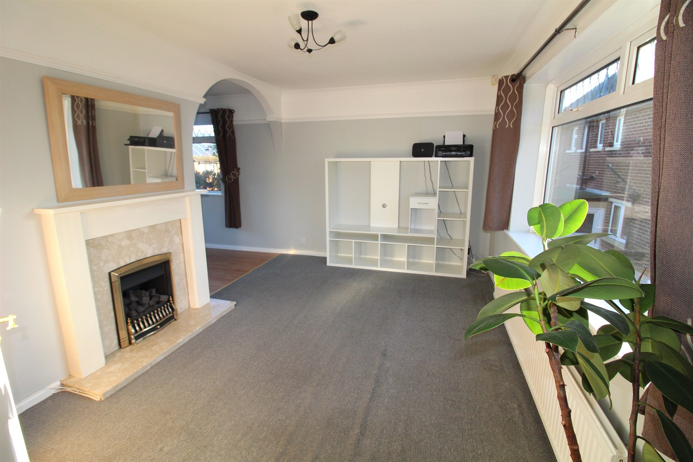

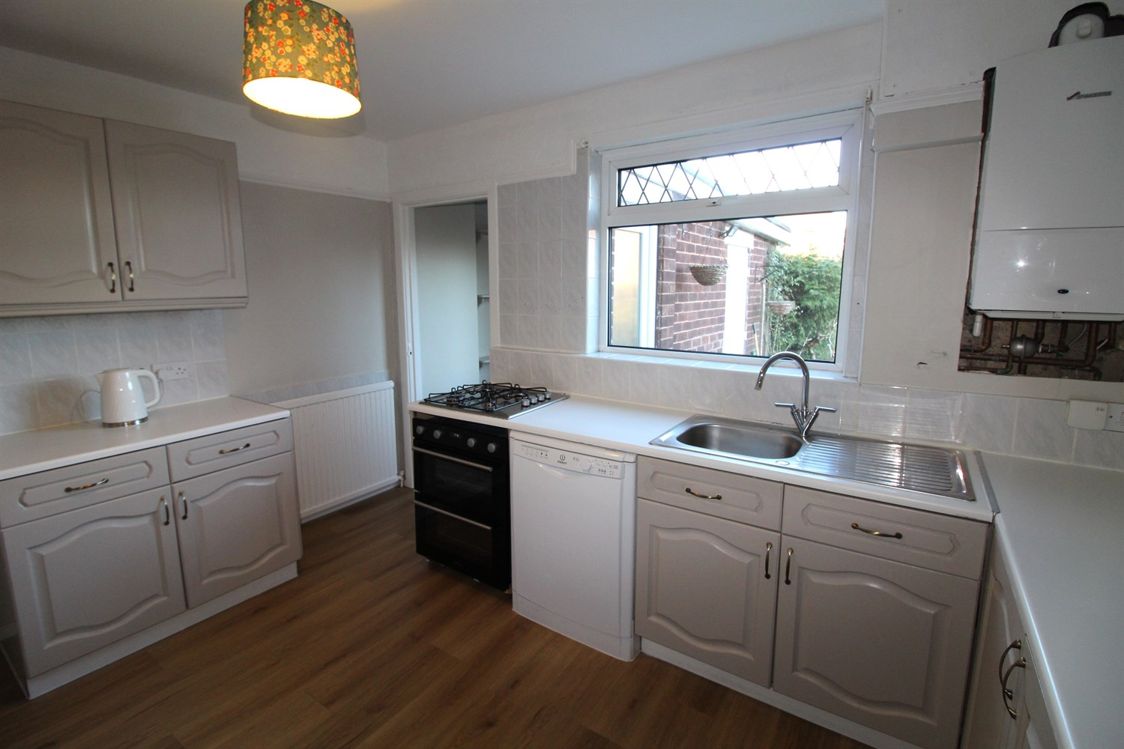

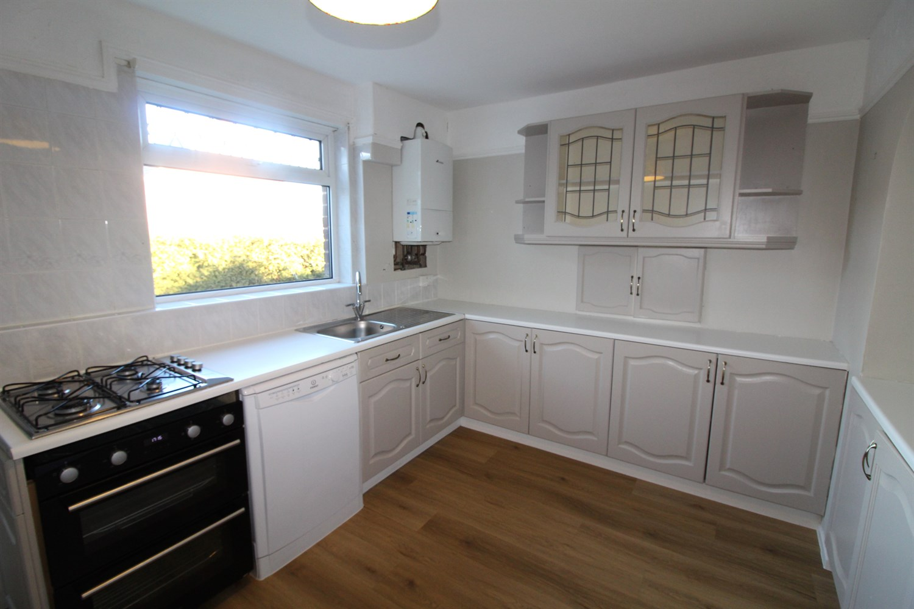

1 Bathroom(s)

1 Reception(s)

3 Bedroom(s)

00

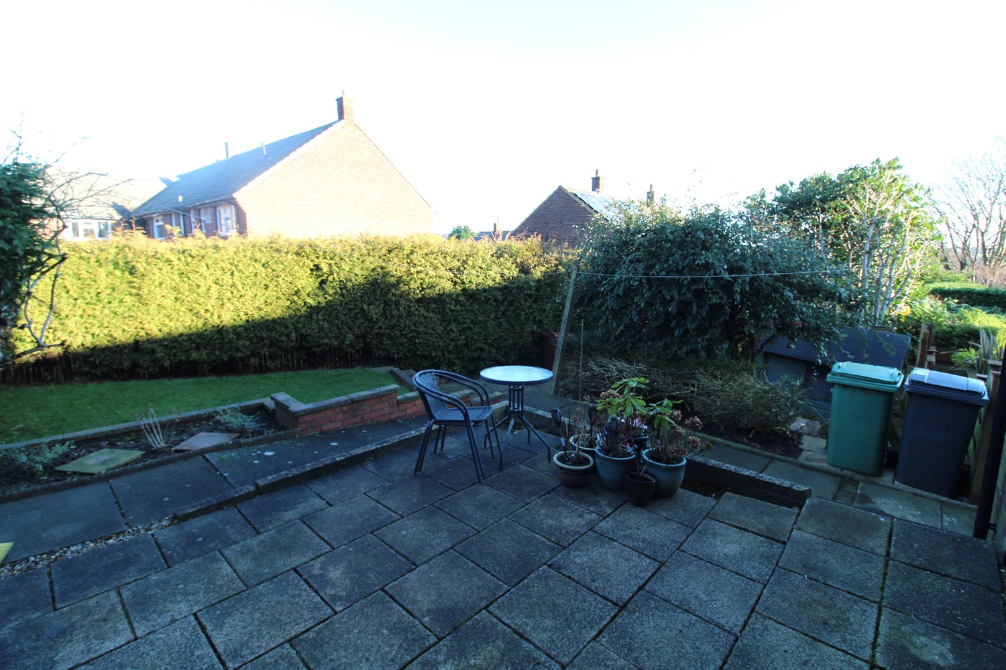

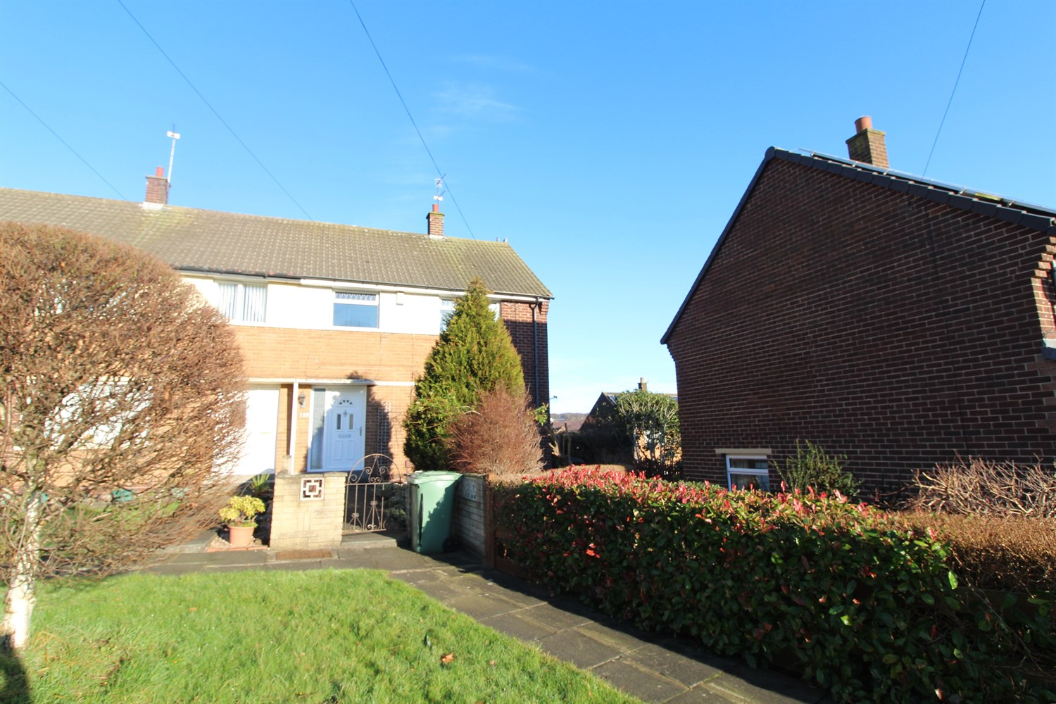

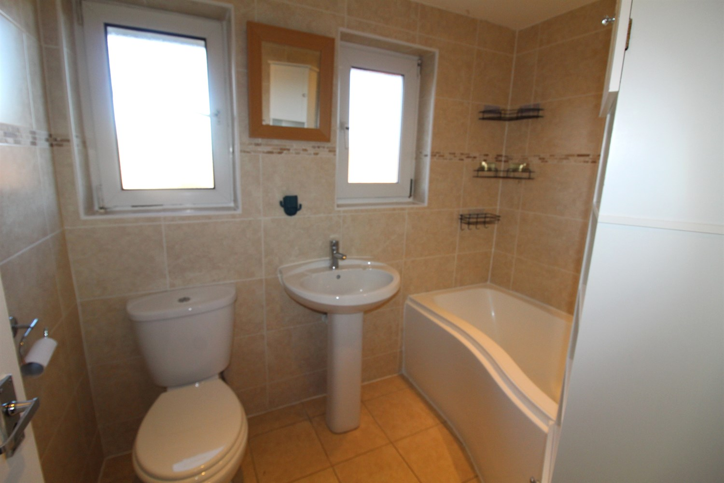

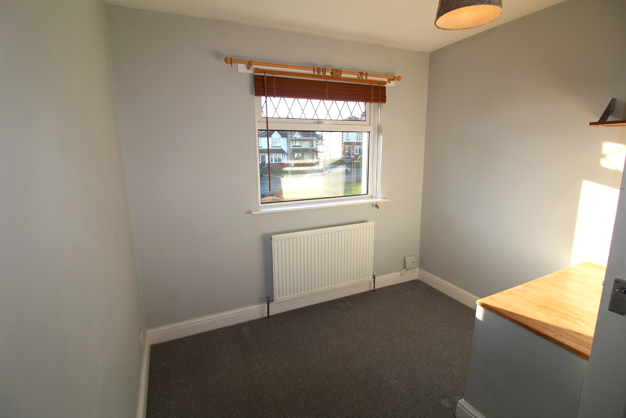

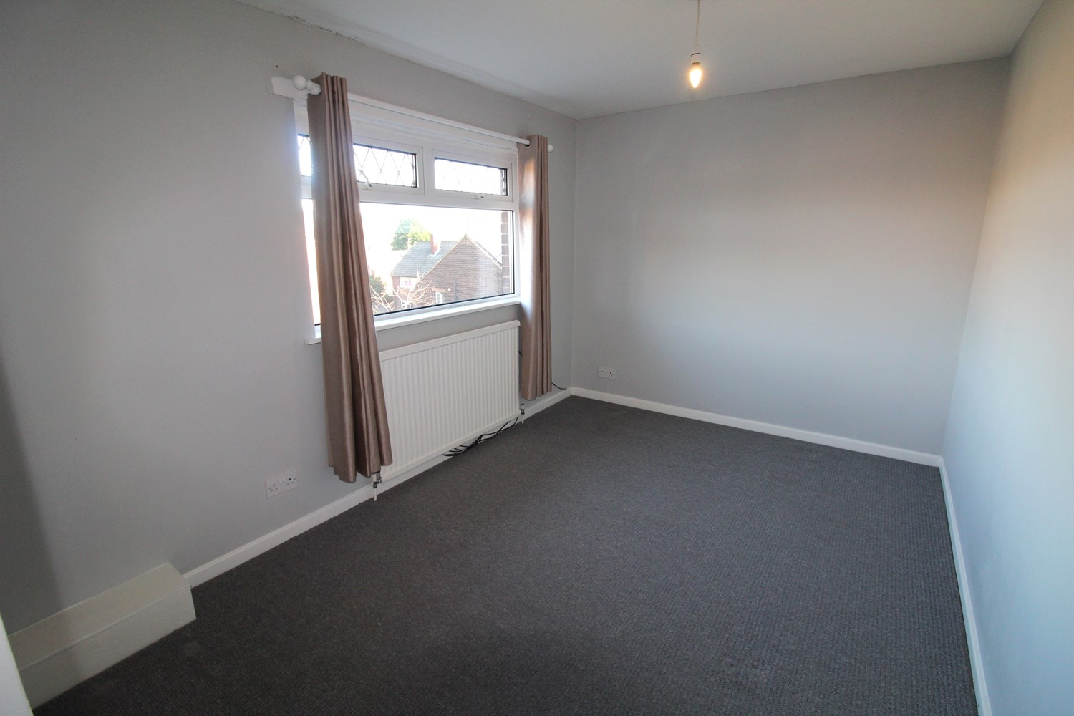

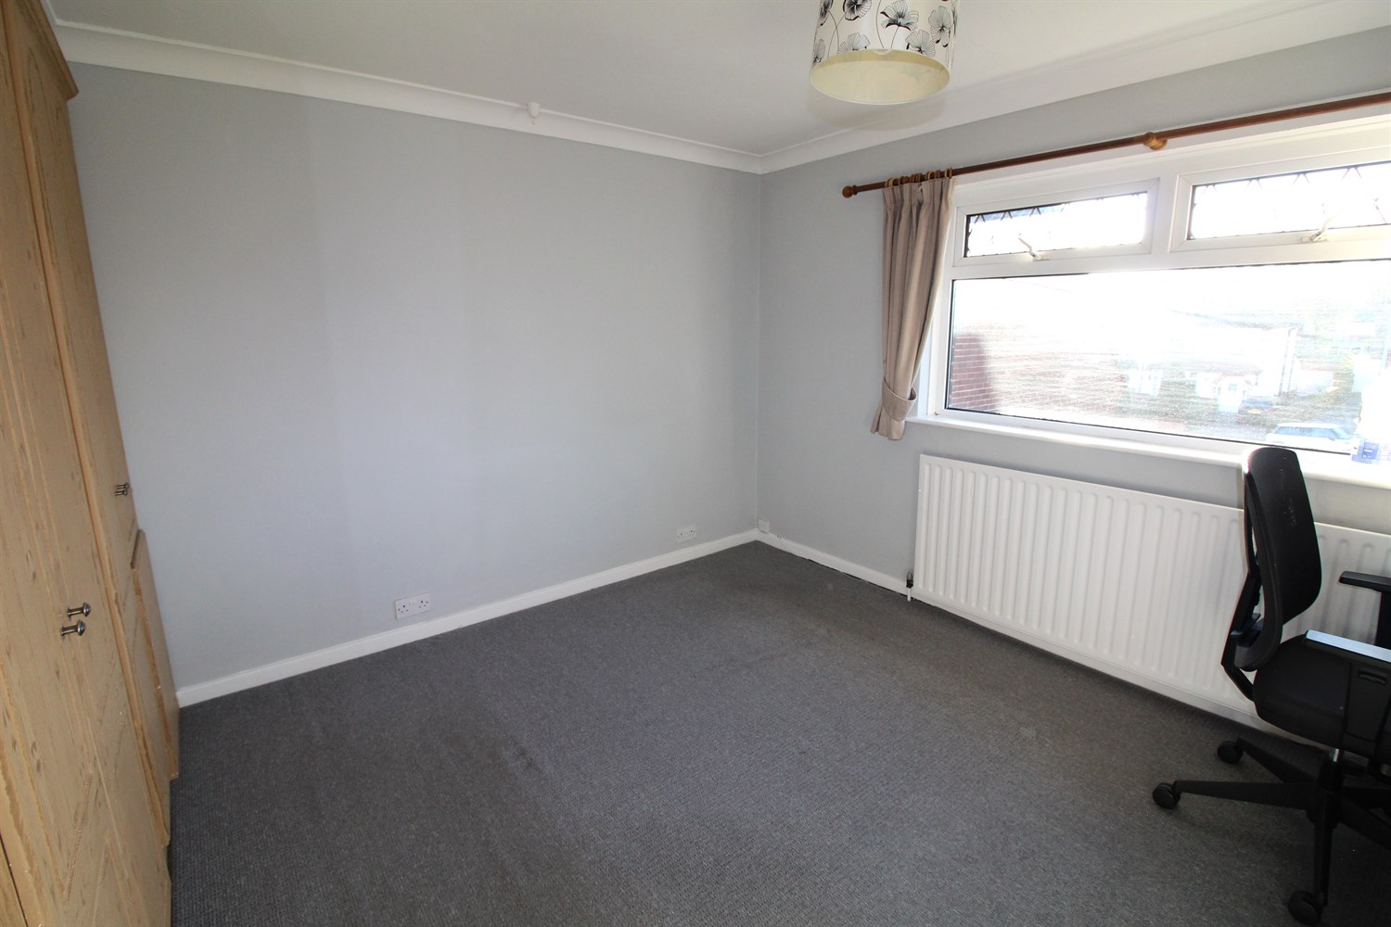

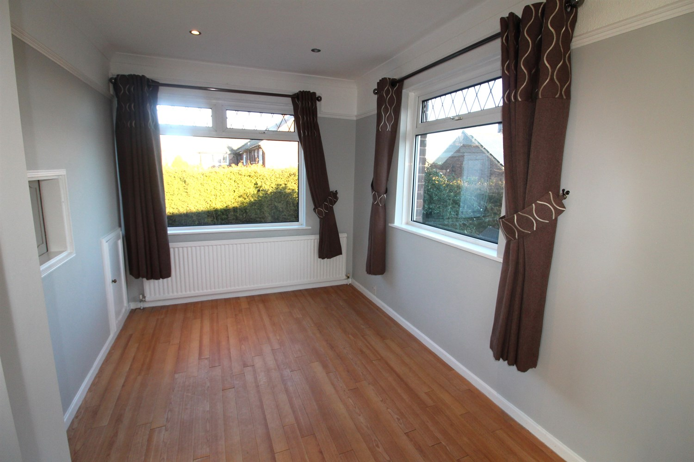

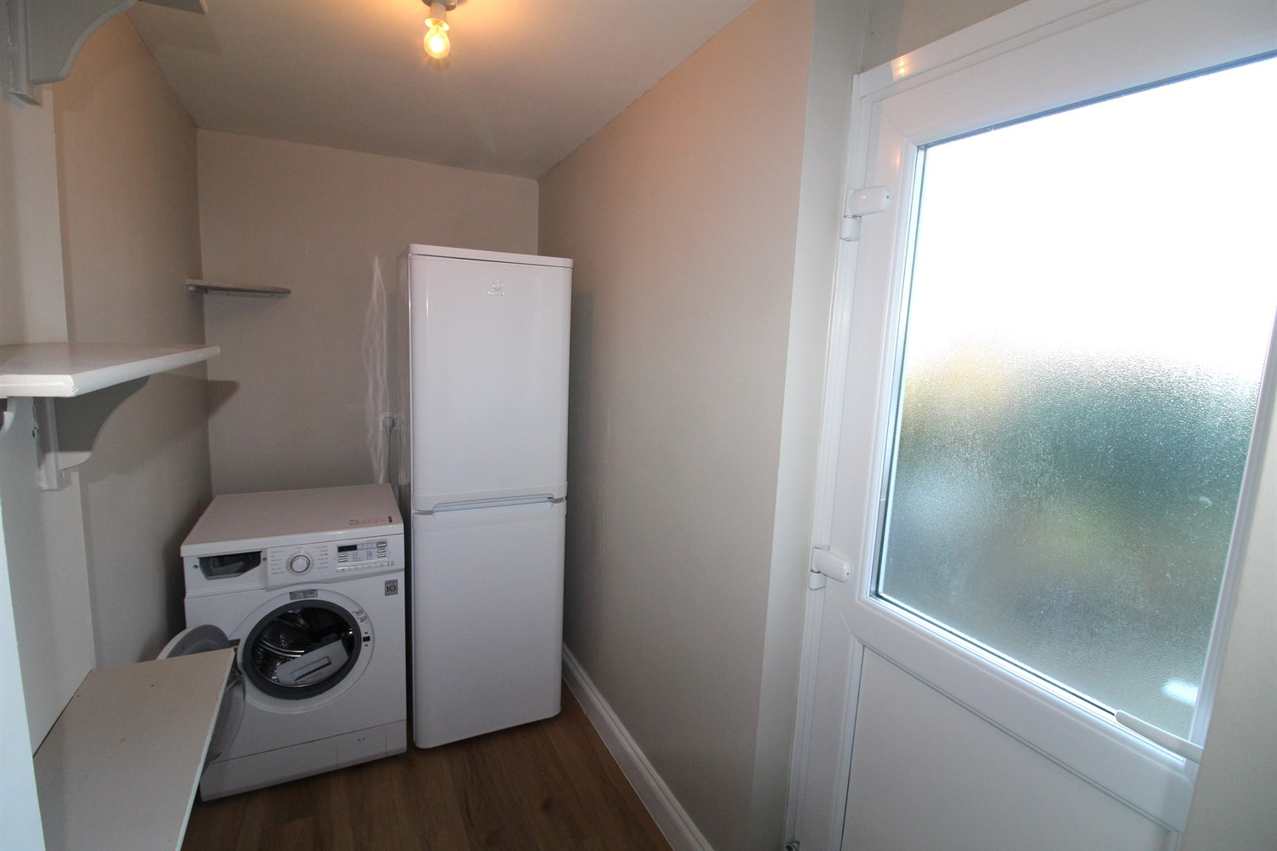

|  |
| --- |
| **Hallway**  Stairs leading to first floor. |
| **Lounge**  Spacious lounge with double glazed windows to front and side, gas central heating radiator. |
| **Kitchen**  Fitted with a range of wall and base units with worktops over. Gas cooker top and electric oven, dish washer, stainless steel sink with mixer tap and drainer. Double glazed window to rear. |
| **First Floor** |
| **Bedroom One**  Large double bedroom with double glazed window to front, gas central heating radiator. |
| **Bedroom Two**  Double bedroom with double glazed window to rear, gas central heating radiator. |
| **Bedroom Three**  Single bedroom with double glazed window to front, gas central heating radiator. |
| **Bathroom**  Three piece bathroom suite with shower over bath, W/C and hand wash basin. |
| **Home Information**  COUNCIL TAX BAND:  EPC Rating B  12 Month tenancy. Freehold property On street Parking Broadband:Standard 15 Mbps 1 Mbps Good Superfast 80 Mbps 20 Mbps Good Ultrafast 1800 Mbps 220 Mbps Mobile availability: EE likely to have good coverage . Three limited coverage. O2 limited. Vodafone likely to have good coverage.  Utilities: Water supplied on standard meters. Gas and Electric mains supplied on standard meters. |

|  |  |
| --- | --- |
| These particulars are intended to give a fair description of the property, but their accuracy cannot be guaranteed, and they do not constitute an offer of contract. Intending purchasers must rely on their own inspection of the property. None of the above appliances/services have been tested by ourselves. We recommend purchasers arrange for a qualified person to check all appliances/services before legal commitment.  **Property Ref:** 4684  **For more information, please contact**  0113 258 1150 **|** [lettings@adairpaxton.co.uk](mailto:lettings@adairpaxton.co.uk) **|** www.adairpaxton.co.uk |  |