

**0113 258 1150**

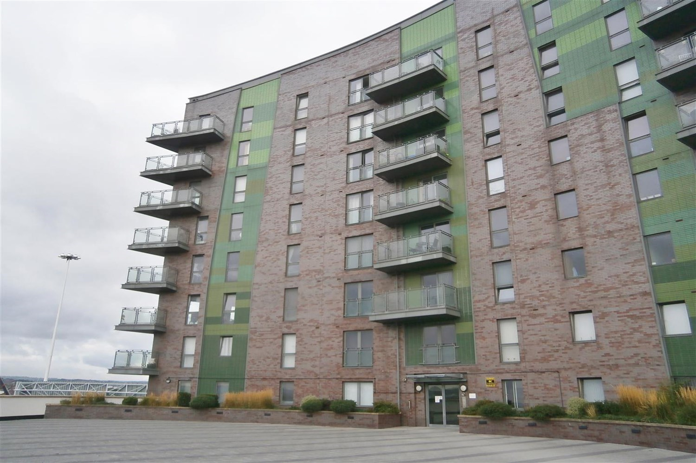



**Available to let £725.00pcm**

**Echo Central 2, Leeds**

Set in the ever popular Echo City development is this one bedroom apartment. The apartment is located close to Leeds City Centre and must be viewed to be appreciated. The property comprises: Communal entrance hall with lift to private entrance hall, open plan living room/kitchen with good quality fixtures and fittings, double bedroom and a modern shower room/w.c. Council Tax Band A EPC rating B. Furnished. Deposit £835. Available 24th January 2025. SORRY NO PETS.

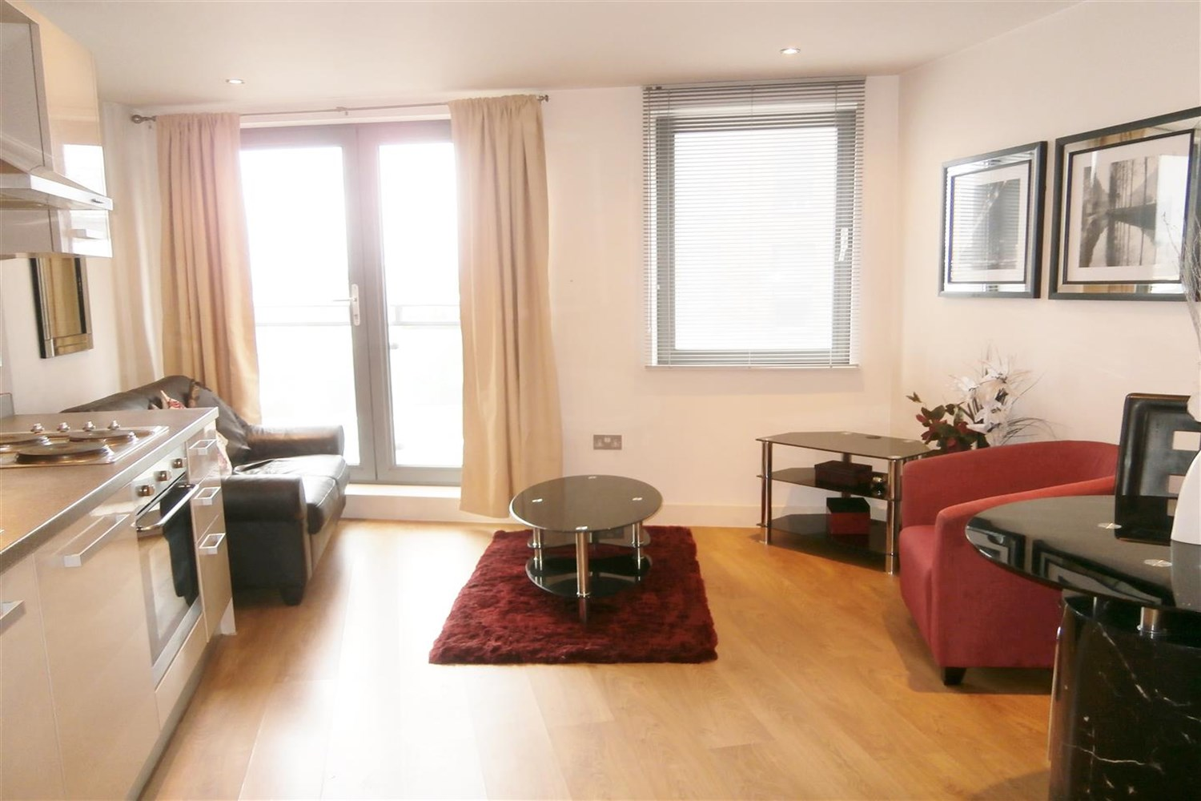

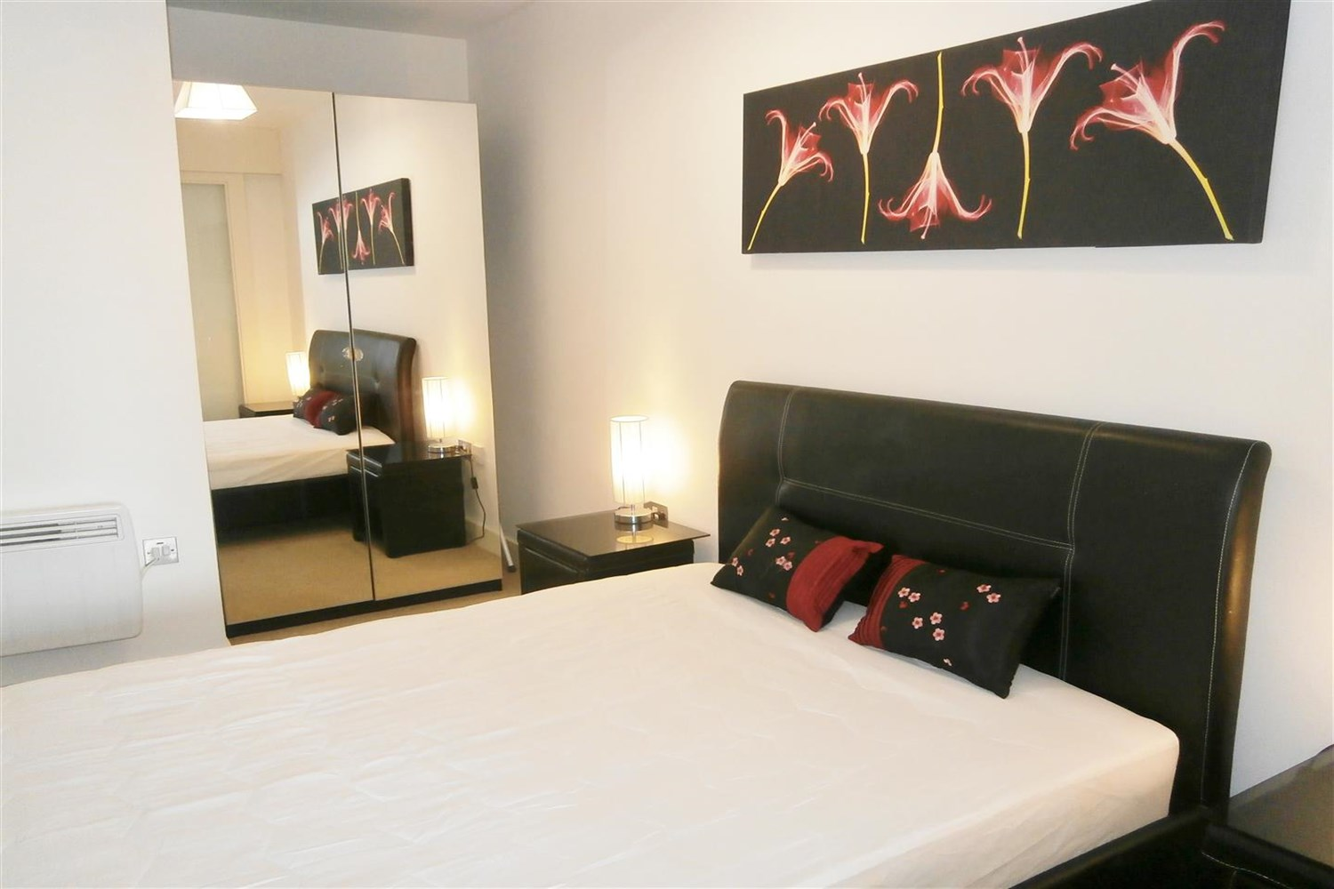

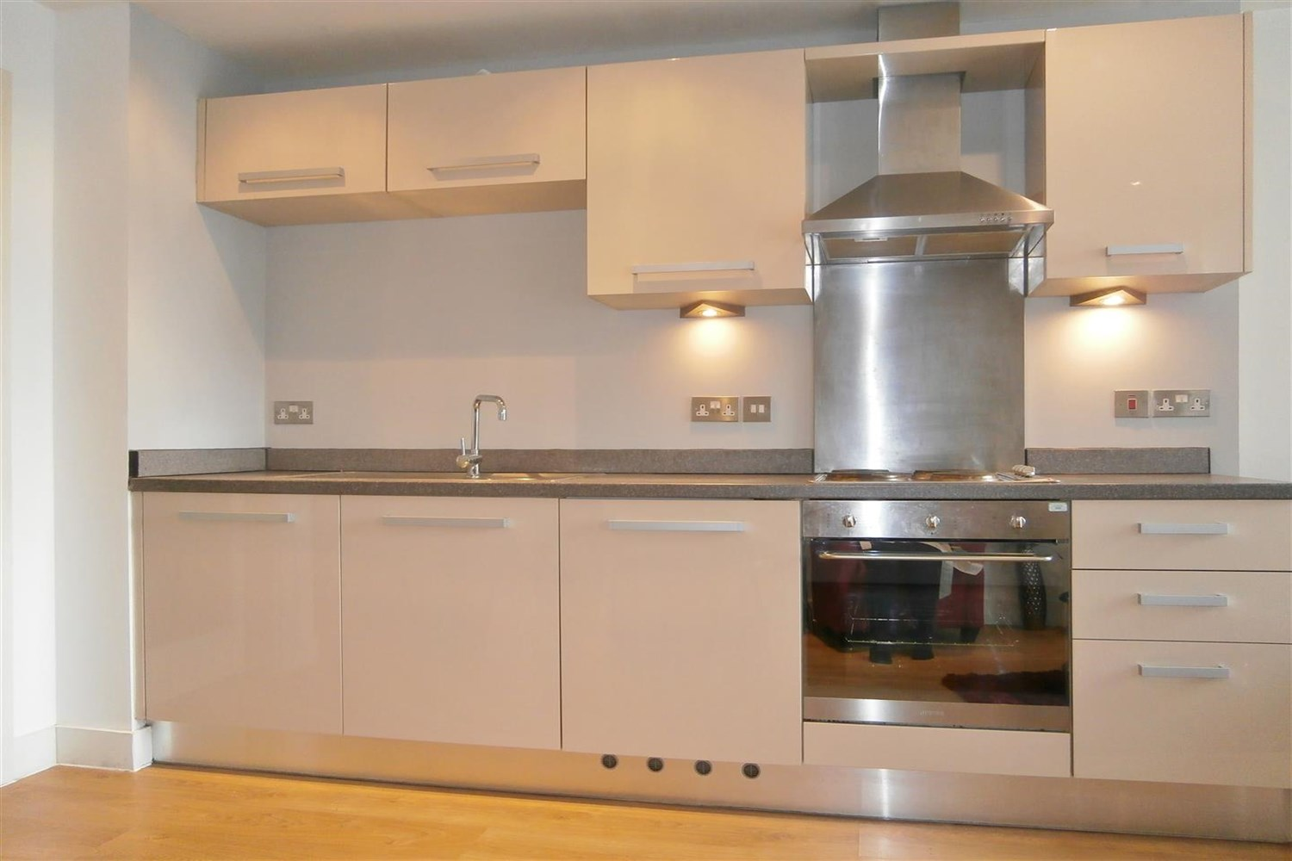

1 Bathroom(s)

0 Reception(s)

0 Bedroom(s)

00

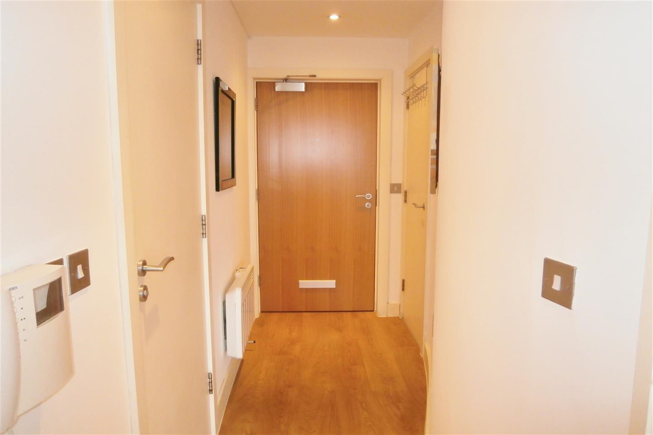

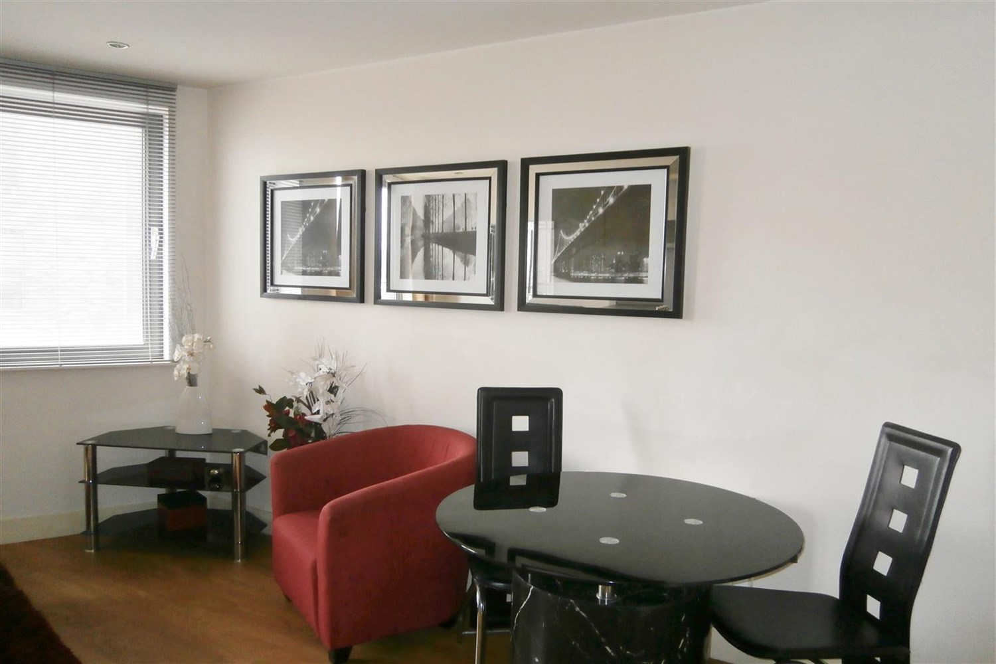

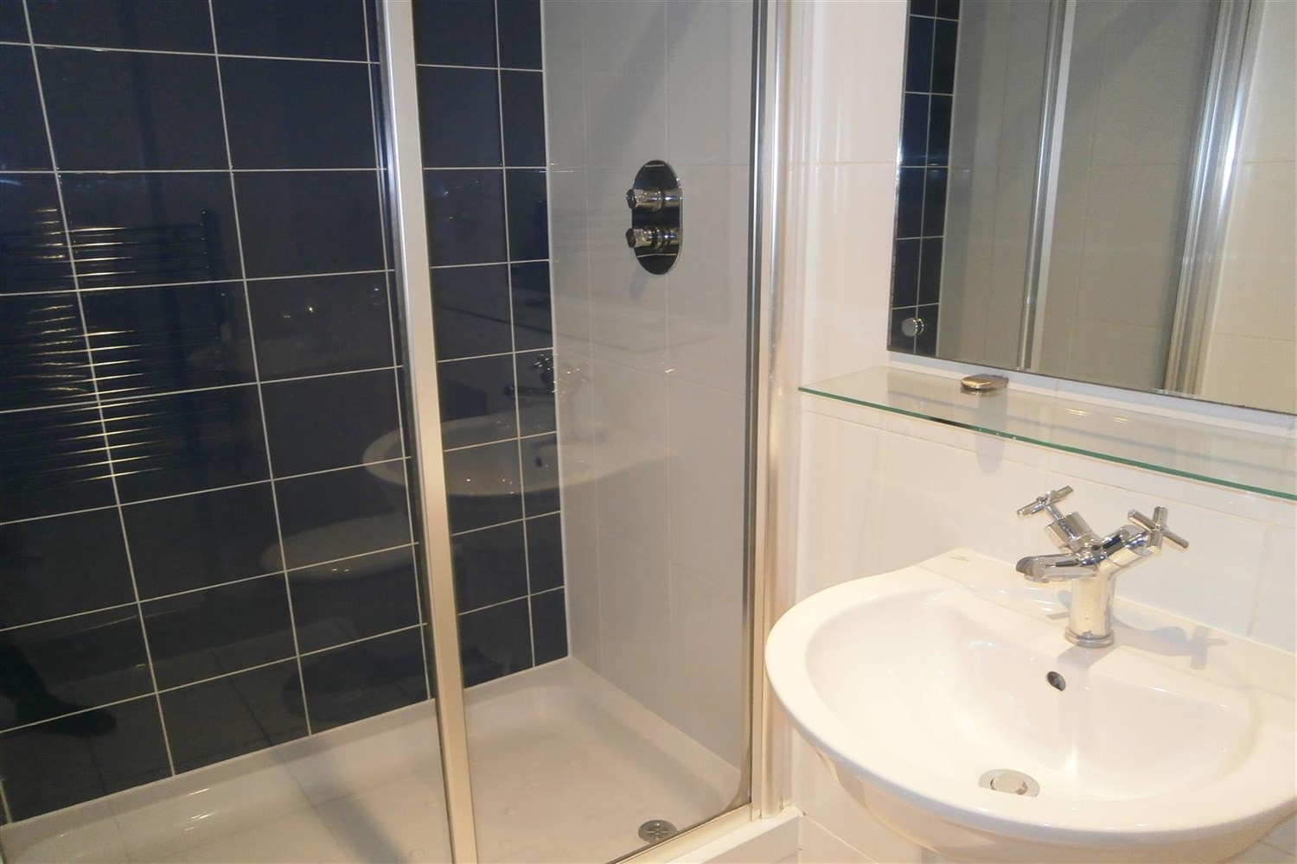

|  |
| --- |
| **Hallway**  Secure video intercom entry system. Wall mounted electric heater. Storage cupboard housing the washing machine. |
| **Open Plan Living Room/Kitchen**  Contemporary open plan living room/kitchen with double glazed French doors opening to a Juliet balcony. Wall mounted electric heater. Open plan to the living room and fitted with a range of high gloss wall, base and drawer units. Stainless steel sink with mixer tap. Integrated electric oven and hob with extractor hood over. |
| **Bedroom**  Double bedroom with carpet and electric wall heater. |
| **Bathroom**  Fitted with a modern three piece white suite comprising shower cubicle, wash hand basin and low level WC. Chrome heated ladder towel rail. Tiled floor. Part tiled walls. |
| **Home Information**  COUNCIL TAX BAND: A EPC Rating B  Leasehold property Broadband: Standard 9 Mbps 0.9 Mbps Good Superfast 80 Mbps 20 Mbps Good Ultrafast 1000 Mbps 1000 Mbps  Mobile availability: EE Limited ThreeLikely to have good coverage O2 Likely to have good coverage Vodafone Likely to have good coverage.  Electric mains supply, water on mains supply. |

|  |  |
| --- | --- |
| These particulars are intended to give a fair description of the property, but their accuracy cannot be guaranteed, and they do not constitute an offer of contract. Intending purchasers must rely on their own inspection of the property. None of the above appliances/services have been tested by ourselves. We recommend purchasers arrange for a qualified person to check all appliances/services before legal commitment.  **Property Ref:** 4593  **For more information, please contact**  0113 258 1150 **|** [lettings@adairpaxton.co.uk](mailto:lettings@adairpaxton.co.uk) **|** www.adairpaxton.co.uk |  |