

**Lodge Cottage, Greenhill Lane, Leeds**

**£925.00pcm**

**Cottage**

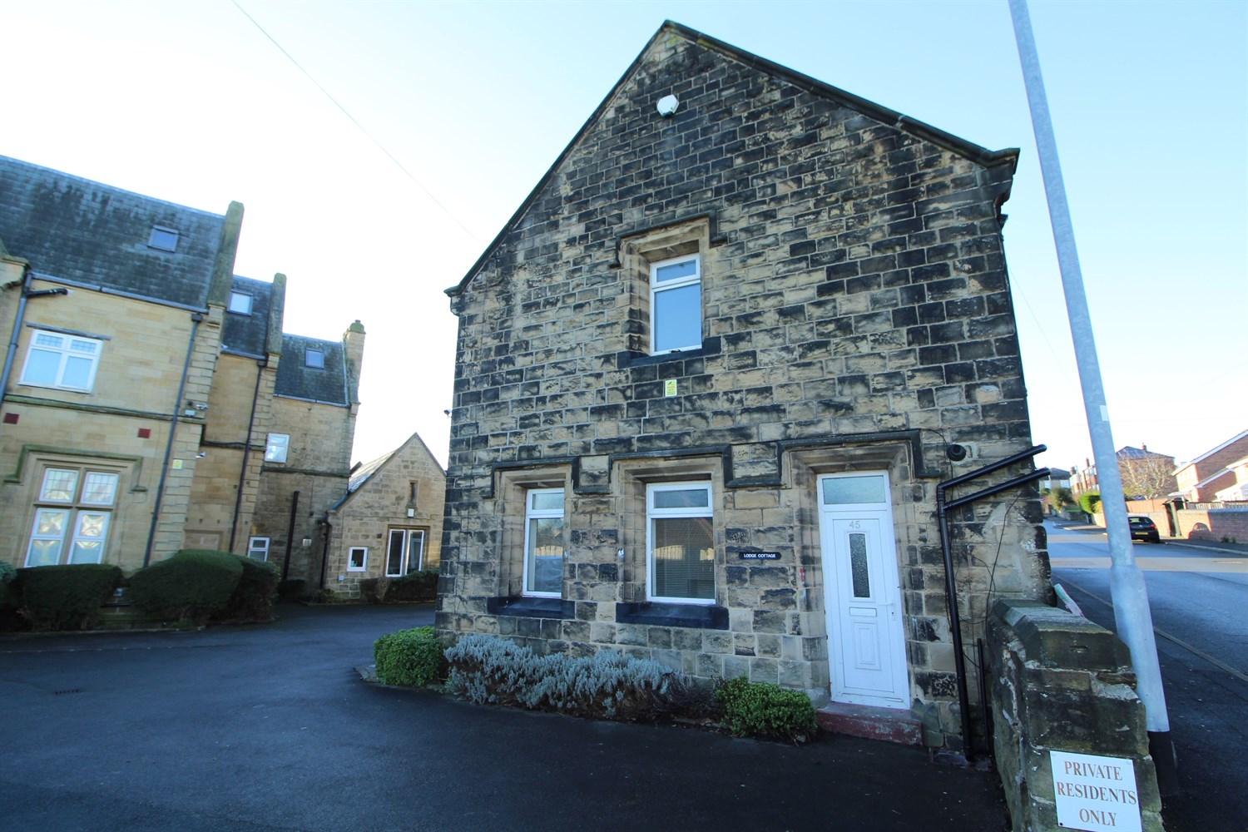

1 Bathroom(s)

1 Reception(s)

1 Bedroom(s)

*** SPACIOUS THREE BEDROOM COTTAGE*** Close to all local amenities and with easy access to Leeds city centre. The property has been fully redecorated and benefits from double glazing and gas central heating with neutral decor throughout. Comprising; Lounge, dining kitchen, two double bedrooms and a single bedroom, bathroom. Off street parking. Furnished. Deposit £1065. Council tax band B, EPC rating C, Sorry no pets. AVAILABLE NOW.



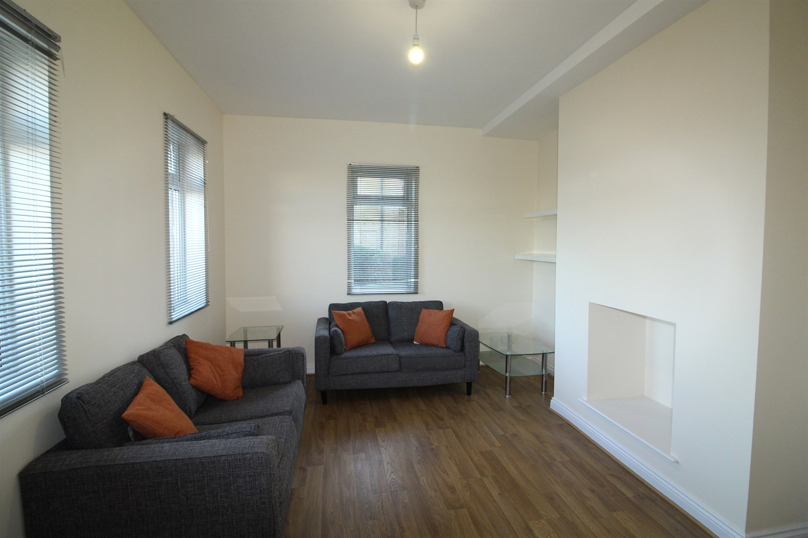

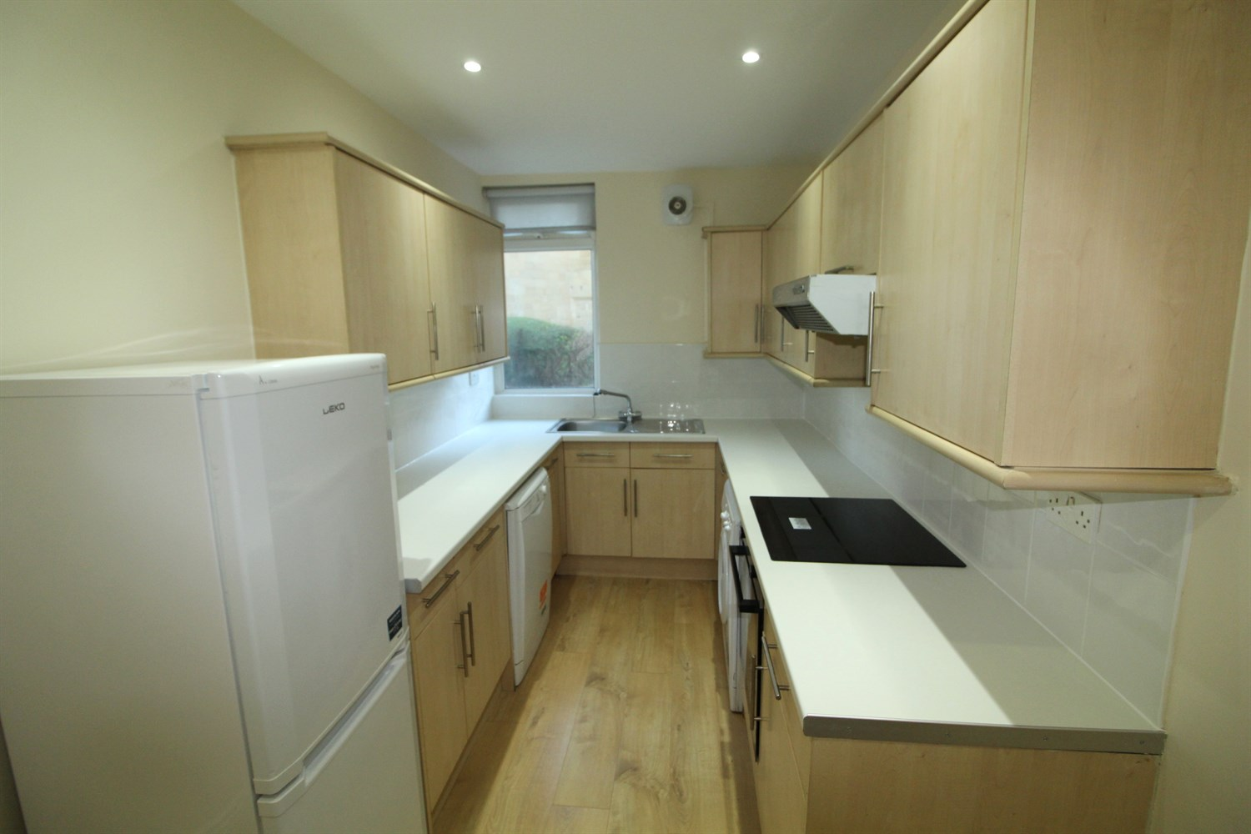

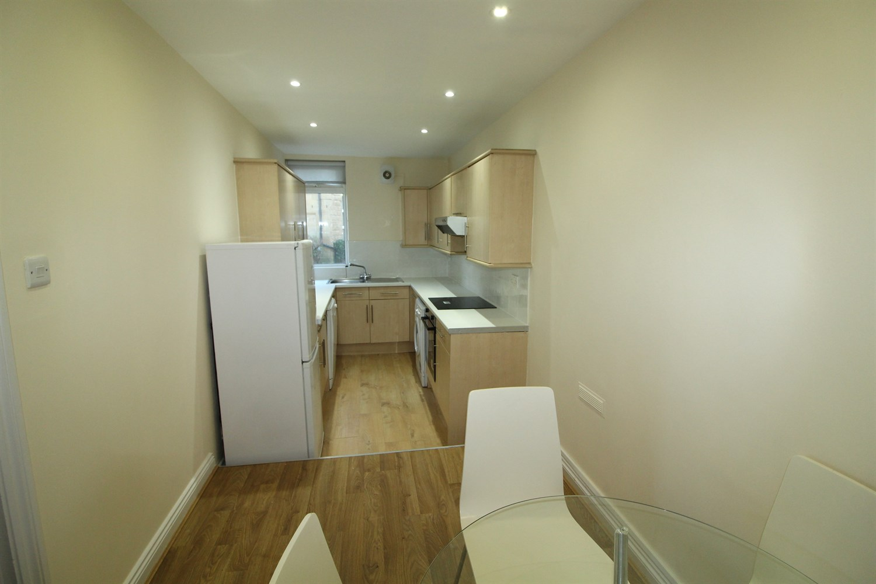

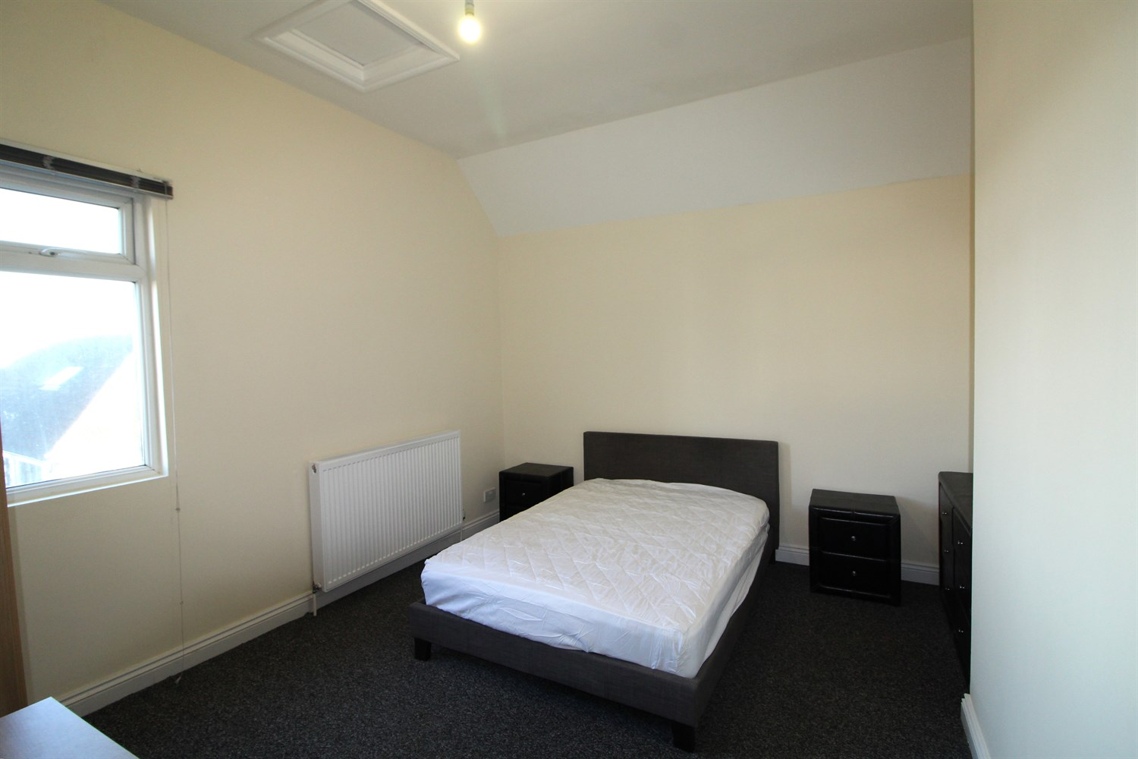

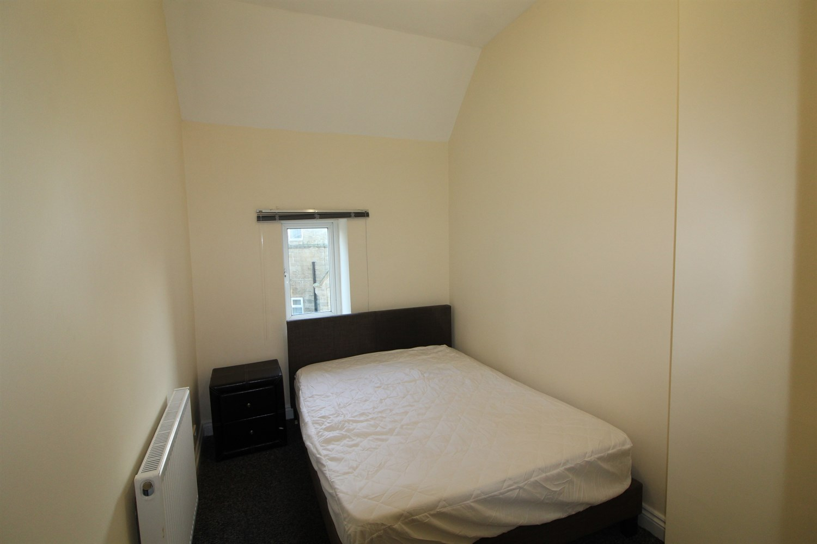

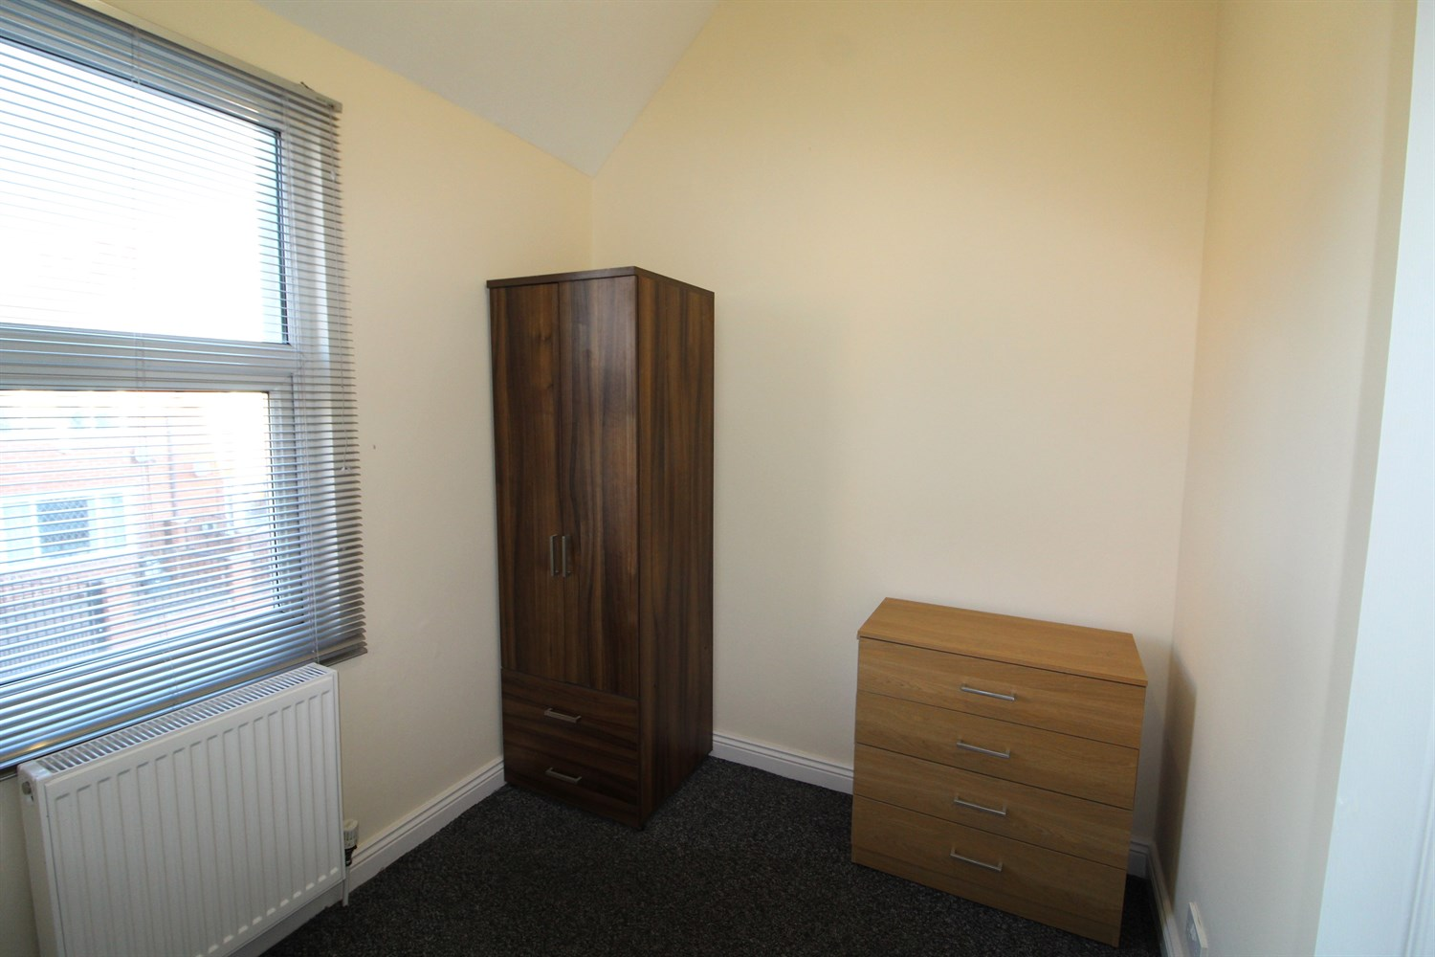



|  |
| --- |
| **Living Room**  Light and airy living room with double glazed windows to two sides. Gas central heating radiator. |
| **Kitchen**  Kitchen and dining area. fitted with a range of wall and base units with work tops over. Stainless steel sink with mixer tap, Washing machine, dishwasher, fridge-freezer, electric oven and hob with extractor over head. |
| **Bedroom 1**  Large double bedroom with window to front, gas central heating radiator. |
| **Bedroom 2**  Double bedroom with window to rear, gas central heating radiator. |
| **Bedroom 3**  Single bedroom with window to front, gas central heating radiator. |
| **Bathroom**  Three piece white bathroom suite with shower over bath. |
| **Home Information**  12 month Tenancy. COUNCIL TAX BAND: B EPC Rating D  Leasehold property Parking included  Broadband: Standard 18 Mbps 1 Mbps Good Superfast --Not available --Not available Unlikely Ultrafast 1000 Mbps 1000 Mbps Mobile availability: EE likely to have good coverage. Three likely to have good coverage. O2 likely to have good coverage. Vodafone limited coverage.  Utilities: Water supplied on standard meters. Electric mains supplied on standard meters. Gas supplied on main meters. |

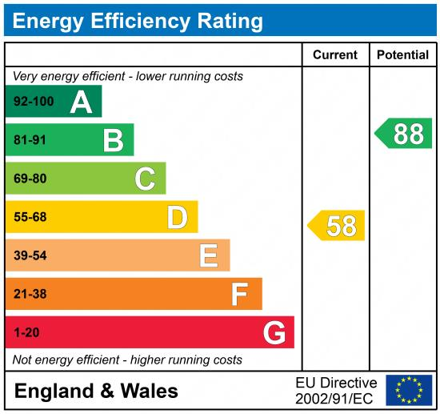

|  |
| --- |
|  |

These particulars are intended to give a fair description of the property, but their accuracy cannot be guaranteed, and they do not constitute an offer of contract. Intending purchasers must rely on their own inspection of the property. None of the above appliances/services have been tested by ourselves. We recommend purchasers arrange for a qualified person to check all appliances/services before legal commitment.

**Property Ref:** 4710

**For more information, please contact**

0113 258 1150 **|** [lettings@adairpaxton.co.uk](mailto:lettings@adairpaxton.co.uk) **|** www.adairpaxton.co.uk