

**0113 258 1150**

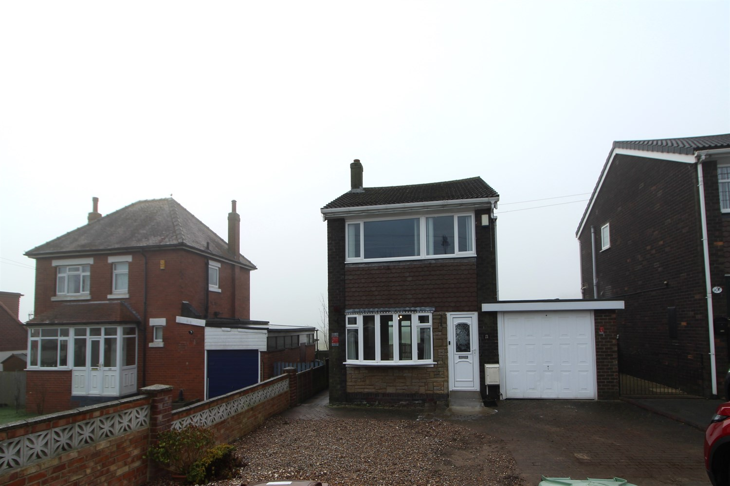



**Available to let £1,500.00pcm**

**Main Street, LS15**

****FULLY REFURBISHED THREE BEDROOM DETACHED HOUSE**** Scholes is a great place to live and now with the new East Leeds Orbital Road makes it very much connected. Its perfect for those looking to live in a village but who don't want to be to remote. The property comprises of an entrance hall with a staircase that leads to the first floor, door leading through to a large sitting room with French doors that lead a small conservatory. Newly fitted kitchen to rear which is fitted with stylish wall and base units, built-in oven, hob, integrated fridge freezer and integrated dish washer.

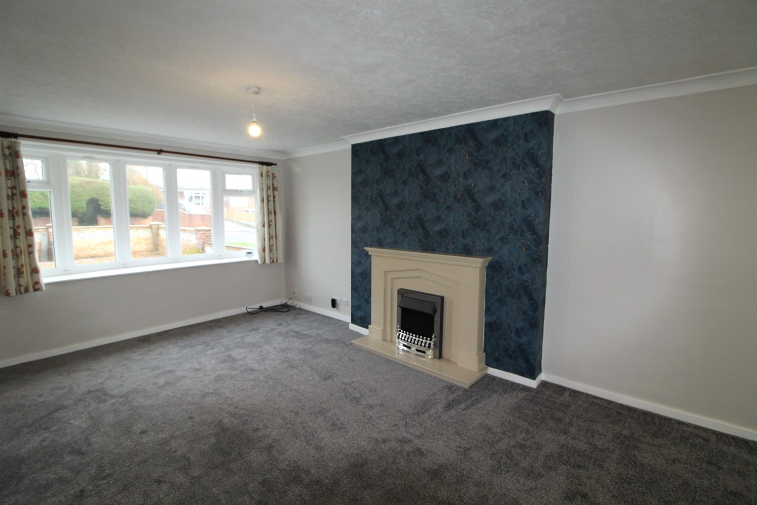

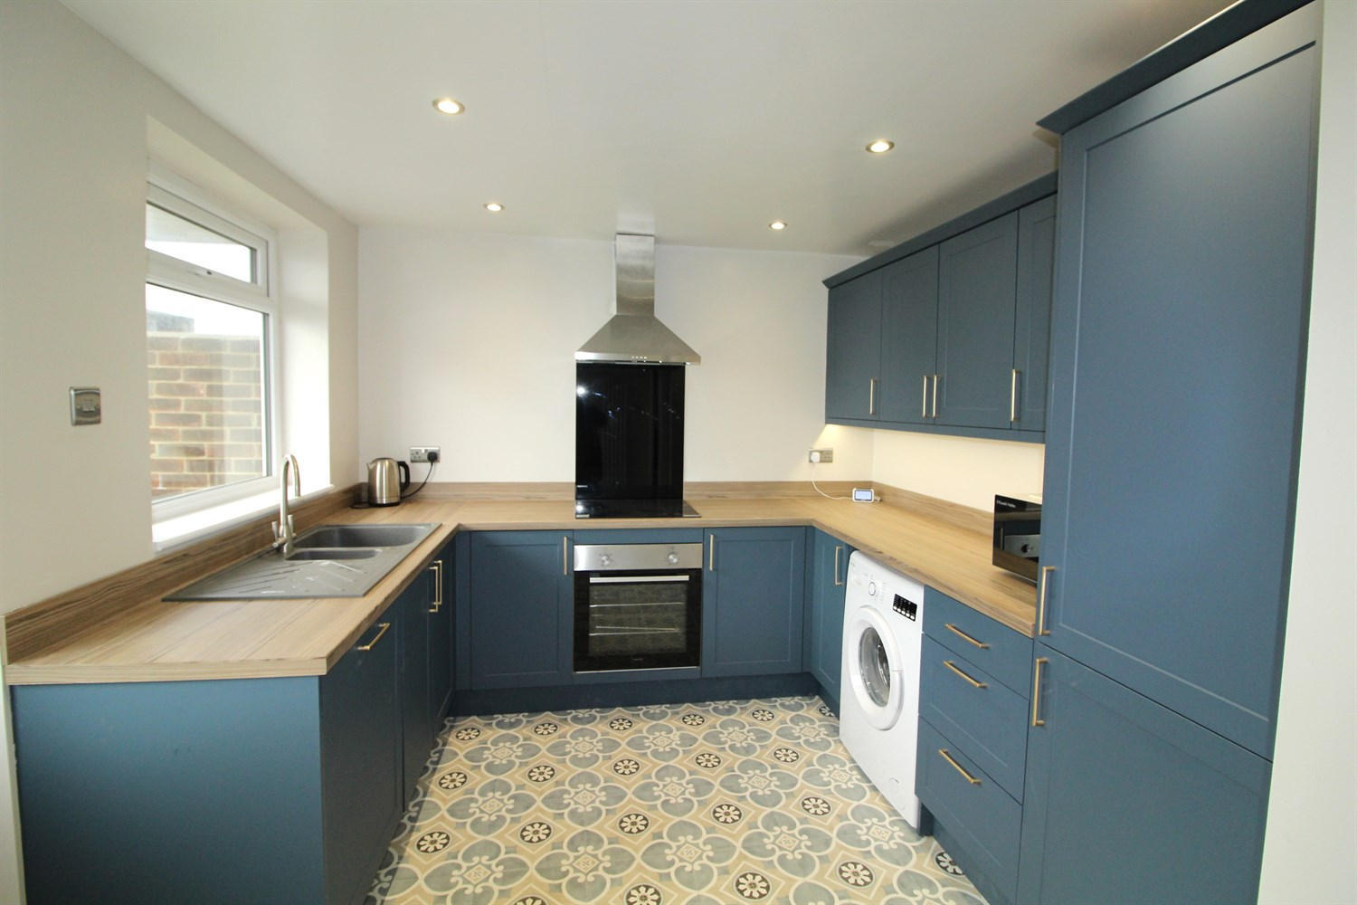

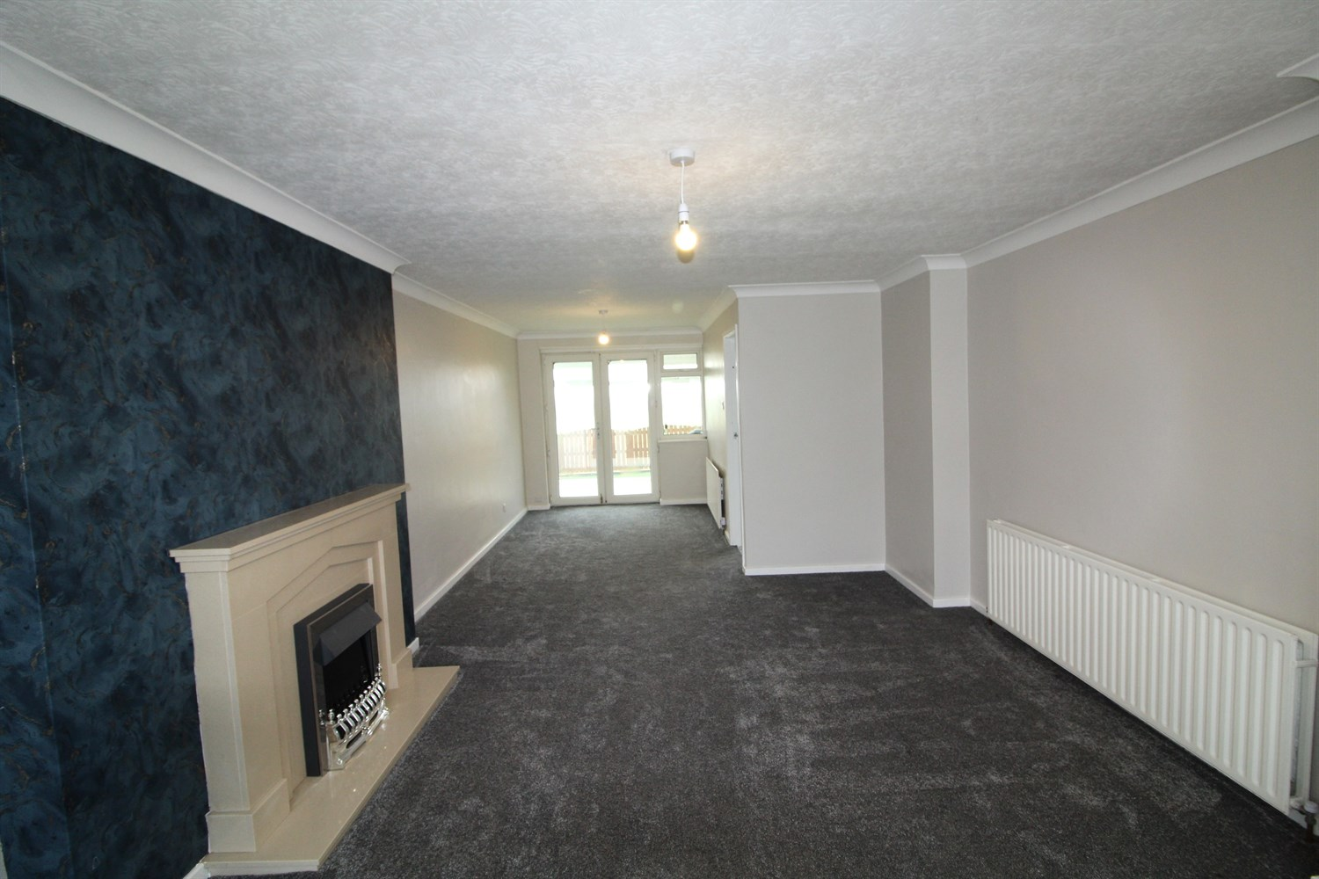

1 Bathroom(s)

1 Reception(s)

3 Bedroom(s)

00

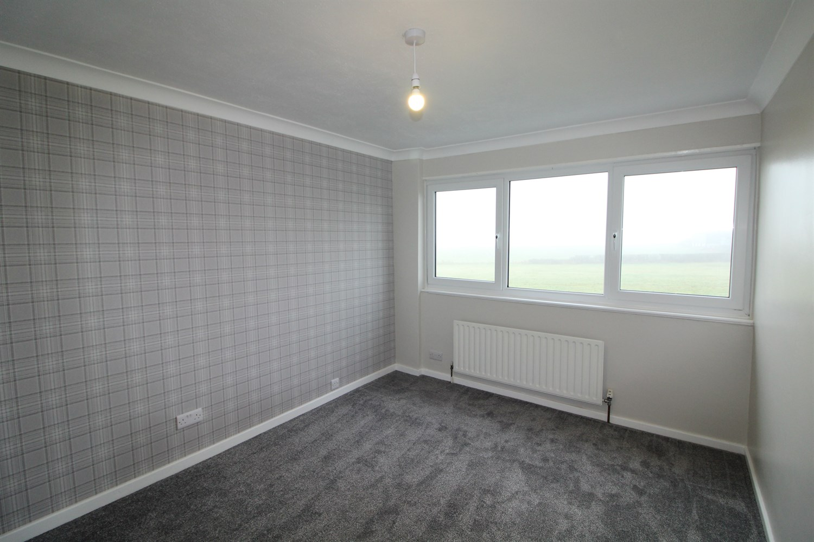

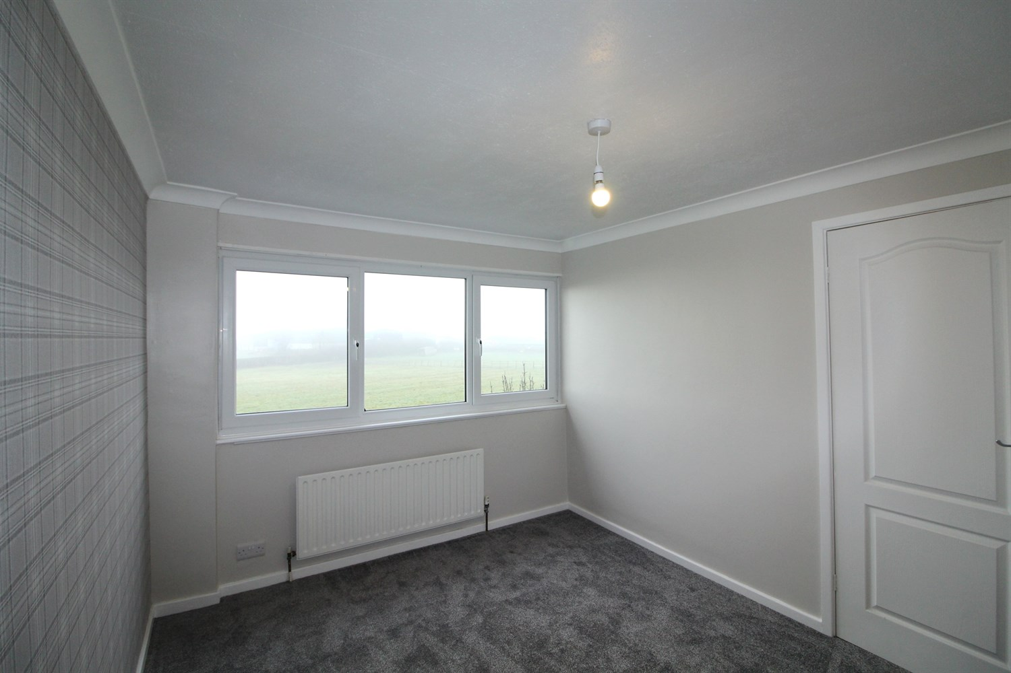

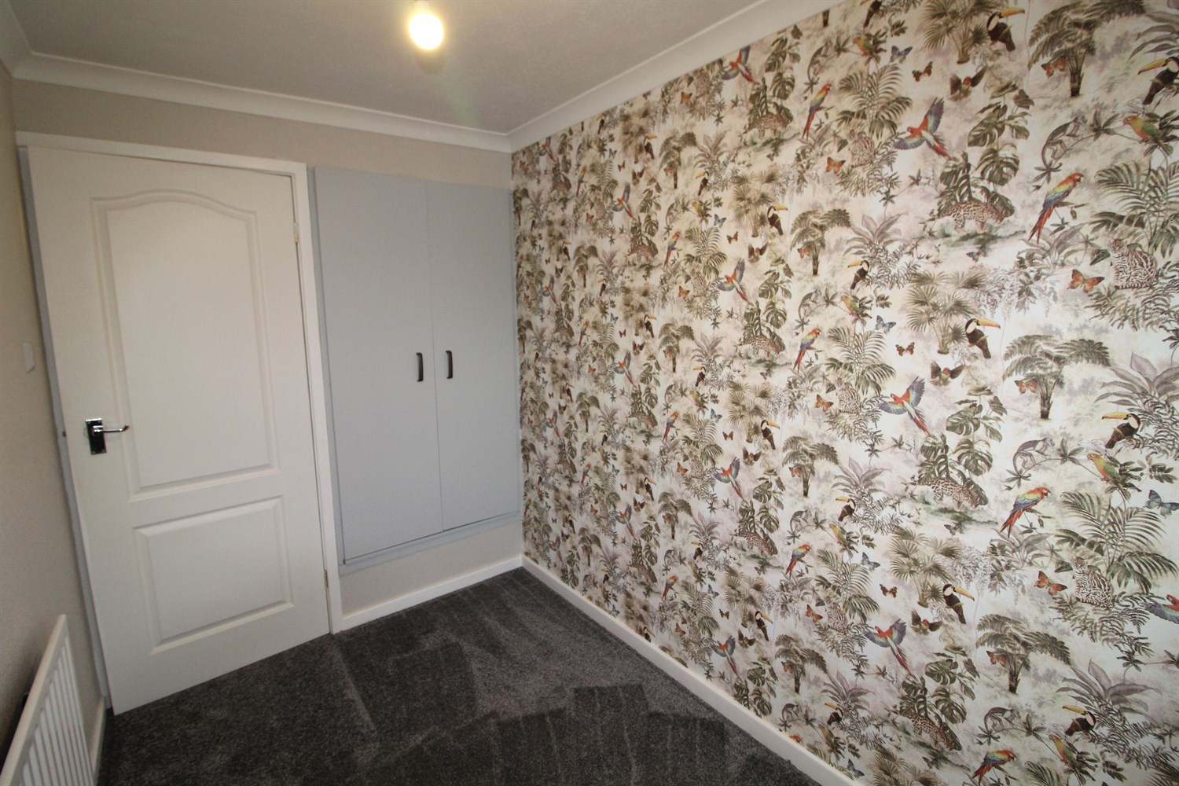

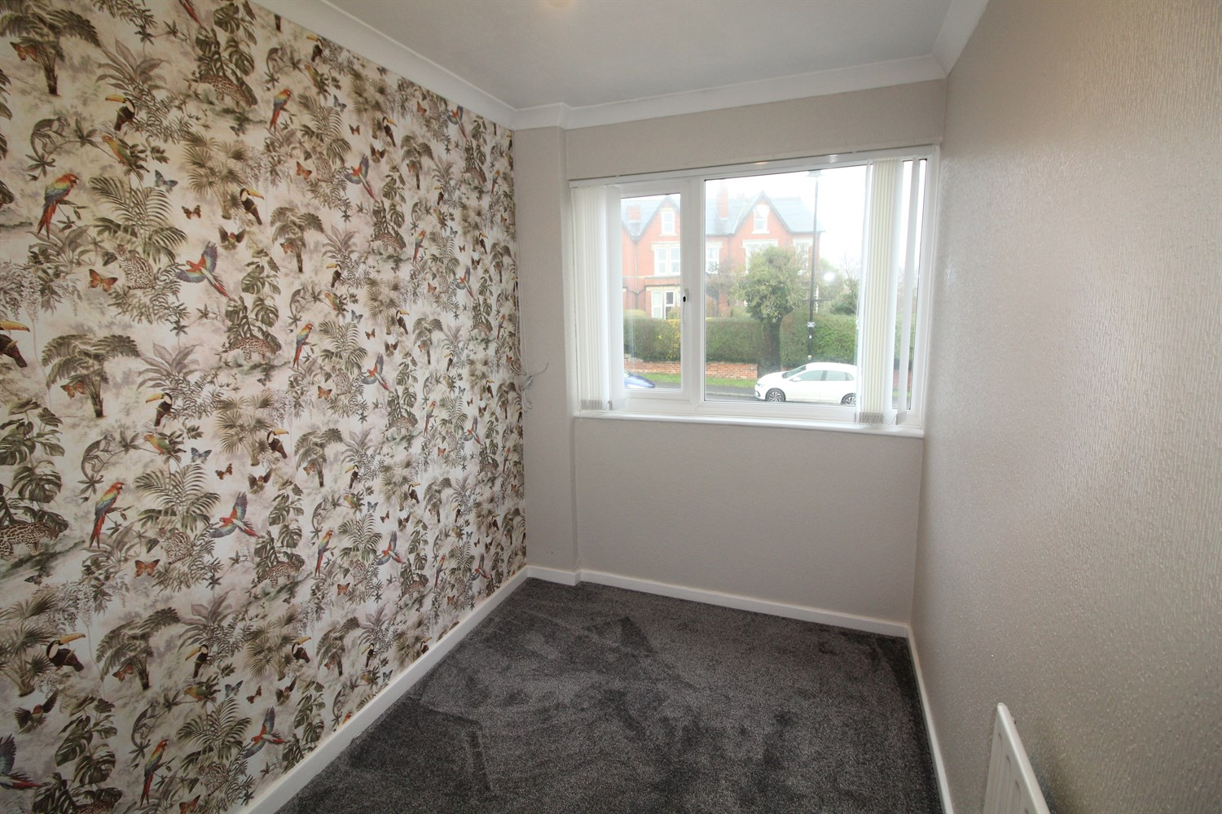

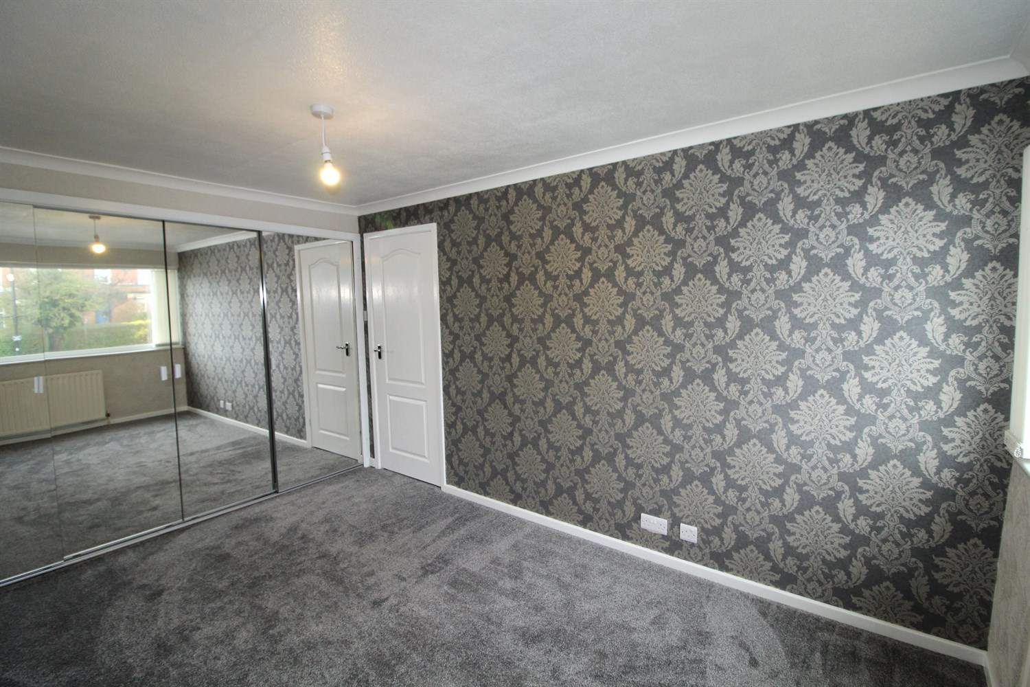

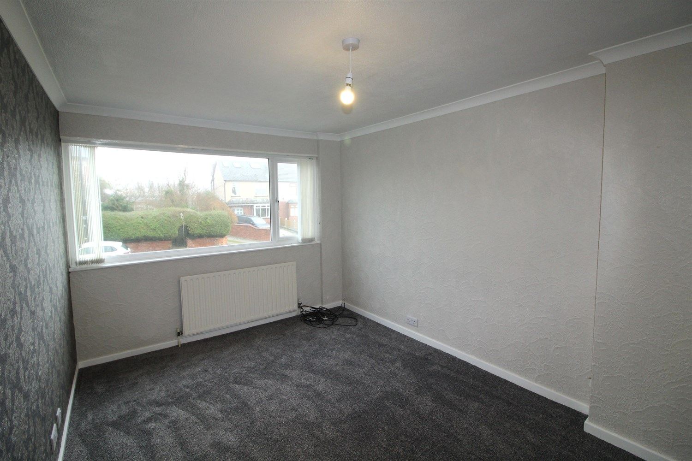

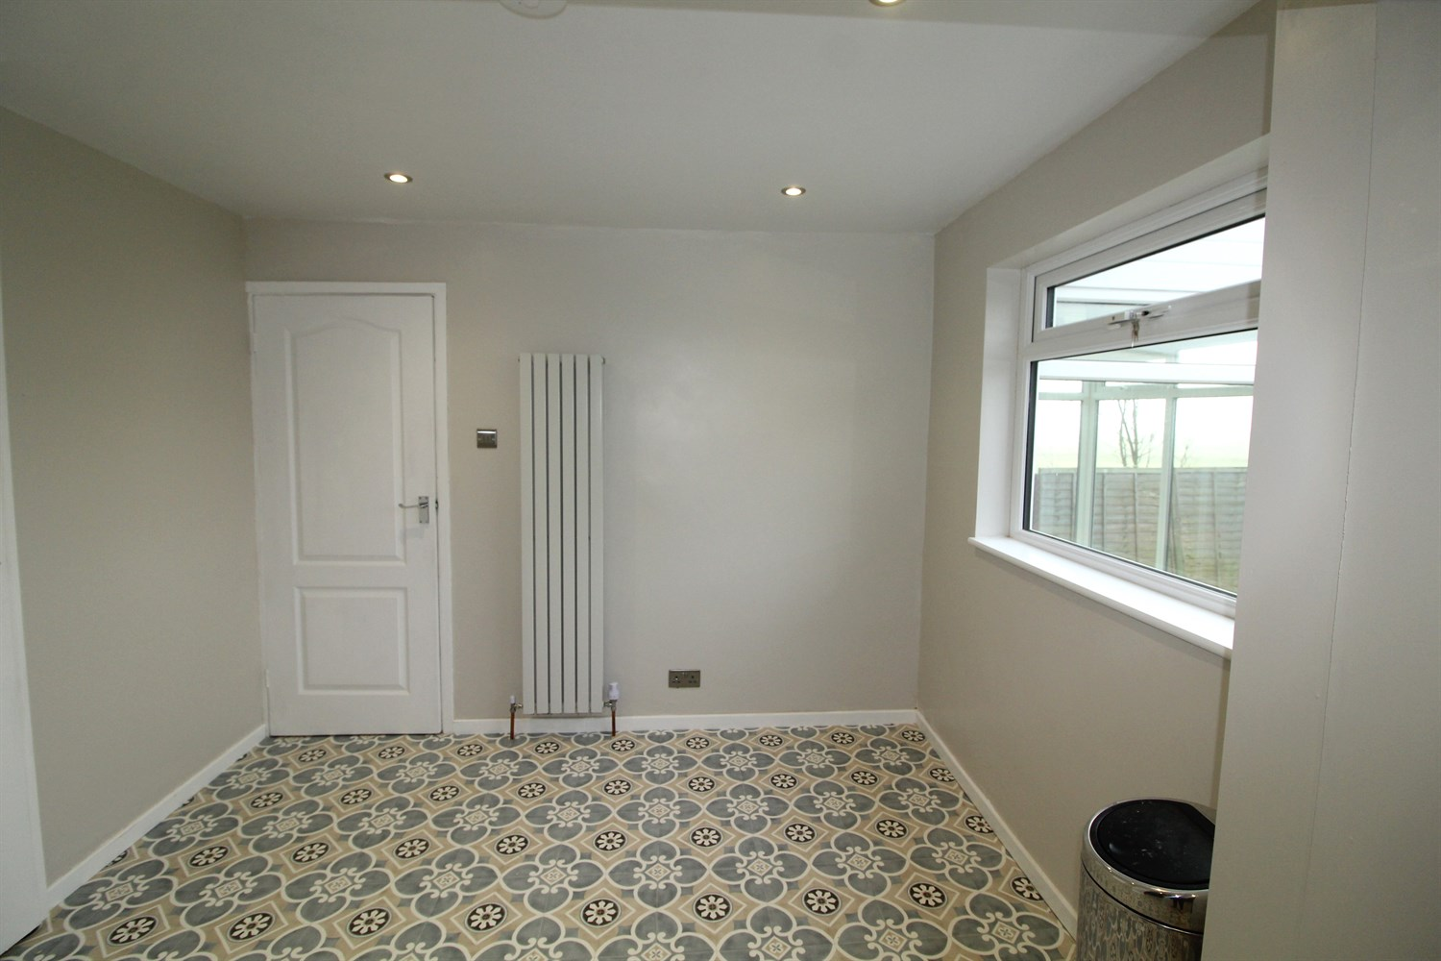

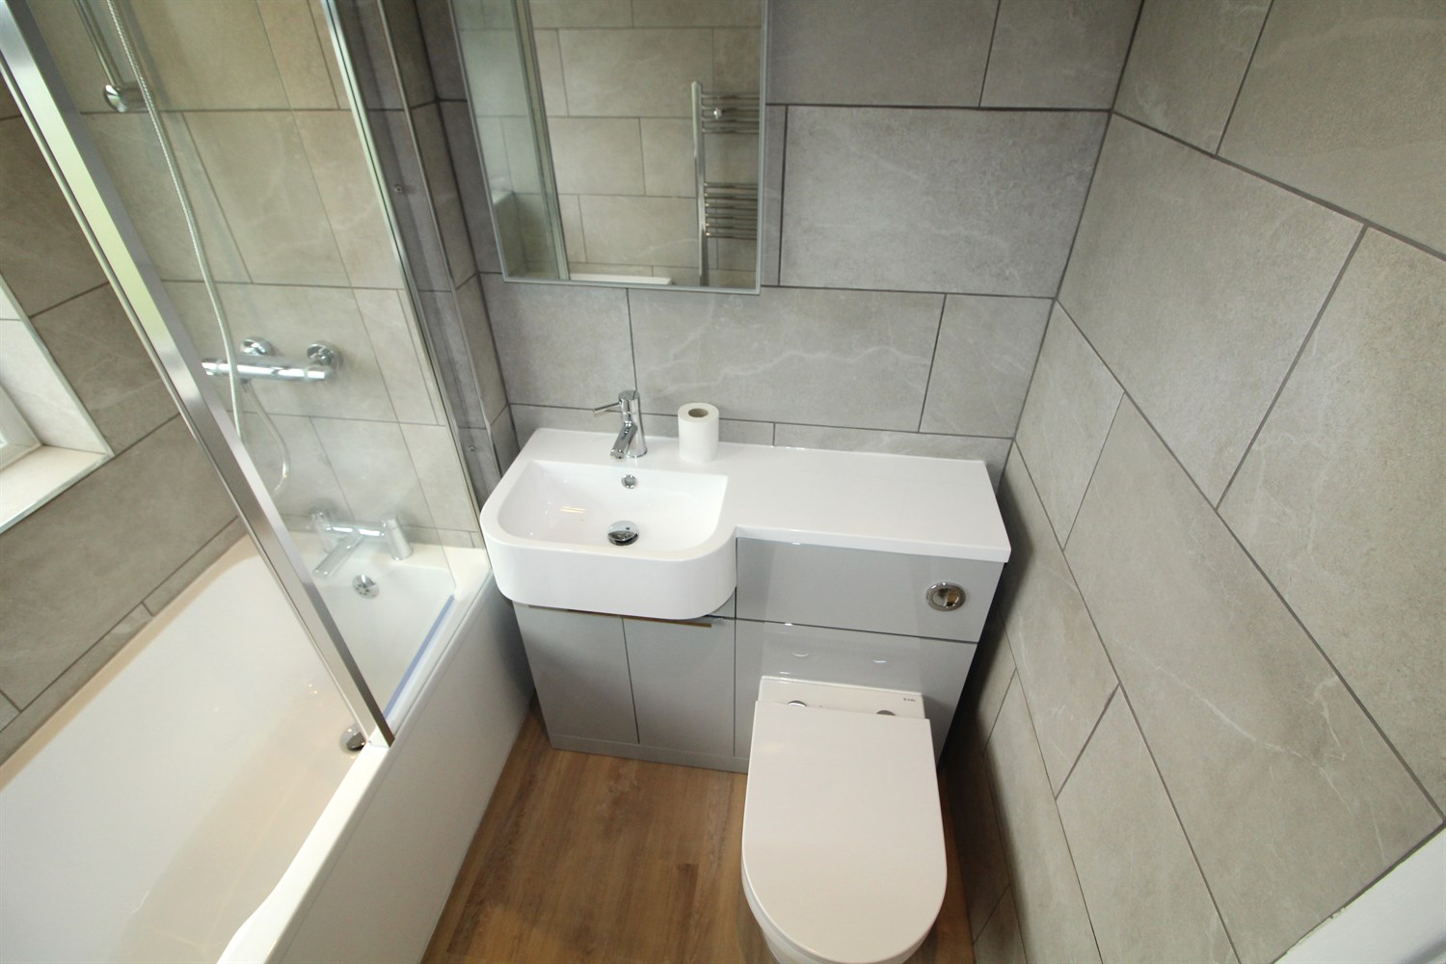

|  |
| --- |
| **Reception 1 8.06m (26'5) x 3.73m (12'3)**  Large through lounge with access to kitchen and conservatory. Doubles glazed window to front, gas central heating radiator, and fire and surround. |
| **Kitchen 5.52m (18'1) x 2.99m (9'10)**  Stylish kitchen fitted with a range of wall and base units integrated dishwasher and fridge freezer. Electric oven and hob with extractor above, Sink with mixer tap and drainer, space for dining table. |
| **Bedroom 1 3.98m (13'1) x 2.82m (9'3)**  Large double bedroom with mirror wardrobes, double glazed window to front and gas central heating radiator. |
| **Bedroom 2 3.58m (11'9) x 2.86m (9'5)**  Double bedroom with double glazed window to rear with beautiful views, gas central heating radiator. |
| **Bedroom 3 2.95m (9'8) x 1.79m (5'10)**  Single bedroom with wardrobe, double glazed window to front and gas central heating radiator. |
| **Bathroom**  Beautifully designed three piece bathroom suite with shower over head. W/c and hand wash basin. |
| **Rear Garden**  The rear garden is mostly lawned with far beautiful views plus a good-sized patio. |
| **Front Garden**  To the front is a wide gravelled area and a stone flagged driveway leads down to the property and garage, electric garage door. |
| **Home Information**  COUNCIL TAX BAND: D EPC Rating - TBC  Freehold Property Broadband: Standard 2 Mbps 0.4 Mbps Good Superfast 80 Mbps 20 Mbps Good Ultrafast 10000 Mbps 10000 Mbps  Mobile availability: EE Limited Three Limited coverage O2 Limited coverage Vodafone Limited coverage.  Gas and Electric mains supply, water on mains supply. |
| **Holding Fee**  Please note, a holding fee equivalent to 1 week rental will be payable upon application and will form part of the first month rent. |

|  |  |
| --- | --- |
| These particulars are intended to give a fair description of the property, but their accuracy cannot be guaranteed, and they do not constitute an offer of contract. Intending purchasers must rely on their own inspection of the property. None of the above appliances/services have been tested by ourselves. We recommend purchasers arrange for a qualified person to check all appliances/services before legal commitment.  **Property Ref:** 4635  **For more information, please contact**  0113 258 1150 **|** [lettings@adairpaxton.co.uk](mailto:lettings@adairpaxton.co.uk) **|** www.adairpaxton.co.uk |  |