

**0113 258 1150**

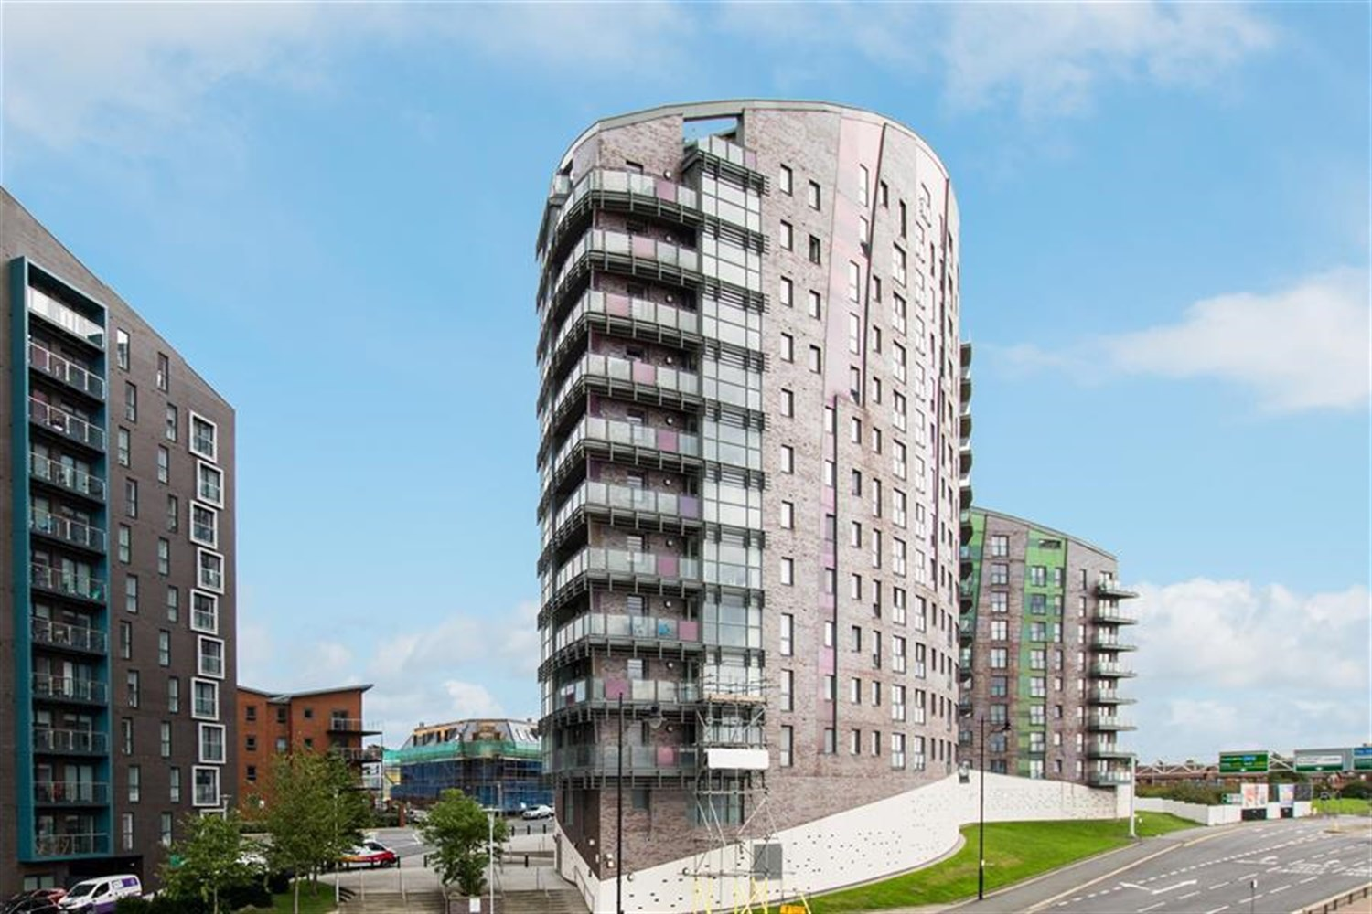



**For Sale £95,000.00**

**Echo Central 1, Leeds**

***ONE BEDROOM APARTMENT - EWS1 COMPLIANT***Set within the ever popular and exciting Echo Central development. A short walk to all the amenities Leeds City centre has to offer and great links to the motorway network. Stylish and contemporary accommodation which would suit the professional seeking a city base. Having quality modern fittings throughout, the interior briefly comprises of: Communal entrance with security intercom and lifts to all floors, private hallway with utility/store, open plan living/dining/kitchen having a range of contemporary high gloss units with integrated appliances and Juliette balcony, Spacious double bedroom and shower room. Council Tax Band A.

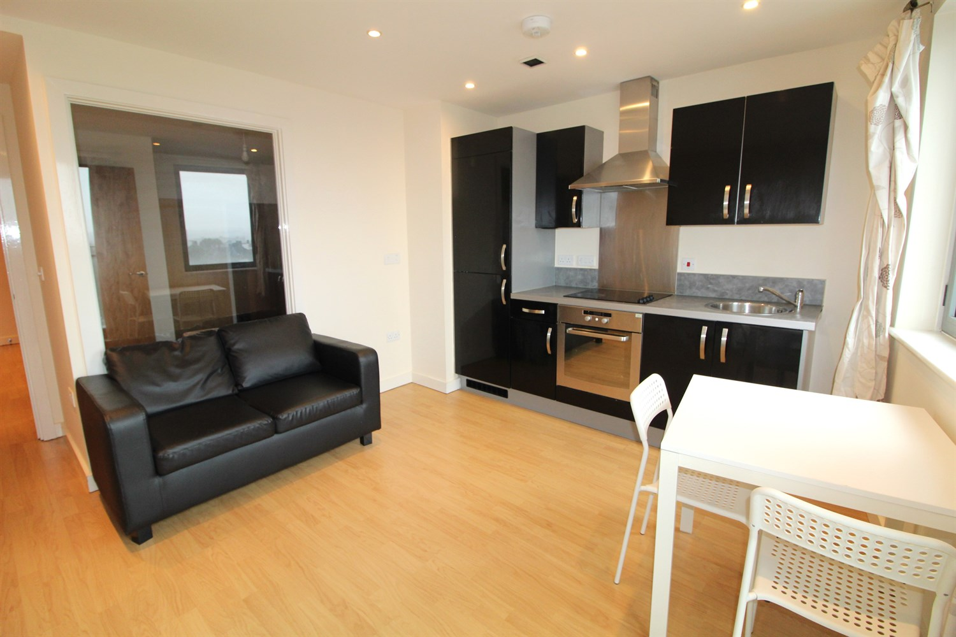

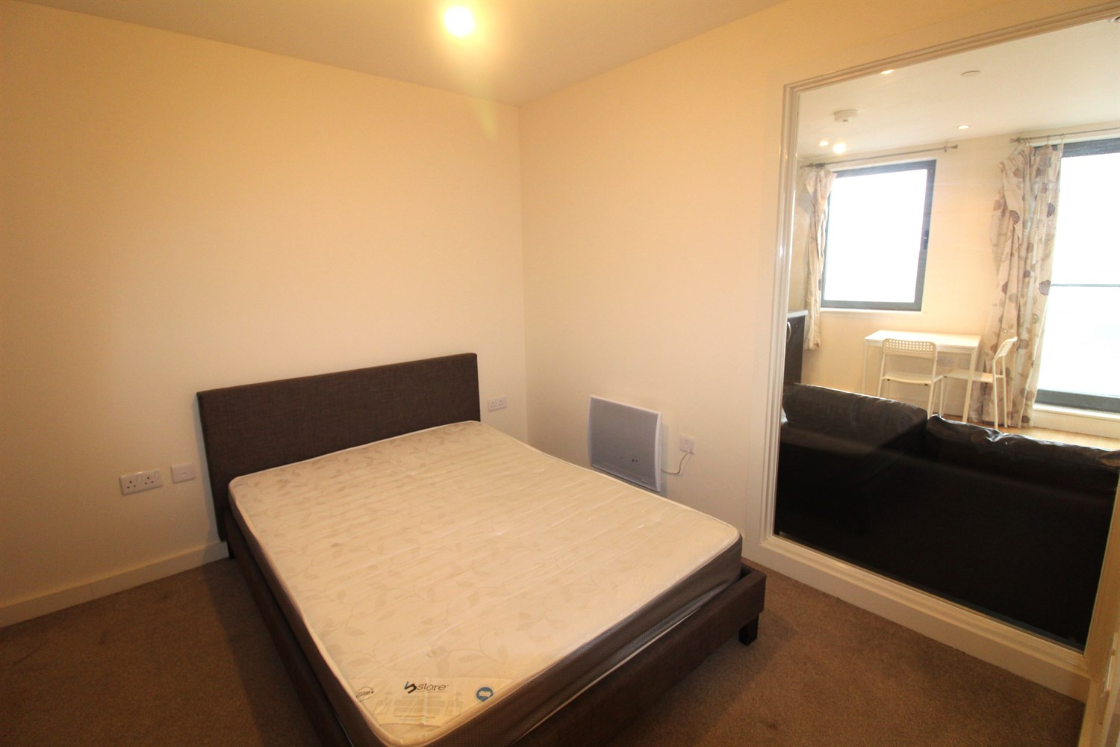

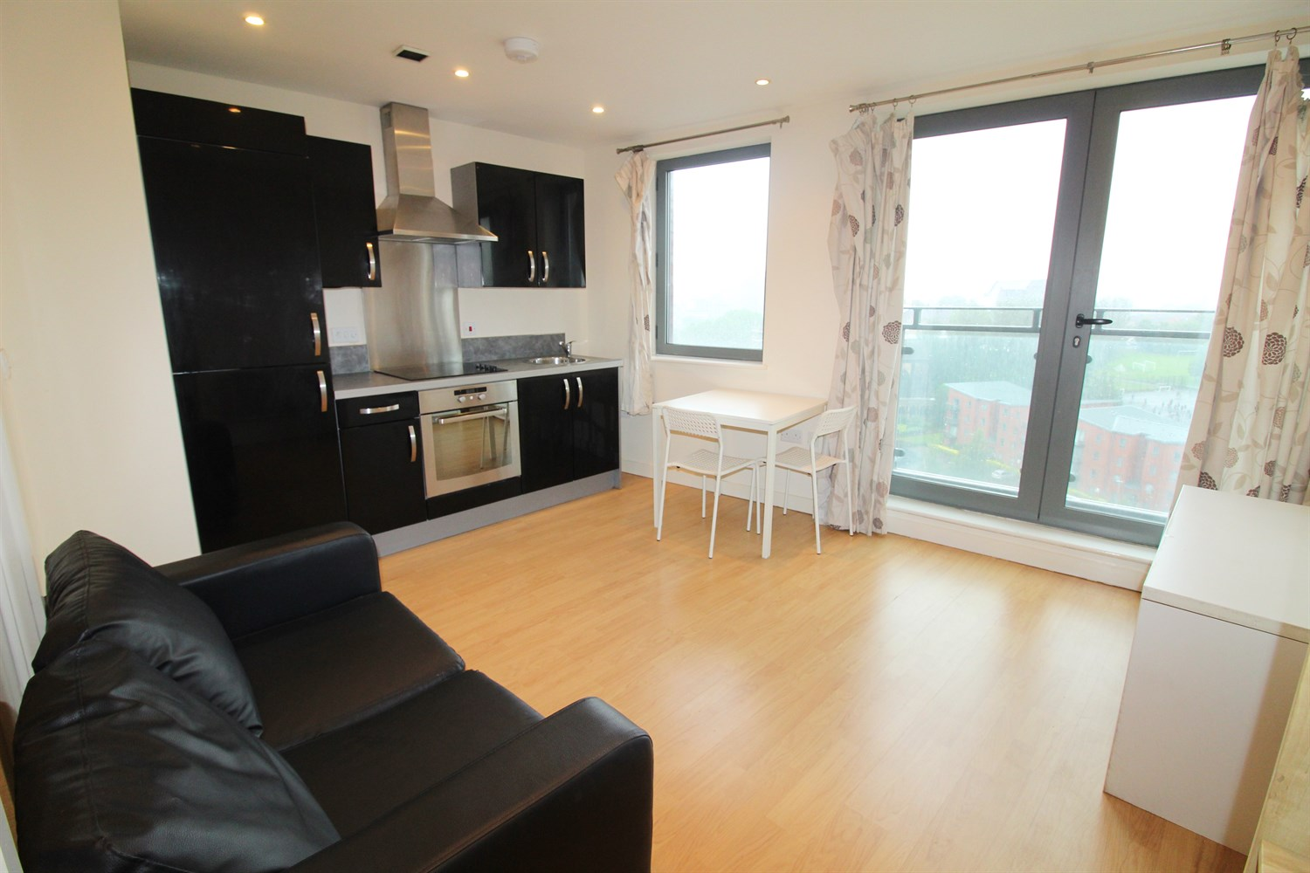

1 Bathroom(s)

0 Reception(s)

1 Bedroom(s)

00

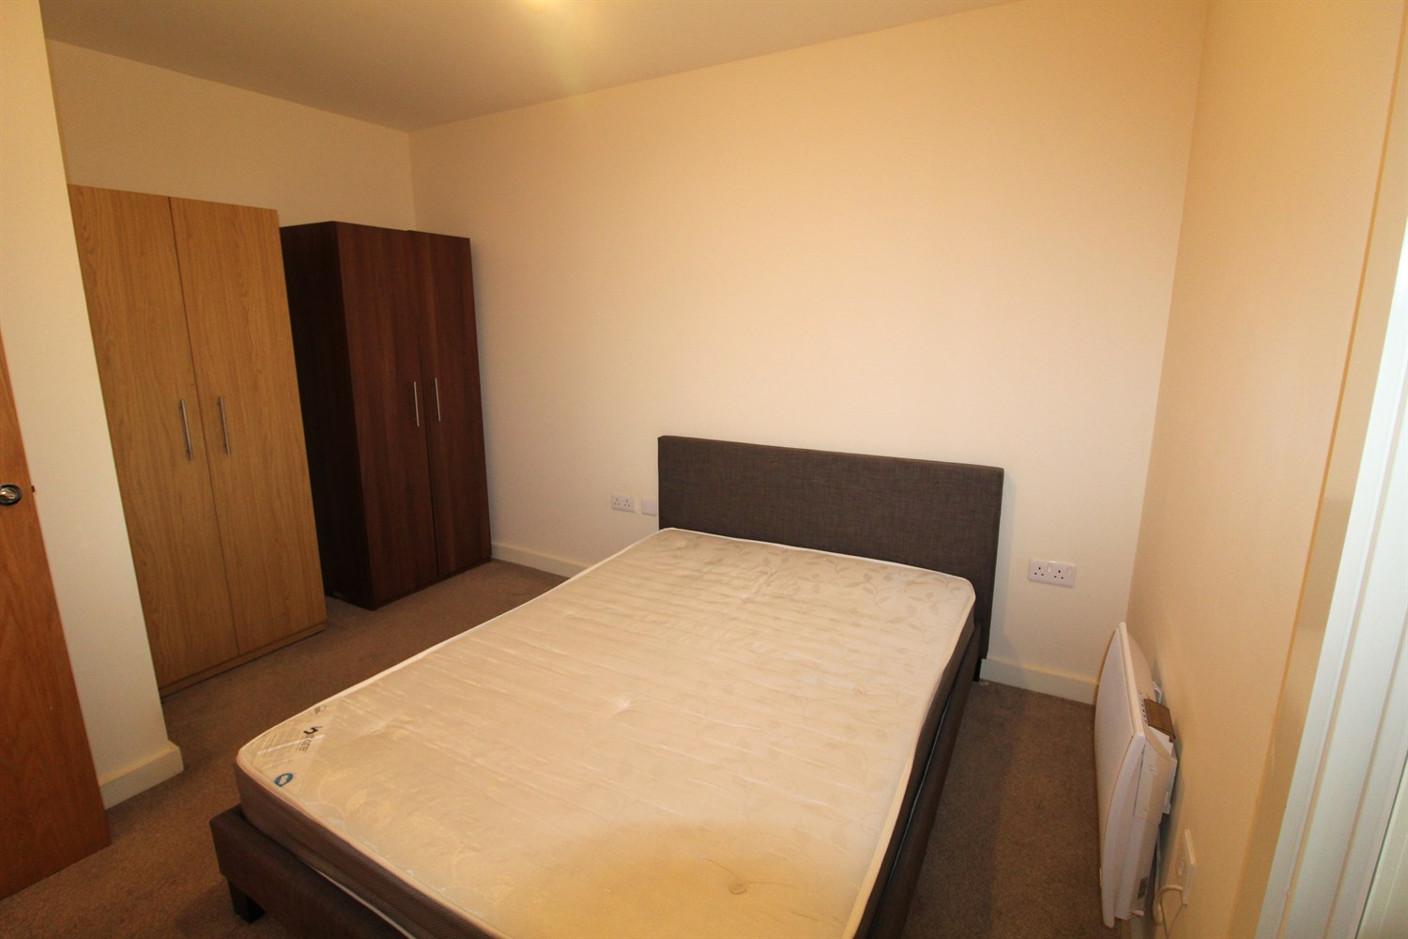

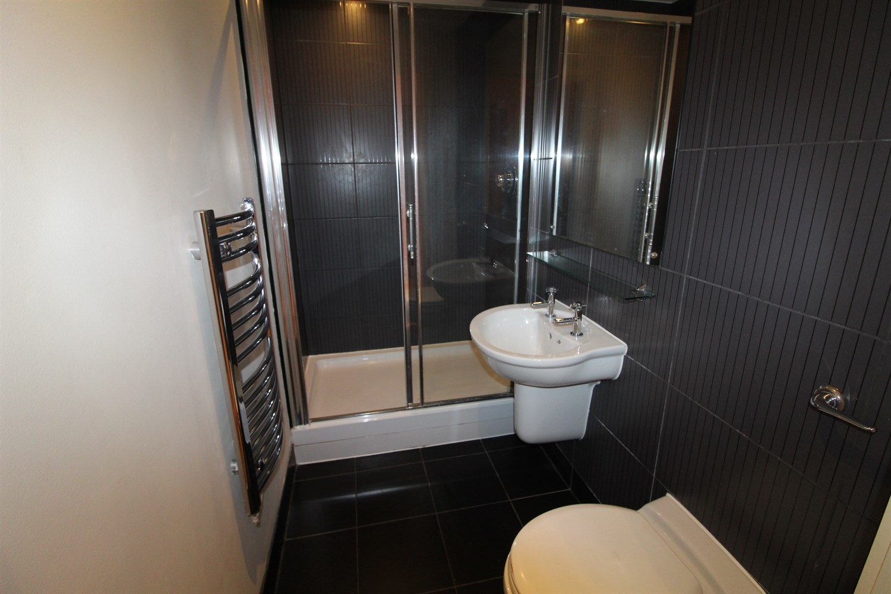

|  |
| --- |
| **Hallway**  Private entrance hall. Secure entry phone system. |
| **Open Plan Living Room/Kitchen**  Contemporary open plan living room/kitchen with double glazed French doors opening to a Juliet balcony. Wall mounted electric heater. Open plan to the living room and fitted with a range of high gloss wall, base and drawer units. Stainless steel sink with mixer tap. Integrated electric oven and hob with extractor hood over. |
| **Bedroom**  Double bedroom with wall mounted electric radiator. Window through to the living area. |
| **Shower Room**  Fitted with a three piece suite comprising shower cubicle, WC and wash hand basin. Tiled walls and floor. Inset ceiling spotlights. |
| **Tenure**  The lease is 155 years less one day, from 1 January 2007. Ground Rent of £200.00 is due 1 January each year. |
| **Service Charge**  Service Charge: The Service Charge is quarterly and is £412.48 per quarter. |

|  |  |
| --- | --- |
| These particulars are intended to give a fair description of the property, but their accuracy cannot be guaranteed, and they do not constitute an offer of contract. Intending purchasers must rely on their own inspection of the property. None of the above appliances/services have been tested by ourselves. We recommend purchasers arrange for a qualified person to check all appliances/services before legal commitment.  **Property Ref:** 3201  **For more information, please contact**  0113 258 1150 **|** [sales@adairpaxton.co.uk](mailto:sales@adairpaxton.co.uk) **|** www.adairpaxton.co.uk |  |