

**0113 258 1150**

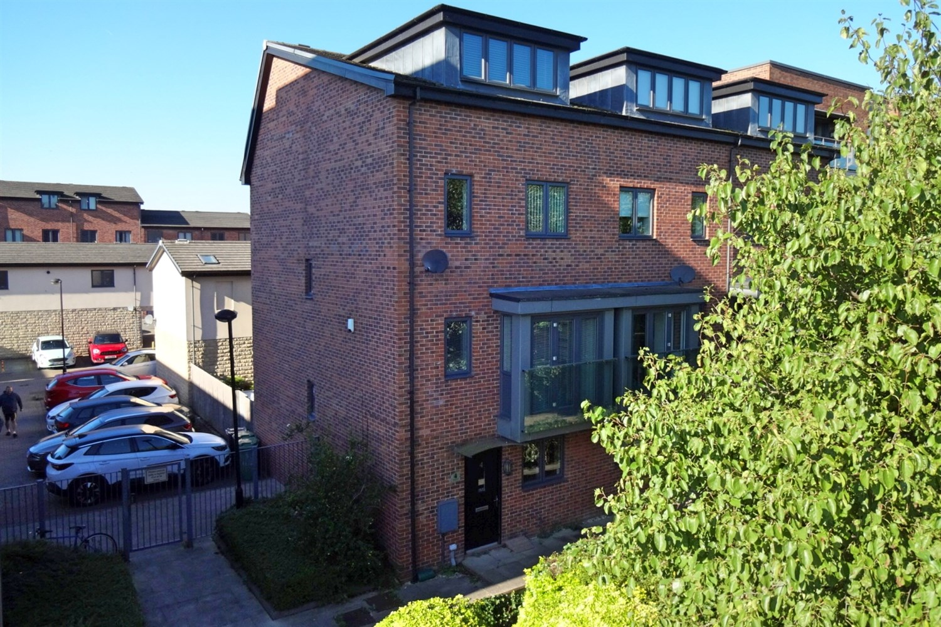



**Available to let £1,850.00pcm**

**Atkinson Quay, LS10**

A superb opportunity has arisen to rent this stunning townhouse waterside to the River Aire. The popular development is situated within walking distance of Leeds city centre and many local amenities. Situated over four levels, the spacious accommodation comprises: entrance hall, cloakroom/wc, living/kitchen/diner, lounge, four bedrooms and three bathrooms. Externally the property has a rear enclosed garden, allocated parking. An early viewing is highly recommended to avoid disappointment. Available 4th January 2025.Deposit £2130, council tax band B, EPC rating C.

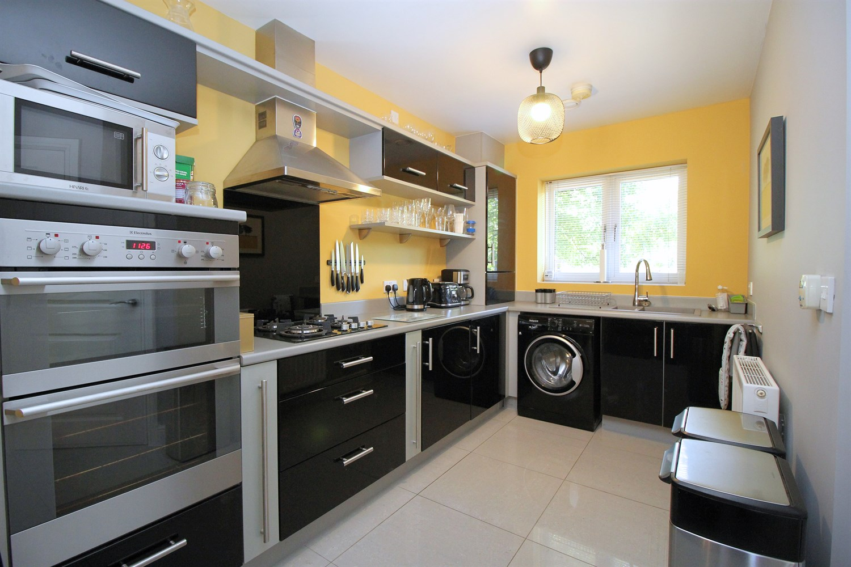

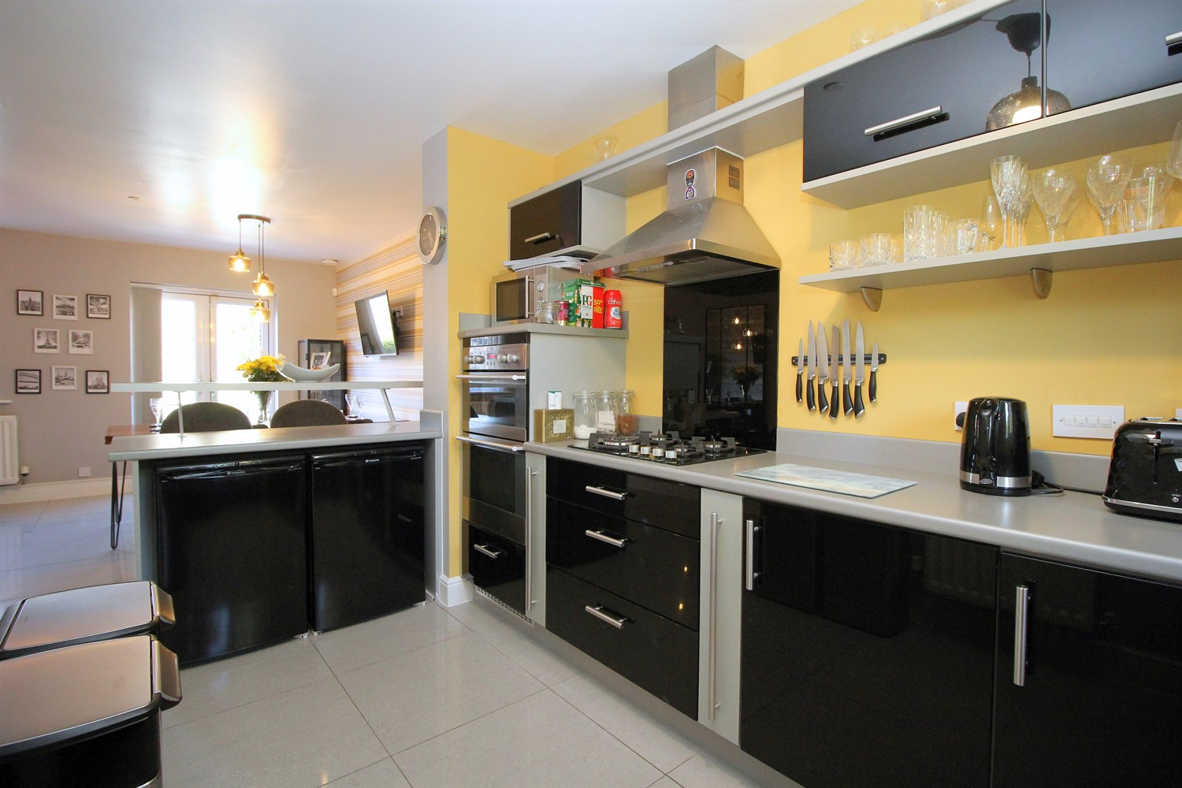

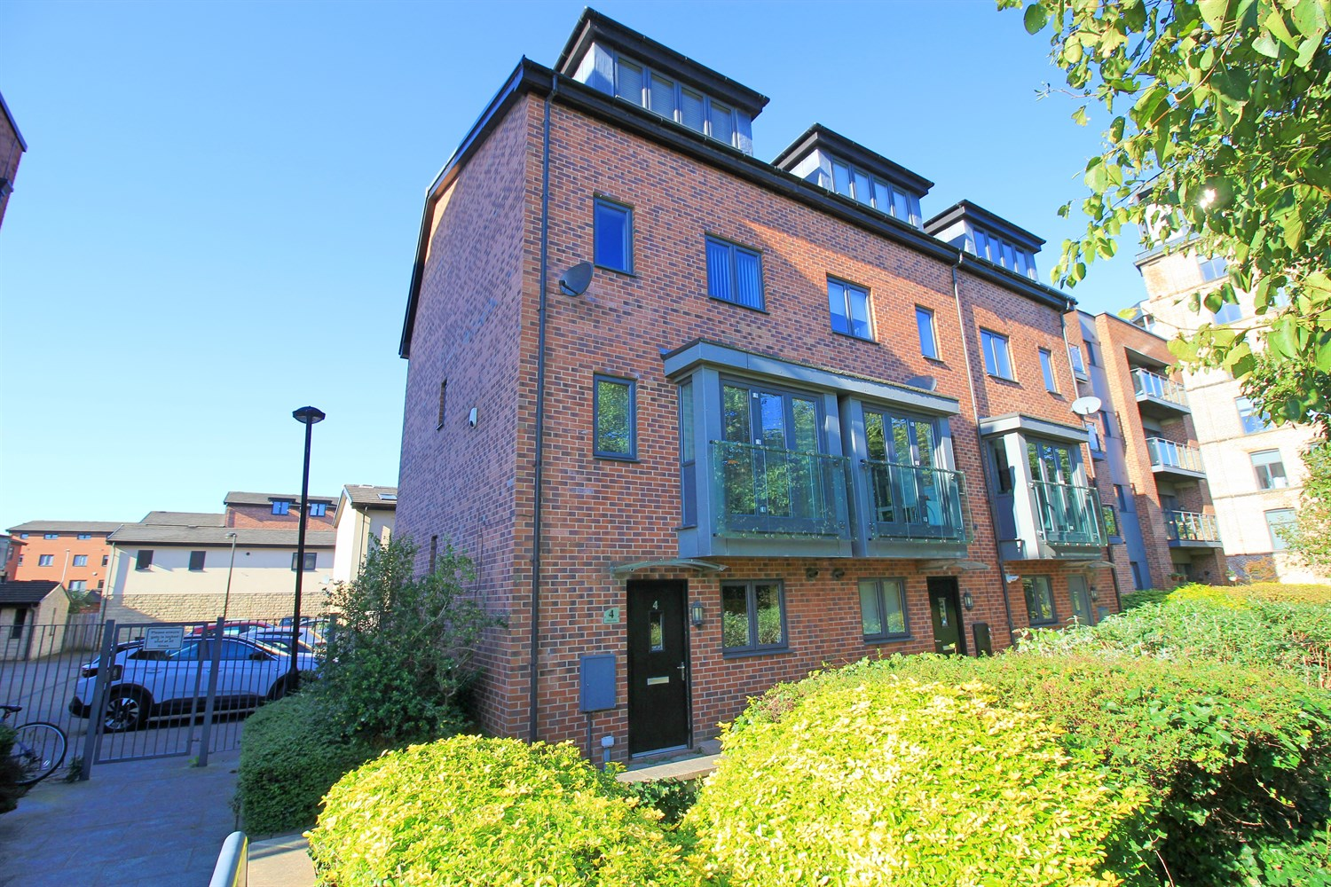

3 Bathroom(s)

1 Reception(s)

4 Bedroom(s)

00

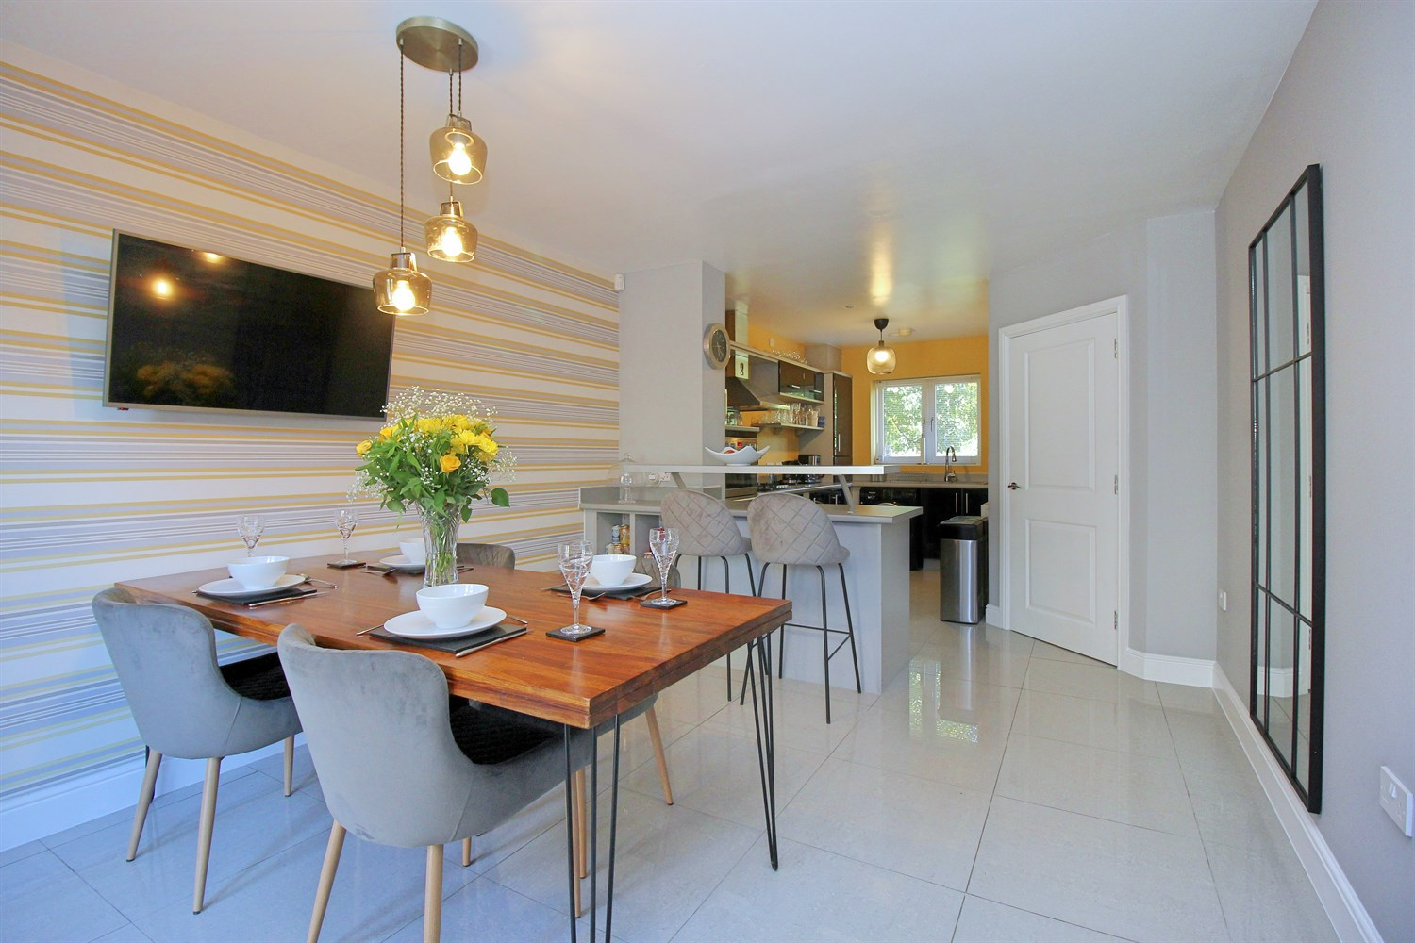

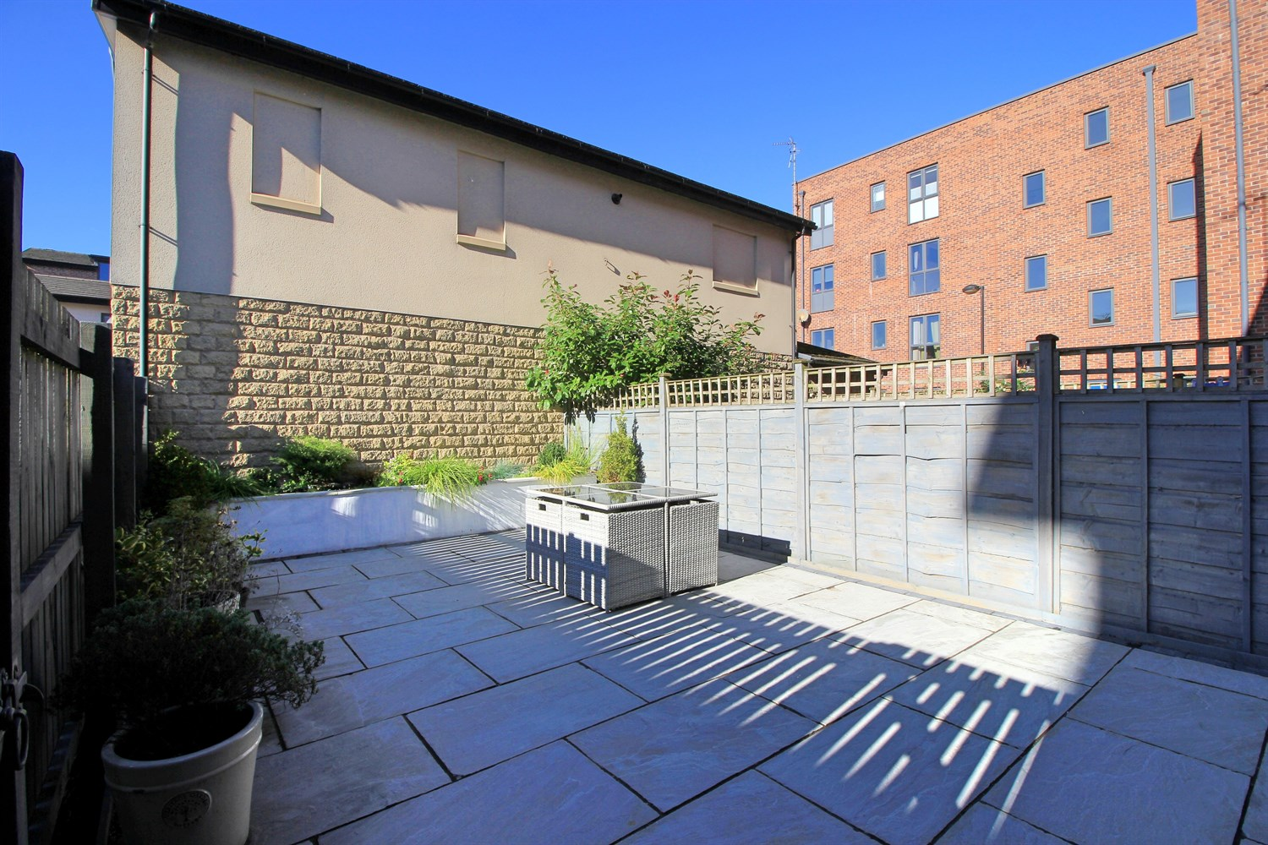

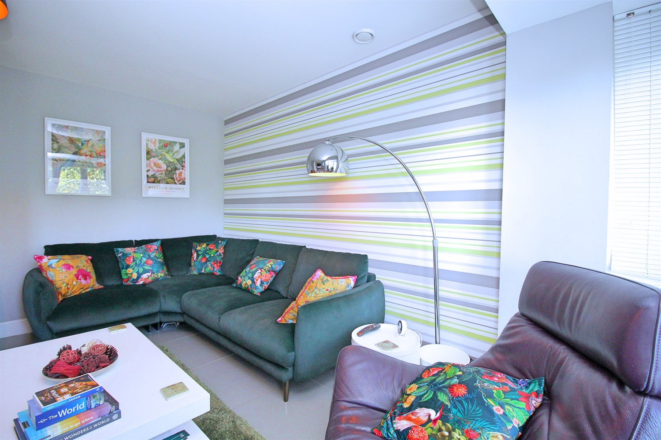

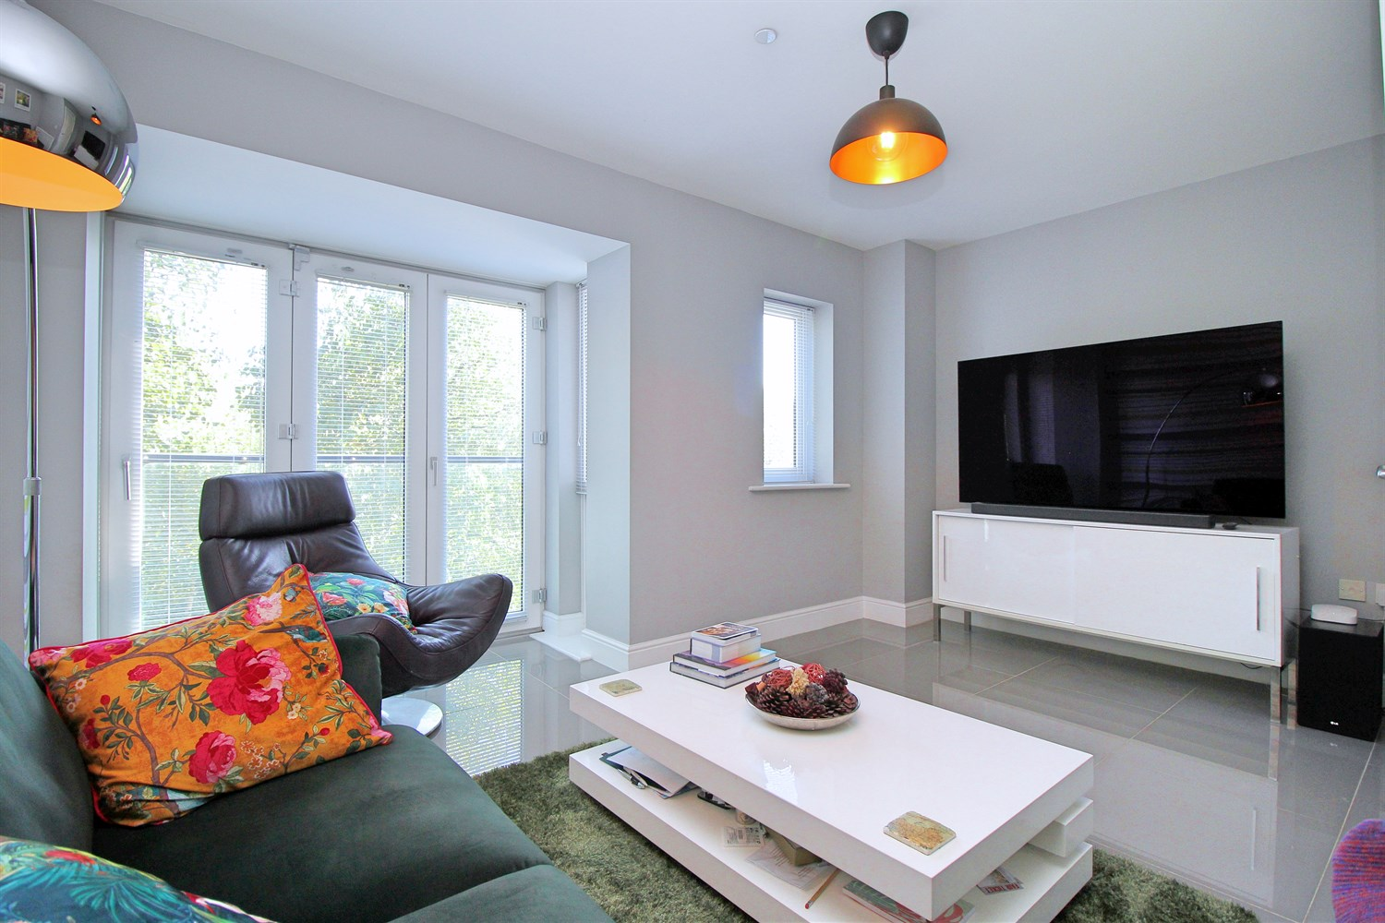

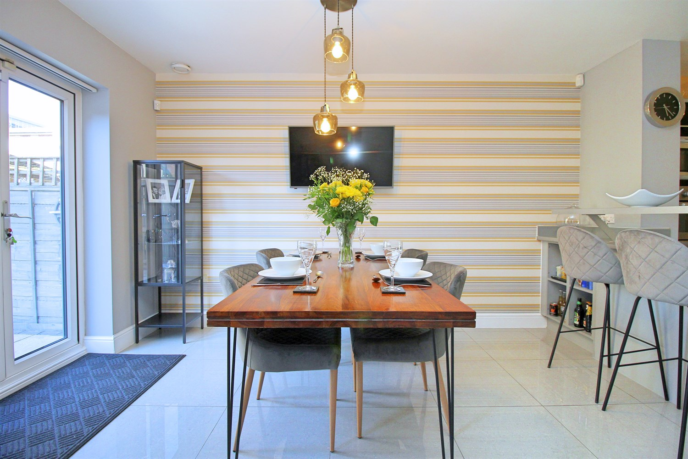

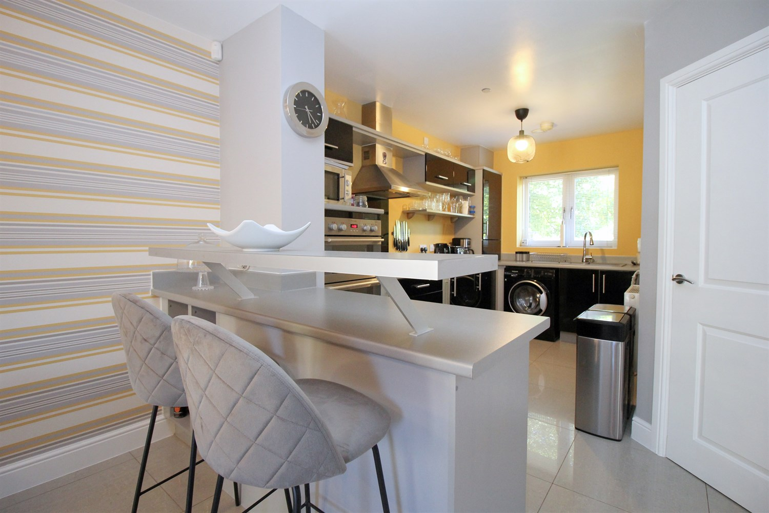

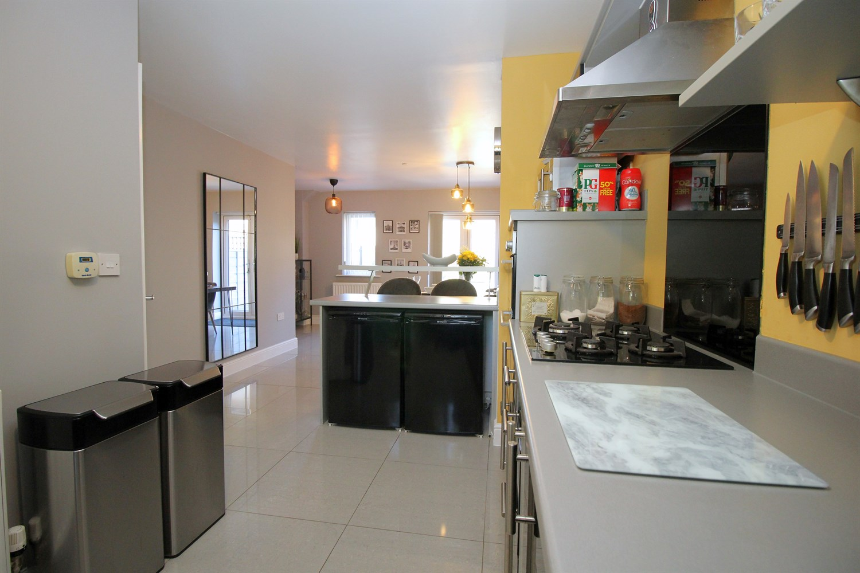

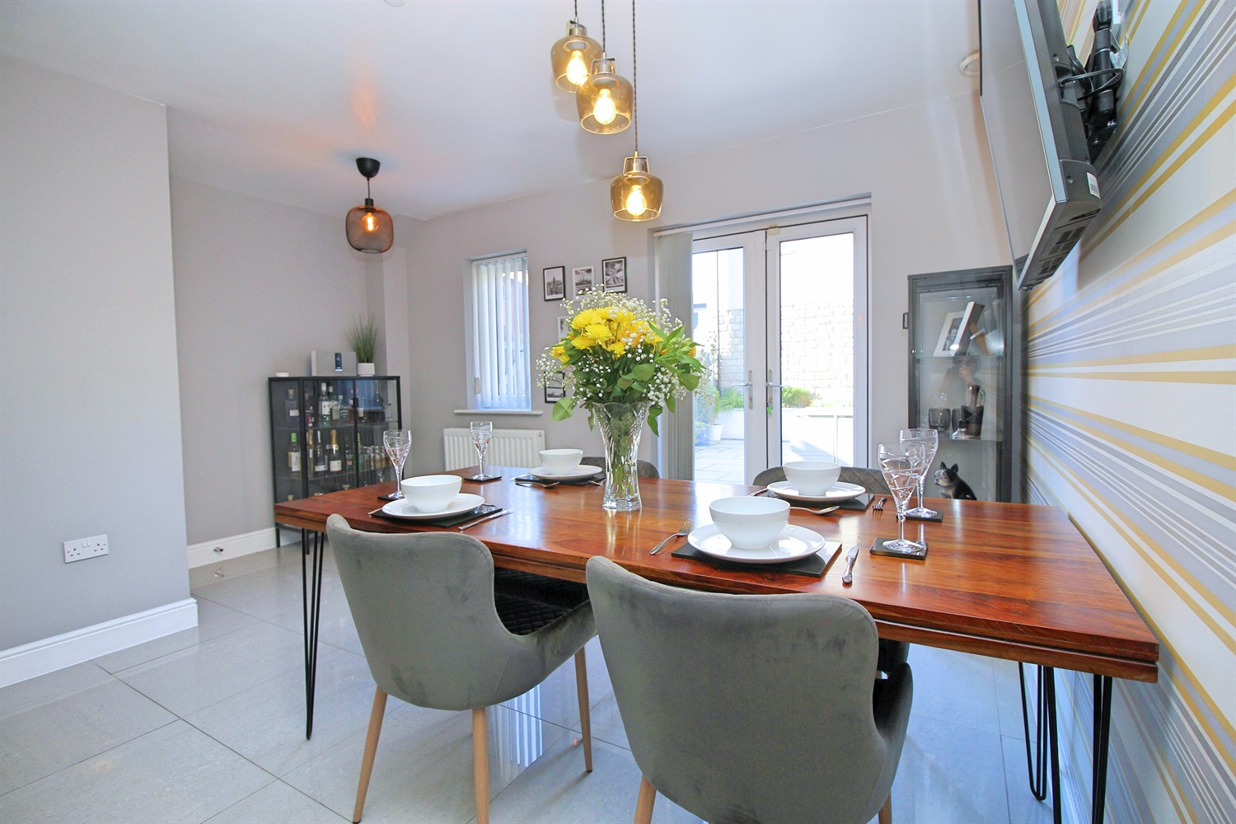

|  |
| --- |
| **Reception 1 4.41m (14'6) x 4.3m (14'1)**  A light and spacious reception room situated to the first floor to the front. Having bi-folding doors and a Juliet style balcony, a double glazed window to the front and a gas central heating radiator |
| **Kitchen 2.2m (7'3) x 3.65m (12')**  A superb open plan ground floor living space having the kitchen situated to the front aspect. The kitchen has a range of stylish modern fitted units feature tile splashback. Appliances comprise of a gas hob with an extractor fan over, an electric oven, plus a 1.5 sink and drainer unit with a mixer tap. The kitchen area has a double glazed window to the front. The dining area has a pair of double glazed French doors leading into the rear garden, a rear facing double glazed window, two gas central heating radiators and ceiling spotlighting and an under-stairs storage cupboard. |
| **Dining Area 4.42m (14'6) x 4.12m (13'6)**  The dining area has a pair of double glazed French doors leading into the rear garden, a rear facing double glazed window, two gas central heating radiators and ceiling spotlighting and an under-stairs storage cupboard. |
| **Master With En-suite 4.42m (14'6) x 7.74m (25'5)**  A large double bedroom having a double glazed window to the front with river views, a double glazed Velux style window to the rear and two gas central heating radiators |
| **Bedroom 2 2.36m (7'9) x 4.28m (14'1)**  A double bedroom situated to the rear, having two double glazed windows, a gas central heating radiator and a storage cupboard. |
| **Bedroom 3 4.41m (14'6) x 2.58m (8'6)**  Double bedroom situated on the first floor facing the rear, double glazed window and a gas central heating radiator. |
| **Bedroom 4 2.36m (7'9) x 3.68m (12'1)**  Fourth double bedroom situated to the rear, double glazed window and a gas central heating radiator. |
| **En Suite**  Suite comprising of a shower enclosure with a mains fed mixer shower, a hand wash basin plus a low flush WC. Having a heated towel rail and an extractor fan. |
| **Bathroom 3**  Suite comprising of bath with shower over head shower screen, a hand wash basin with a pedestal, plus a low flush WC. Having an obscured double glazed window, a heated towel rail and an extractor fan |
| **Bathroom**  Suite comprising walk in shower, a hand wash basin with a pedestal, plus a low flush WC. a heated towel rail and an extractor fan. |
| **Small Garden**  Enclosed low maintenance garden. |
| **Parking**  Allocated parking. |
| **Home Information**  12 Month tenancy only!  COUNCIL TAX BAND: B EPC Rating C  Leasehold property Parking available  Broadband:  Standard 5 Mbps 0.6 Mbps Good Superfast --Not available --Not available Unlikely Ultrafast 1000 Mbps 220 Mbps Mobile availability: EE limited coverage. Three limited coverage. O2 likely to have good coverage. Vodafone limited coverage.  Utilities: Water supplied on standard meters. Electric mains supplied on standard meters. |

|  |  |
| --- | --- |
| These particulars are intended to give a fair description of the property, but their accuracy cannot be guaranteed, and they do not constitute an offer of contract. Intending purchasers must rely on their own inspection of the property. None of the above appliances/services have been tested by ourselves. We recommend purchasers arrange for a qualified person to check all appliances/services before legal commitment.  **Property Ref:** 4254  **For more information, please contact**  0113 258 1150 **|** [lettings@adairpaxton.co.uk](mailto:lettings@adairpaxton.co.uk) **|** www.adairpaxton.co.uk |  |