

**0113 258 1150**

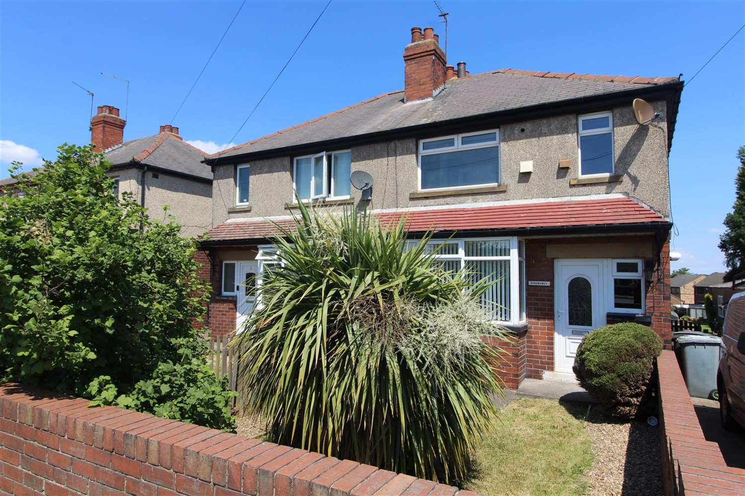



**Available to let £900.00pcm**

**Bradford Road, Tingley**

Traditional three bedroom semi-detached house occupying a convenient position within easy reach of Leeds, Wakefield, Dewsbury and the motorway network. Ideal family home with gas central heating, Upvc double glazing. Hall, lounge, dining kitchen, two double bedrooms and single bedroom, combined bathroom and wc. Driveway and good size rear garden with lawn and patio area. Council tax band B EPC Rating E. Deposit £1095. Available 15th January 2025. Sorry no pets.

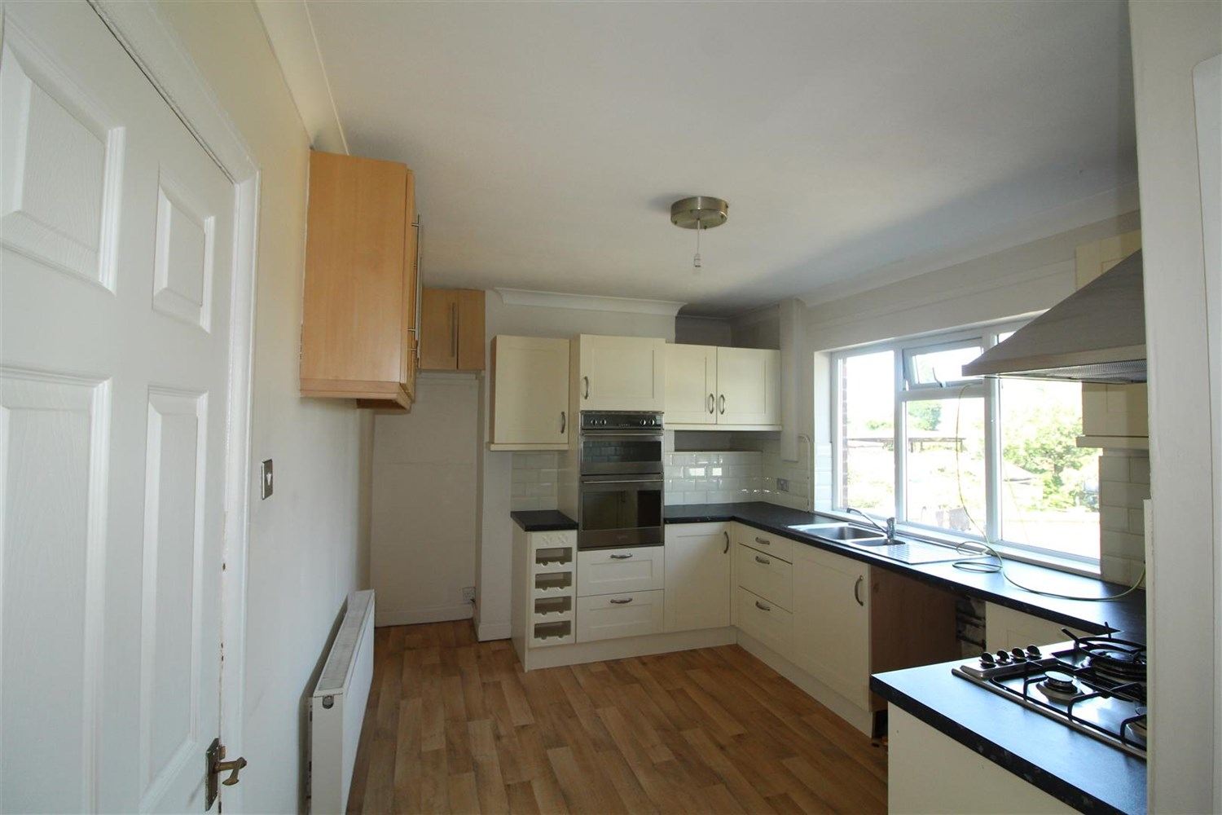

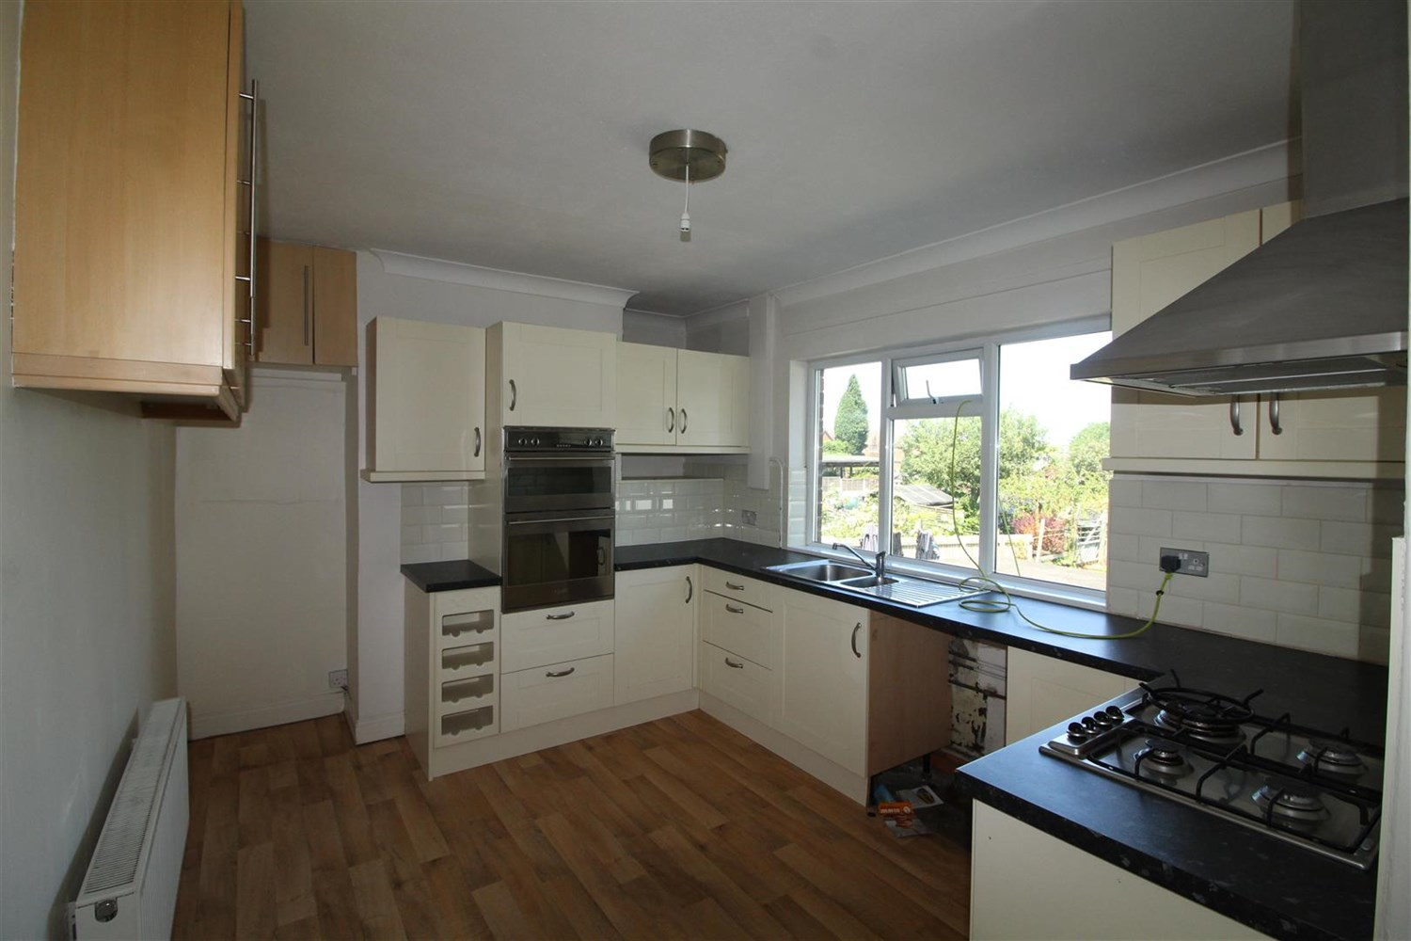

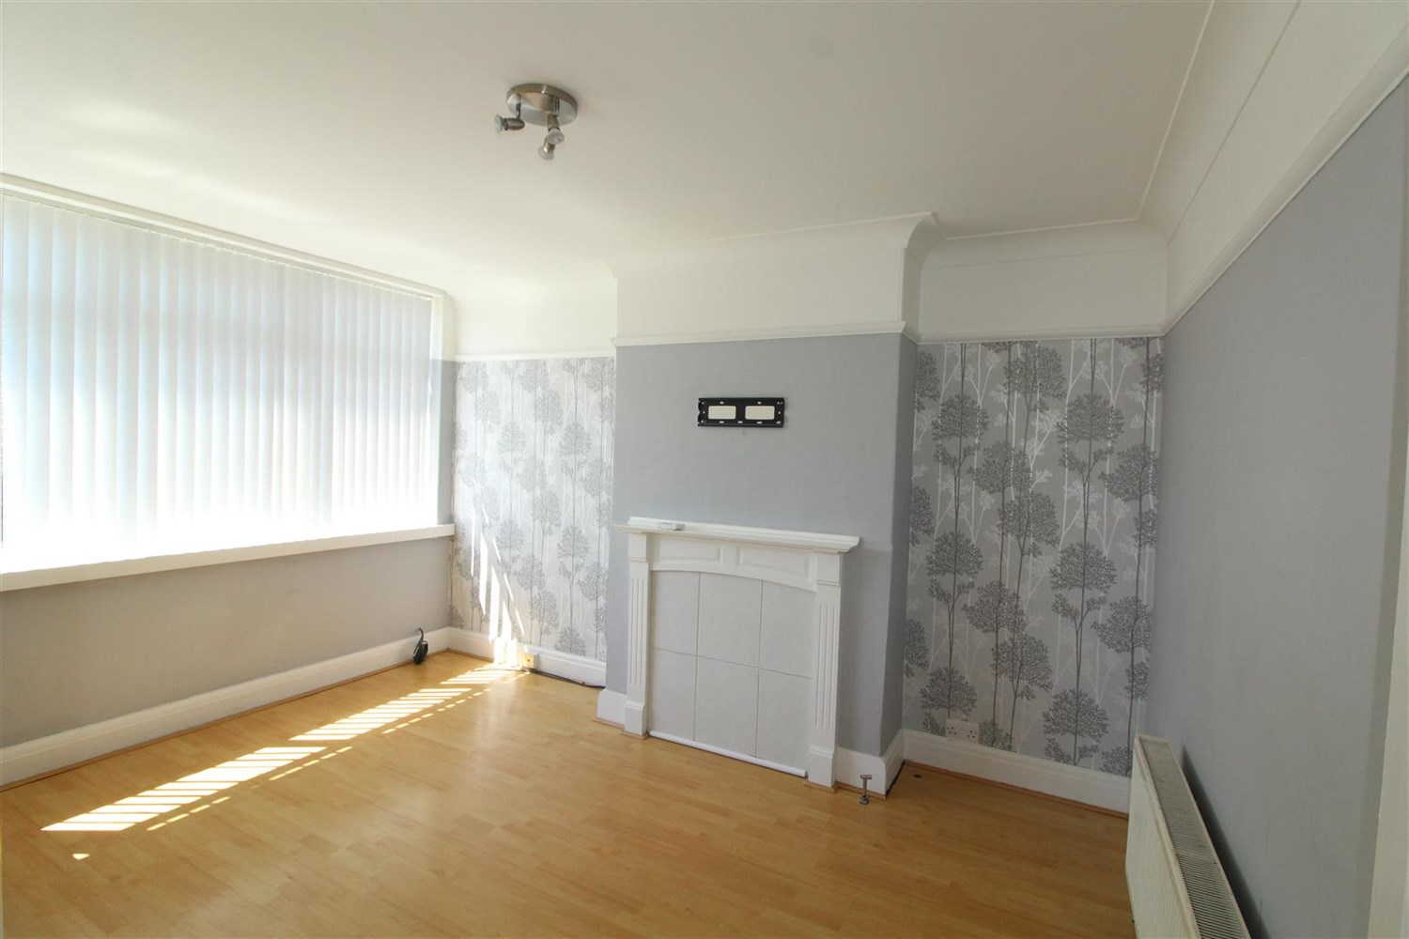

1 Bathroom(s)

1 Reception(s)

1 Bedroom(s)

00

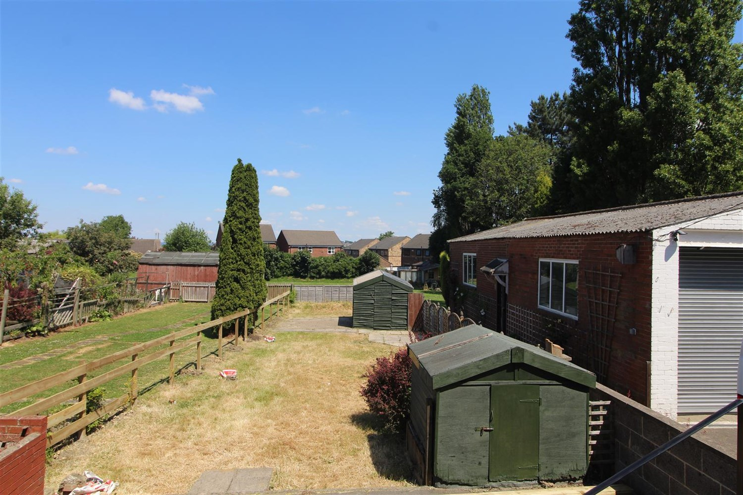

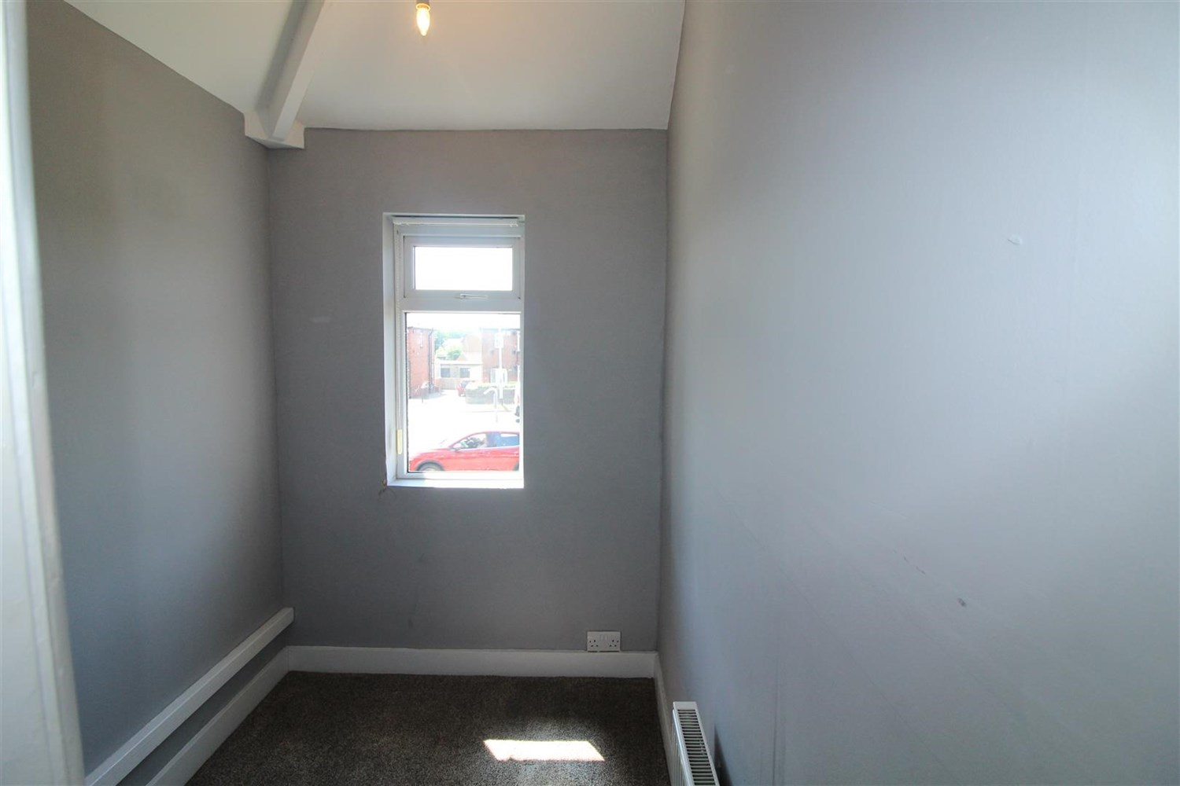

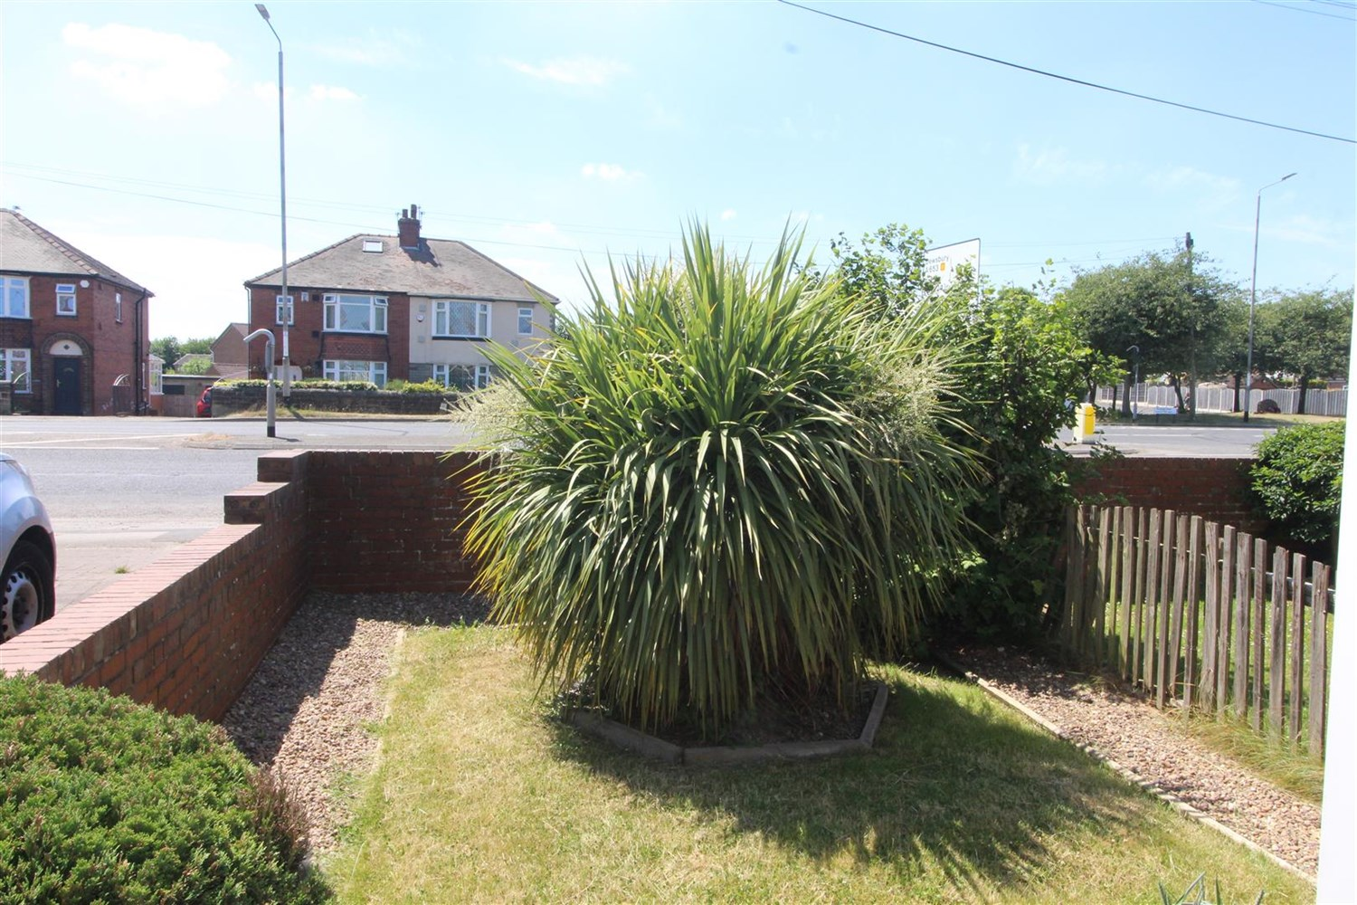

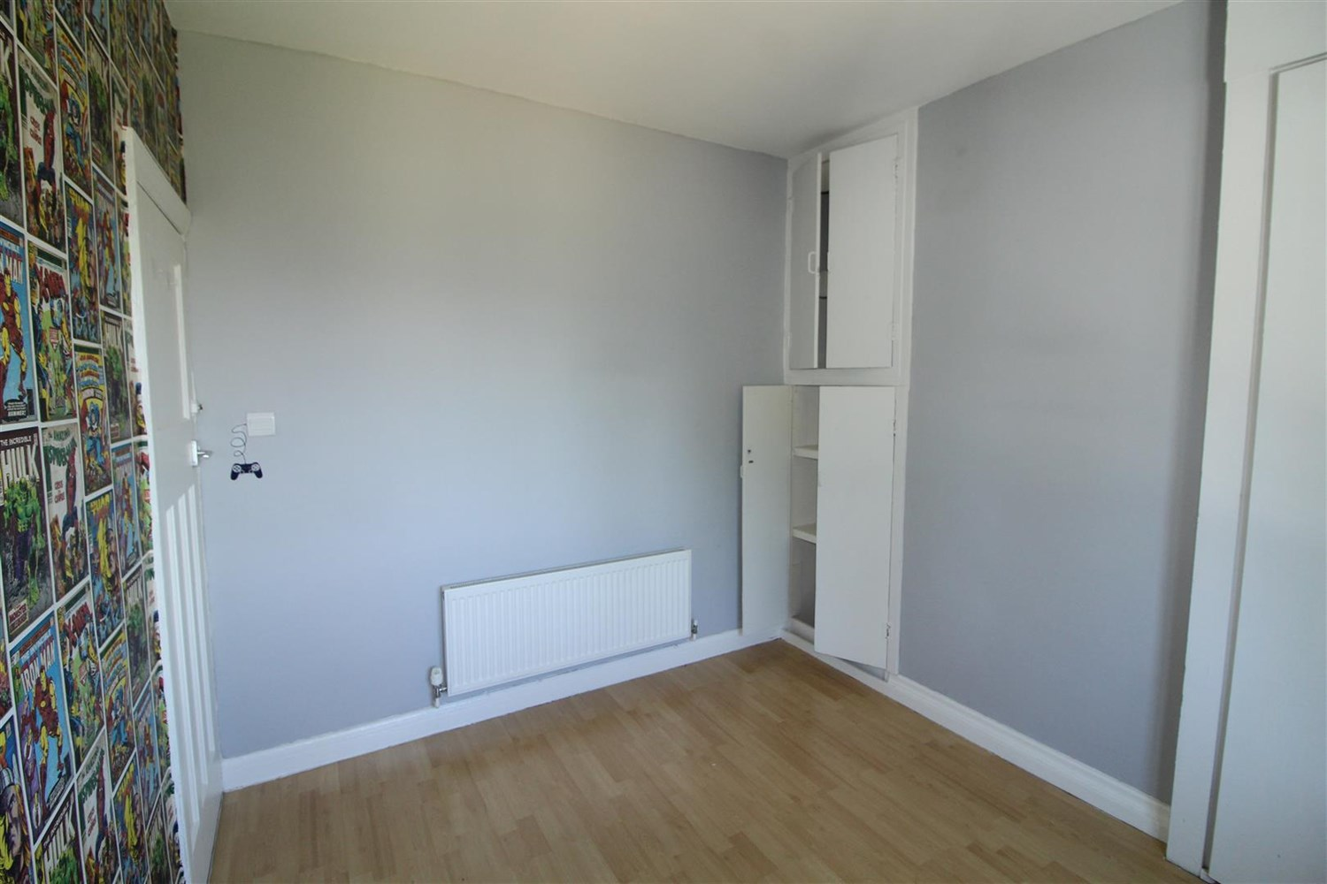

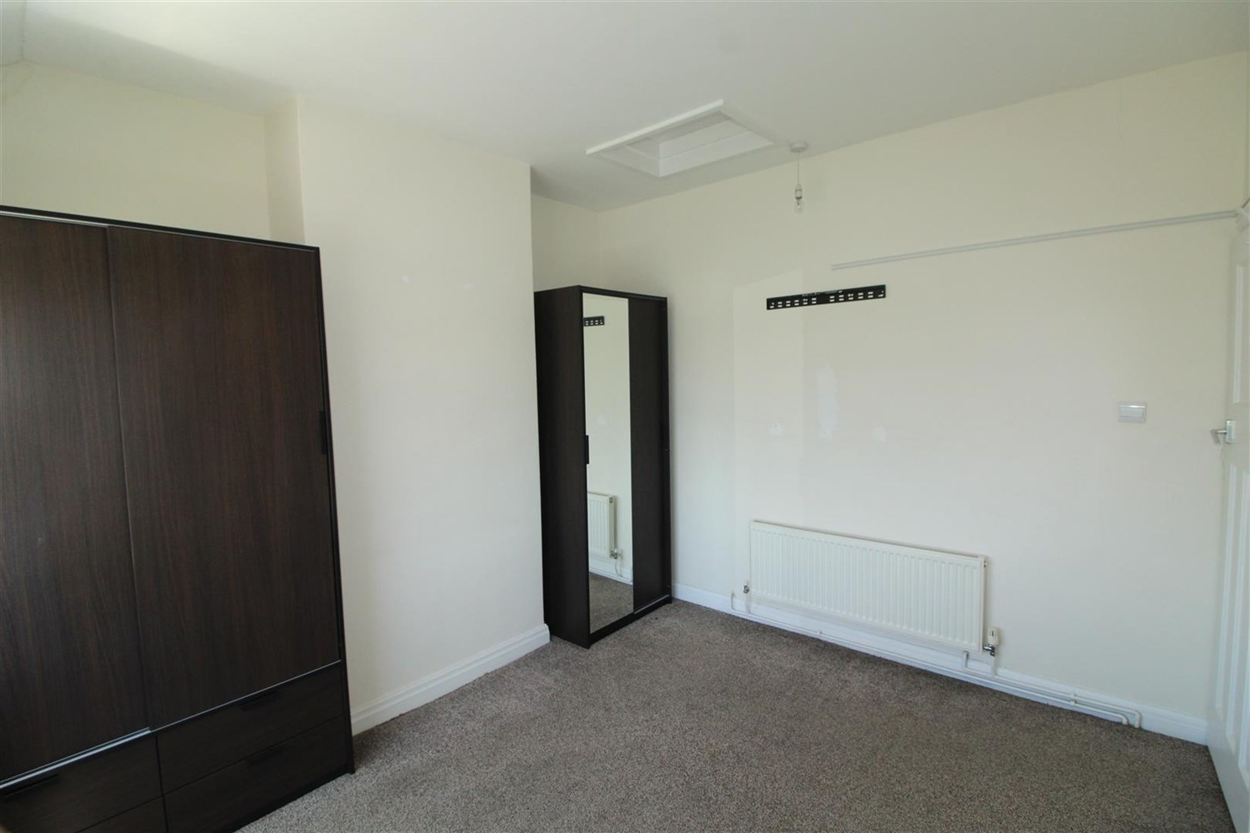

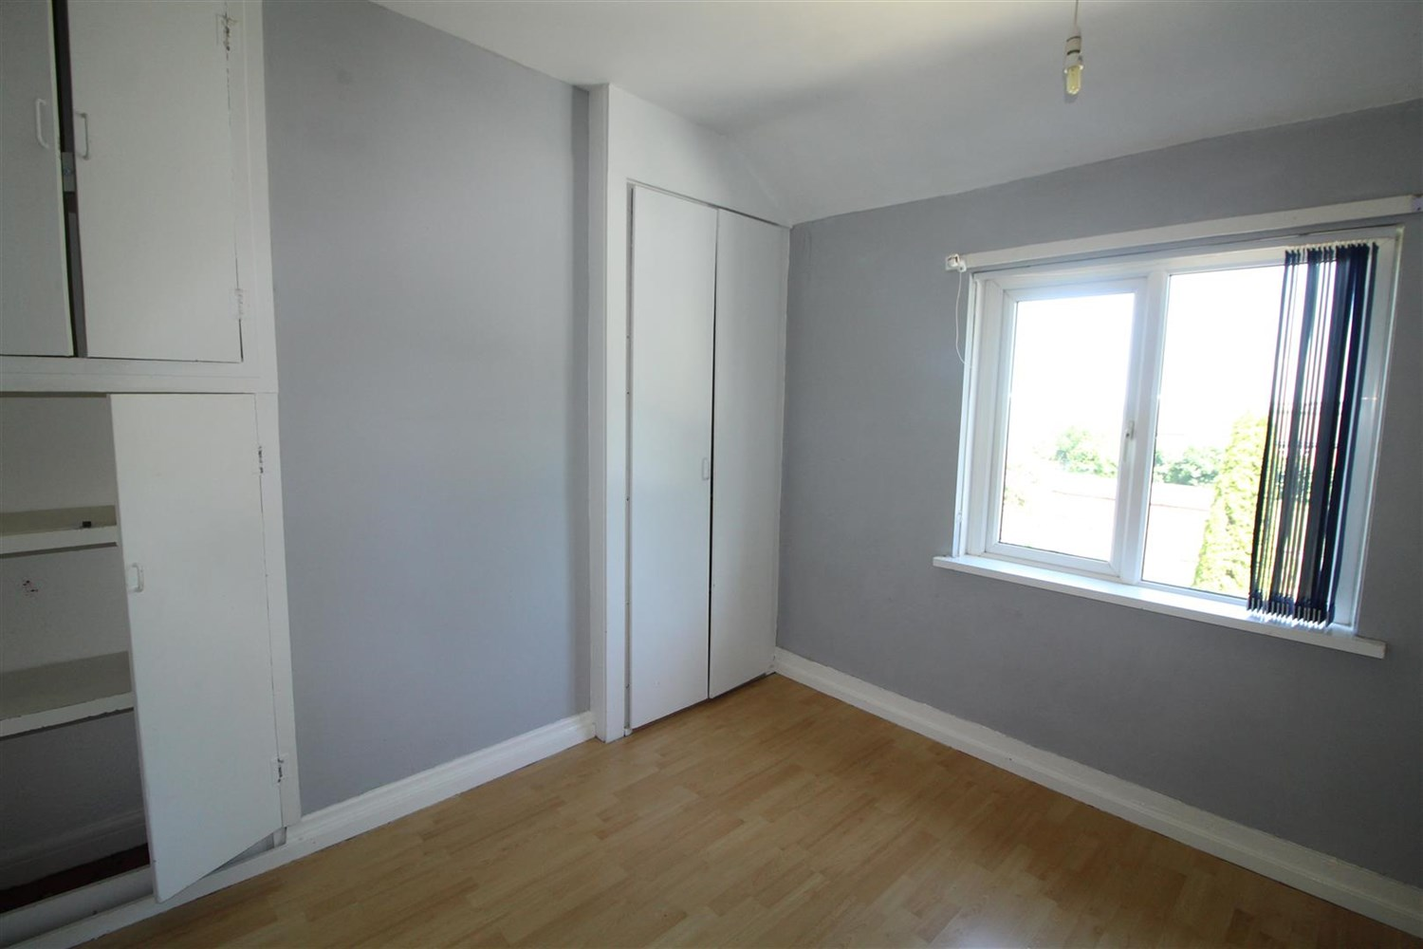

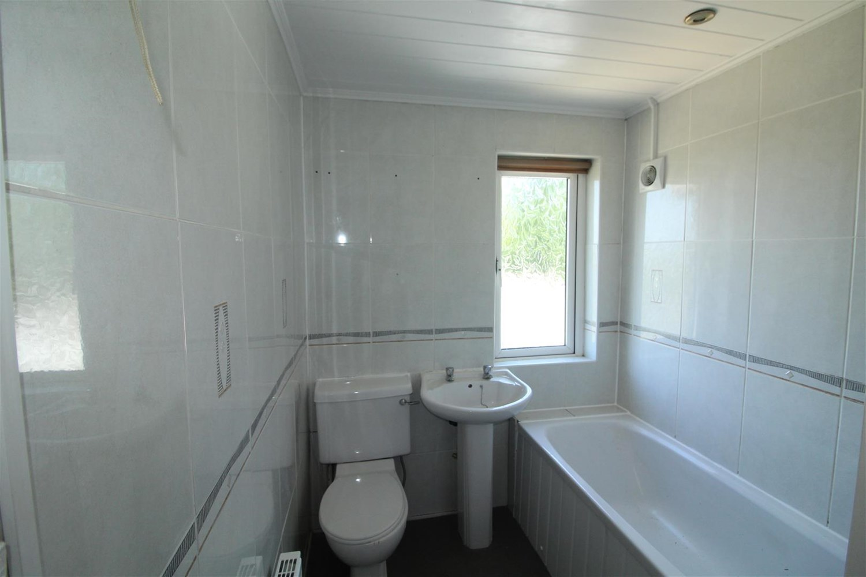

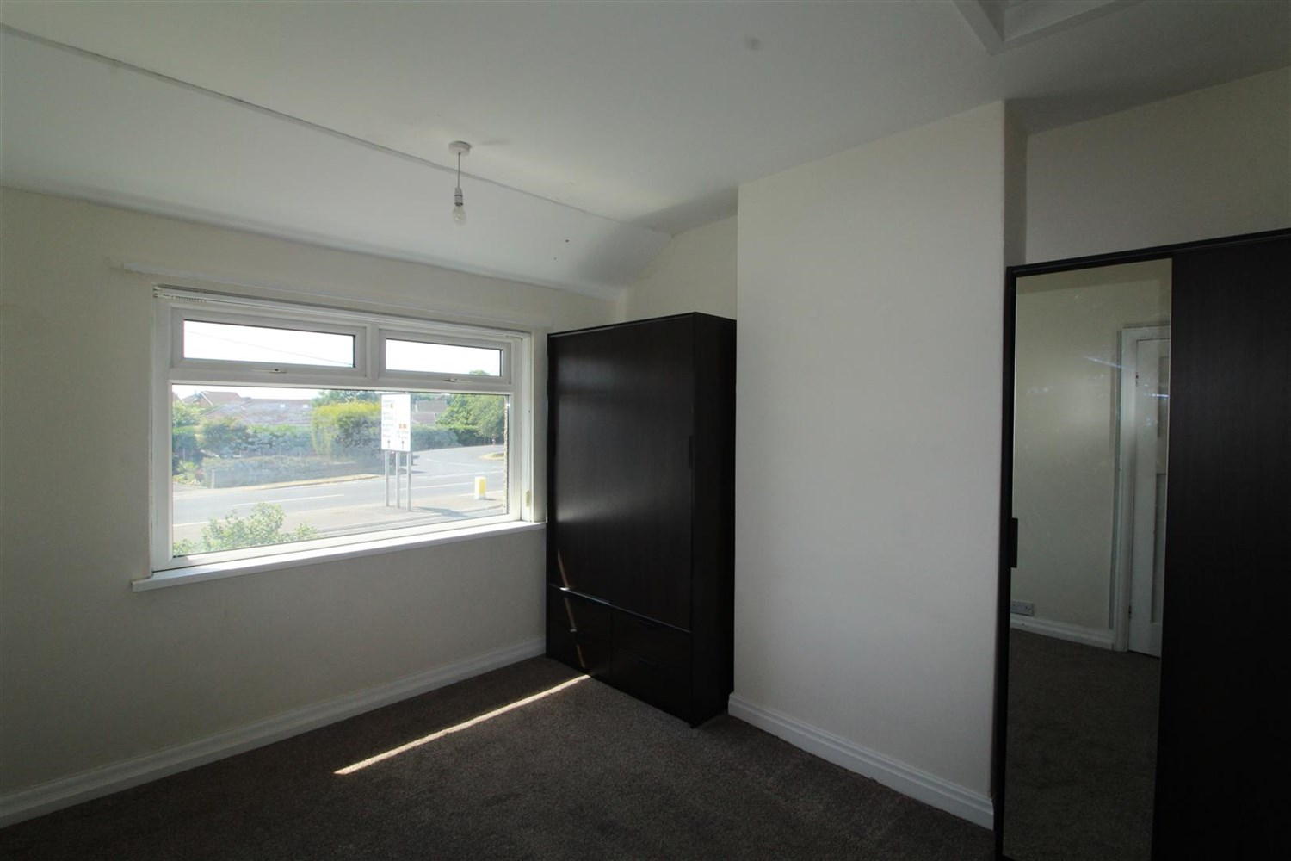

|  |
| --- |
| **Living Room**  Living room with uPVC double glazed window to front, Fire surround ( no fire), gas central heating radiator. |
| **Kitchen**  Spacious modern kitchen fitted with a range of wall and base units with worktops over, stainless steel sink and mixer tap, Gas cooker top with extractor over integrated electric oven, uPVC double glazed window to rear. |
| **Bedroom 1**  Double bedroom with uPVC double glazed window to front, wardrobes and gas central heating radiator. |
| **Bedroom 2**  Double bedroom with uPVC double glazed window to rear, wardrobes and gas central heating radiator. |
| **Bedroom 3**  Third bedroom with uPVC double glazed window to front, gas central heating radiator. |
| **Bathroom**  Three Piece bathroom suite compromising of bath, w/c and hand wash basin, window to rear, gas central heating radiator. |
| **Home Information**  COUNCIL TAX BAND:  EPC Rating   Freehold property Driveway.  Broadband: Standard 8 Mbps 0.9 Mbps Good Superfast 80 Mbps 20 Mbps Good Ultrafast 1000 Mbps 220 Mbps  Mobile availability: EE likely to have good coverage. Three limited coverage. O2 likely to have good coverage. Vodafone limited coverage.  Utilities: Water supplied on standard meters. Electric mains supplied on standard meters. Gas mains supplied on standard meters. |

|  |  |
| --- | --- |
| These particulars are intended to give a fair description of the property, but their accuracy cannot be guaranteed, and they do not constitute an offer of contract. Intending purchasers must rely on their own inspection of the property. None of the above appliances/services have been tested by ourselves. We recommend purchasers arrange for a qualified person to check all appliances/services before legal commitment.  **Property Ref:** 4537  **For more information, please contact**  0113 258 1150 **|** [lettings@adairpaxton.co.uk](mailto:lettings@adairpaxton.co.uk) **|** www.adairpaxton.co.uk |  |