

**Station Road, LS18**

**Available to let £950.00pcm**

Adair Paxton are delighted to offer this FULLY REFURBISHED TWO BED STONE END TERRACE COTTAGE close to Horsforth train station and with all amenities close by. The property has been refurbished to a high standard with quality fixtures and fittings throughout. Comprising; lounge with original stone fireplace and electric fire, spacious dining kitchen to include oven/hob/extractor, integrated dishwasher and fridge, utility room, two double bedrooms and stylish shower room. Gas central heating. Enclosed paved rear garden, on street parking with permit. Unfurnished. Deposit £1095. Available December 9th.

**0113 258 1150**

**0800 000 000**

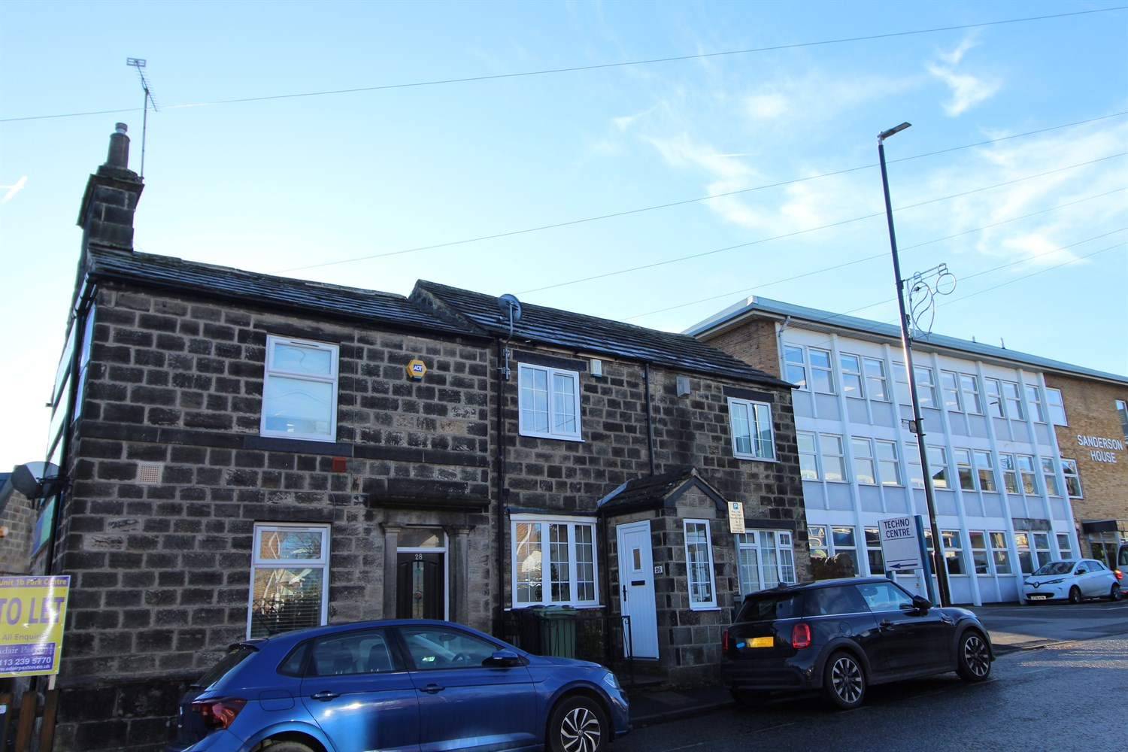



1 Reception(s)

1 Bathroom(s)

2 Bedroom(s)

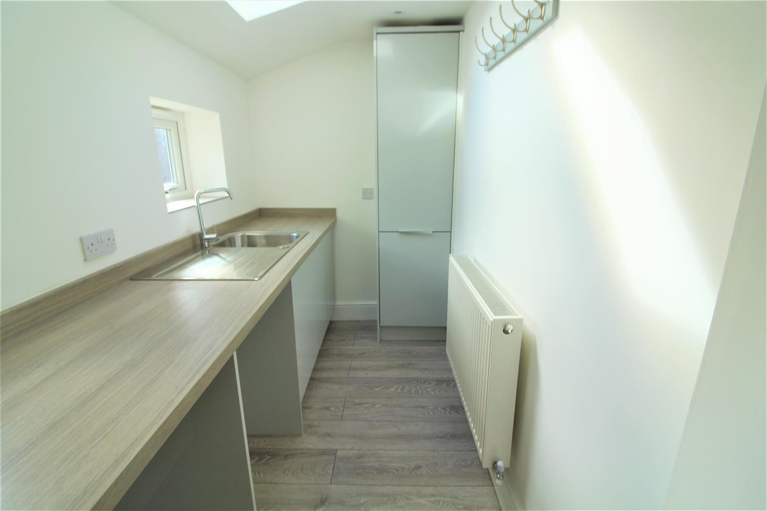

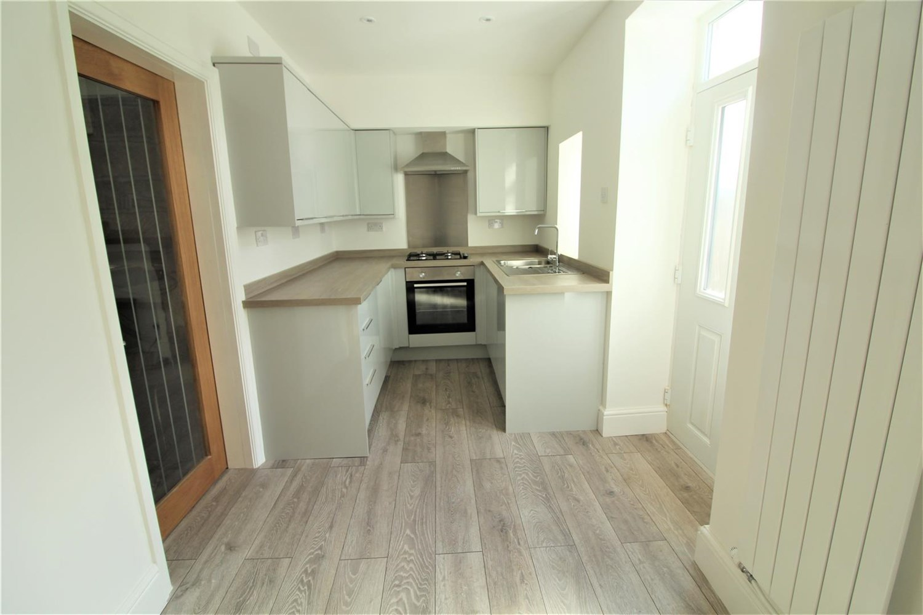

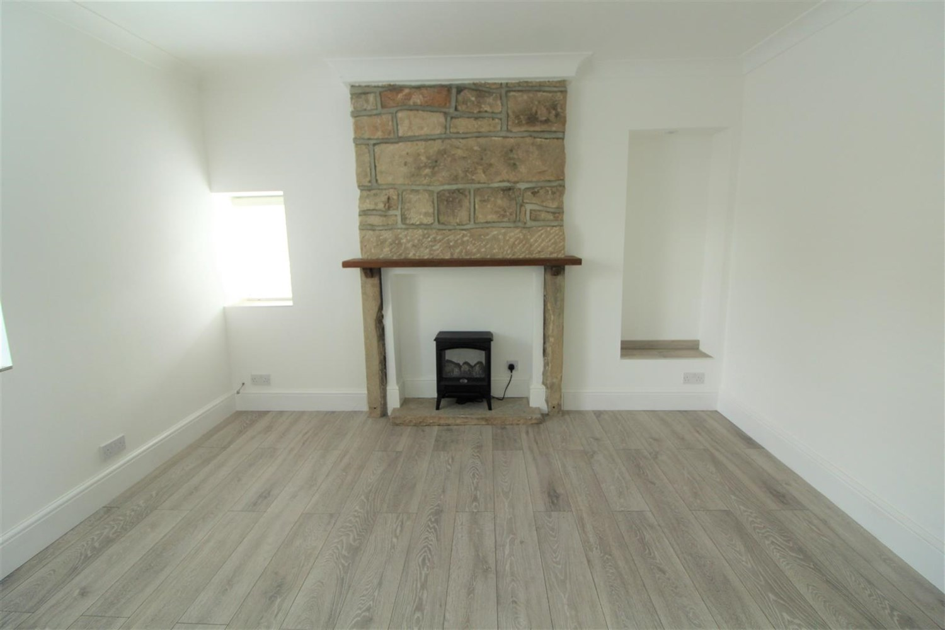

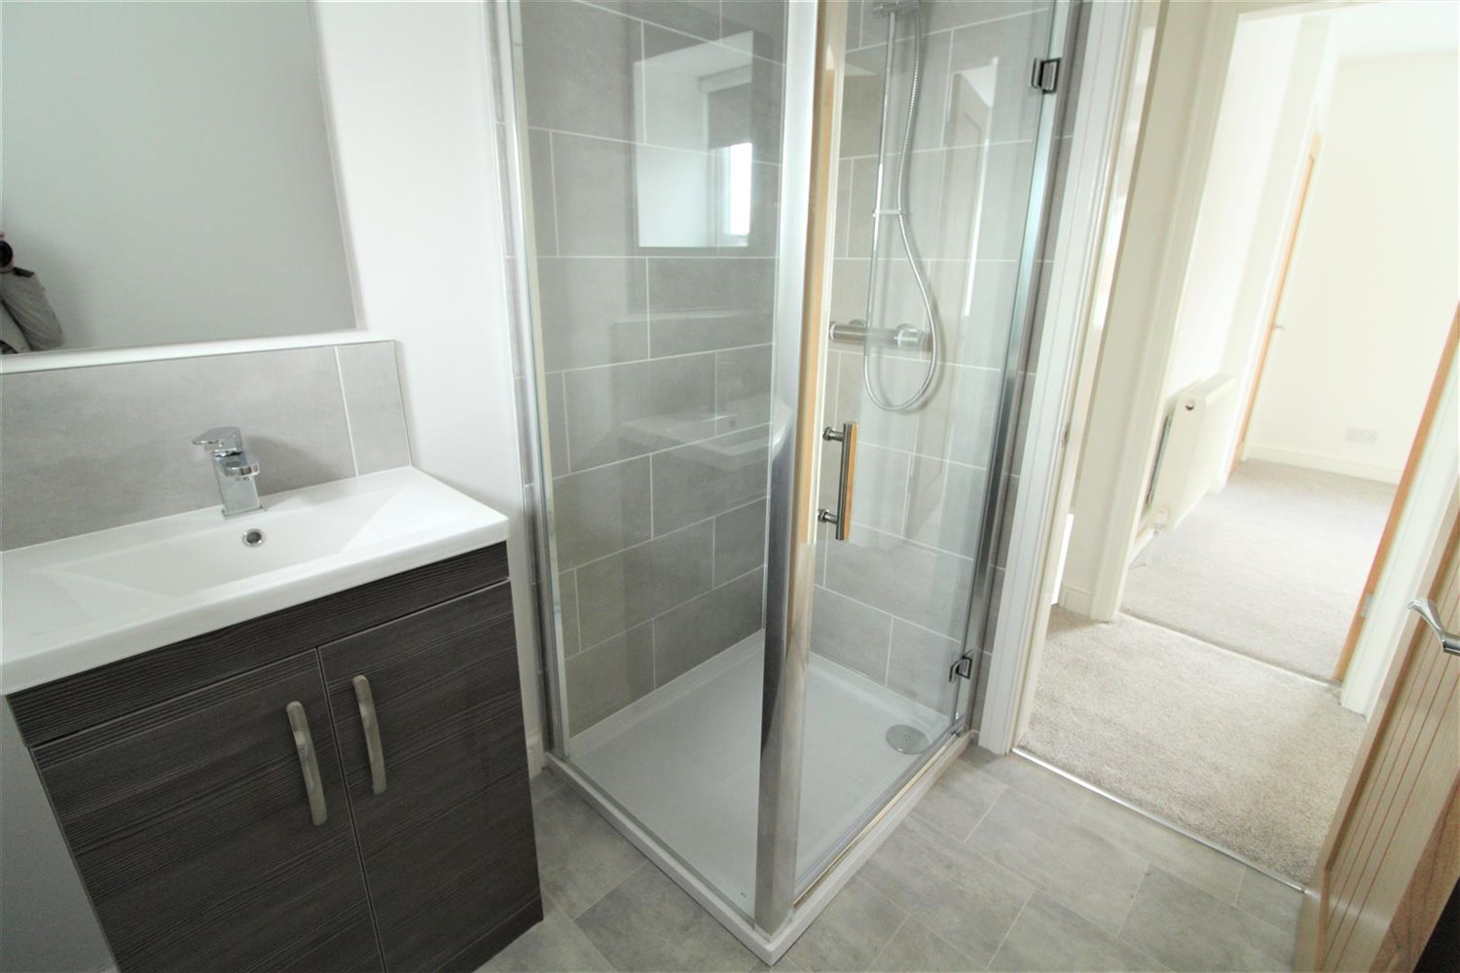

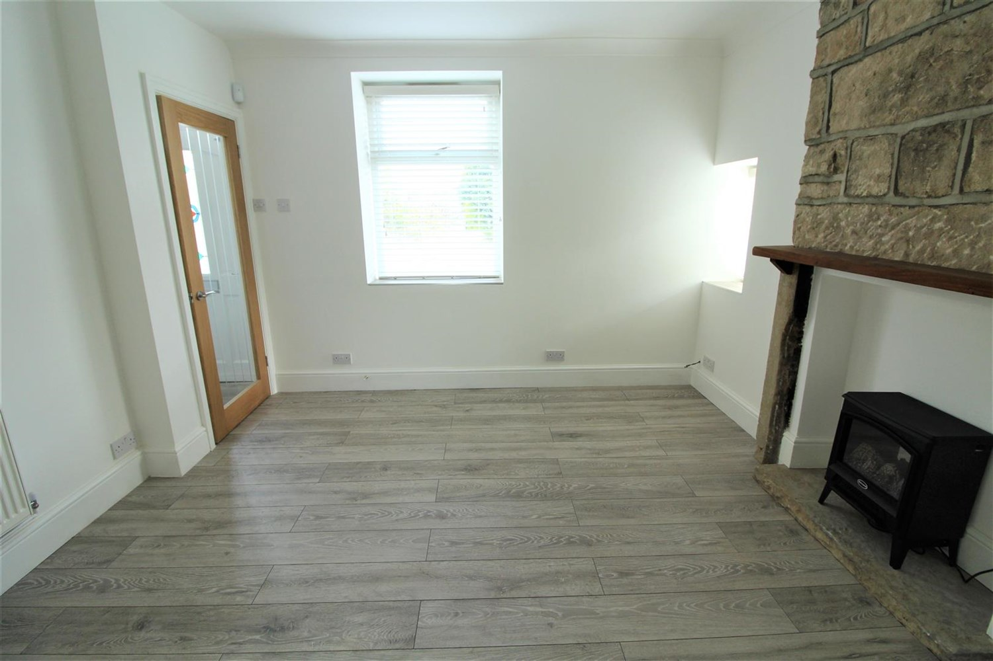

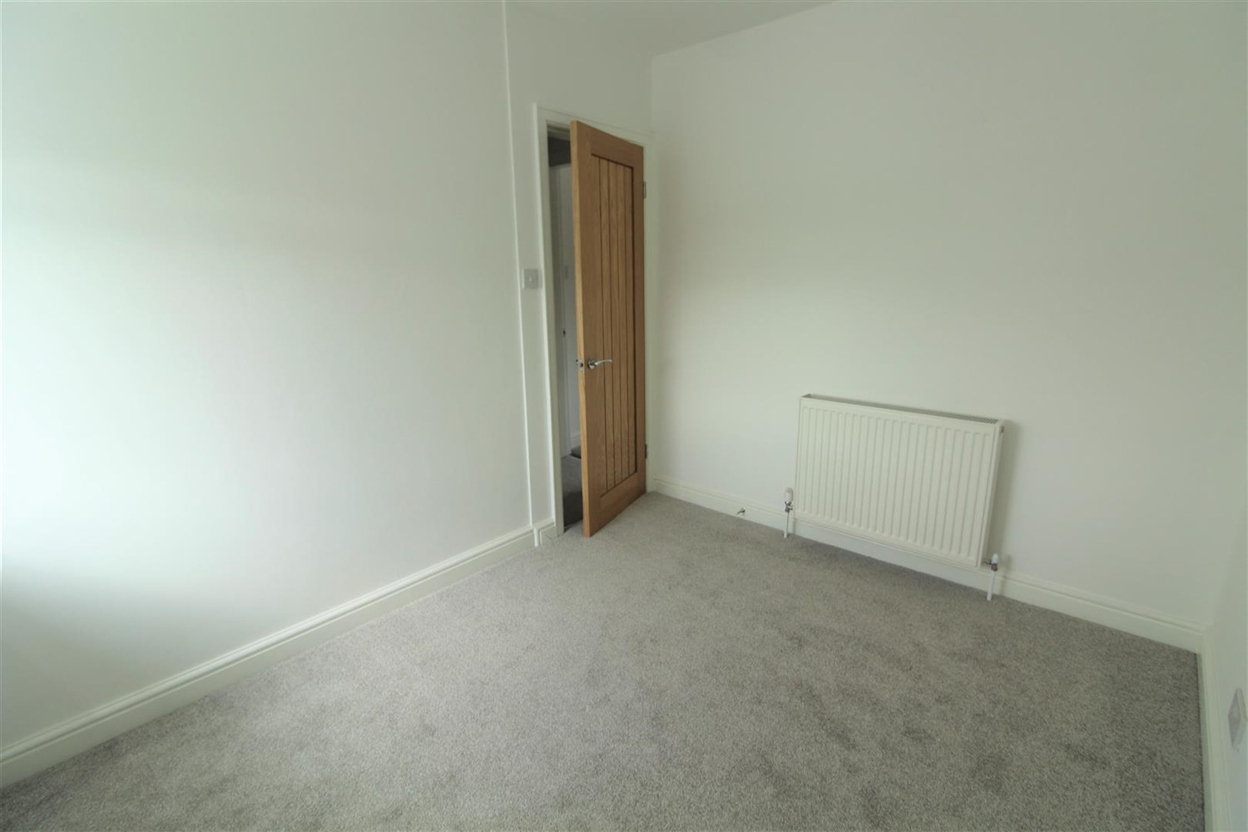

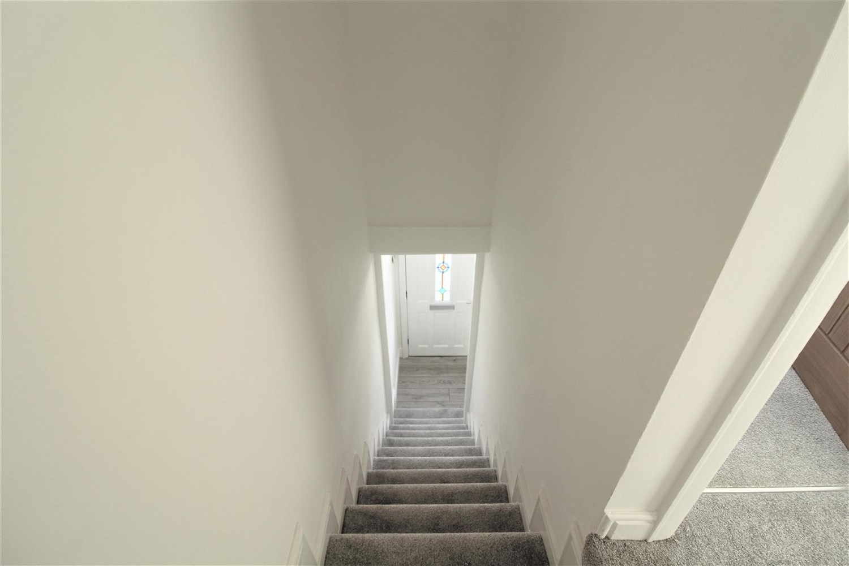

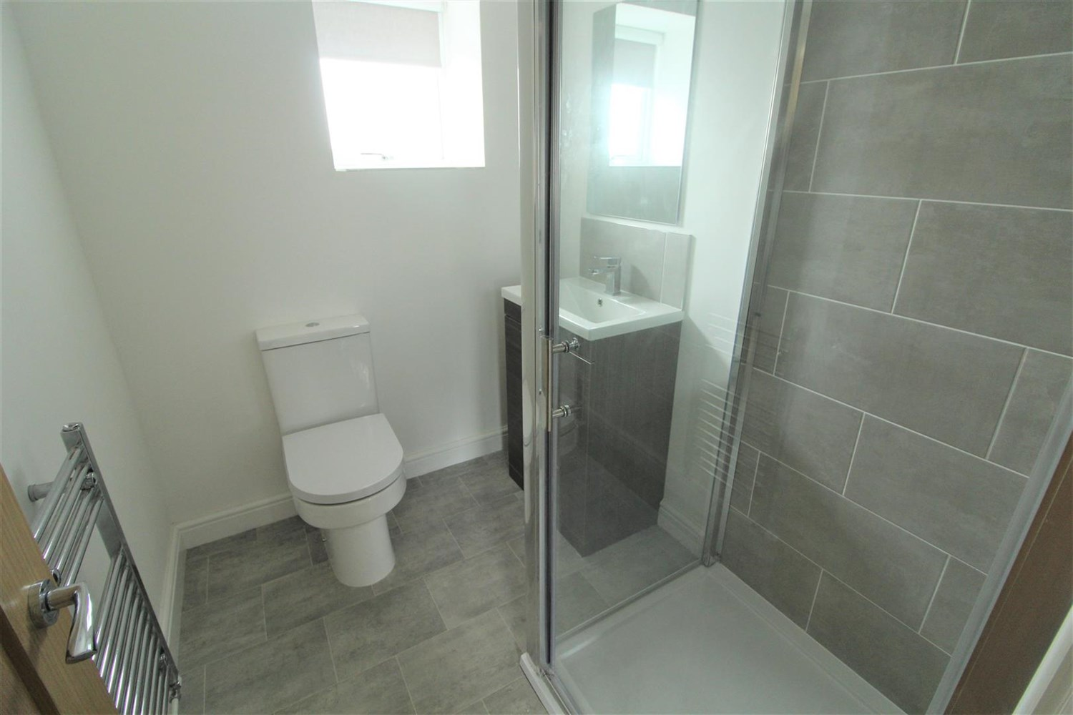

|  |
| --- |
| **Living Room**  Light and airy living room with electric fire with surround. |
| **Kitchen**  Modern fitted kitchen with Electric oven and hob with extractor over head. Stainless steel sink with drainer and mixer tap window to rear. |
| **Bedroom 1**  Double bedroom with carpets and window to front. |
| **Bedroom 2**  Double bedroom with carpets and window to rear. |
| **Bathroom**  Modern bathroom with walk in shower, w/c and hand wash basin, part tiled walls. |
| **Small Garden**  Low maintenance rear garden. |
| **Parking**  On street parking with permit. |
| **Home Information**  EPC BAND: E COUNCIL TAX BAND: B  Freehold property On street parking with permit.  Broadband:  Standard 11 Mbps 0.9 Mbps Good Superfast --Not available --Not available Unlikely Ultrafast 1000 Mbps 220 Mbps  Mobile availability: EE likely to have good coverage. Three likely to have good coverage. O2 likely to have good coverage. Vodafone limited coverage.  Utilities: Gas supplied on standard meter. Water supplied on a meter. Electric mains supplied on standard meters. |

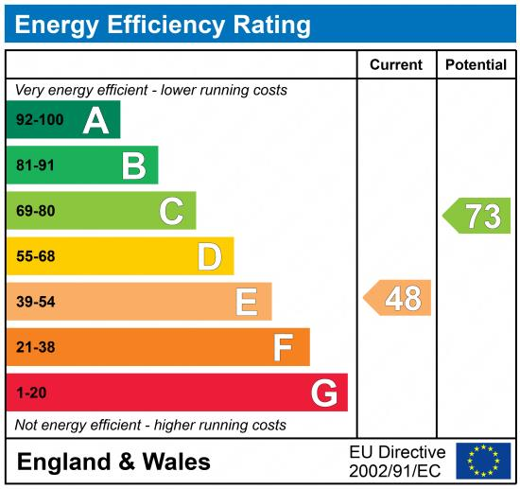

|  |
| --- |
|  |

These particulars are intended to give a fair description of the property, but their accuracy cannot be guaranteed, and they do not constitute an offer of contract. Intending purchasers must rely on their own inspection of the property. None of the above appliances/services have been tested by ourselves. We recommend purchasers arrange for a qualified person to check all appliances/services before legal commitment.

**Property Ref:** 4469

**For more information, please contact**

0113 258 1150 **|** [lettings@adairpaxton.co.uk](mailto:lettings@adairpaxton.co.uk) **|** www.adairpaxton.co.uk