

**0113 258 1150**

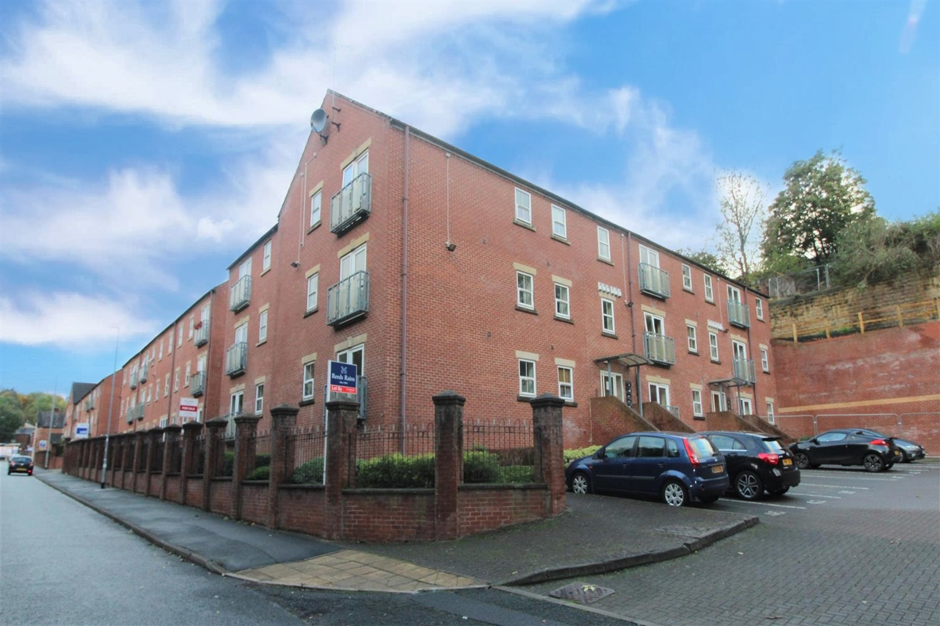



**For Sale £129,950.00**

**Stephenson House, Pullman Court, Morley**

***TWO BEDROOM TOP FLOOR APARTMENT WITH ALLOCATED PARKING*** This spacious second floor apartment is offered to the market with NO ONWARD CHAIN. The property briefly comprises; Communal entrance hall, private entrance hall, open plan kitchen/living room, master bedroom with en-suite shower room, second double bedroom and a house bathroom. The property is located close to local amenities in Morley centre, great motorway links and is within a stones' throw of Morley train station! The apartment is ready to move into and is ideal for a first time buyer or investor. The property is currently tenanted on a rolling basis at £795pcm.

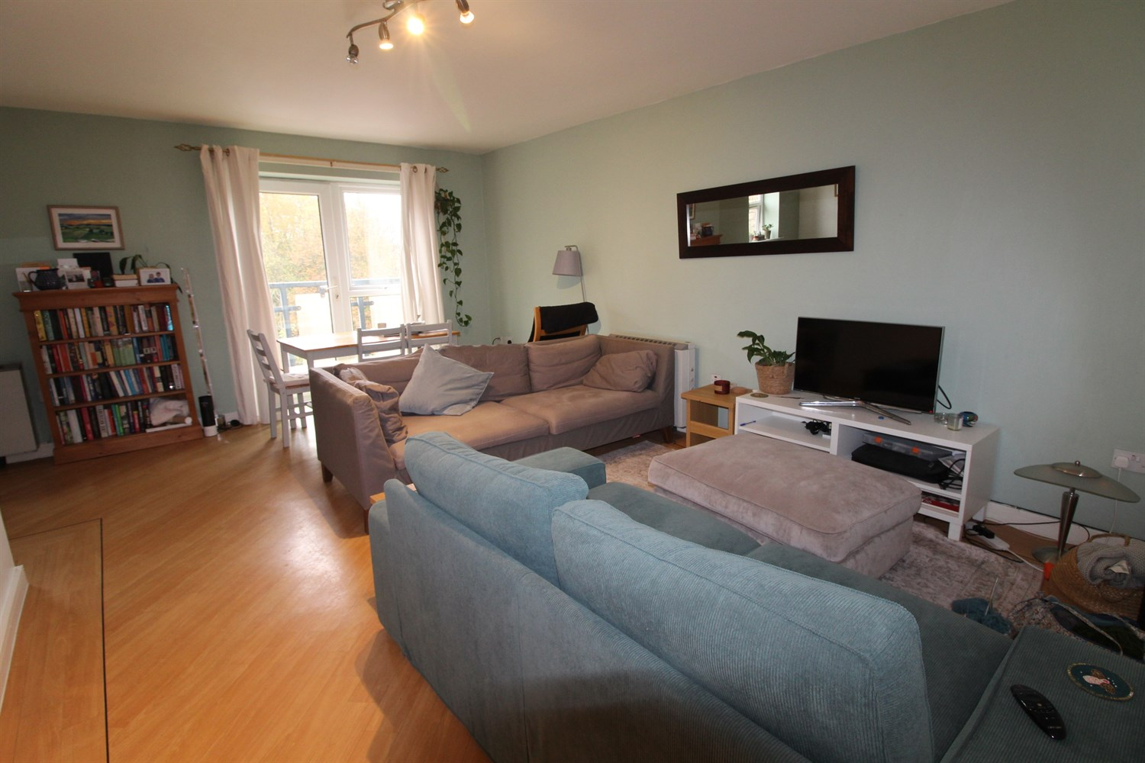

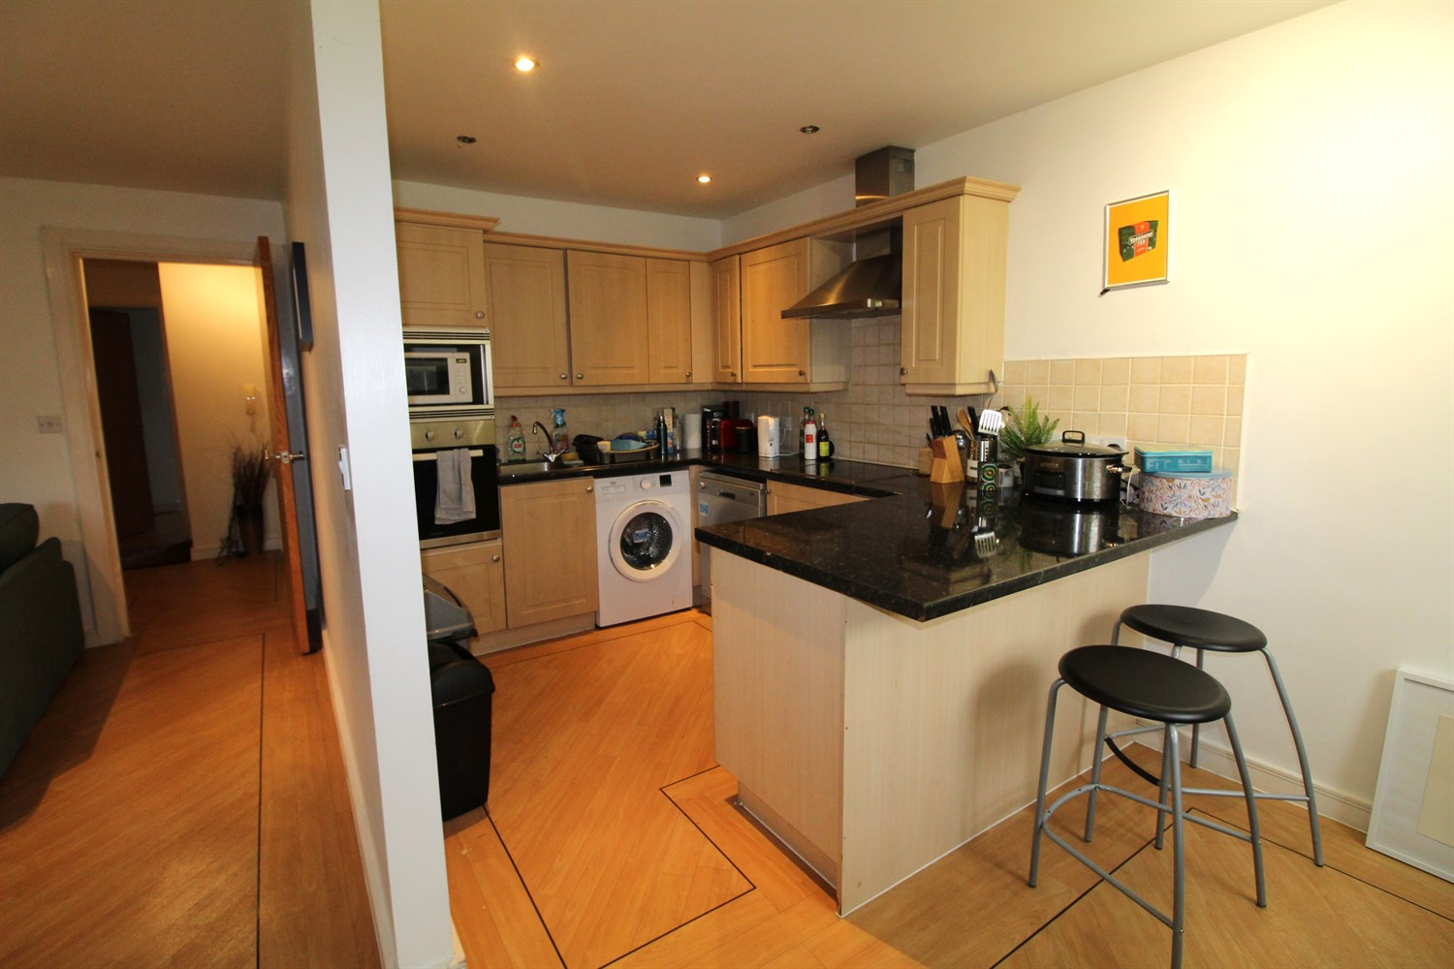

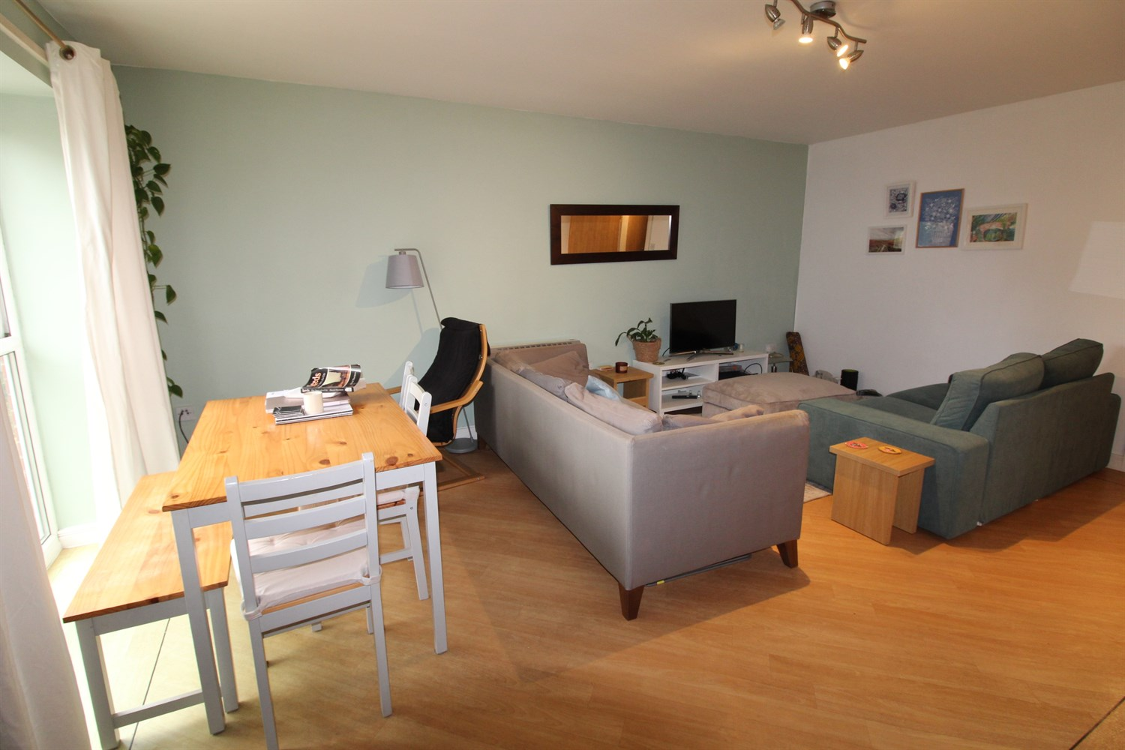

2 Bathroom(s)

1 Reception(s)

2 Bedroom(s)

00

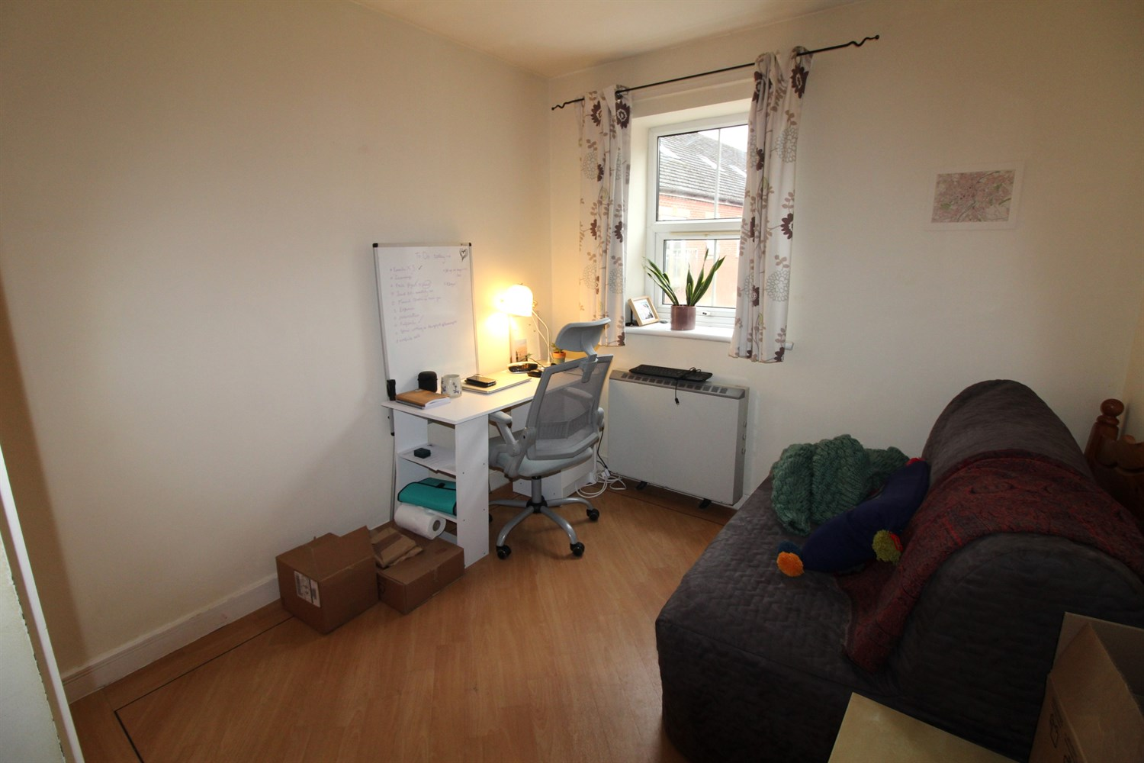

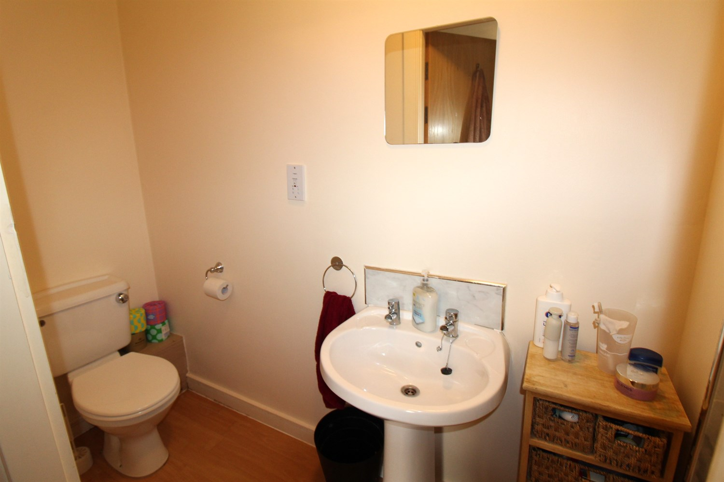

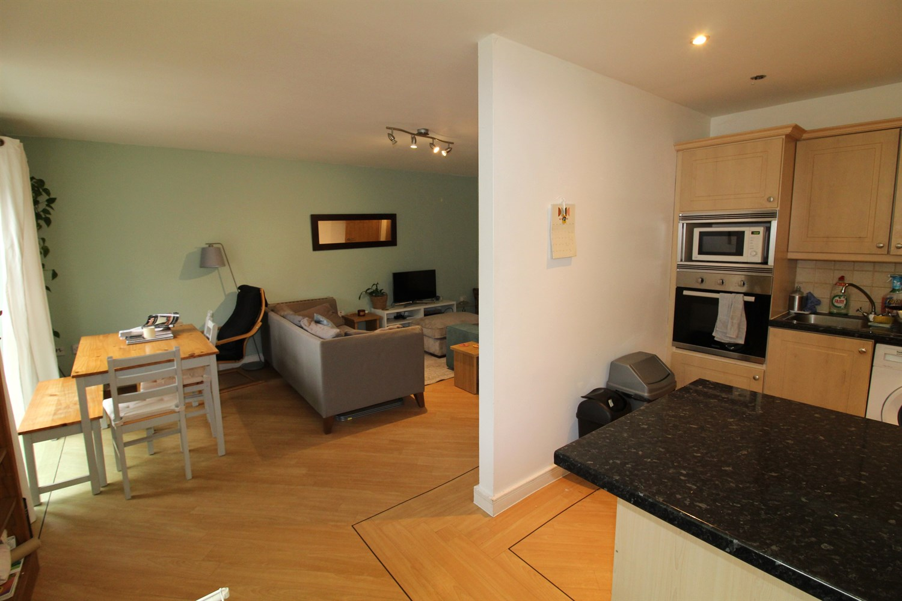

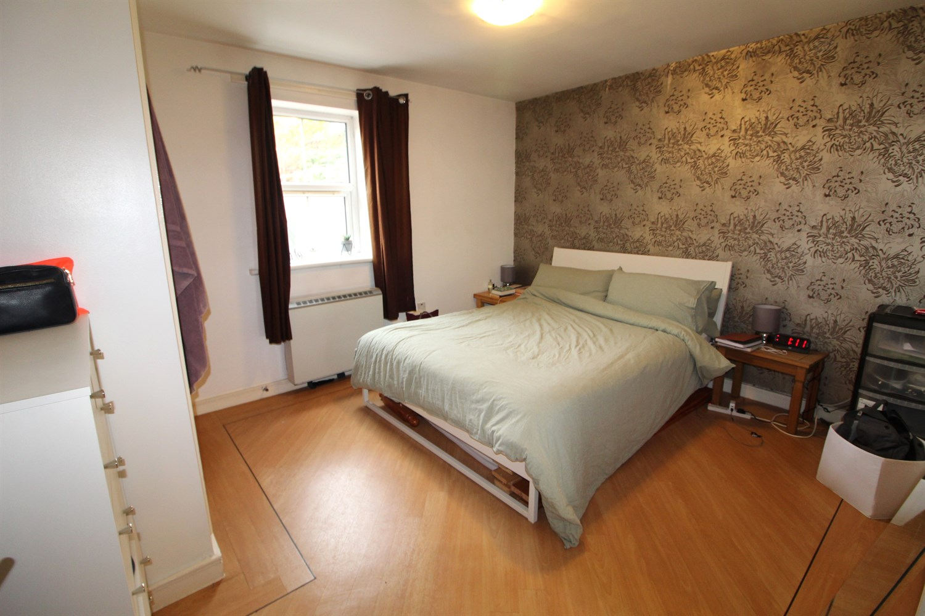

|  |
| --- |
| **Communal Hallway**  Secure communal entrance with intercom entry system. |
| **Private Hallway**  Door from the communal hallway. Storage cupboard. |
| **Lounge**  Light and airy open plan living space with uPVC double glazed window and uPVC double glazed double doors leading to Juliette balcony. Wall mounted electric heater. |
| **Breakfast Kitchen**  Fitted with a range of wall, base and drawer units with worktops over. Integrated electric oven, fridge and freezer. 4-ring hob with extractor hood above. Space for washing machine and dishwasher. Part tiled walls. Breakfast bar. |
| **Bedroom One 3.95m (13') x 3.35m (11')**  Double bedroom with built in wardrobes. uPVC double glazed window. Wall mounted electric heater. |
| **En-Suite Shower Room**  Fitted with a three piece suite comprising; shower cubicle, WC and wash hand basin. |
| **Bedroom Two 3.35m (11') x 2.7m (8'10)**  Second bedroom with uPVC double glazed window. Wall mounted electric radiator. |
| **House Bathroom**  Fitted with a three piece white suite comprising; bath, washbasin and WC. Shower cubicle. Tiled walls and floor. Heated towel rail. |
| **Tenure**  Leasehold - 103 years remaining |
| **Service Charge**  £325.00 per quarter. |

|  |  |
| --- | --- |
| These particulars are intended to give a fair description of the property, but their accuracy cannot be guaranteed, and they do not constitute an offer of contract. Intending purchasers must rely on their own inspection of the property. None of the above appliances/services have been tested by ourselves. We recommend purchasers arrange for a qualified person to check all appliances/services before legal commitment.  **Property Ref:** 4371  **For more information, please contact**  0113 258 1150 **|** [sales@adairpaxton.co.uk](mailto:sales@adairpaxton.co.uk) **|** www.adairpaxton.co.uk |  |