

**0113 258 1150**

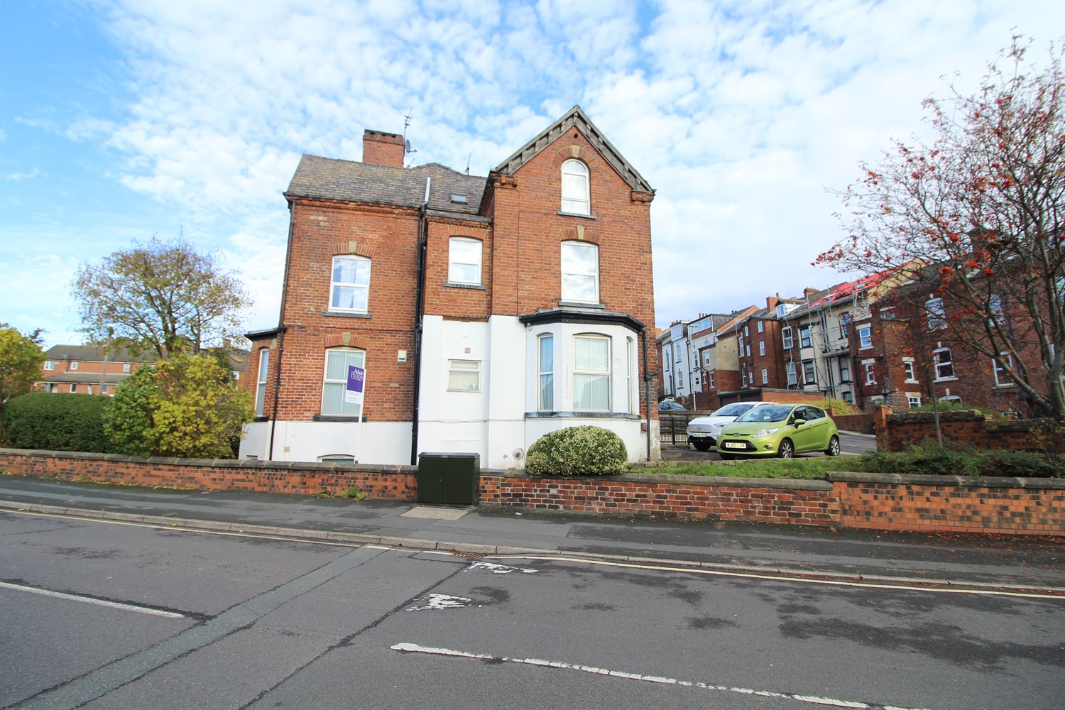



**Available to let £675.00pcm**

**Belle Vue Road, Leeds**

***GARDEN STUDIO WITH ALLOCATED PARKING SPACE***Being ideally located within walking distance of Leeds City Centre and offering compact yet very well presented accommodation is this garden studio. The accommodation briefly comprises of: Entrance Hall with storage area, living area/bedroom, kitchen with appliances, bathroom with shower over bath, one allocated parking space. Gas central heating and uPVC double glazing.   
  
FURNISHED. Council tax band A,EPC Rating D, Deposit £775. Available Now.

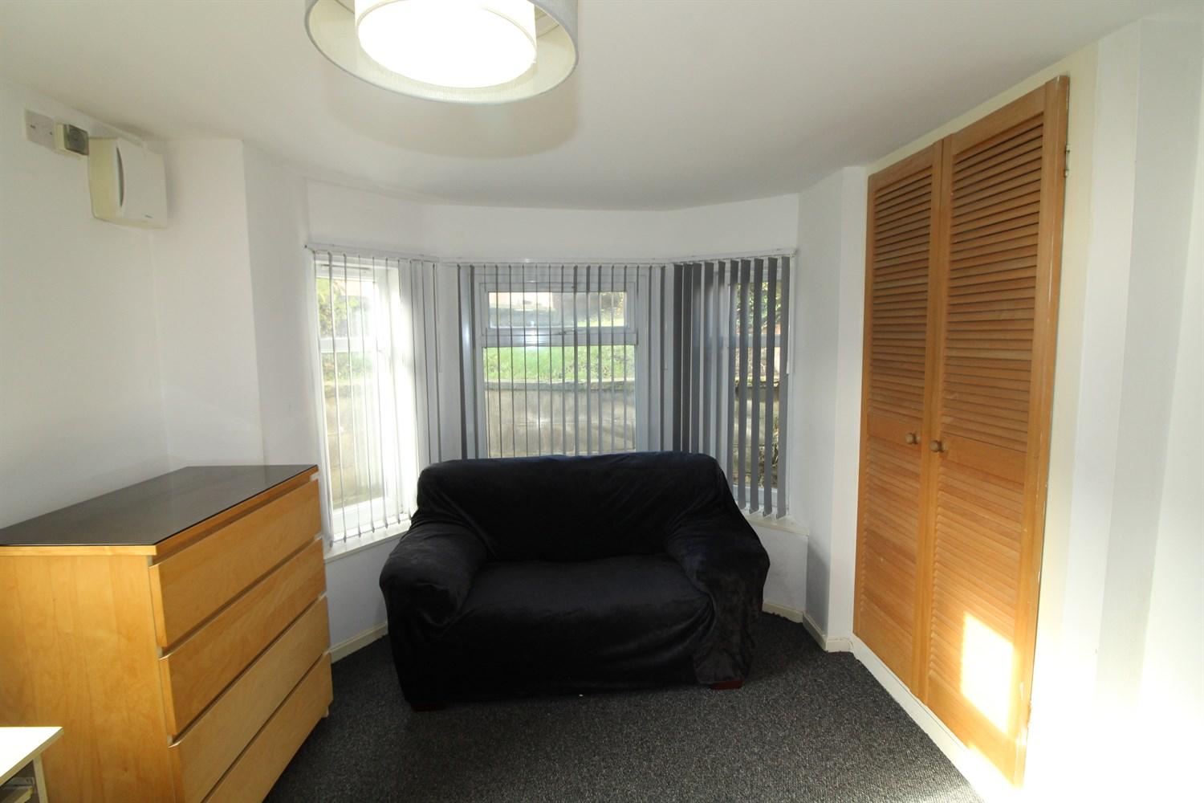

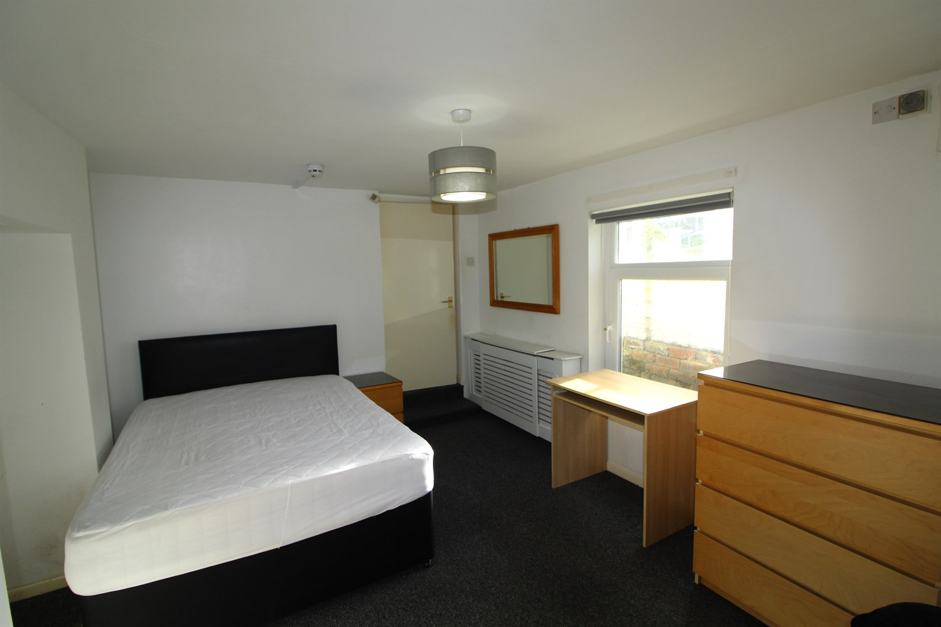

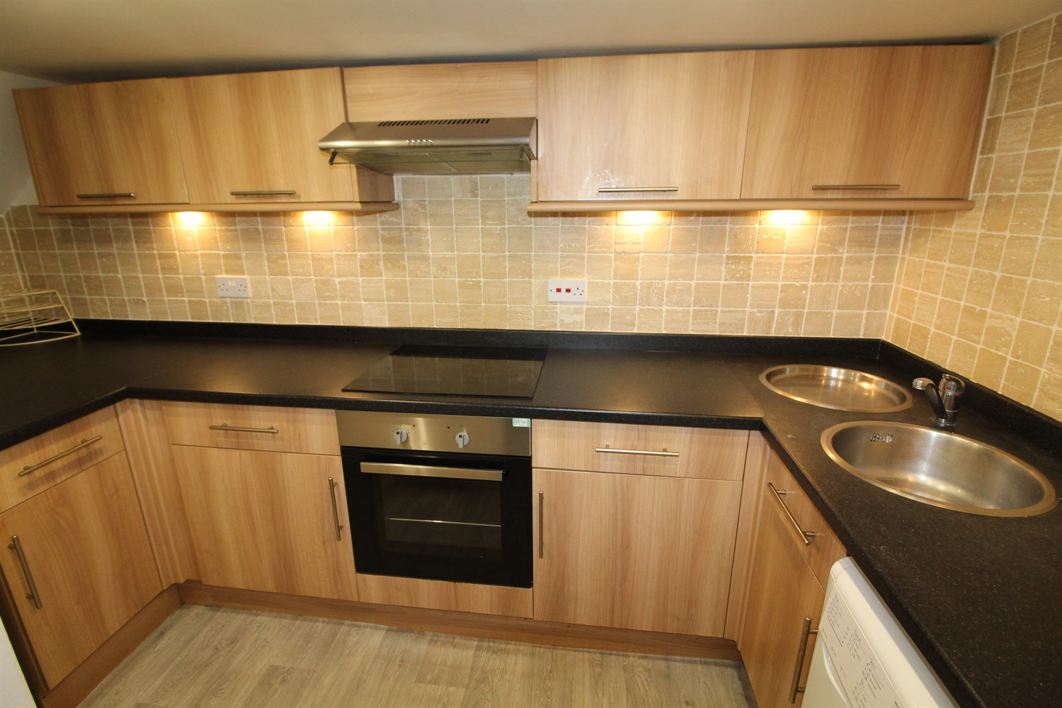

1 Bathroom(s)

1 Reception(s)

0 Bedroom(s)

00

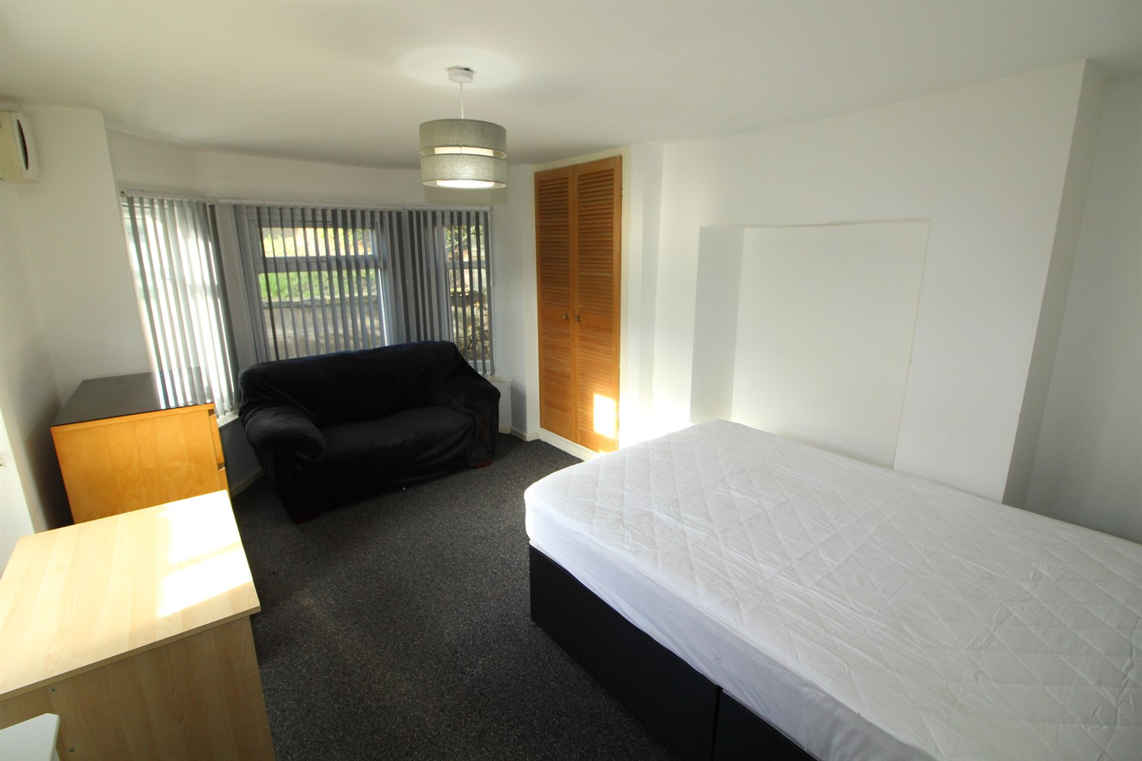

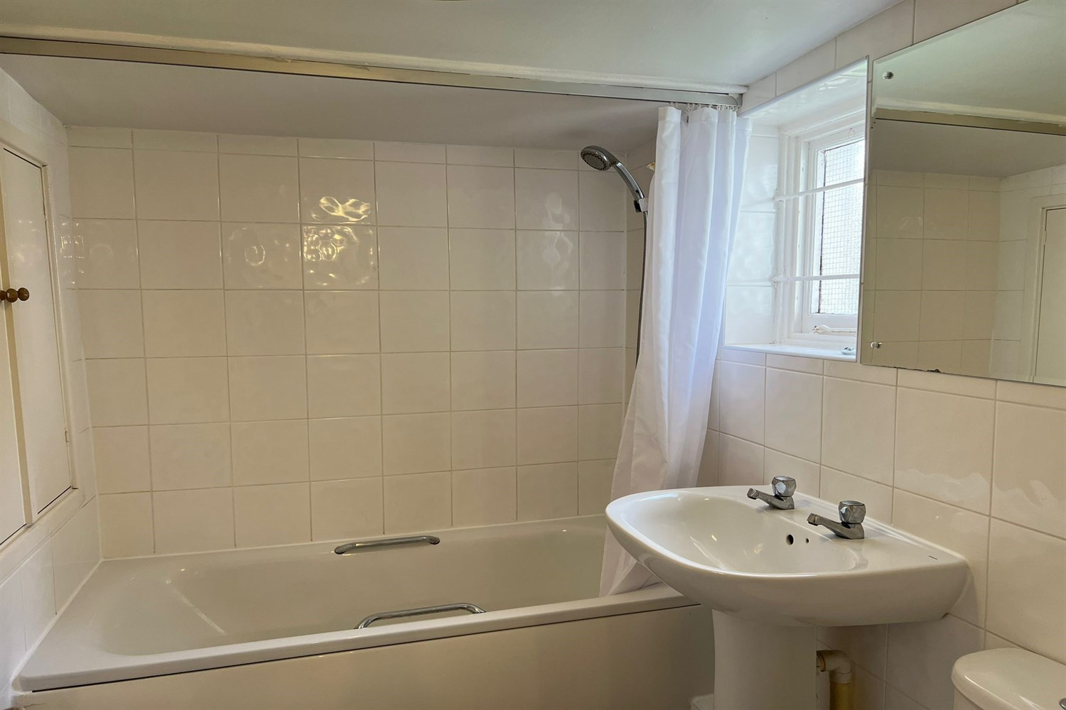

|  |
| --- |
| **Bedroom/living room**  Light and airy living area. Two double glazed windows. Wall mounted electric heater. Double bed. Built in cupboard. |
| **Kitchen**  Modern kitchen fitted with a range of wall and base units with worktops over. Electric oven and hob built in with extractor over head, stainless steel sink with drainer and mixer tap, gas central heating radiator. |
| **Bathroom**  Three Piece white bathroom suite with shower over, w/c and hand wash basin. Tiled walls, and uPVC window double glazed window. |
| COUNCIL TAX BAND: A EPC Rating D  Leasehold property Parking Broadband: Standard 12 Mbps 1 Mbps Good Superfast 88 Mbps 20 Mbps Good Ultrafast 1000 Mbps 1000 Mbps Mobile availability: EE limited Coverage . Three limited coverage. O2 likely to have good coverage. Vodafone limited coverage.  Utilities: Water supplied on standard meters. Gas and Electric mains supplied on standard meters. |

|  |  |
| --- | --- |
| These particulars are intended to give a fair description of the property, but their accuracy cannot be guaranteed, and they do not constitute an offer of contract. Intending purchasers must rely on their own inspection of the property. None of the above appliances/services have been tested by ourselves. We recommend purchasers arrange for a qualified person to check all appliances/services before legal commitment.  **Property Ref:** 3726  **For more information, please contact**  0113 258 1150 **|** [lettings@adairpaxton.co.uk](mailto:lettings@adairpaxton.co.uk) **|** www.adairpaxton.co.uk |  |