

**Echo Central, LS9**

**Available to let £900.00pcm**

Adair Paxton are pleased to offer this superb FURNISHED TWO BED/TWO BATH FURNISHED APARTMENT WITH SECURE PARKING within the popular Echo Central One development. Only a short walk from Leeds city centre and all the amenities on offer in this vibrant city. The apartment has an allocated parking space in a secure underground car park. The accommodation on offer briefly comprises of: Hallway with utility store, spacious open plan living/dining/kitchen, two double bedrooms one with en-suite and house bathroom. Council tax band C, EPC rating C Deposit £1035. Secure Parking. Furnished. Available 3rd December.

**0113 258 1150**

**0800 000 000**

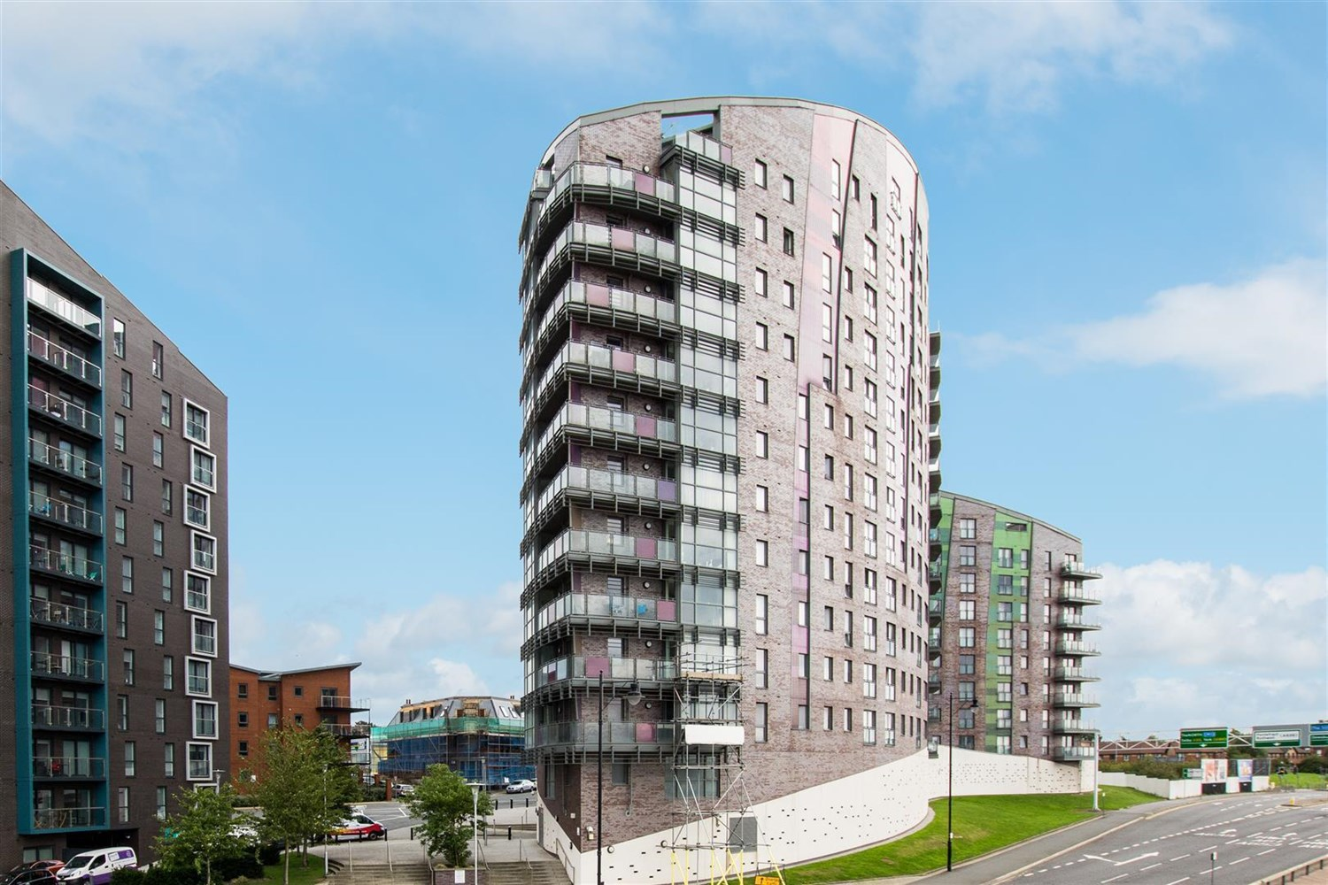



1 Reception(s)

2 Bathroom(s)

2 Bedroom(s)

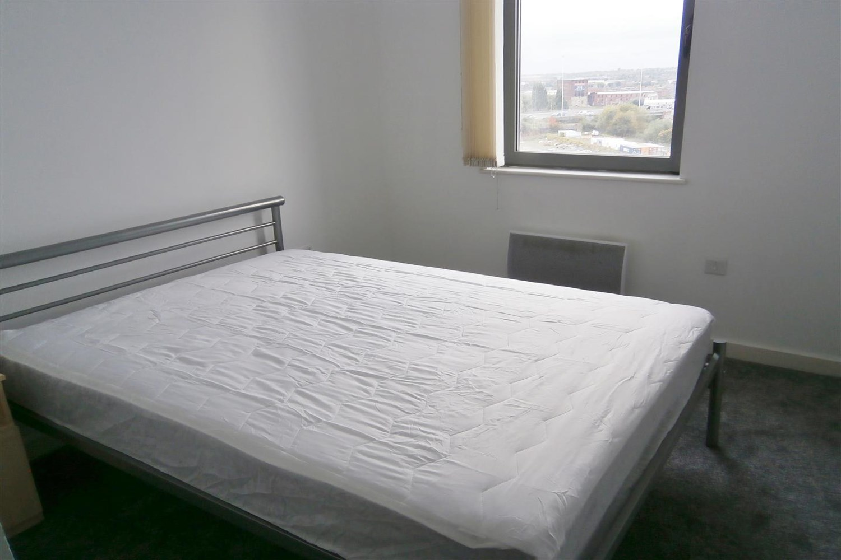

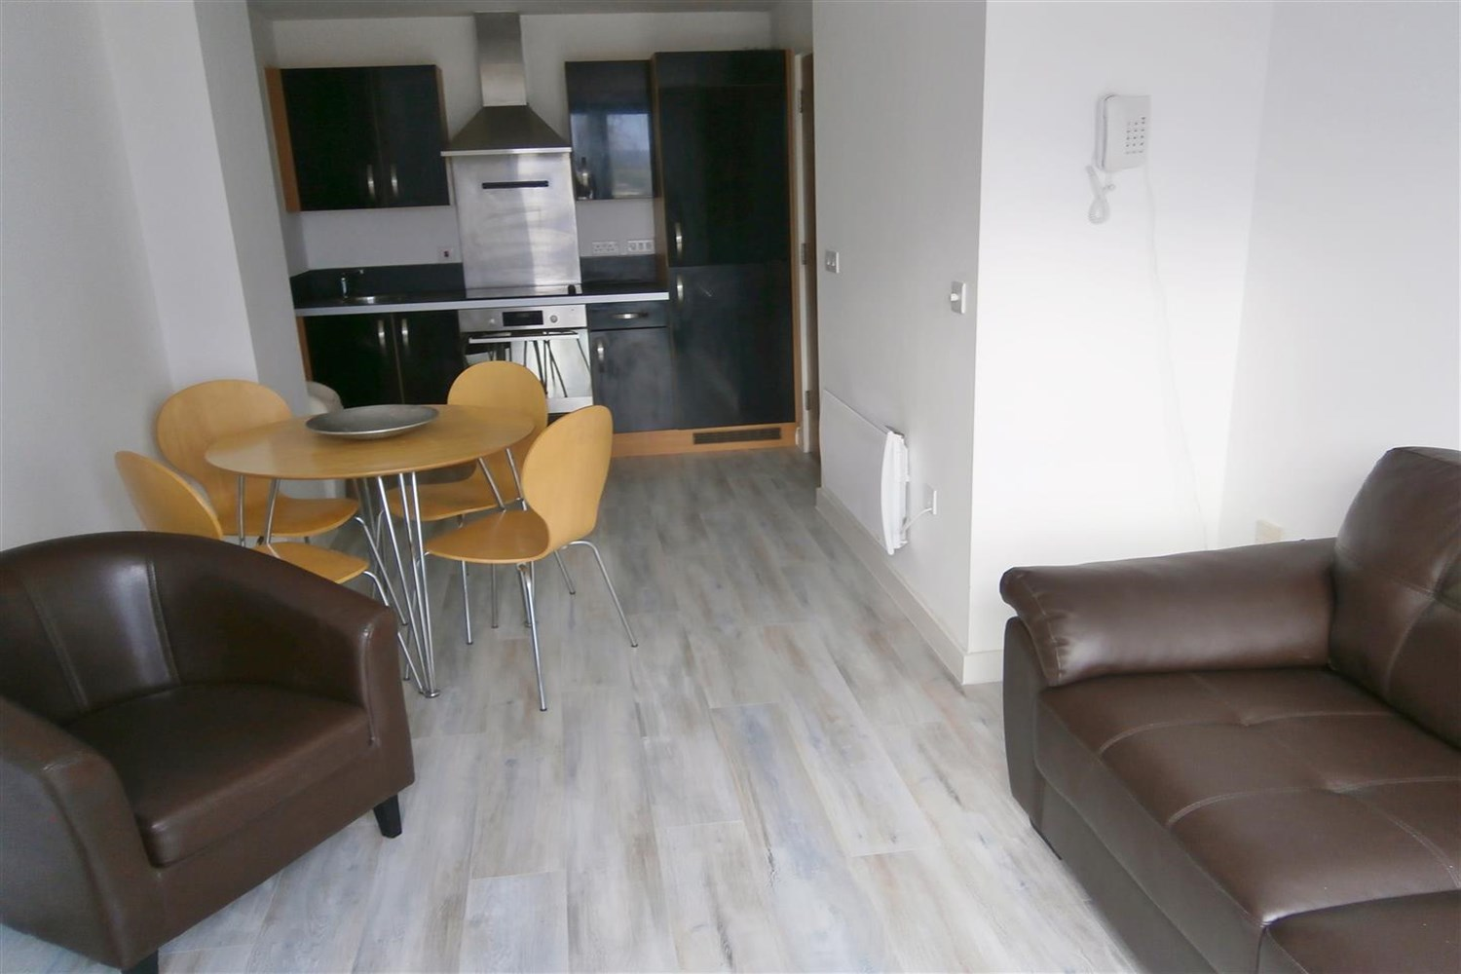

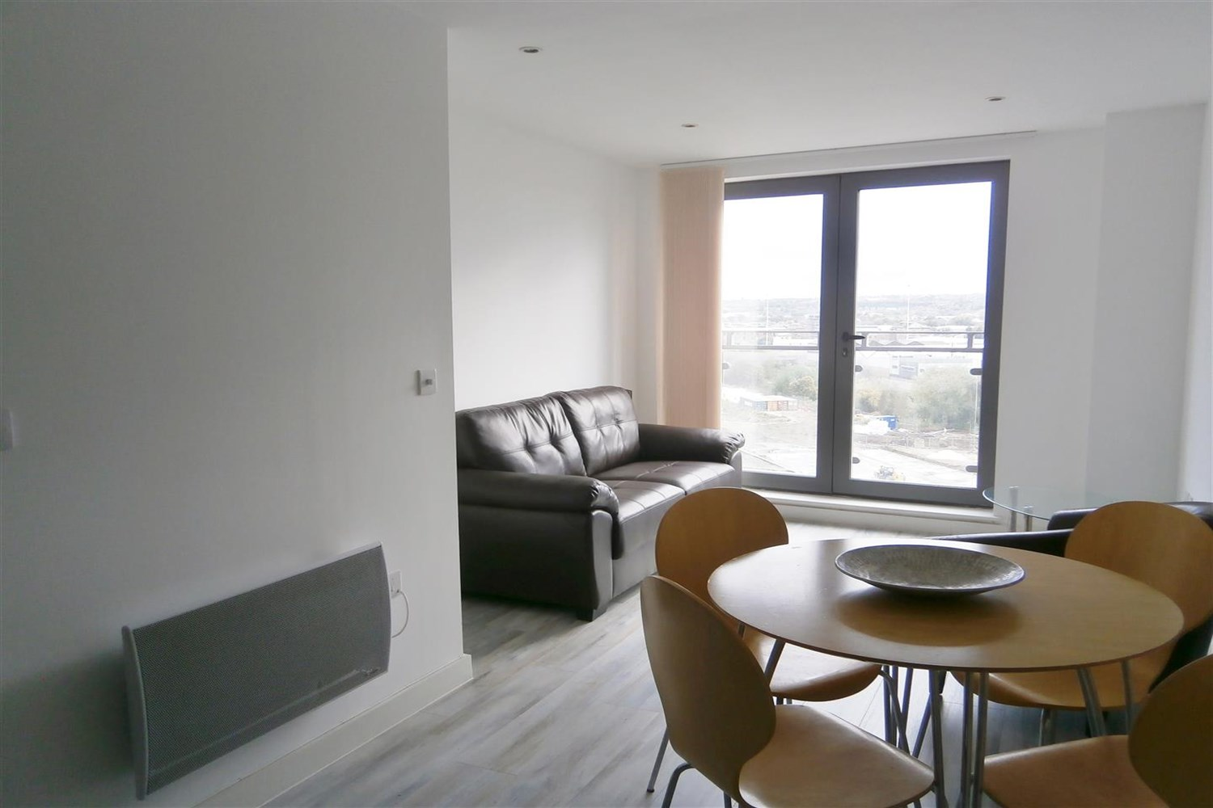

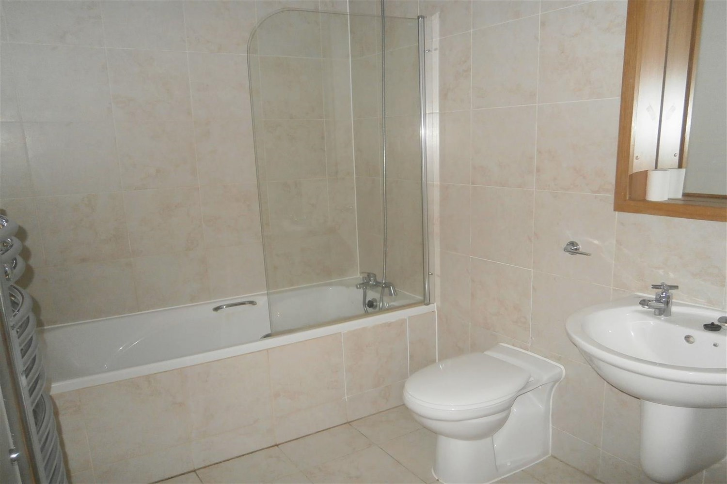

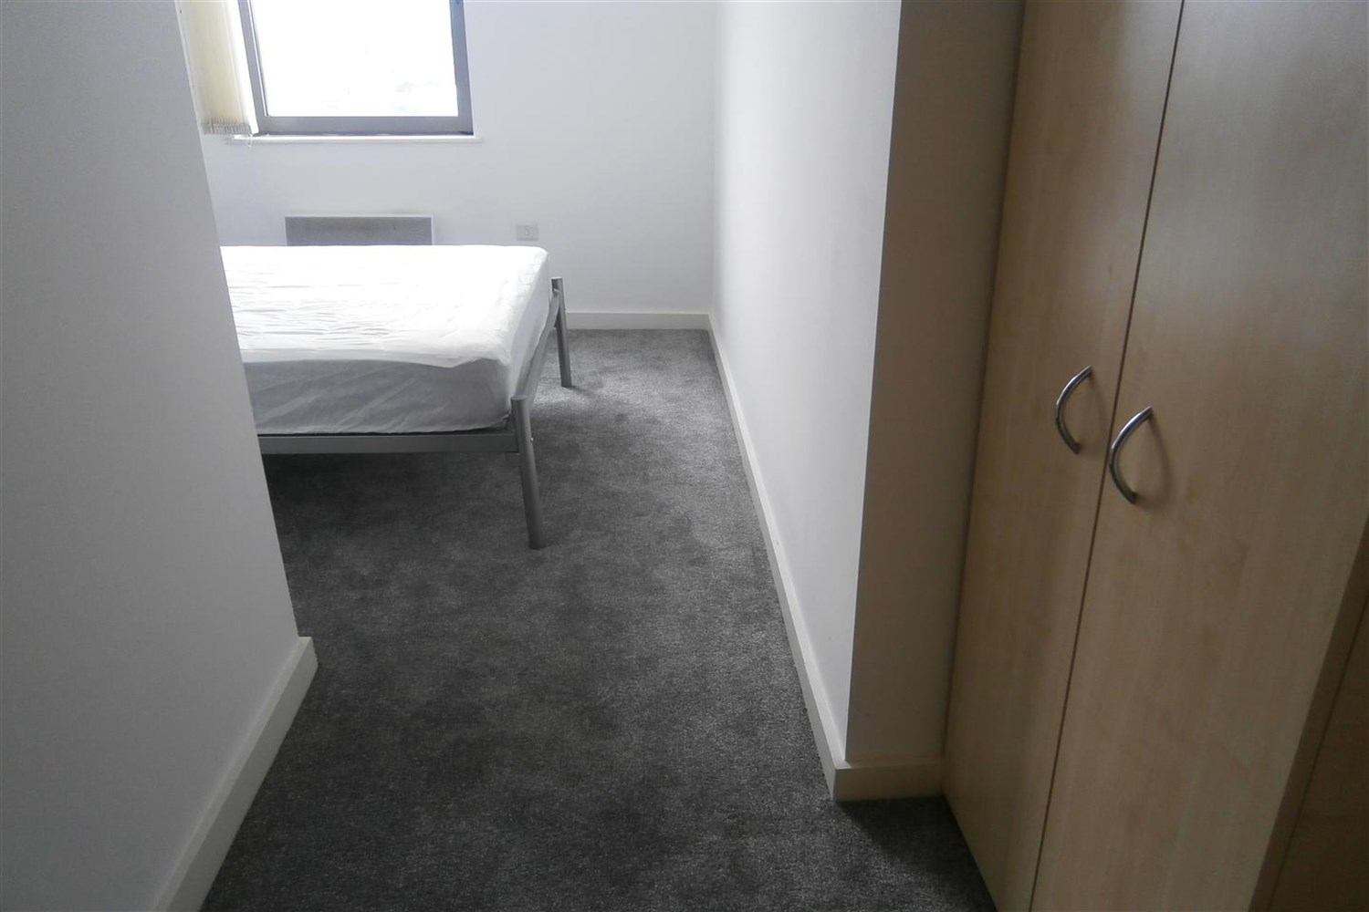

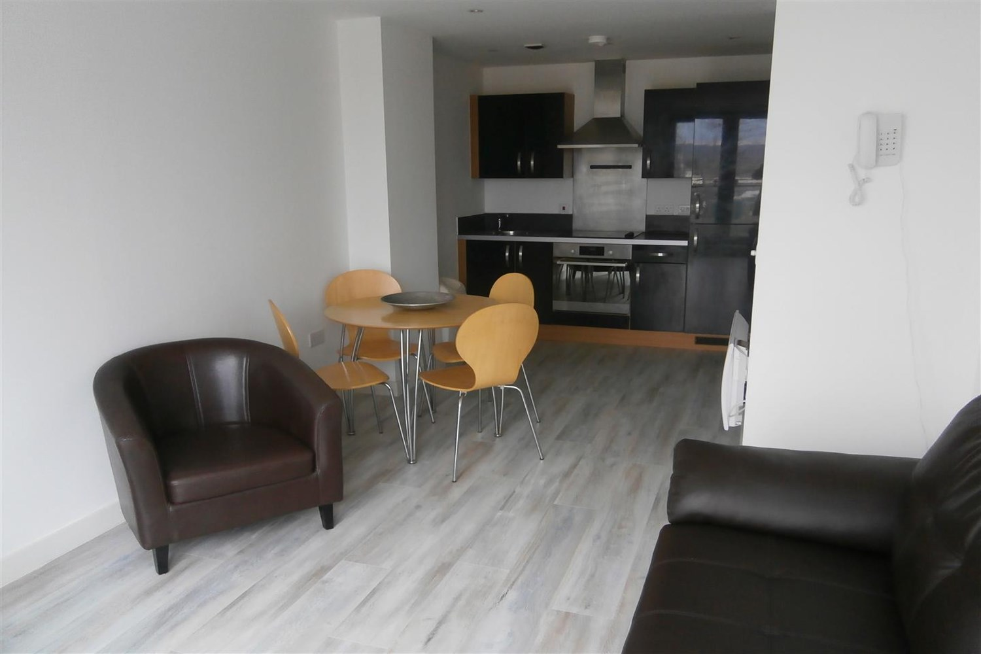

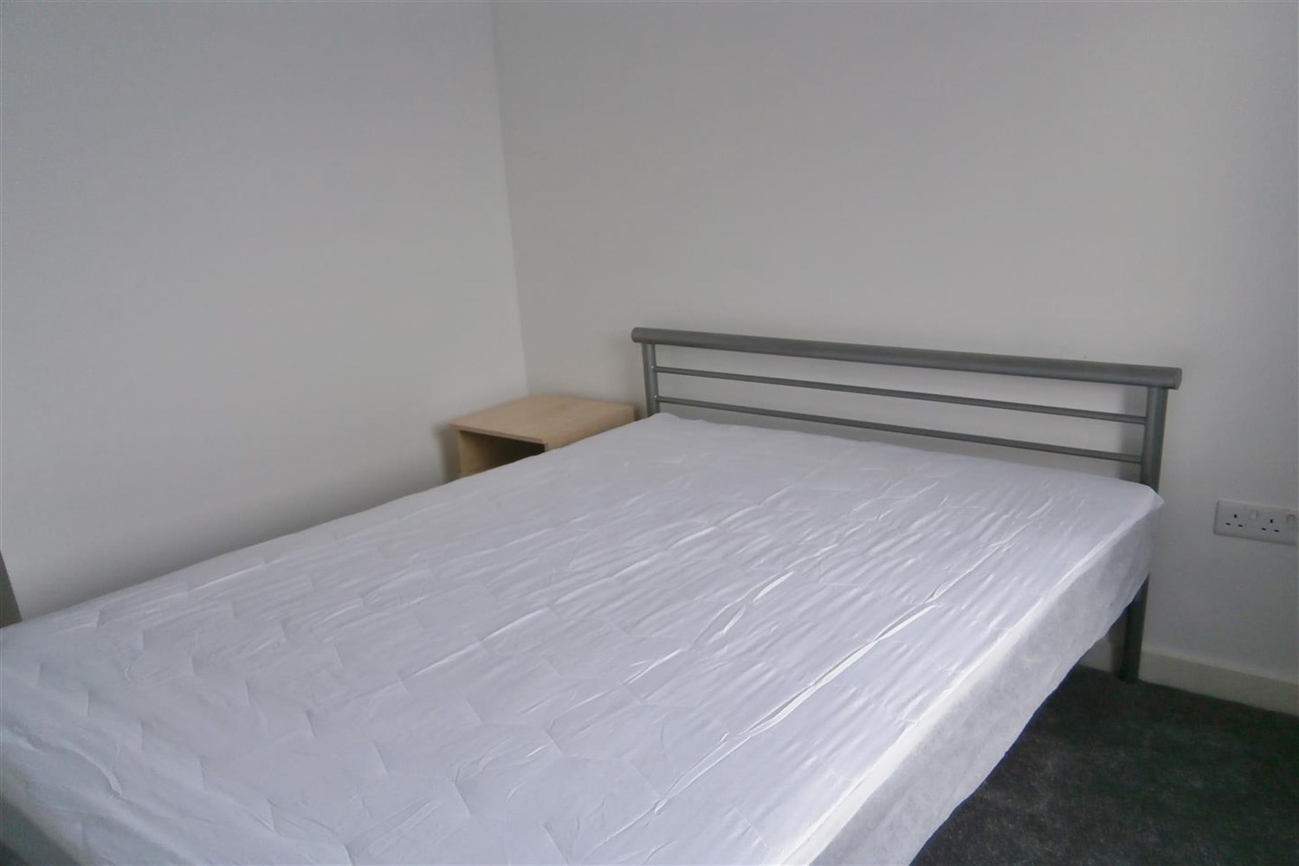

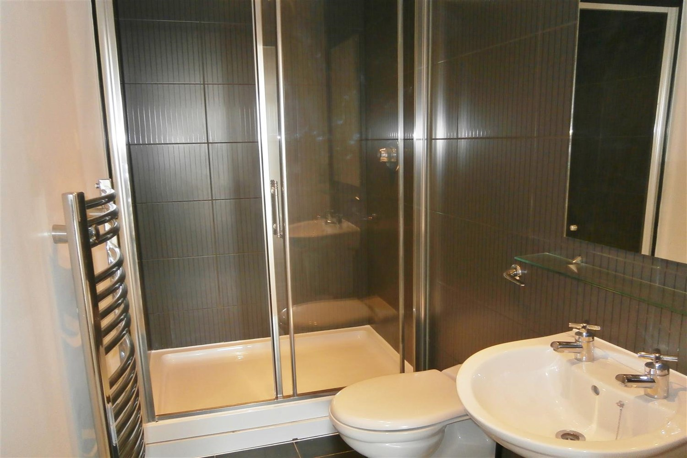

|  |
| --- |
| **Open Plan Kitchen and Living Room**  Beautiful living and kitchen area with access to a wrap around balcony, Kitchen fitted with a range of wall and base units with worktops over, stainless steel sink with tap and drainer, integrated fridge freezer. |
| **Bedroom 1**  Double bedroom with carpet, window and electric wall heater. |
| **Bedroom 2**  Double bedroom with carpet, window and electric wall heater. |
| **Bathroom 1**  Shower room with walk in shower, w/c and hand wash basin, tiled walls and floor. electric heater. |
| **Bathroom 2**  Three piece bathroom suite with bath shower over, shower screen, w/c and hand wash basin, tiled walls and floor electric heater. |
| **Parking**  Allocated parking space. |
| **Home Information**  COUNCIL TAX BAND: C EPC Rating   Leasehold property Parking Included Broadband: Standard 9 Mbps 0.9 Mbps Good Superfast 80 Mbps 20 Mbps Good Ultrafast 1000 Mbps 1000 Mbps  Mobile availability: EE Limited Three Likely to have good coverage O2 Likely to have good coverage Vodafone Likely to have good coverage.  Electric mains supply, water on mains supply. |

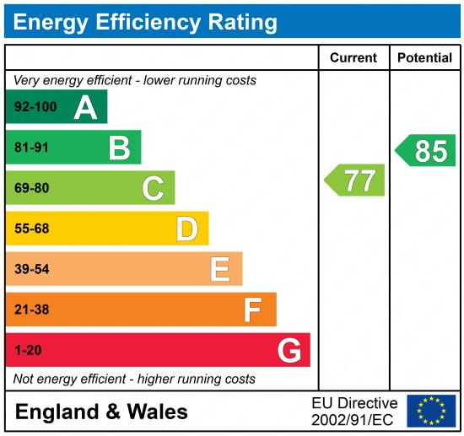

|  |
| --- |
|  |

These particulars are intended to give a fair description of the property, but their accuracy cannot be guaranteed, and they do not constitute an offer of contract. Intending purchasers must rely on their own inspection of the property. None of the above appliances/services have been tested by ourselves. We recommend purchasers arrange for a qualified person to check all appliances/services before legal commitment.

**Property Ref:** 4346

**For more information, please contact**

0113 258 1150 **|** [lettings@adairpaxton.co.uk](mailto:lettings@adairpaxton.co.uk) **|** www.adairpaxton.co.uk