

**402 Echo Central 2, Leeds**

**Available to let £995.00pcm**

***STUNNING TWO BED APARTMENT WITH WRAP AROUND BALCONY AND SECURE PARKING*** in this popular development with stylish interior, a short walk to all the amenities Leeds City Centre has to offer and handy for the motorway network. Comprising; Hallway, Open plan Lounge/Kitchen/Diner, Two Double Bedrooms and House Bathroom, secure underground parking, Council Tax Band C. EPC rating Deposit £1145. Available 30th December 2024.

**0113 258 1150**

**0800 000 000**

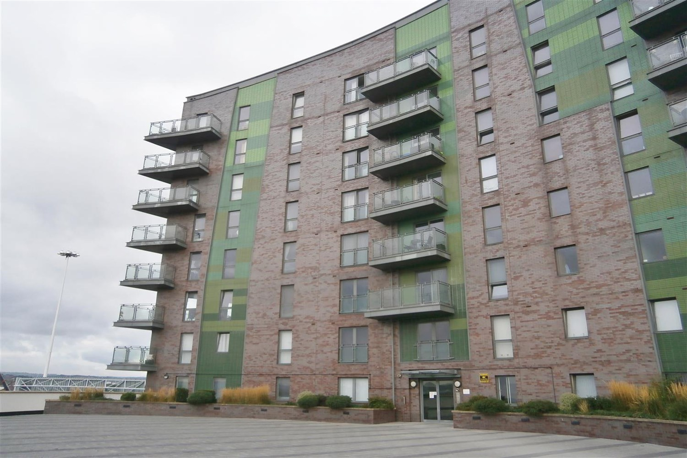



1 Reception(s)

1 Bathroom(s)

0 Bedroom(s)

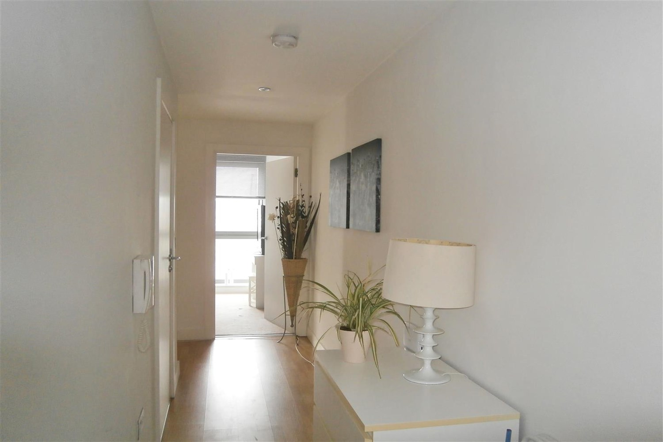

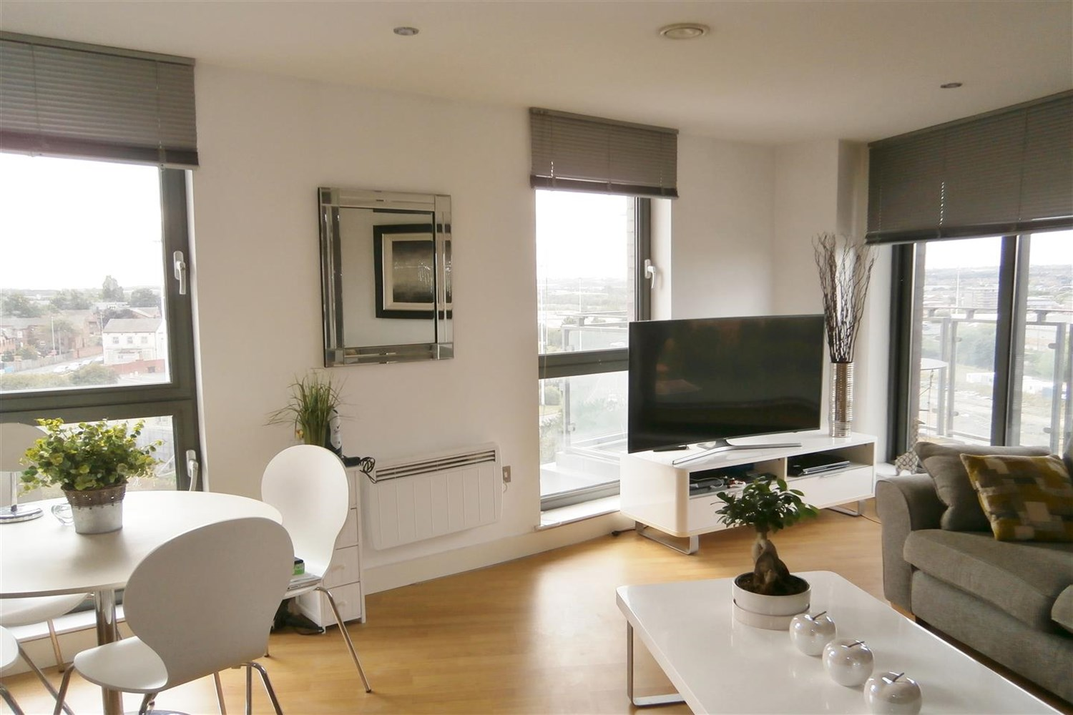

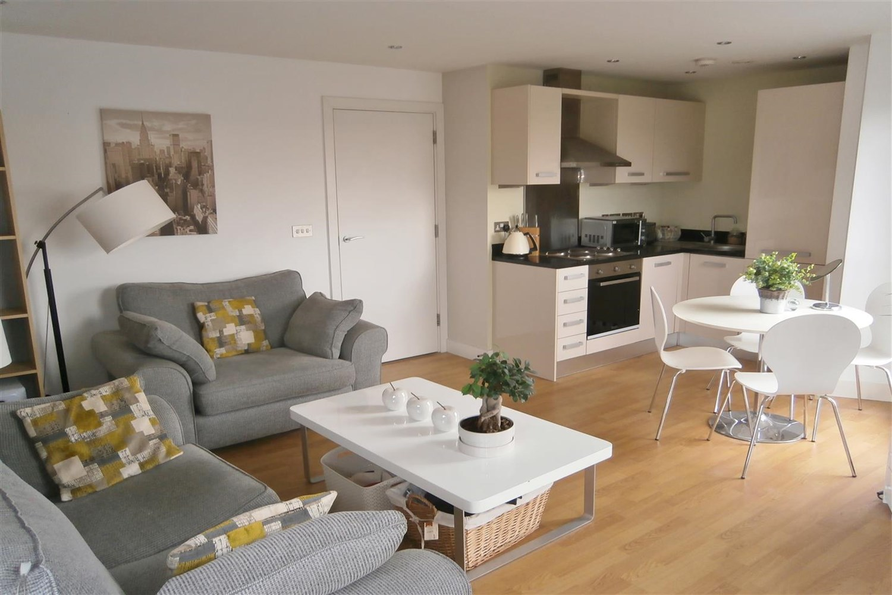

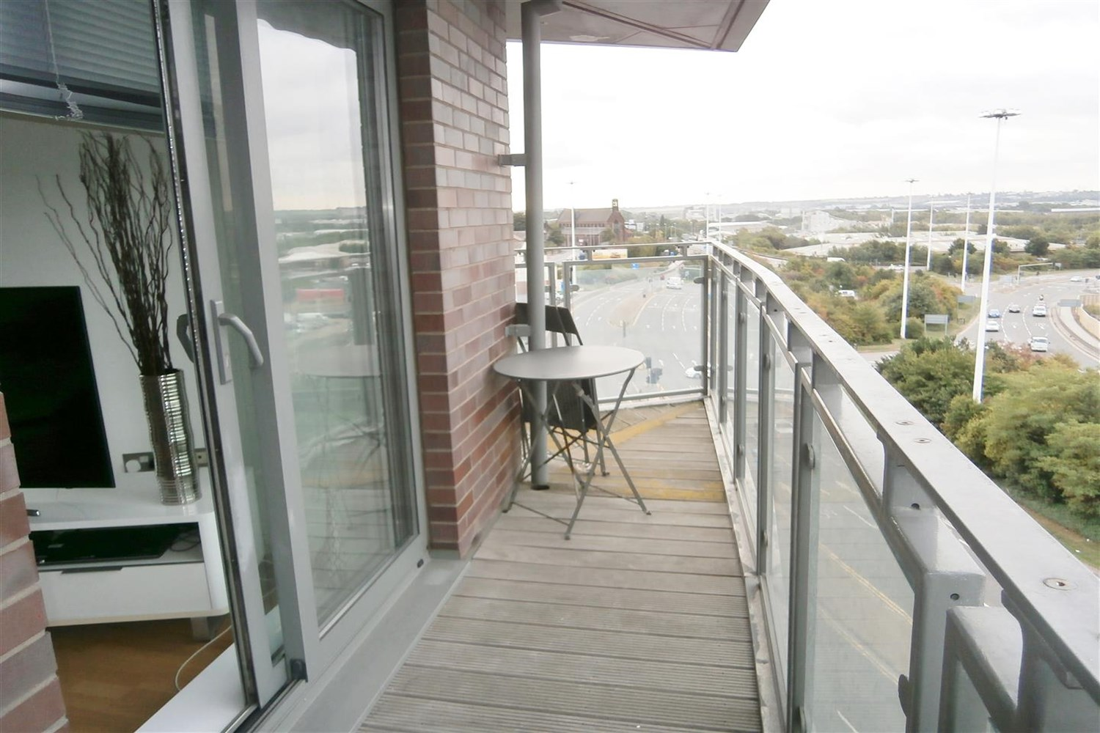

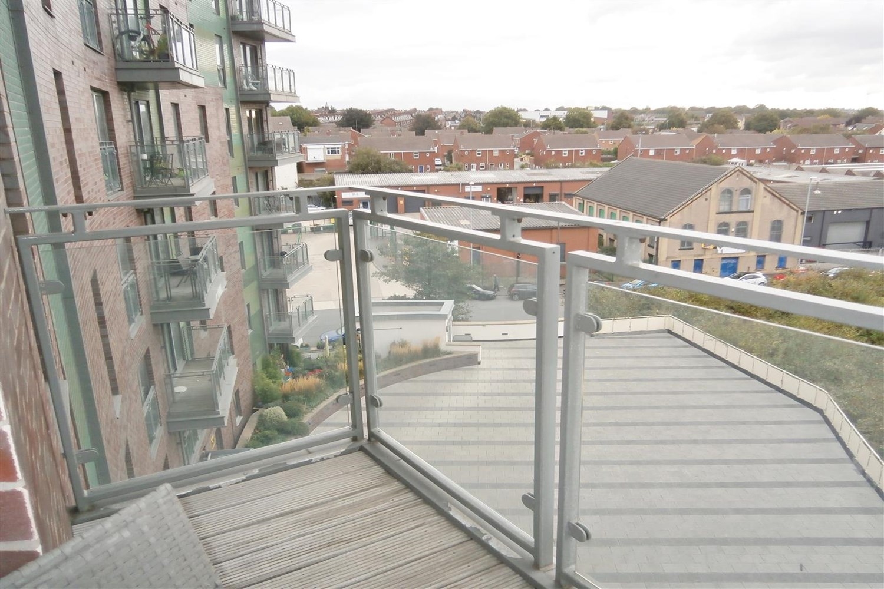

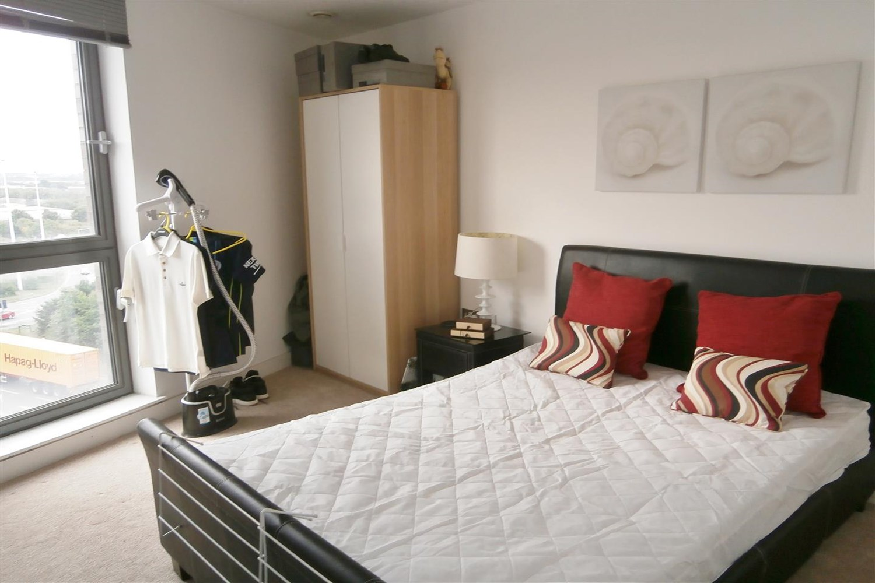

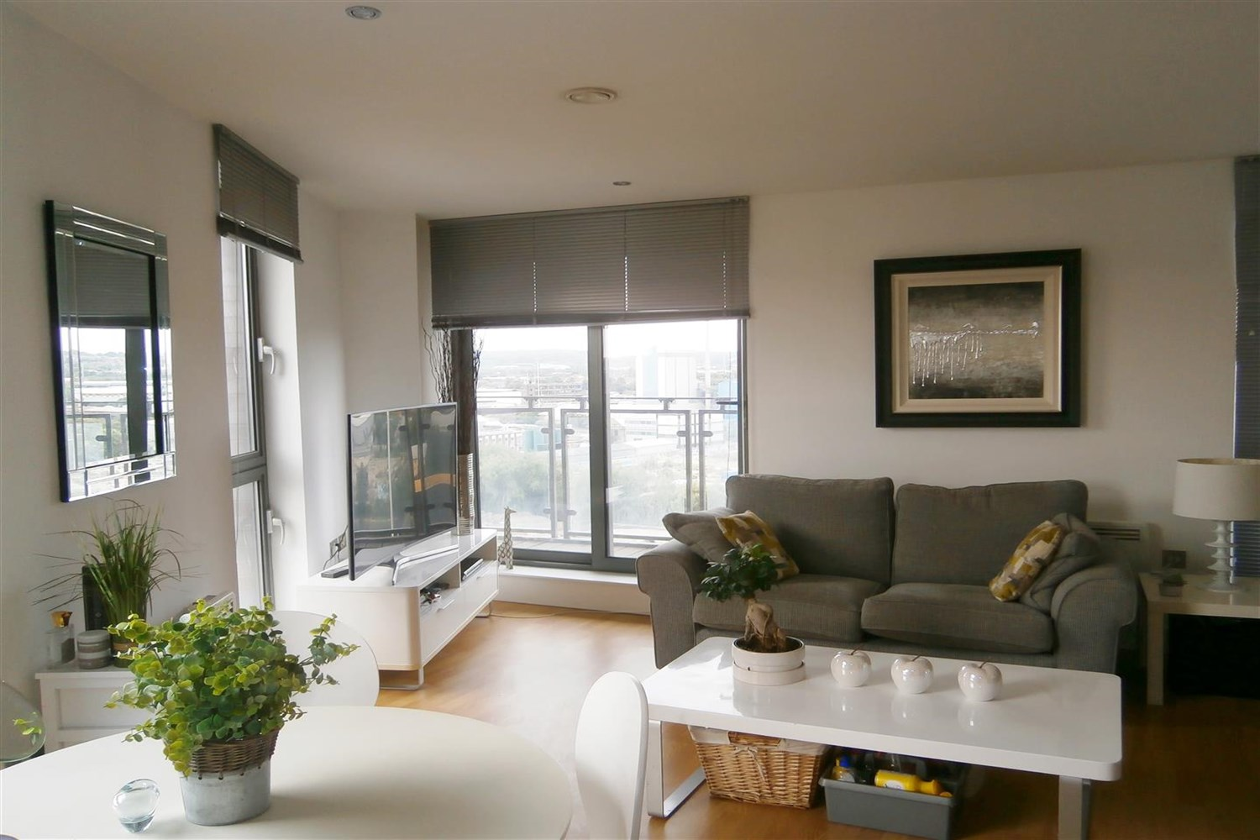

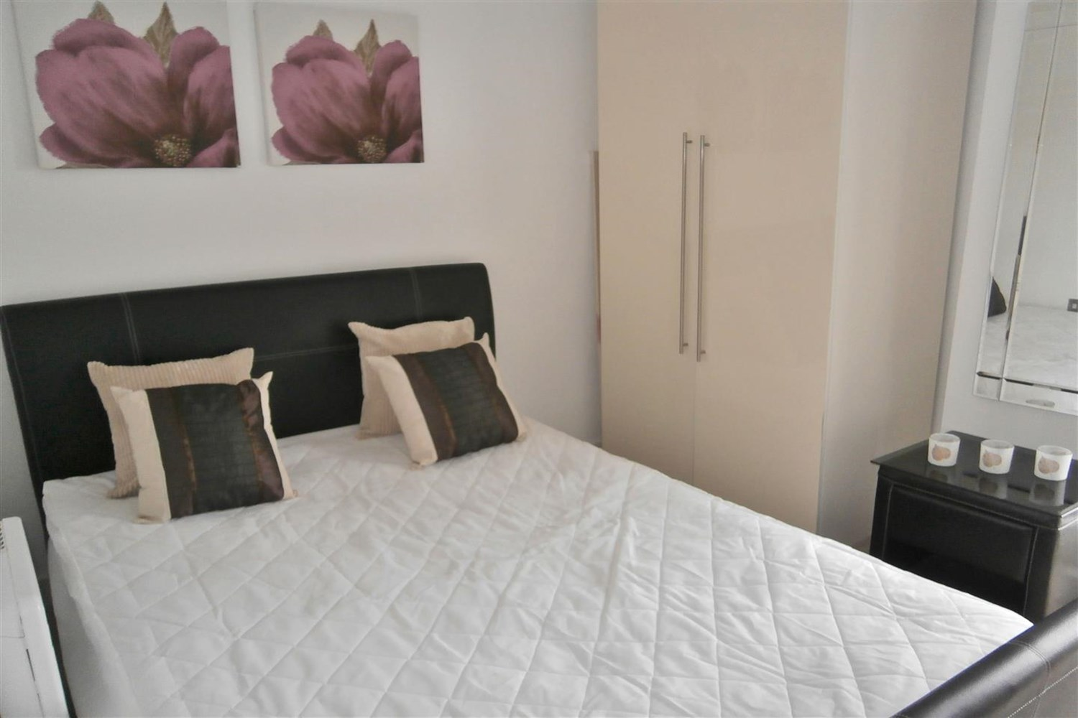

|  |
| --- |
| **Hallway**  Hallway with intercom. |
| **Open Plan Kitchen and Living Room**  Beautiful living and kitchen area with access to a wrap around balcony, Kitchen fitted with a range of wall and base units with worktops over, stainless steel sink with tap and drainer, integrated fridge freezer. |
| **Bedroom 1**  Double bedroom with carpet, window and electric wall heater. |
| **Bedroom 2**  Double bedroom with carpet, window and electric wall heater. |
| **Bathroom**  Spacious bathroom with bath and shower over, w/c and hand wash basin, tiled walls electric heater. |
| **Home Information**  COUNCIL TAX BAND: C EPC Rating C  Leasehold property Parking Included Broadband: Standard 9 Mbps 0.9 Mbps Good Superfast 80 Mbps 20 Mbps Good Ultrafast 1000 Mbps 1000 Mbps  Mobile availability: EE Limited Three Likely to have good coverage O2 Likely to have good coverage Vodafone Likely to have good coverage.  Electric mains supply, water on mains supply. |

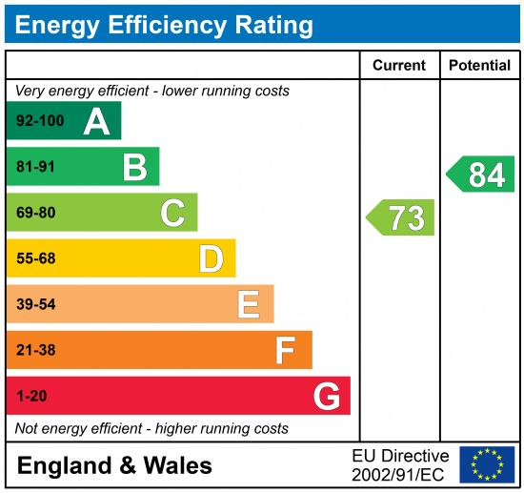

|  |
| --- |
|  |

These particulars are intended to give a fair description of the property, but their accuracy cannot be guaranteed, and they do not constitute an offer of contract. Intending purchasers must rely on their own inspection of the property. None of the above appliances/services have been tested by ourselves. We recommend purchasers arrange for a qualified person to check all appliances/services before legal commitment.

**Property Ref:** 4345

**For more information, please contact**

0113 258 1150 **|** [lettings@adairpaxton.co.uk](mailto:lettings@adairpaxton.co.uk) **|** www.adairpaxton.co.uk