

**Echo Central 2, Echo Central 2, Leeds, LS9**

**Available to let £1,200.00pcm**

TWO SECURE PARKING SPACES & LARGE OUTDOOR TERRACE - SPACIOUS TWO BED/TWO BATH DUPLEX APARTMENT - A short walk to all the amenities Leeds city centre has to offer and with great links to the motorway network. Comprising; Hallway with utility and storage cupboard, spacious master bedroom and en-suite shower room. Staircase to spacious open plan lounge/kitchen/diner with patio doors, second double bedroom, hallway leading to house bathroom with shower over bath, large outdoor terrace, two secure parking spaces. Furnished. Council tax band C. Sorry no pets. Bond £1380. Available 31st December

**0113 258 1150**

**0800 000 000**

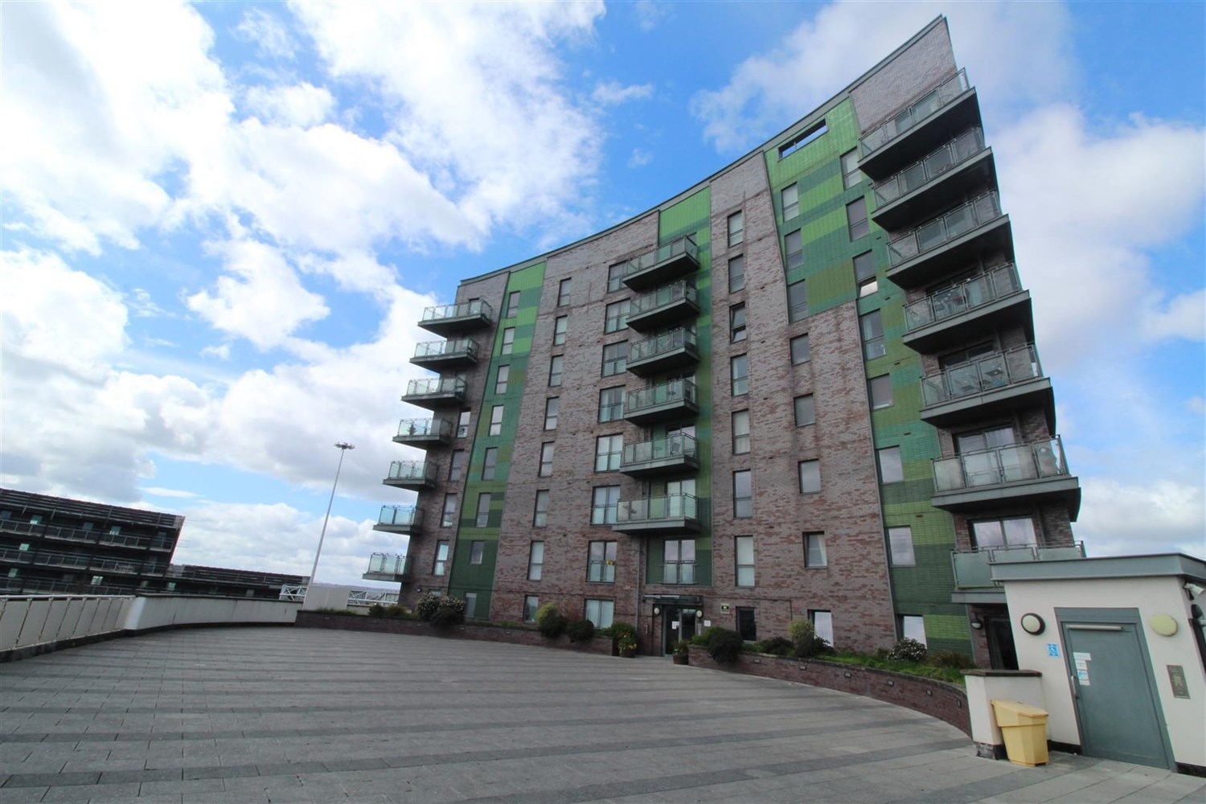



1 Reception(s)

2 Bathroom(s)

0 Bedroom(s)

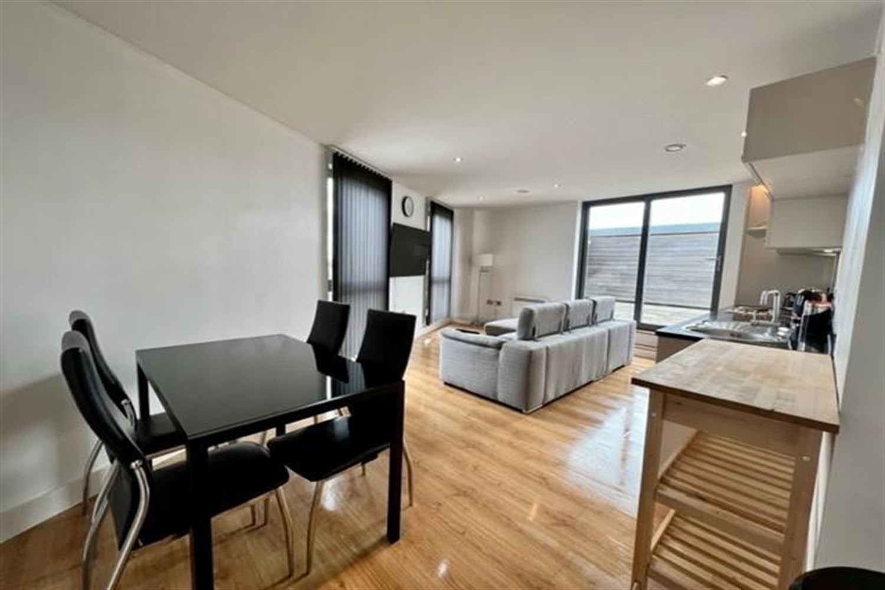

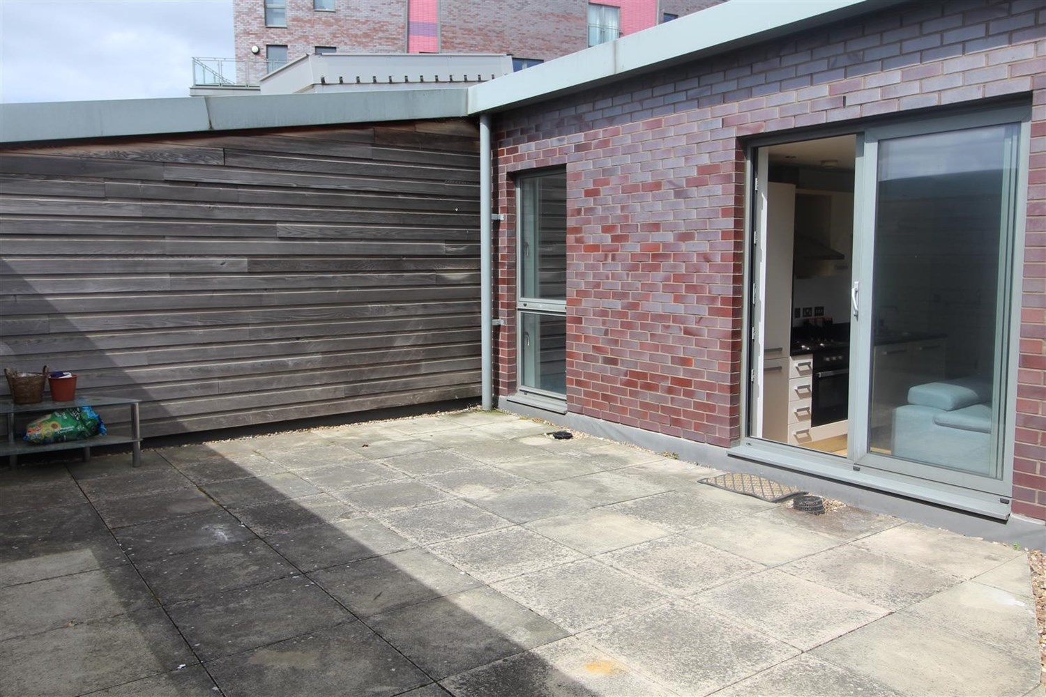

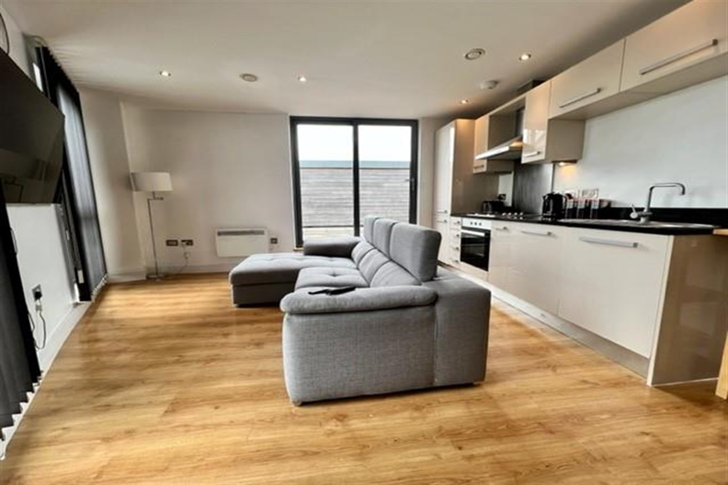

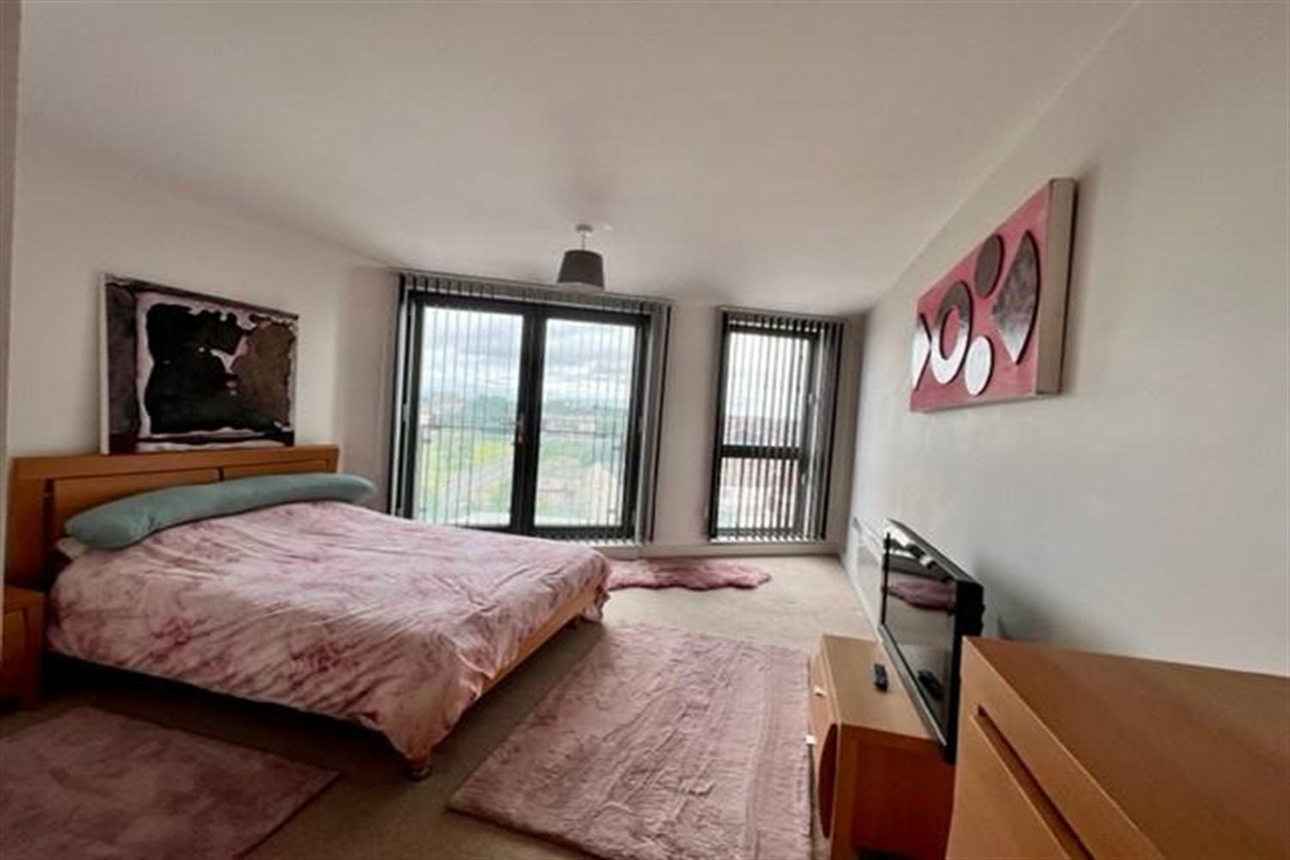

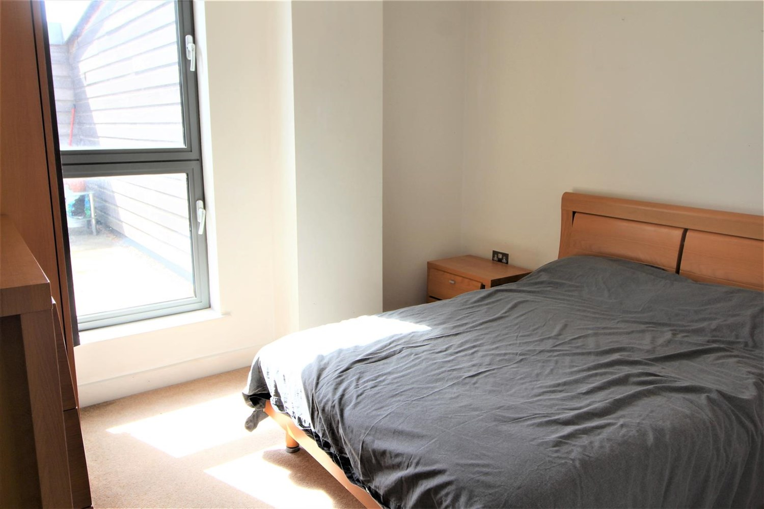

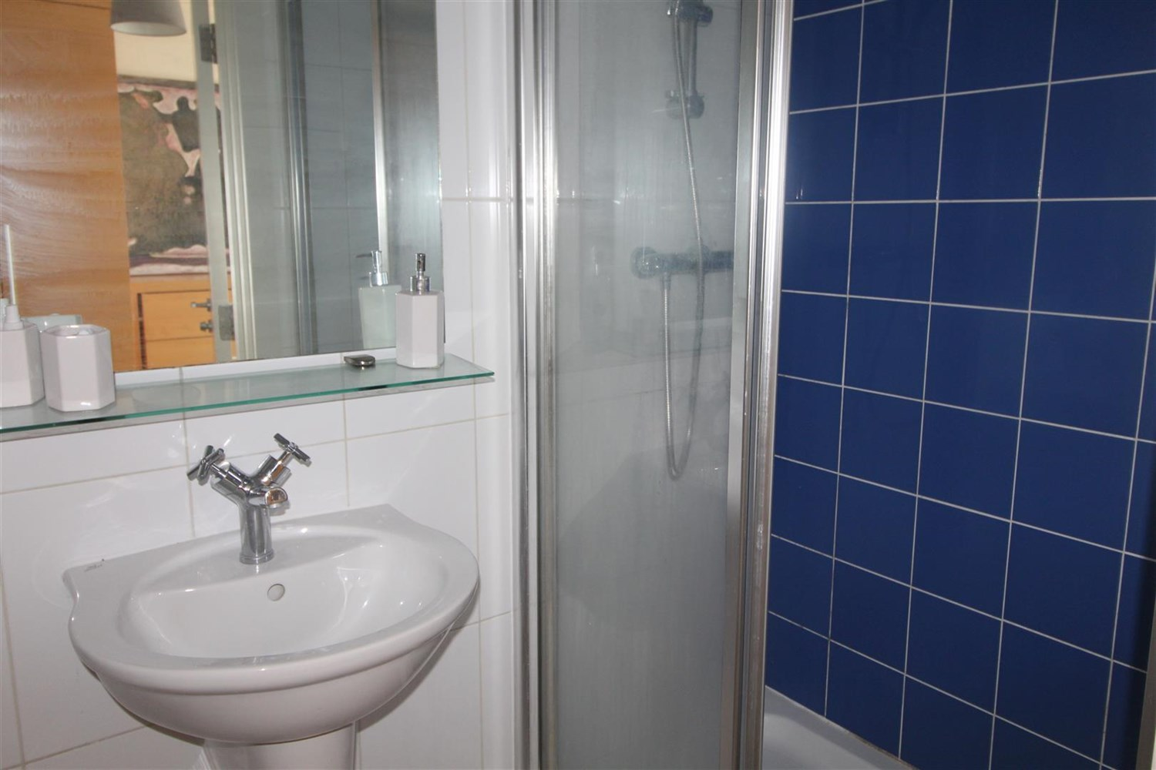

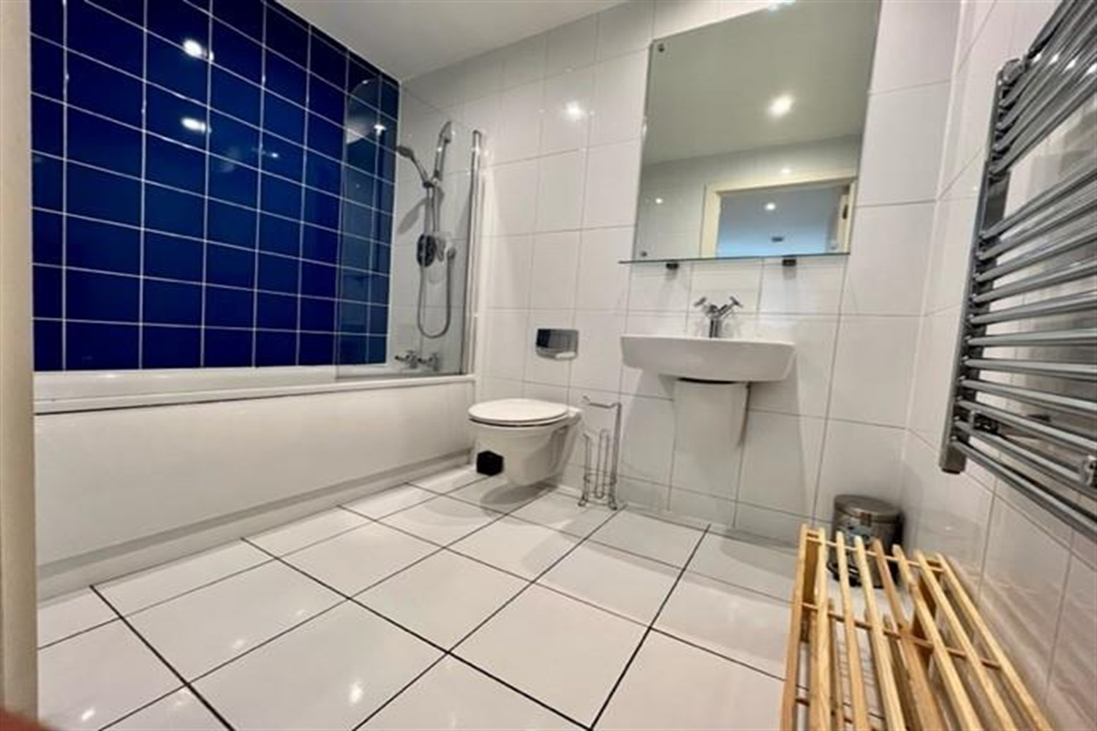

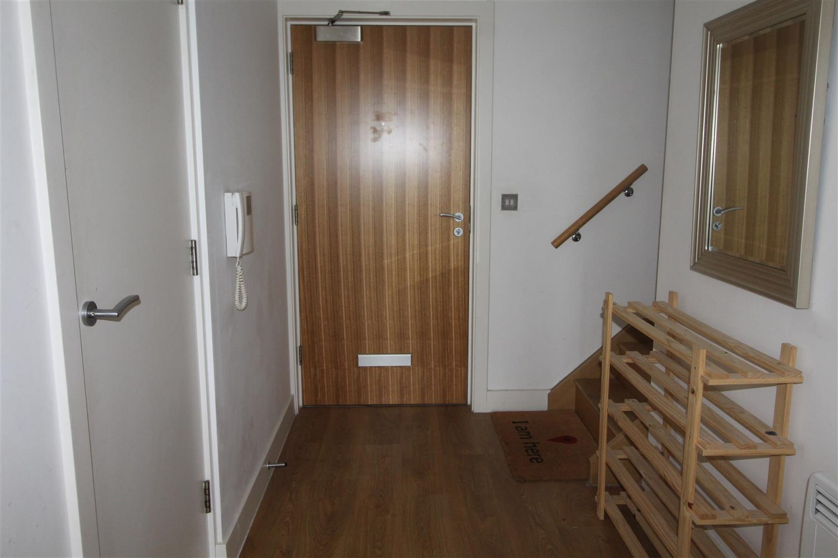

|  |
| --- |
| **Communal Entrance**  Secure intercom entry system. |
| **Private Entrance Hall**  Intercom entry system. Laminate flooring. Storage cupboard housing the boiler and washing machine. |
| **Open Plan Kitchen and Living Room**  Open plan living room/kitchen. Double glazed patio doors opening to large terrace balcony. Laminate flooring. Electric wall mounted heater. Kitchen fitted with cream high gloss wall and base units. Circular stainless steel sink. Electric oven & hob with extractor hood over. Integrated fridge/freezer. |
| **Bedroom 1**  Large bedroom with double glazed French doors opening to Juliet balcony and window. Electric heater. |
| **Ensuite**  Ensuite shower room with walk in shower. w/c and hand wash basin. Tiled walls, electric radiator. |
| **Bedroom 2**  Second double bedroom with double glazed window, electric wall heater. |
| **House Bathroom**  Three piece bathroom suite with bath and shower over, shower screen, w/c and hand wash basin. Tiled walls and floor, electric wall heater. |
| **Parking For Two Cars**  Under croft parking for two cars. |
| **Home Information**  COUNCIL TAX BAND: C EPC Rating :D  Leasehold property Two Parking Spaces   Broadband: Standard 9 Mbps 725.9 Mbps Good Superfast 8725 Mbps 2725 Mbps Good Ultrafast 1725725725 Mbps 1725725725 Mbps  Mobile availability: EE Limited Three Likely to have good coverage O2 Likely to have good coverage Vodafone Likely to have good coverage.  Electric mains supply, water on mains supply. |

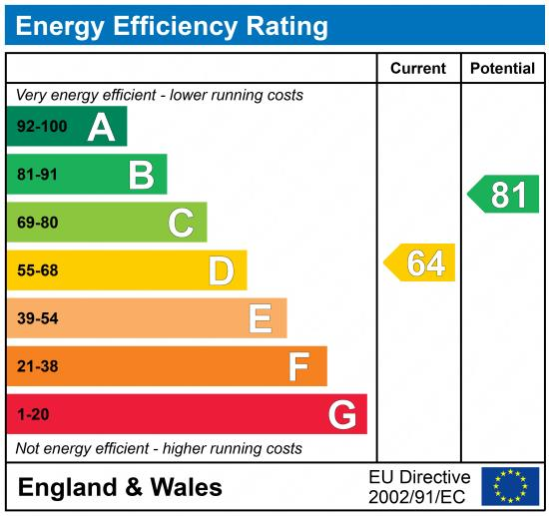

|  |
| --- |
|  |

These particulars are intended to give a fair description of the property, but their accuracy cannot be guaranteed, and they do not constitute an offer of contract. Intending purchasers must rely on their own inspection of the property. None of the above appliances/services have been tested by ourselves. We recommend purchasers arrange for a qualified person to check all appliances/services before legal commitment.

**Property Ref:** 4391

**For more information, please contact**

0113 258 1150 **|** [lettings@adairpaxton.co.uk](mailto:lettings@adairpaxton.co.uk) **|** www.adairpaxton.co.uk