

**0113 258 1150**

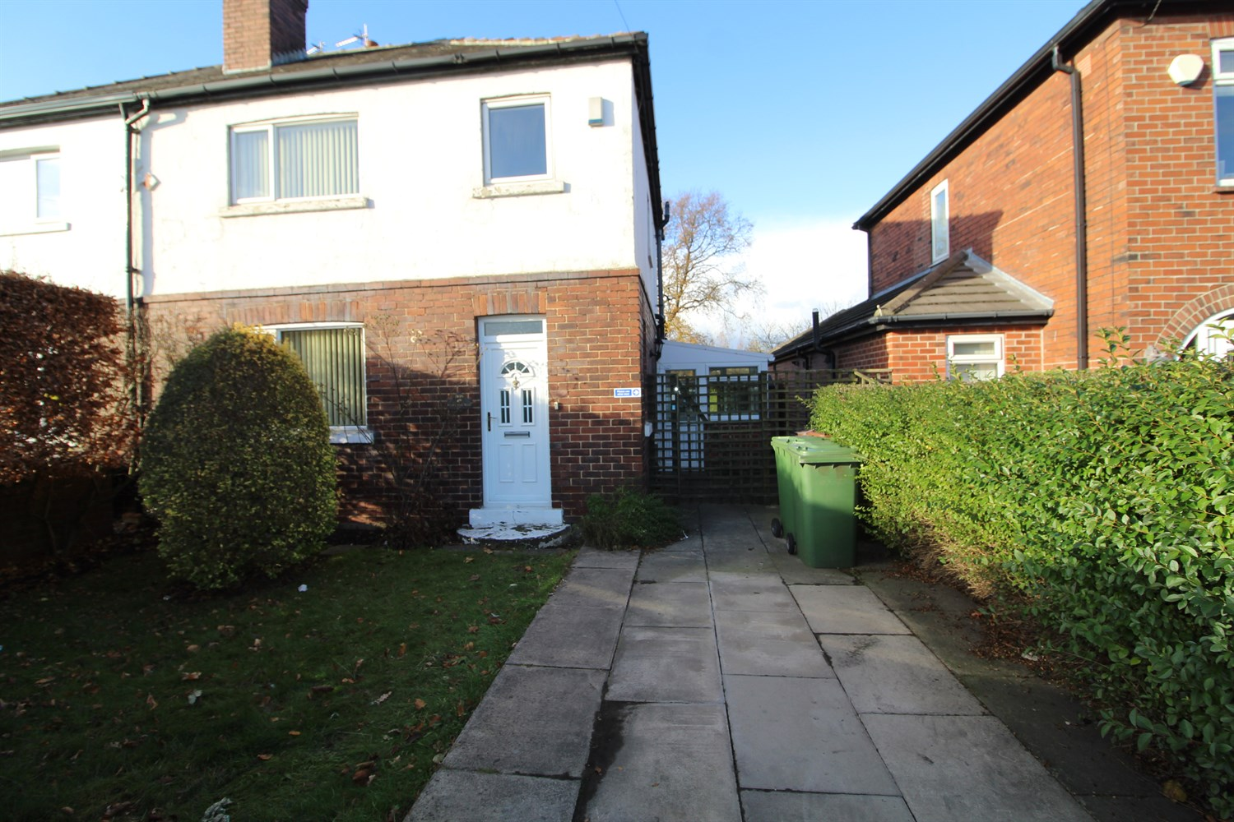



**Available to let £850.00pcm**

**Denby Dale Road, Wakefield**

* SUPERB THREE DOUBLE BEDROOM PROPERTY. Viewing is essential to fully appreciate the superb living space. Perfectly positioned for its quick access to J39 of the M1 motorway. You can find a number of useful local amenities. This would be a perfect home for families. The property comprises; Entrance hallway; Small kitchen with uPVC door leading to garden; Fitted Kitchen with freestanding electric cooker. Useful storage cupboard; Large Living Room and second reception room; Large Bedroom , second double bedroom, House bathroom. To the outside is enclosed large lawned rear garden and off street parking space to front. EPC rating , Council tax band , deposit £980. Available Now.

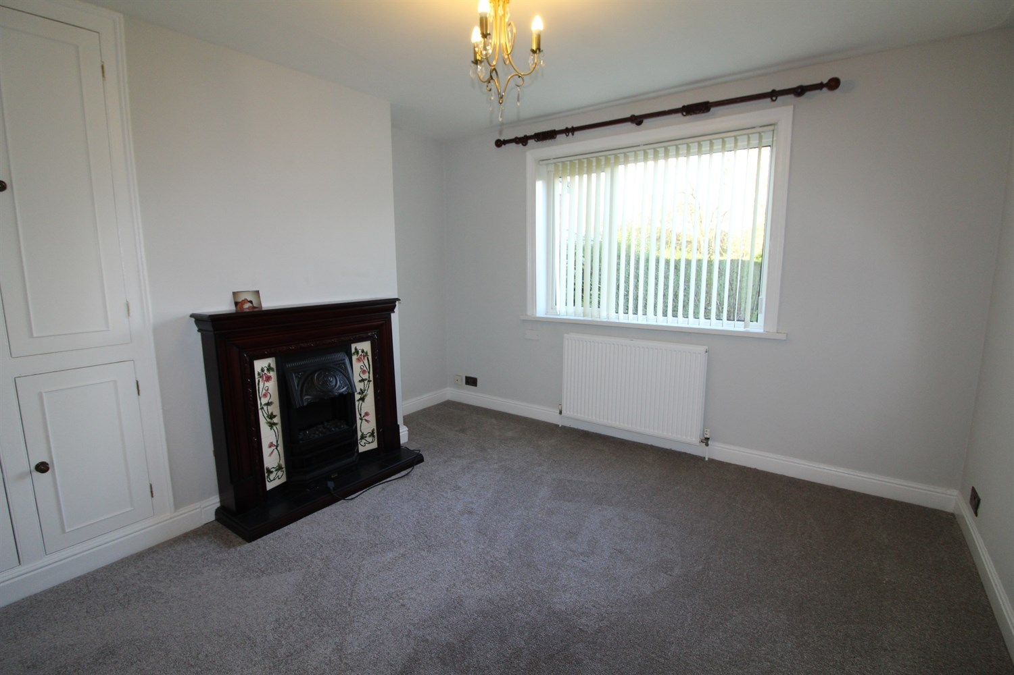

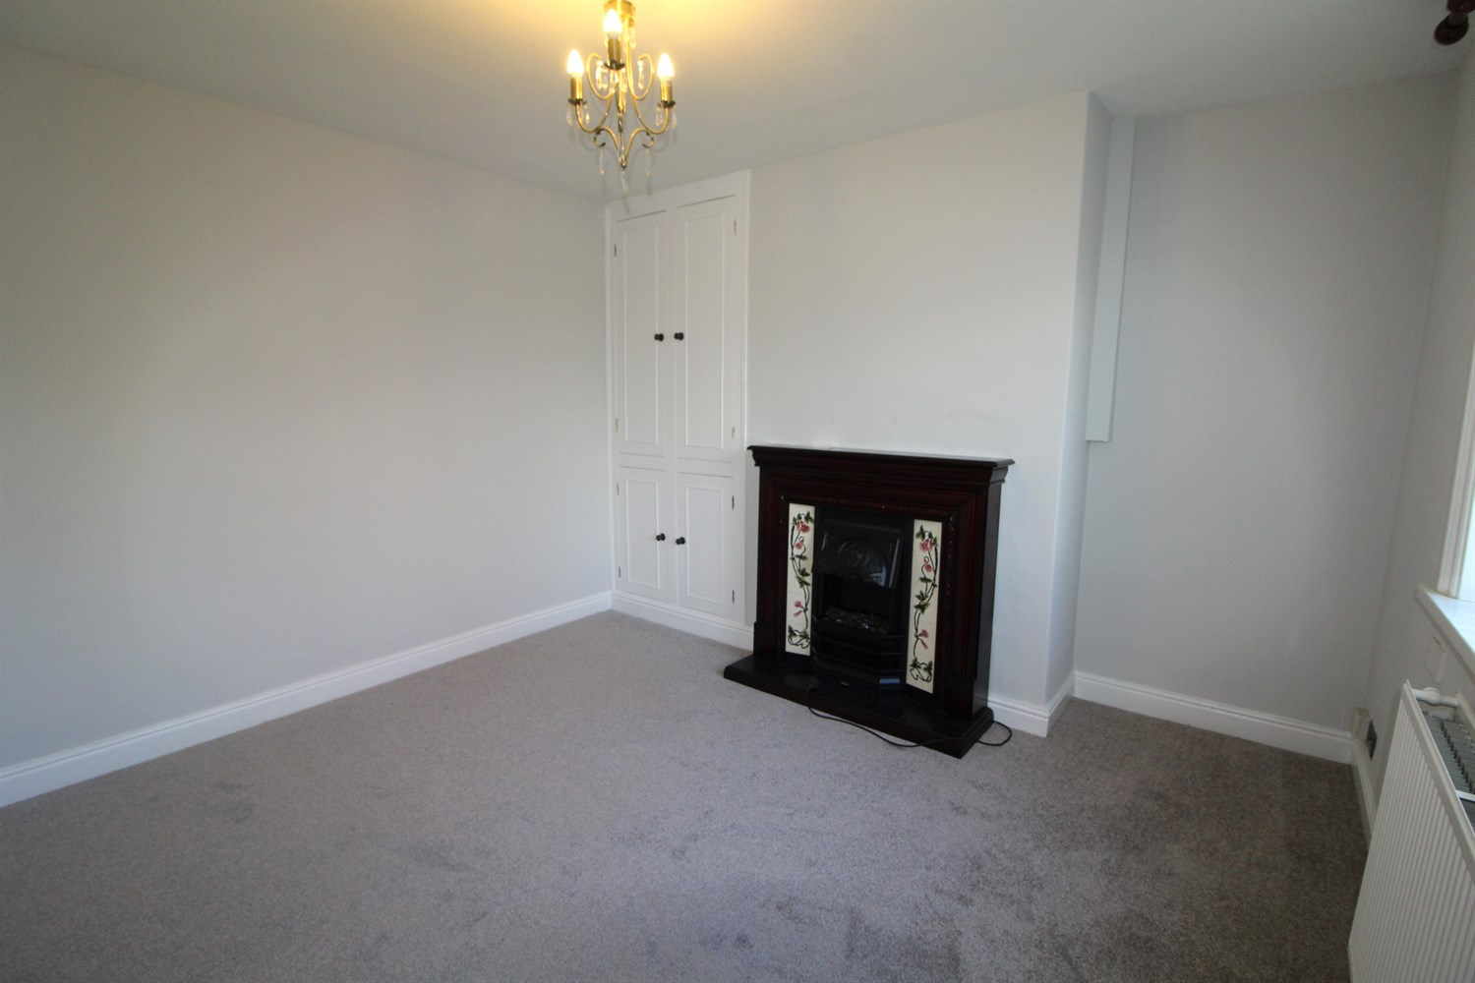

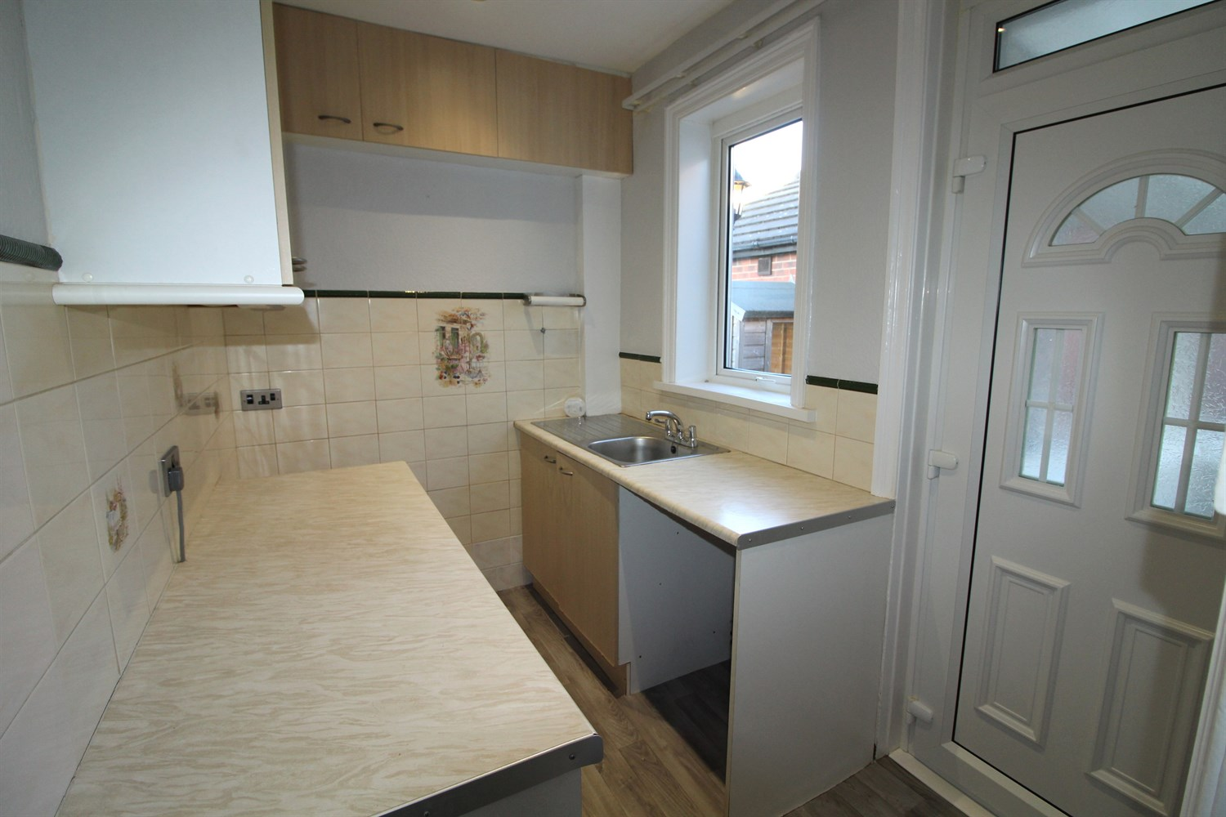

1 Bathroom(s)

2 Reception(s)

1 Bedroom(s)

00

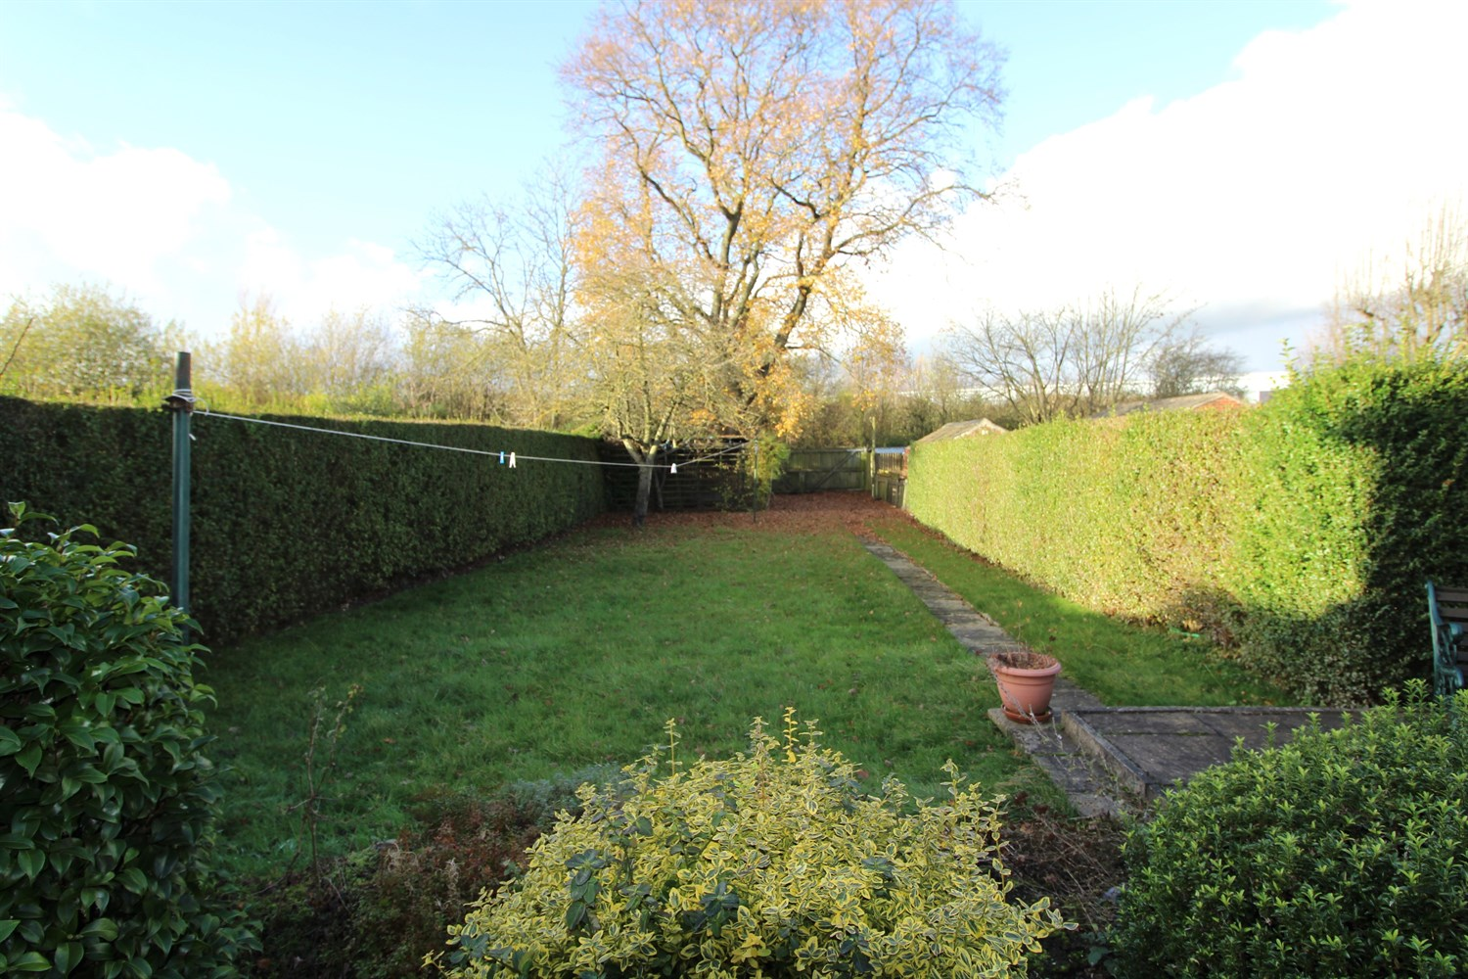

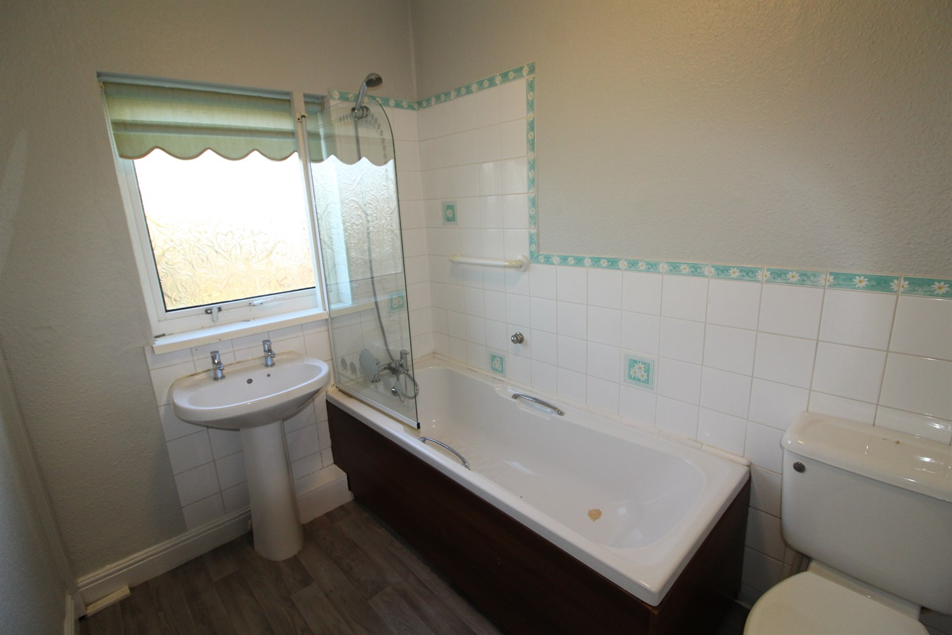

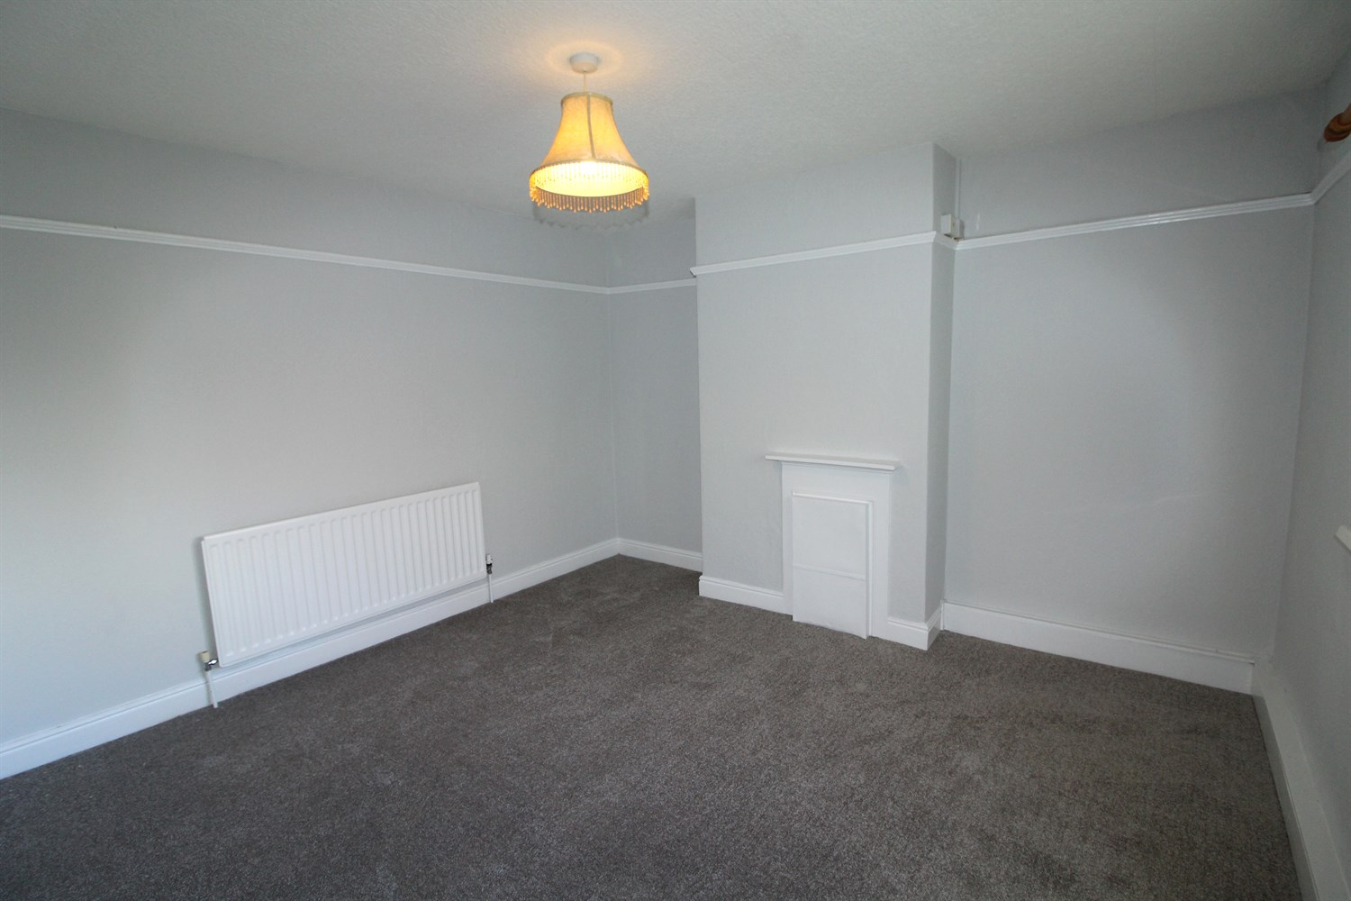

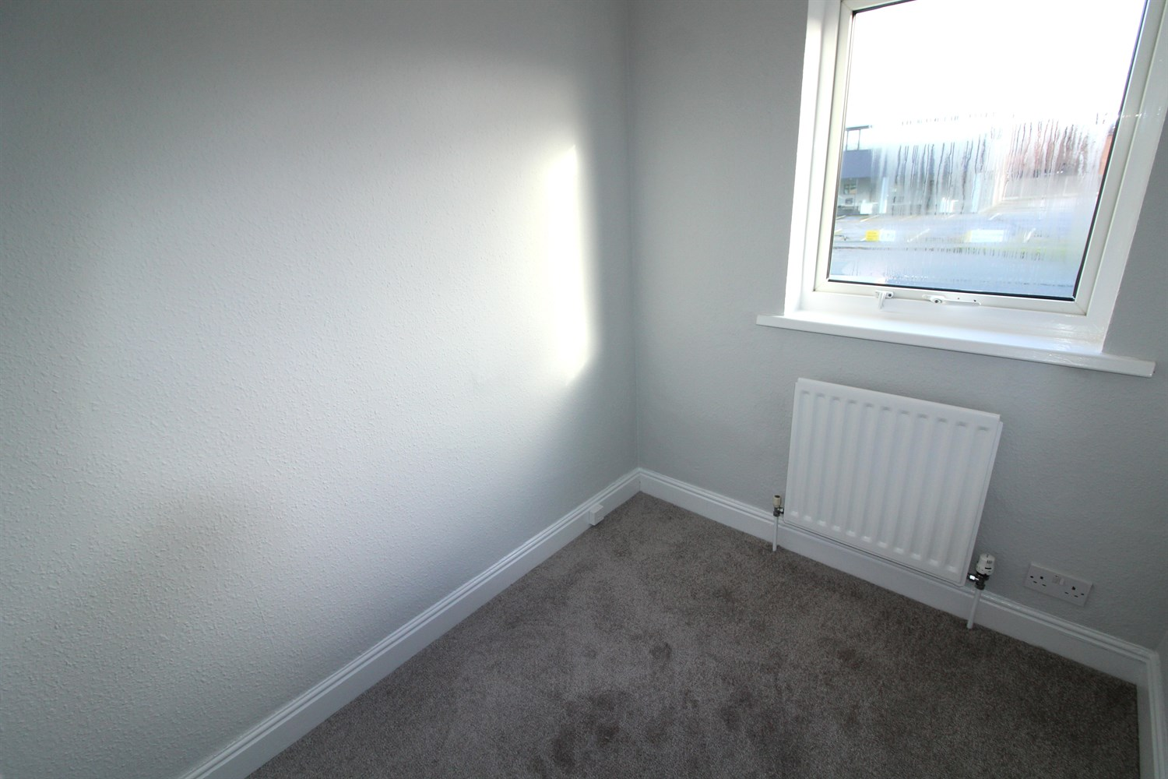

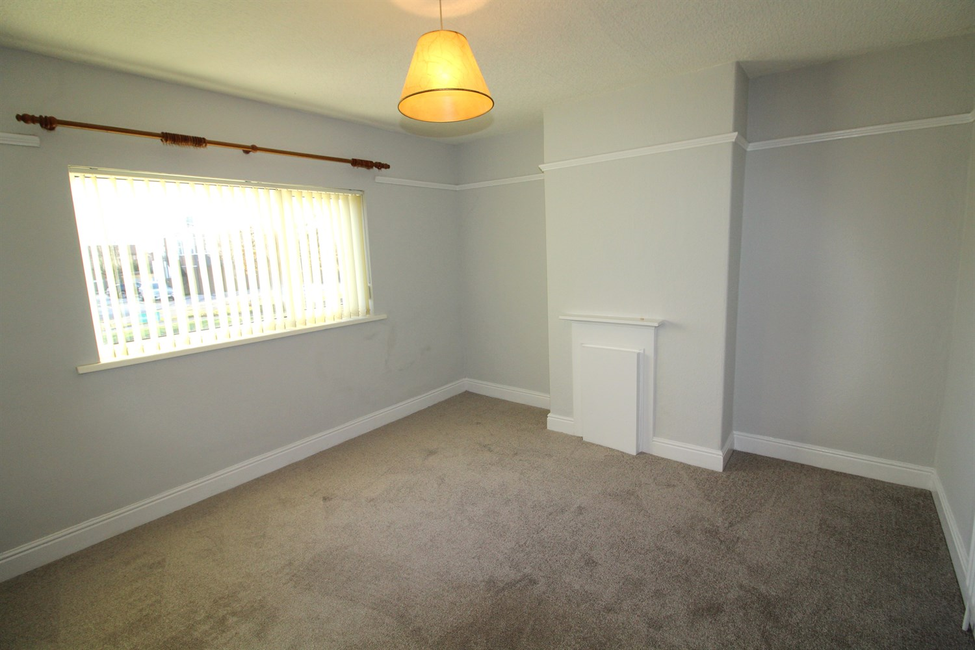

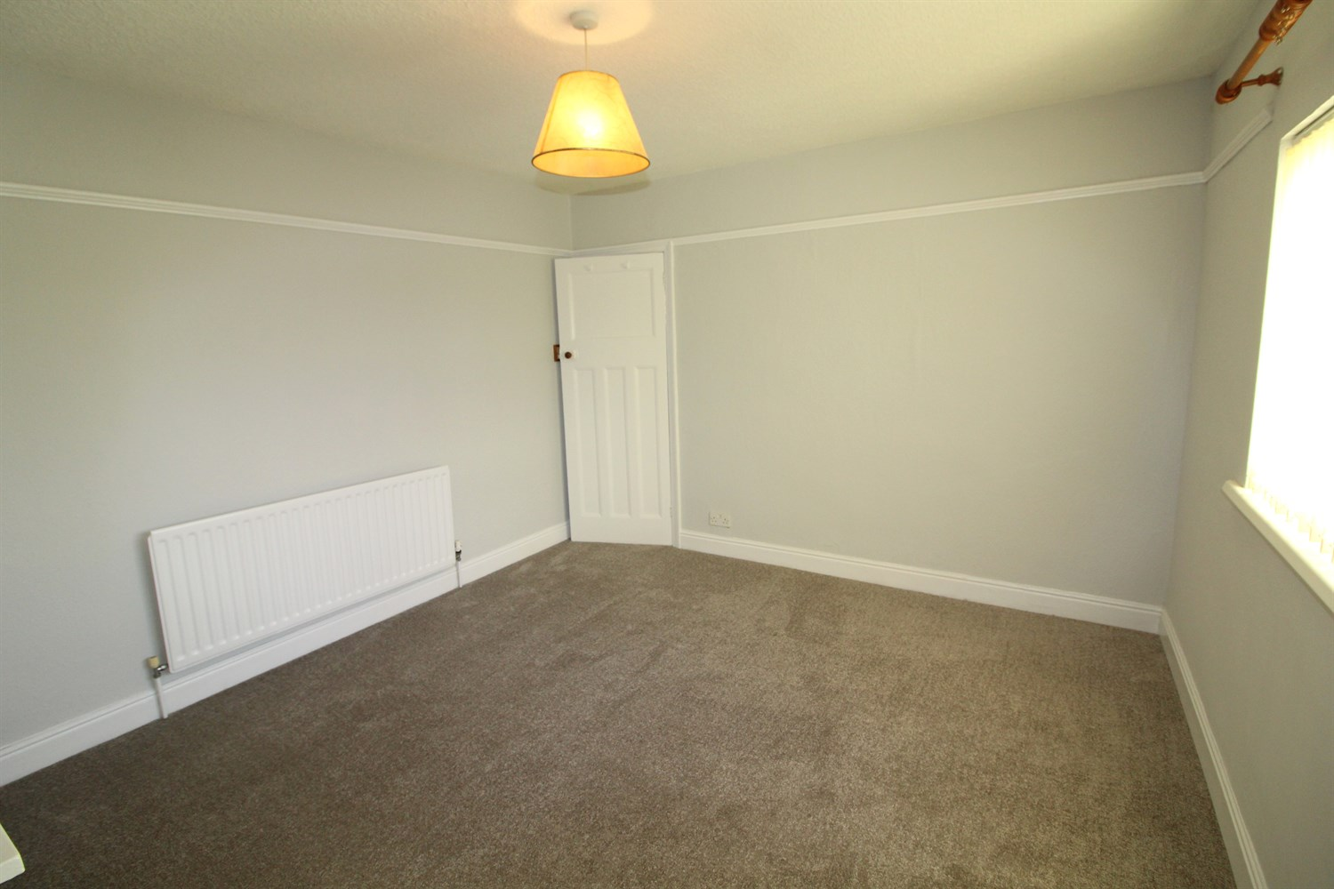

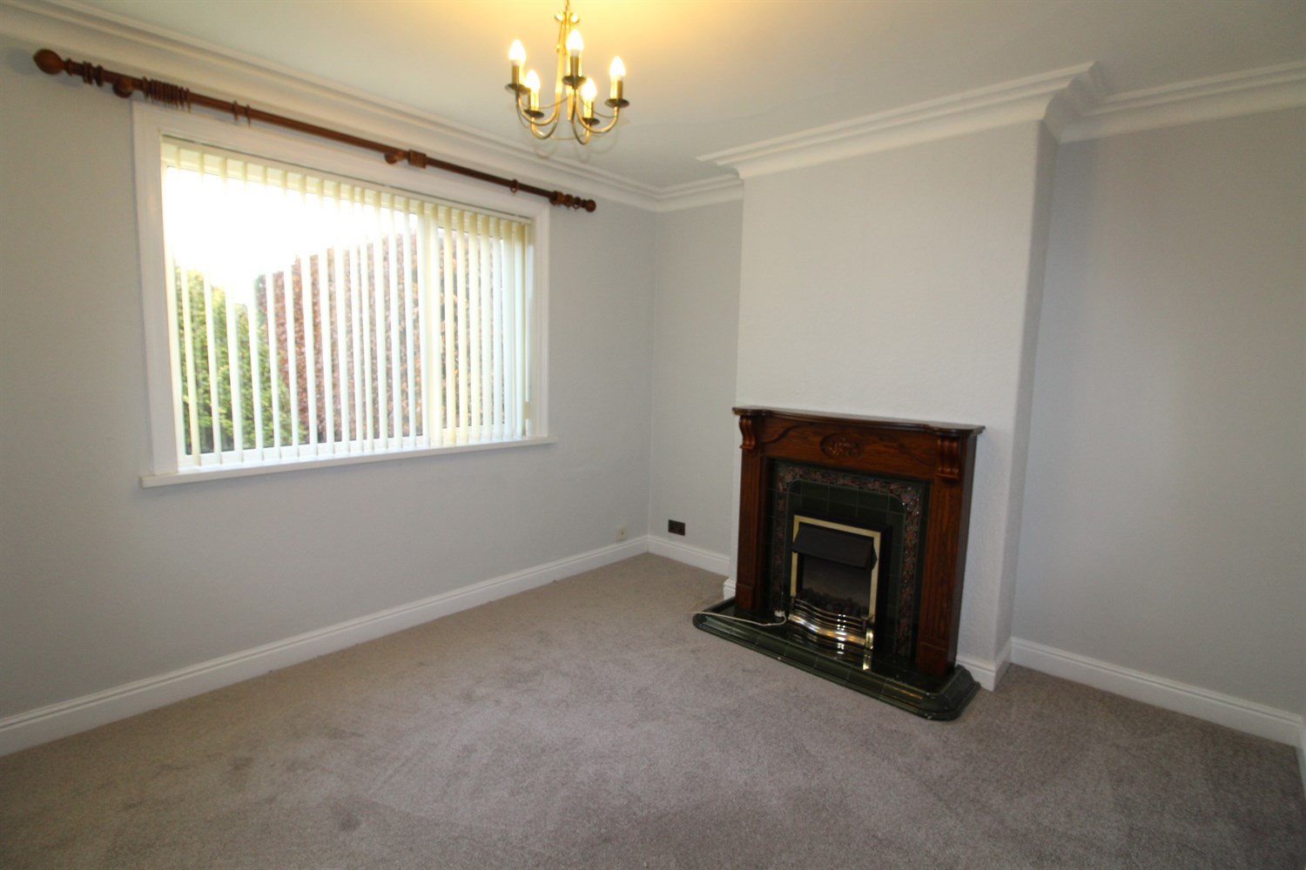

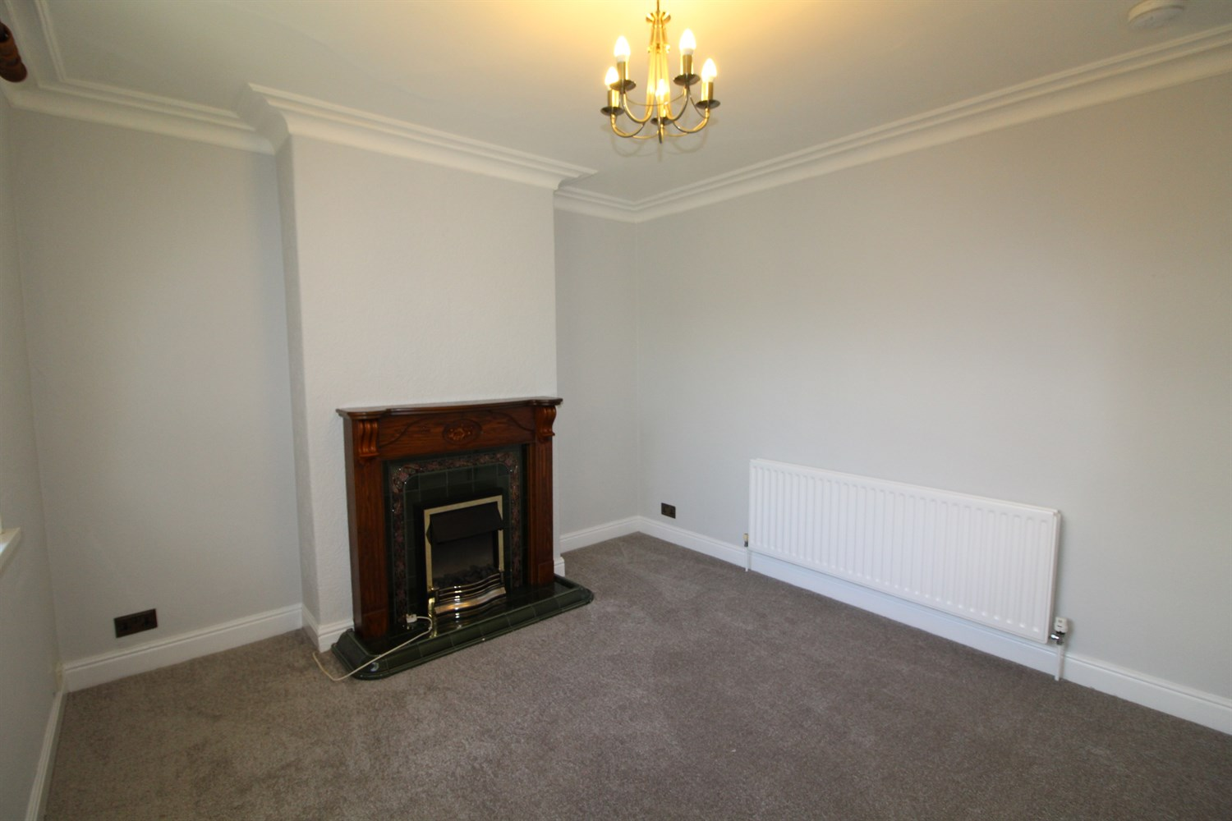

|  |
| --- |
| **Living Room 3.89m (12'9) x 3.47m (11'5)**  Light and airy living room with uPVC double glazed window to front, fire and surround, gas central heating radiator. |
| **Dining Room 3.89m (12'9) x 3.79m (12'5)**  Light and airy Dining room with uPVC double glazed window to rear, fire and surround, gas central heating radiator. |
| **Kitchen 2.66m (8'9) x 1.81m (5'11)**  Fitted with a range of wall and base units, freestanding electric cooker, space for under counter fridge freezer, stainless steel sink. Large storage cupboard. |
| **Bedroom 1 3.91m (12'10) x 3.78m (12'5)**  Double bedroom with uPVC double glazed window to front, gas central heating radiator. |
| **Bedroom 2 3.89m (12'9) x 3.46m (11'4)**  Double bedroom with uPVC double glazed window to rear, gas central heating radiator. |
| **Bedroom 3 2.19m (7'2) x 1.82m (6')**  Small bedroom to front with uPVC double glazed window, gas central heating radiator. |
| **House Bathroom 2.53m (8'4) x 1.8m (5'11)**  Three piece bathroom suite with shower over, shower screen, w/c and hand wash basin, part tiled walls. |
| **Home Information**  COUNCIL TAX BAND: C EPC Rating D  Freehold property Driveway.  Broadband: Standard 7 Mbps 1 Mbps Good Superfast --Not available --Not available Unlikely Ultrafast 1000 Mbps 220 Mbps  Mobile availability: EE limited coverage. Three limited coverage. O2 limited coverage. Vodafone limited coverage.  Utilities: Water supplied on standard meters. Electric mains supplied on standard meters. Gas mains supplied on standard meters. |

|  |  |
| --- | --- |
| These particulars are intended to give a fair description of the property, but their accuracy cannot be guaranteed, and they do not constitute an offer of contract. Intending purchasers must rely on their own inspection of the property. None of the above appliances/services have been tested by ourselves. We recommend purchasers arrange for a qualified person to check all appliances/services before legal commitment.  **Property Ref:** 4488  **For more information, please contact**  0113 258 1150 **|** [lettings@adairpaxton.co.uk](mailto:lettings@adairpaxton.co.uk) **|** www.adairpaxton.co.uk |  |