

Princess Terrace, Charlotte Close, Halifax - For Sale £229,950.00

**THREE BEDROOM END-TOWN HOUSE with NO ONWARD CHAIN** Situated within this convenient and much sought after popular development is a superb, spacious three bedroom town house. The property has been very well maintained and is ready to move into. Briefly comprising; entrance hall, guest WC, spacious kitchen and living room to the ground floor. To the first floor there is a master bedroom with an en-suite shower room, second double bedroom, a third single bedroom and a house bathroom. Externally the property has a garden to the rear and an allocated parking space to the front. The property provides excellent access to the local amenities of Savile Park and Skircoat Green as well as easy access to Halifax town centre, the Trans Pennine road and rail network linking the business centre’s of Manchester and Leeds. An internal viewing is highly recommended to appreciate the accommodation on offer.
0113 258 1150
0800 000 000
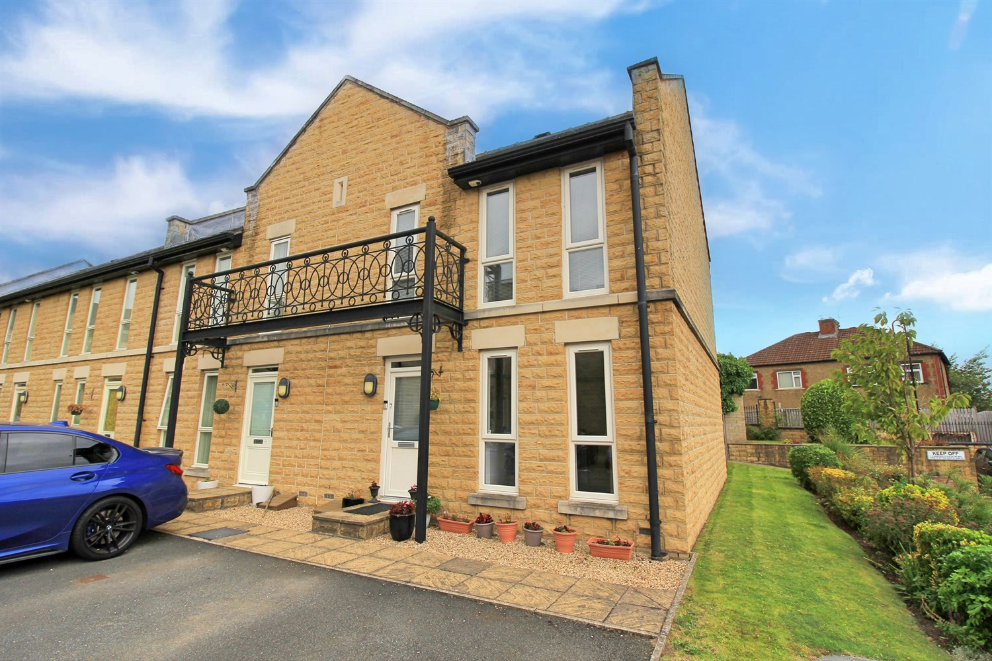
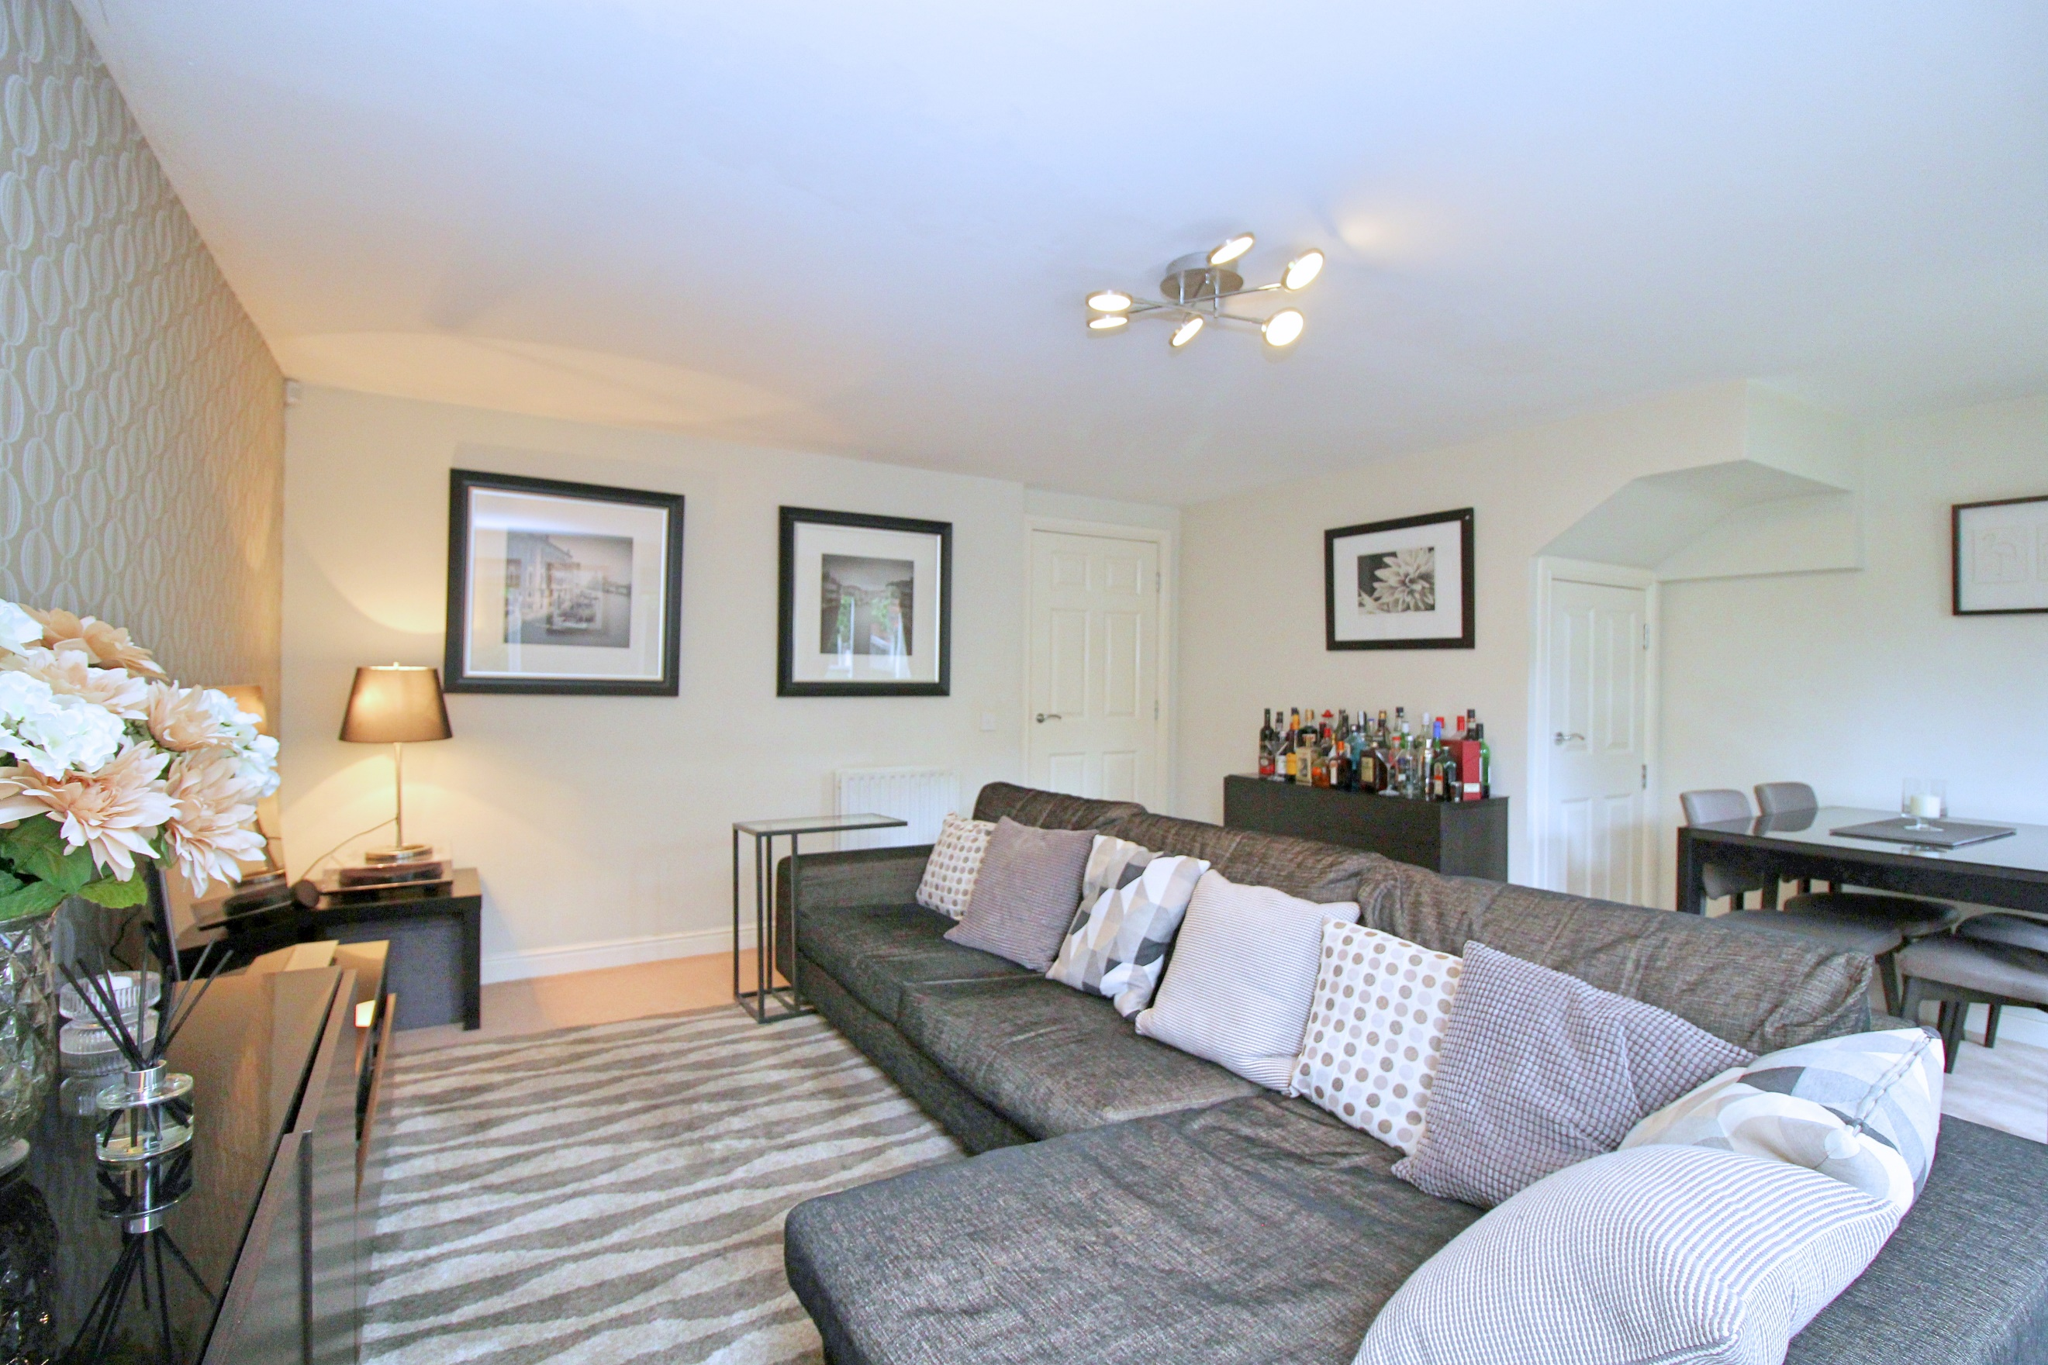
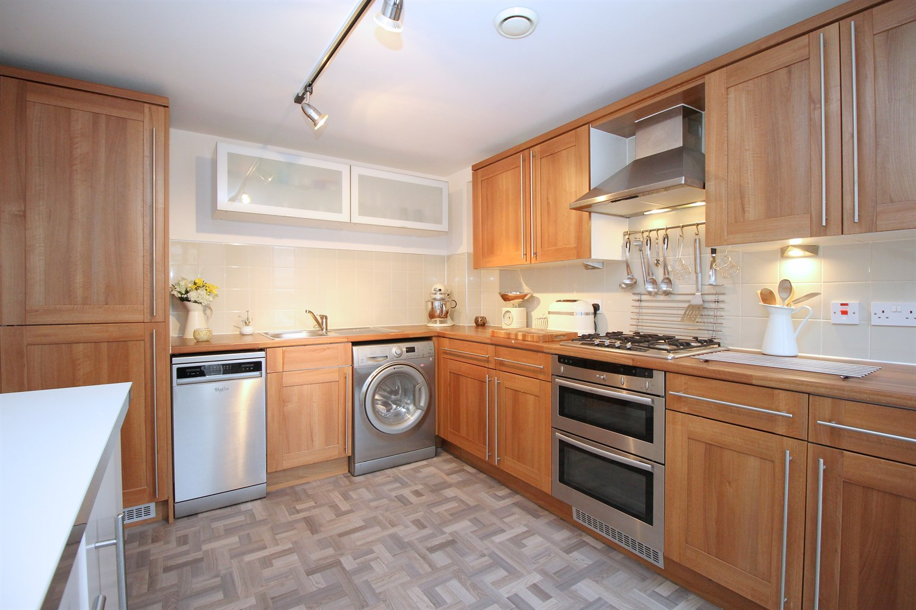
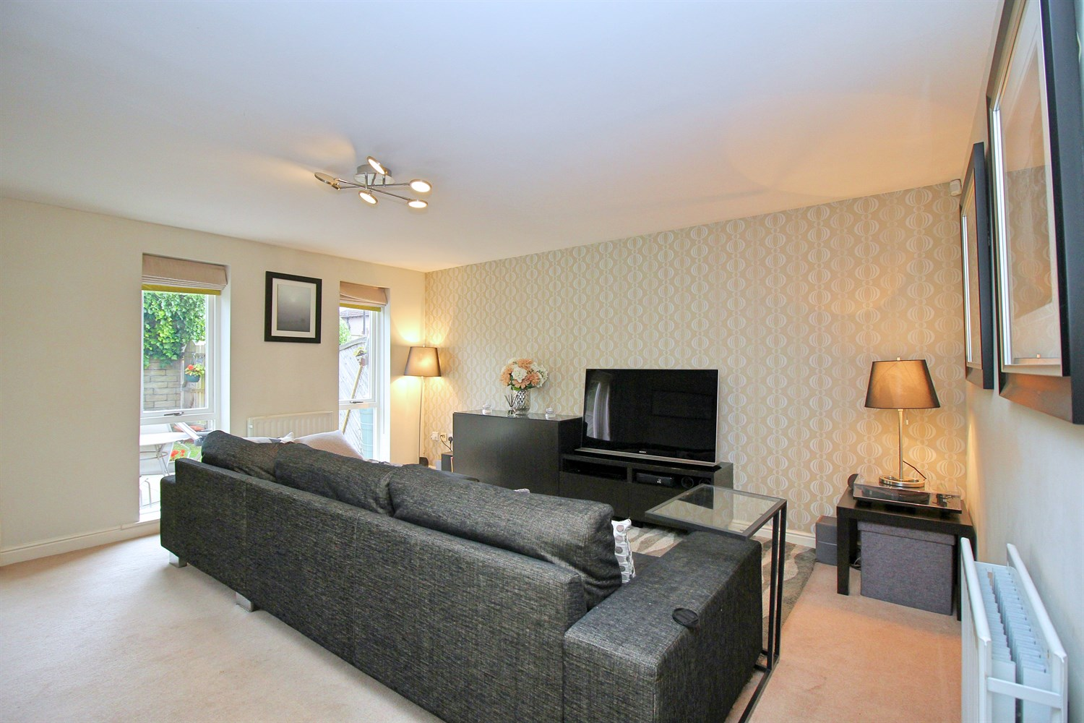
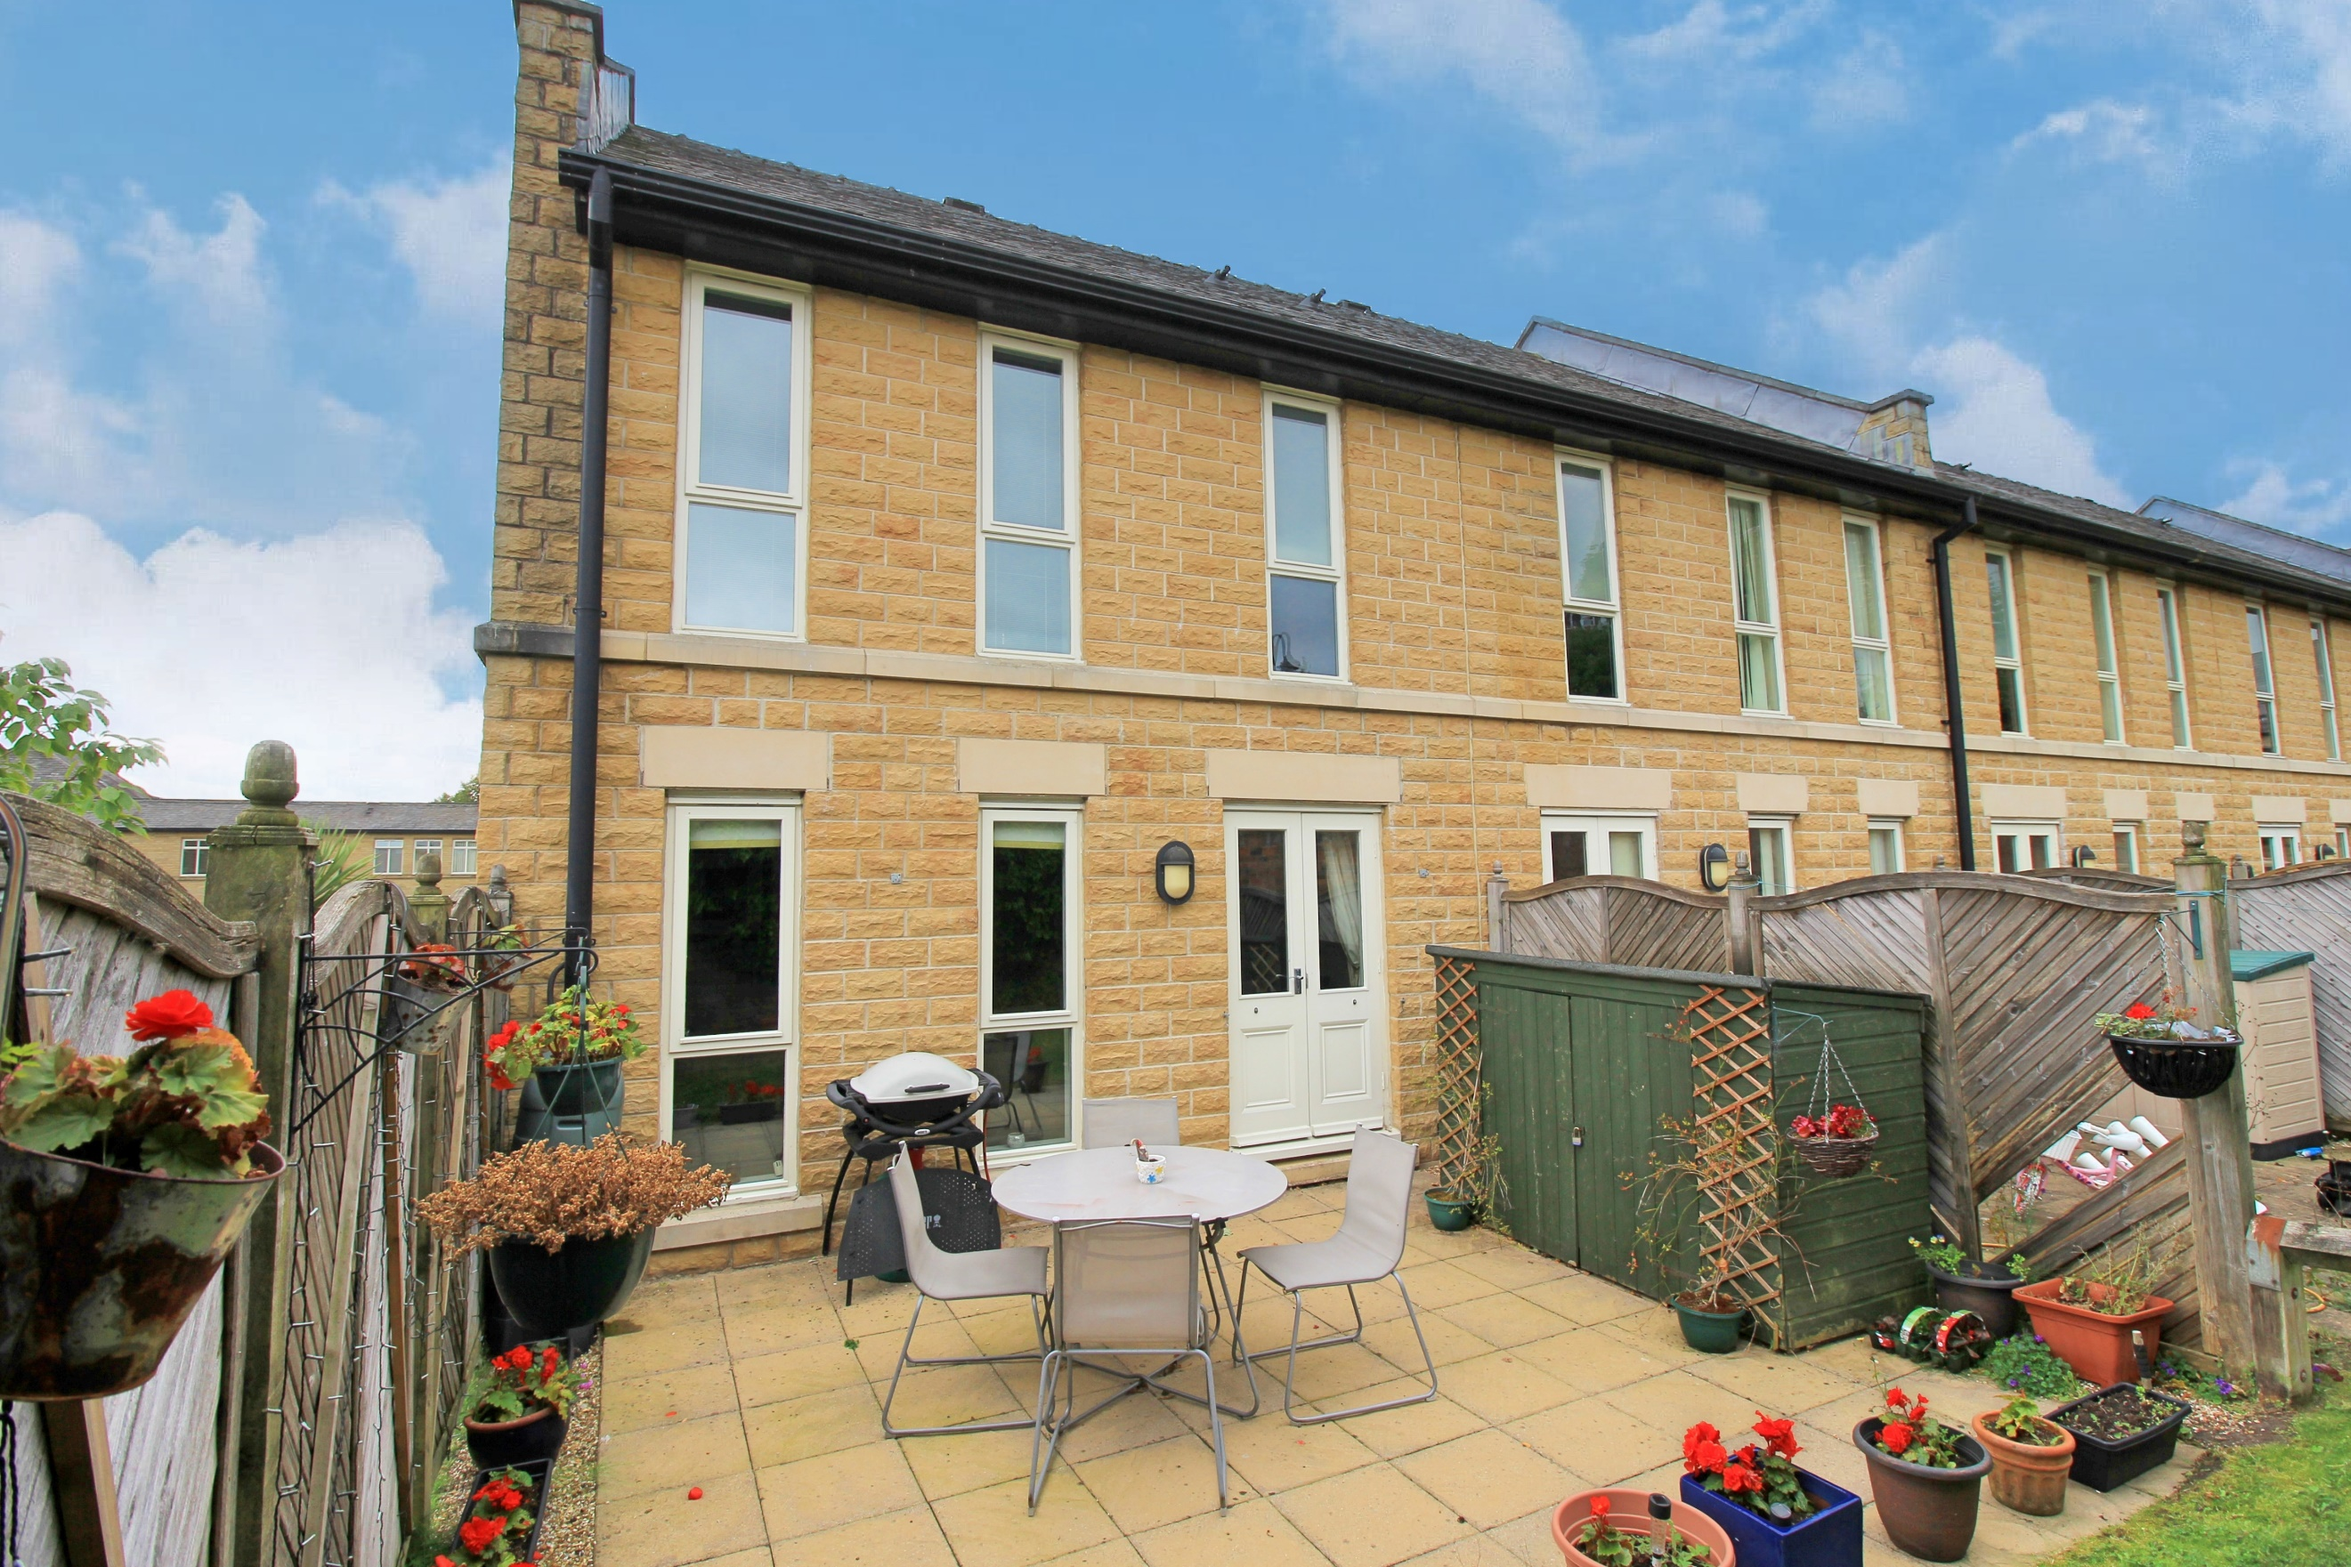
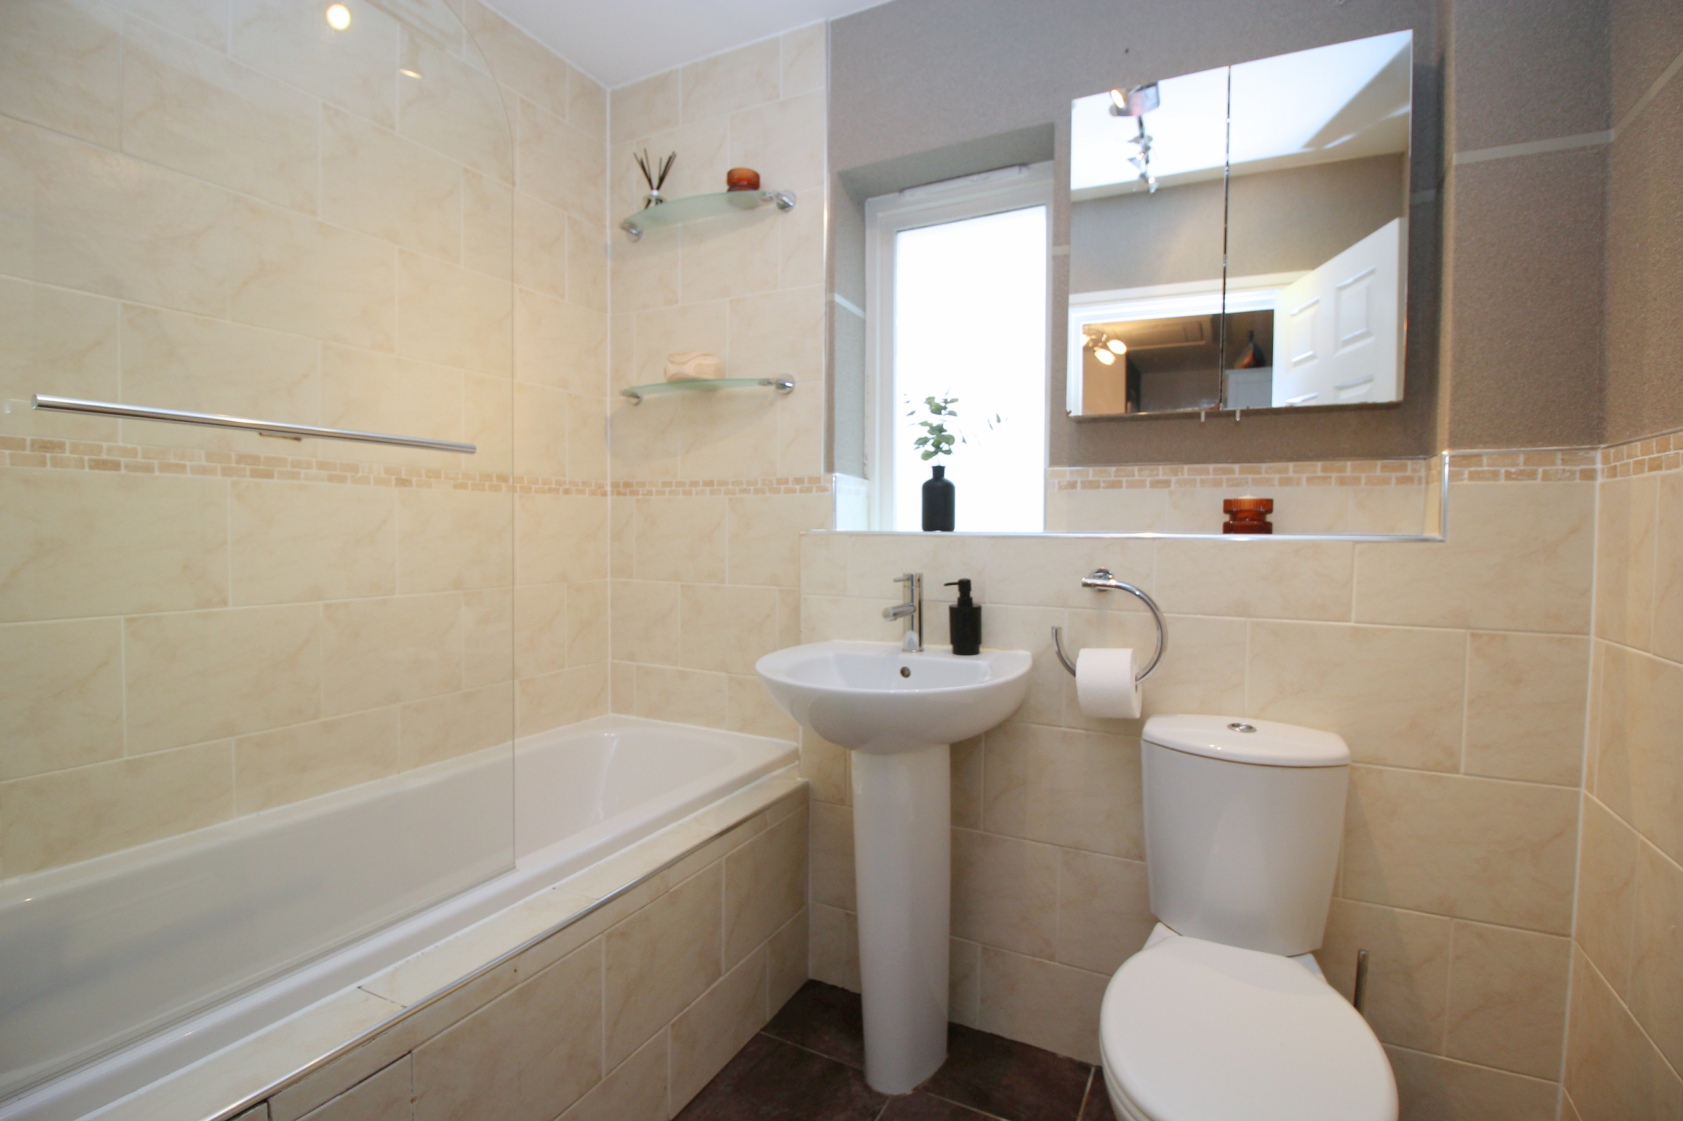
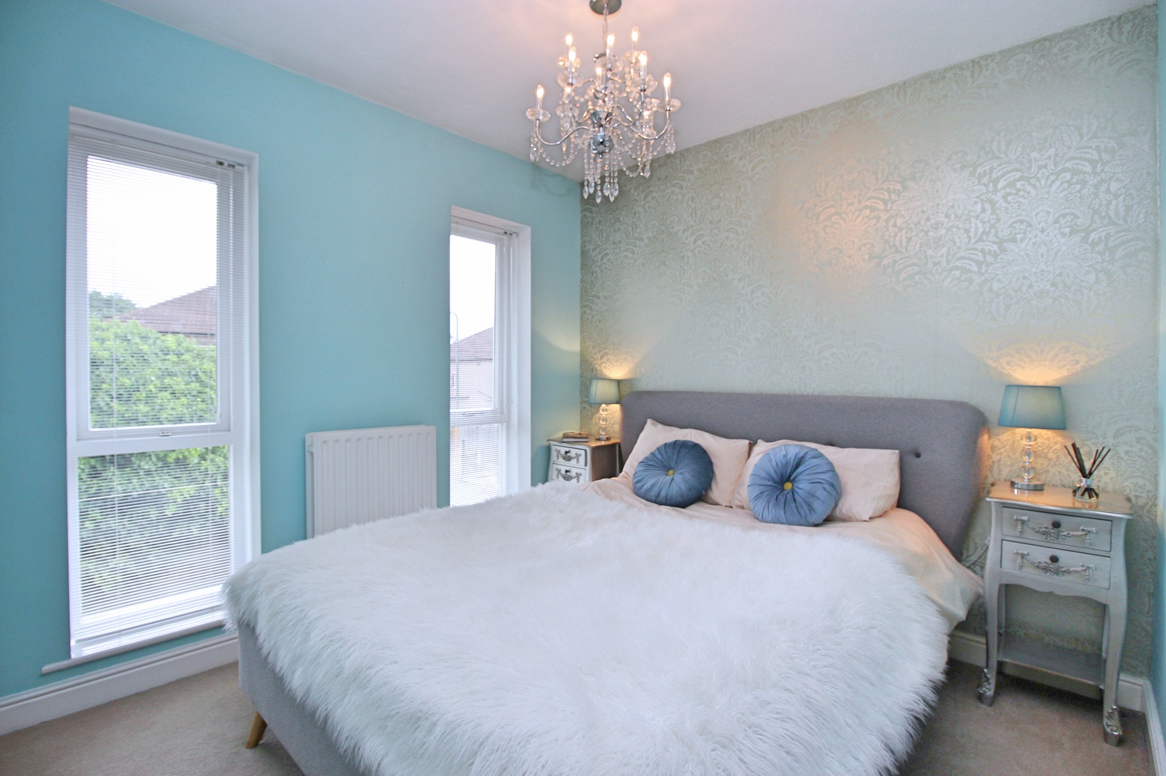
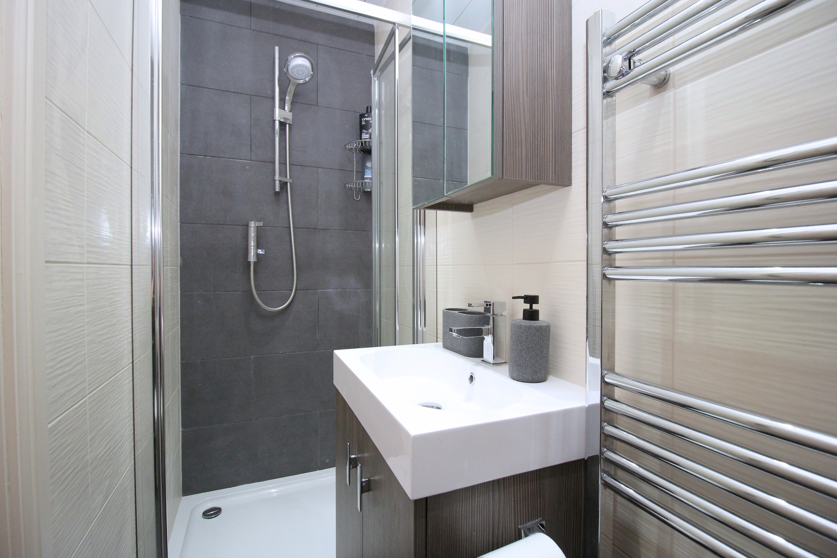
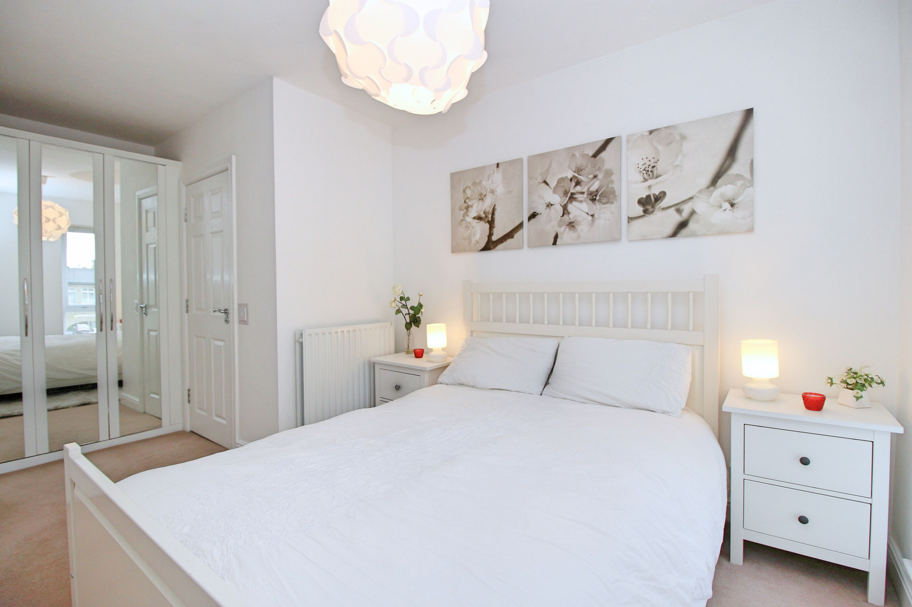

Entrance Hall
Via front entrance door. Storage cupboard. Gas central heating radiator. Stairs to first floor.

Guest WC
Fitted with a two piece suite comprising; WC and wash hand basin. Gas central heating radiator.

2.92m (9'7) x 3.71m (12'2)
Spacious kitchen, fitted with a range of wall, base and drawer units with worktops over. Integrated oven with 4-ring gas hob and extractor hood over. Integrated fridge/freezer. Space for washing machine and dishwasher. Tall gas central heating radiator. Two uPVC double glazed windows to front. Part tiled walls.

Living Room 4.16m (13'8) x 4.57m (15')
Light and airy living area with uPVC double glazed windows and door to the rear. Gas central heating radiator. Dining area with space for a dining table. Under stairs storage cupboard.

First Floor Landing

Master Bedroom 2.98m (9'9) x 4.93m (16'2)
Master bedroom with two uPVC double glazed windows to front. Built in wardrobes. Gas central heating radiator.

En-Suite Shower Room
Fitted with a three piece suite comprising; shower cubicle, vanity wash hand basin and WC. Tiled walls and floor. Wall mounted heated towel rail.

Bedroom Two 2.76m (9'1) x 3.35m (11')
Second double bedroom with Two double glazed windows to front. Gas central heating radiator.

Bedroom Three
Third bedroom with double glazed window to rear. Gas central heating radiator.

House Bathroom
Fitted with a three piece suite comprising; bath with shower above, WC and wash hand basin. Tiled walls and floor. uPVC double glazed window.

Outside
To the front of the property is a parking space for one vehicle. To the rear of the house is a patio area ideal for entertaining and a lawned area beyond.

Tenure
Leasehold - 977 years remaining

Service Charge
Service charge - £1172.33 per annum

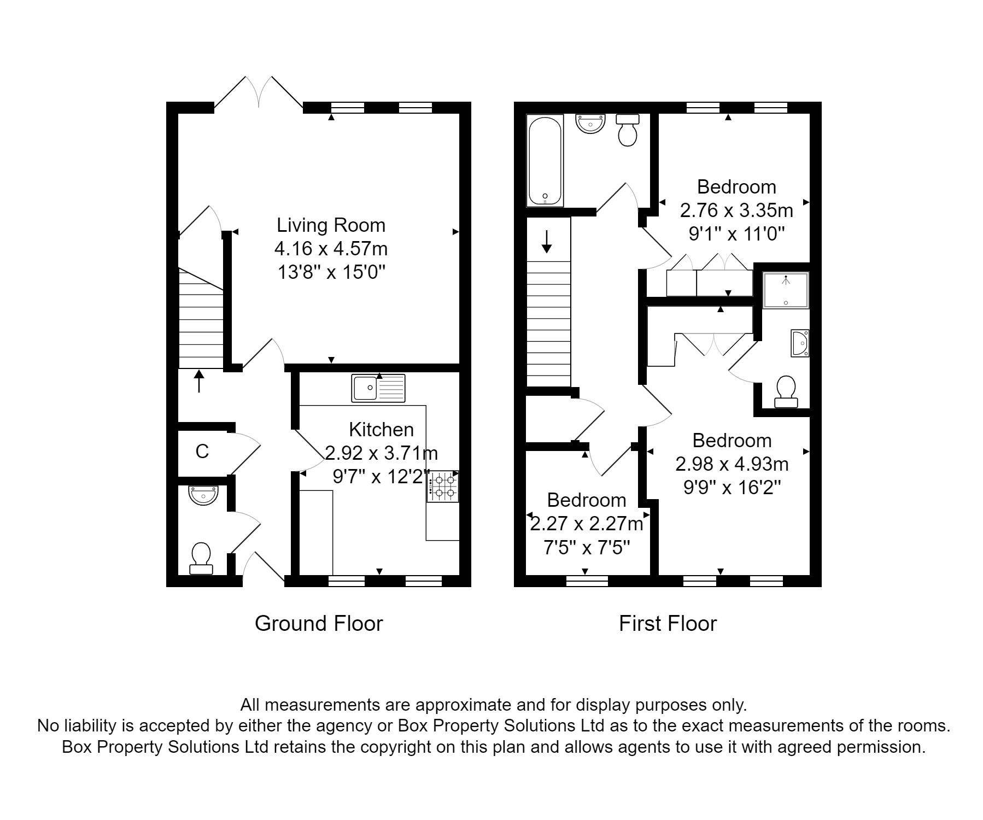

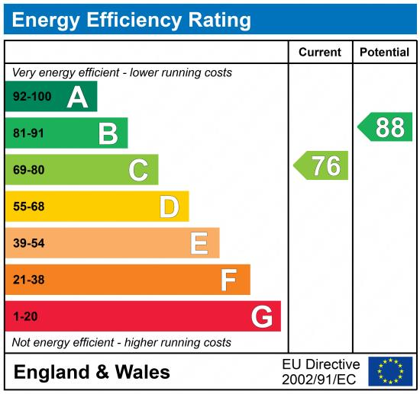

These particulars are intended to give a fair description of the property, but their accuracy cannot be guaranteed, and they do not constitute an offer of contract. Intending purchasers must rely on their own inspection of the property. None of the above appliances/services have been tested by ourselves. We recommend purchasers arrange for a qualified person to check all appliances/services before legal commitment.

Property Ref: 3452

For more information, please contact

0113 258 1150 | sales@adairpaxton.co.uk | www.adairpaxton.co.uk

