

**0113 258 1150**

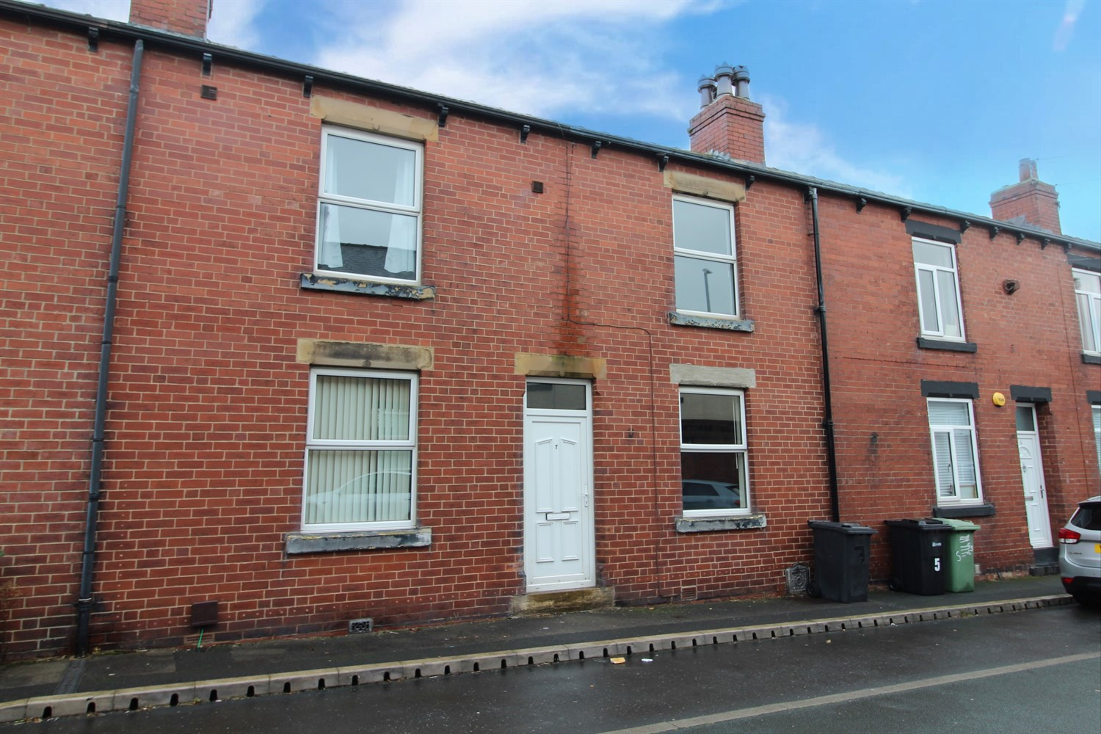



**For Sale £129,950.00**

**7 Woodland Crescent, Rothwell, LS26 0PJ**

***TWO BEDROOM MID TERRACED HOUSE, OFFERED TO THE MARKET WITH NO ONWARD CHAIN*** Located in this popular residential area of Rothwell, offering ease of access to Leeds city centre and Wakefield, local shops, schools and amenities are also close by. The property is now in need of cosmetic updating and briefly comprises: Open plan kitchen/diner and living room to the ground floor. Cellar. To the first floor there are two bedrooms and a house bathroom. To the rear of the property is an enclosed garden. The property is ideal for a first time buyer or investor.

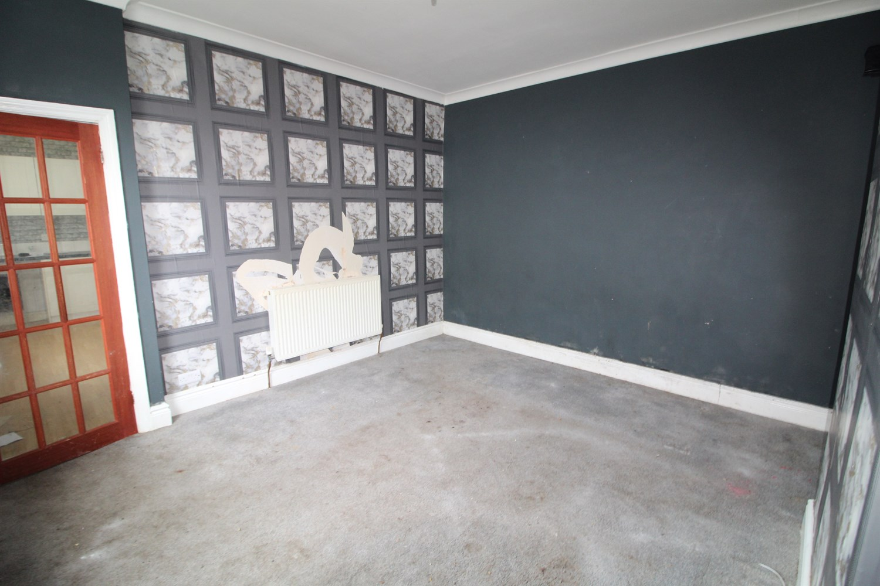

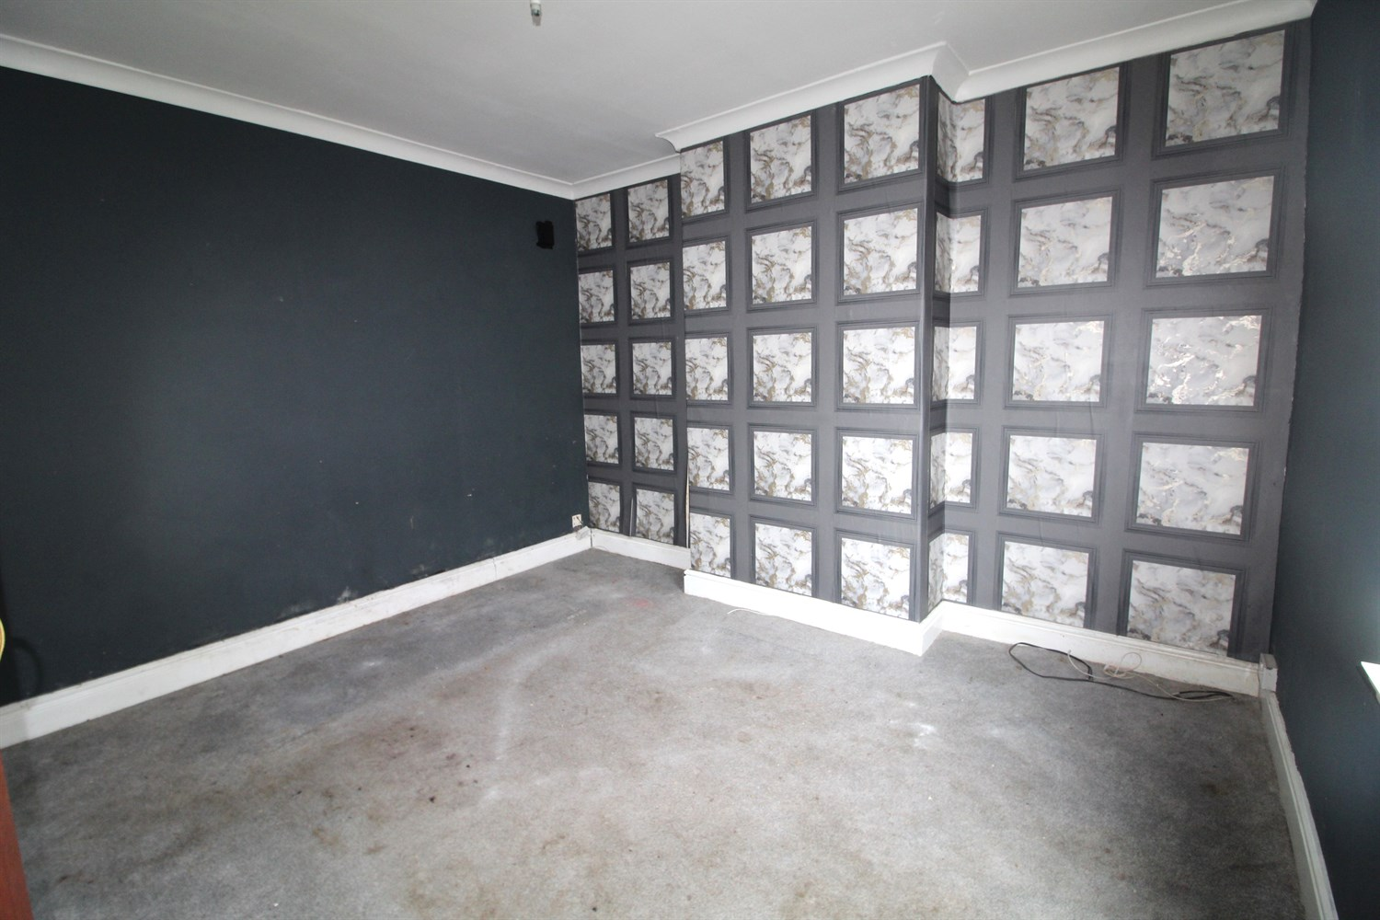

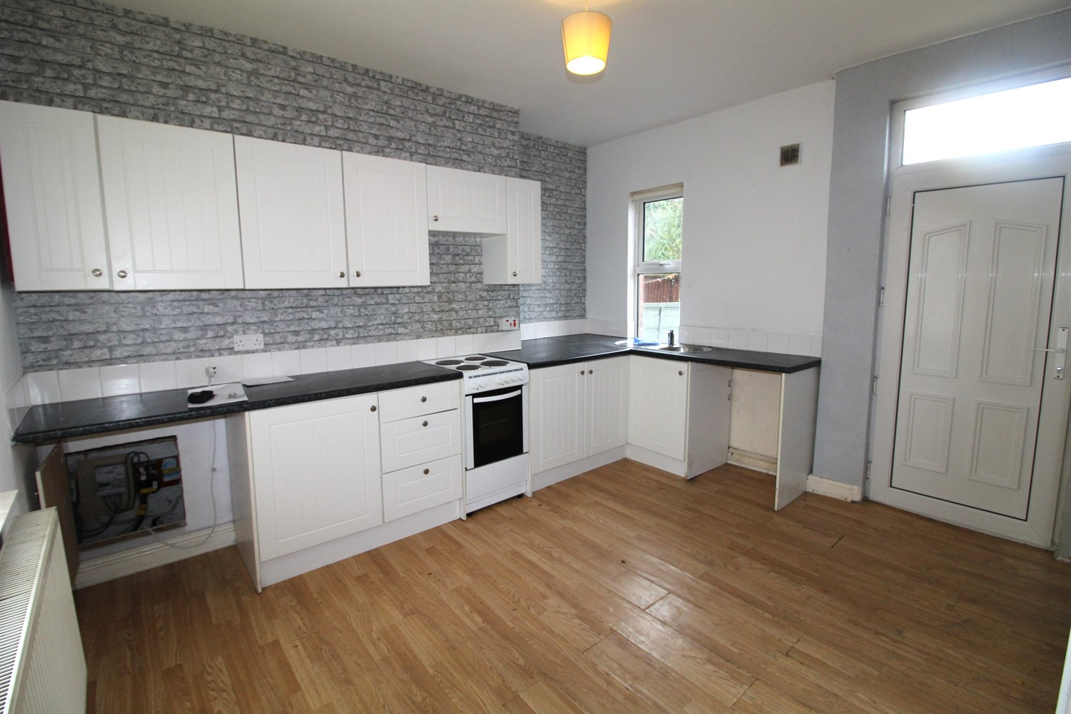

1 Bathroom(s)

1 Reception(s)

2 Bedroom(s)

00

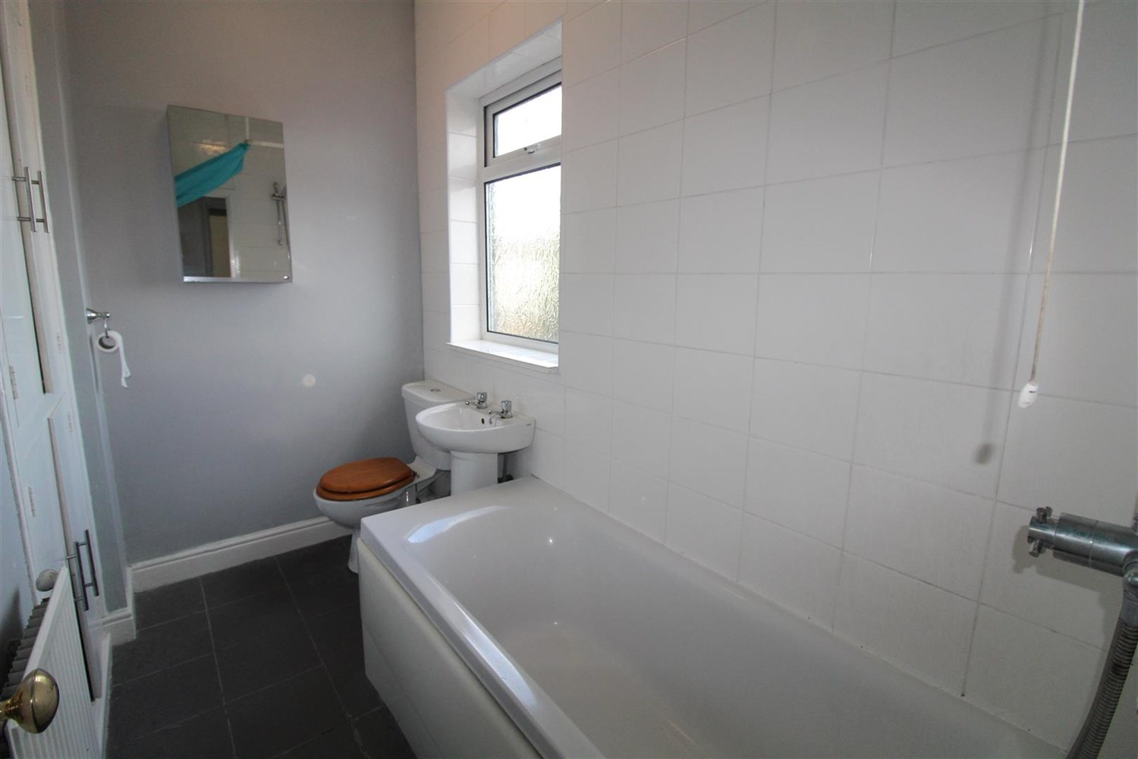

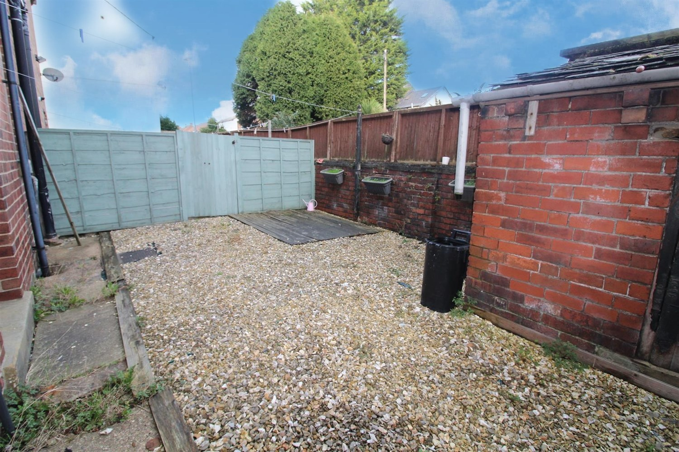

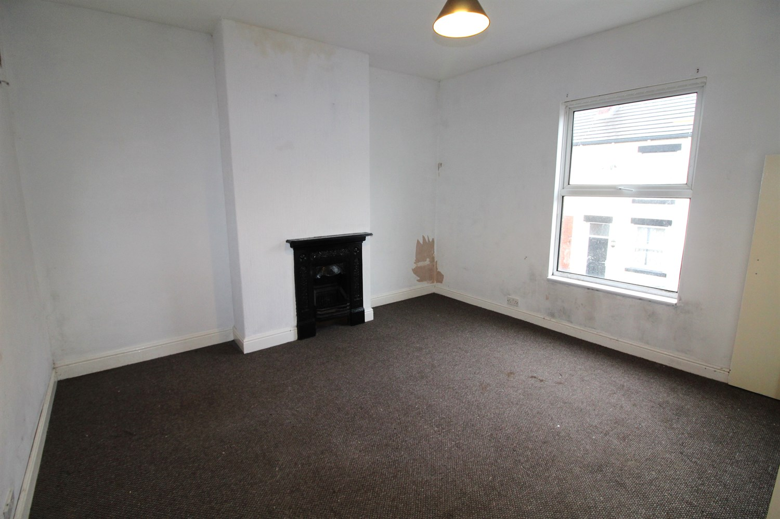

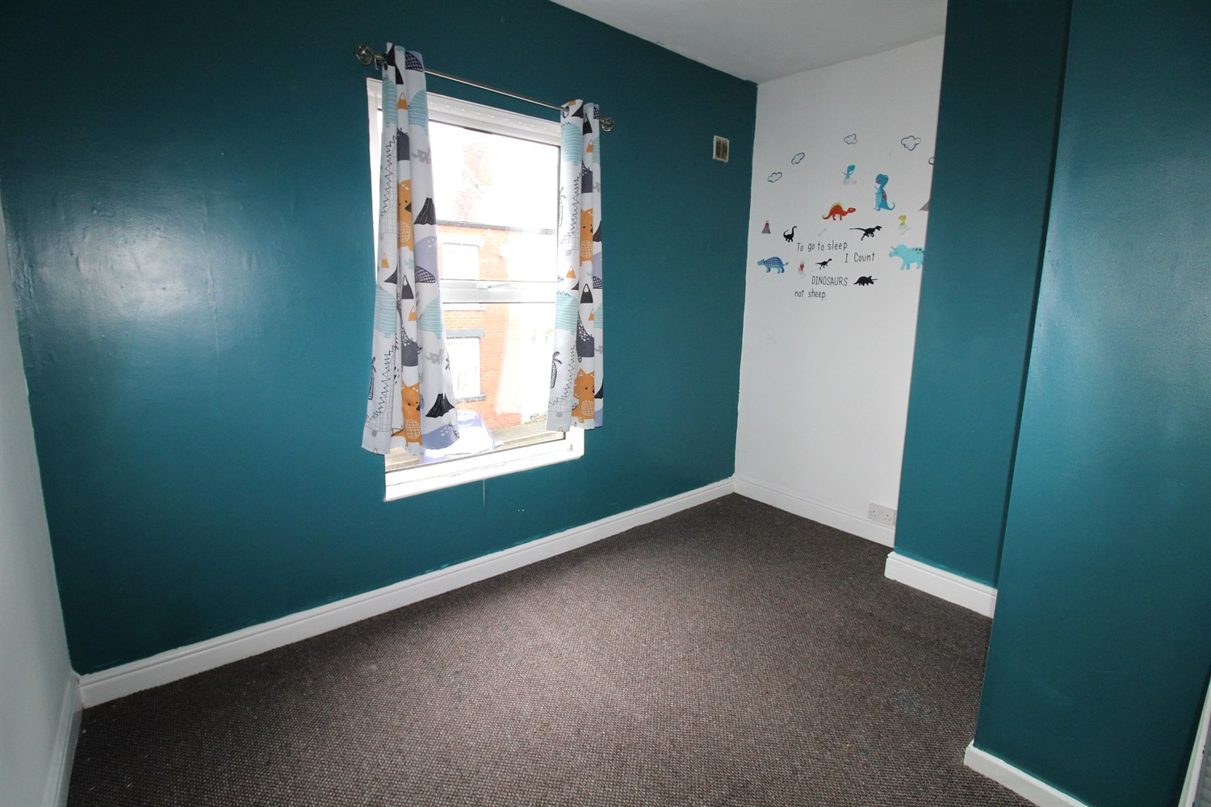

|  |
| --- |
| **Hallway**  Via front entrance door. Stairs to first floor. |
| **Kitchen 3.56m (11'8) x 3.99m (13'1)**  Fitted with a range of wall, base and drawer units with worktops over. Space for cooker and washing machine. Stainless steel sink with mixer tap and drainer. Gas central heating radiator. uPVC double glazed window to front and back. Door leading to rear garden. |
| **Lounge 3.56m (11'8) x 3.79m (12'5)**  Living area with uPVC double glazed window to front. Gas central heating radiator. |
| **Bedroom 1 3.82m (12'6) max x 4.06m (13'4)**  Double bedroom with uPVC double glazed window to front. Gas central heating radiator. |
| **Bedroom 2 2.55m (8'4) x 3.65m (12')**  Second bedroom with uPVC double glazed window to front. Gas central heating radiator. |
| **Bathroom**  Fitted with a three piece white suite comprising; bath with shower over, WC and wash hand basin. Part tiled walls. Double glazed window. |
| **Outside**  To the rear of the property is an enclosed garden. |

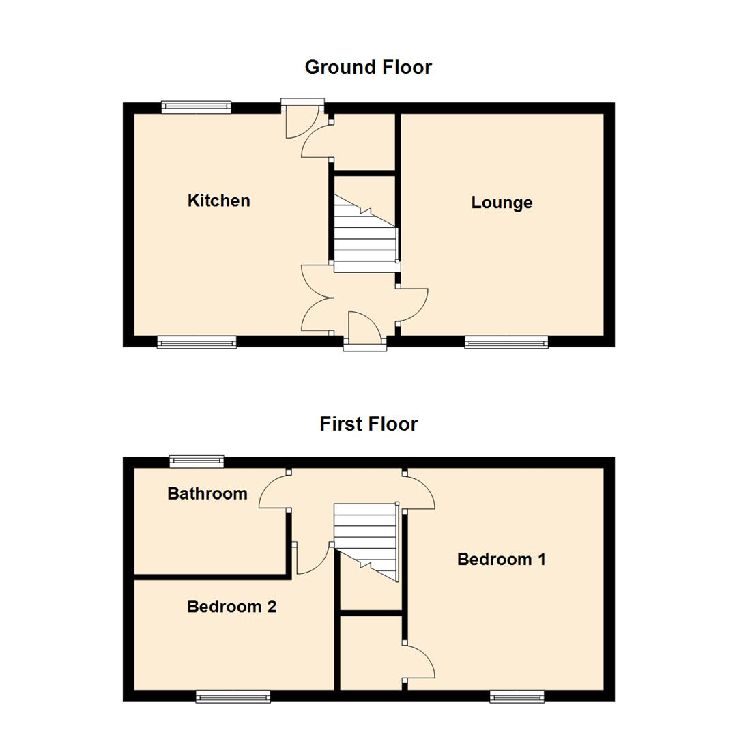

|  |  |
| --- | --- |
| These particulars are intended to give a fair description of the property, but their accuracy cannot be guaranteed, and they do not constitute an offer of contract. Intending purchasers must rely on their own inspection of the property. None of the above appliances/services have been tested by ourselves. We recommend purchasers arrange for a qualified person to check all appliances/services before legal commitment.  **Property Ref:** 4030  **For more information, please contact**  0113 258 1150 **|** [sales@adairpaxton.co.uk](mailto:sales@adairpaxton.co.uk) **|** www.adairpaxton.co.uk |  |