

**Eggleston Street, Rodley**

**For Sale £135,000.00**

## **ONE BEDROOM MID TERRACE HOUSE - NO ONWARD CHAIN** Ideally located in Rodley with the nature reserve on your doorstep, this one bedroom house is now in need of updating and briefly comprises; Living Room and kitchen to the ground floor. Cellar. Double bedroom and bathroom to the first floor. With the ring road and public transport links close by, along with local amenities in the village and up into Farsley, the property would suit a range of buyers and is one not to be missed.

**0113 258 1150**

**0800 000 000**

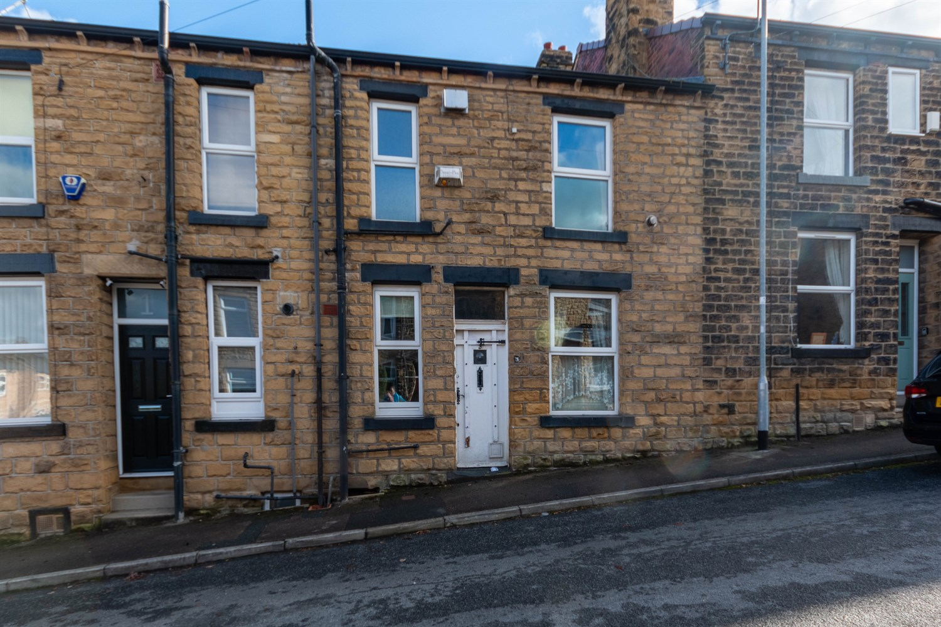



1 Reception

1 Bathroom

1 Bedroom

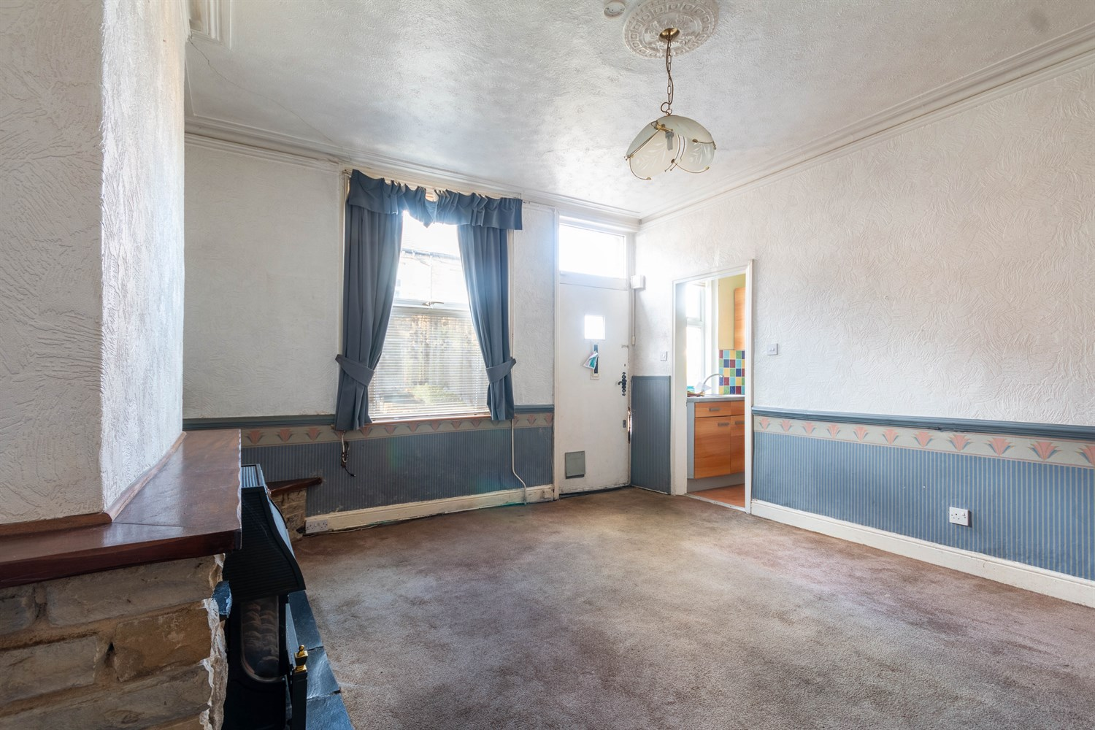

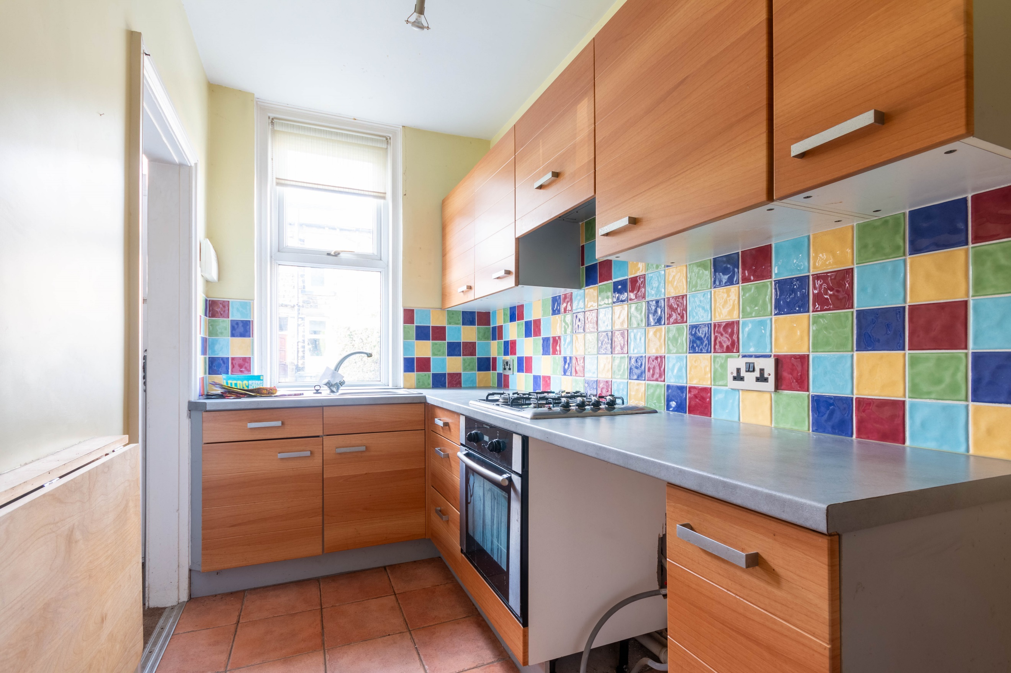

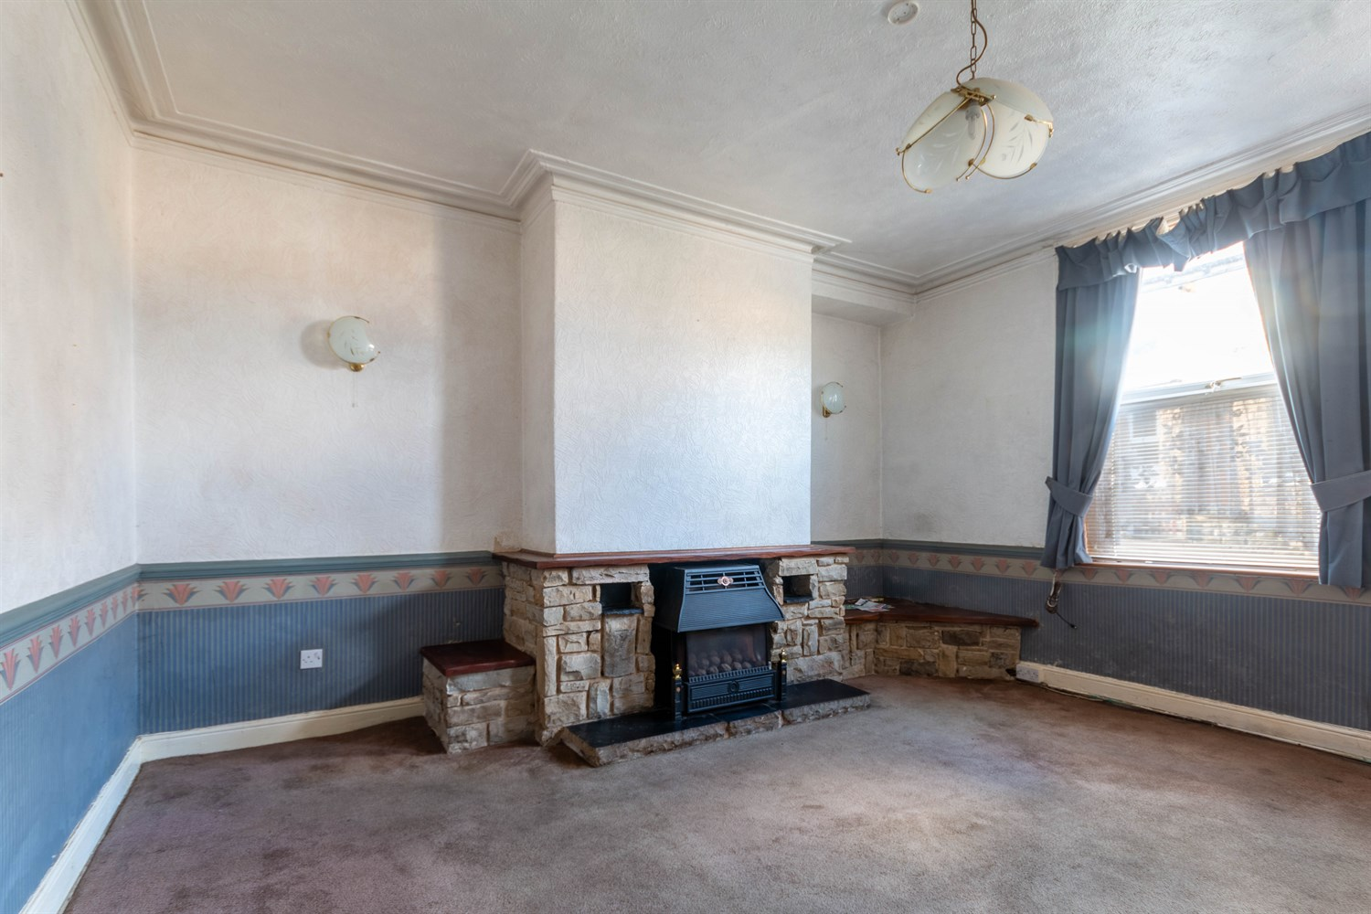

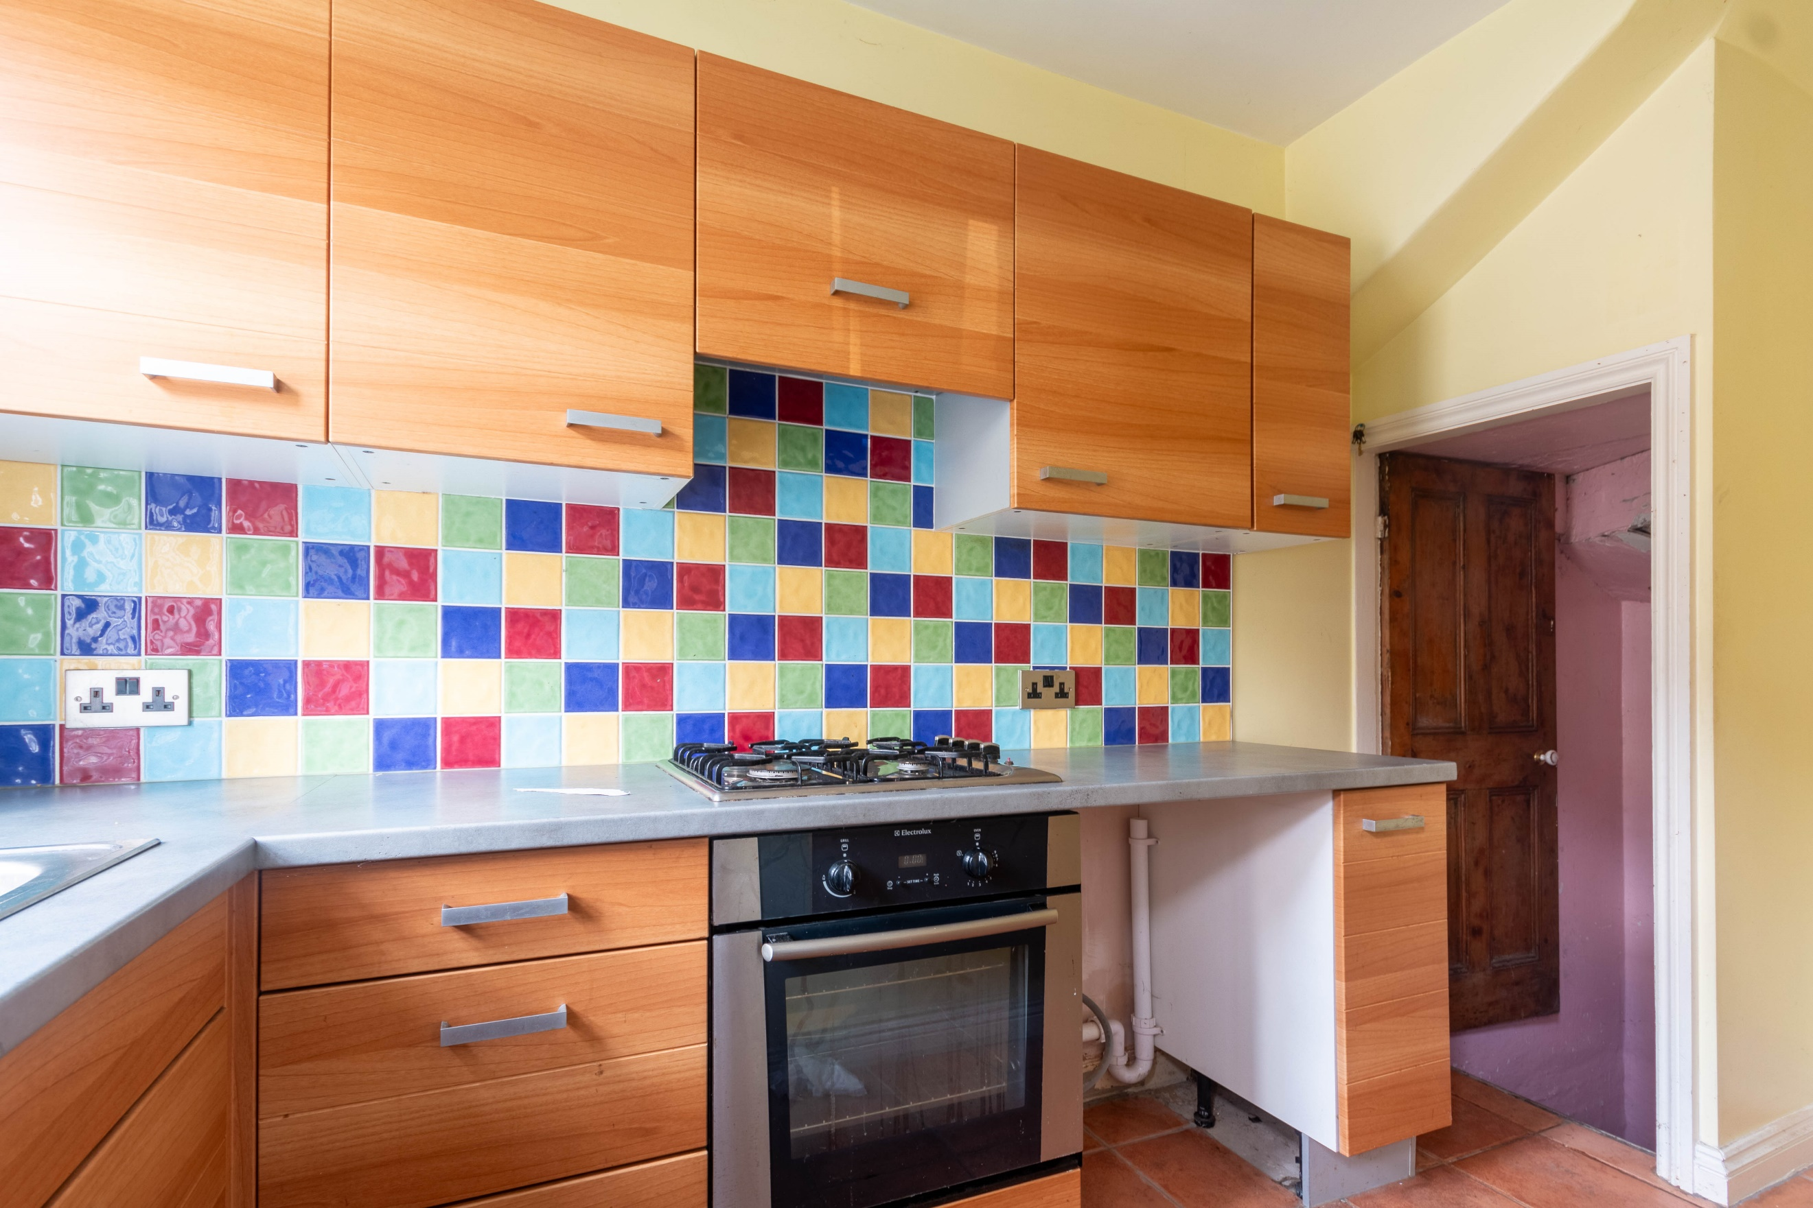

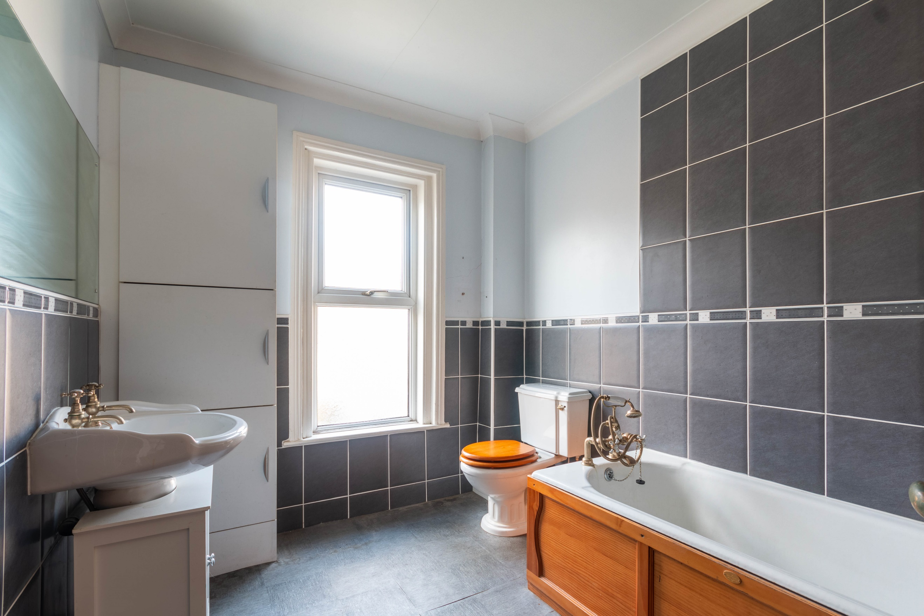

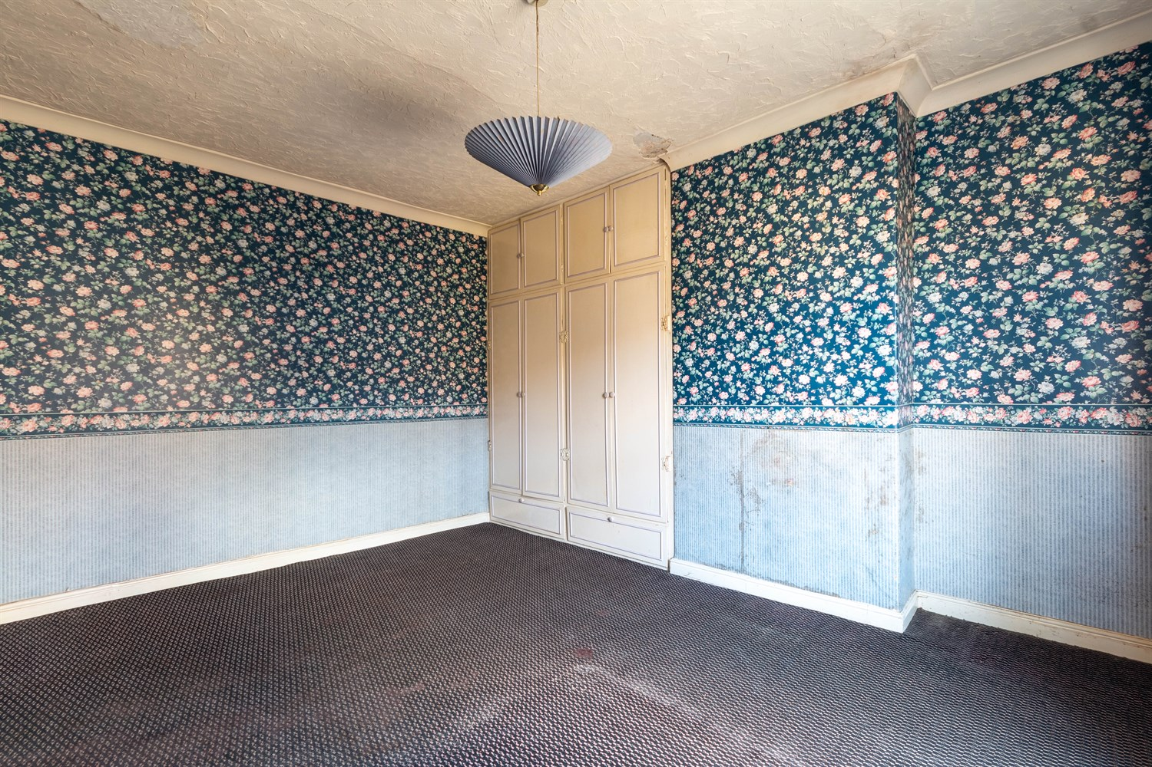

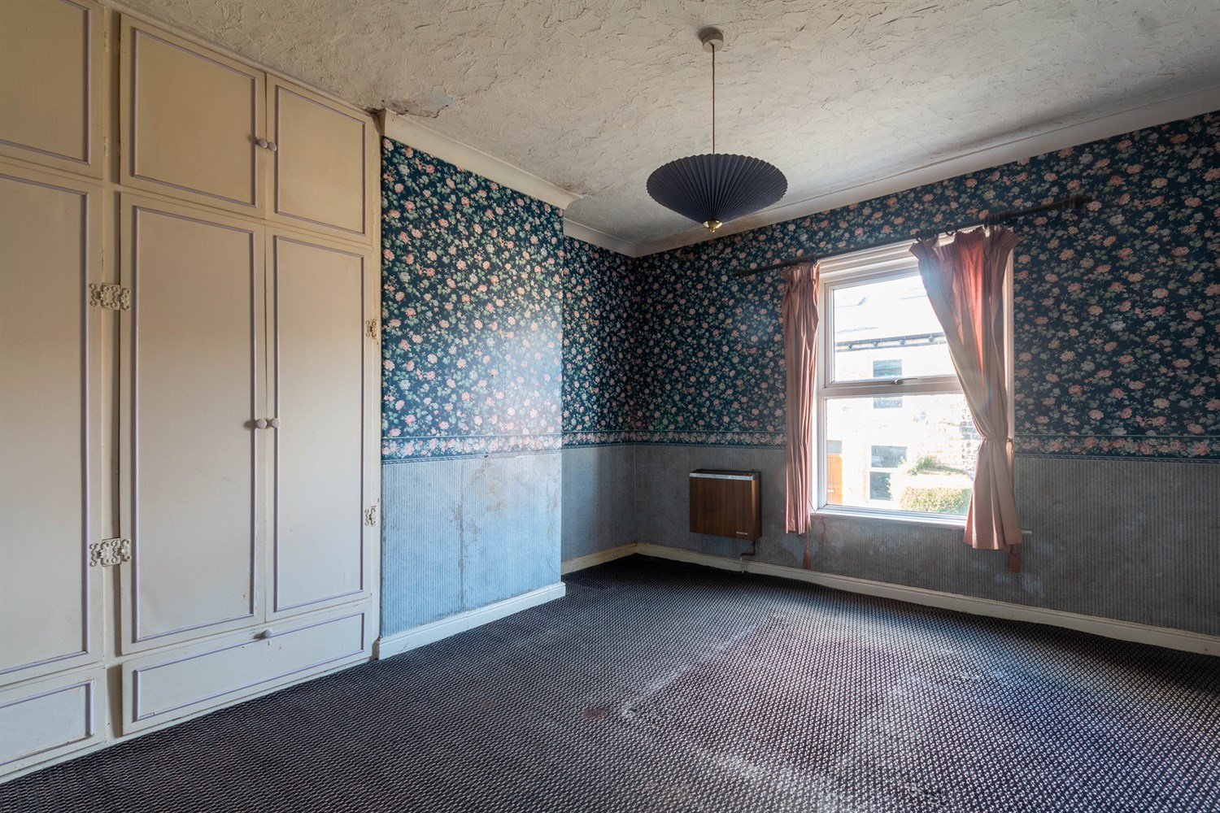

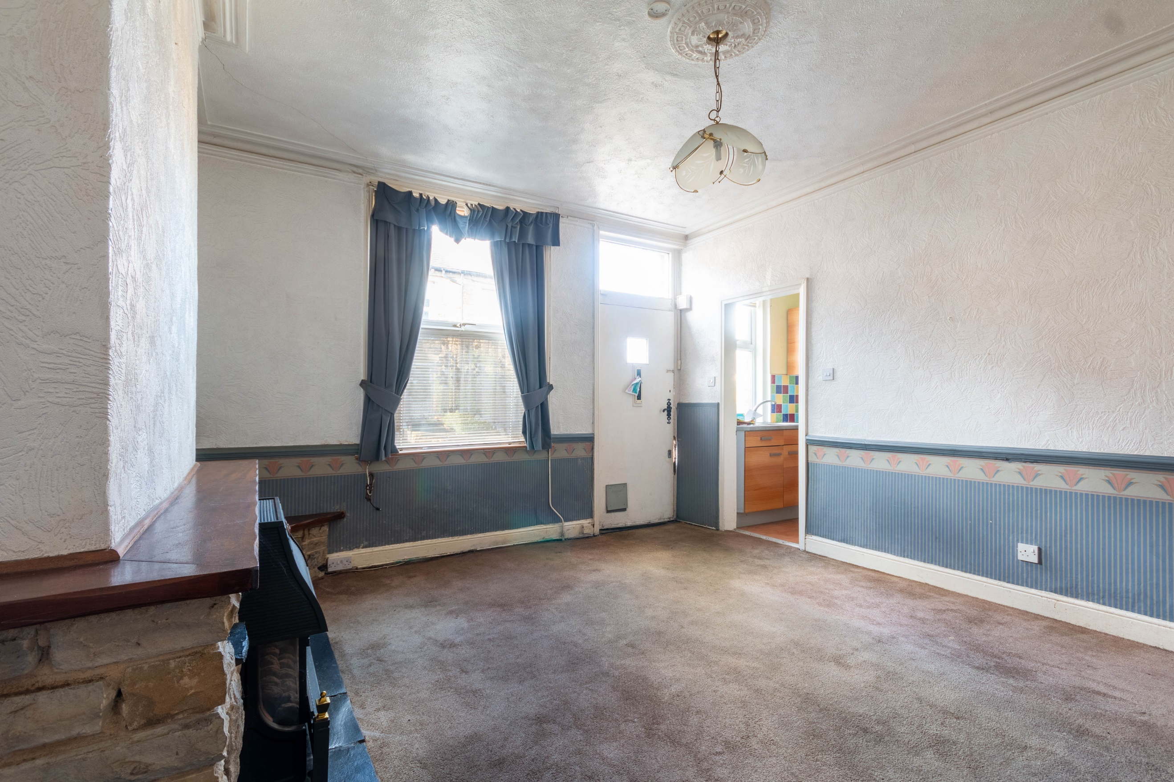

|  |
| --- |
| **Lounge 4.19m (13'9) x 4.45m (14'7)**  Via front entrance door. uPVC double glazed window to front. Stone fireplace to chimney breast. |
| **Kitchen**  Fitted with a range of wall, base and drawer units with worktops over. Integrated electric oven with gas hob and extractor over. Stainless steel sink with mixer tap. Part tiled walls. Double glazed window to front. Door to cellar. |
| **Bedroom 1 3.6m (11'10) x 4.45m (14'7)**  Double bedroom with double glazed window to front. Built in wardrobes. |
| **Bathroom**  Fitted with a three piece suite comprising; bath with hand shower over, WC and wash hand basin. Tiled walls and floor. uPVC double glazed window. |
| **Agents Note**  The sale of this property is subject to Grant of Probate. |

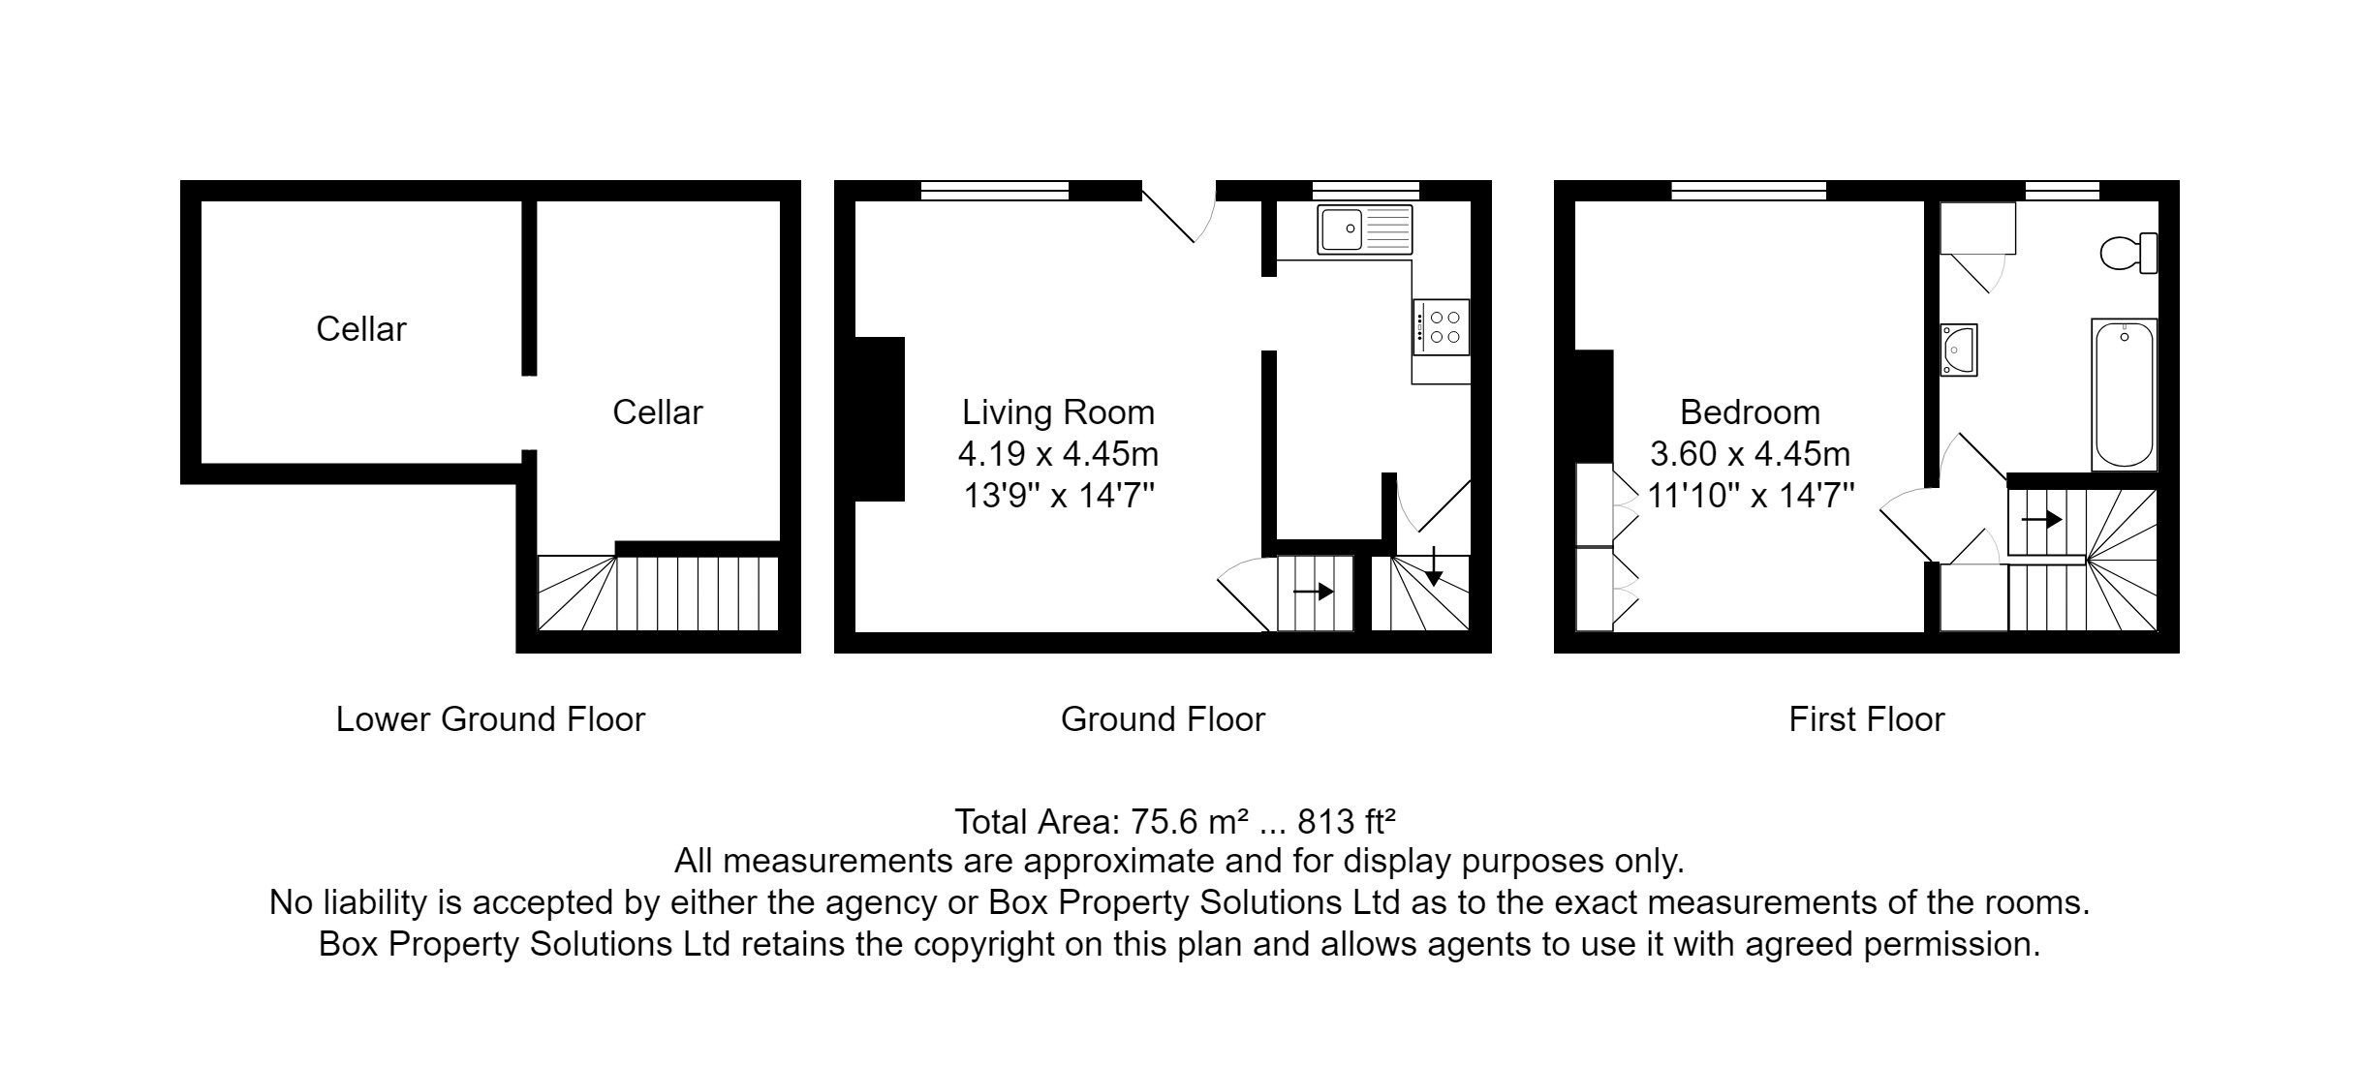

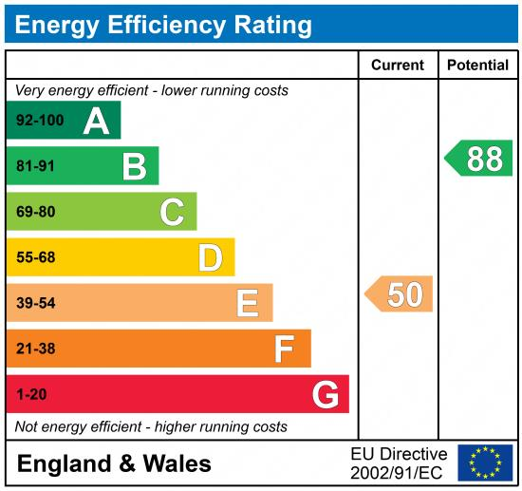

|  |
| --- |
|  |

These particulars are intended to give a fair description of the property, but their accuracy cannot be guaranteed, and they do not constitute an offer of contract. Intending purchasers must rely on their own inspection of the property. None of the above appliances/services have been tested by ourselves. We recommend purchasers arrange for a qualified person to check all appliances/services before legal commitment.

**Property Ref:** 4216

**For more information, please contact**

0113 258 1150 **|** [sales@adairpaxton.co.uk](mailto:sales@adairpaxton.co.uk) **|** www.adairpaxton.co.uk