

**0113 258 1150**

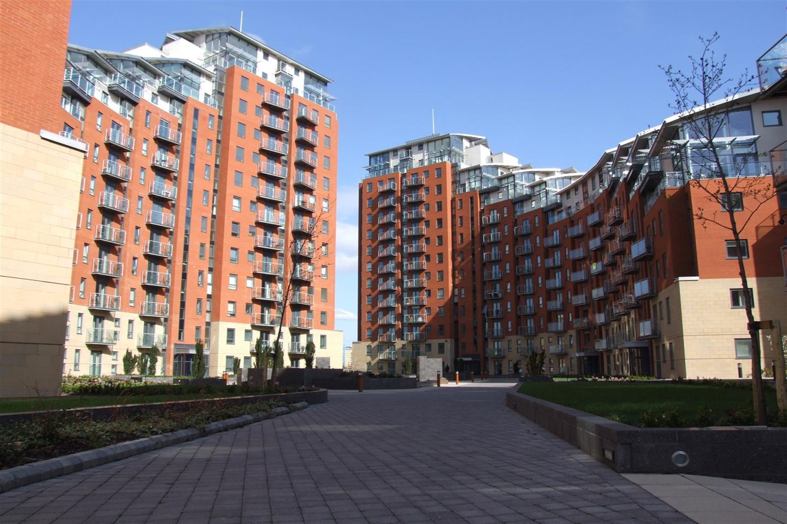



**Available to let £995.00pcm**

**Beringa, Gotts Road, Leeds**

A lovely seventh floor apartment, located in the popular City Island development. City Island is situated between the River Aire and Leeds Liverpool Canal, and is well positioned for easy access into and out of the city centre, as well as the bars and restaurants the West End of the city has to offer. This TWO bedroom property is available furnished, and boasts a City facing balcony as well as secure under croft parking. Available 22nd November. Sorry, no pets. Deposit £1145.

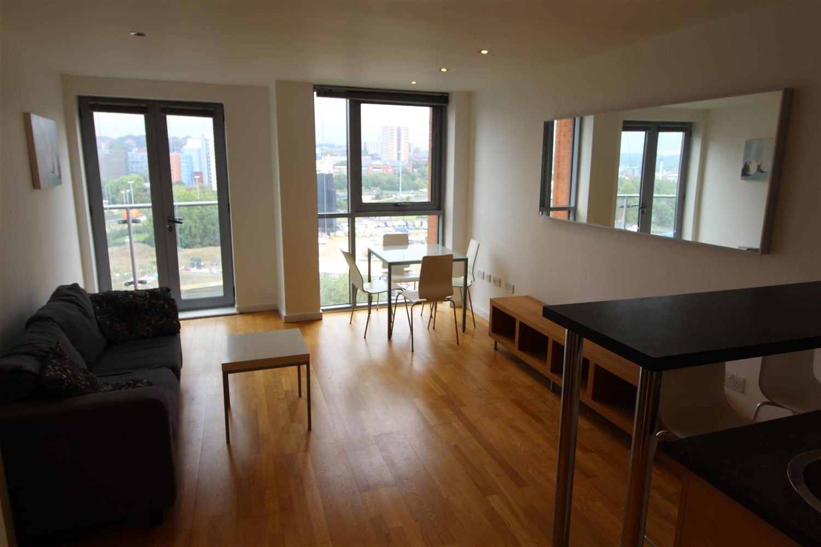

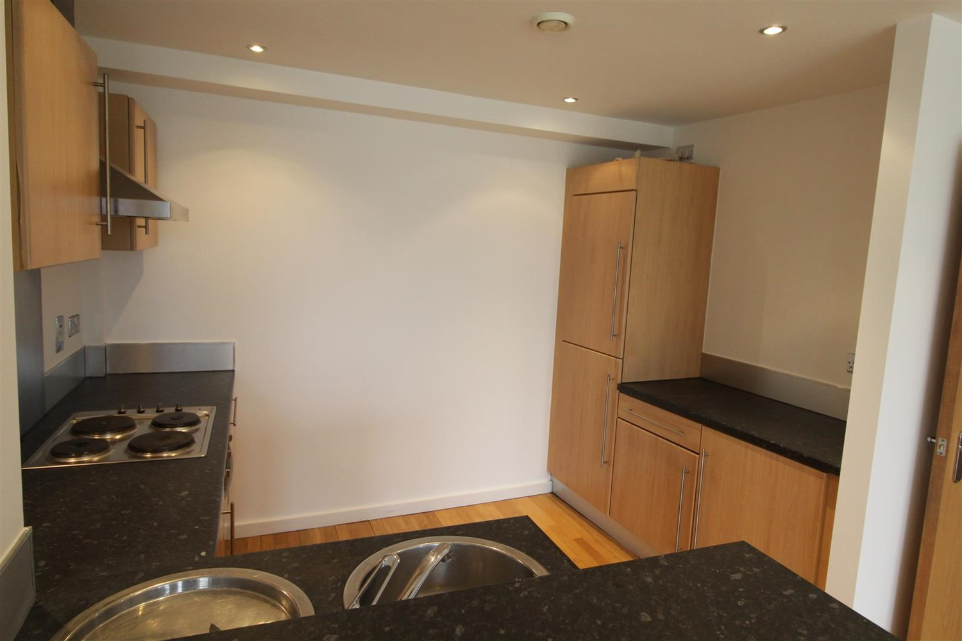

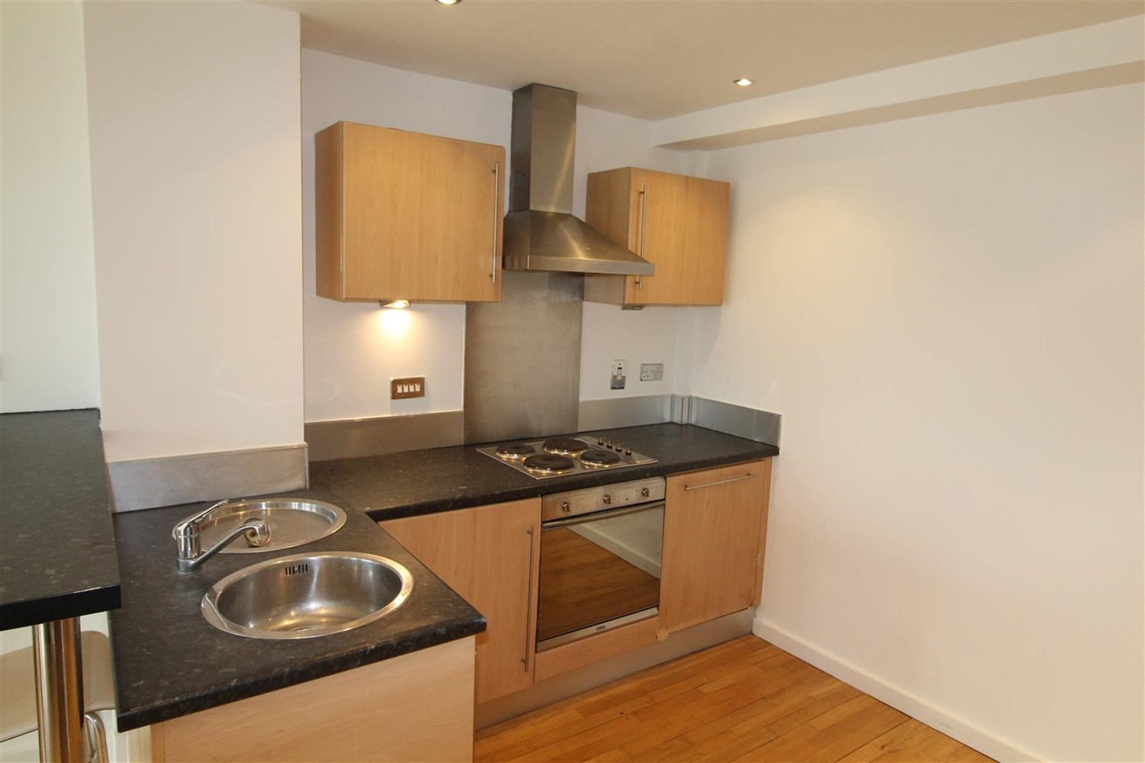

1 Bathroom(s)

1 Reception(s)

1 Bedroom(s)

00

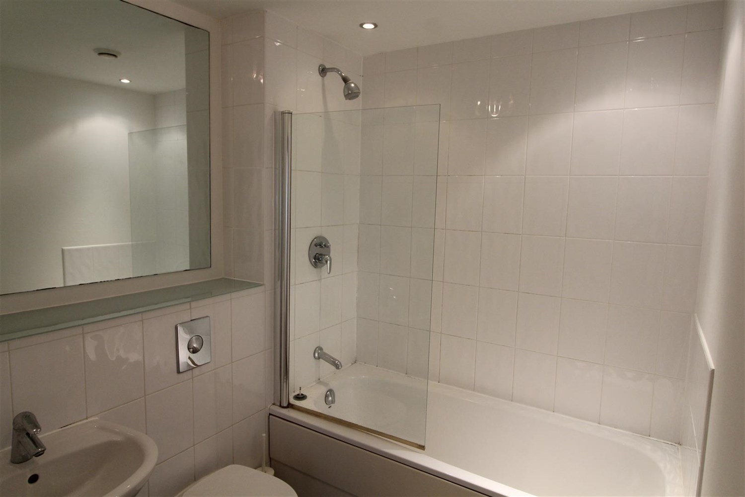

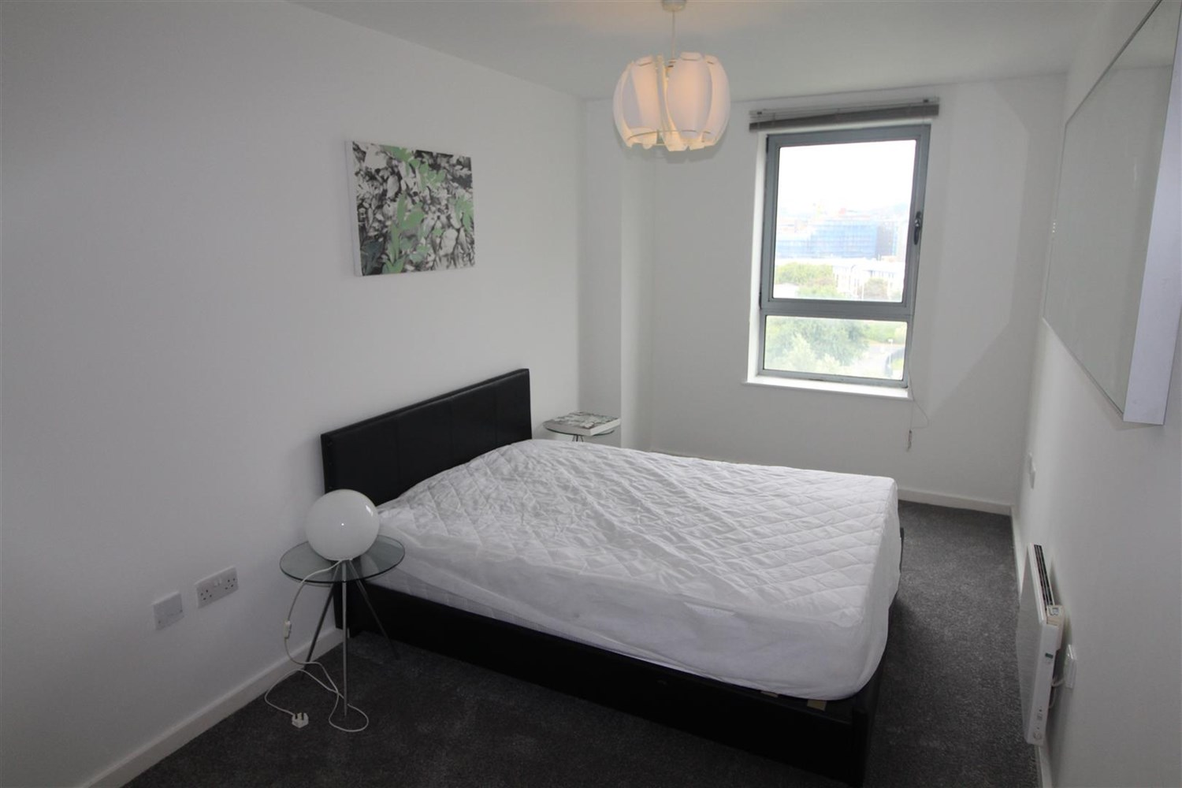

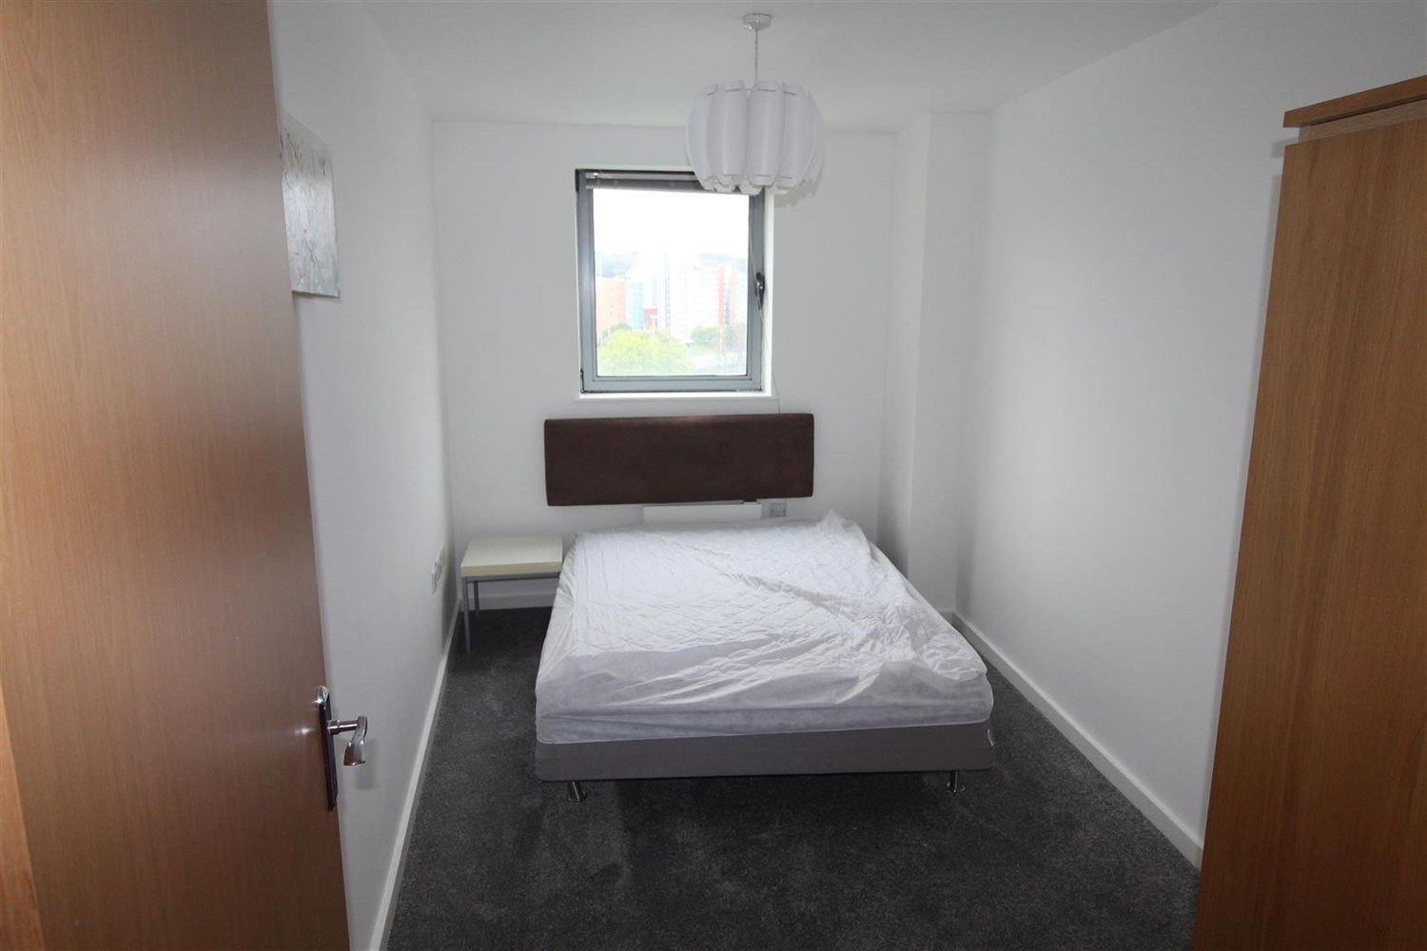

|  |
| --- |
| **Communal entrance**  Secure entrance with intercom system, access to all floors via lift and staircase. |
| **Kitchen**  The kitchen area offers a range of wall and base mounted units, single drainer stainless steel sink with mixer tap, integrated oven, hob and extractor, fridge freezer and washing machine. |
| **Living room**  A good sized room with wood effect flooring, electric panel radiator and door to balcony, boasting waterside views. |
| **Bedroom 1**  Double bedroom with an electric panel radiator and double glazed window. |
| **Bedroom 2**  Second bedroom with double glazed window. |
| **Bathroom**  Three piece white suite comprising bath with shower over and glass shower screen, W/C and basin, tiling to walls and floor and heated towel rail. |
| COUNCIL TAX BAND: D EPC Rating C  Leasehold property Parking available  Broadband availability: Standard 16 Mbps 1 Mbps Good Superfast 80 Mbps 20 Mbps Good Ultrafast 1000 Mbps 1000 Mbps  Mobile availability: EE Limited Three Limited O2 Likely Vodafone Likely  Utilities: Water supplied on standard meters. Electric mains supplied on standard meters. |

|  |  |
| --- | --- |
| These particulars are intended to give a fair description of the property, but their accuracy cannot be guaranteed, and they do not constitute an offer of contract. Intending purchasers must rely on their own inspection of the property. None of the above appliances/services have been tested by ourselves. We recommend purchasers arrange for a qualified person to check all appliances/services before legal commitment.  **Property Ref:** 3762  **For more information, please contact**  0113 258 1150 **|** [lettings@adairpaxton.co.uk](mailto:lettings@adairpaxton.co.uk) **|** www.adairpaxton.co.uk |  |