

**Branch Road, LS12**

**£925.00pcm**

**House**

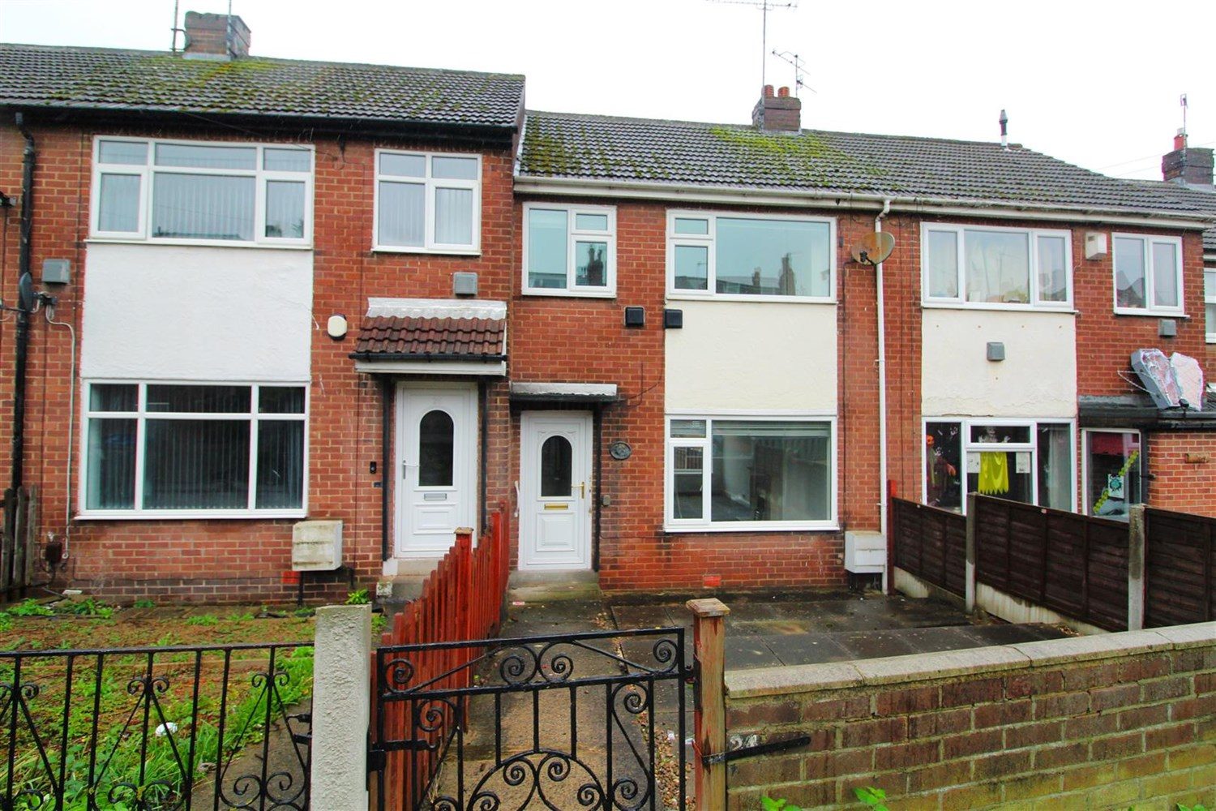

1 Bathroom(s)

1 Reception(s)

1 Bedroom(s)

***THREE BEDROOM MID-TOWN HOUSE*** Adair Paxton are delighted to offer this attractive two bedroom town house to the market. Spacious and well presented throughout, the property is Ideally located for access to Leeds and Bradford City Centres along with Ring Road and Motorway Networks. Good local schools, shops and bus routes are nearby. The property also benefits from UPVC double glazing, gas central heating and garage to the rear. The property briefly comprises: Entrance hall, spacious through lounge and modern fitted kitchen to the ground floor. To the first floor there are two double bedrooms, a single bedroom and a shower room. Externally the property has gardens to the front and rear, and a detached garage. Council tax band - A. EPC rating - C. Deposit £1,065. Available Now.



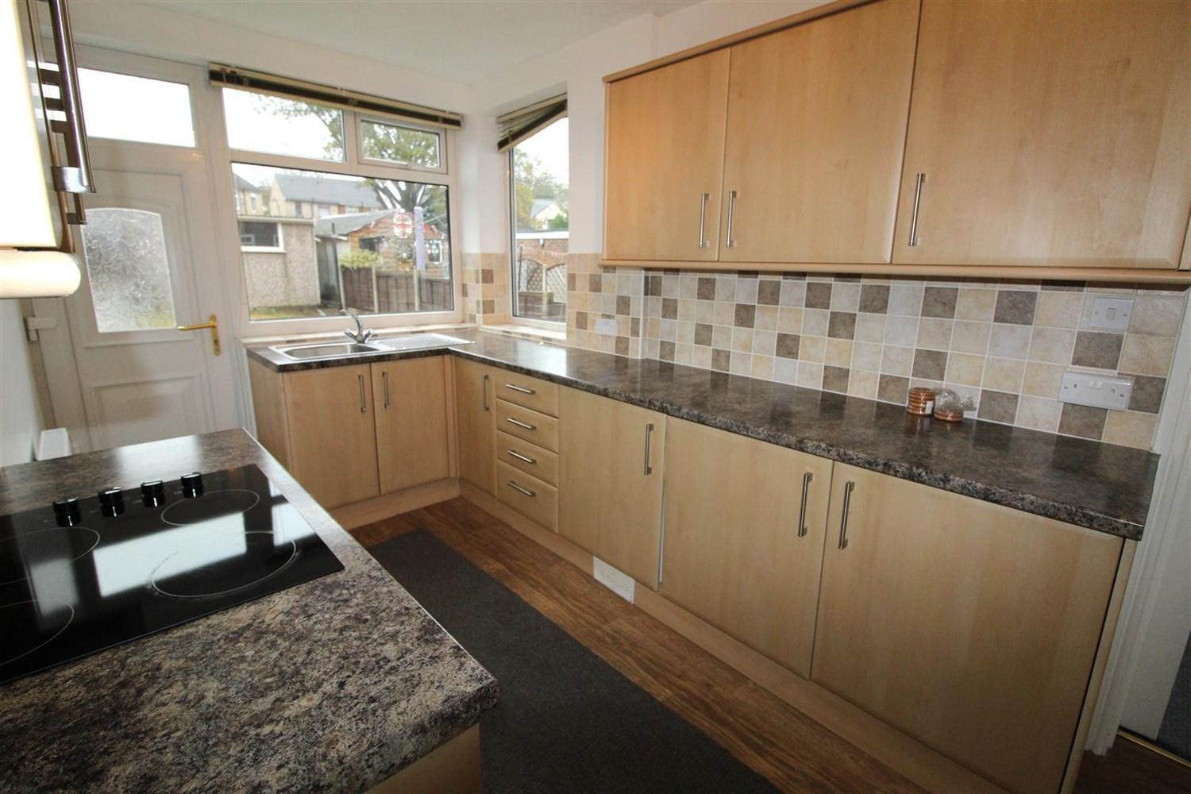

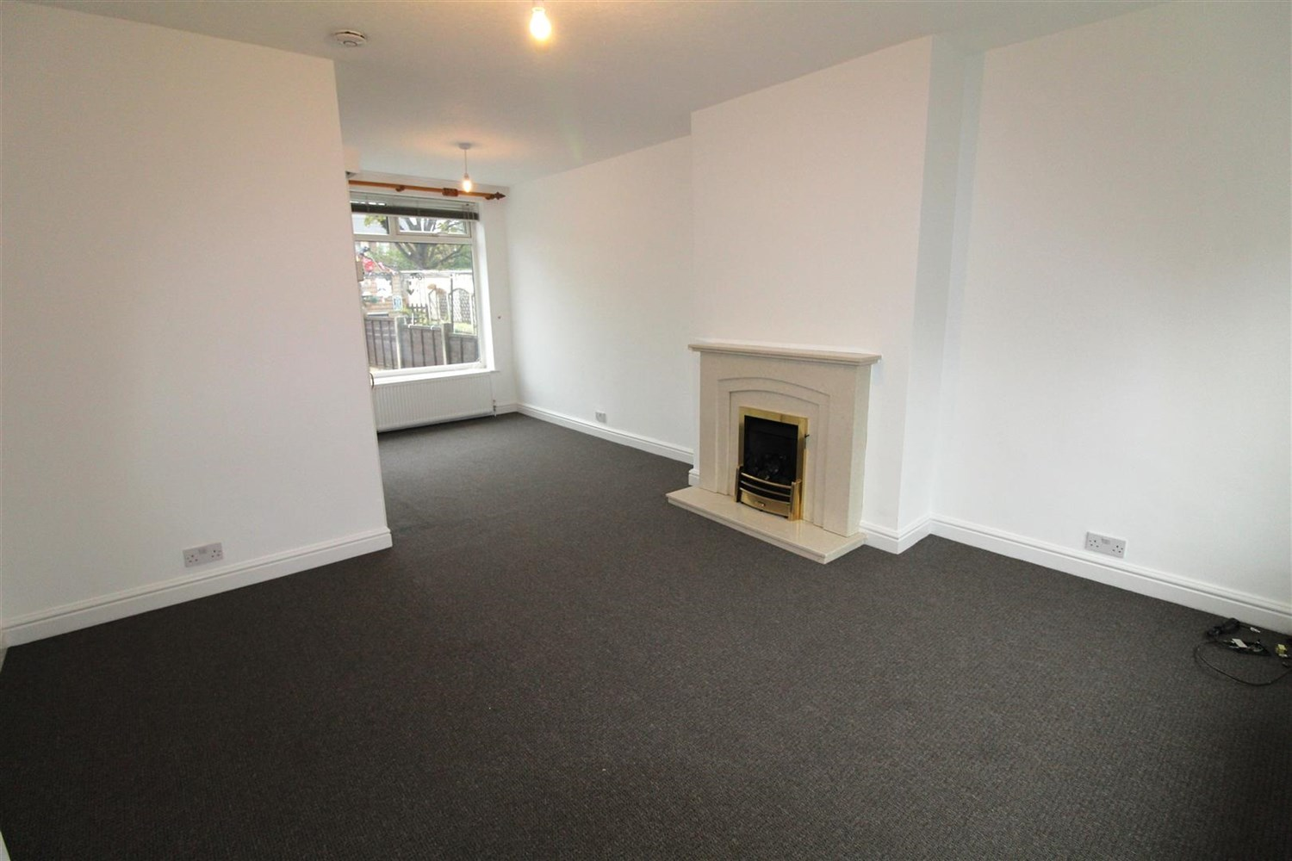

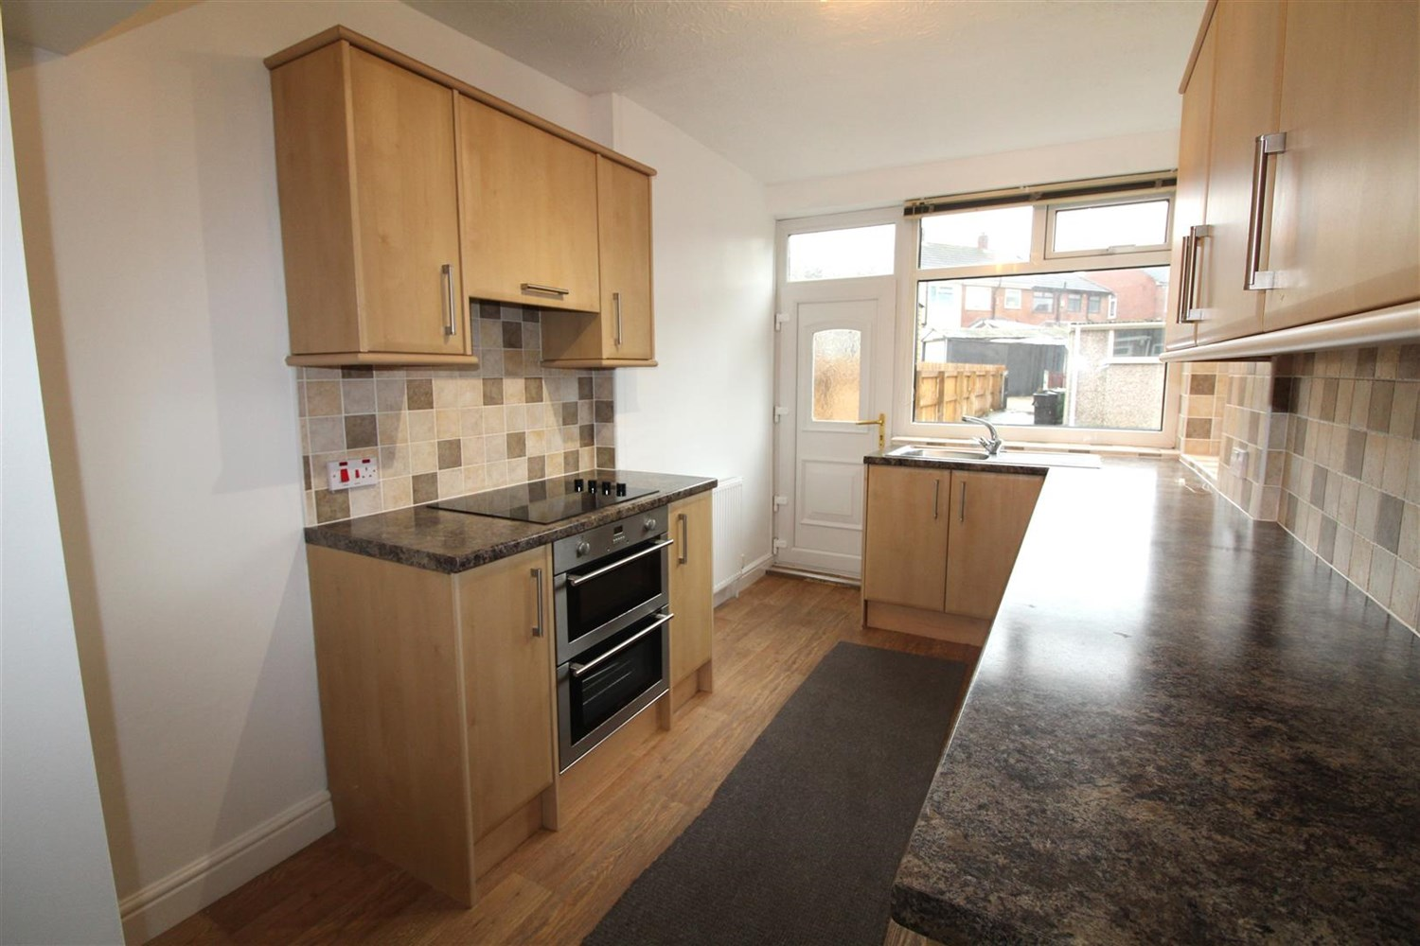

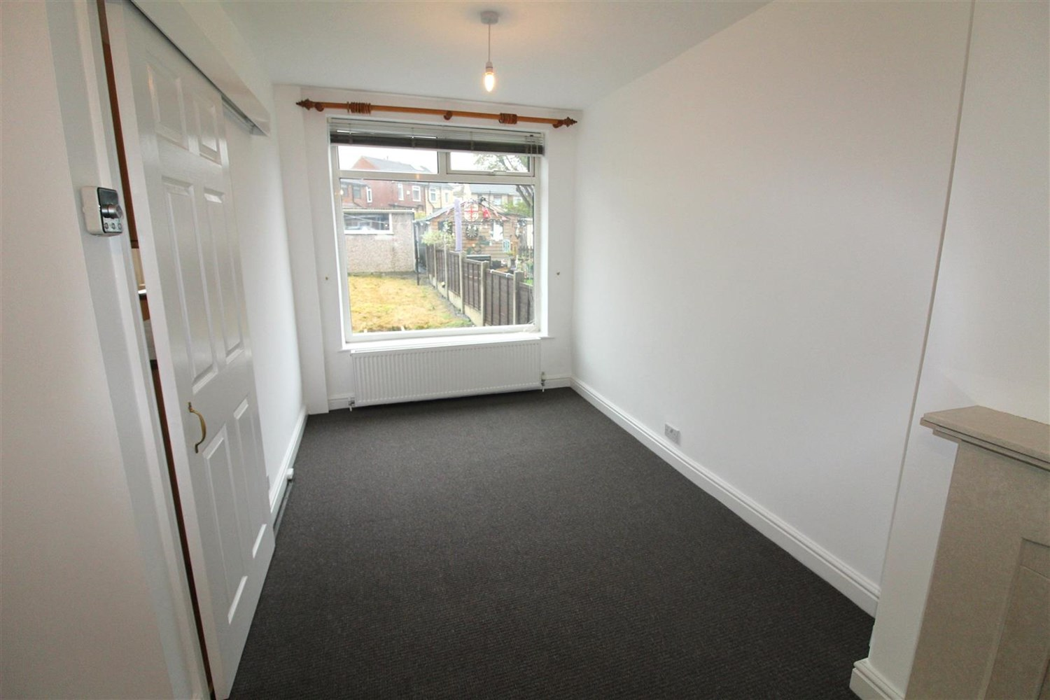

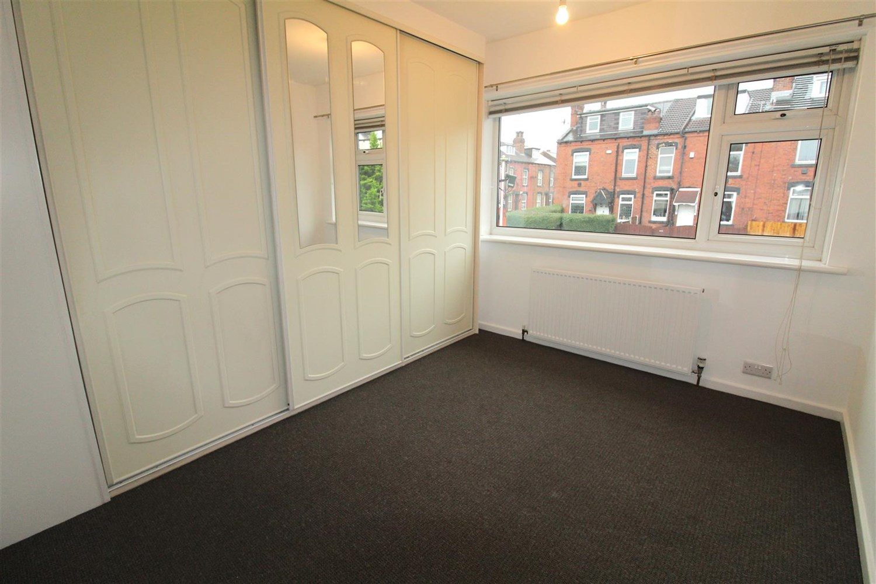

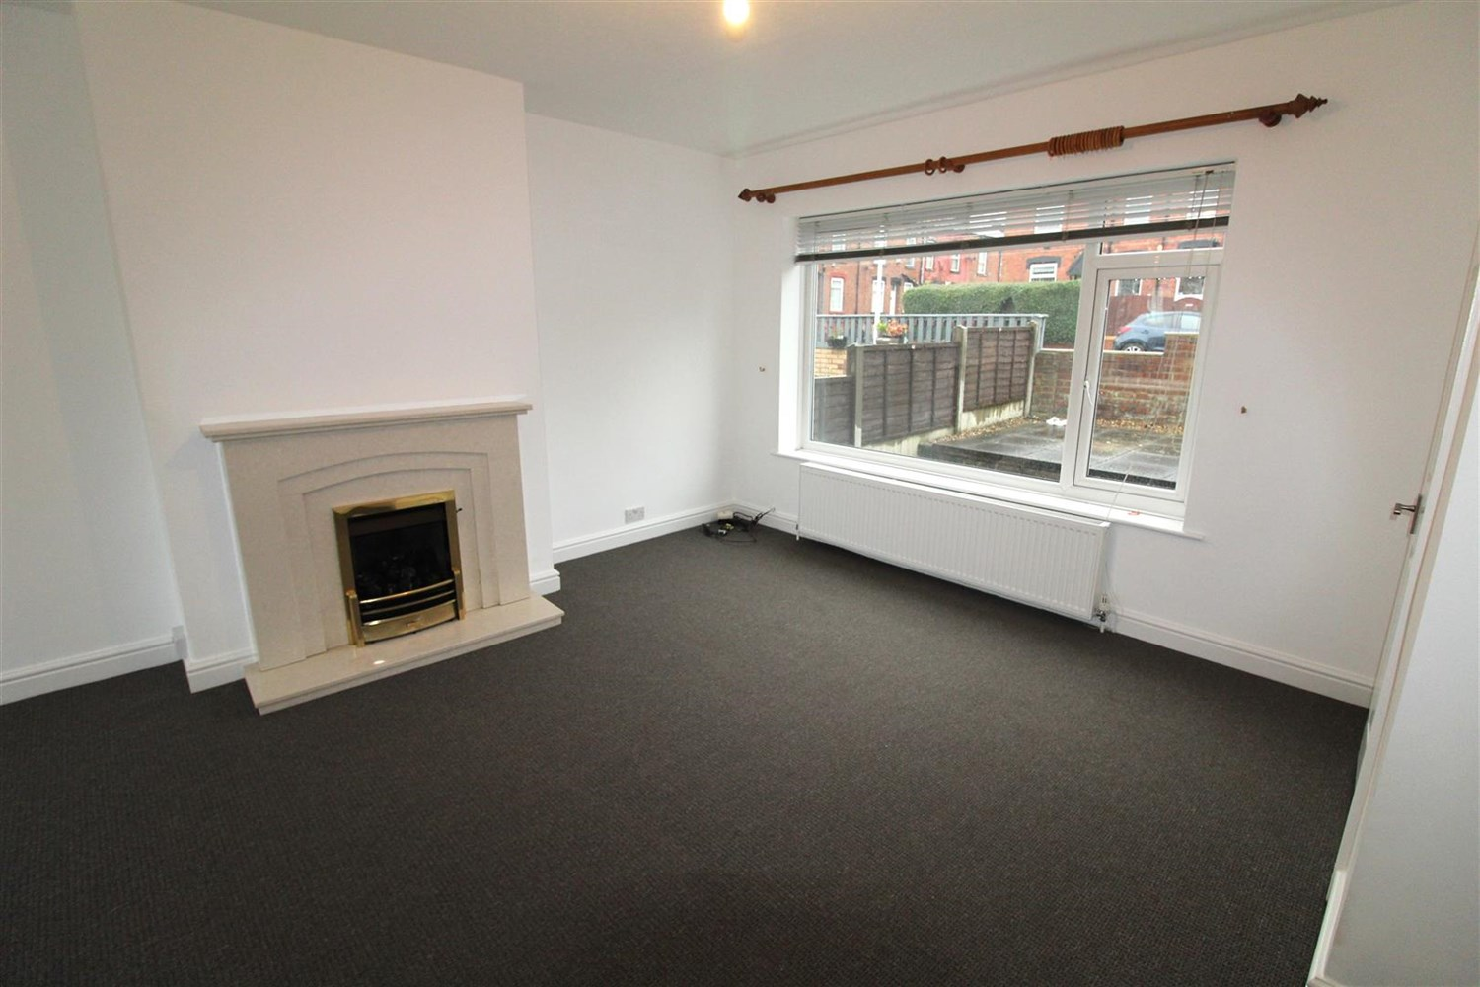



|  |
| --- |
| **Hallway**  Via uPVC double glazed entrance door. Stairs to first floor. |
| **Living Room 6.64m (21'9) x 3.87m (12'8)**  Light and Airy living area with uPVC double glazed window to front and rear. Two gas central heating radiators. Gas fire to chimney breast. |
| **Kitchen 4.41m (14'6) x 2.36m (7'9)**  Fitted with a range of wall, base and drawer units with worktops over. Integrated oven with electric hob and extractor hood over. Integrated fridge, freezer and washing machine. Part tiled walls. uPVC double glazed window and uPVC double glazed door to the rear. |
| **Master Bedroom 3.37m (11'1) x 3.05m (10'0)**  Double bedroom with uPVC double glazed window to front. Gas central heating radiator. Built in wardrobes. |
| **Bedroom 2 3.02m (9'11) x 2.98m (9'9)**  Second double bedroom with uPVC double glazed window to rear. Gas central heating radiator. Cupboard housing combi boiler. |
| **Bedroom 3 2.19m (7'2) x 1.75m (5'9)**  Third bedroom with uPVC double glazed window to front. Gas central heating radiator. |
| **Bathroom**  Fitted with a three piece suite comprising: Shower, WC and wash hand basin. uPVC double glazed window. Wall mounted heated towel rail. Tiled walls. |
| **Gardens to Front & Rear**  To the front of the property is an enclosed courtyard style garden. To the rear is a lawned garden with a patio area and a single garage. |
| **Home Information**  COUNCIL TAX BAND: C EPC Rating A  Freehold property On street parking.  Broadband: Standard 6 Mbps 0.8 Mbps Good Superfast 80 Mbps 20 Mbps Good Ultrafast 1000 Mbps 1000 Mbps  Mobile availability: EE limited coverage. Three limited coverage. O2 likely to have good coverage. Vodafone limited coverage.  Utilities: Water supplied on standard meters. Electric mains supplied on standard meters. Gas mains supplied on standard meters. |

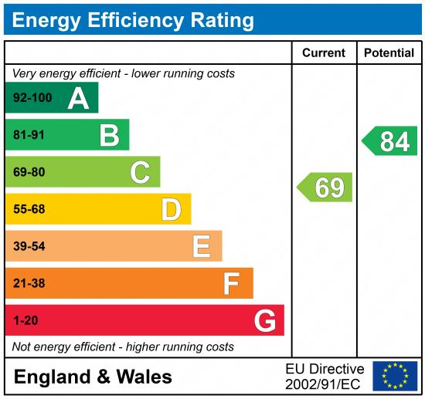

|  |
| --- |
|  |

These particulars are intended to give a fair description of the property, but their accuracy cannot be guaranteed, and they do not constitute an offer of contract. Intending purchasers must rely on their own inspection of the property. None of the above appliances/services have been tested by ourselves. We recommend purchasers arrange for a qualified person to check all appliances/services before legal commitment.

**Property Ref:** 4467

**For more information, please contact**

0113 258 1150 **|** [lettings@adairpaxton.co.uk](mailto:lettings@adairpaxton.co.uk) **|** www.adairpaxton.co.uk