

Long Causeway, Adel
For Sale £389,950.00

Adair Paxton are pleased to offer this two bedroom detached stone cottage situated in the heart of 'old' Adel. The Granary was originally part of the farm outbuildings to Beck cottage and stands on a pleasant plot. Accessed via a gated entrance, this beautiful home must be viewed to appreciate the accommodation on offer and briefly comprises; entrance hall, lounge, kitchen/diner and guest WC to the ground floor. To the first floor there are two double bedrooms and a modern shower room. Externally, the driveway leads to a detached stone built garage. The property has enclosed gardens and a patio area enjoying a great deal of privacy. The property is situated in this convenient and highly sought after location to the North of Leeds. There is a wide choice of amenities nearby including shops, schools and recreational facilities and the property is ideally placed for daily travelling into the centre of Leeds.
0113 258 1150
0800 000 000
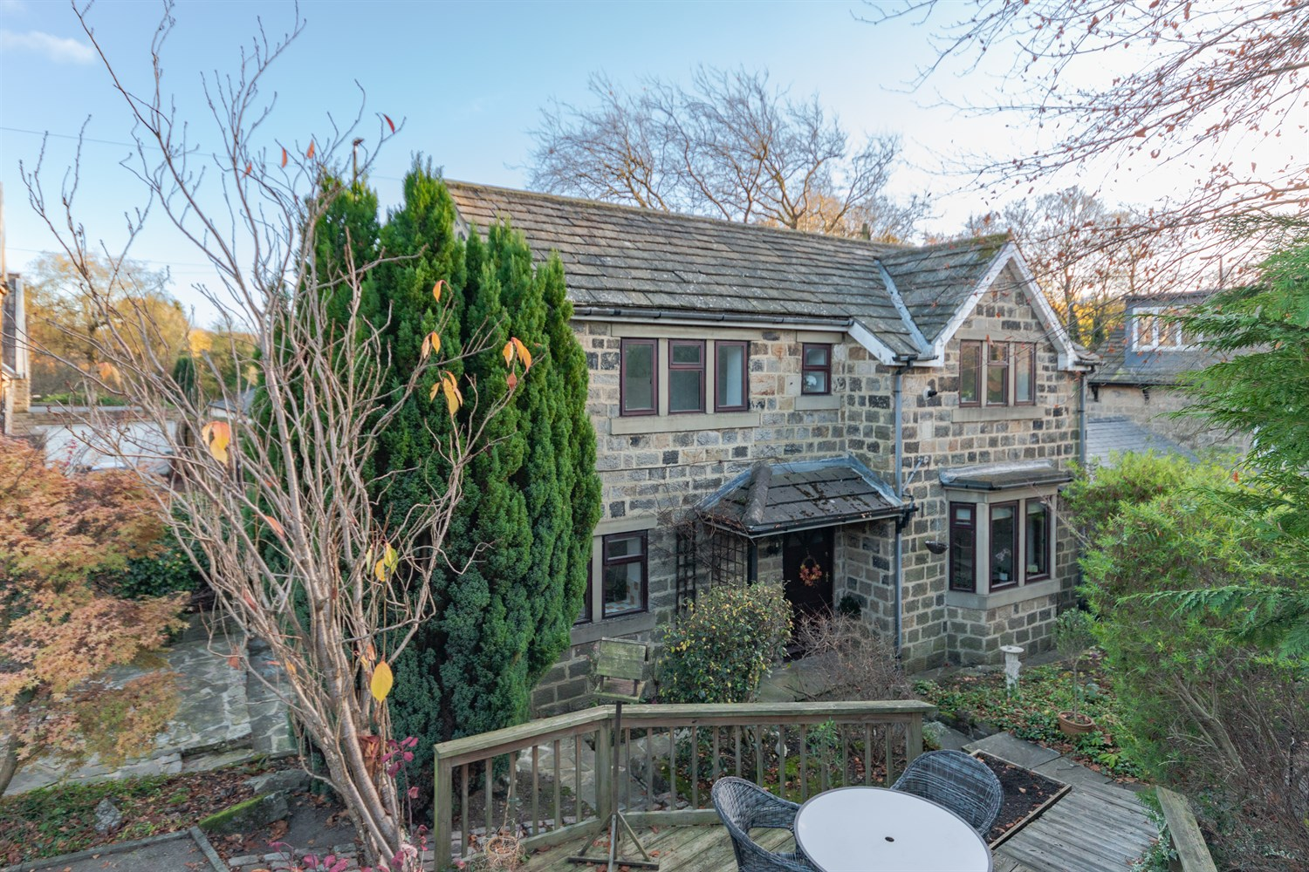
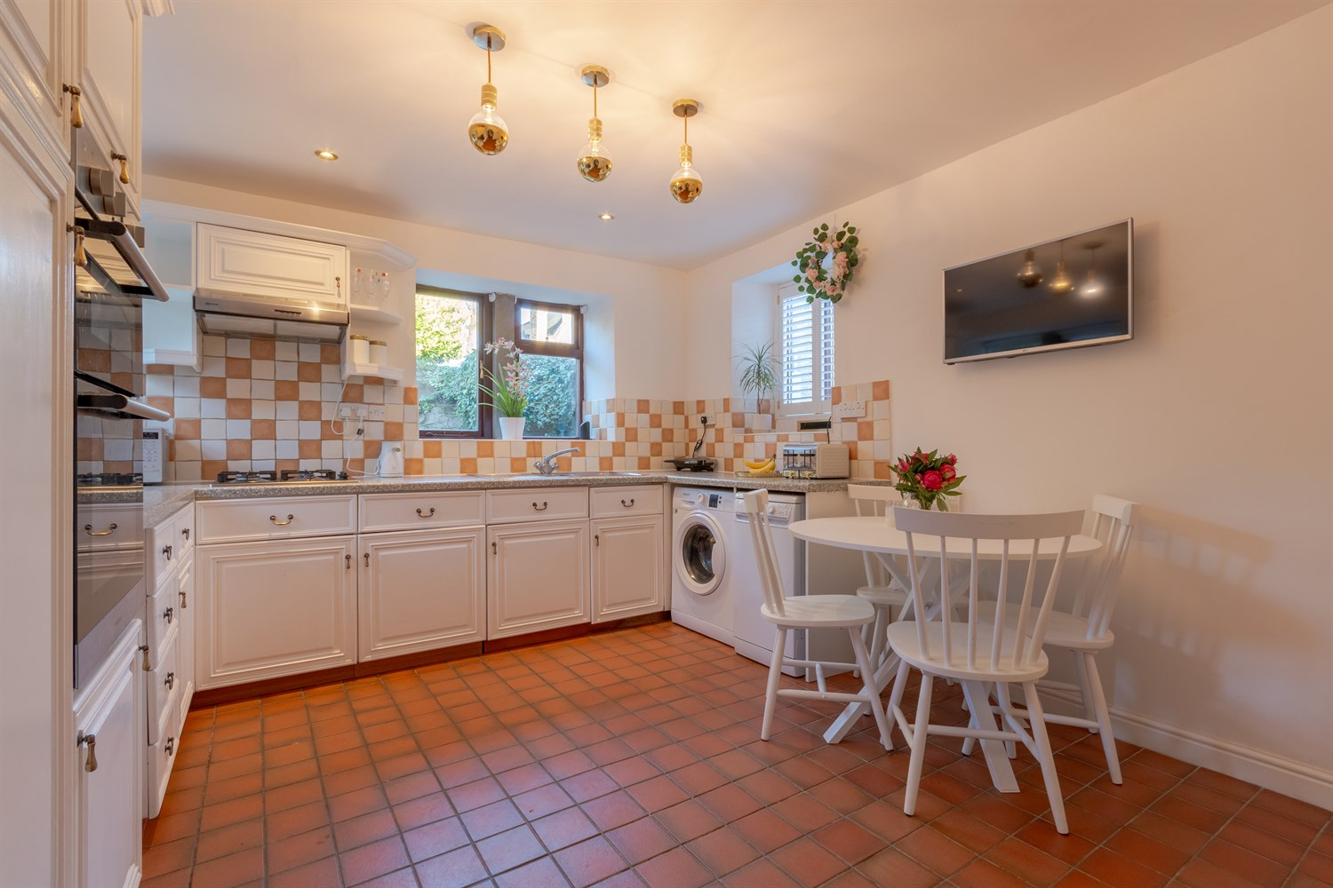
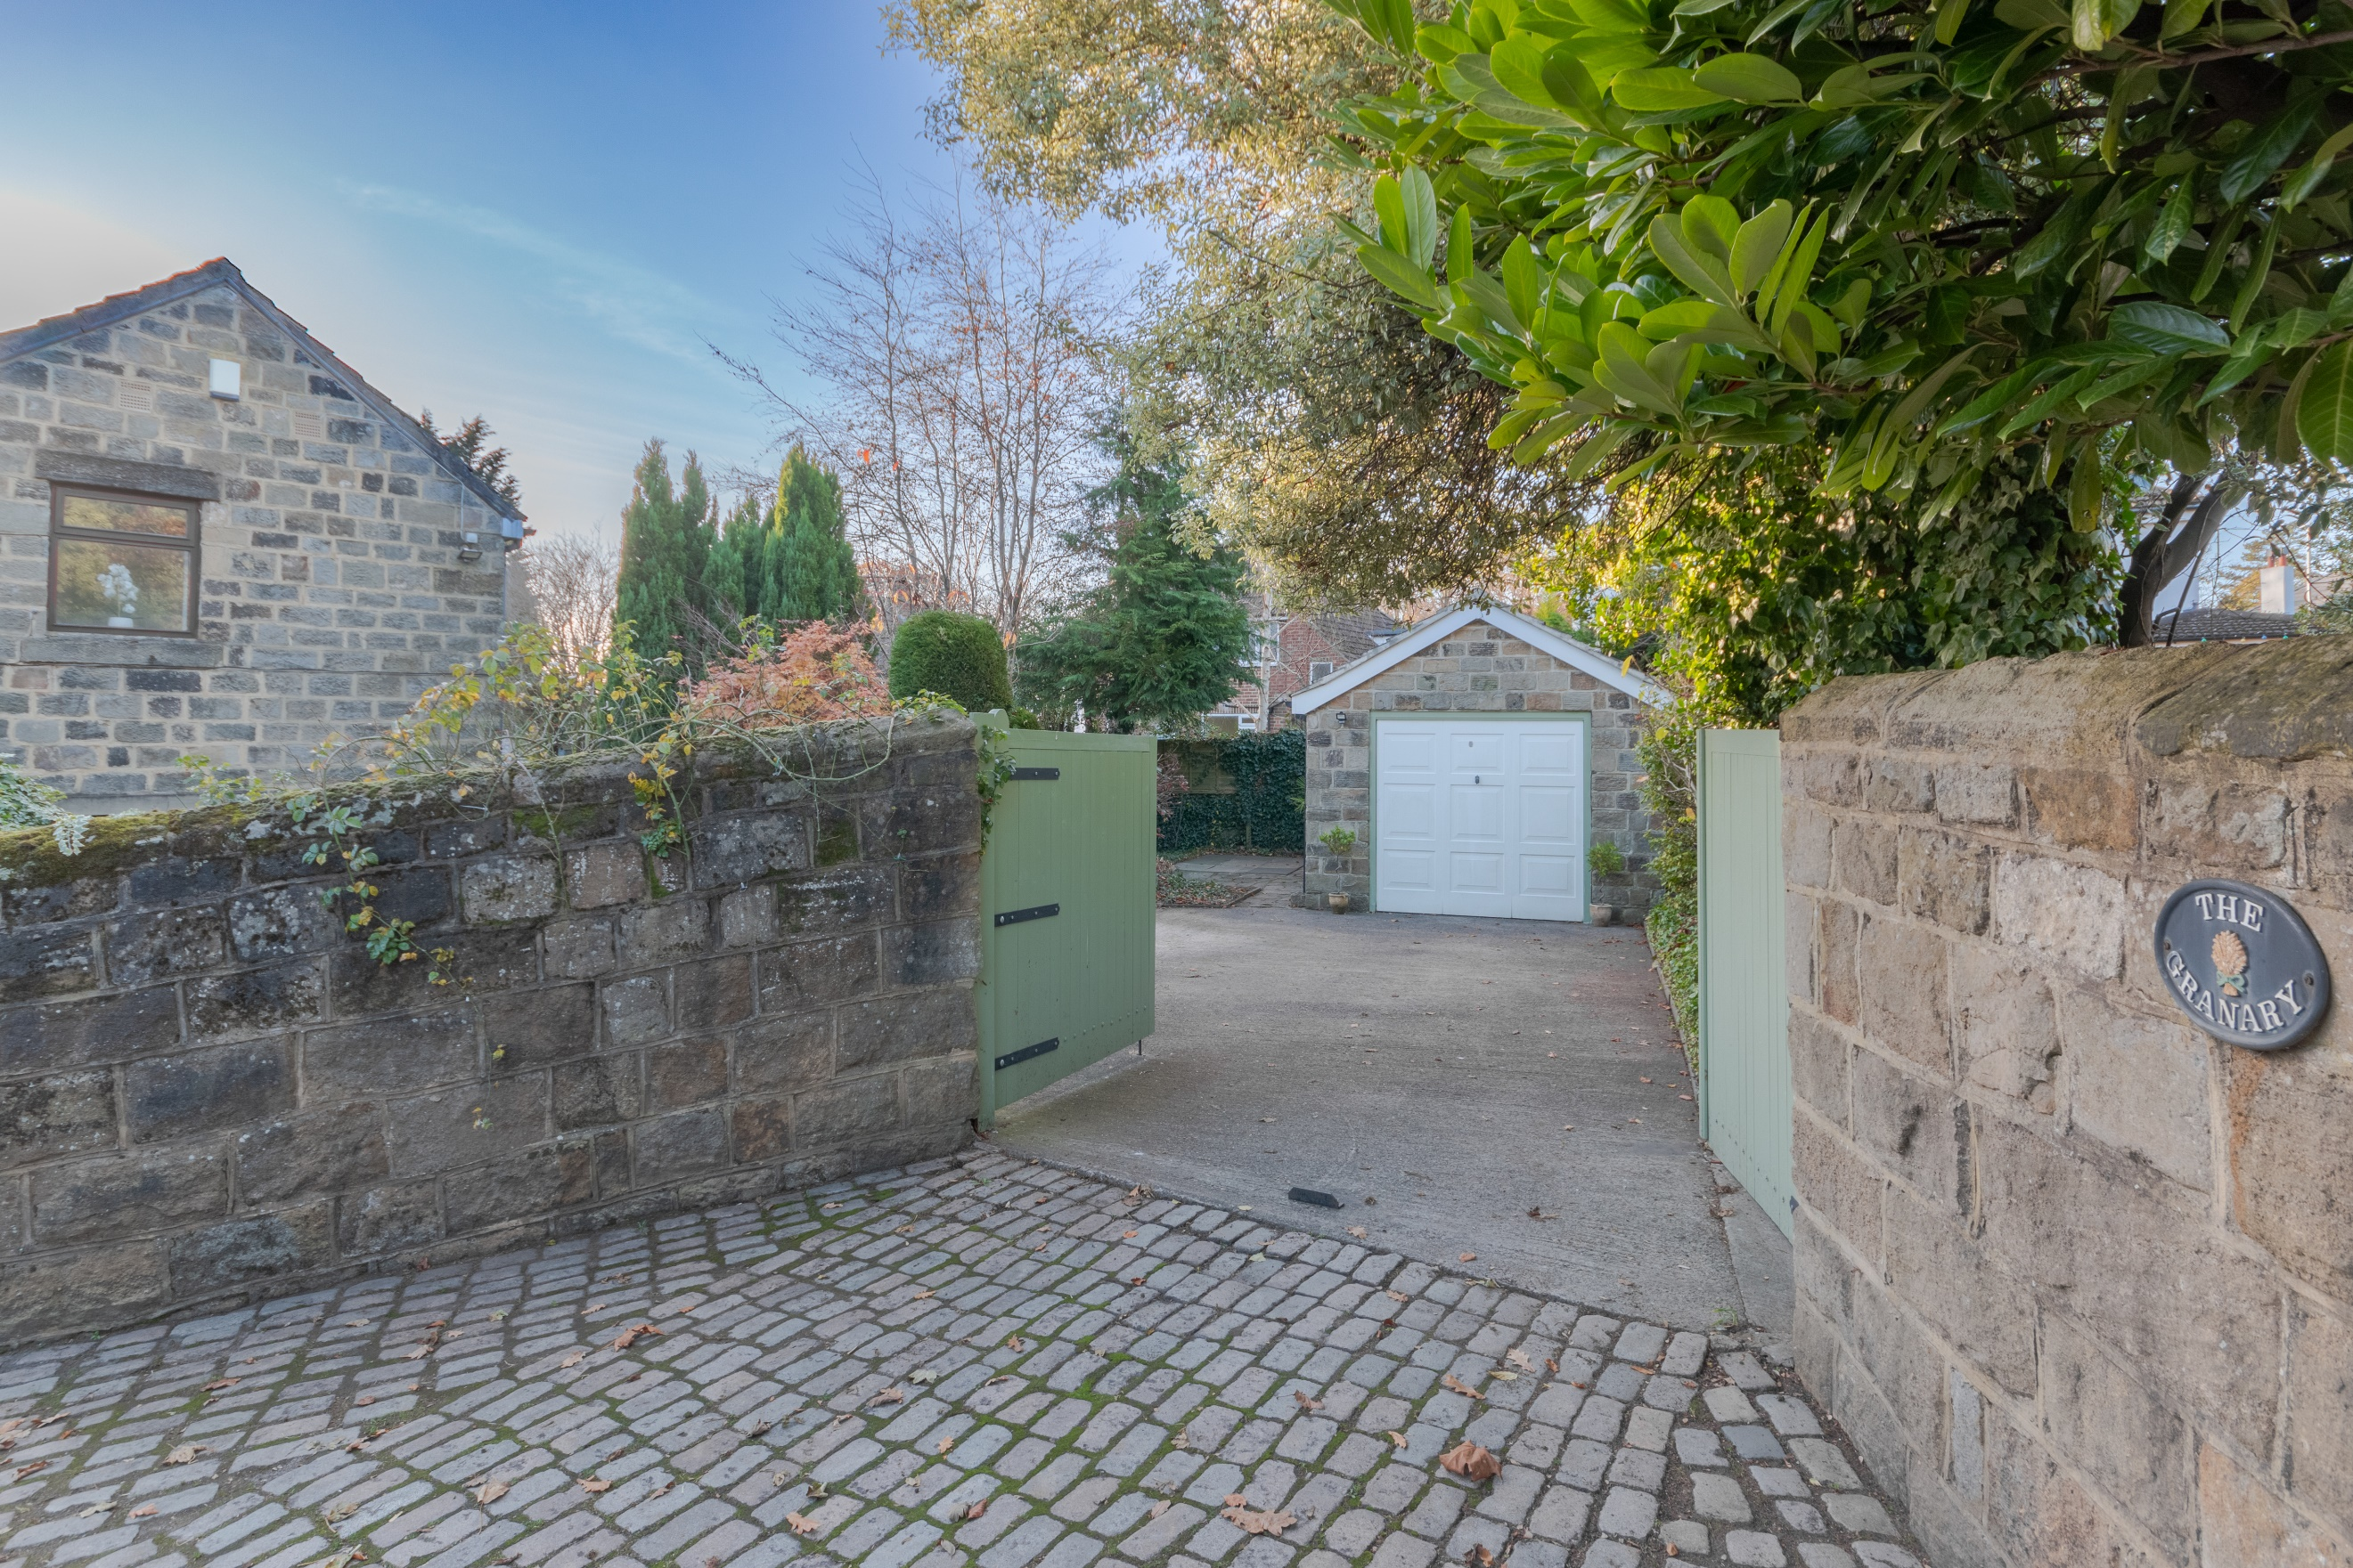
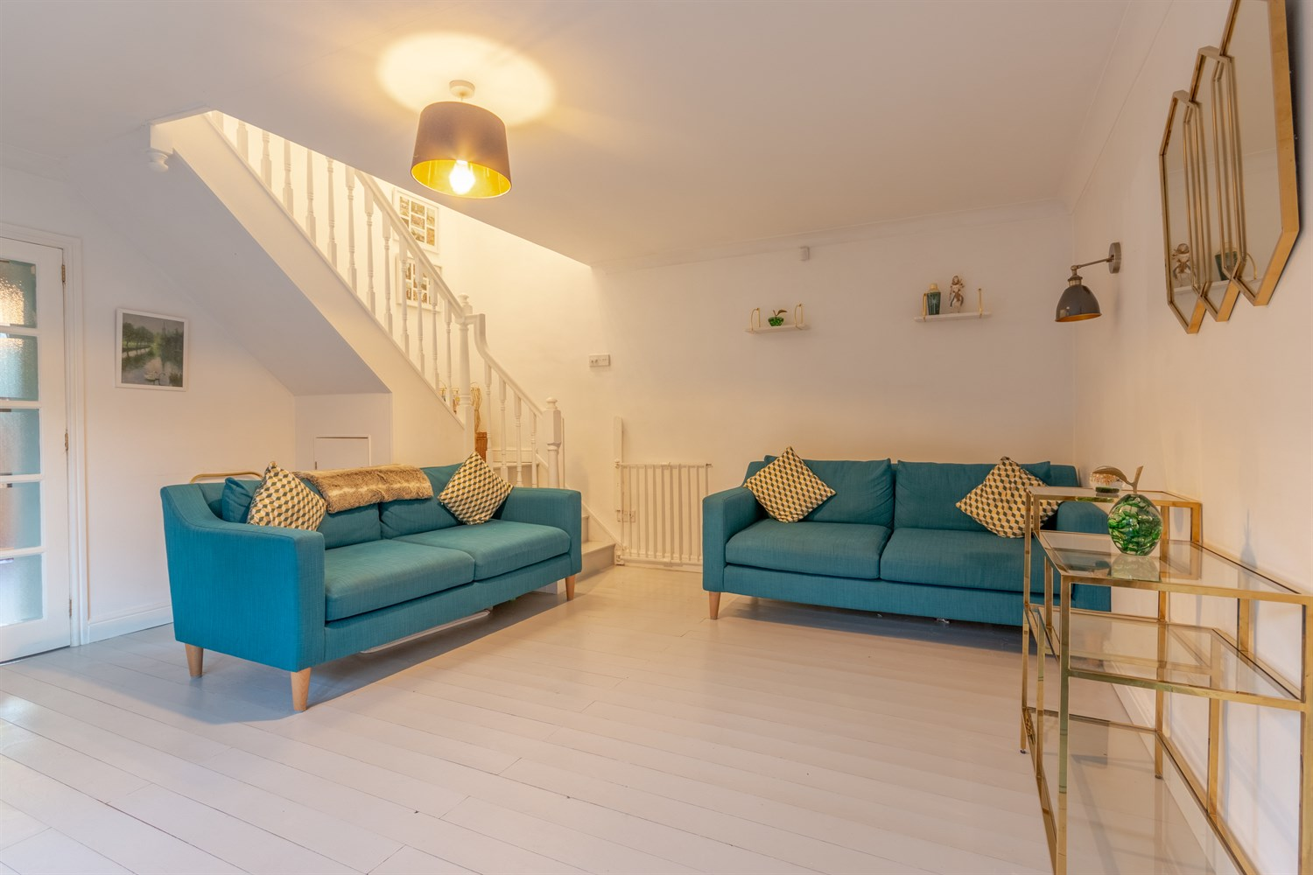
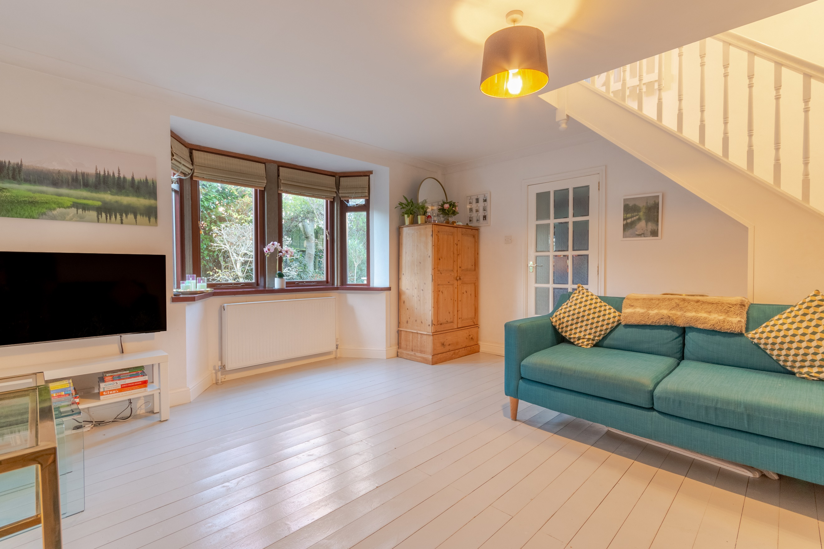
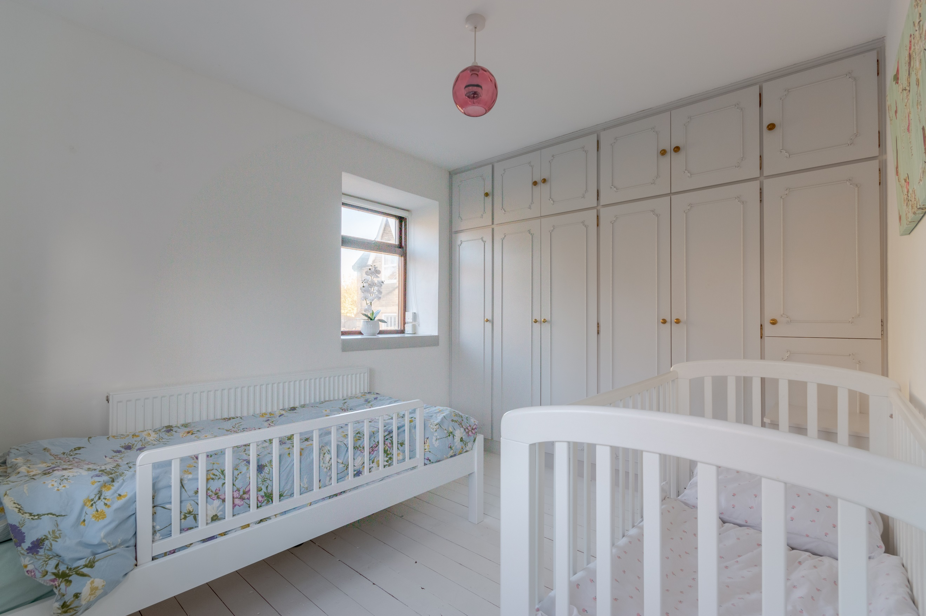
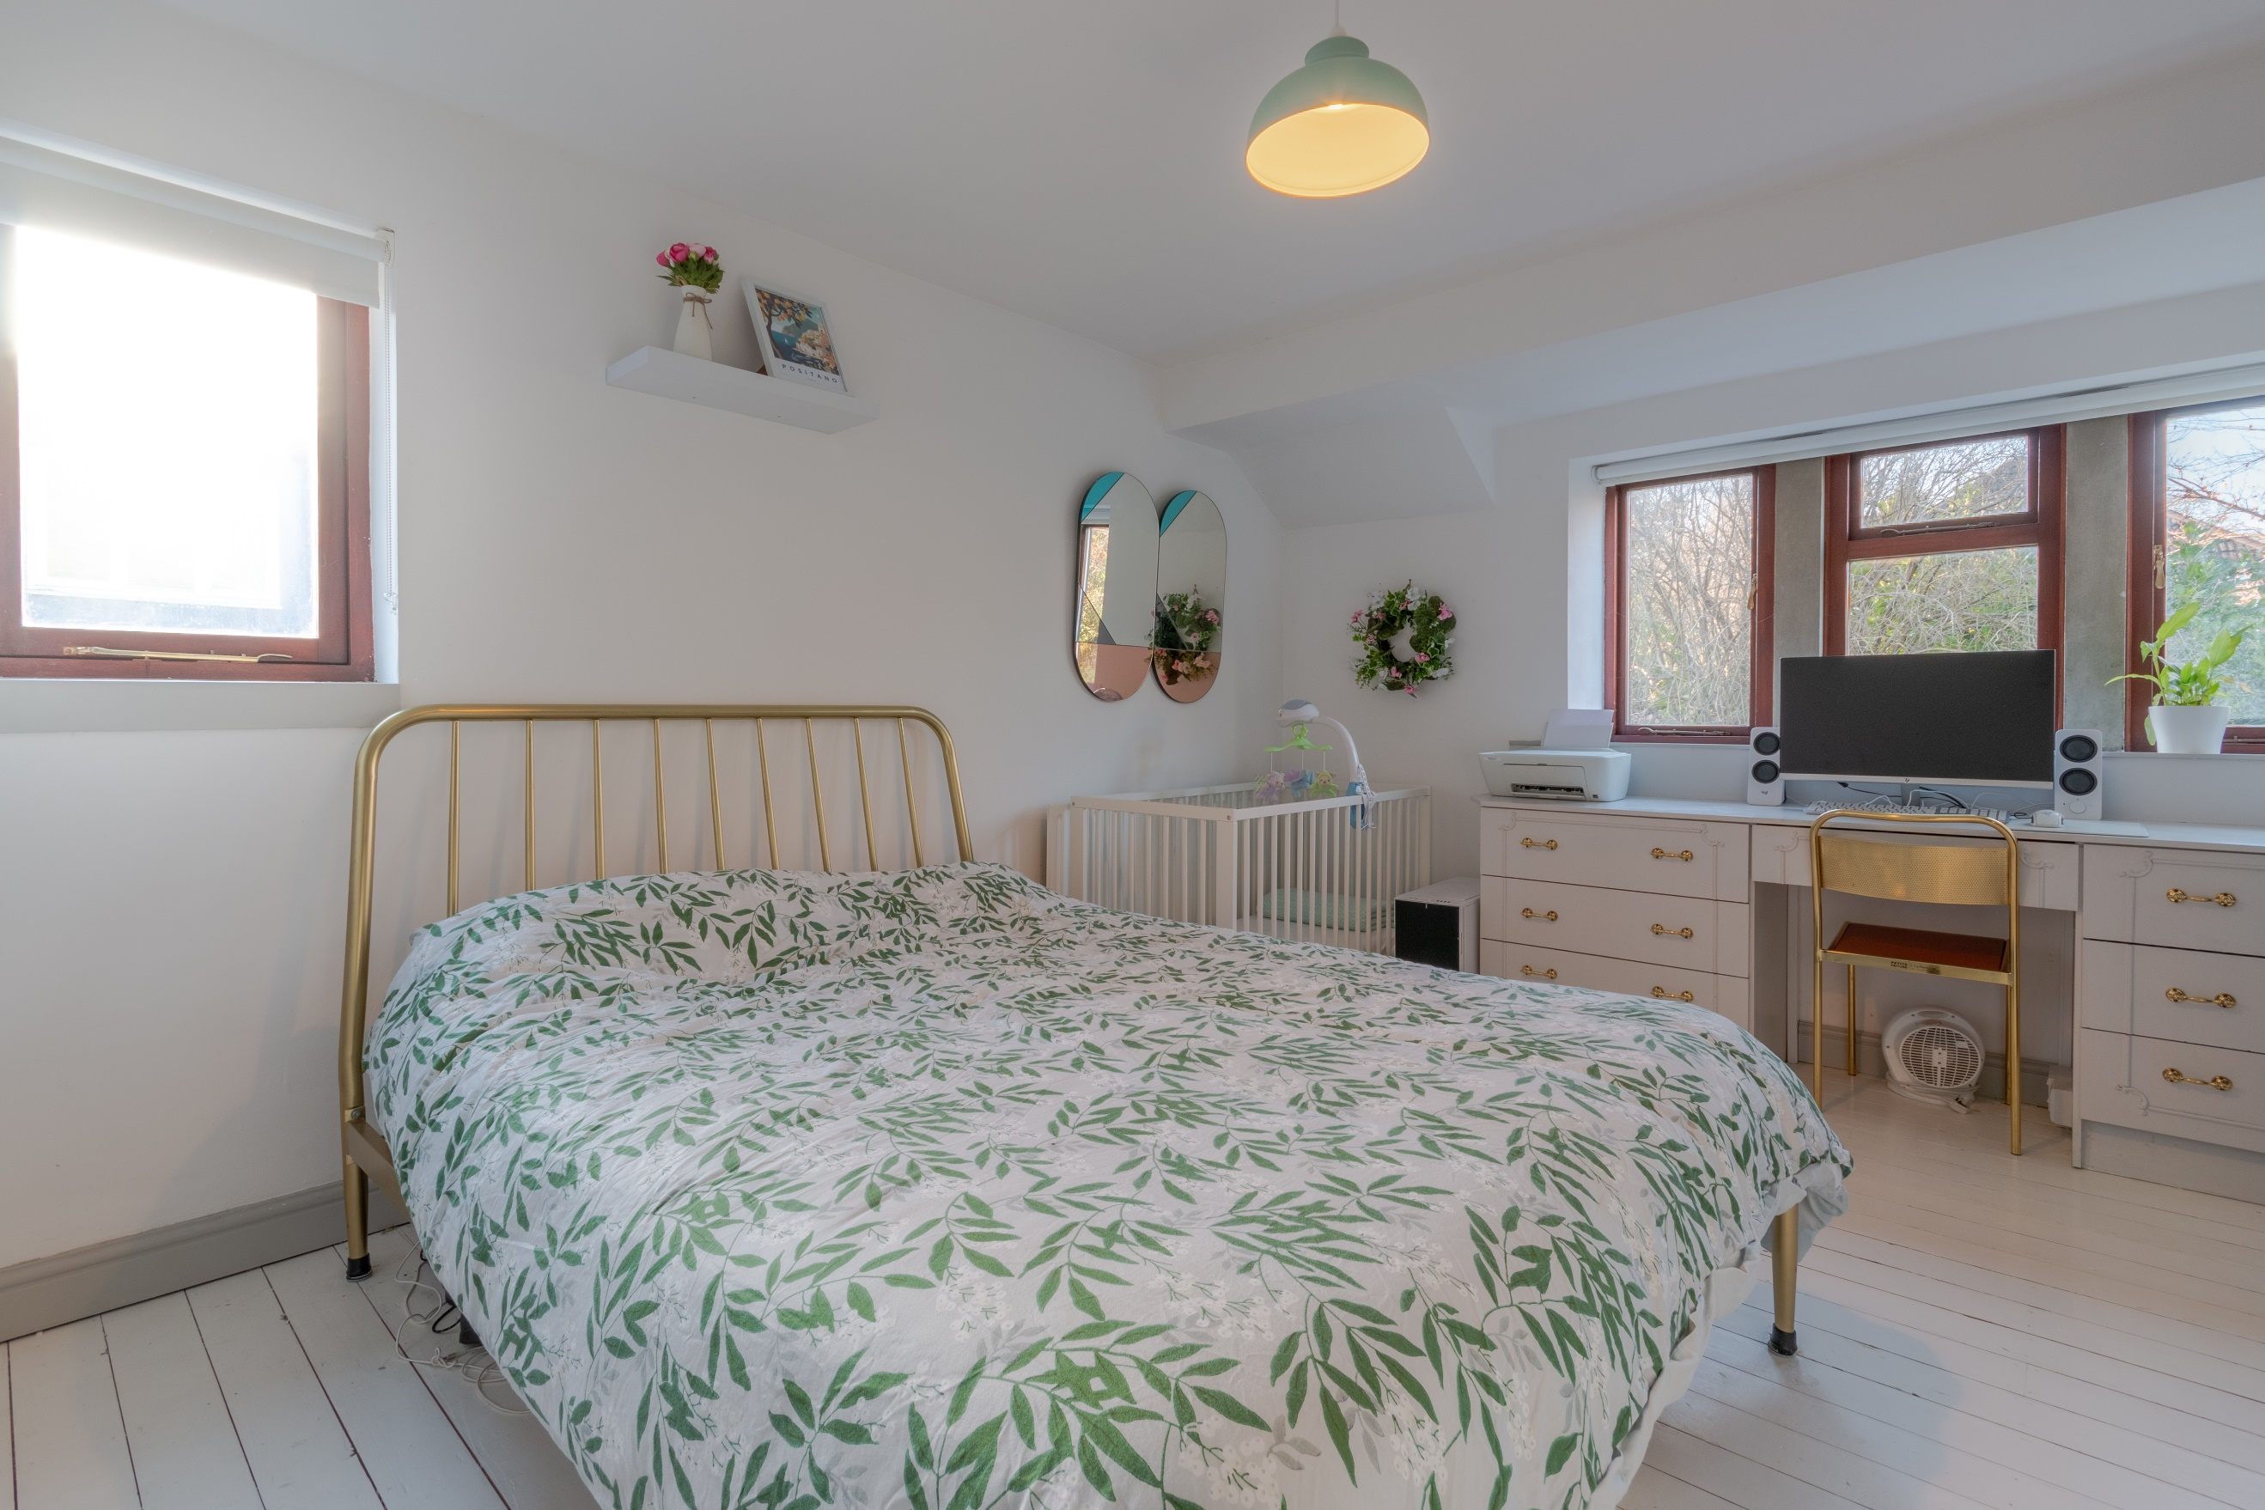
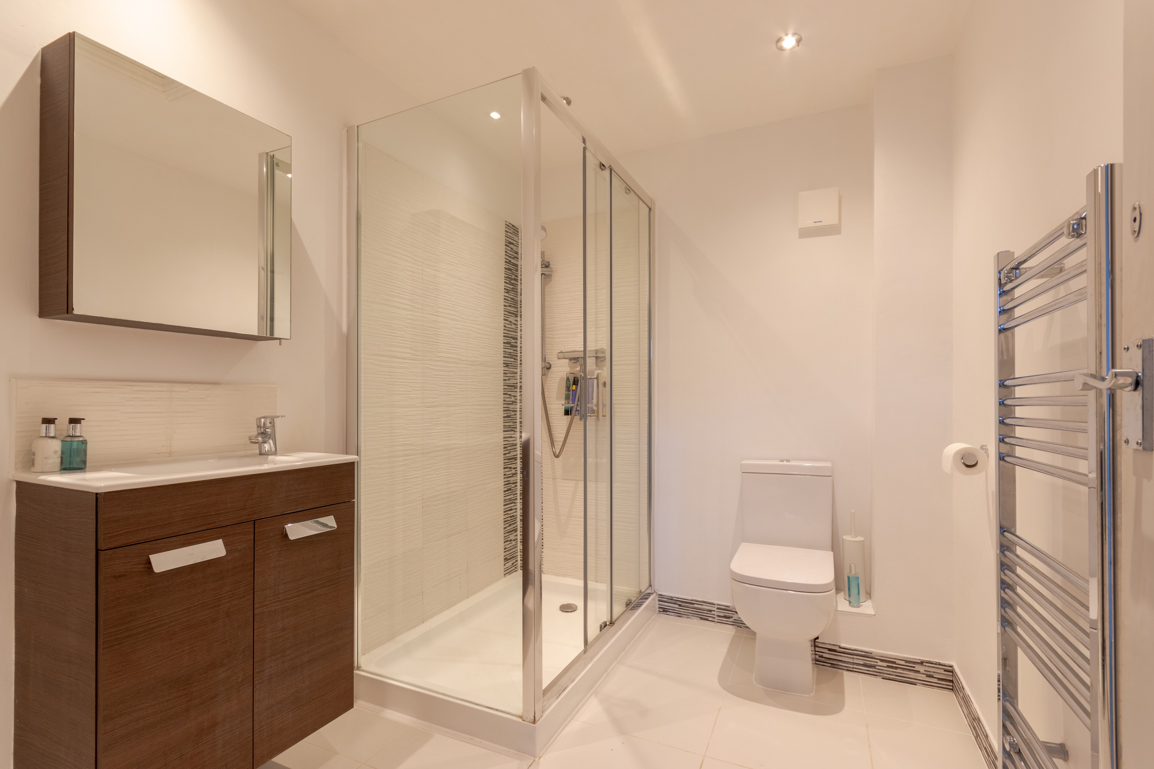
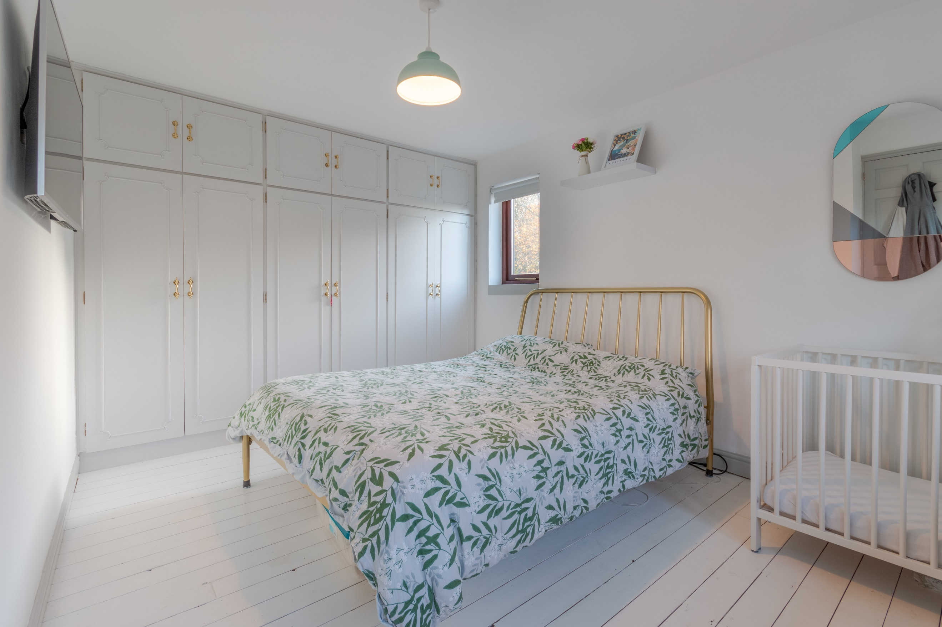

Entrance Hall
Via the front entrance door.

Kitchen/Diner
Fitted with a range of wall, base and drawer units with worktops over. Integrated oven with 4-ring gas hob and extractor hood over. Stainless steel stink with mixer tap and drainer. Space for washing machine, dishwasher and fridge/freezer. Tiled floor and part tiled walls. Window to front, rear and side. Inset ceiling spotlights. Gas central heating radiator.

Living Room
Spacious lounge with window to front. Gas central heating radiator. Stairs to first floor.

Guest WC
Fitted with a two piece suite comprising; WC and wash hand basin.

Bedroom 1
Master bedroom with window to front. Built in wardrobes. Gas central heating radiator.

Bedroom 2
Second double bedroom with window to front. Built in wardrobes. Gas central heating radiator.

Shower Room
Fitted with a three piece suite comprising; walk in shower cubicle, vanity wash hand basin and WC. Tiled floor and part tiled walls. Heated towel rail. Inset ceiling spotlights.

Outside
The Granary is accessed via entrance gates, leading to a detached stone built garage with a uPVC double glazed window to the side and light and power. The enclosed gardens and patio area provide an excellent level of privacy.

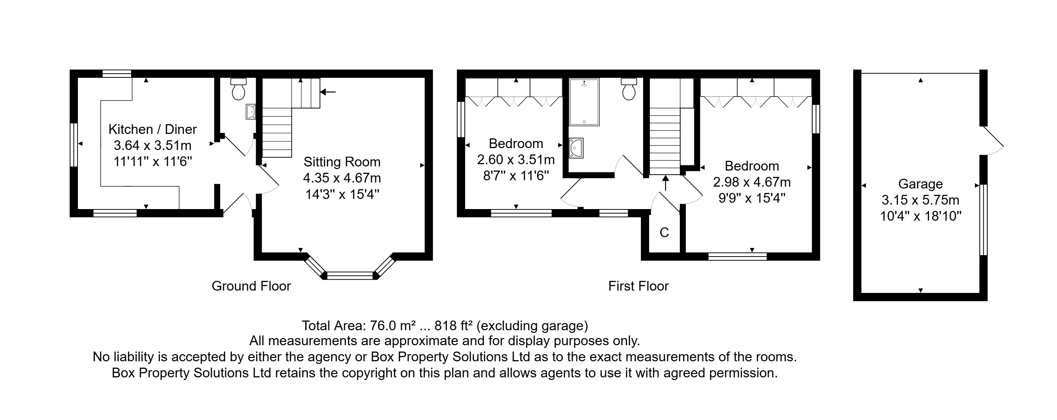

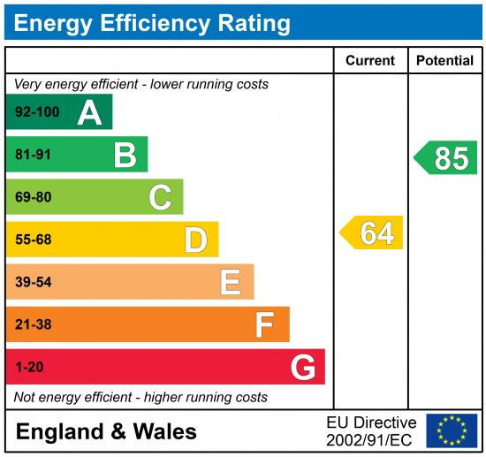

These particulars are intended to give a fair description of the property, but their accuracy cannot be guaranteed, and they do not constitute an offer of contract. Intending purchasers must rely on their own inspection of the property. None of the above appliances/services have been tested by ourselves. We recommend purchasers arrange for a qualified person to check all appliances/services before legal commitment.

Property Ref: 4332

For more information, please contact

0113 258 1150 | sales@adairpaxton.co.uk | www.adairpaxton.co.uk

