

**Beringa, City Island**

**For Sale £130,000.00**

## ***SPACIOUS ONE BEDROOM APARTMENT with NO ONWARD CHAIN*** Located in this popular development, this delightful third floor apartment briefly comprises: entrance hall, living room with doors leading out to the balcony, separate kitchen, double bedroom and house bathroom. City Island enjoys well maintained communal gardens and offers easy access to the vibrant city centre, including shopping centre’s, restaurants, cafes, and cultural attractions. Offered to the market with NO ONWARD CHAIN, an early internal viewing is highly recommended.

**0113 258 1150**

**0800 000 000**

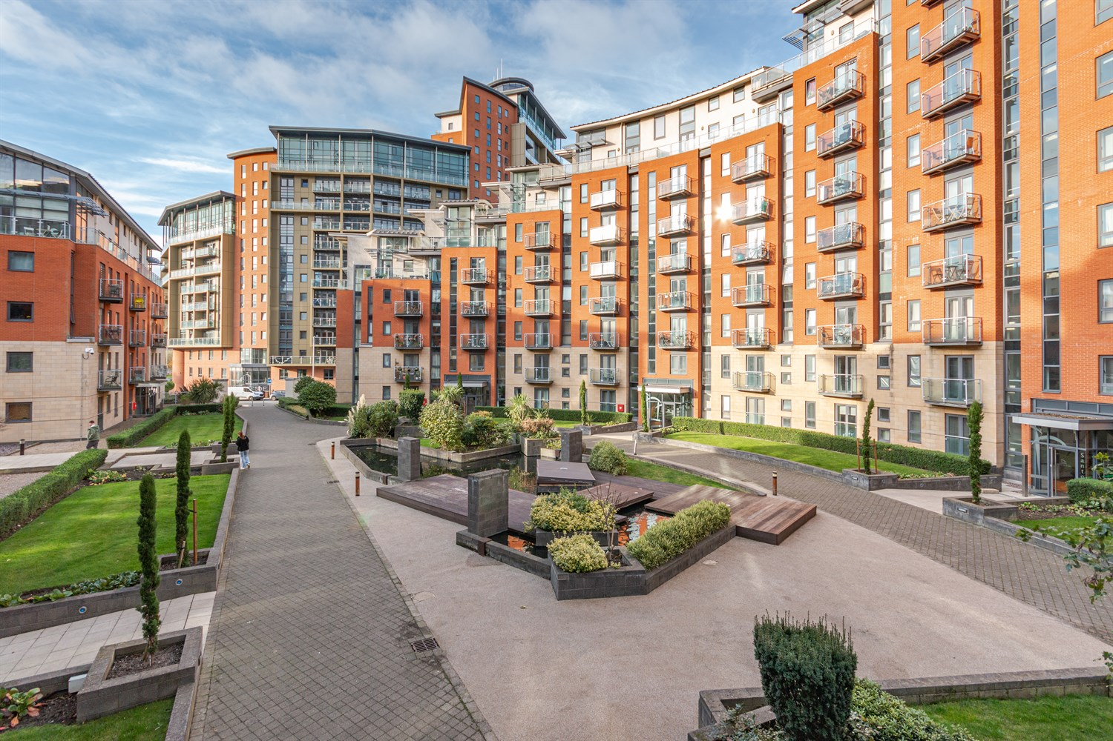



1 Reception

1 Bathroom

1 Bedroom

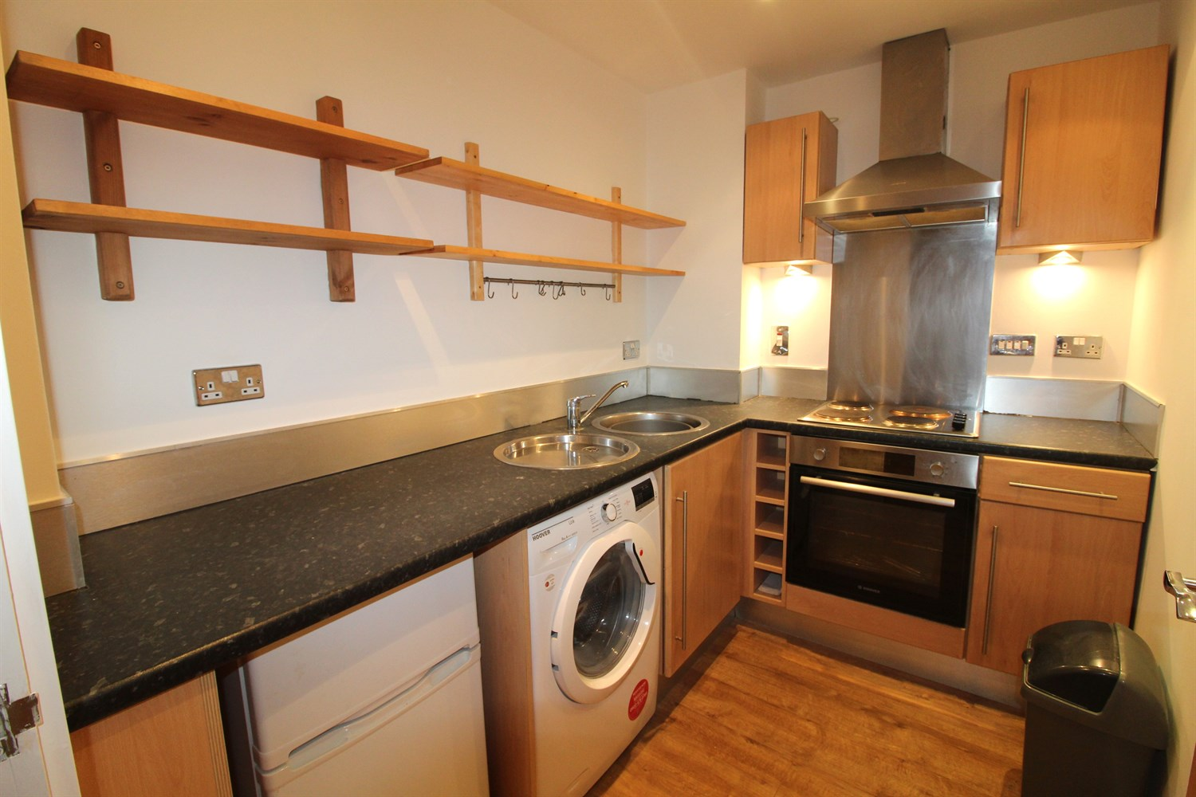

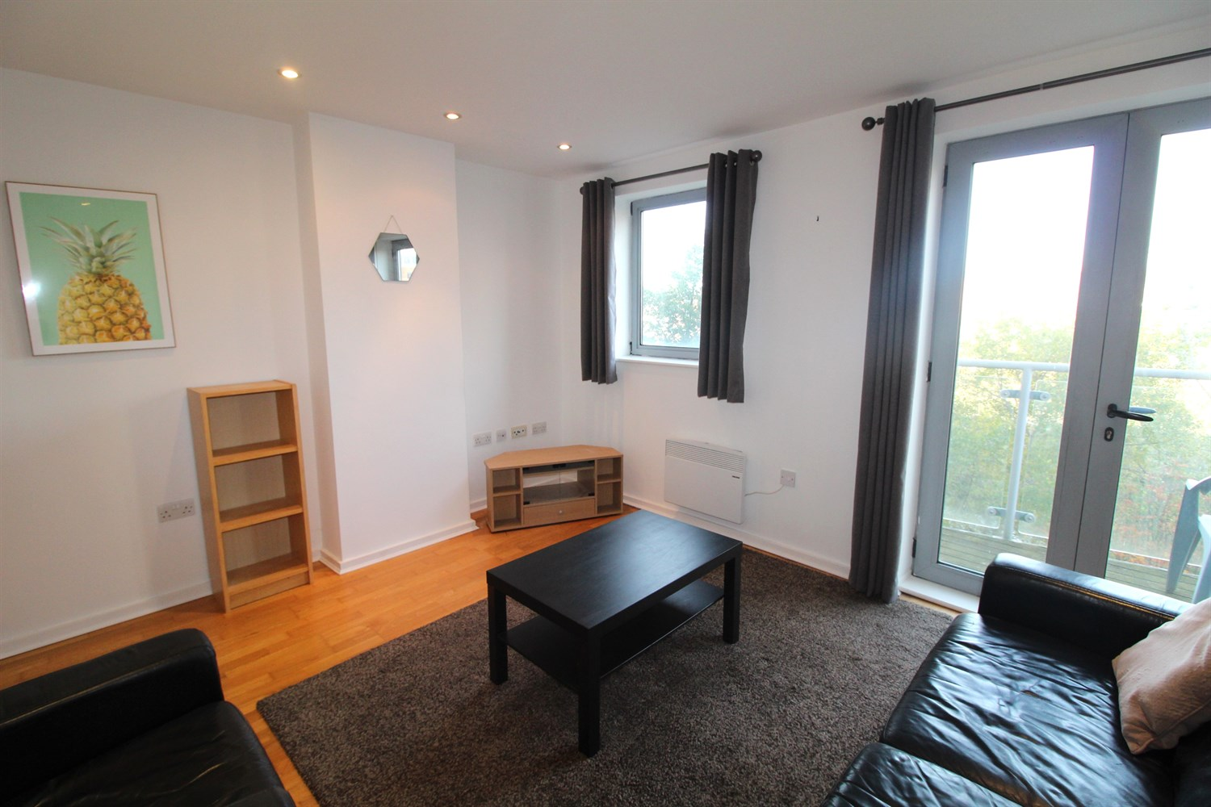

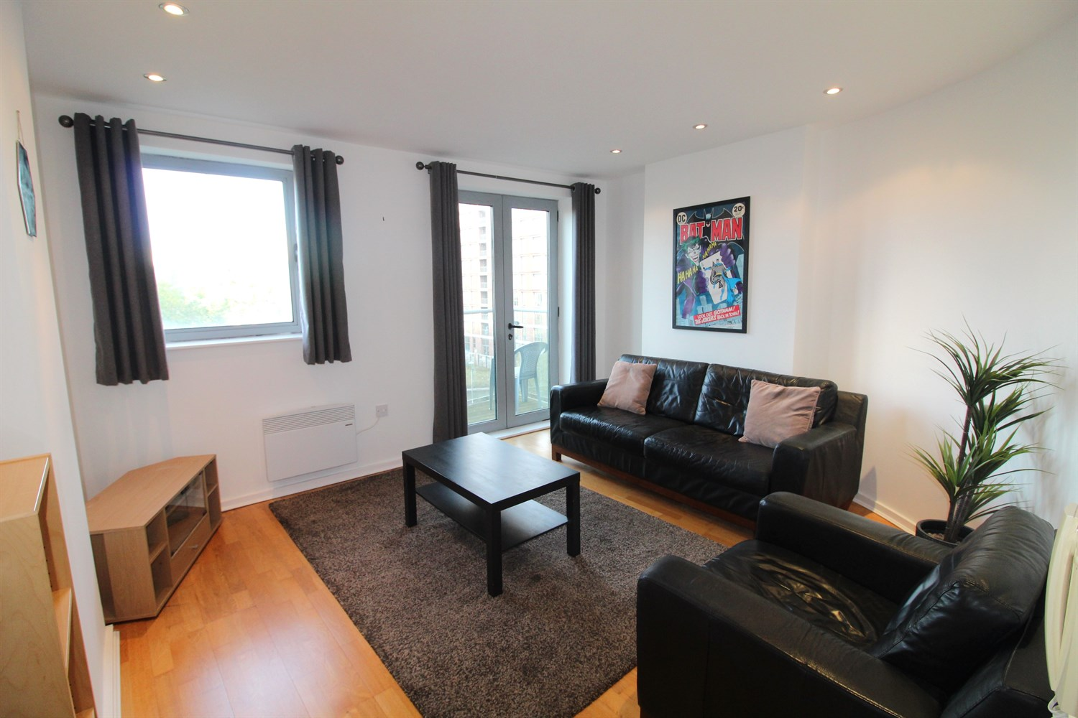

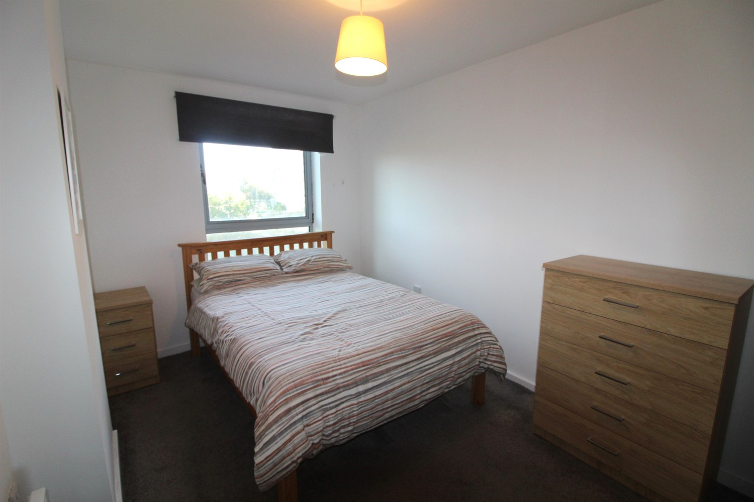

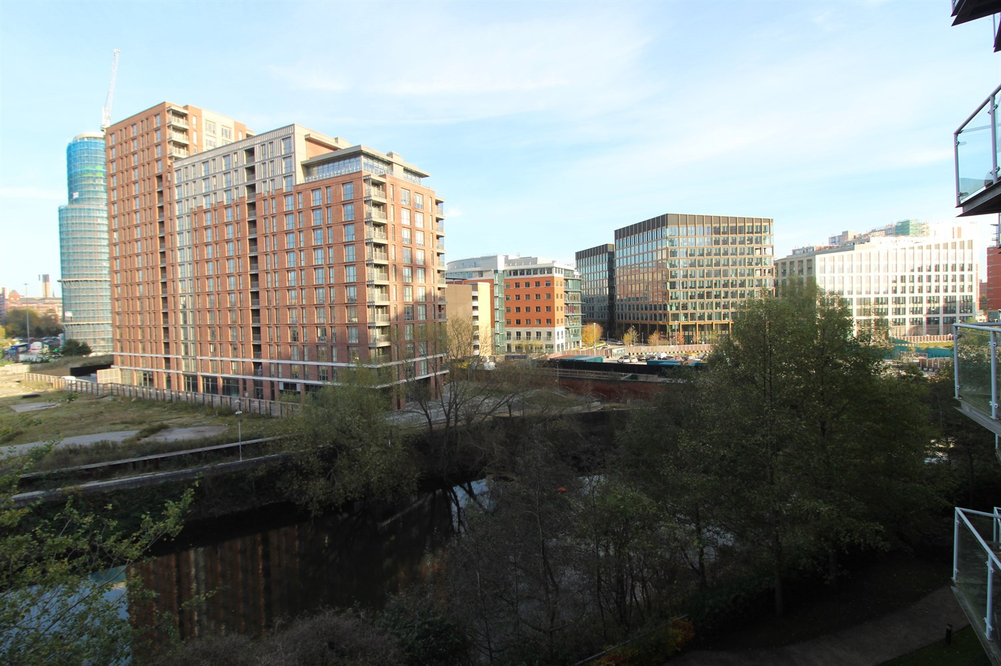

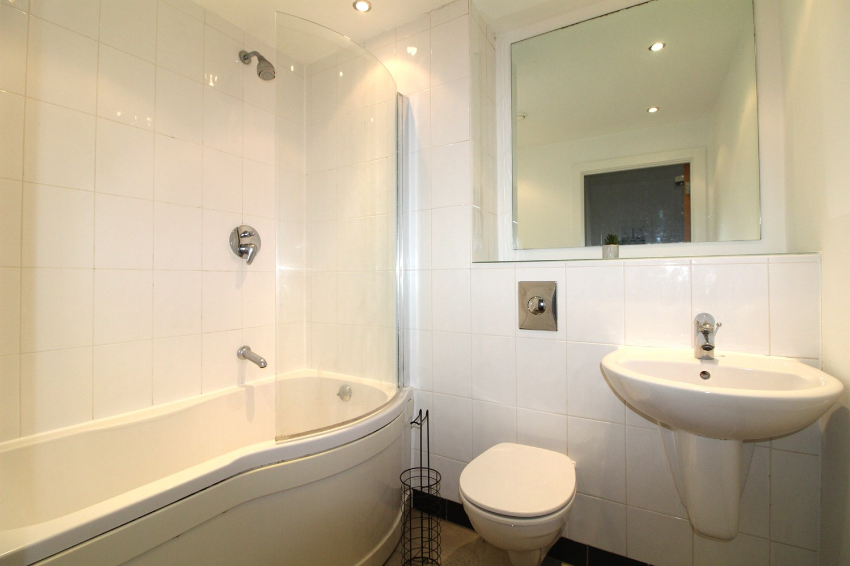

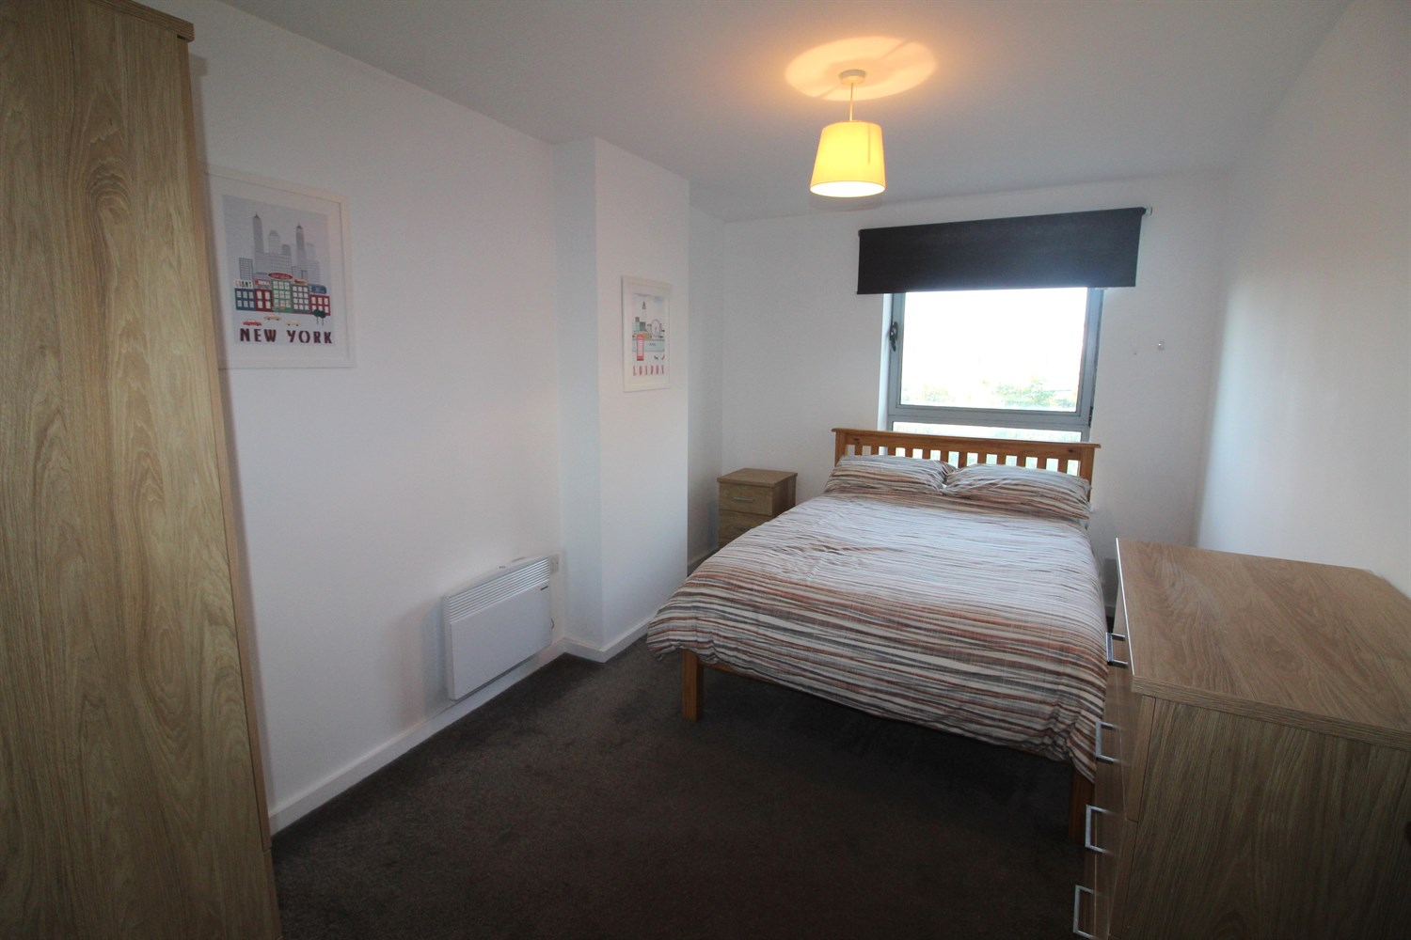

|  |
| --- |
| **Communal Hallway**  Communal entrance with stairs and lift to all floors. |
| **Private Entrance Hall**  Via front entrance door. |
| **Kitchen**  Fitted with a range of wall, base and drawer units with worktops over. Integrated oven with 4-ring hob and extractor hood over. Space for fridge and washing machine. Inset ceiling spotlights. |
| **Living Room**  Light and airy living area with double glazed window and door leading out to the balcony with river views. Wall mounted electric radiator. Inset ceiling spotlights. |
| **Bedroom 1**  Double bedroom with double glazed window. Wall mounted electric radiator. Inset ceiling spotlights. |
| **Bathroom**  Fitted with a three piece white suite comprising; bath with shower over, WC and wash hand basin. Tiled walls and floor. Heated towel rail. Inset ceiling spotlights. |
| **Tenure**  Ground rent is £200 per year  The lease is 999 years from 1 January 2003. |
| **Service Charge**  The service charge for 2024 is £1544.87 |

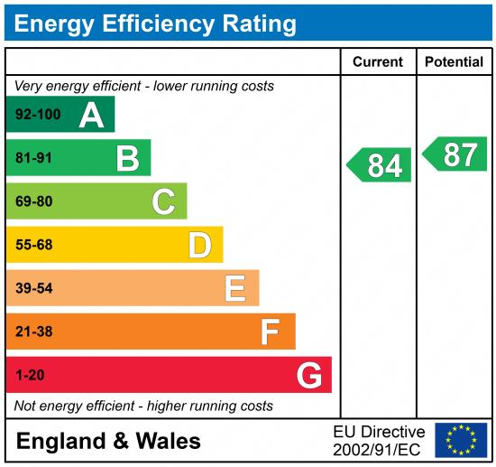

|  |
| --- |
|  |

These particulars are intended to give a fair description of the property, but their accuracy cannot be guaranteed, and they do not constitute an offer of contract. Intending purchasers must rely on their own inspection of the property. None of the above appliances/services have been tested by ourselves. We recommend purchasers arrange for a qualified person to check all appliances/services before legal commitment.

**Property Ref:** 4364

**For more information, please contact**

0113 258 1150 **|** [sales@adairpaxton.co.uk](mailto:sales@adairpaxton.co.uk) **|** www.adairpaxton.co.uk