

**0113 258 1150**

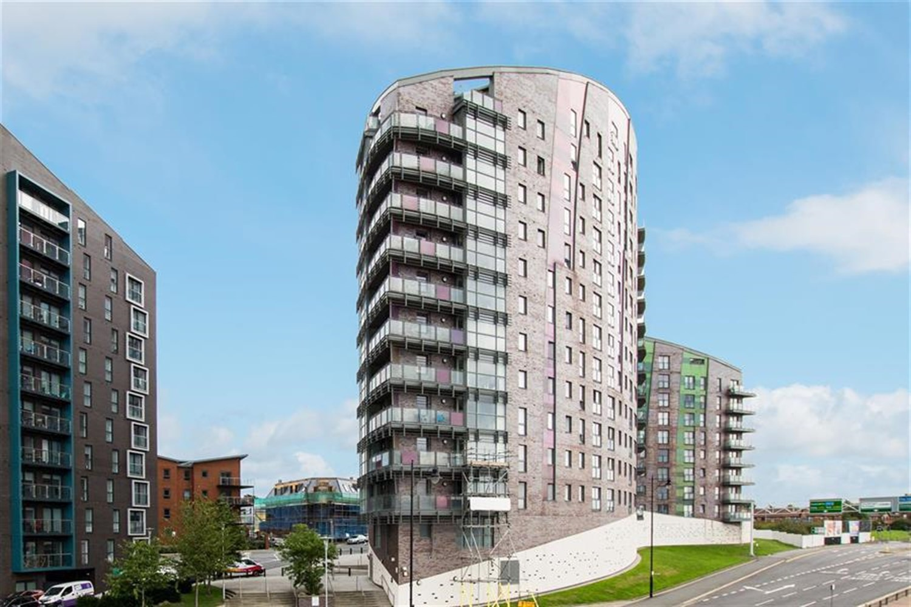



**For Sale £99,950.00**

**Echo Central One, Leeds**

***ONE BEDROOM APARTMENT - EWS1 COMPLIANT***Set within the ever popular and exciting Echo Central development. A short walk to all the amenities Leeds City centre has to offer and great links to the motorway network. Stylish and contemporary accommodation which would suit the professional seeking a city base. Having quality modern fittings throughout, the interior briefly comprises of: Communal entrance with security intercom and lifts to all floors, private hallway with utility/store, open plan living/dining/kitchen having a range of contemporary high gloss units with integrated appliances and Juliette balcony, Spacious double bedroom and shower room. Council Tax Band A. Tenanted until November 2024 at £775pcm.

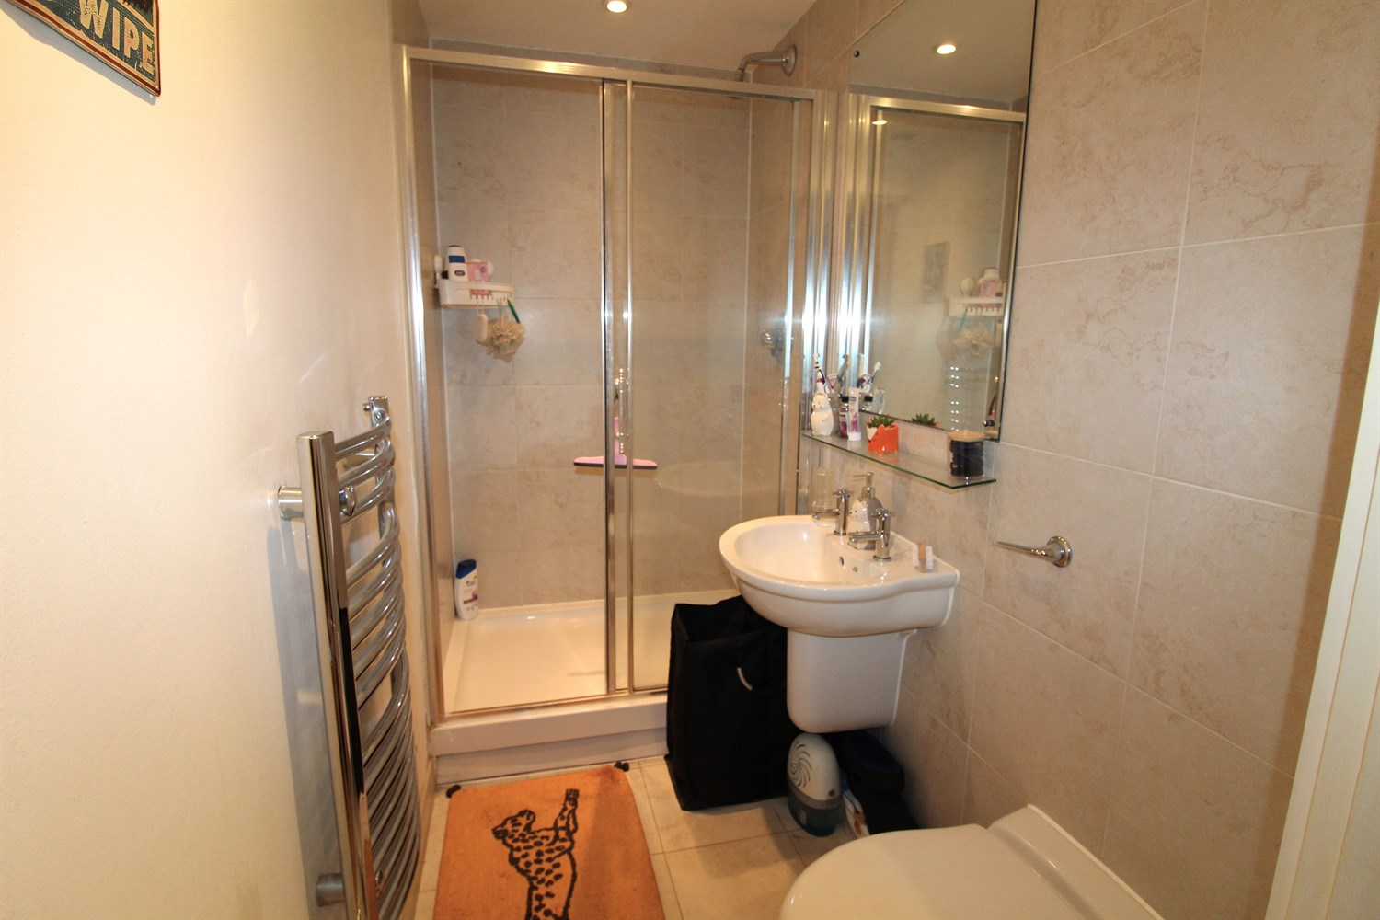

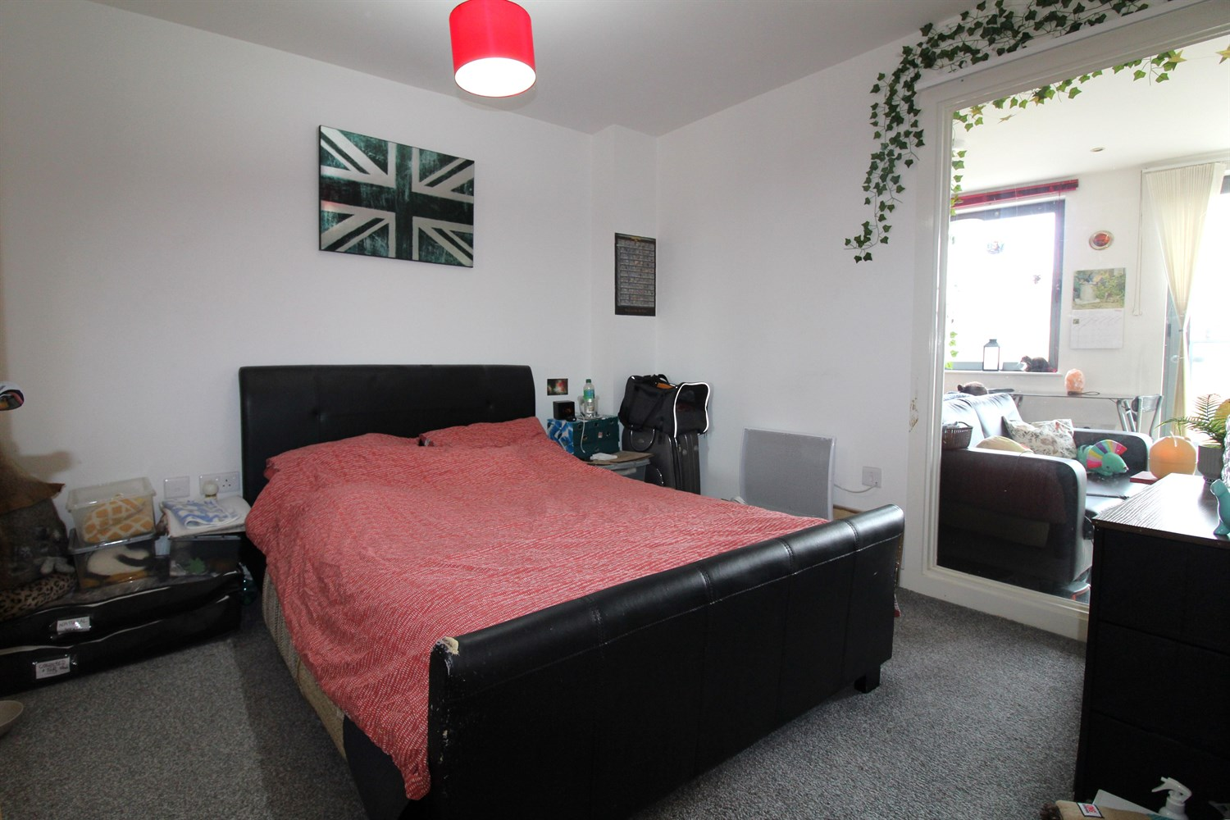

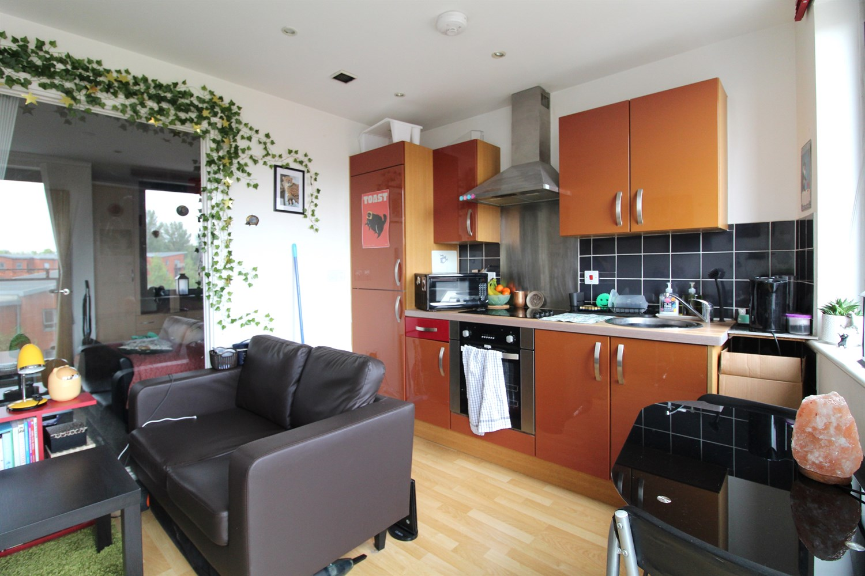

1 Bathroom(s)

1 Reception(s)

1 Bedroom(s)

00

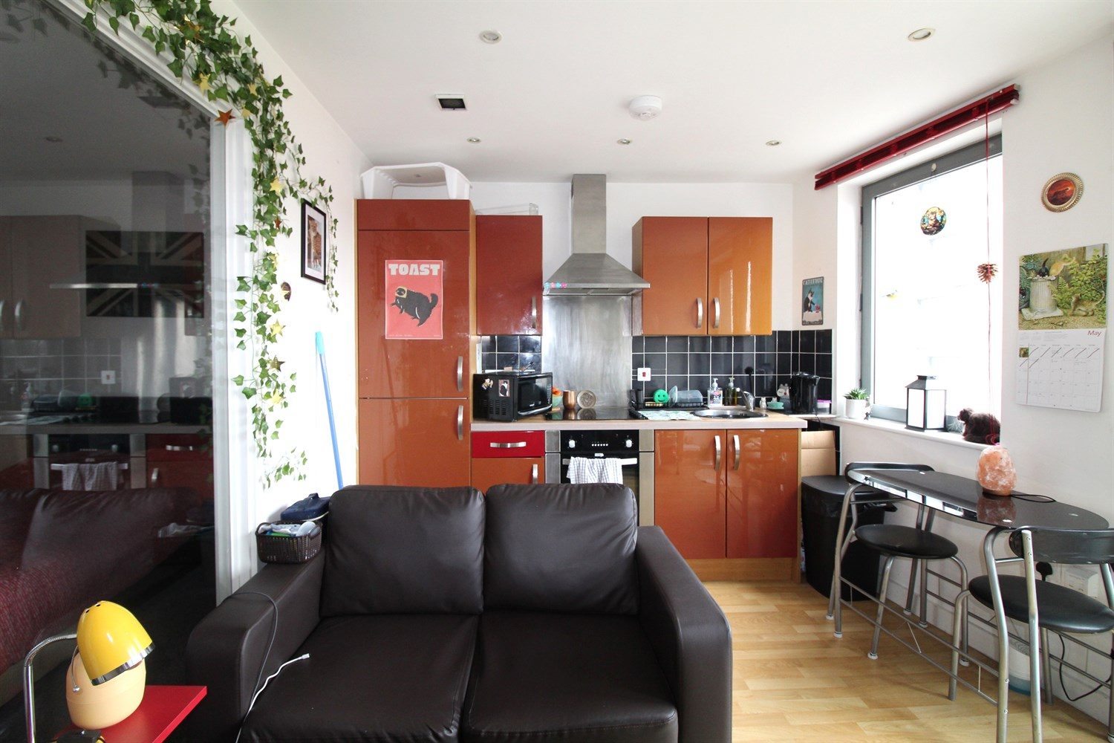

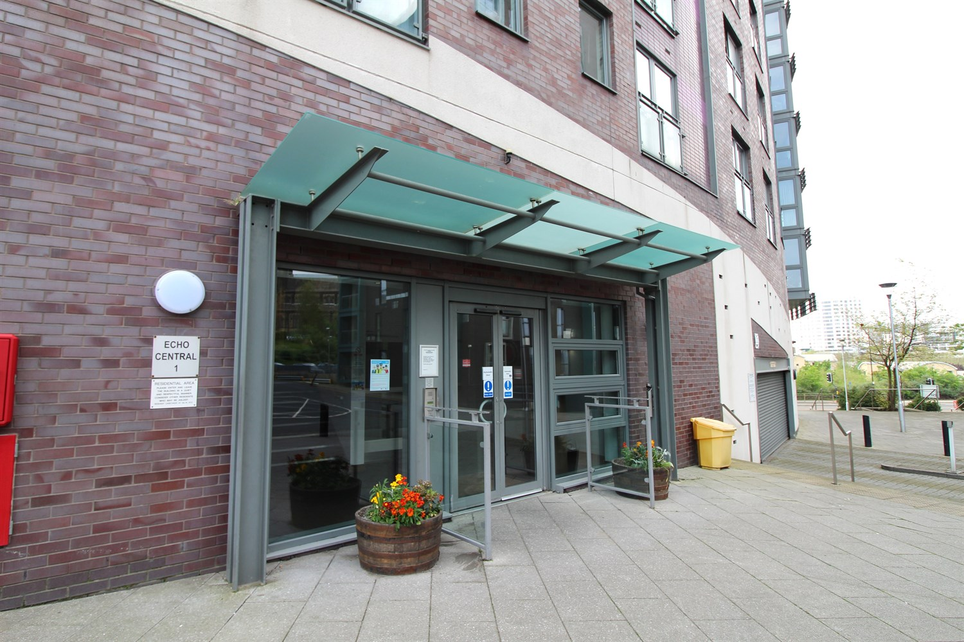

|  |
| --- |
| **Communal Entrance**  Entry via secure video intercom entry system. Stairs and lift to all floors. |
| **Private Hallway**  Secure video intercom entry system. Wall mounted electric heater. Storage cupboard housing the washing machine. |
| **Open Plan Living Room/Kitchen**  Contemporary open plan living room/kitchen with double glazed French doors opening to a Juliet balcony. Wall mounted electric heater. Open plan to the living room and fitted with a range of high gloss wall, base and drawer units. Stainless steel sink with mixer tap. Integrated electric oven and hob with extractor hood over. |
| **Lounge** |
| **Double Bedroom** |
| **Shower Room**  Fitted with a modern three piece white suite comprising shower cubicle, wash hand basin and low level WC. Chrome heated ladder towel rail. Tiled floor. Part tiled walls. |
| **Service Charge**  The service charges are £410.34 per quarter. |
| **Tenure**  The ground rent is £200 per year. |

|  |  |
| --- | --- |
| These particulars are intended to give a fair description of the property, but their accuracy cannot be guaranteed, and they do not constitute an offer of contract. Intending purchasers must rely on their own inspection of the property. None of the above appliances/services have been tested by ourselves. We recommend purchasers arrange for a qualified person to check all appliances/services before legal commitment.  **Property Ref:** 2290  **For more information, please contact**  0113 258 1150 **|** [sales@adairpaxton.co.uk](mailto:sales@adairpaxton.co.uk) **|** www.adairpaxton.co.uk |  |