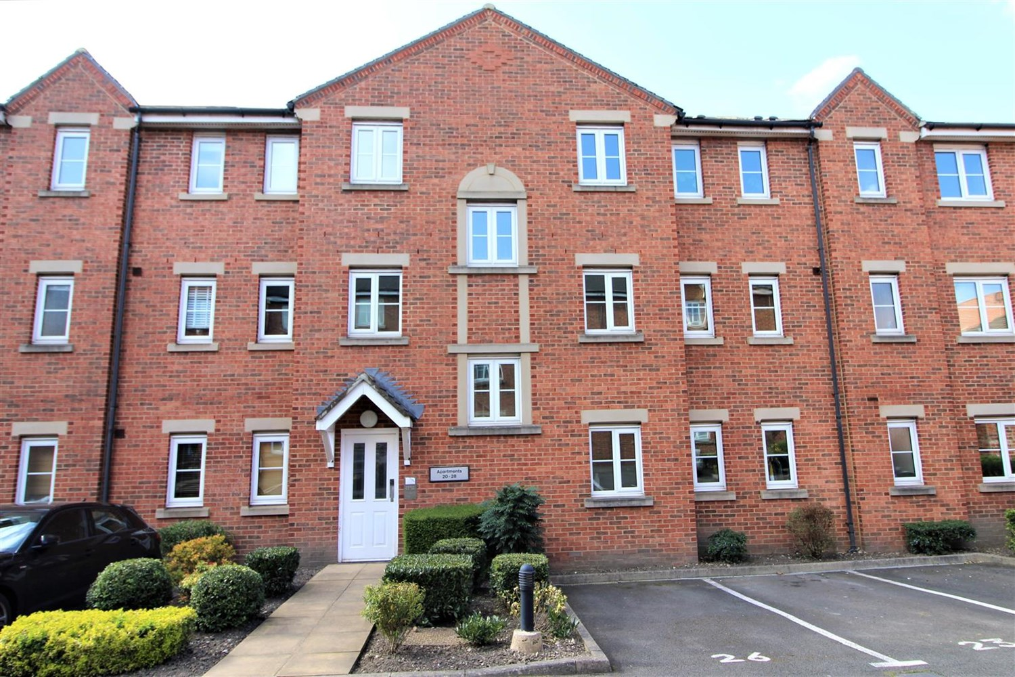



|  |  |
| --- | --- |
| **Abbotts Mews, Abbotts Mews, Leeds, LS4**  **£995.00pcm**  **Apartment** | |
|  |

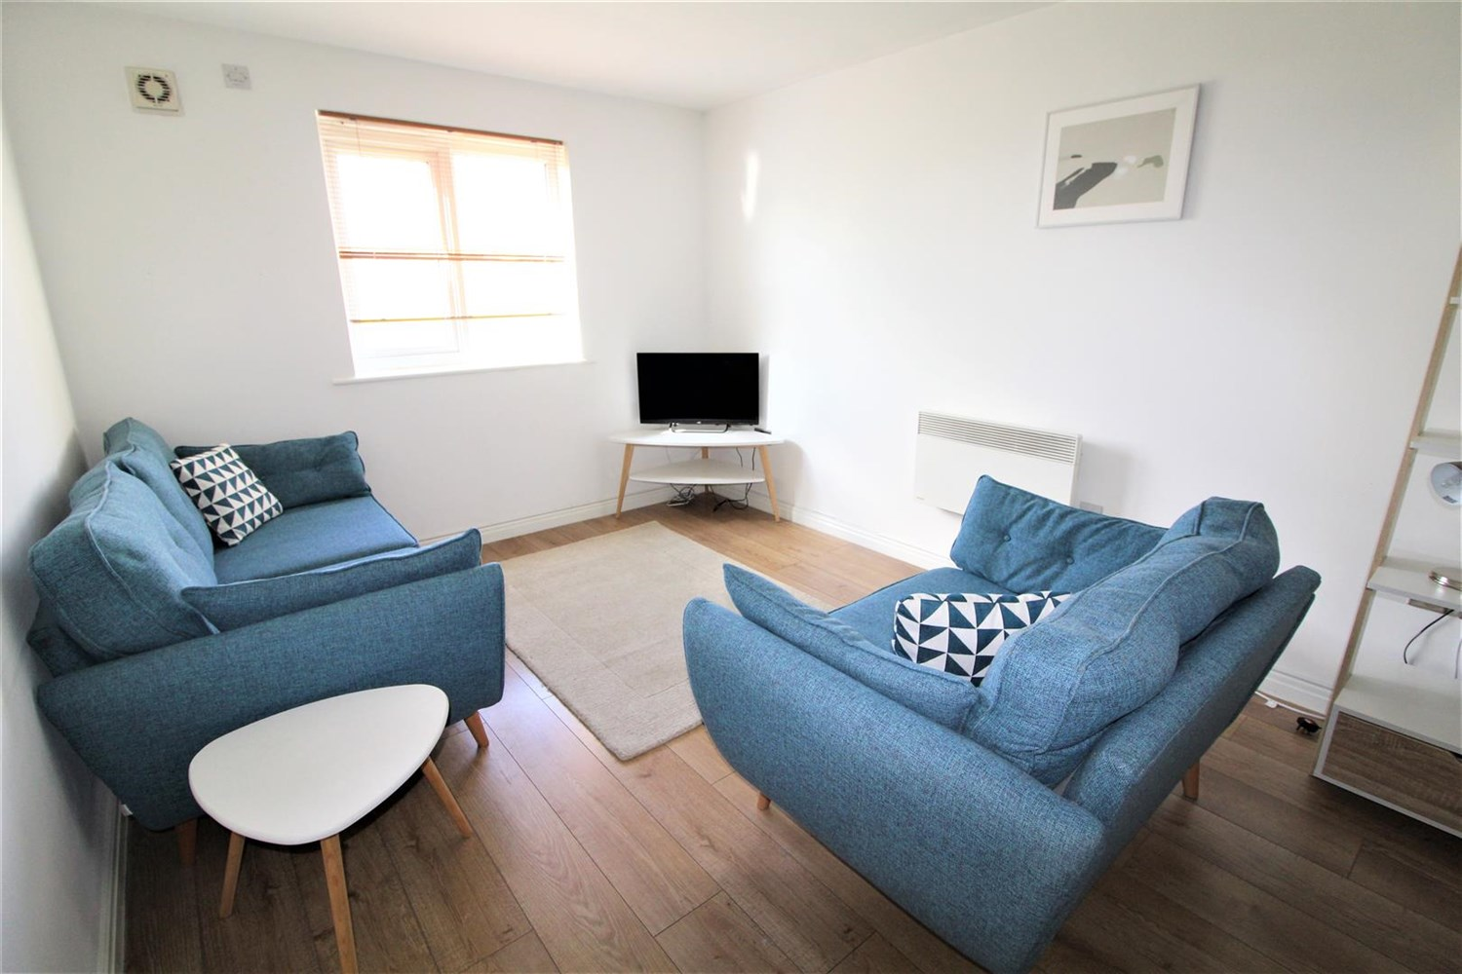

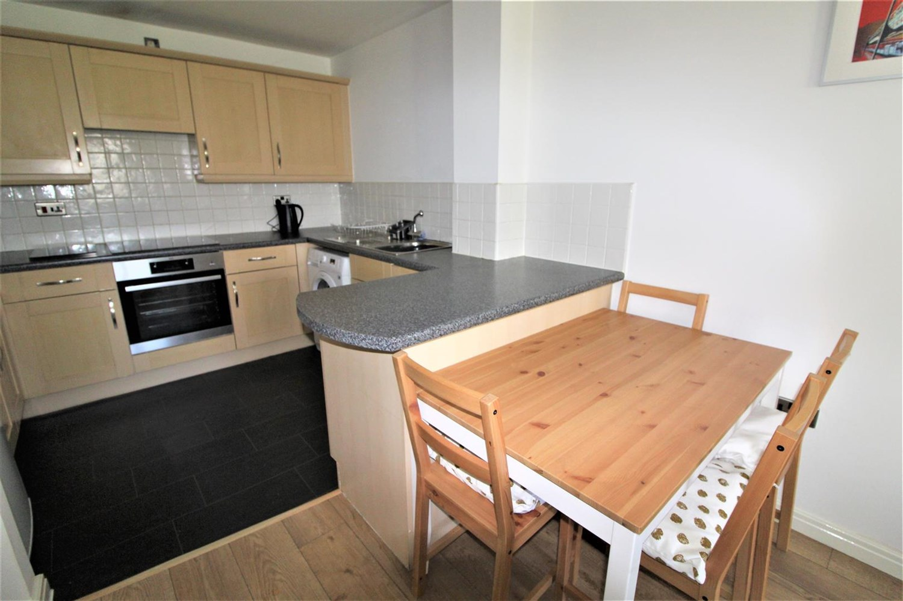

2 Bathroom(s)

1 Reception(s)

2 Bedroom(s)

00

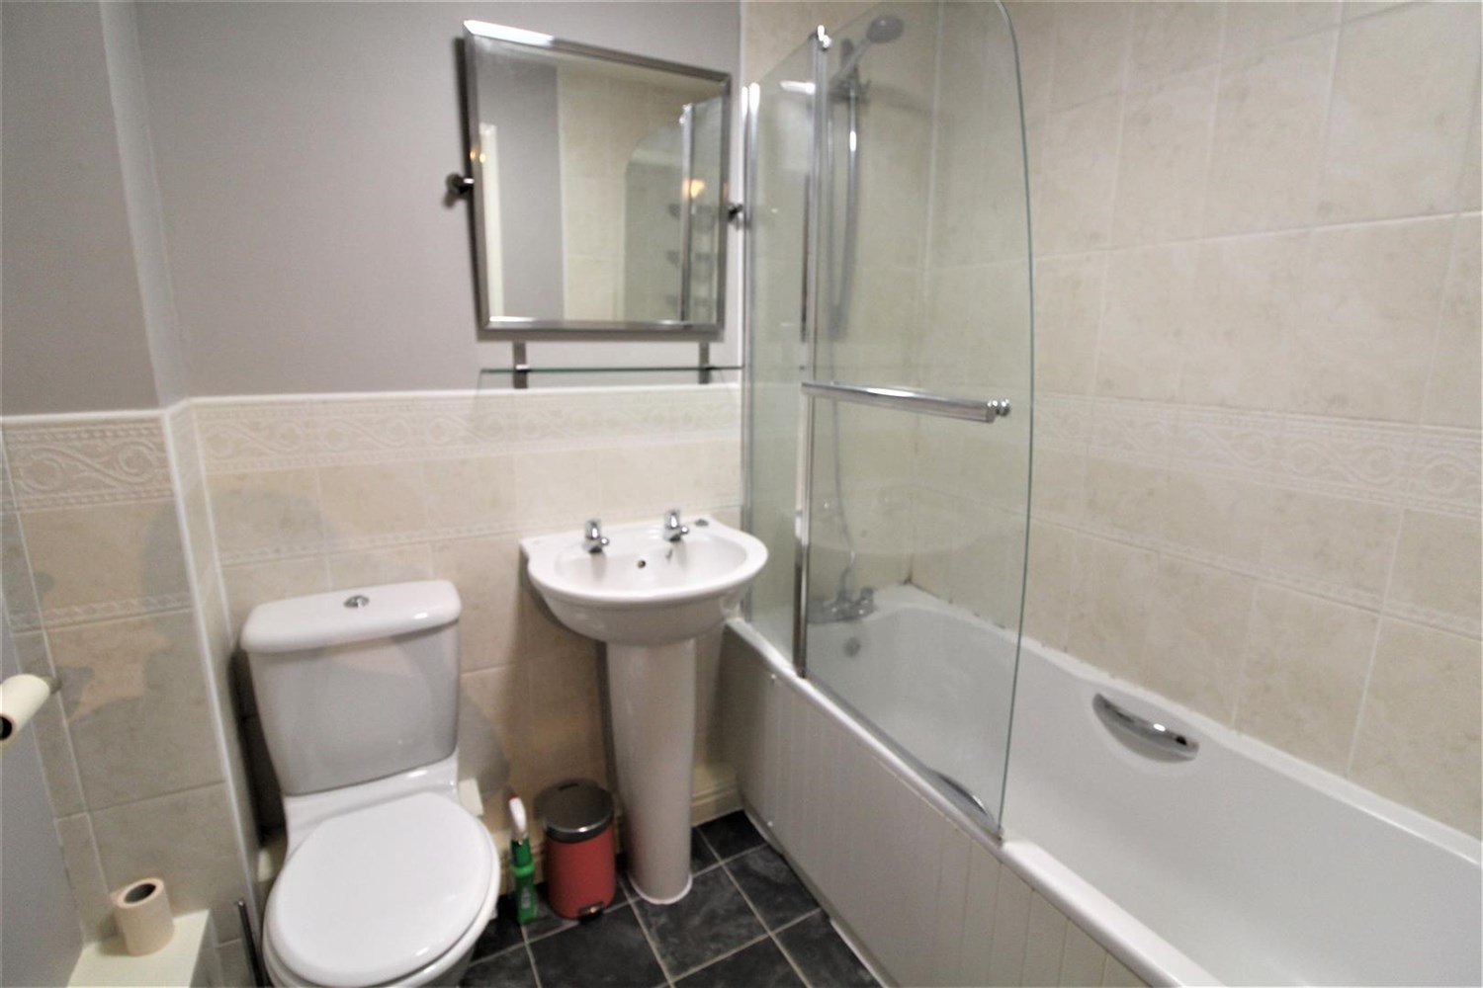

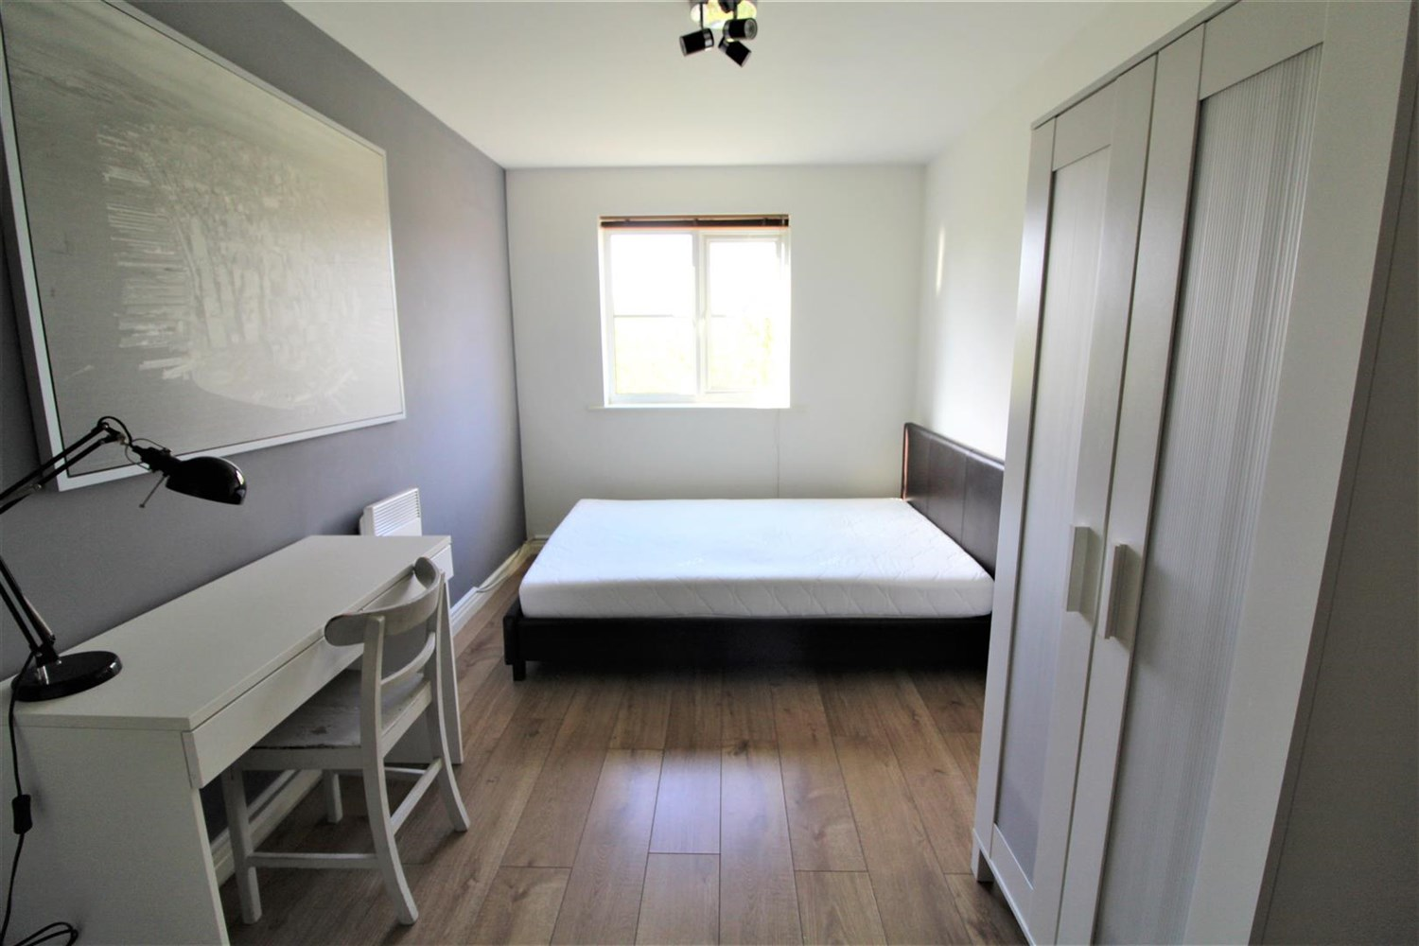

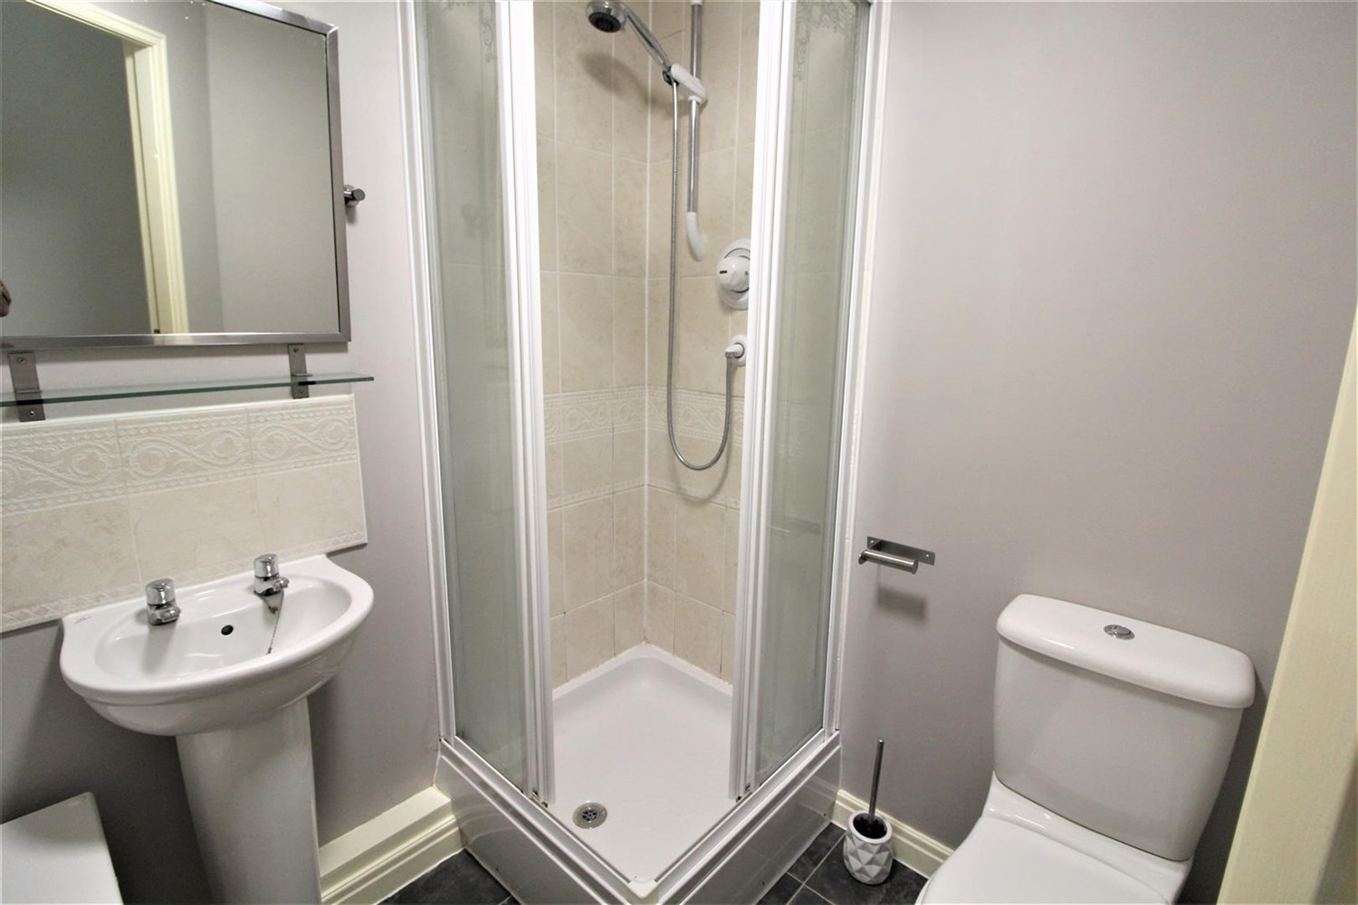

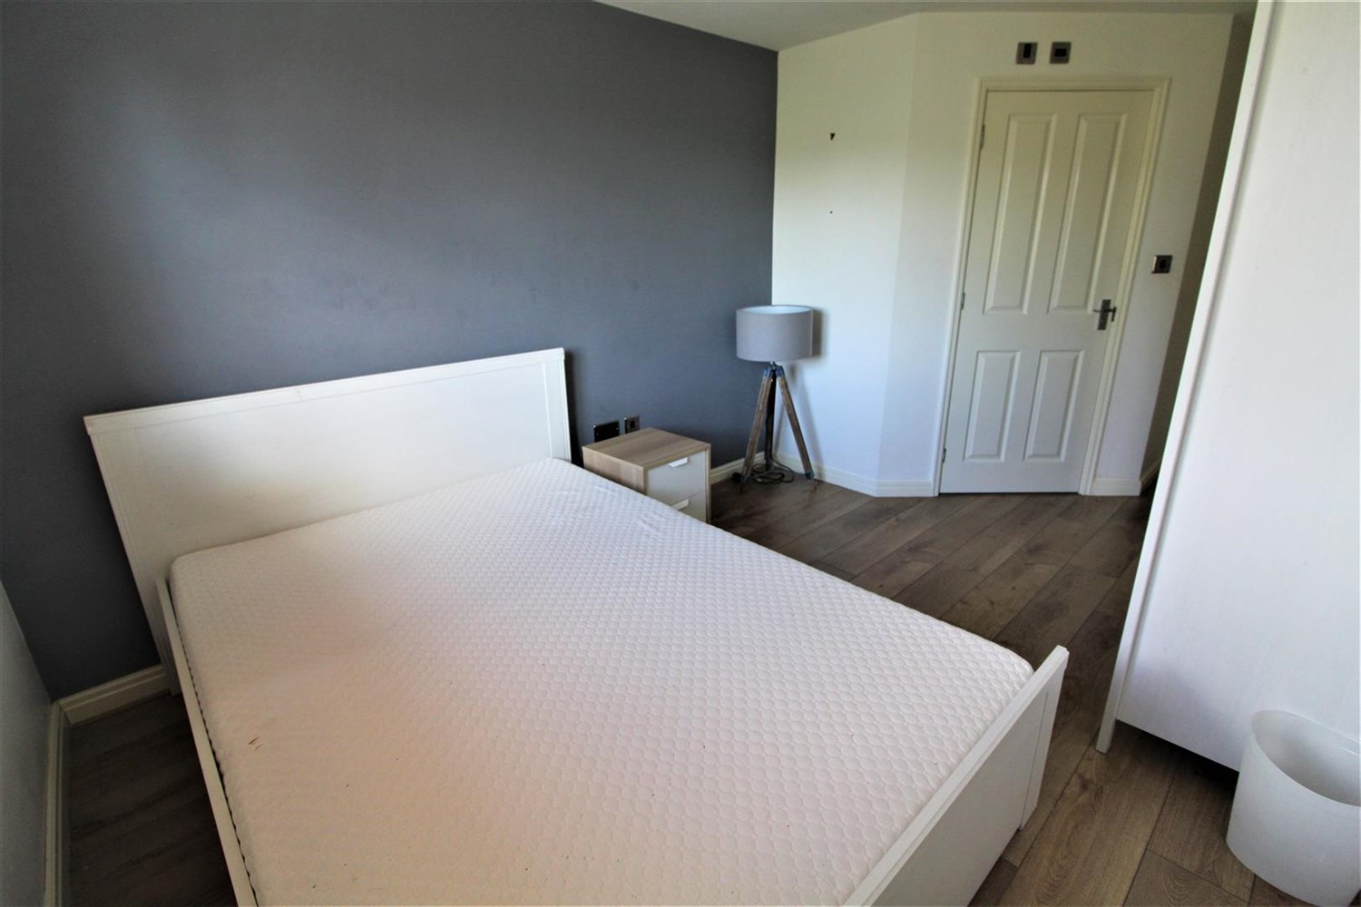

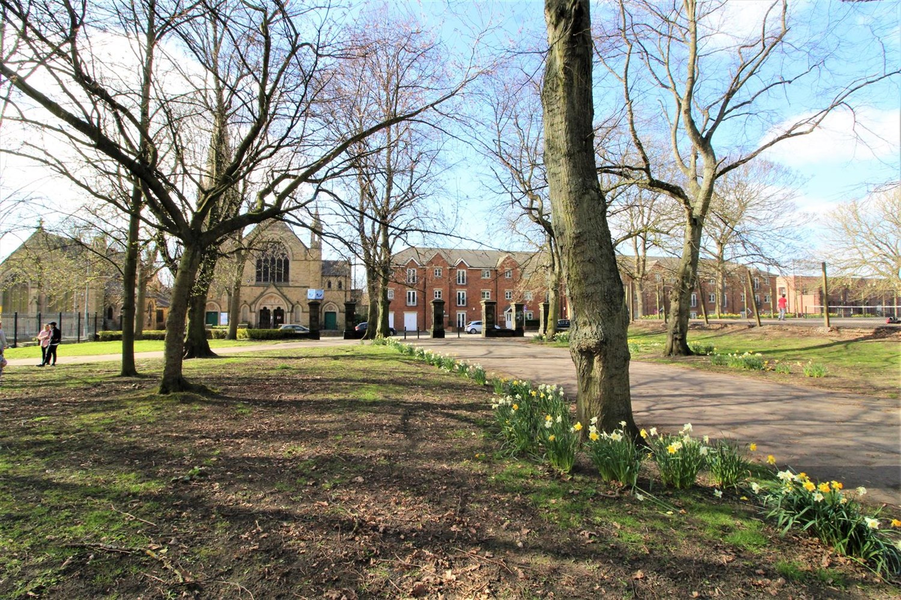

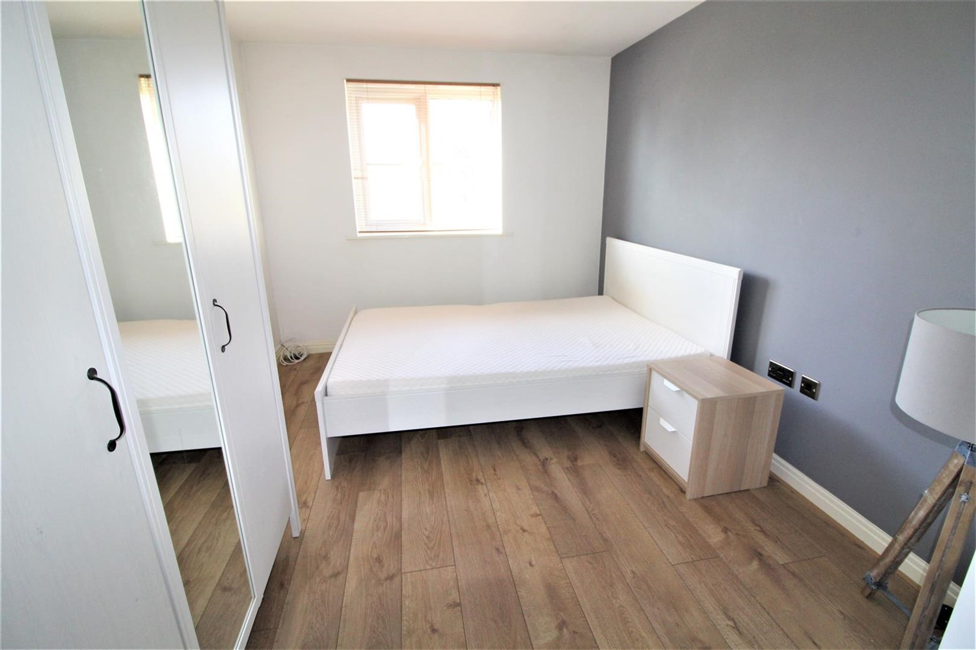

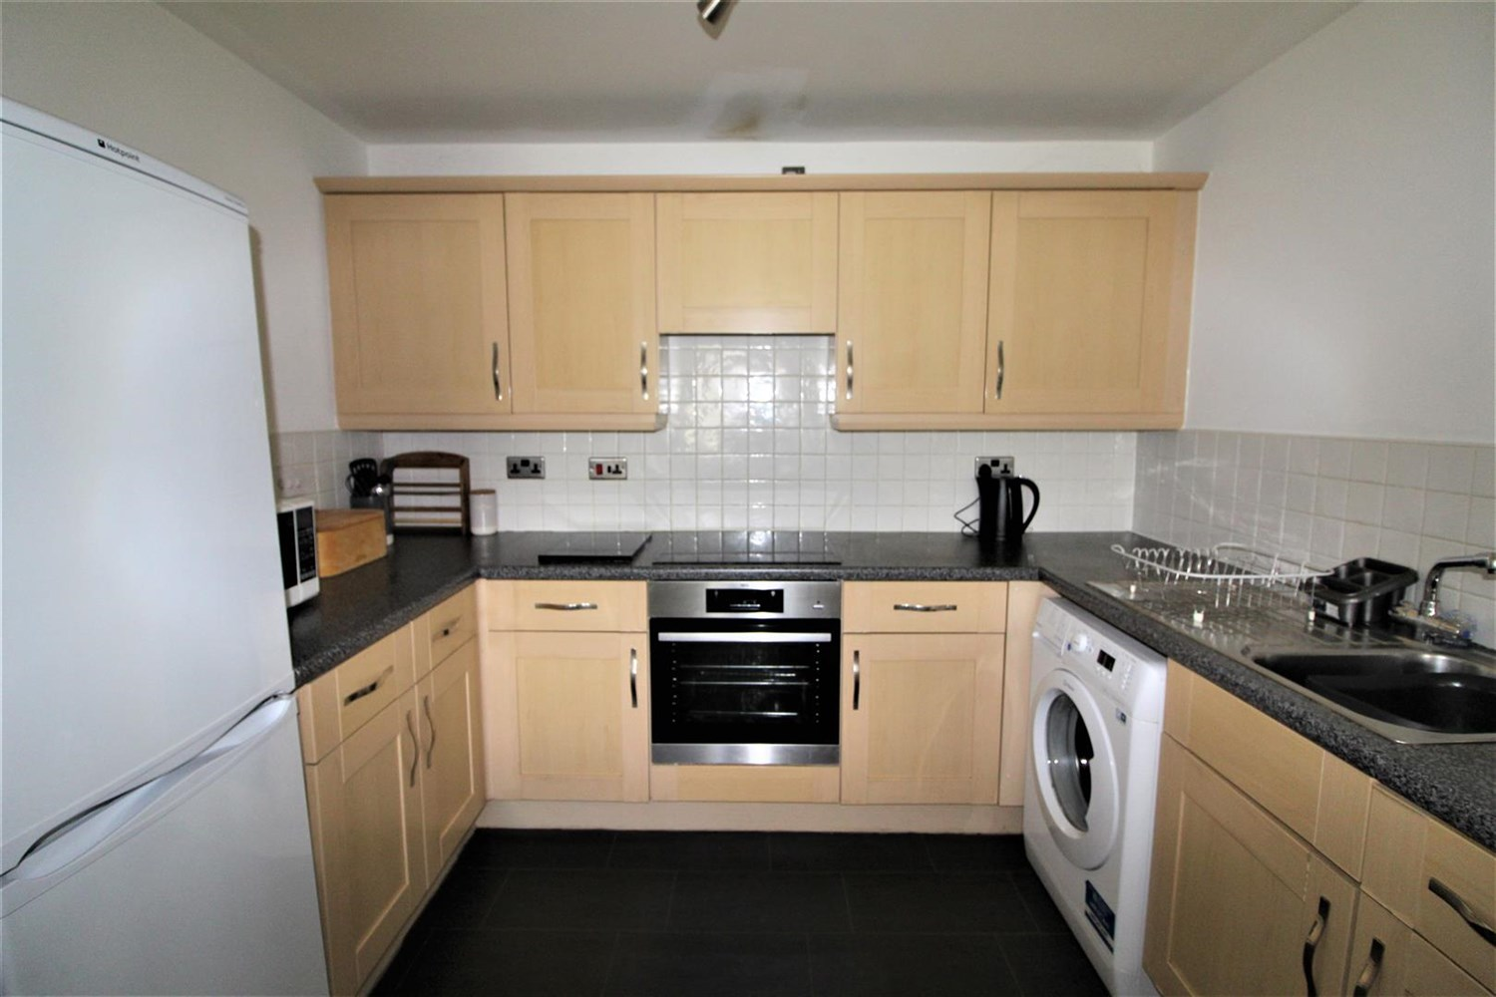

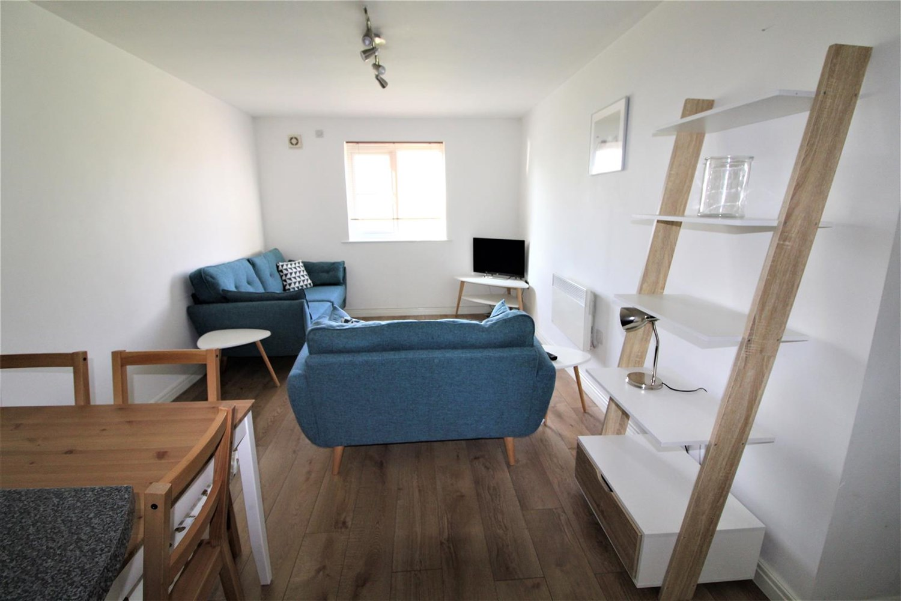

|  |
| --- |
| **Communal entrance**  Communal entrance with stairs to access all floors. |
| **Kitchen**  The kitchen area offers a range of wall and base mounted units, single drainer stainless steel sink with mixer tap, integrated oven, induction hob and extractor and space for fridge freezer and washing machine. |
| **Living room**  Light and airey living space with a wall mounted electric radiator and a double glazed window. |
| **Bedroom 1**  Double bedroom with uPVC double glazed window. Wall mounted electric radiator and access to the en-suite bathroom. |
| **En-suite**  Fitted with a three piece white suite comprising; shower cubicle, W/C and wash hand basin. Part tiled walls. |
| **Bedroom 2**  Second double bedroom with uPVC double glazed window. Wall mounted electric radiator. |
| **Bathroom**  Fitted with a three piece white suite comprising; Bath with over head shower, W/C and hand wash basin. |
| COUNCIL TAX BAND: B EPC Rating B  Leasehold property Parking available  Broadband availability: Standard 15 Mbps 1 Mbps Good Superfast 80 Mbps 20 Mbps Good Ultrafast 1000 Mbps 1000 Mbps  Mobile availability: EE Limited Three Limited O2 Likely Vodafone Likely  Utilities: Water supplied on standard meters. Electric mains supplied on standard meters. |

|  |  |
| --- | --- |
| These particulars are intended to give a fair description of the property, but their accuracy cannot be guaranteed, and they do not constitute an offer of contract. Intending purchasers must rely on their own inspection of the property. None of the above appliances/services have been tested by ourselves. We recommend purchasers arrange for a qualified person to check all appliances/services before legal commitment.  **Property Ref:** 3992  **For more information, please contact**  0113 258 1150 **|** [lettings@adairpaxton.co.uk](mailto:lettings@adairpaxton.co.uk) **|** www.adairpaxton.co.uk |  |