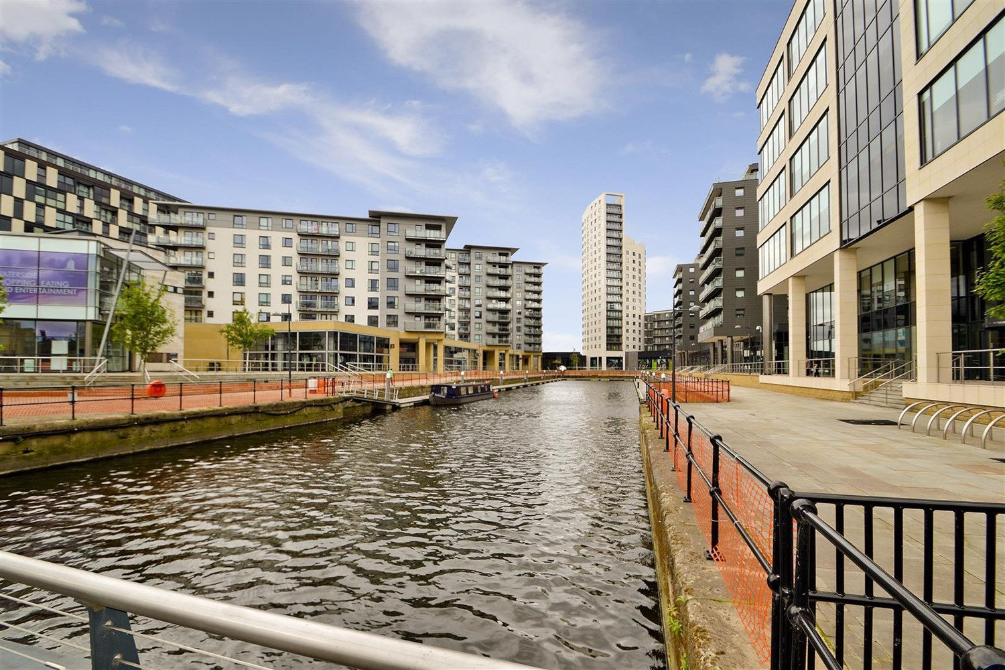



|  |  |
| --- | --- |
| **Magellan House, LS10**  **£995.00pcm**  **Apartment** | |
|  |

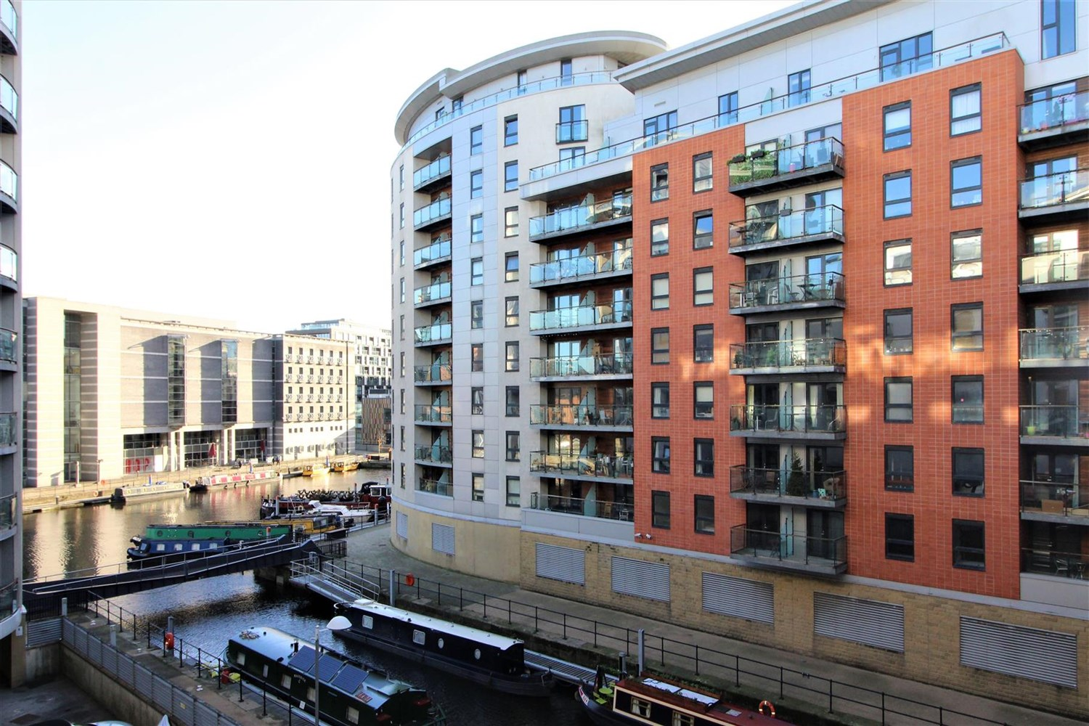

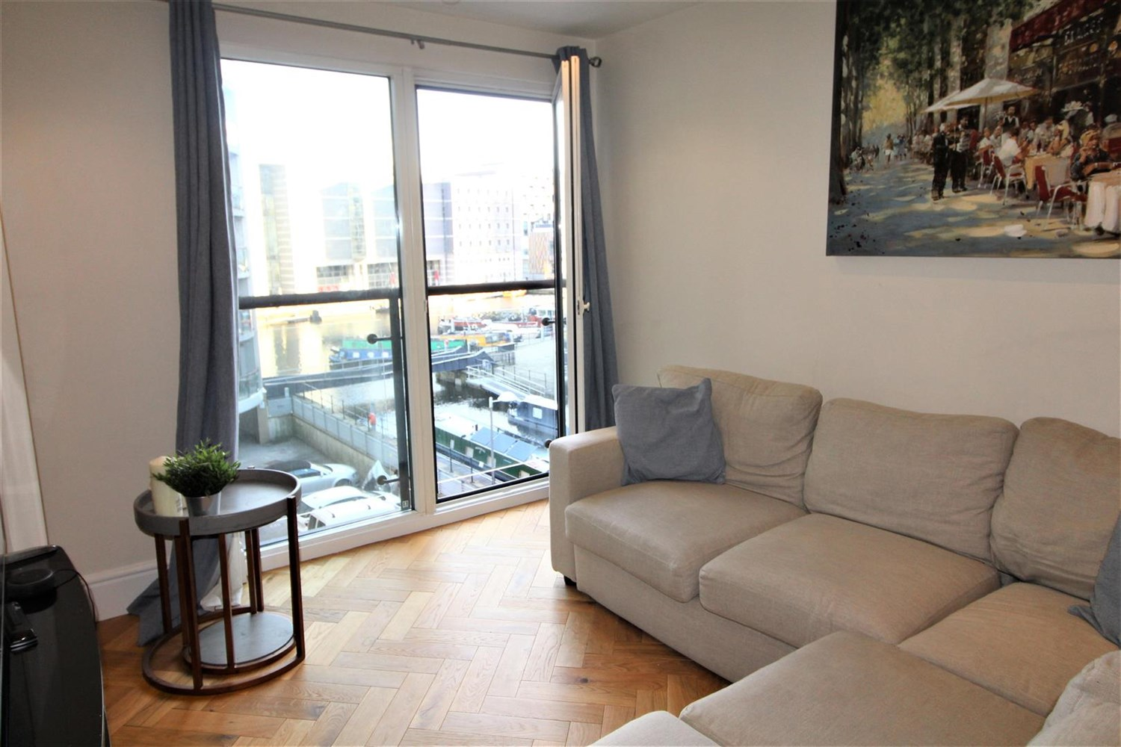

2 Bathroom(s)

1 Reception(s)

2 Bedroom(s)

00

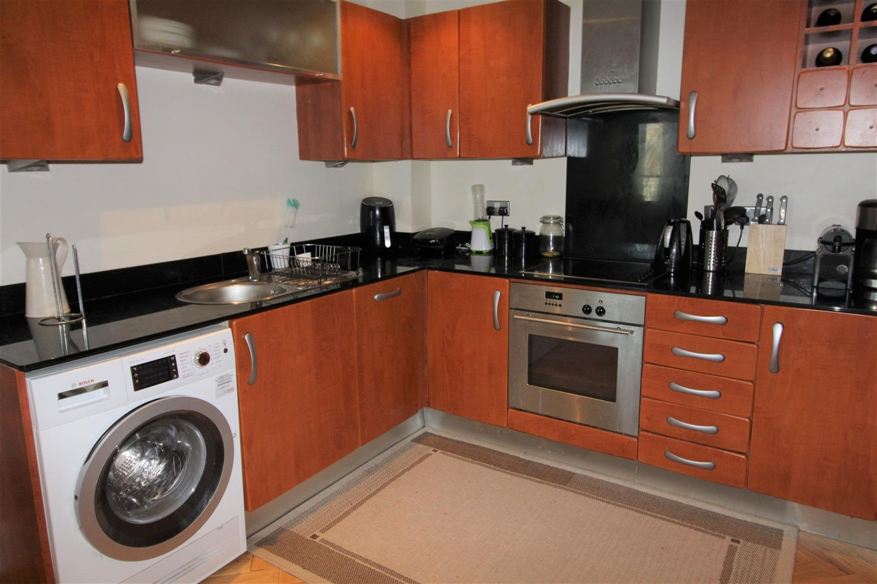

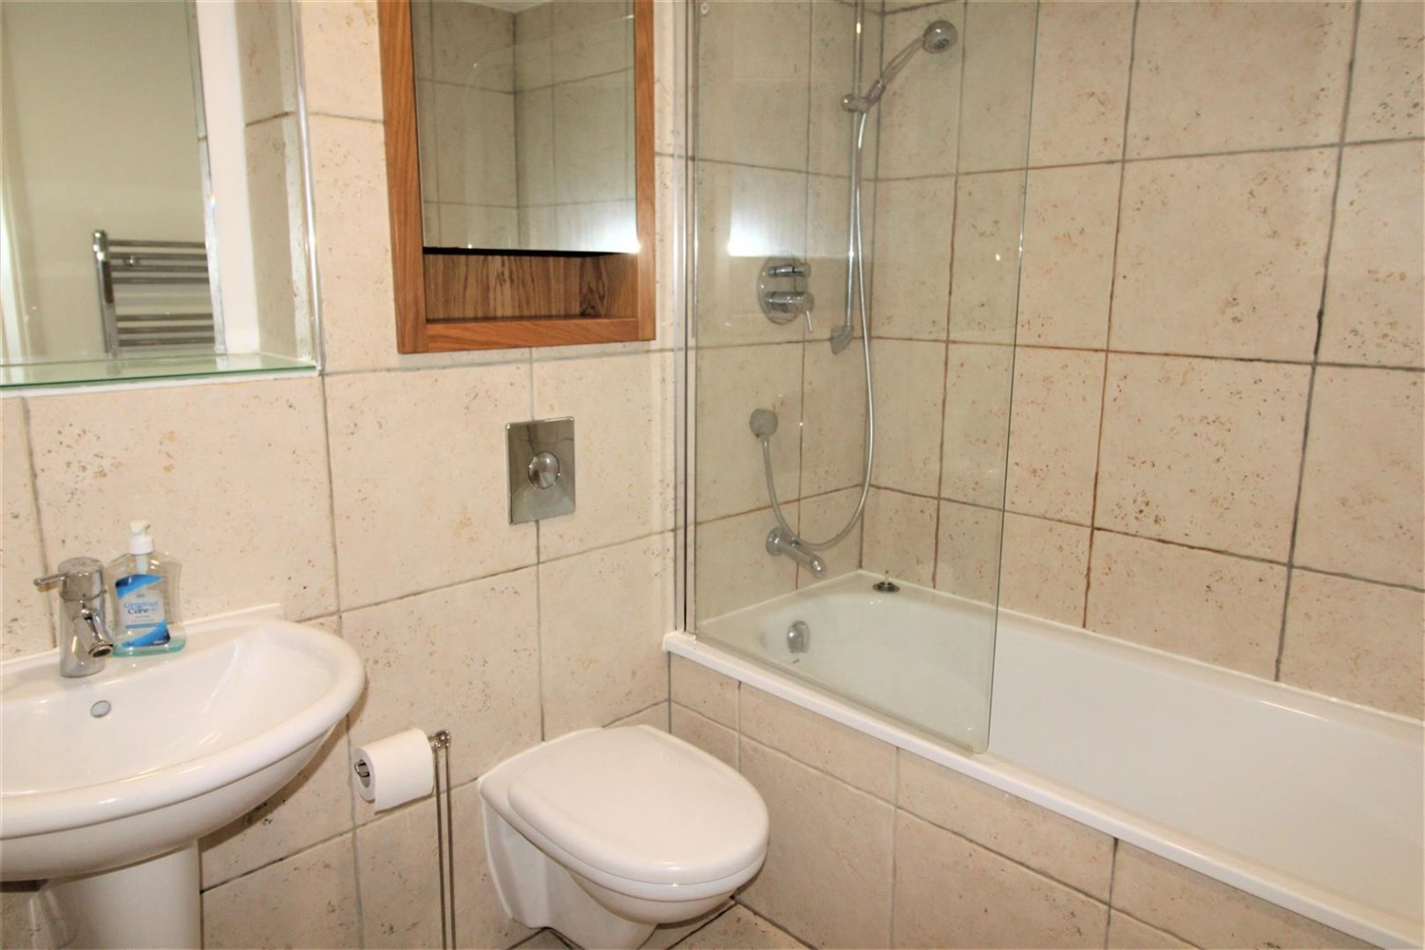

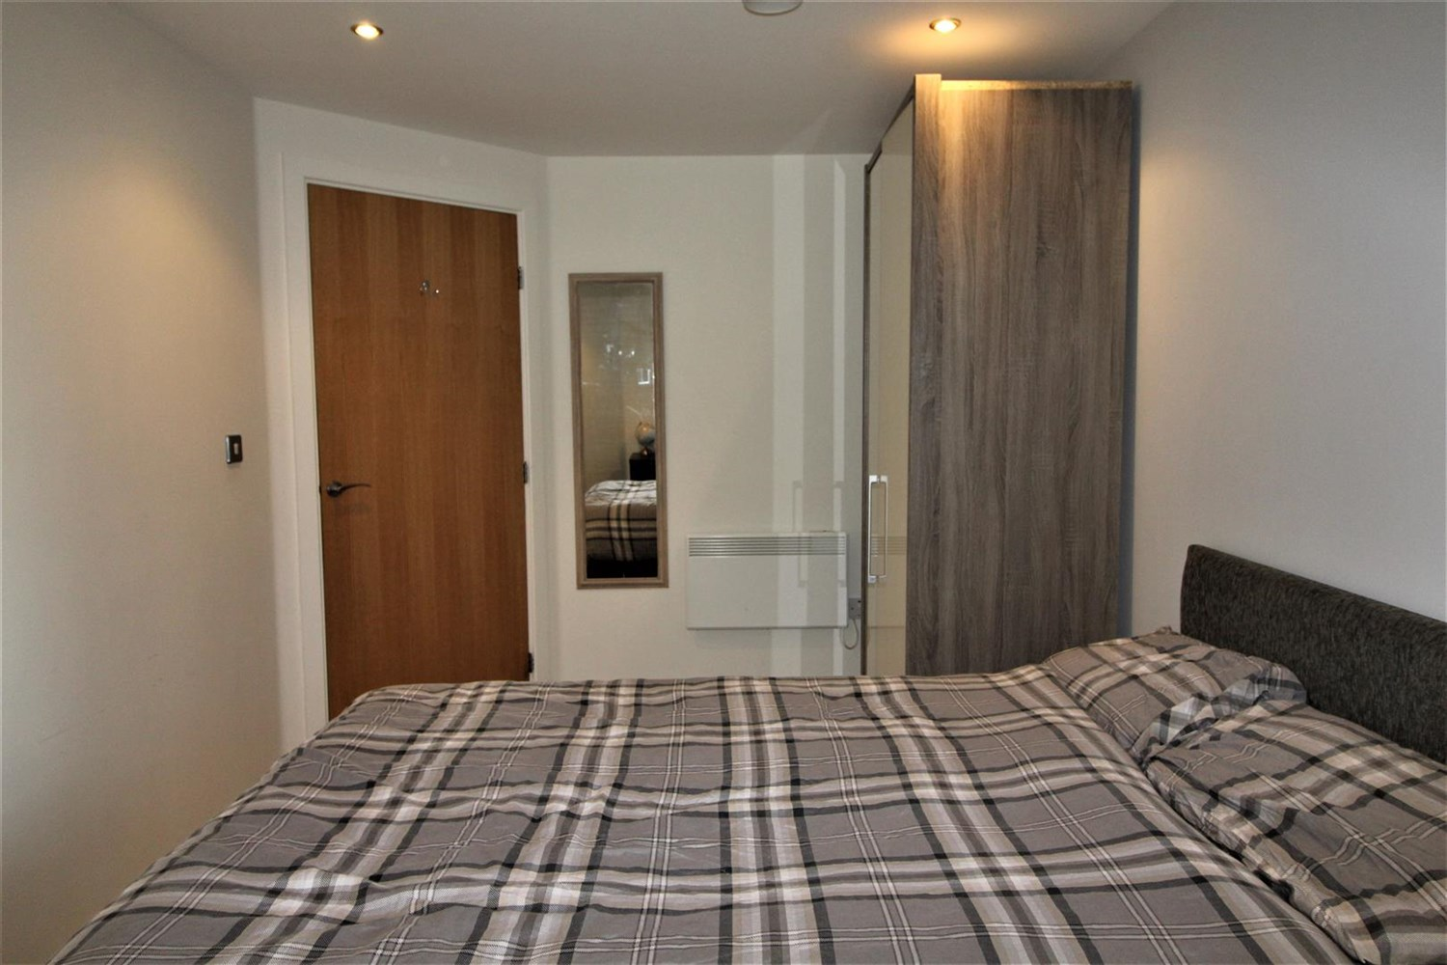

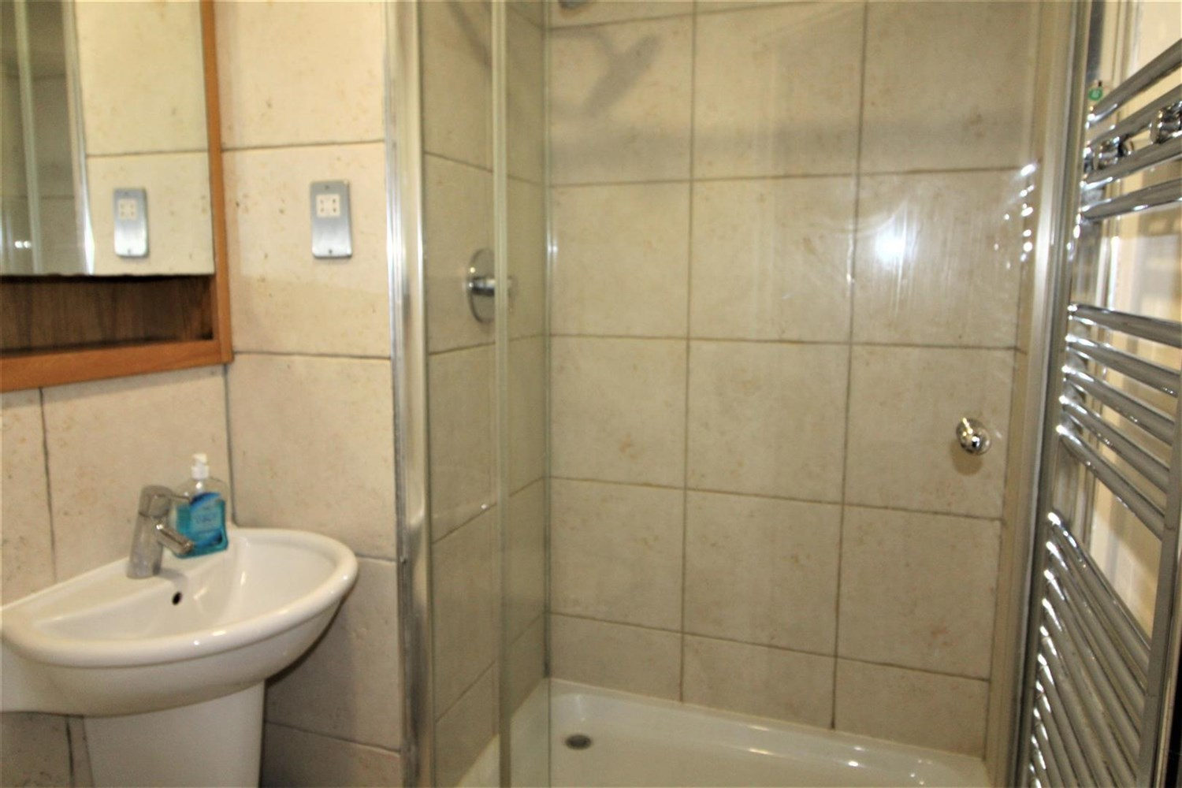

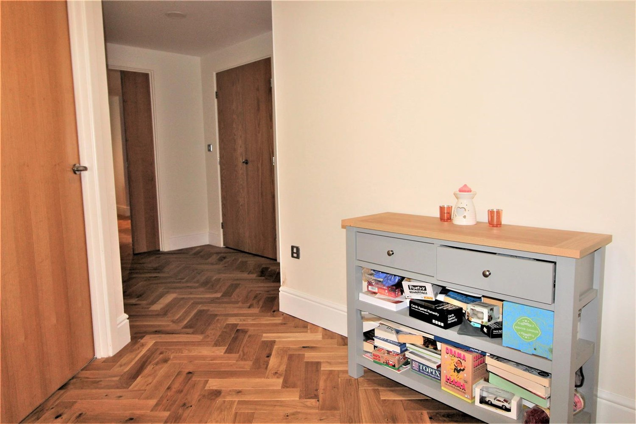

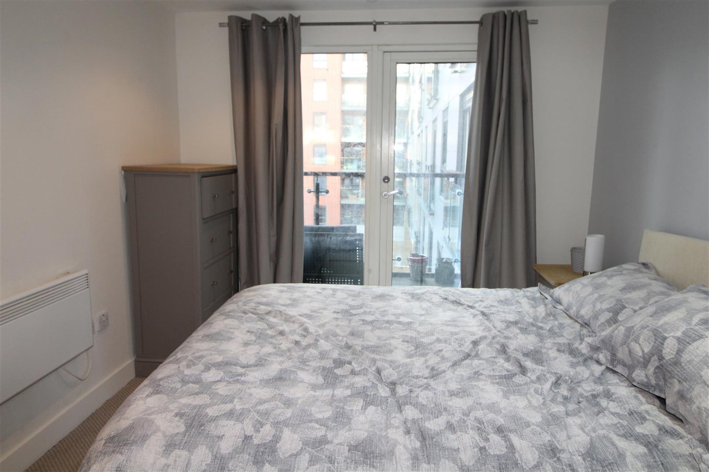

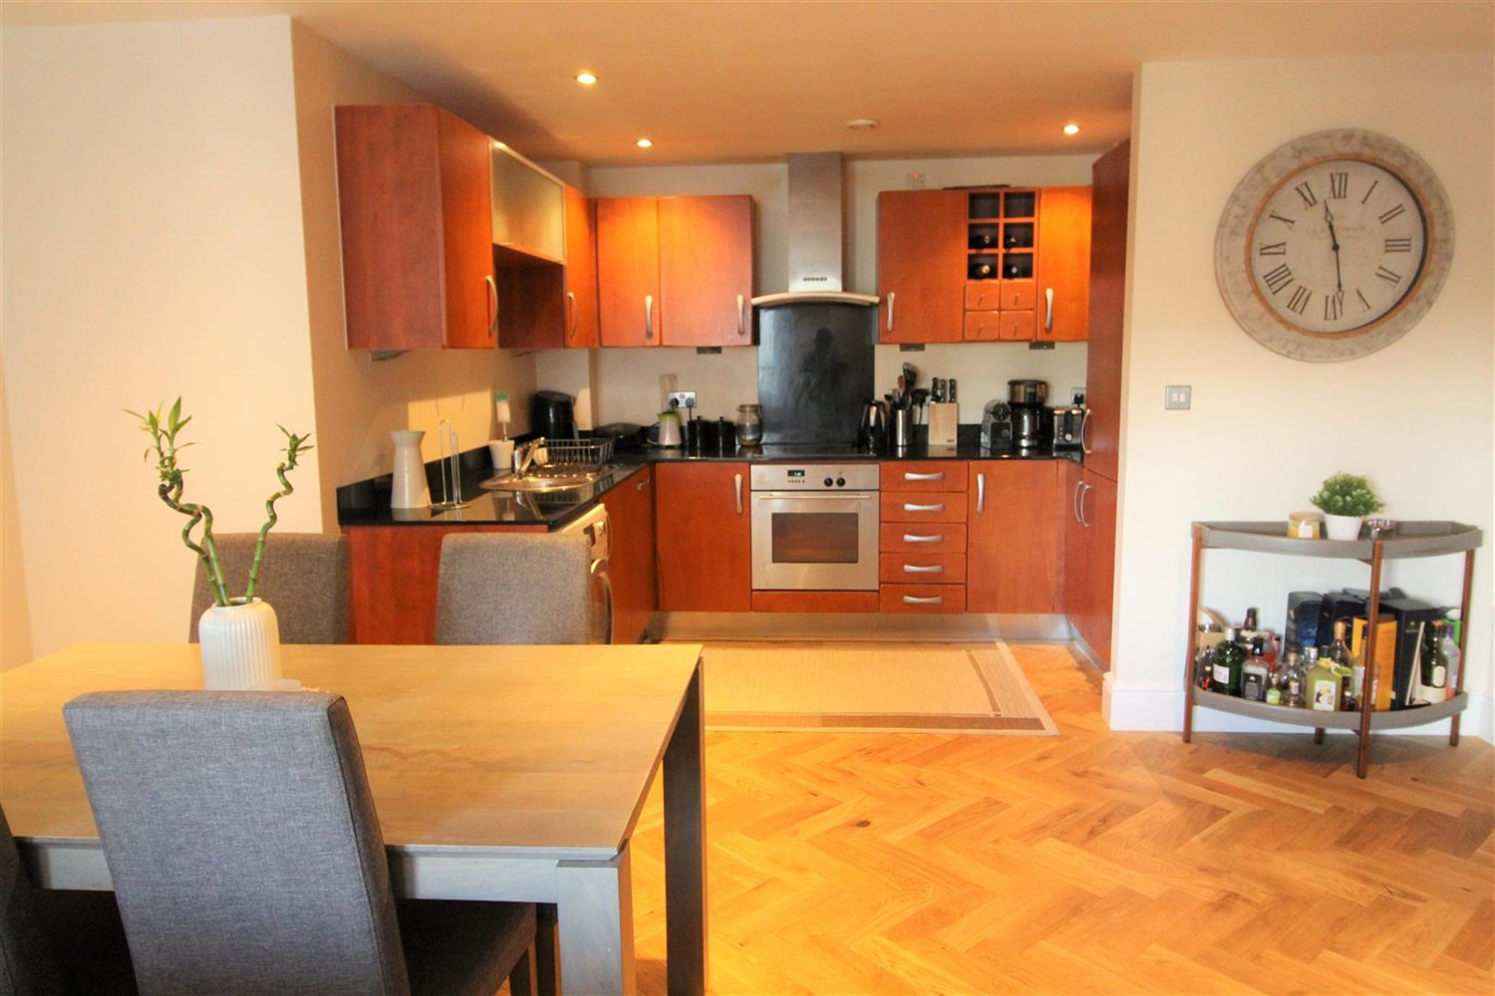

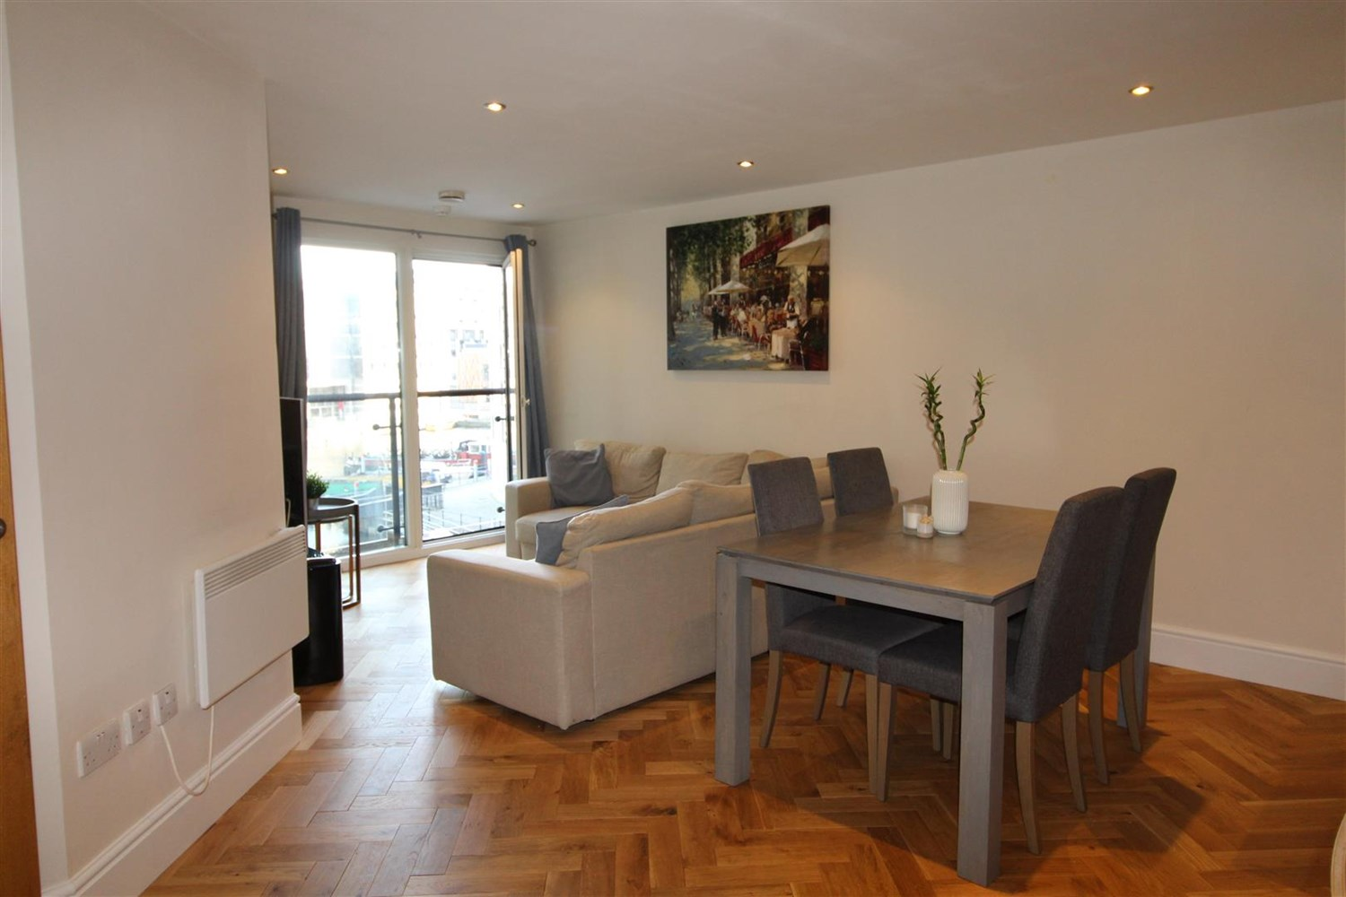

|  |
| --- |
| **Hallway**  Spacious hallway with intercom and storage cupboard. |
| **Open Plan Kitchen and Living Room**  Open plan living/dining room and kitchen with access to the balcony. Kitchen is fitted with a range wall and base units with worktops over, electric oven and hob with extractor fan, integrated fridge freezer, stainless steel sink with mixer tap and drainer. |
| **Bedroom 1**  Double bedroom with window to front, electric heater access to en suite. |
| **En Suite**  En suite with walk in shower, w/c and hand wash basin, tiled walls and electric heater. |
| **Bedroom 2**  Double bedroom with window to front, electric heater. |
| **House Bathroom**  Three piece white bathroom suite with shower over, shower screen, w/c and hand wash basin. Mirror to wall and tiled walls, electric wall heater. |
| month Tenancy. 12 months. COUNCIL TAX BAND: E EPC Rating C  Leasehold property  Broadband:  Standard 16 Mbps 1 Mbps Good Superfast 80 Mbps 20 Mbps Good Ultrafast 330 Mbps 50 Mbps Mobile availability: EE Limited Limited Three Limited Limited O2 Likely Likely Vodafone Likely Likely  Utilities: Water supplied on standard meters. Electric mains supplied on standard meters. |

|  |  |
| --- | --- |
| These particulars are intended to give a fair description of the property, but their accuracy cannot be guaranteed, and they do not constitute an offer of contract. Intending purchasers must rely on their own inspection of the property. None of the above appliances/services have been tested by ourselves. We recommend purchasers arrange for a qualified person to check all appliances/services before legal commitment.  **Property Ref:** 3790  **For more information, please contact**  0113 258 1150 **|** [lettings@adairpaxton.co.uk](mailto:lettings@adairpaxton.co.uk) **|** www.adairpaxton.co.uk |  |