

**Crown Street Buildings, , LS2**

**£925.00pcm**

**Apartment**

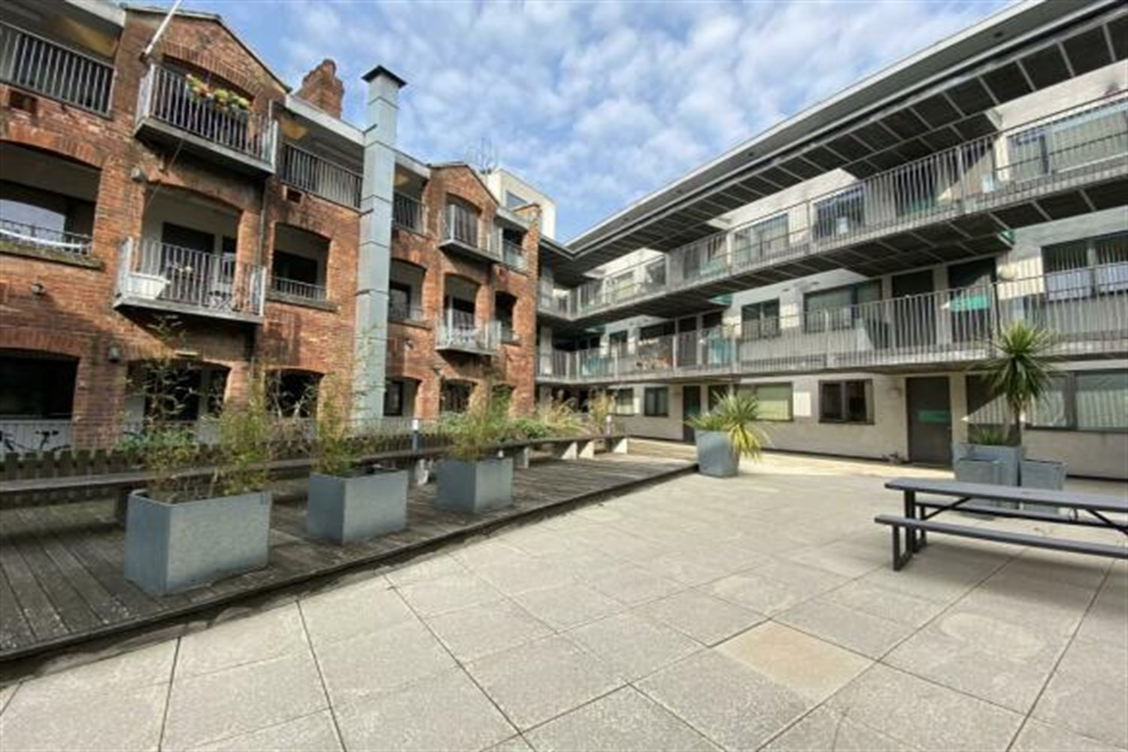

1 Bathroom(s)

1 Reception(s)

2 Bedroom(s)

***SECOND FLOOR, TWO BEDROOM APARTMENT WITH A BALCONY*** Close to the Corn Exchange and Kirkgate Market. Located a short walk to the bus and train station. Handy for all the amenities Leeds city centre has to offer. Comprising; hallway, spacious lounge/kitchen/diner, hallway, two double bedrooms and house bathroom. This property also boasts a large communal patio area. Deposit £1065. EPC rating C, council tax band - D. Furnished, Available 25th November. Sorry No Pets.



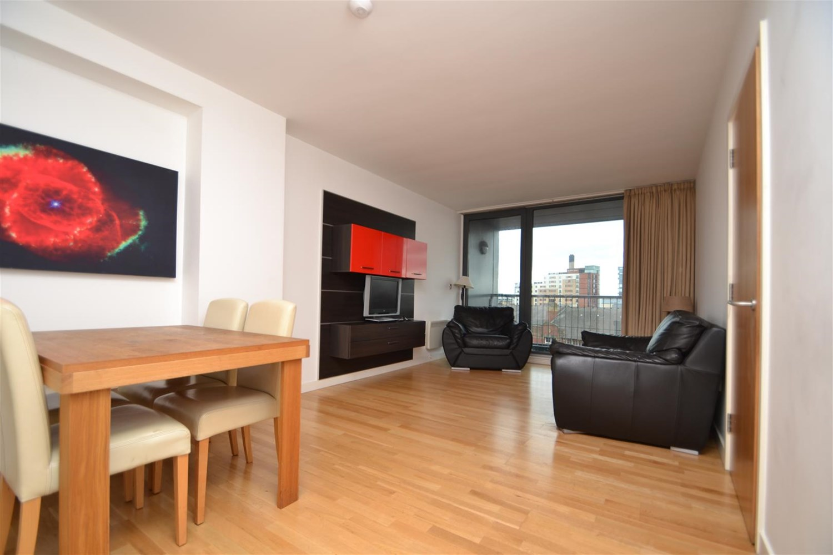

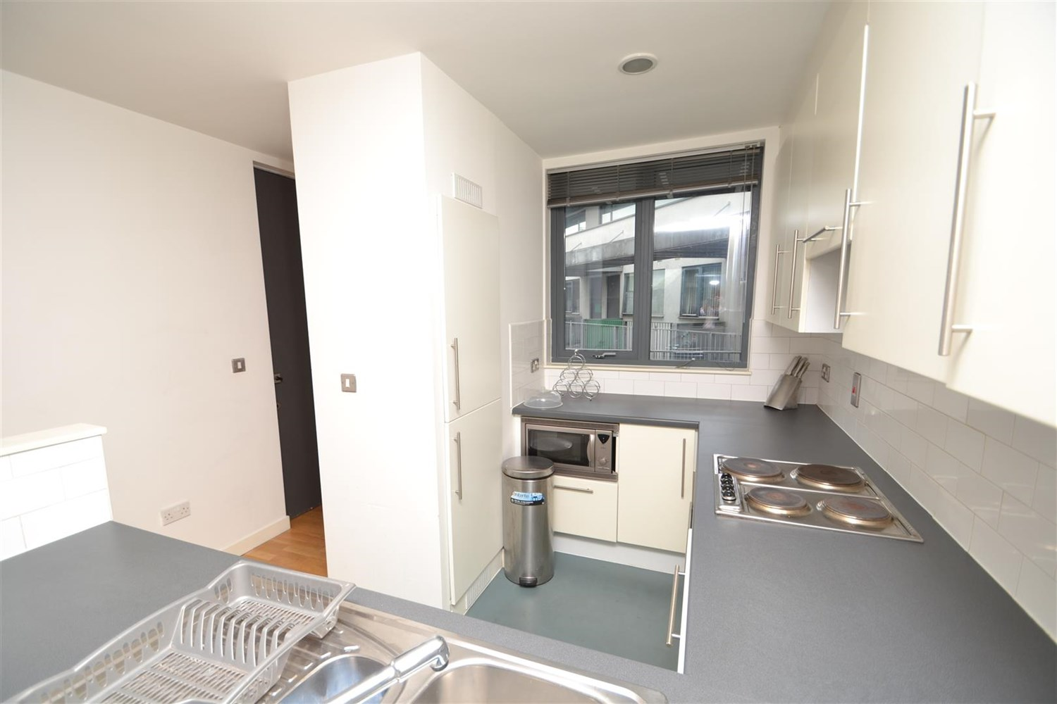

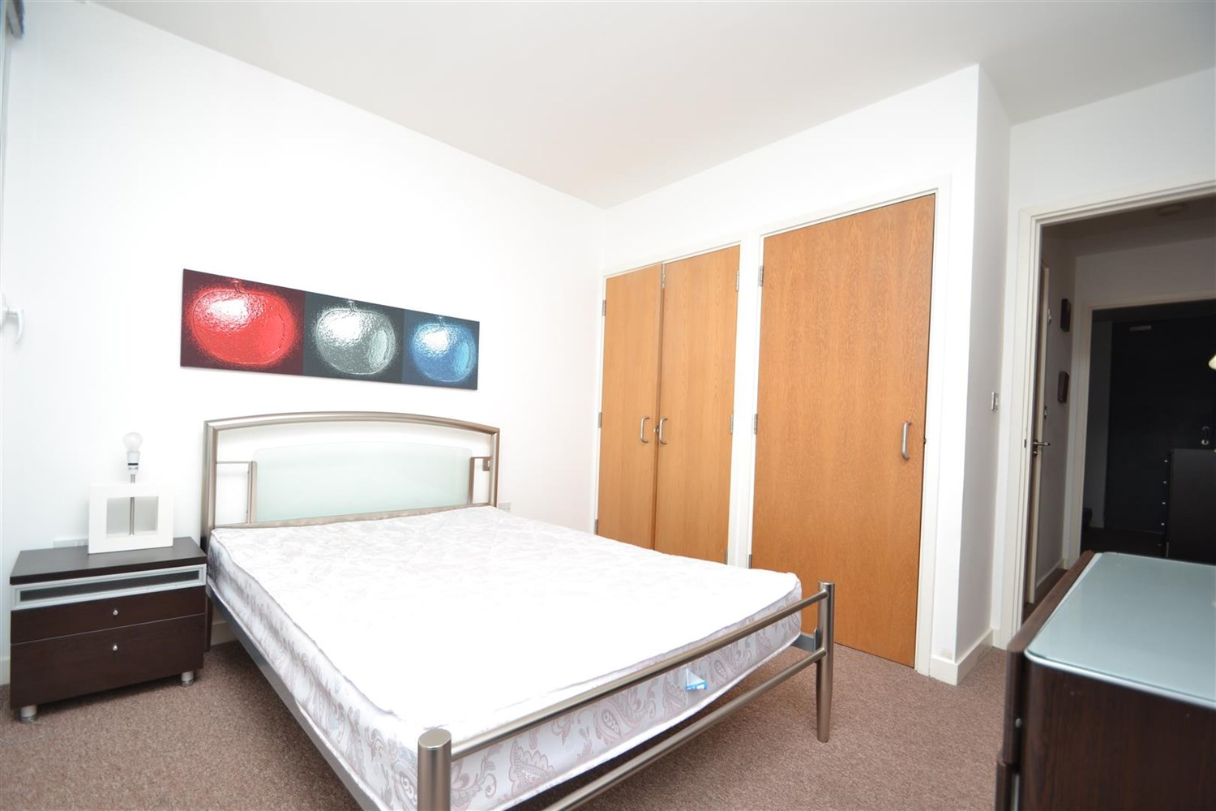

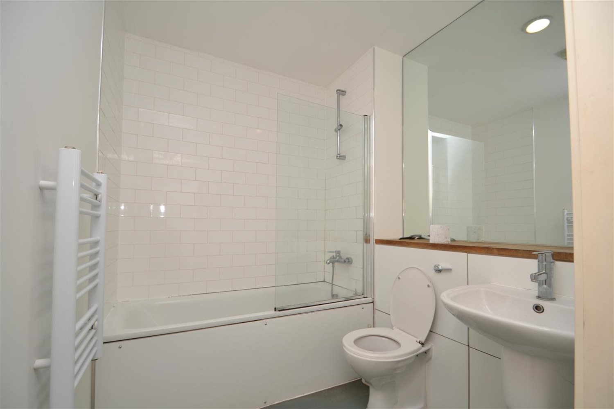

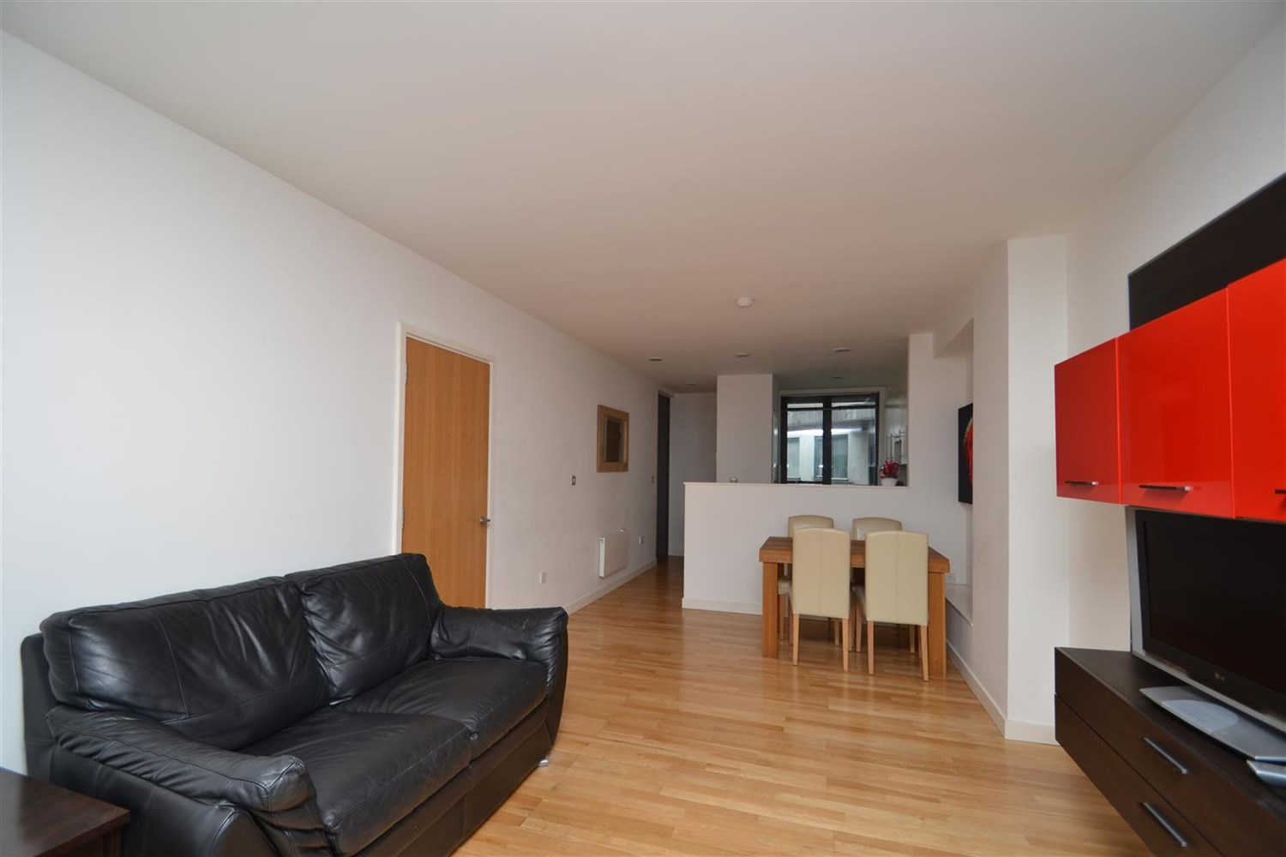

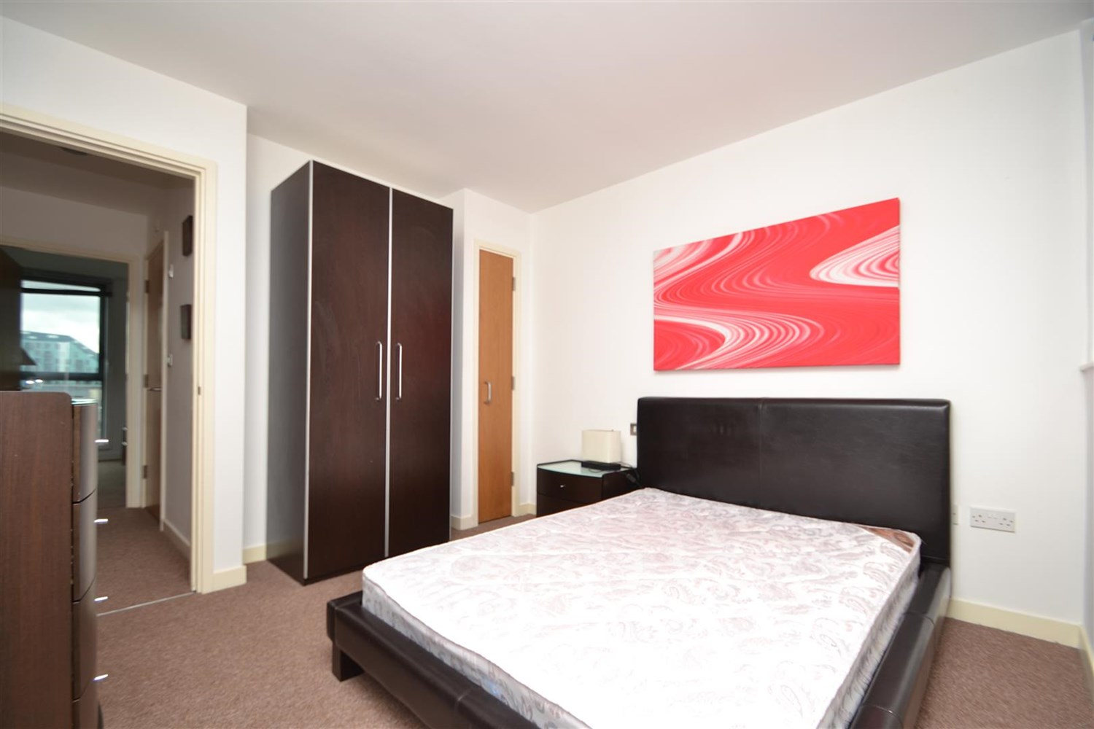



|  |
| --- |
| **Open Plan Kitchen and Living Room**  Spacious open plan living area and kitchen, space for dining table, lounge area with electric heater, sliding doors leading to balcony. Modern kitchen fitted with a range of wall and base units with worktops over, stainless steel sink with mixer tap, electric oven and hob with extractor overhead. Microwave fitted in to overhead space, Intergraded fridge and microwave. |
| **Bedroom 1**  Double bedroom with a fitted wardrobe, double glazed window and a wall mounted electric radiator. |
| **Bedroom 2**  Second double bedroom with a double glazed window and a wall mounted electric radiator. |
| **Bathroom**  Three piece bathroom with bath and shower over head, shower screen, W/C, hand wash basin. Tiled walls and floor, electric wall heater, large mirror. |
| Council Tax: EPC Rating:   No Parking.  Broadband: Standard highest download speed: 16mbps. Standard highest upload speed: 1mbps. Ultrafast highest download speed: 1000mbps. Ultrafast highest upload speed: 1000mbps.  Mobile availability: EE likely to have good coverage. Three likely to have good coverage. O2 likely to have good coverage. Vodafone likely to have good coverage.  Utilities: No gas. Water supplied on a meter. Electric mains supplied on standard meters |

|  |
| --- |
|  |

These particulars are intended to give a fair description of the property, but their accuracy cannot be guaranteed, and they do not constitute an offer of contract. Intending purchasers must rely on their own inspection of the property. None of the above appliances/services have been tested by ourselves. We recommend purchasers arrange for a qualified person to check all appliances/services before legal commitment.

**Property Ref:** 4115

**For more information, please contact**

0113 258 1150 **|** [lettings@adairpaxton.co.uk](mailto:lettings@adairpaxton.co.uk) **|** www.adairpaxton.co.uk