

**0113 258 1150**

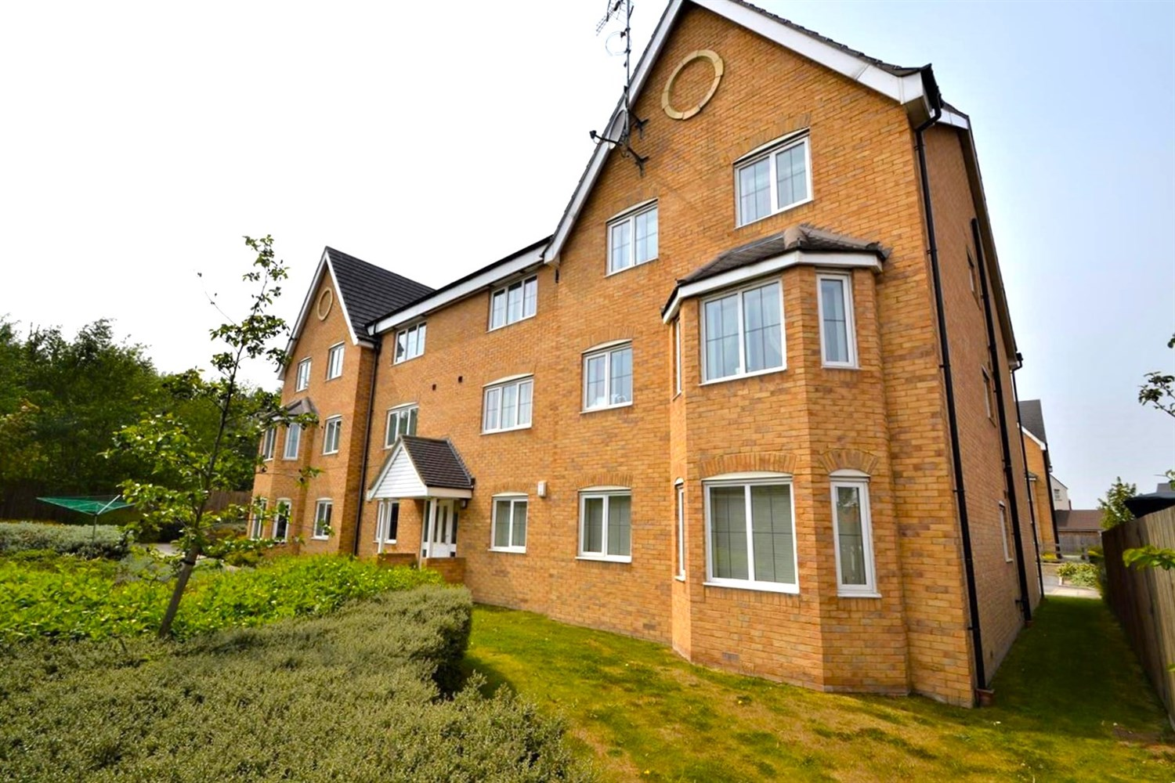



**Valuation £115,000.00**

**18 Bracken Green, Off Fall Lane, East Ardsley, WF3 2LT**

***SPACIOUS TWO BEDROOM APARTMENT WITH ALLOCATED PARKING SPACE*** The property is within easy access to Leeds and Wakefield, close to the motorway network and handy for all amenities. The apartment briefly comprises; entrance hall, lounge/diner/kitchen, two double bedrooms and bathroom with shower over bath. Externally there are well maintained communal gardens and an allocated parking space. Ideal opportunity for a First-time buyer/Investor. EPC Rating C, Council Tax band - A.

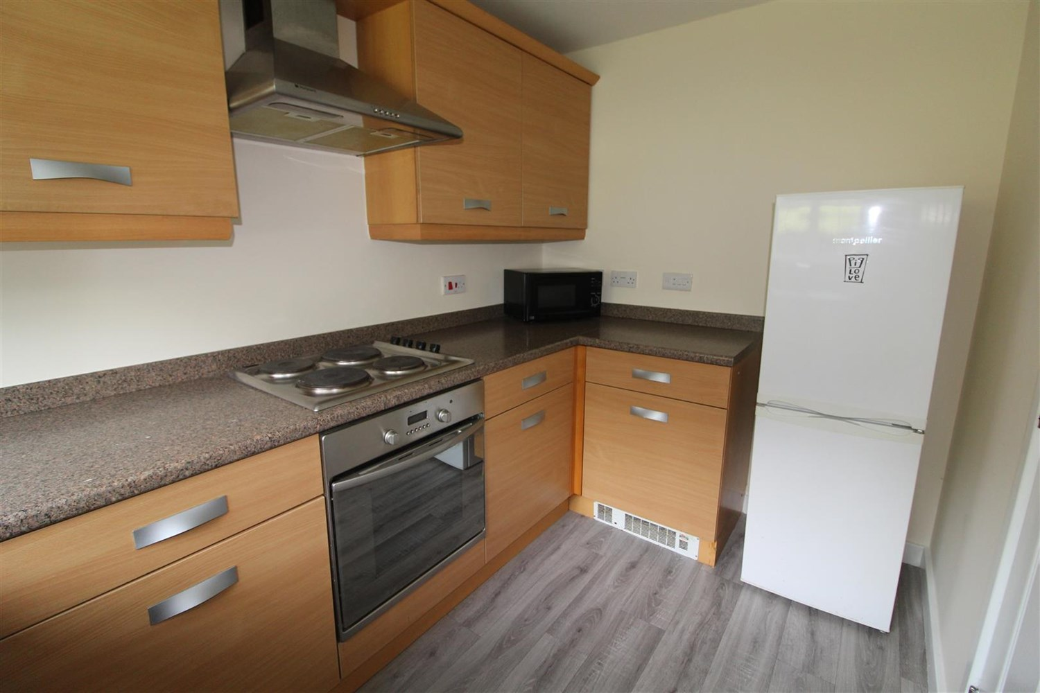

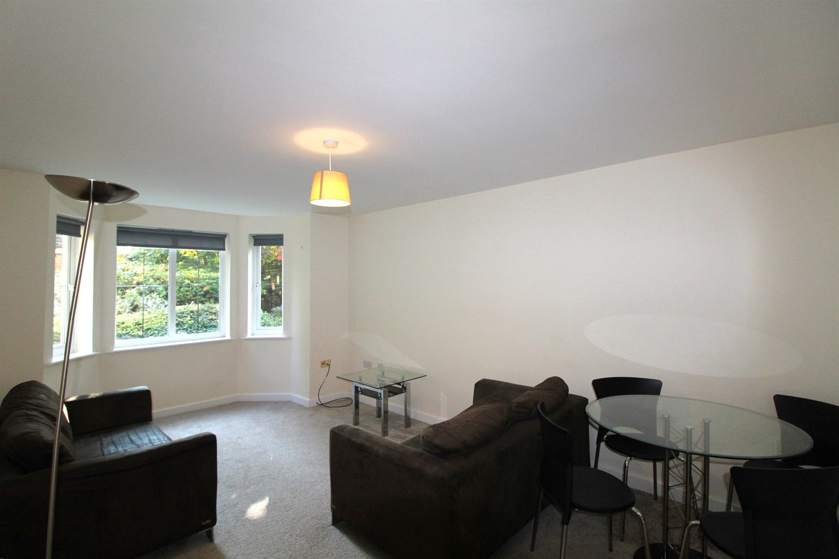

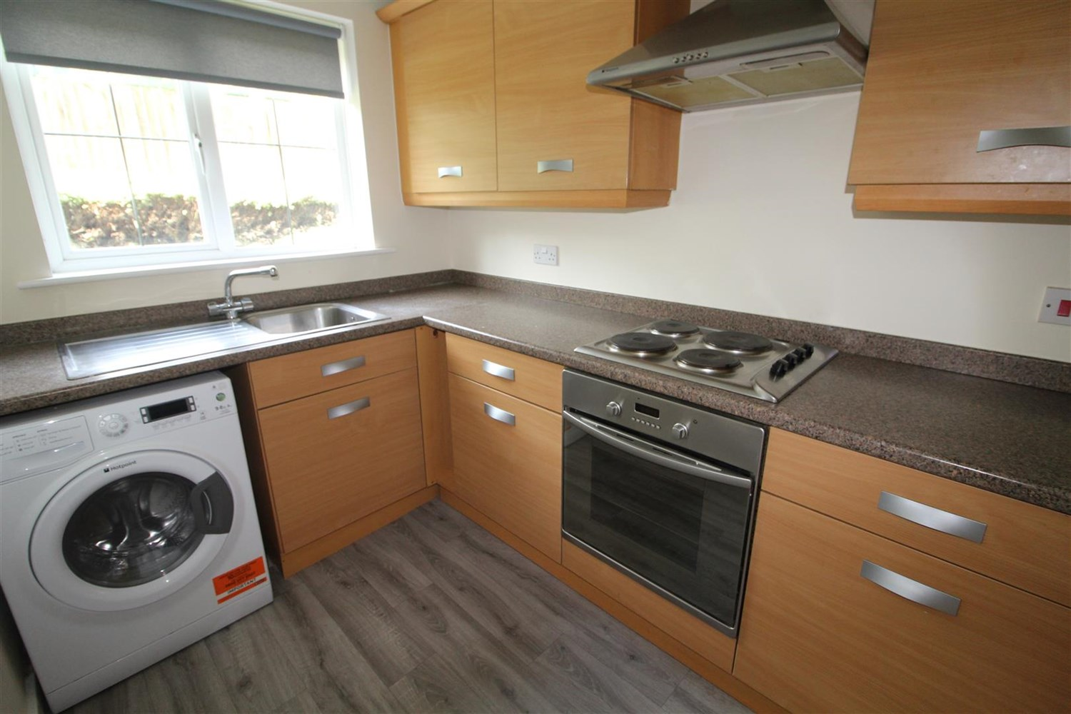

2 Bathroom(s)

1 Reception(s)

2 Bedroom(s)

00

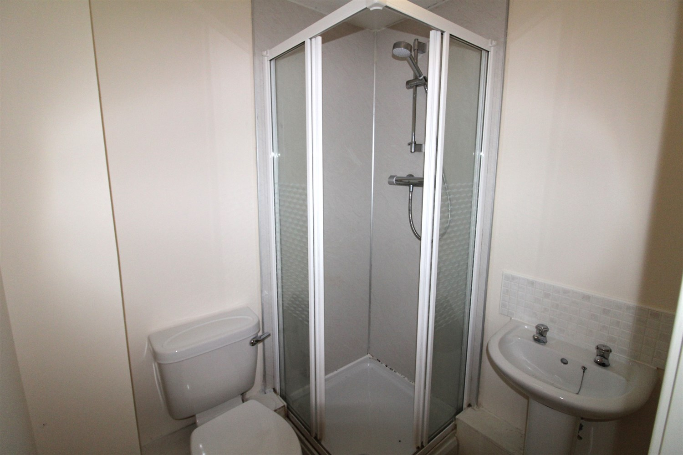

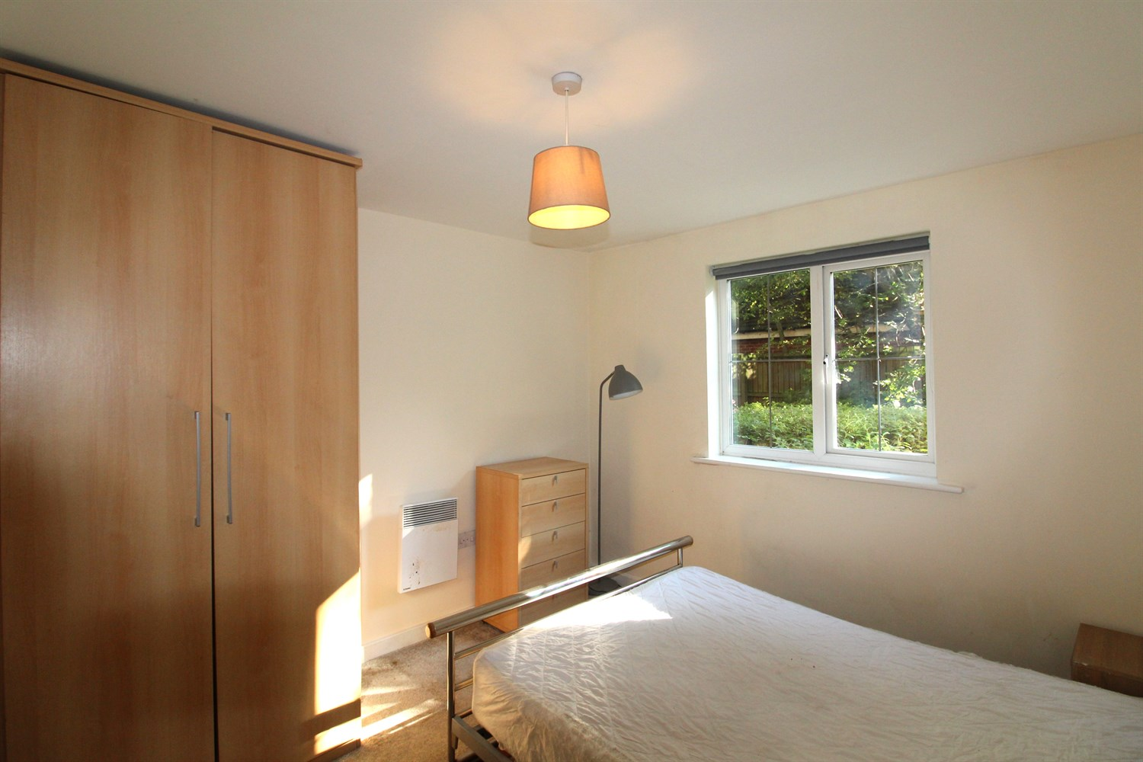

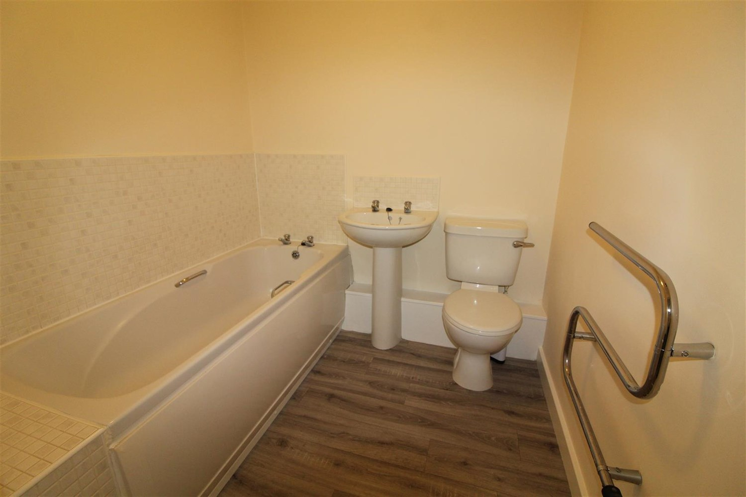

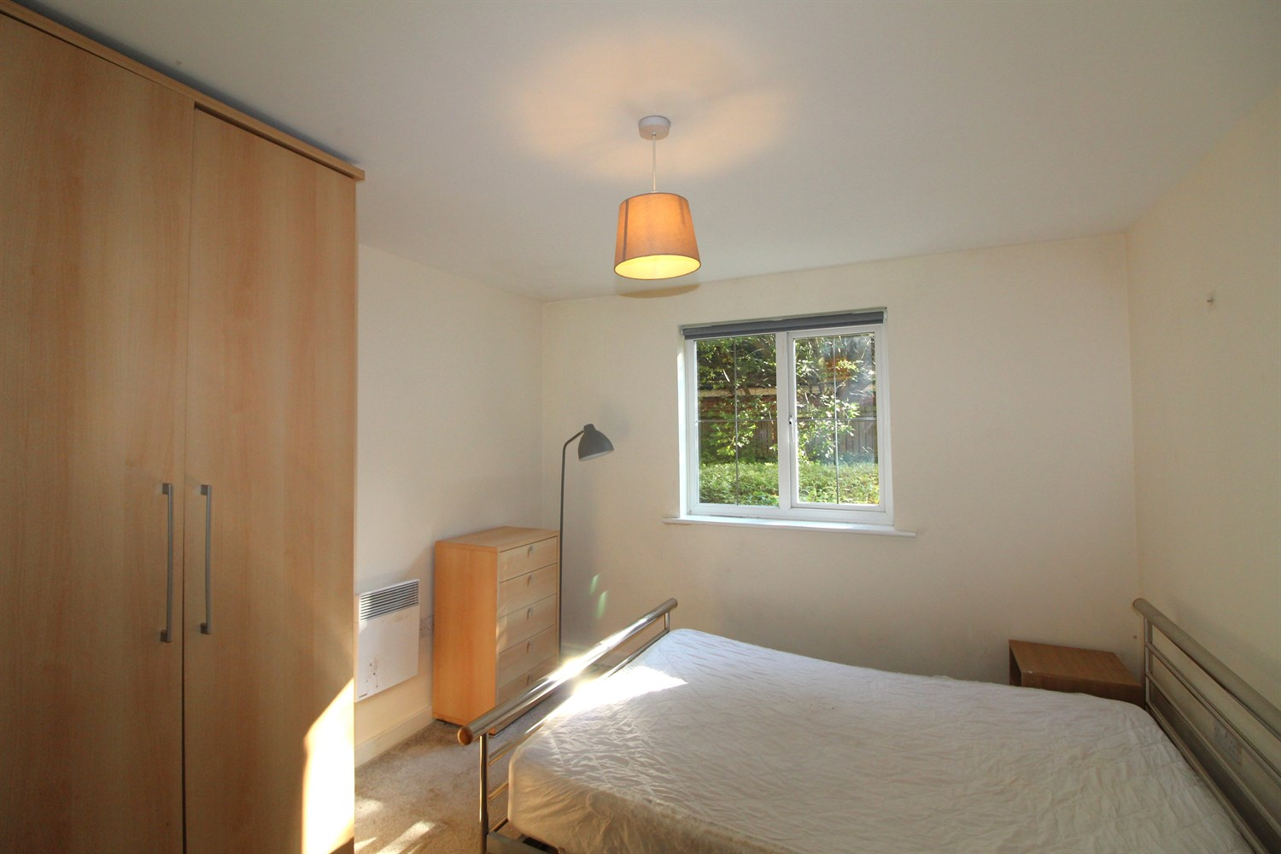

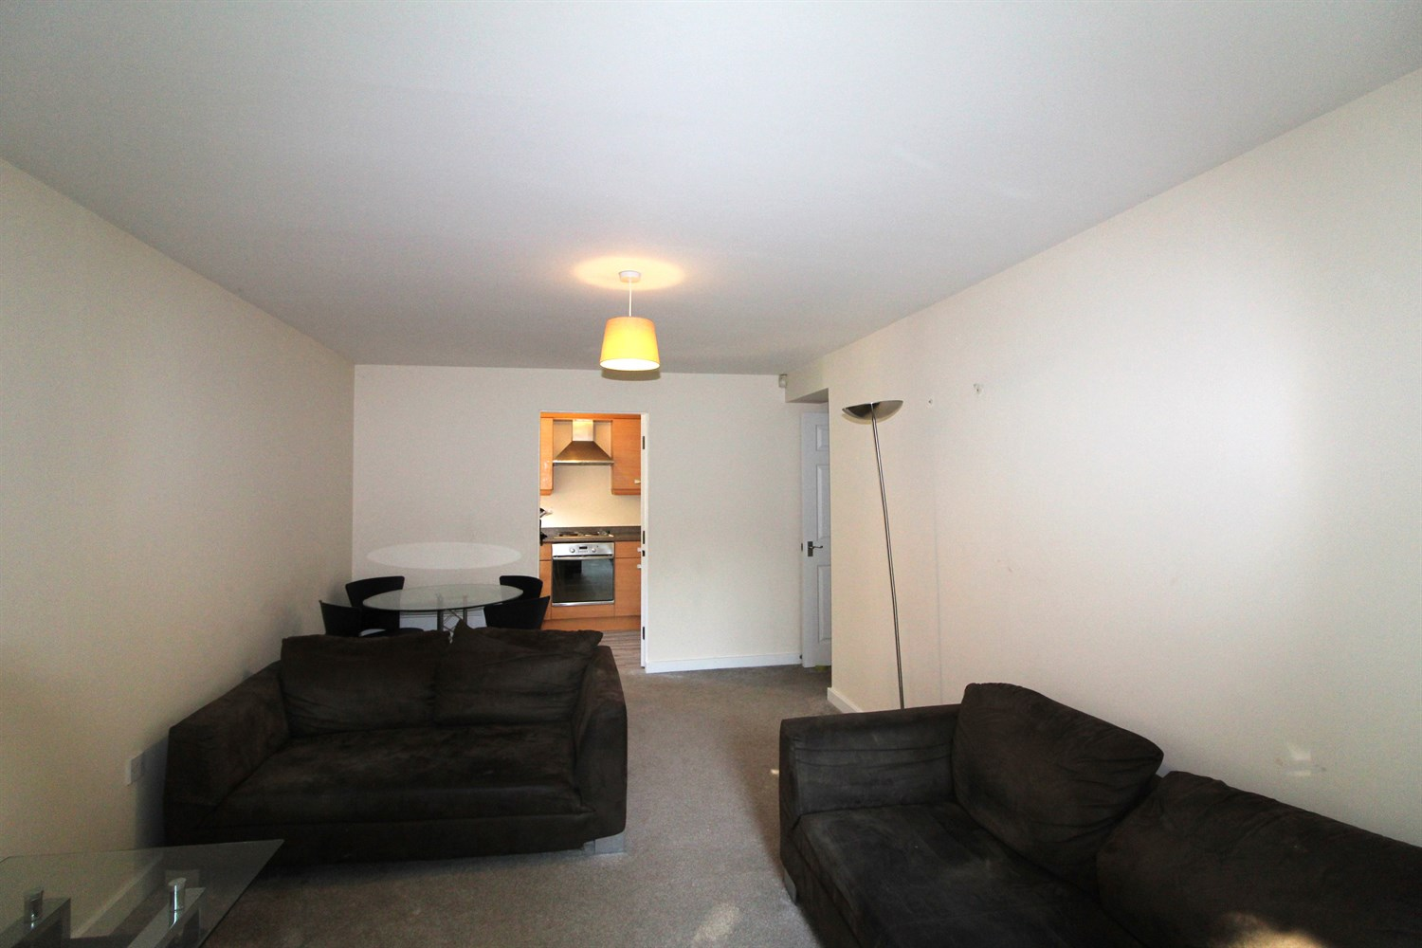

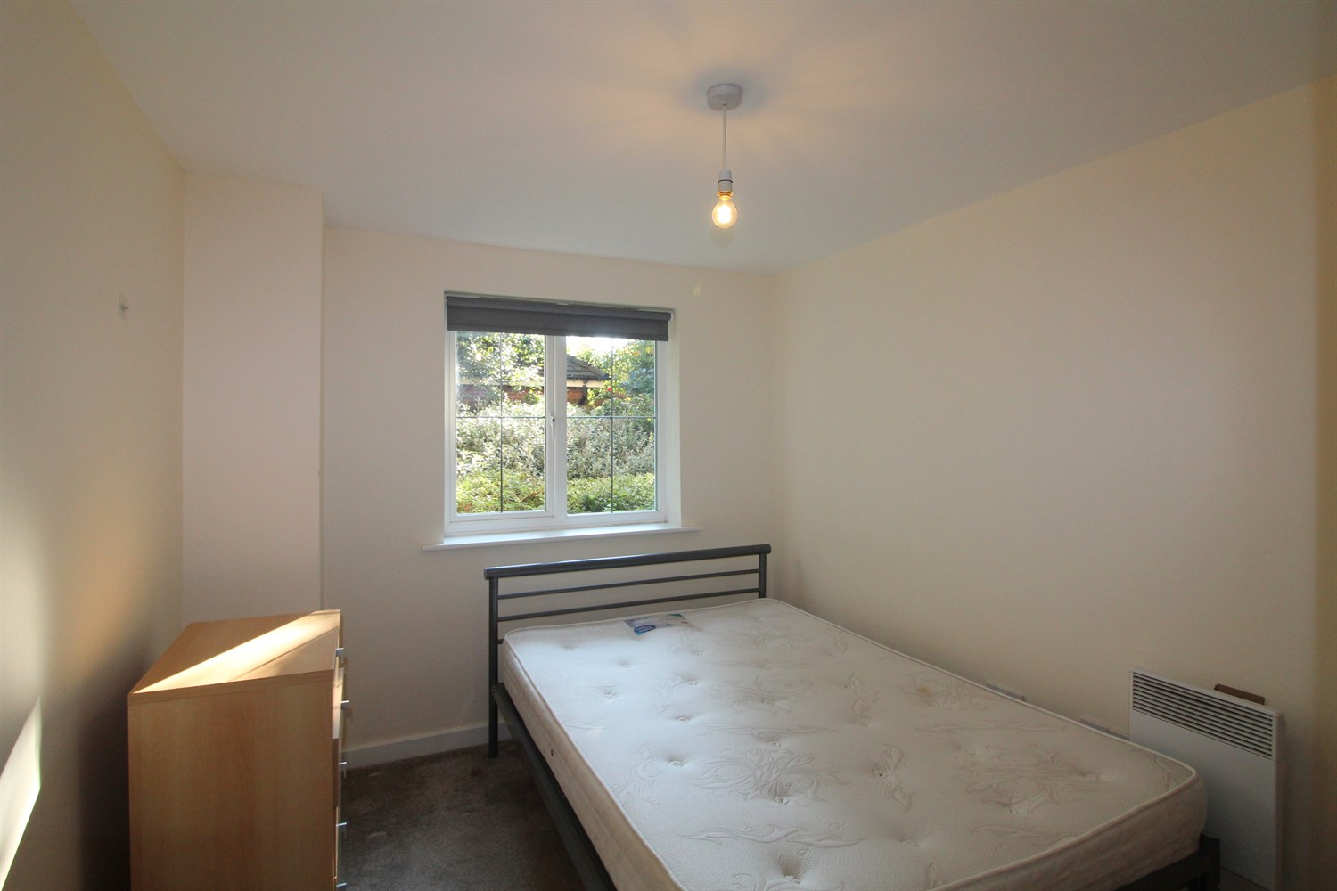

|  |
| --- |
| **Communal entrance**  Secure communal entrance with stairs to all floors. |
| **Private Entrance Hall**  Entrance hall with storage cupboard. |
| **Living room**  Spacious living area with bay window to front. Wall mounted electric radiator. |
| **Kitchen**  Fitted with a range of wall, base and drawer units with worktops over. Single drainer stainless steel sink with mixer tap and drainer. Integrated over with 4-ring hob and extractor above. Plumbed for washing machine. Part tiled walls. Space for fridge freezer. Window to front. |
| **Bedroom 1**  Double bedroom with double glazed window. Wall mounted electric radiator. |
| **En-suite**  Fitted with a three-piece white suite comprising; shower cubicle, W/C, and wash hand basin. |
| **Bedroom 2**  Second bedroom with double glazed window. Wall mounted electric radiator. |
| **Bathroom**  Fitted with a three-piece white suite comprising; bath, W/C and wash hand basin. Part tiled wall. Wall mount heated towel rail. |
| **Tenure**  The term of the Lease is 125 years from 1st January 2006. Ground Rent: £84.21 per annum |
| **Service Charge**  Service charge is £581.03 paid every 6 months. |

|  |  |
| --- | --- |
| These particulars are intended to give a fair description of the property, but their accuracy cannot be guaranteed, and they do not constitute an offer of contract. Intending purchasers must rely on their own inspection of the property. None of the above appliances/services have been tested by ourselves. We recommend purchasers arrange for a qualified person to check all appliances/services before legal commitment.  **Property Ref:** 3950  **For more information, please contact**  0113 258 1150 **|** [sales@adairpaxton.co.uk](mailto:sales@adairpaxton.co.uk) **|** www.adairpaxton.co.uk |  |