

**0113 258 1150**

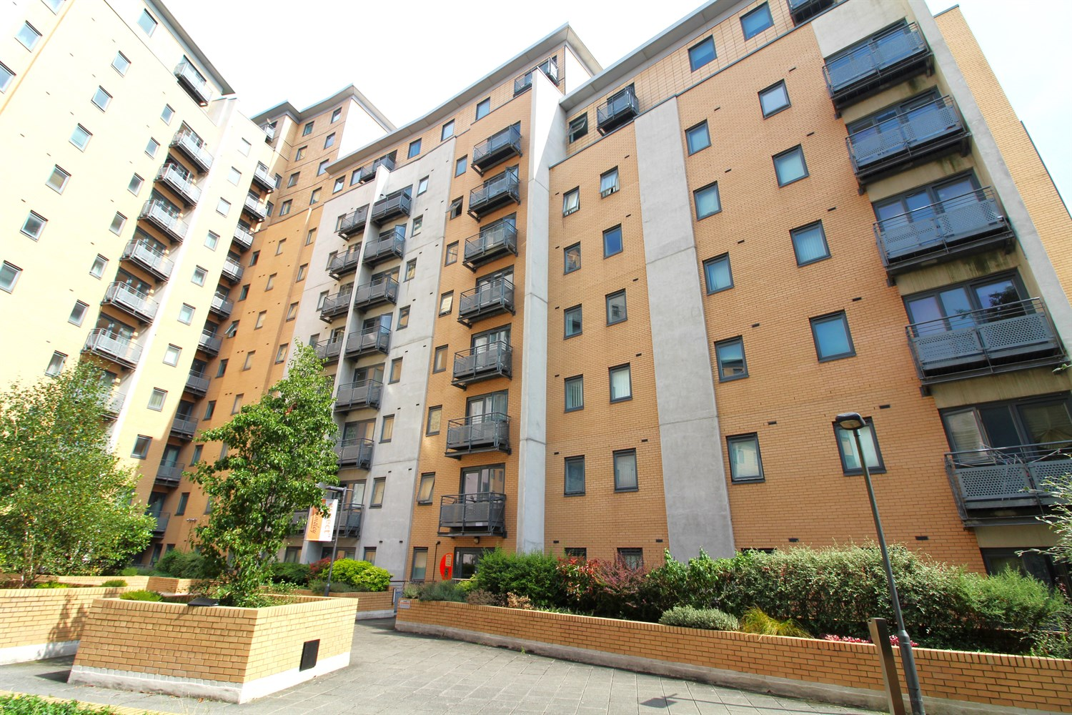



**For Sale £175,000.00**

**55/Aspect 14, LS2**

**TWO BEDROOM APARTMENT OFFERED WITH NO ONWARD CHAIN - EWS1 COMPLIANT - A1 RATING***WITH PARKING** A wonderfully large apartment located at the popular Aspect 14 development. Located in the Northern Quarter of the city, Aspect 14 is ideally placed for access to Leeds' First Direct Arena, Leeds University, Trinity, Victoria Gate and more. Motorway access is a mere stones throw away, and Leeds Bus Station is a short stroll. The apartment briefly comprises; Open plan living, master bedroom with en-suite shower room, second double bedroom and a house bathroom. Onsite caretaker and well maintained communal grounds. This is the ideal INVESTORS opportunity. Council Tax Band - D. EPC - B

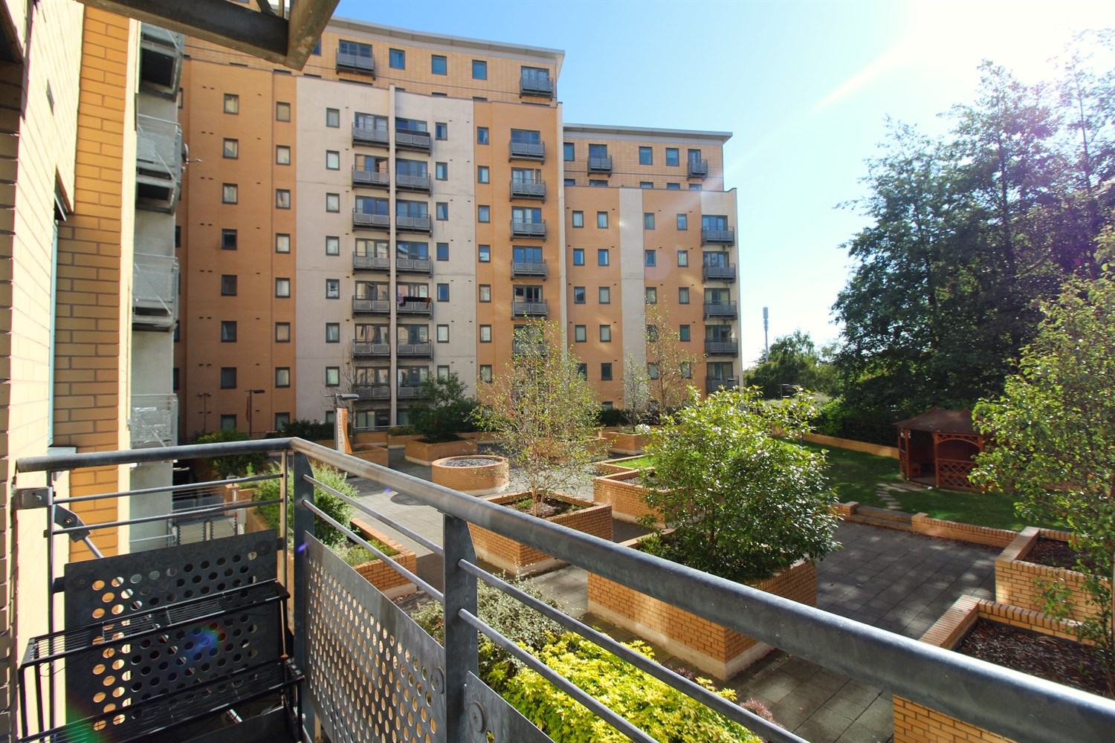

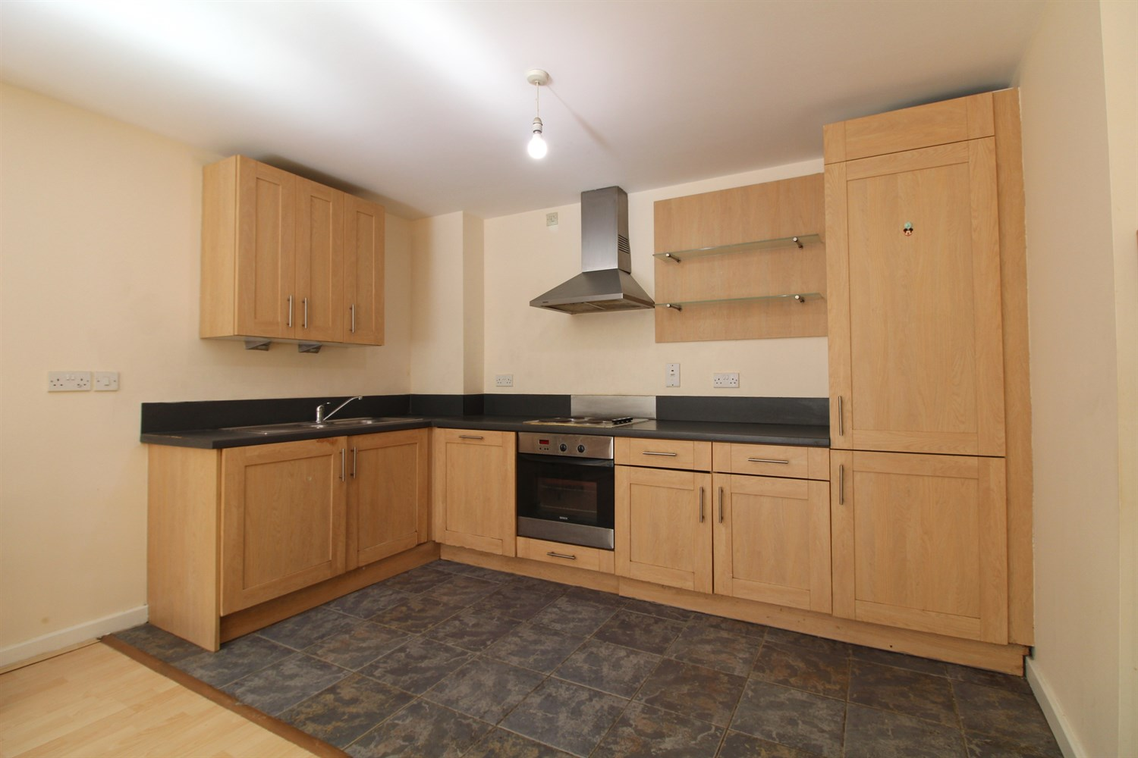

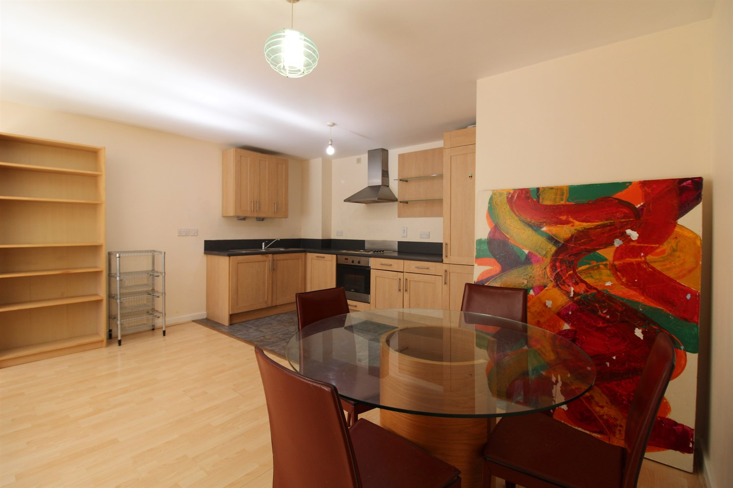

2 Bathroom(s)

1 Reception(s)

2 Bedroom(s)

00

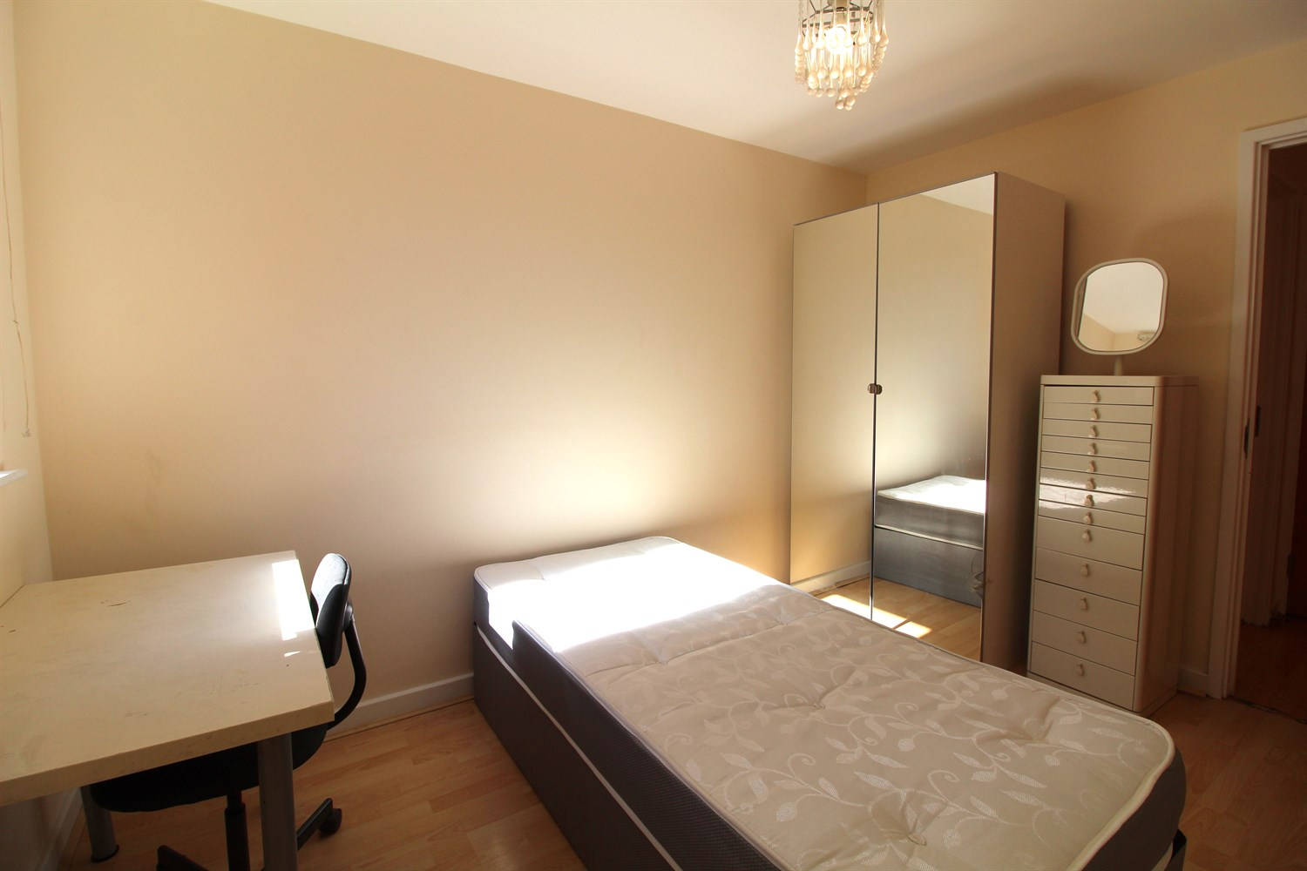

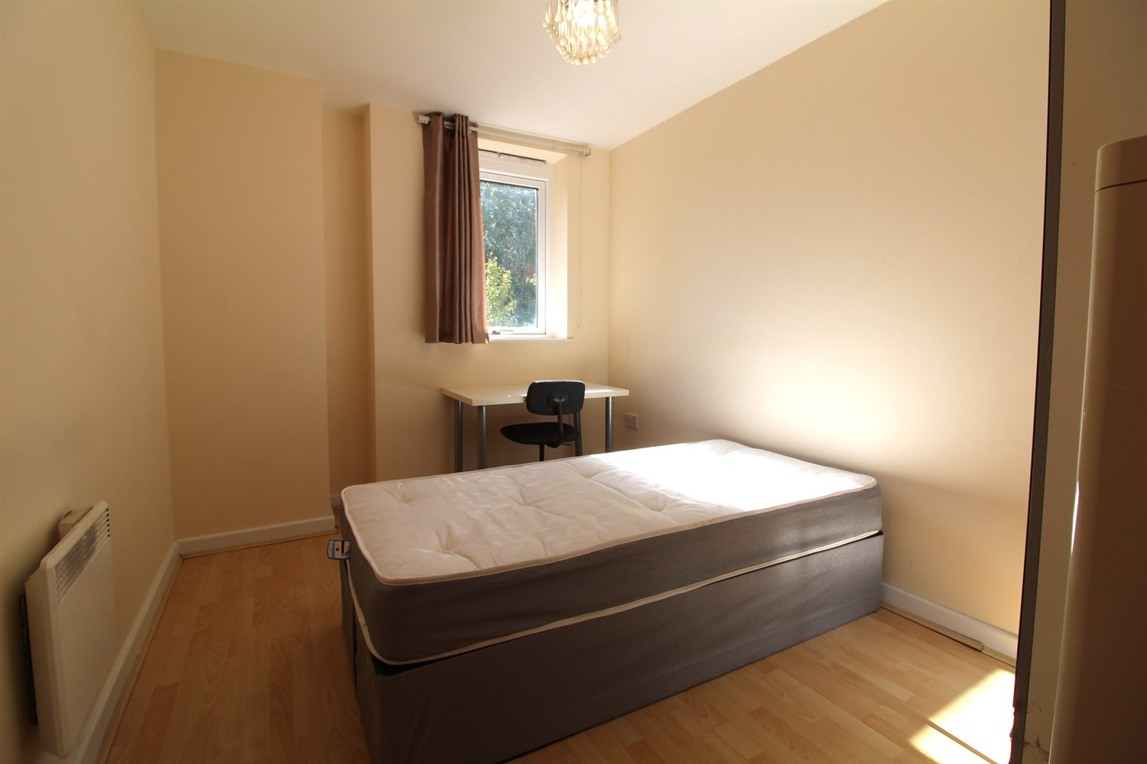

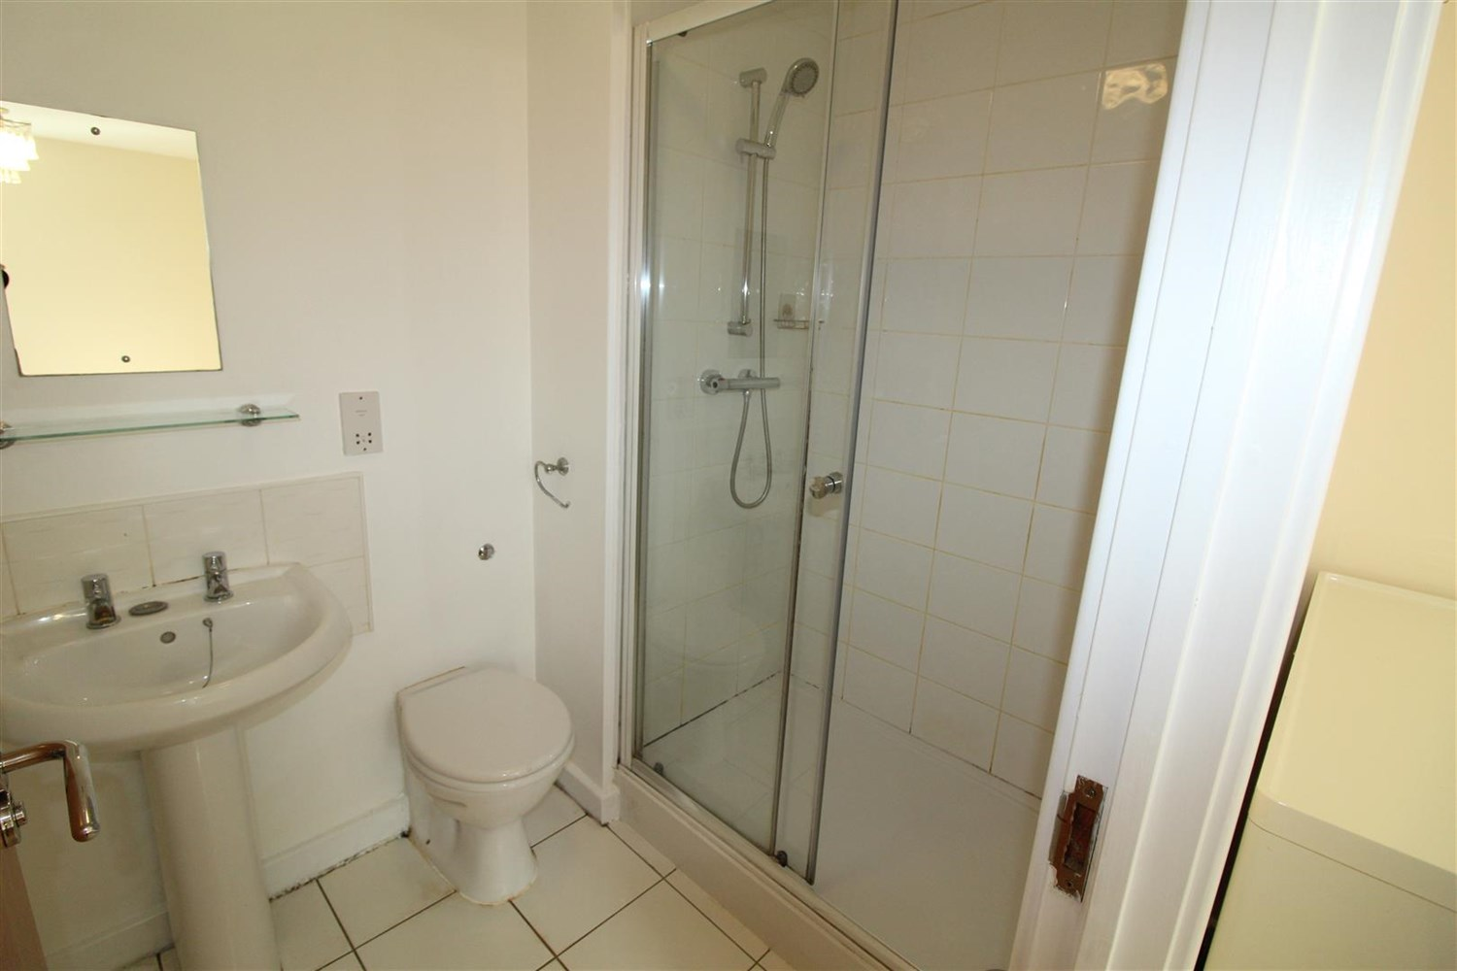

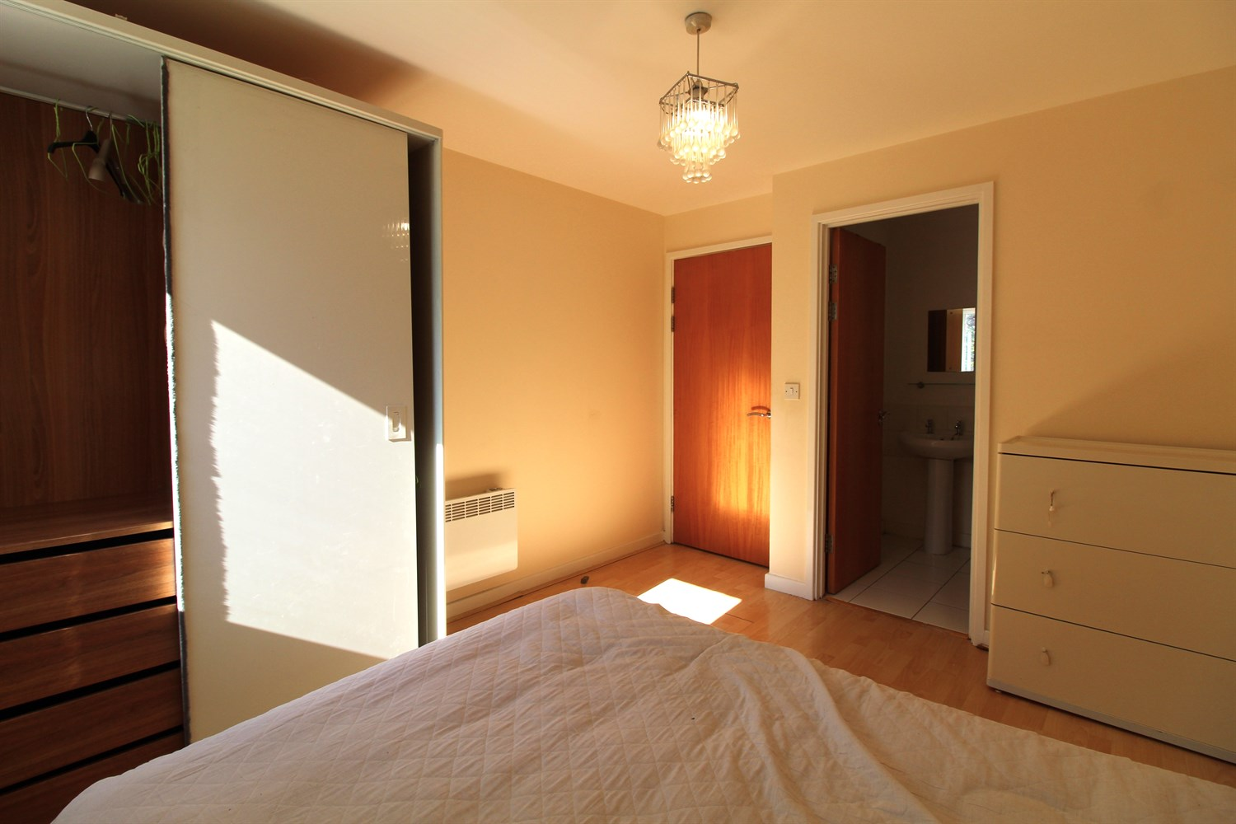

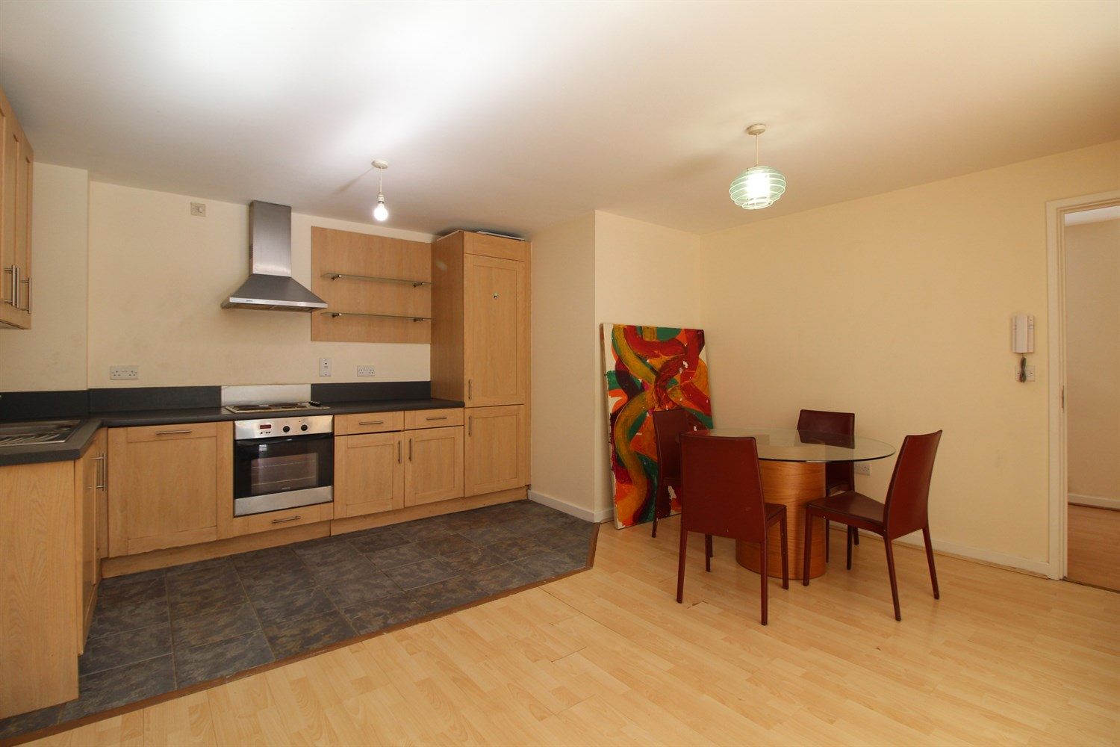

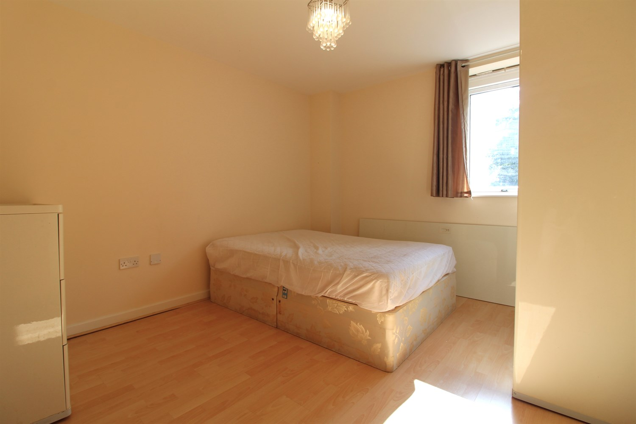

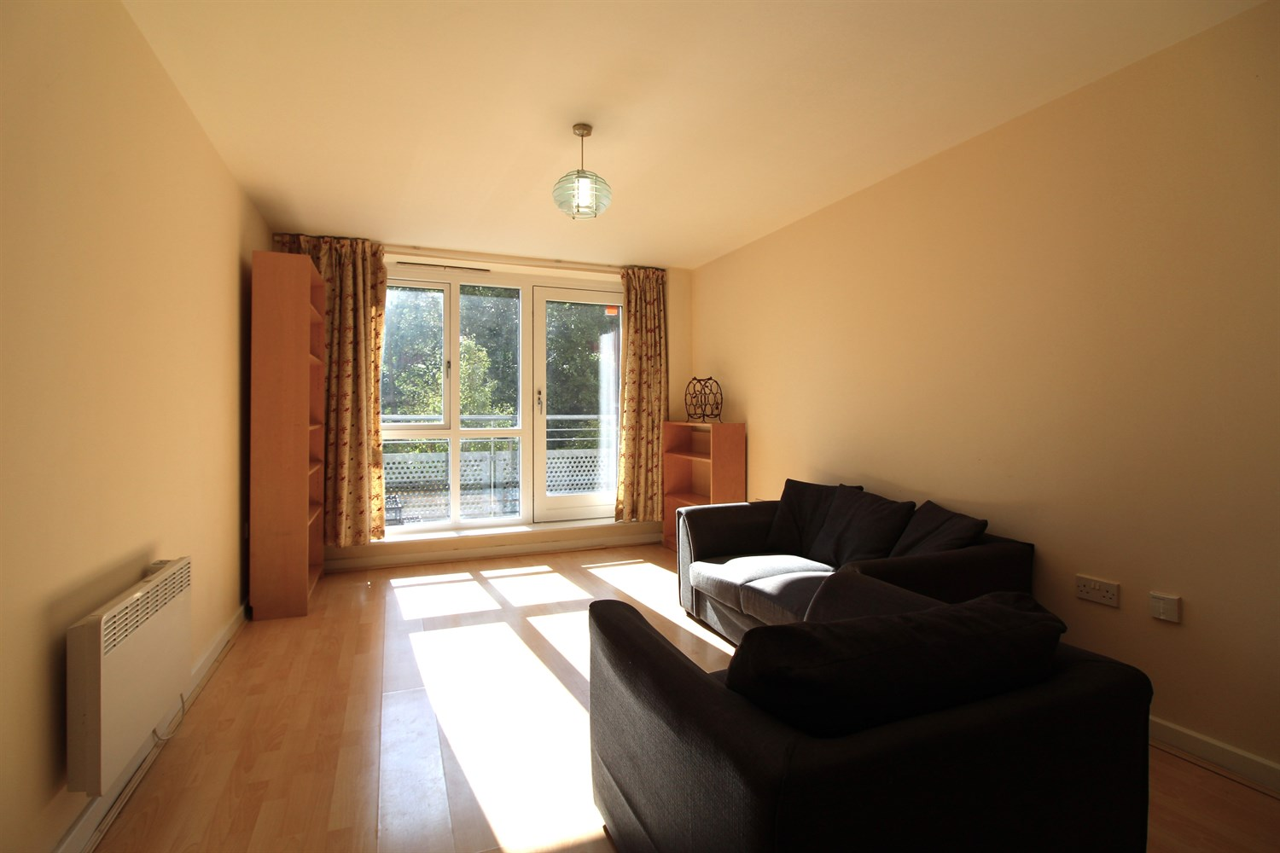

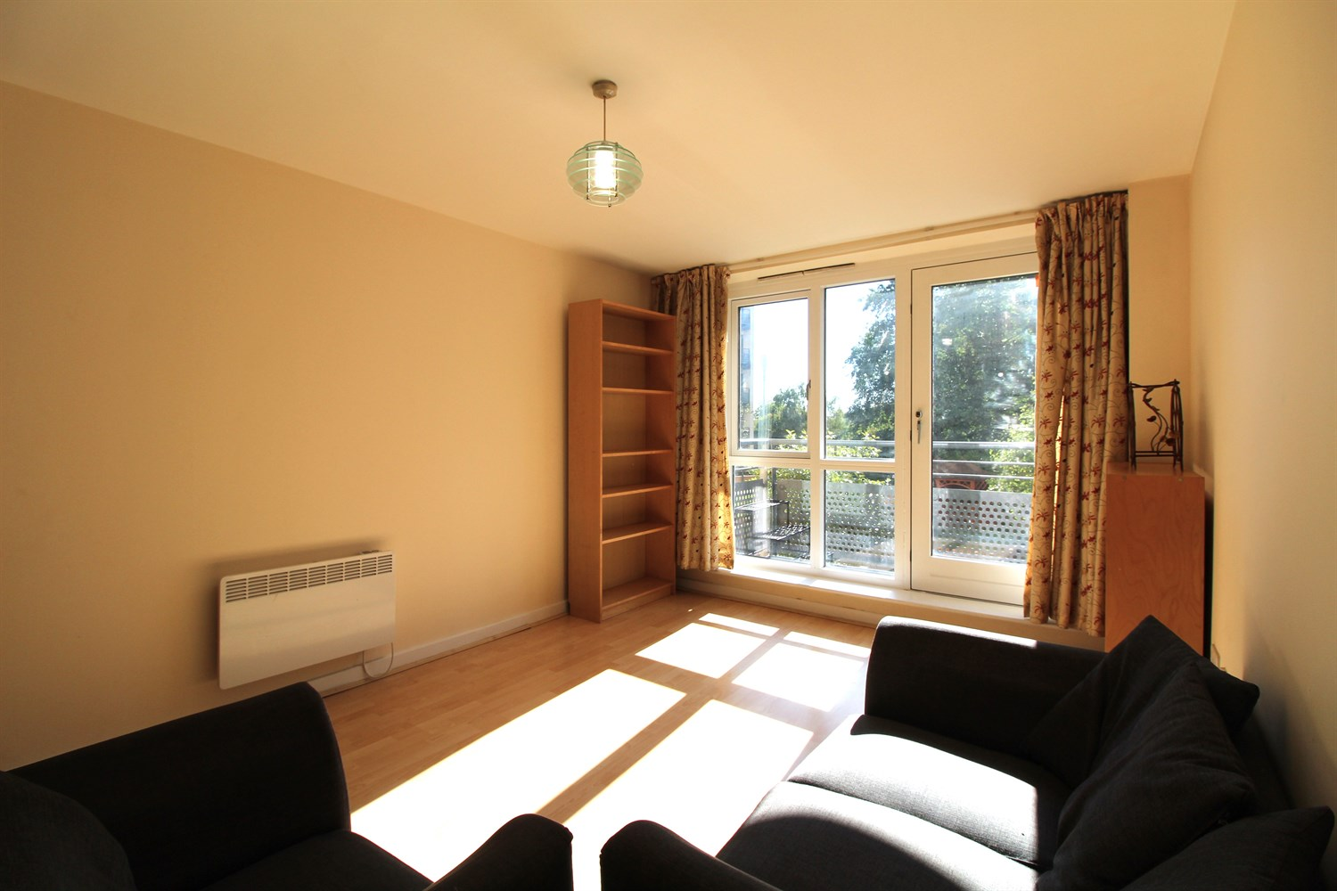

|  |
| --- |
| **Communal entrance**  Secure block entrance with post boxes, video entrance phone and access to all floors via lift and stairs |
| **Private Entrance Hall**  With laminate flooring, video entrance phone, storage cupboard |
| **Open Plan Kitchen/Living room**  Open plan living area with access to balcony. Kitchen area having a range of wall, base and drawer units with worktops over. integrated oven, hob and extractor, single drainer stainless steel sink unit with mixer tap, washing machine, fridge freezer and dishwasher. Electric radiator. |
| **Bedroom 1**  Double bedroom with double glazed window. Electric radiator. |
| **En-suite**  En-suite shower room with shower cubicle, low flush w.c and basin. Heated towel rail. |
| **Bedroom 2**  Second double bedroom with double glazed window. Electric radiator. |
| **Bathroom**  A white bathroom suite comprising bath, low flush WC and basin. Heated towel rail. |
| **Parking**  Secure underground allocated parking, lift to access. |
| **Tenure**  Lease term of 999 years, less one day starting on 1st January 2003 Ground rent - £150 per year |
| **Service Charge**  Service charge: £332.45 per quarter Service charge for car park space - £11 per quarter. |

|  |  |
| --- | --- |
| These particulars are intended to give a fair description of the property, but their accuracy cannot be guaranteed, and they do not constitute an offer of contract. Intending purchasers must rely on their own inspection of the property. None of the above appliances/services have been tested by ourselves. We recommend purchasers arrange for a qualified person to check all appliances/services before legal commitment.  **Property Ref:** 3945  **For more information, please contact**  0113 258 1150 **|** [sales@adairpaxton.co.uk](mailto:sales@adairpaxton.co.uk) **|** www.adairpaxton.co.uk |  |