

**0113 258 1150**

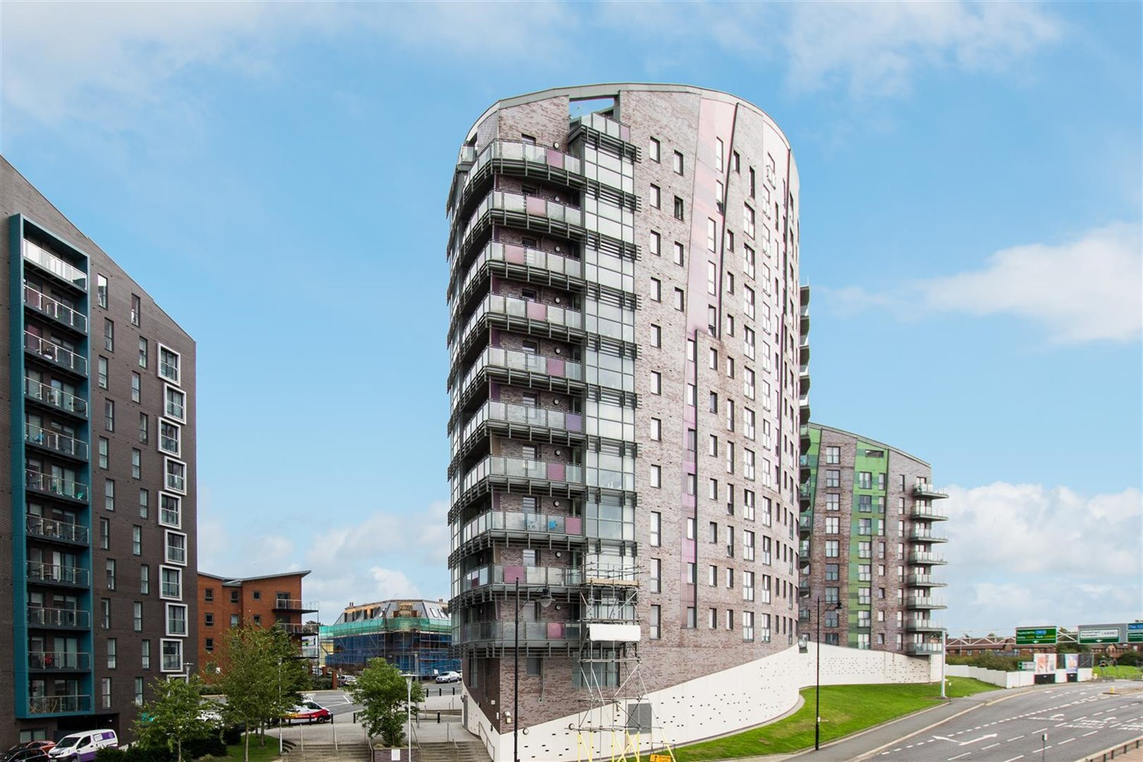



**For Sale £105,000.00**

**Echo Central One, Leeds**

**ONE BEDROOM APARTMENT with NO ONWARD CHAIN** A spacious one bedroom apartment offered for sale with vacant possession in Echo Central One. This fourth floor apartment is well presented and ready to move into/rent out. The apartment briefly comprises; Communal hallway with lift to all floors, private hallway, open plan lounge/kitchen, double bedroom and a shower room.

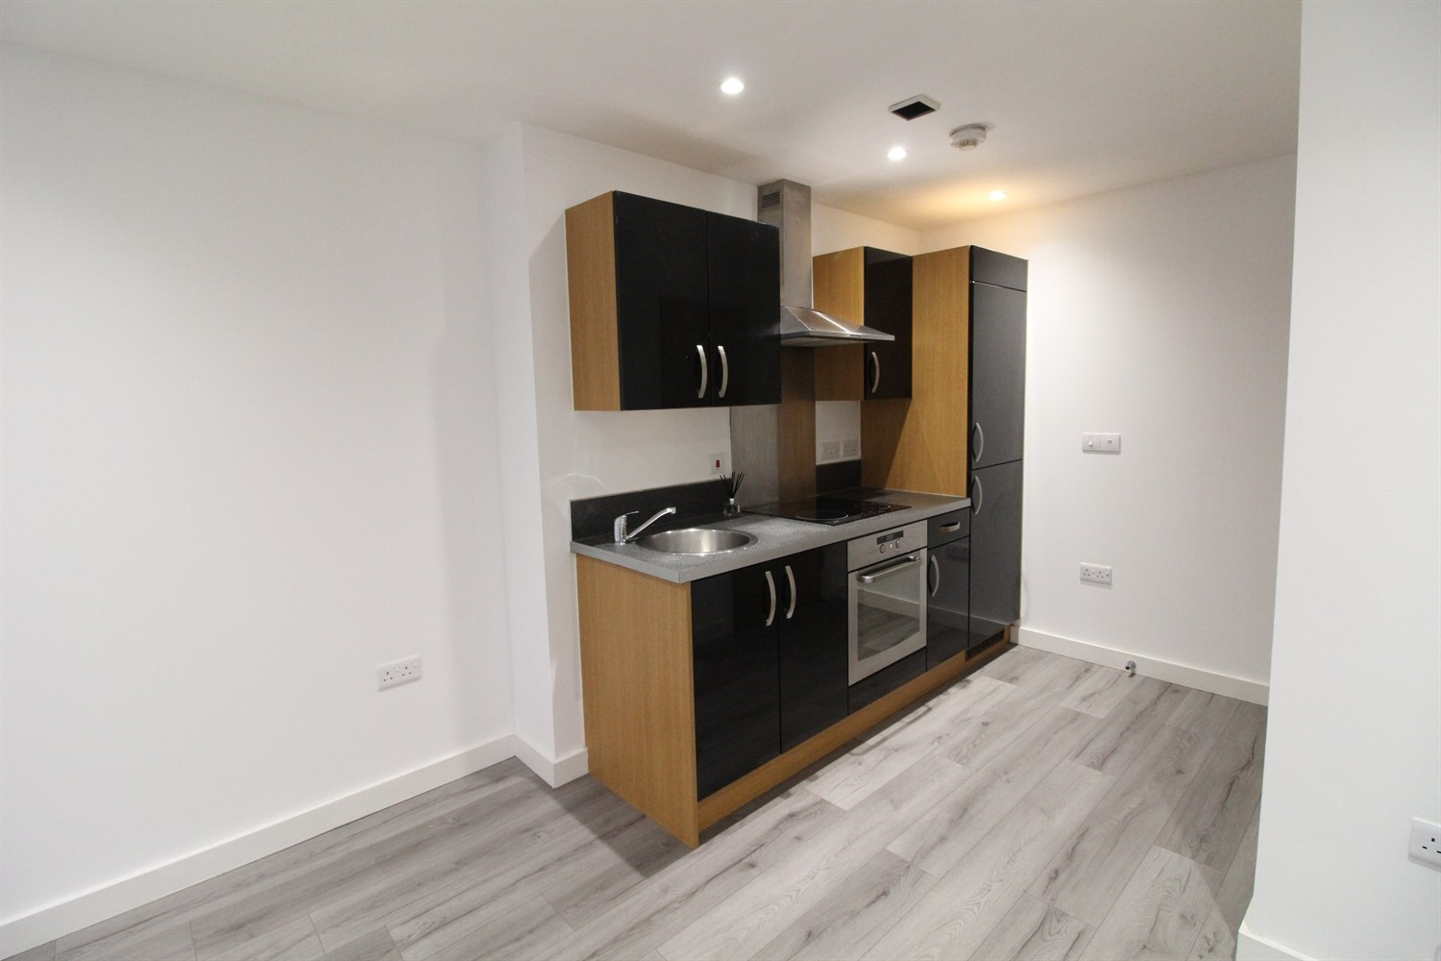

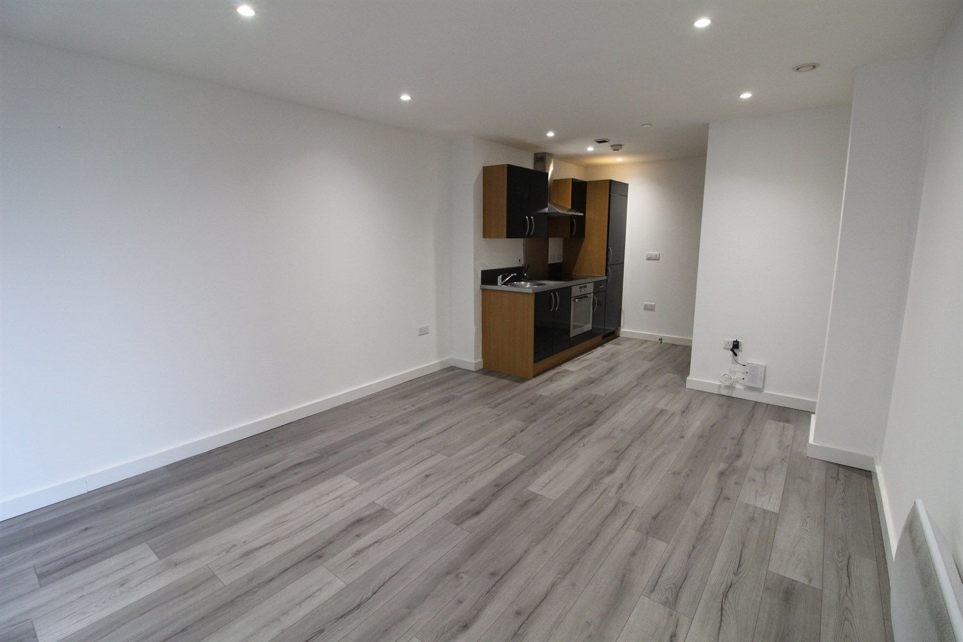

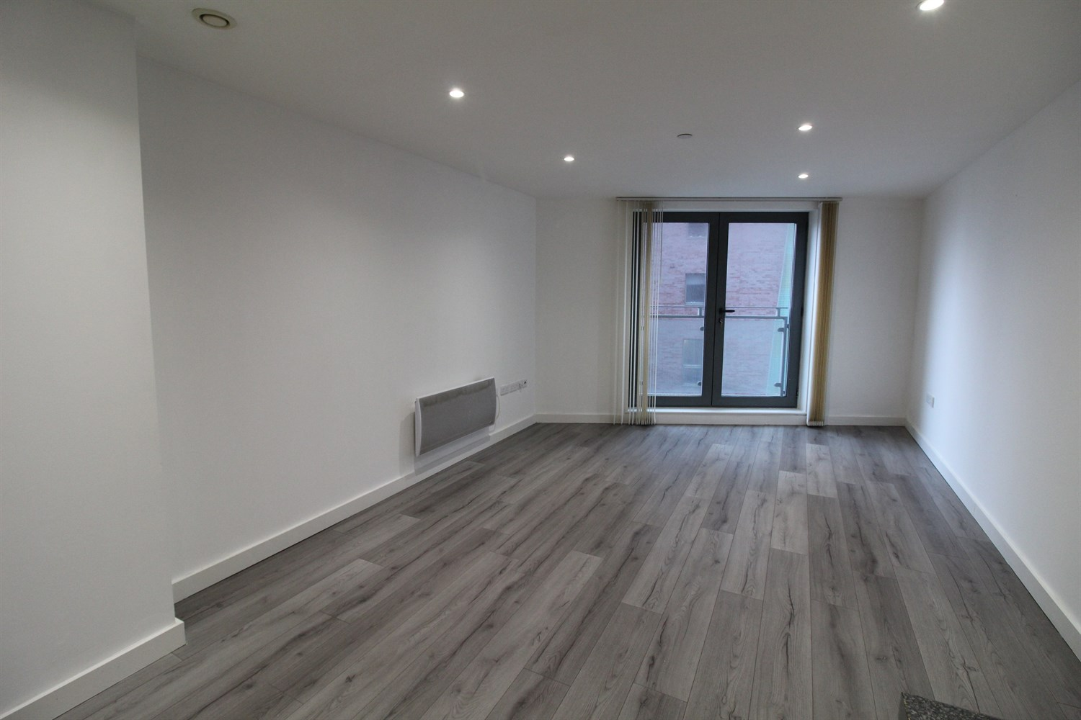

1 Bathroom(s)

1 Reception(s)

1 Bedroom(s)

00

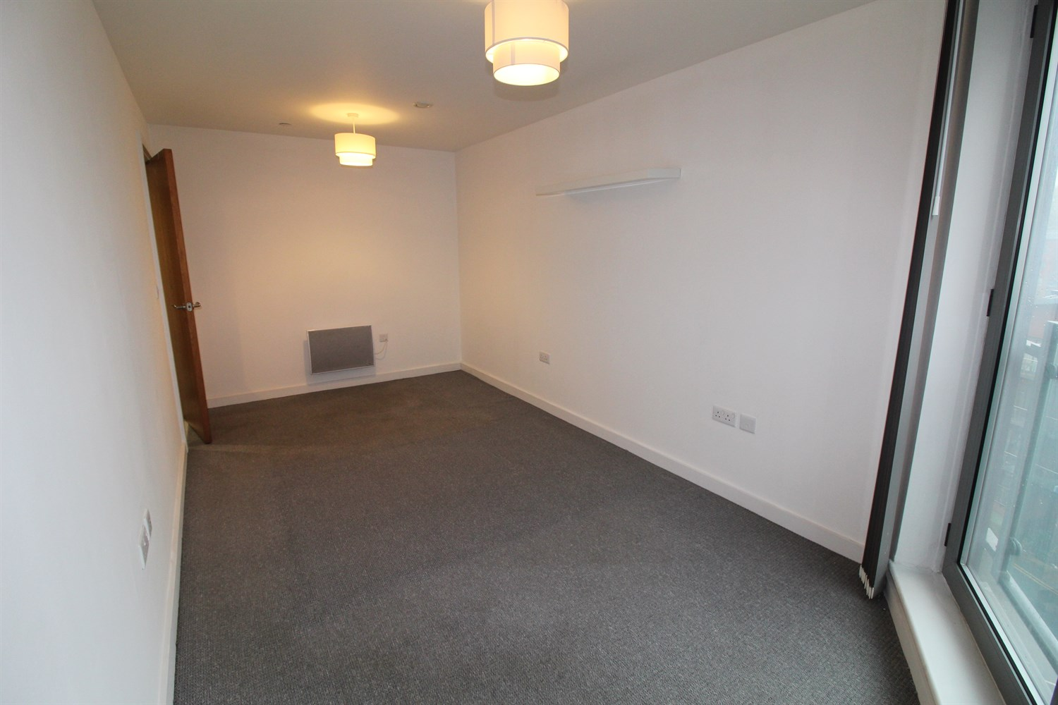

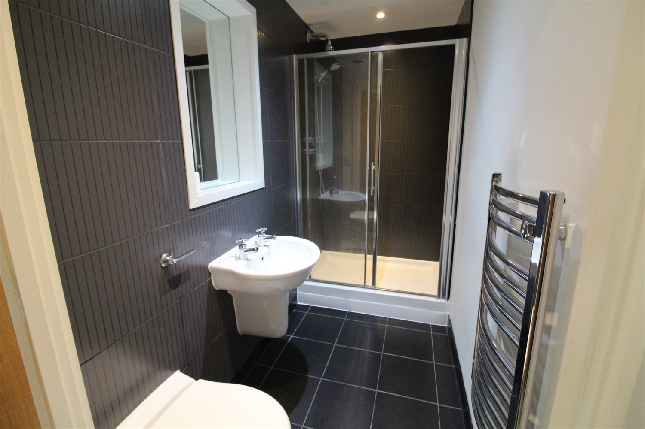

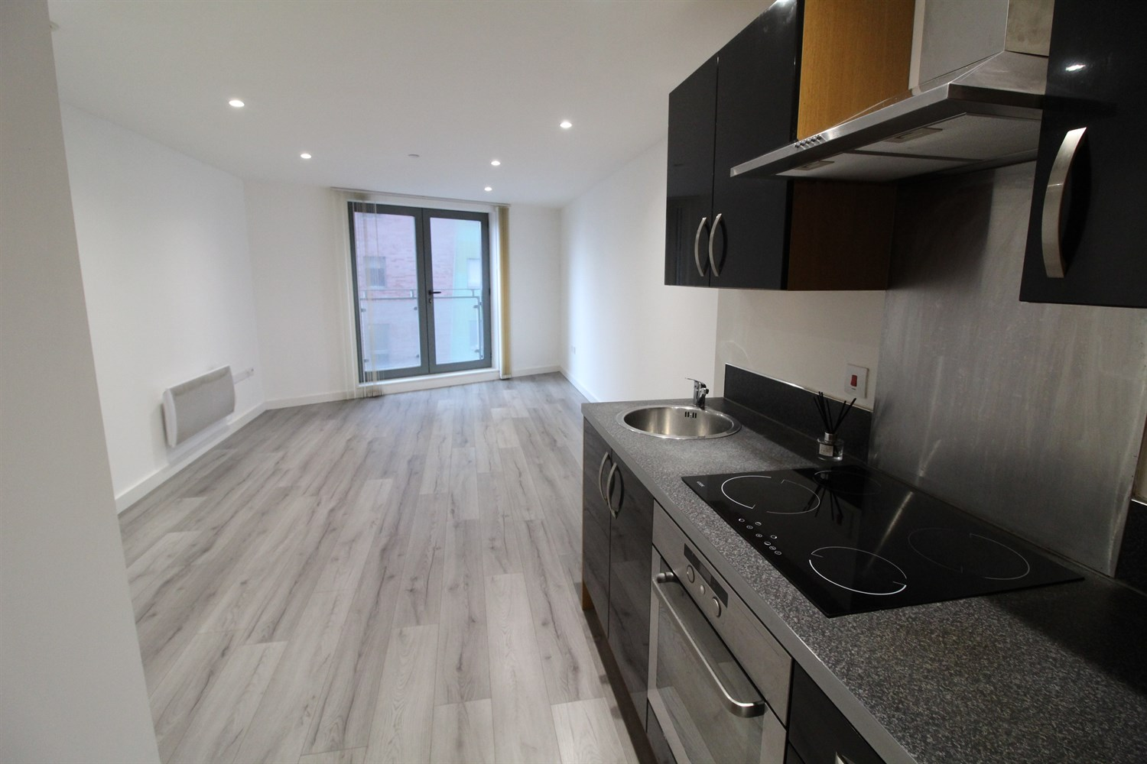

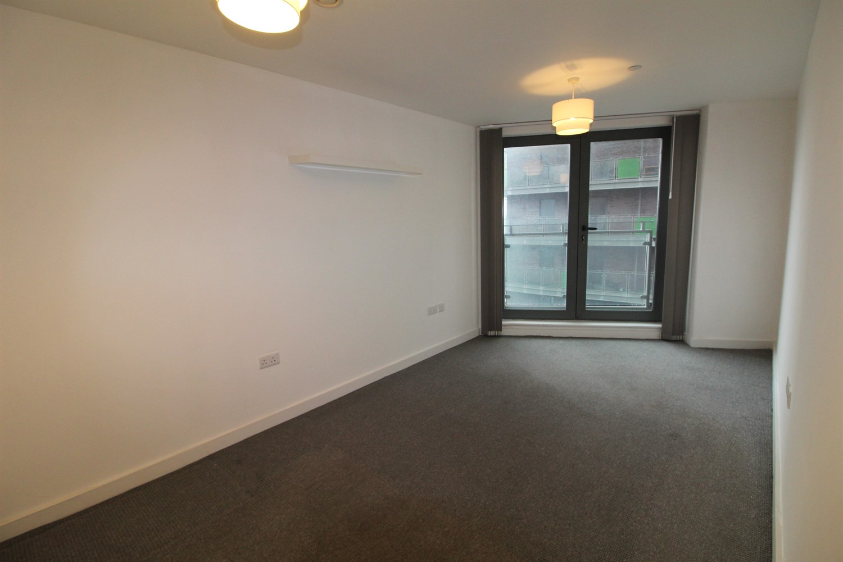

|  |
| --- |
| **Hallway**  Entry phone system, recessed spot lights. |
| **Open Plan Living Room / Kitchen 6.3m (20'8) x 3.51m (11'6)**  The spacious open plan living area has been redecorated. TV and Phone points, electric wall mounted heater. Double glazed Juliet balcony. |
| **Kitchen**  The open plan Kitchen has a range of high gloss black units with integrated ceramic hob, electric oven, round stainless steel sink and large fridge / freezer. |
| **Bedroom 1 5.2m (17'1) x 2.8m (9'2)**  The good sized double bedroom. Electric wall mounted heater and double glazed Juliet Balcony. |
| **Shower Room 2.63m (8'8) x 1.2m (3'11)**  The shower room is partly tiled with low flush WC, hand basin and large shower unit. Chrome heated towel rail, recessed mirror and shaver point. |
| **Service Charge**  The Service charges are £543.83 per quarter. |
| **Tenure**  Leasehold - £200 per annum 155 years from 2007 |

|  |  |
| --- | --- |
| These particulars are intended to give a fair description of the property, but their accuracy cannot be guaranteed, and they do not constitute an offer of contract. Intending purchasers must rely on their own inspection of the property. None of the above appliances/services have been tested by ourselves. We recommend purchasers arrange for a qualified person to check all appliances/services before legal commitment.  **Property Ref:** 4215  **For more information, please contact**  0113 258 1150 **|** [sales@adairpaxton.co.uk](mailto:sales@adairpaxton.co.uk) **|** www.adairpaxton.co.uk |  |