

**0113 258 1150**

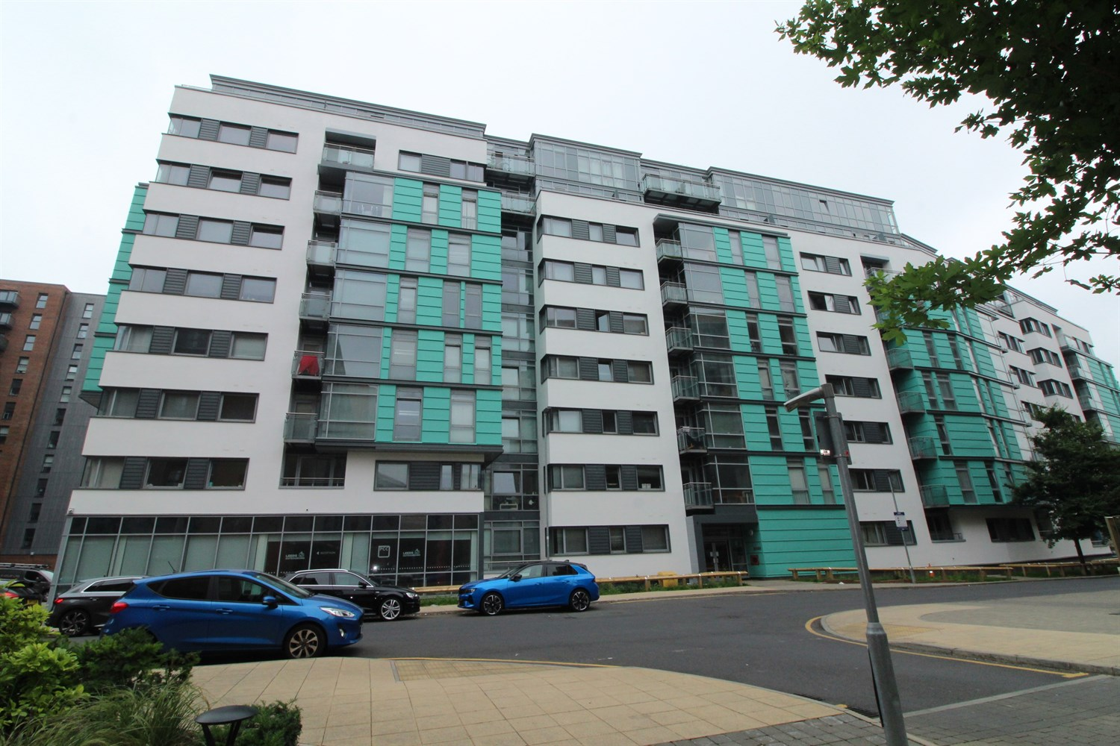



**For Sale £100,000.00**

**Apartment 424 Manor Mills, Leeds, LS11 9BR**

***LARGE STUDIO APARTMENT - EWS1 COMPLIANT*** Being ideally located only a short walk Leeds City Centre is this superb studio within the exciting Manor Mills development. Offering stylish and contemporary interior with modern fittings throughout. The apartment briefly comprises: Open plan living room/bedroom/kitchen with balcony and a shower room. Viewing highly recommended. The apartment is tenanted until September 2024 at £750pcm.

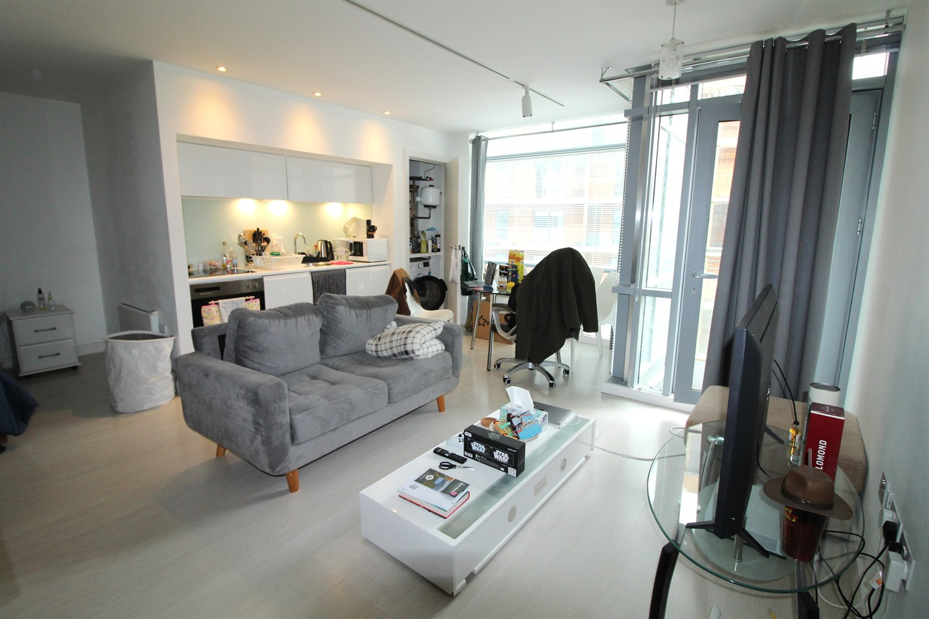

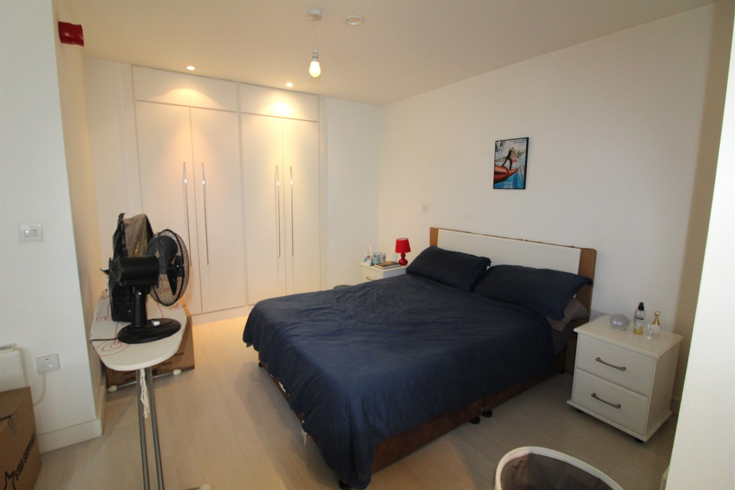

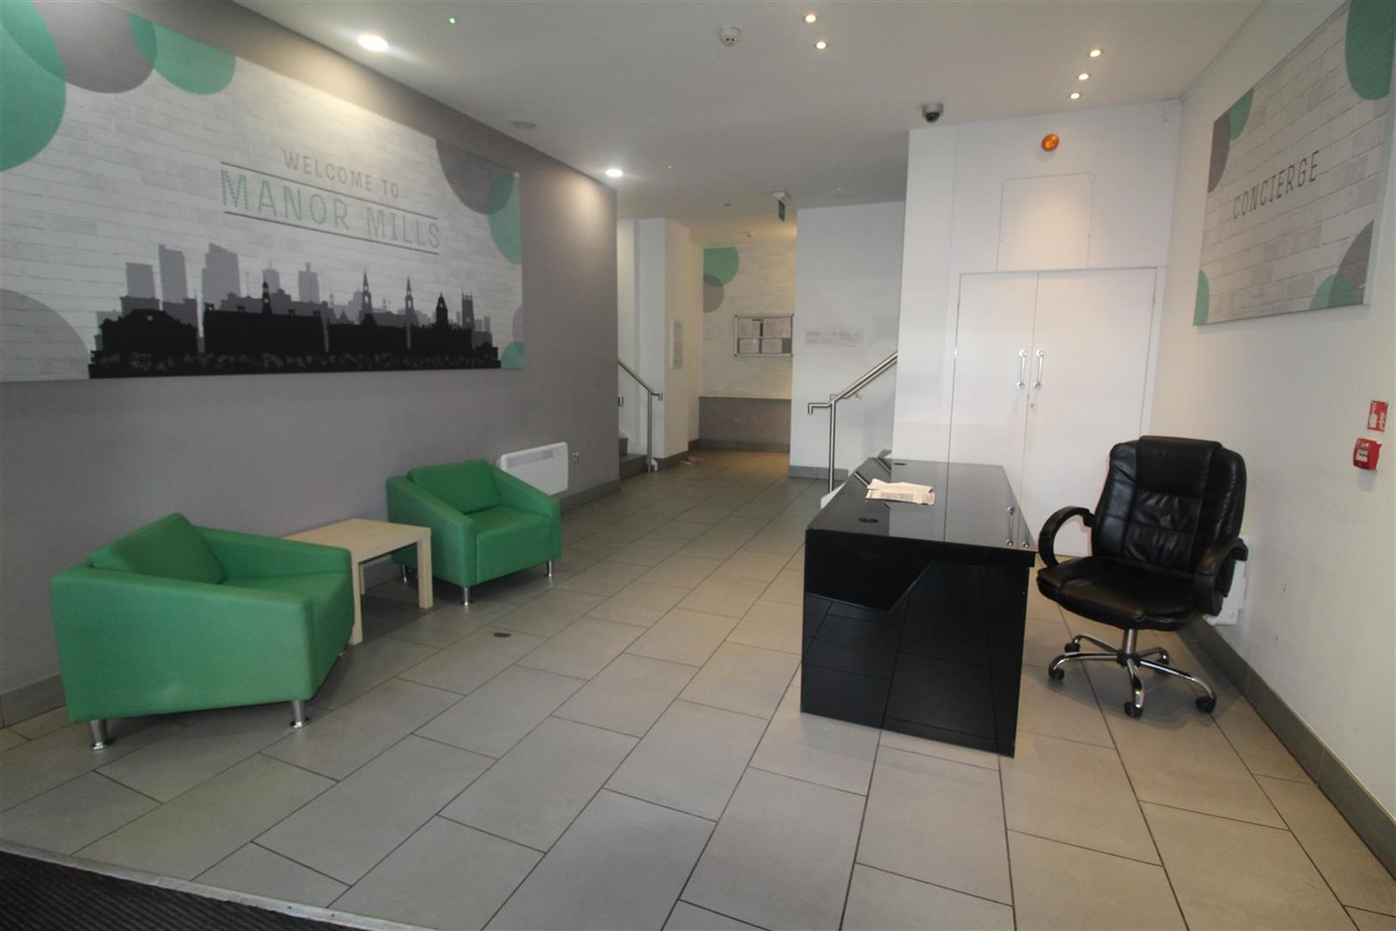

1 Bathroom(s)

0 Reception(s)

1 Bedroom(s)

00

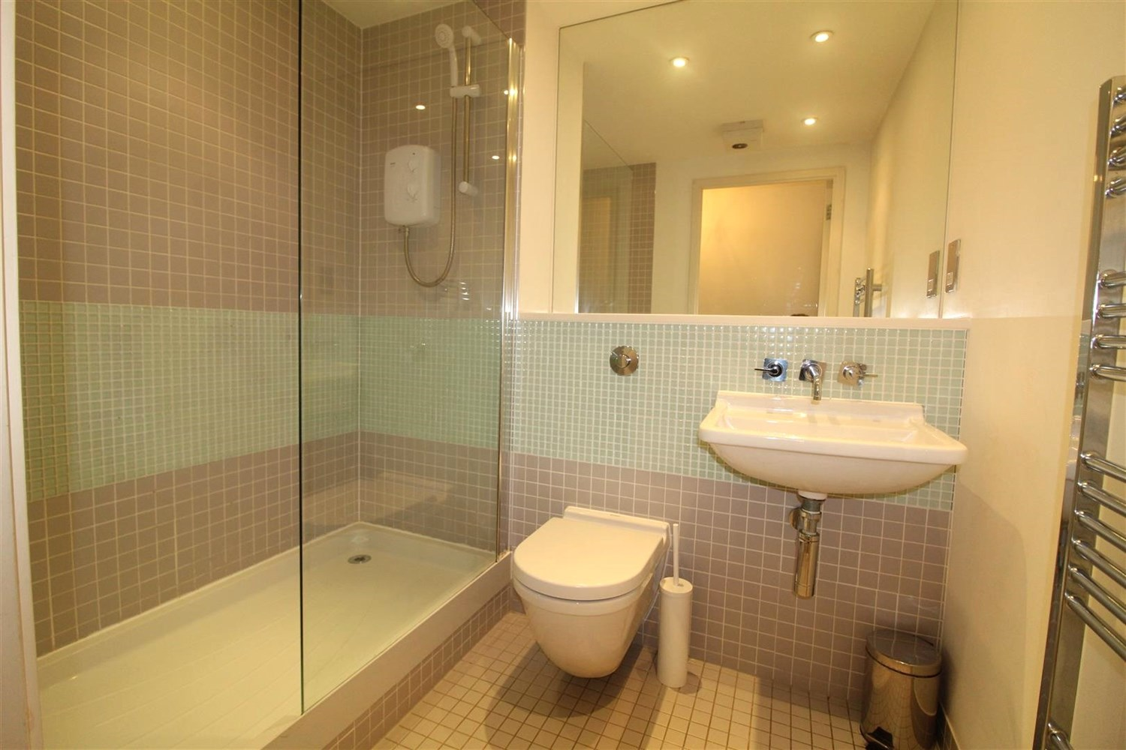

|  |
| --- |
| **Hallway**  Video entry phone system. |
| **Open Plan Living Room/Kitchen**  Open living space with a kitchen space comprising: integrated oven, 2 ring hob, stainless steel sink. Plumbed for washing machine. Inset ceiling spotlights. Door out to the balcony. |
| **Bedroom**  Double bedroom opening to living area. Built in wardrobes. Inset ceiling spotlights. |
| **Shower Room**  Fitted with a shower cubicle, WC and wash hand basin. Tiled walls and floor. Wall mounted heated towel rail. |
| **Tenure**  Leasehold - 999 years from 2006. £370.39 per annum |
| **Service Charge**  £826.09 six monthly. Including insurance. |

|  |  |
| --- | --- |
| These particulars are intended to give a fair description of the property, but their accuracy cannot be guaranteed, and they do not constitute an offer of contract. Intending purchasers must rely on their own inspection of the property. None of the above appliances/services have been tested by ourselves. We recommend purchasers arrange for a qualified person to check all appliances/services before legal commitment.  **Property Ref:** 2900  **For more information, please contact**  0113 258 1150 **|** [sales@adairpaxton.co.uk](mailto:sales@adairpaxton.co.uk) **|** www.adairpaxton.co.uk |  |