

**Beechwood Crescent, Leeds**

**For Sale £225,000.00**

### ***OVER 1300 sq ft - GROUND FLOOR APARTMENT - NO ONWARD CHAIN*** This spacious duplex apartment is located a stones throw from Burley Park train station and would be ideal for a student parent buyer or owner occupier. The property is ideally located for local amenities, shops, bars and restaurants in Headingley. The universities are also within easy reach. The property briefly comprises Communal entrance hall, private entrance hall, lounge, kitchen, conservatory, master bedroom and second bedroom to the ground floor. To the lower ground floor there are three good sized rooms. Externally the property has enclosed gardens to the front and rear.

**0113 258 1150**

**0800 000 000**

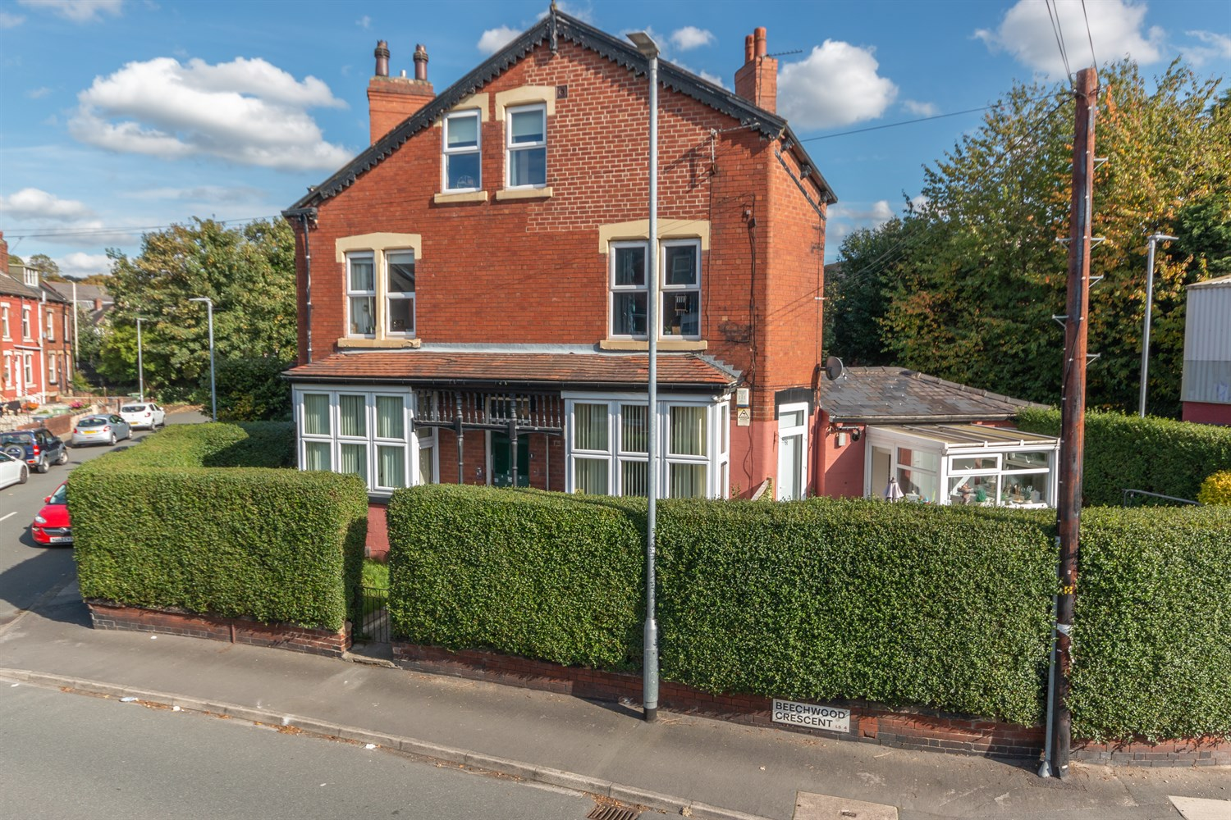



1 Reception(s)

1 Bathroom(s)

2 Bedroom(s)

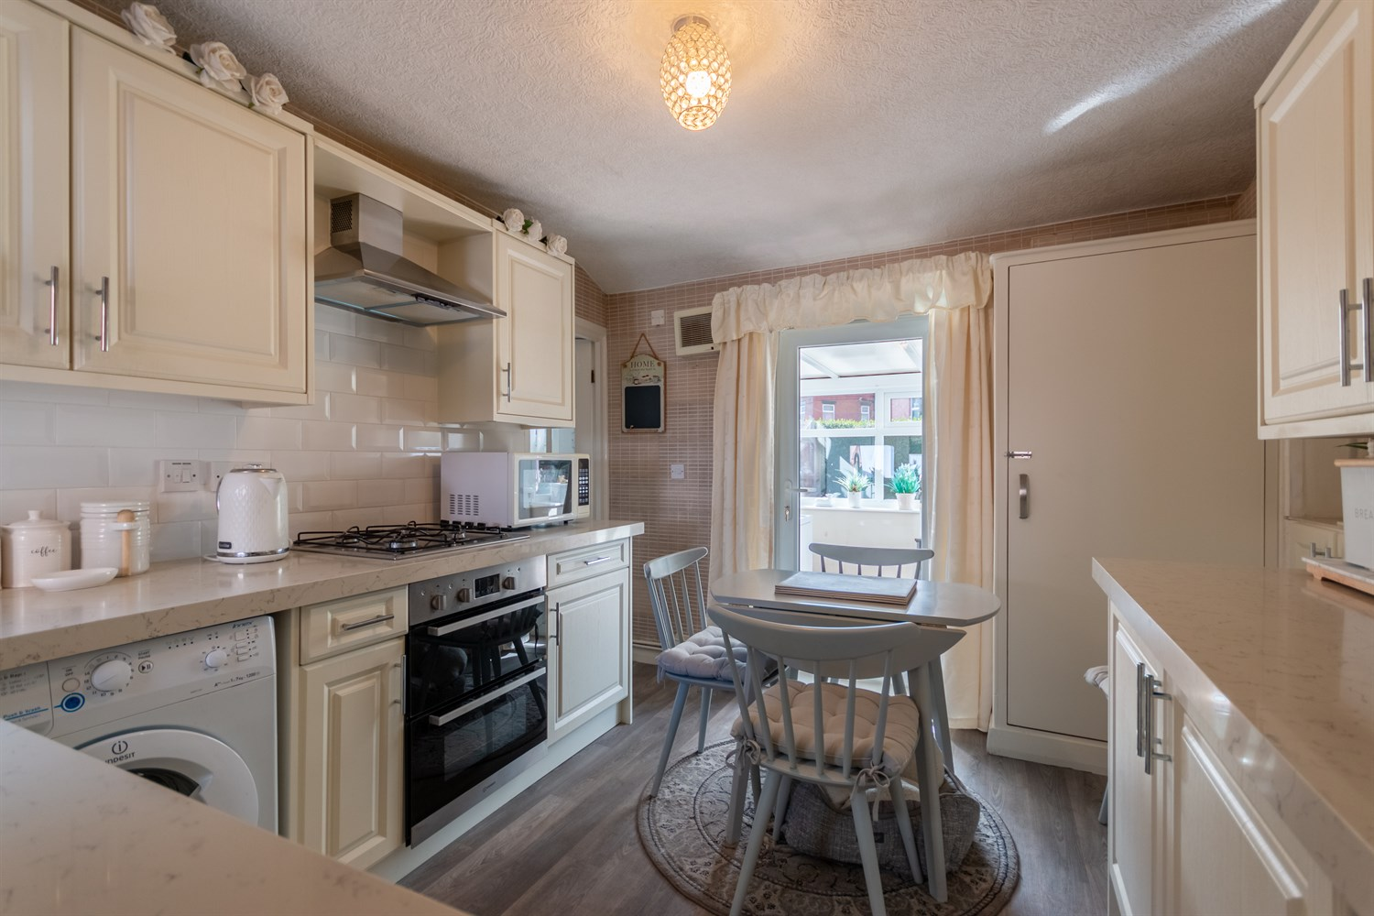

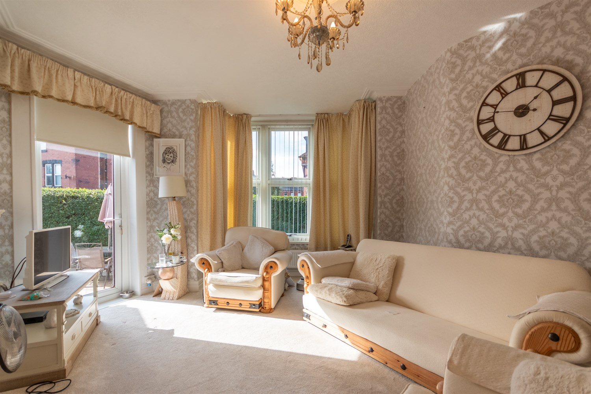

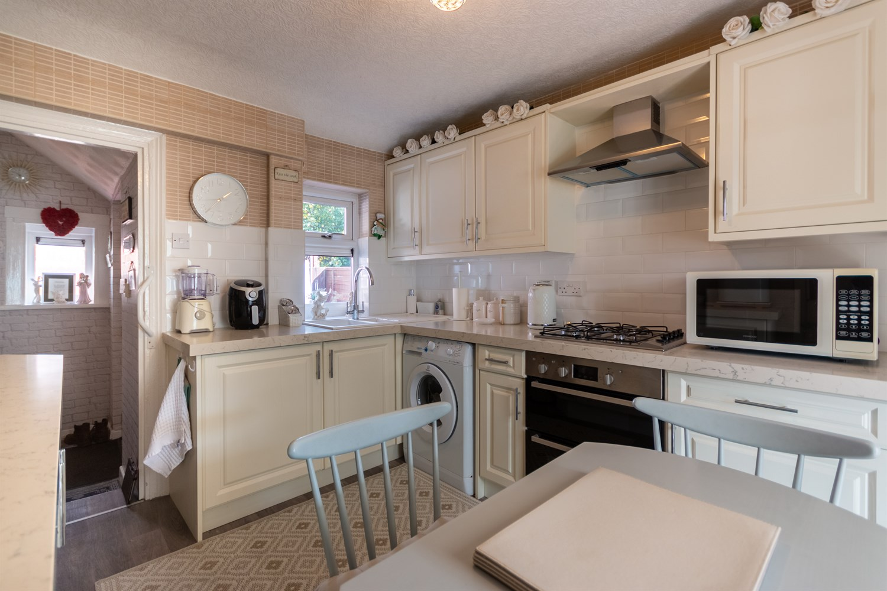

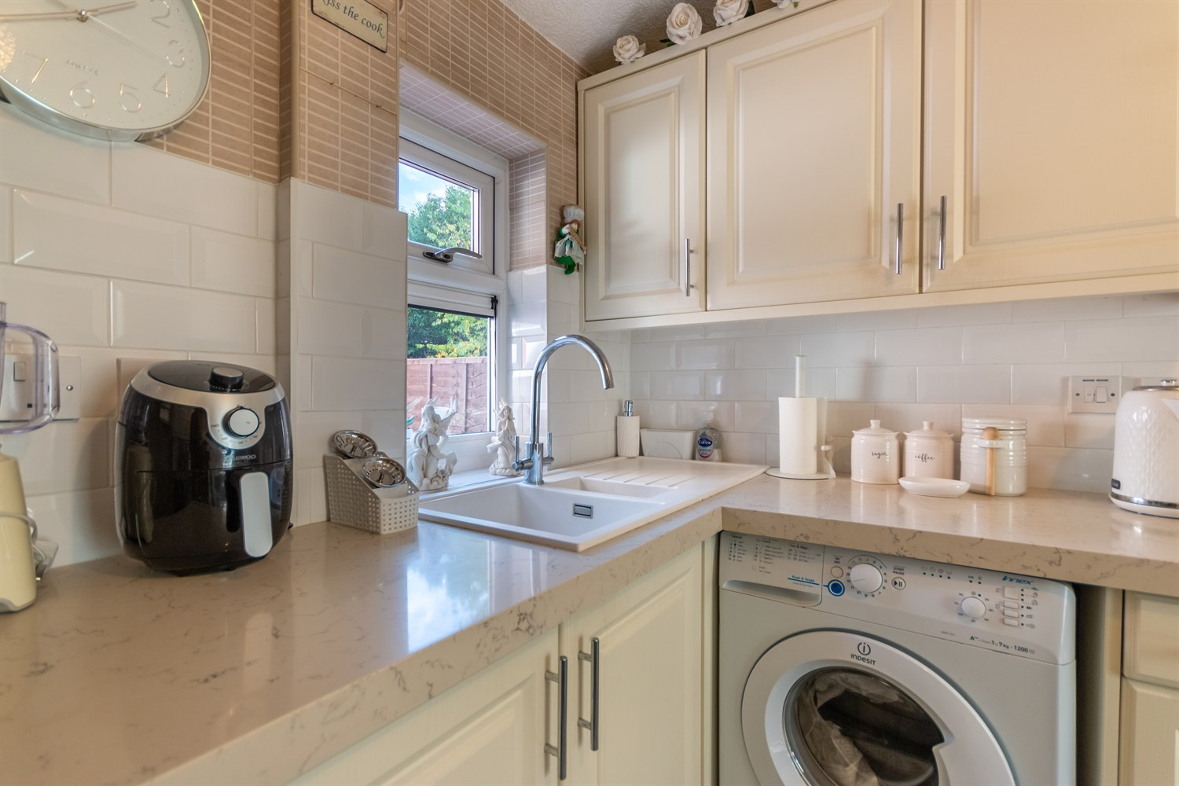

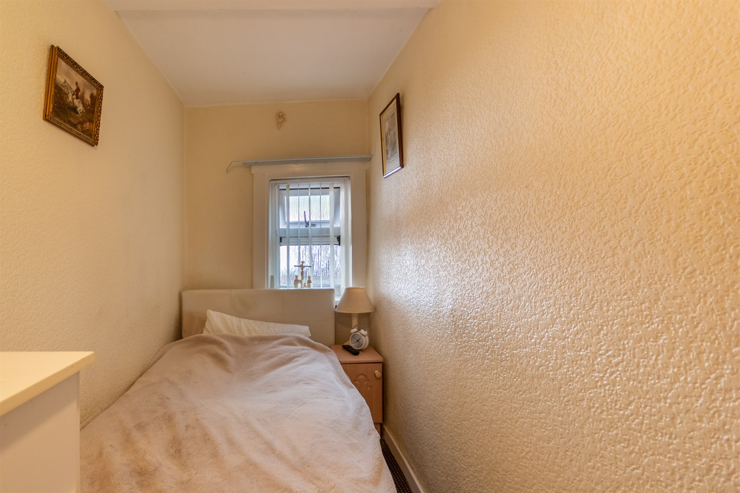

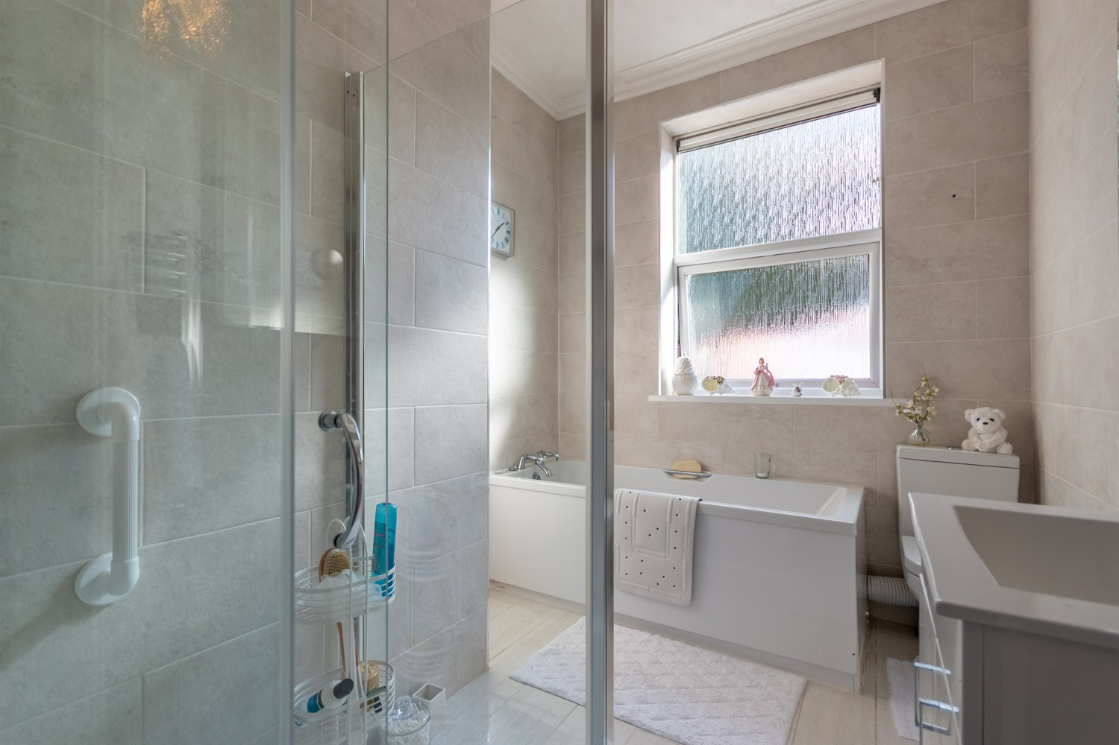

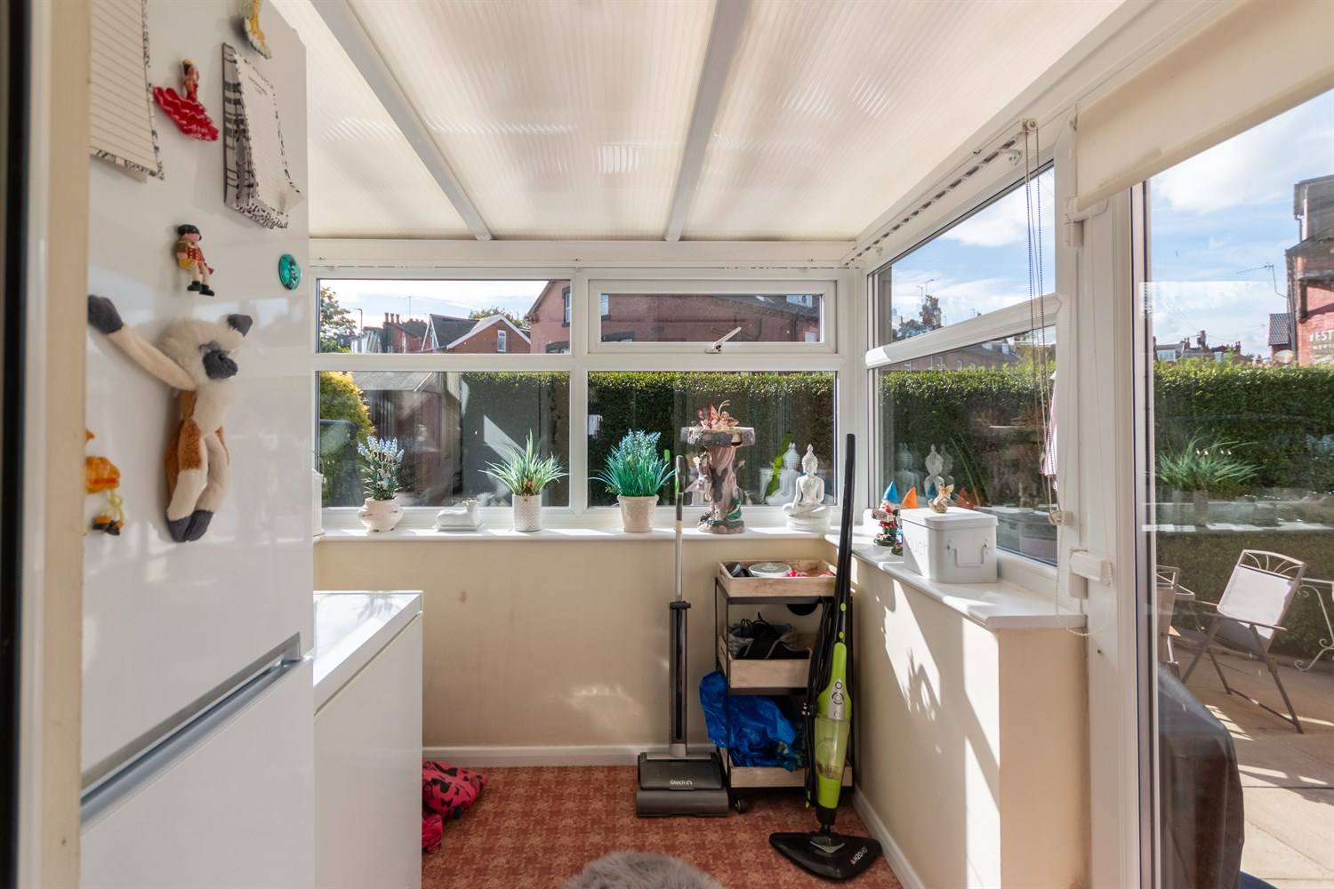

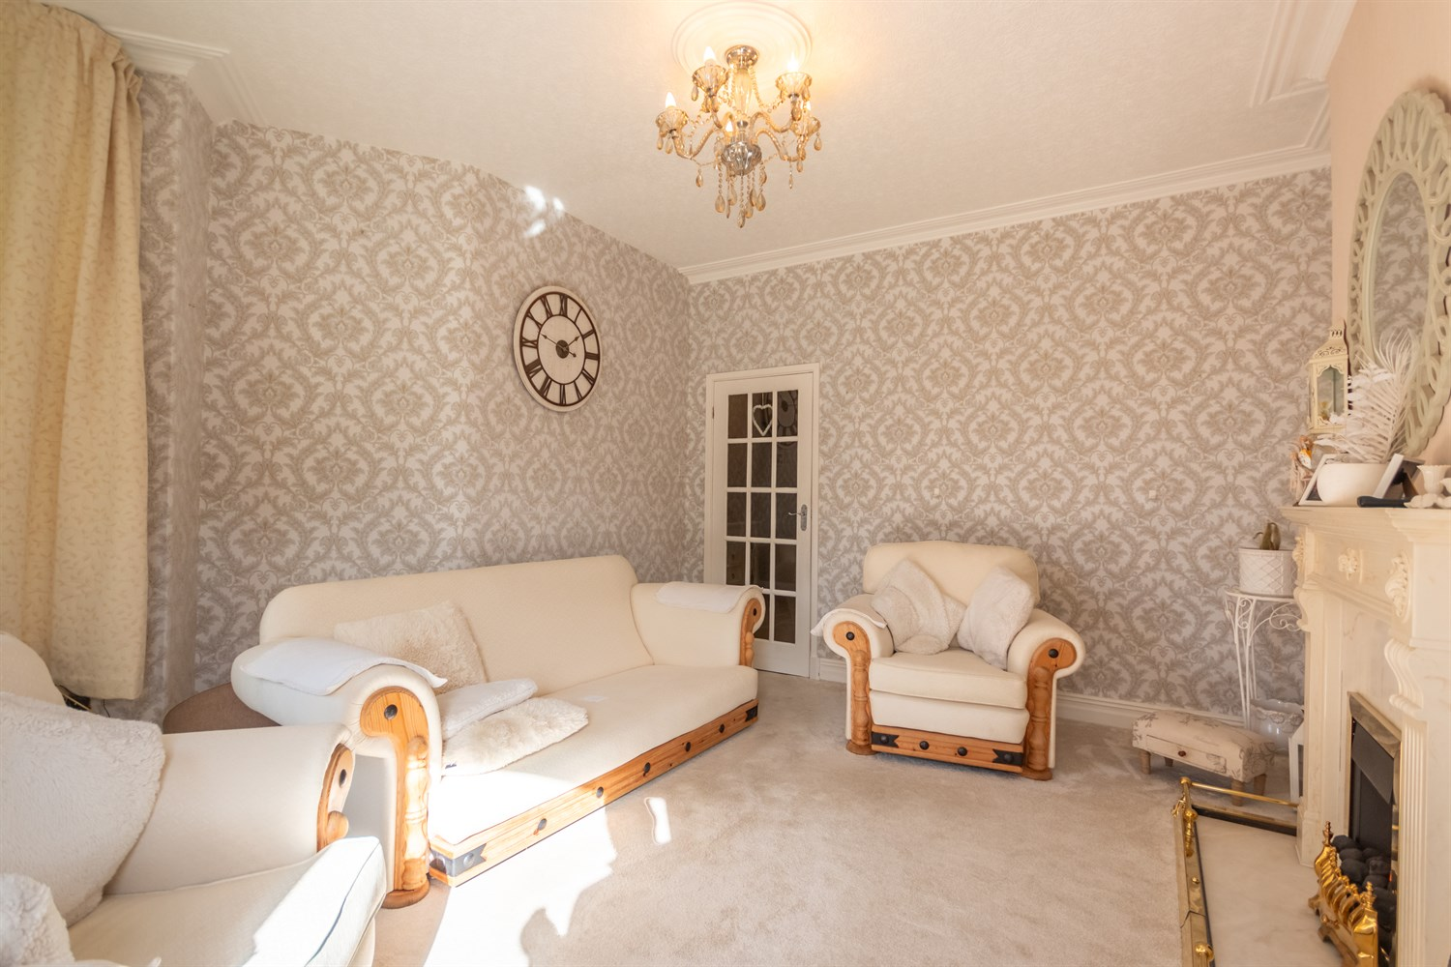

|  |
| --- |
| **Communal Hallway**  Via front entrance door to communal hallway. Door to apartment 1A. |
| **Private Entrance Hall**  Private entrance hall with high ceilings. Door leading out to the rear garden. |
| **Lower Ground Floor**  Three spacious rooms (restricted head height) |
| **Kitchen**  Fitted with a range of wall, base and drawer units with worktops over. Space for washing machine. Integrated oven with 4-ring gas hob and extractor hood over. 1.5 bowl sink with mixer tap and drainer. Part tiled walls. uPVC double glazed window. |
| **Conservatory 1.85m (6'1) x 1.83m (6'0)**  Light and airy conservatory with uPVC double glazed windows to three sides and uPVC double glazed door leading out to the rear garden. |
| **Living room 3.5m (11'6) x 4.89m (16'1)**  Spacious lounge with uPVC double glazed windows and uPVC double glazed door leading out to an enclosed garden. Gas central heating radiator. Gas fire to chimney breast. |
| **Bathroom**  Fitted with a four piece suite comprising; walk in shower cubicle, bath, WC and vanity wash hand basin. Tiled walls. uPVC double glazed window. |
| **Master Bedroom 3.56m (11'8) x 4.92m (16'2)**  Spacious master bedroom with uPVC double glazed window to front. Gas central heating radiator. Built in wardrobes. |
| **Bedroom 2 1.49m (4'11) x 3.48m (11'5)**  Single bedroom with uPVC double glazed window. Gas central heating radiator. |
| **Courtyard Garden** |
| **Parking** |
| **Service Charge** The service charge and ground rent is £123.81 every 3 months, £495.24 per annum**.** |
| **Tenure** Leasehold |

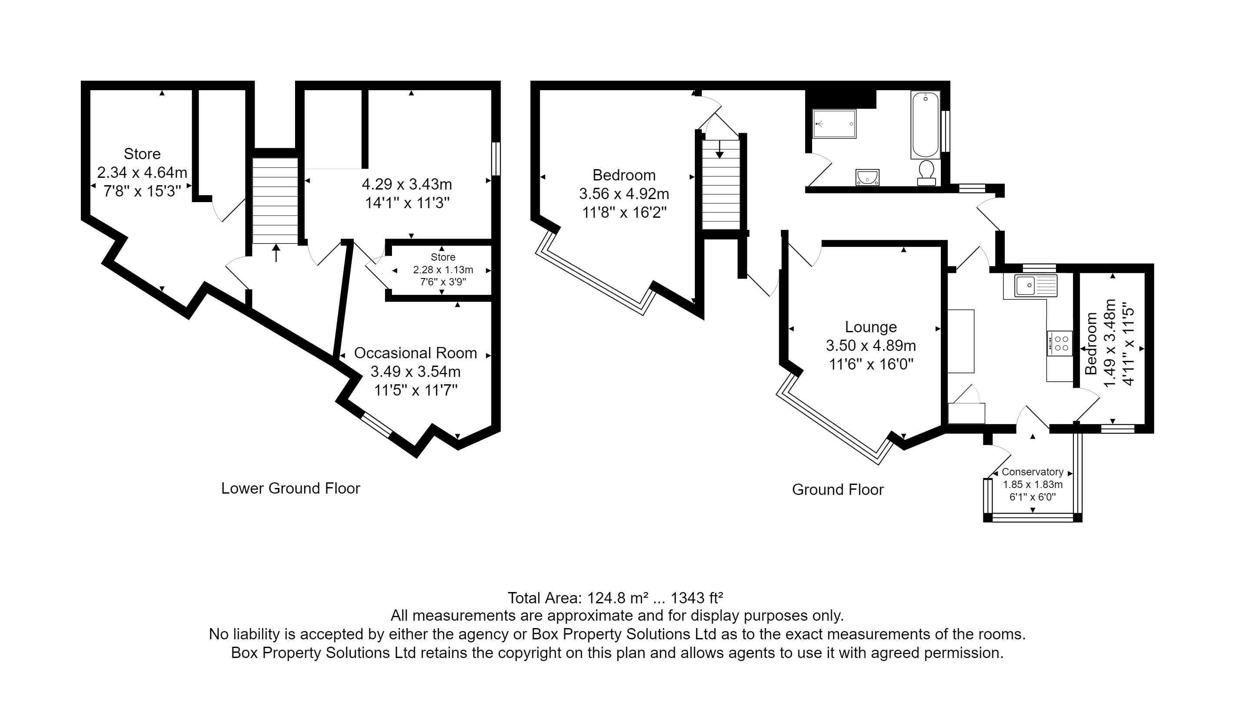

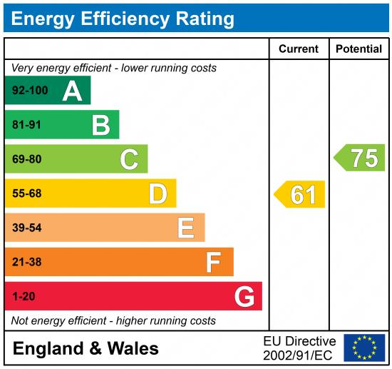

|  |
| --- |
|  |

These particulars are intended to give a fair description of the property, but their accuracy cannot be guaranteed, and they do not constitute an offer of contract. Intending purchasers must rely on their own inspection of the property. None of the above appliances/services have been tested by ourselves. We recommend purchasers arrange for a qualified person to check all appliances/services before legal commitment.

**Property Ref:** 3660

**For more information, please contact**

0113 258 1150 **|** [sales@adairpaxton.co.uk](mailto:sales@adairpaxton.co.uk) **|** www.adairpaxton.co.uk