

**0113 258 1150**

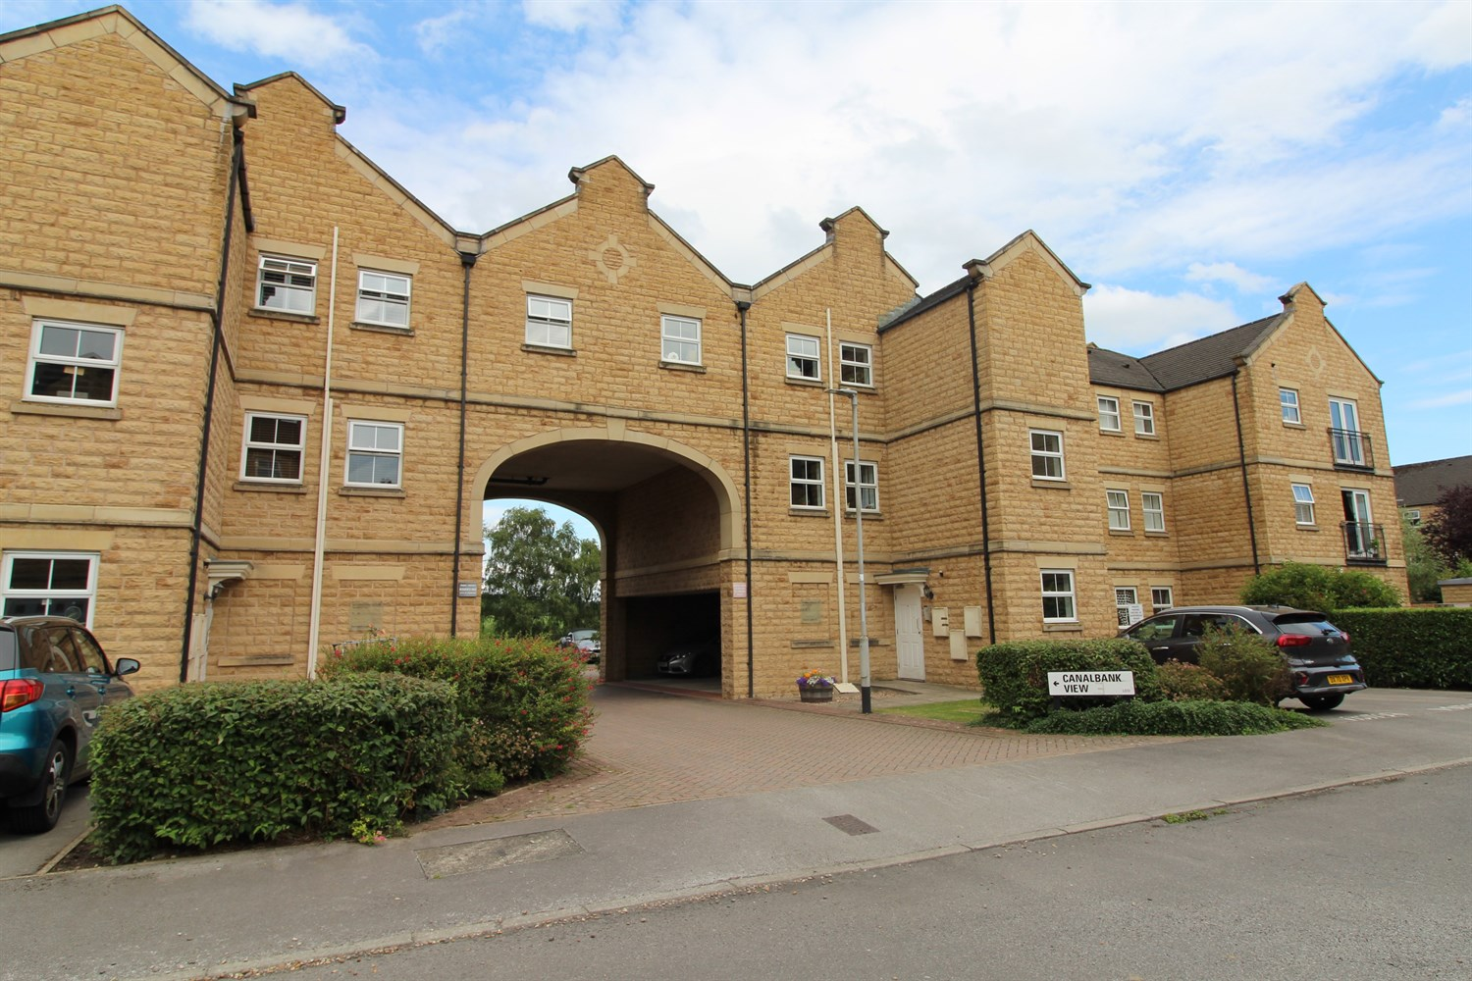



**For Sale £145,000.00**

**54 Narrowboat Wharf, Rodley, Leeds, LS13 1RE**

***TWO BEDROOM FIRST FLOOR APARTMENT WITH PARKING, OFFERED TO THE MARKET WITH NO ONWARD CHAIN*** Must be viewed to be appreciated. Set in the delightful Narrowboat Wharf complex, the apartment is ideally located for the shops, bars and restaurants in Rodley as well as useful transport links to both Leeds and Bradford. This apartment briefly comprises: Communal Entrance hall with secure intercom entry system, private entrance hall, contemporary lounge with dining area and open plan kitchen, two good sized bedrooms with canal view and a house bathroom. Externally there is an allocated covered parking space. Offered for sale with NO ONWARD CHAIN, this property makes an ideal purchase for a first time buyer or buy to let investor. Early internal inspection is highly recommended.

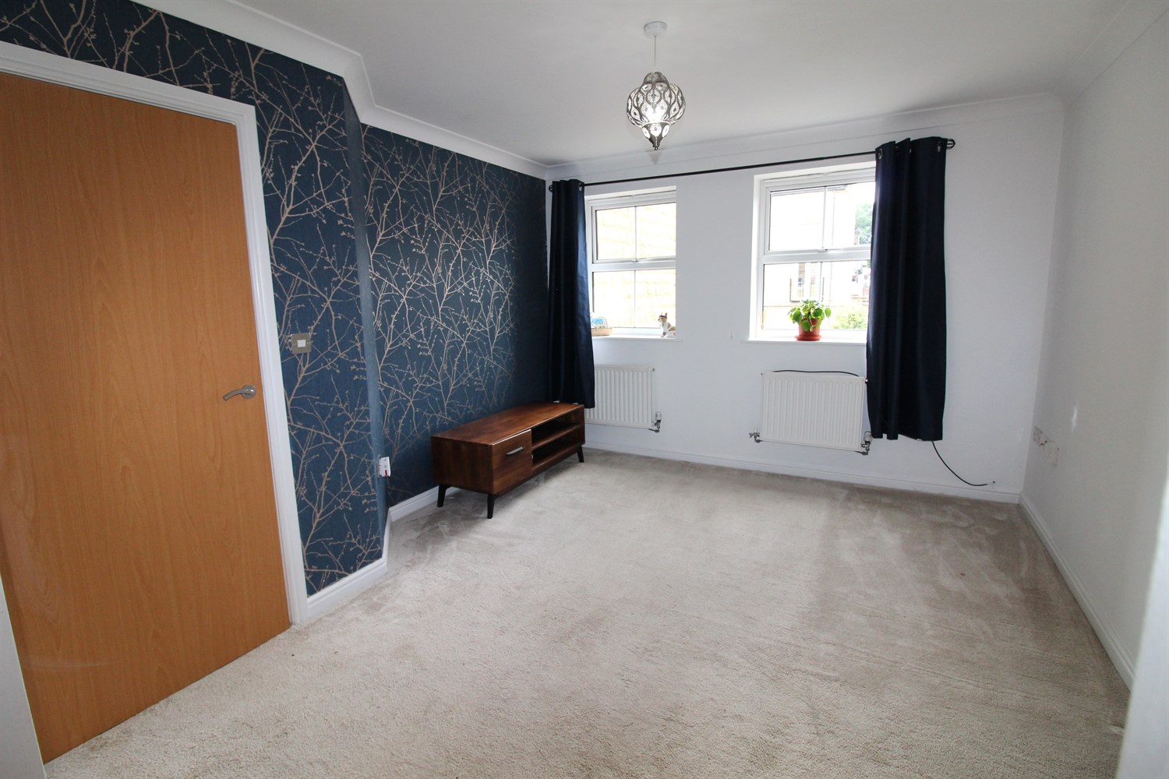

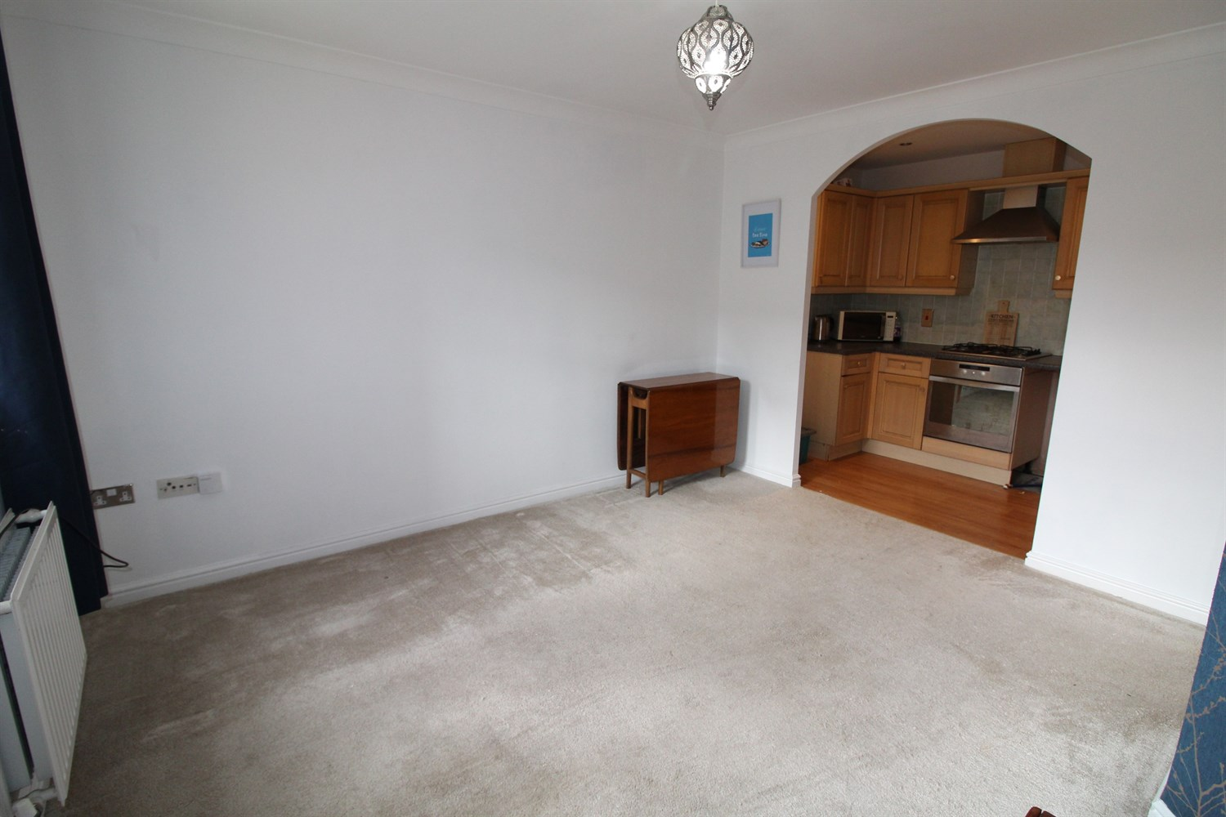

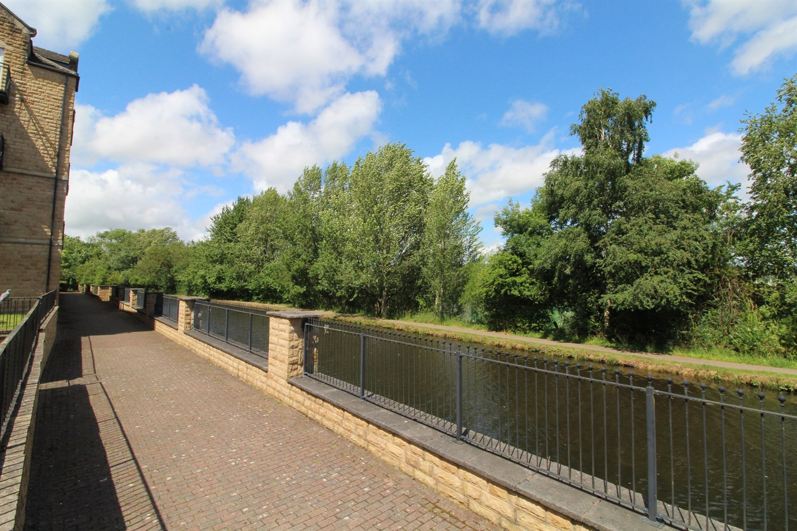

1 Bathroom(s)

1 Reception(s)

2 Bedroom(s)

00

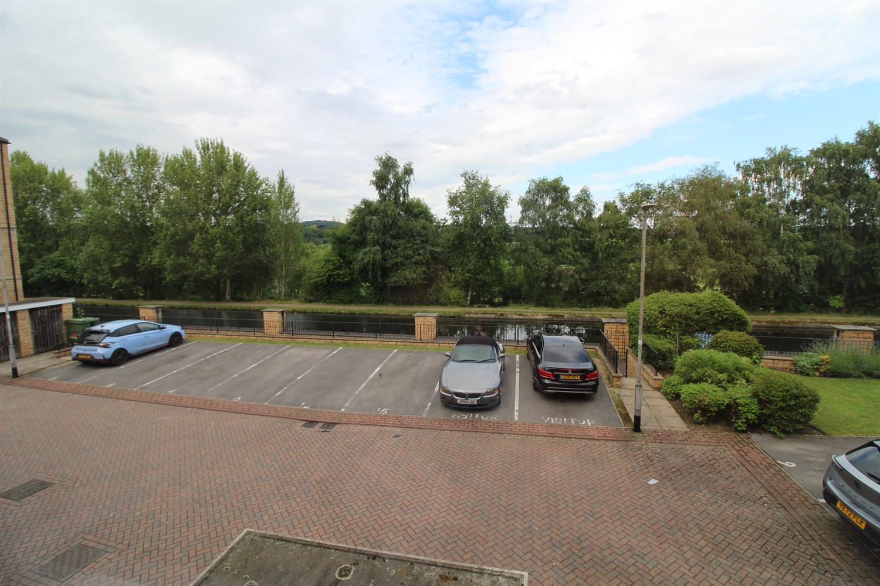

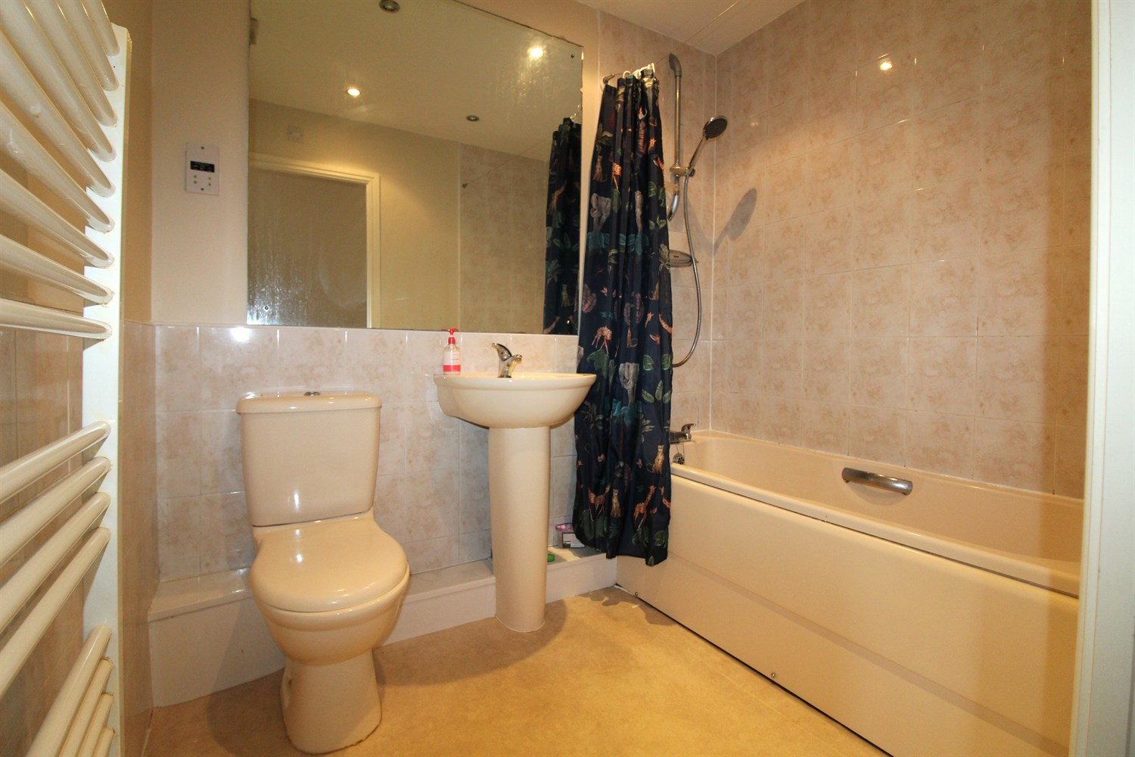

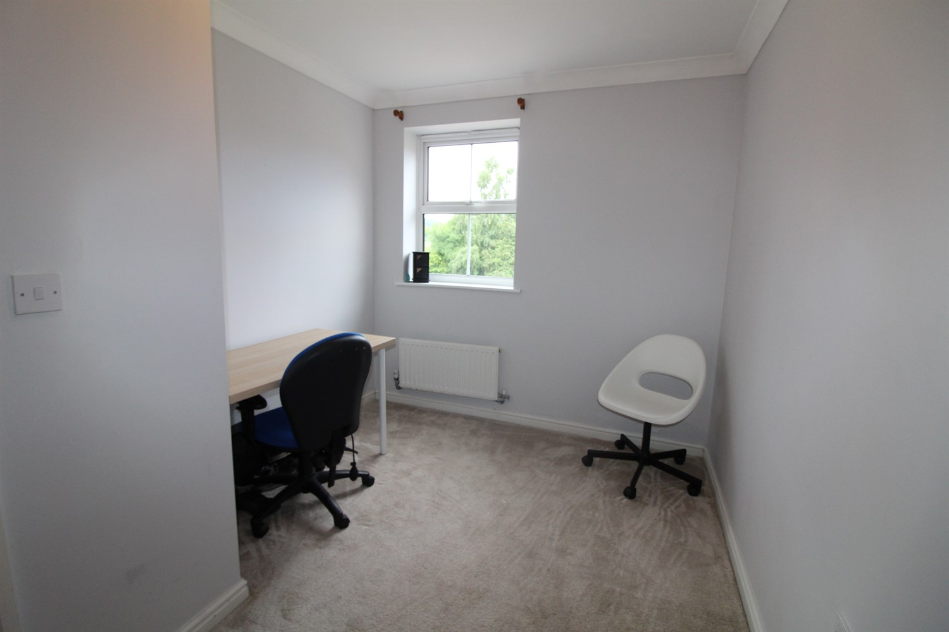

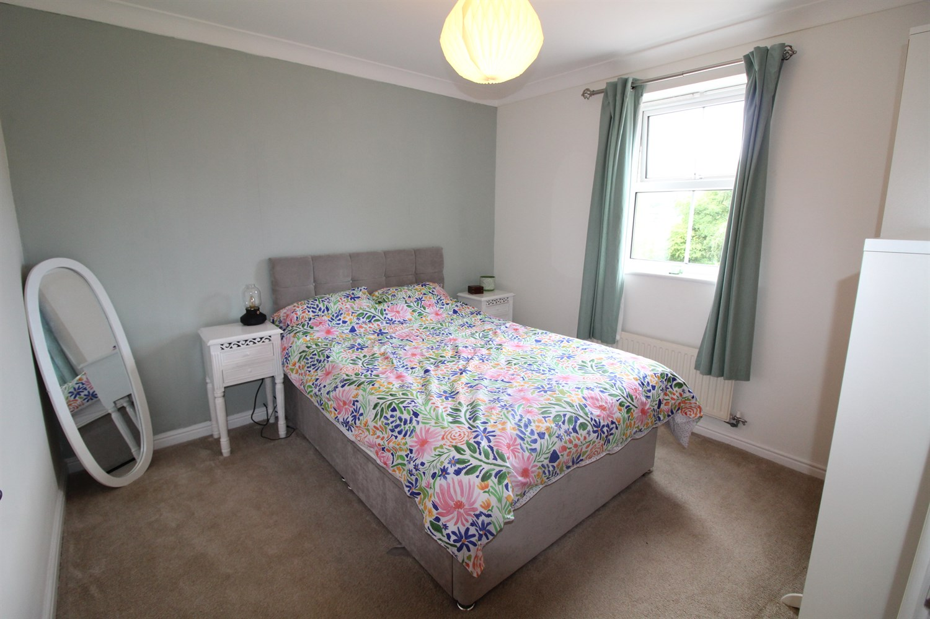

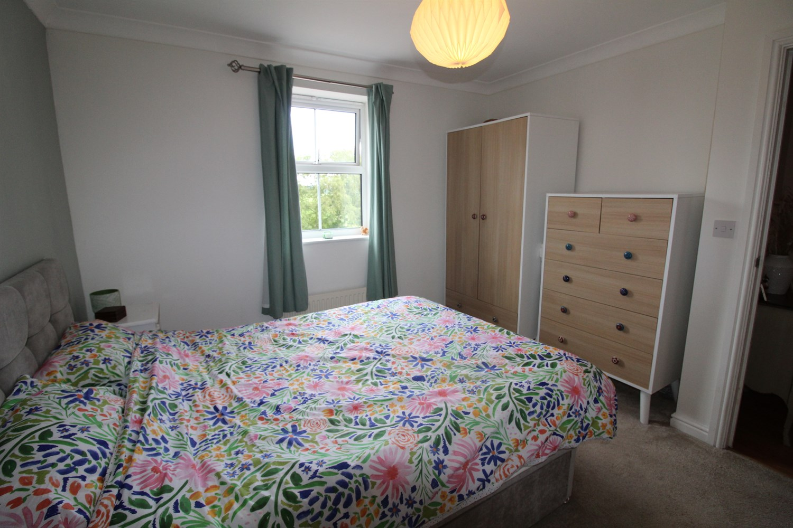

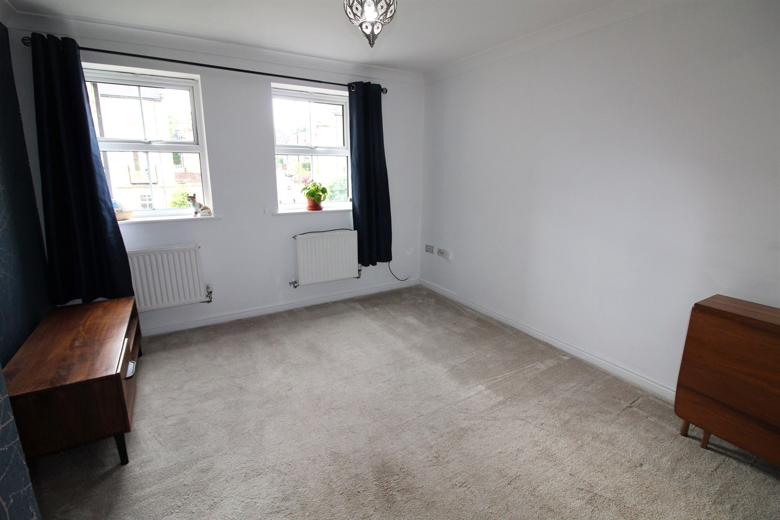

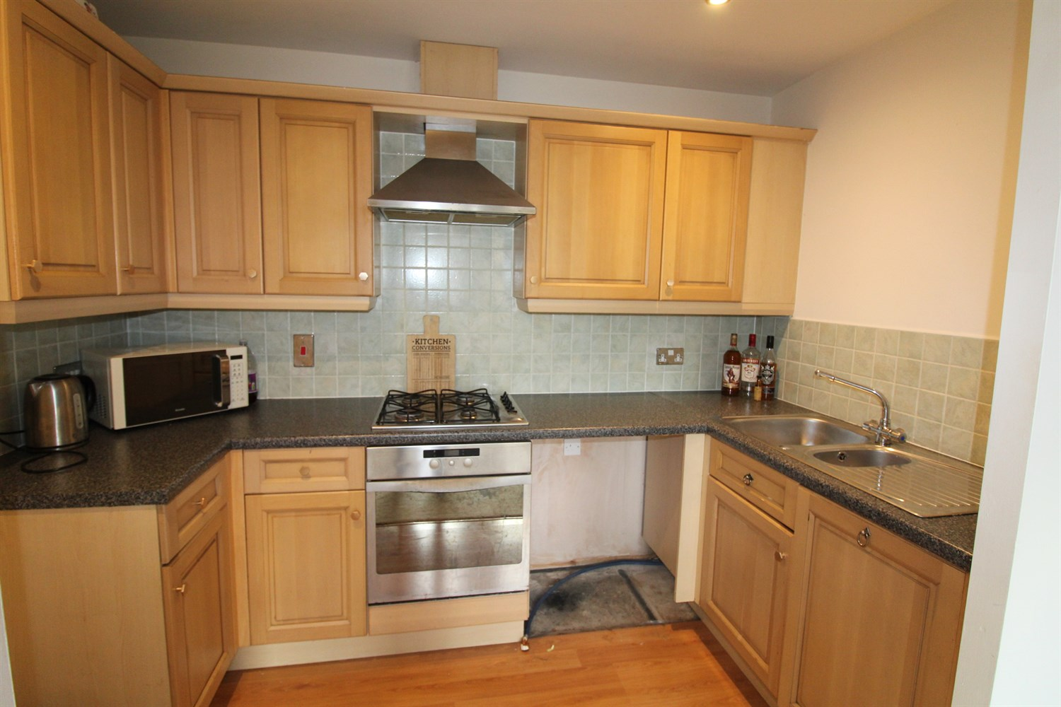

|  |
| --- |
| **Communal Entrance Hall**  Via secure intercom entry system. Stairs to first floor. |
| **Private Hallway**  Laminate flooring, two storage cupboards - one housing boiler. |
| **Lounge**  A spacious lounge with two double glazed windows to the front. Space for dining table, Two gas central heating radiators. Open plan to the kitchen. |
| **Kitchen**  Open plan to the living room. Fitted with a range of wall and base units, integrated dishwasher, electric oven, gas hob with extractor hood over, laminate flooring. |
| **Bedroom 1**  Double bedroom with double glazed window. Gas central heating radiator. |
| **Bedroom 2**  Second bedroom with double glazed window. Gas central heating radiator. |
| **Bathroom**  Fitted with a three piece suite comprising bath with shower over, wash hand basin, WC. Part tiled walls, heated ladder towel rail. |
| **Tenure**  125 years from 1st January 2001.  Ground rent £100 per annum. |
| **Service Charge**  Service Charges £267.43 per quarter. |
| **Parking**  Allocated parking space |

|  |  |
| --- | --- |
| These particulars are intended to give a fair description of the property, but their accuracy cannot be guaranteed, and they do not constitute an offer of contract. Intending purchasers must rely on their own inspection of the property. None of the above appliances/services have been tested by ourselves. We recommend purchasers arrange for a qualified person to check all appliances/services before legal commitment.  **Property Ref:** 2571  **For more information, please contact**  0113 258 1150 **|** [sales@adairpaxton.co.uk](mailto:sales@adairpaxton.co.uk) **|** www.adairpaxton.co.uk |  |