

**0113 258 1150**

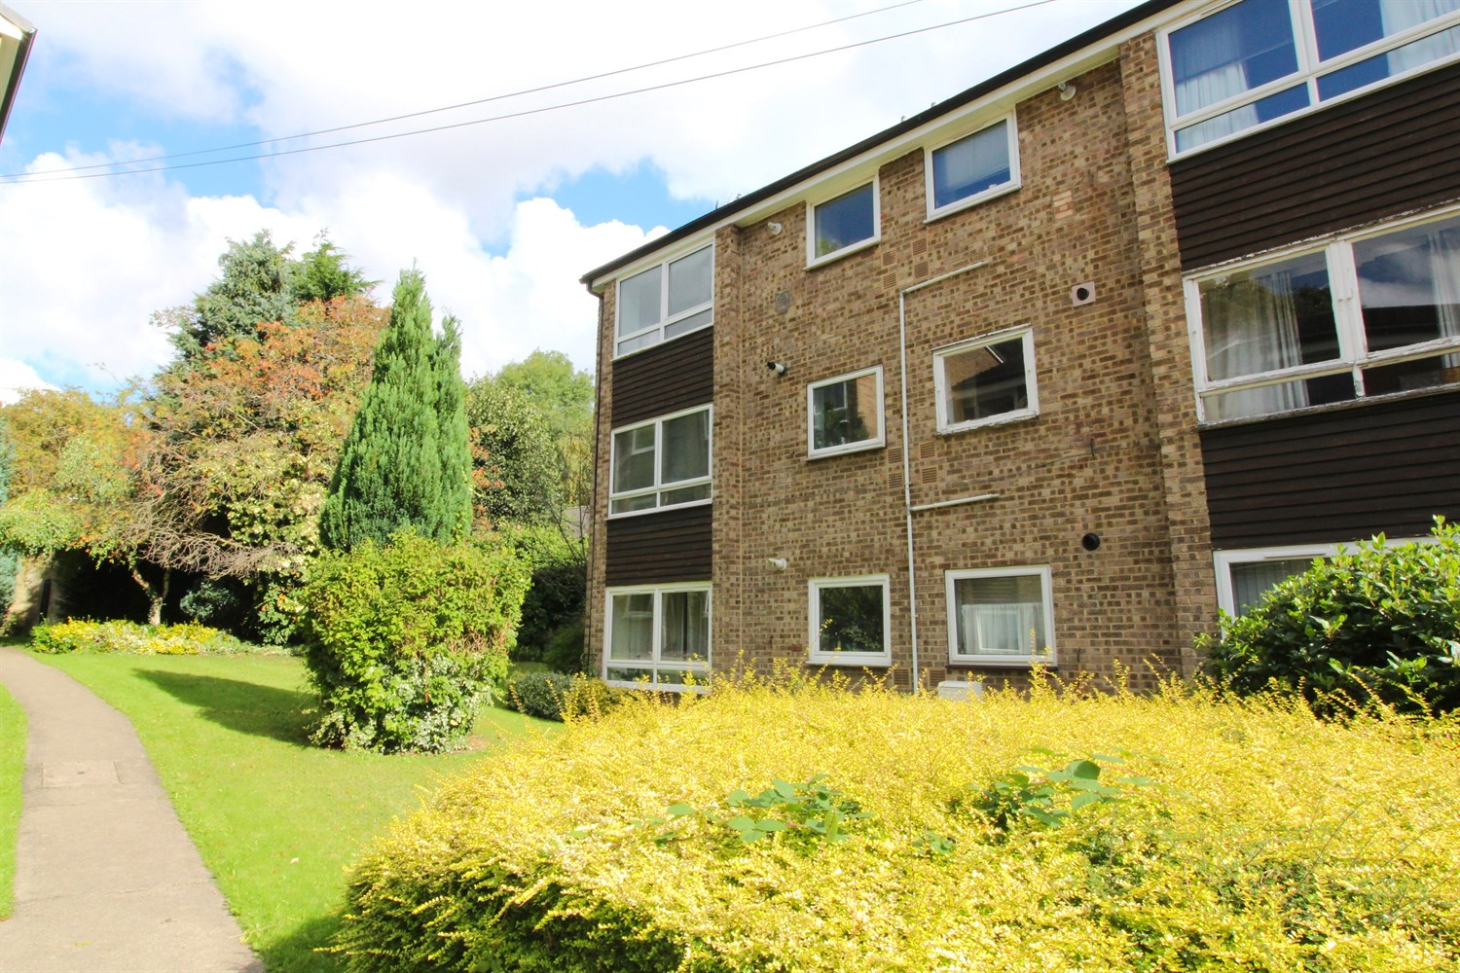



**For Sale £139,950.00**

**Grosvenor Park Gardens, LS6**

***TWO BEDROOM TOP FLOOR APARTMENT WITH GARAGE AND PARKING*** Well presented two bedroom, top floor apartment located in this popular development. The property is within walking distance to the University and City Centre. The accommodation on offer briefly comprising; Entrance hallway with useful storage cupboard, spacious lounge, kitchen with gas hob, electric oven and extractor, two bedrooms and a house bathroom. The property is now in need of some cosmetic updating and would be a great first time buy or investment.

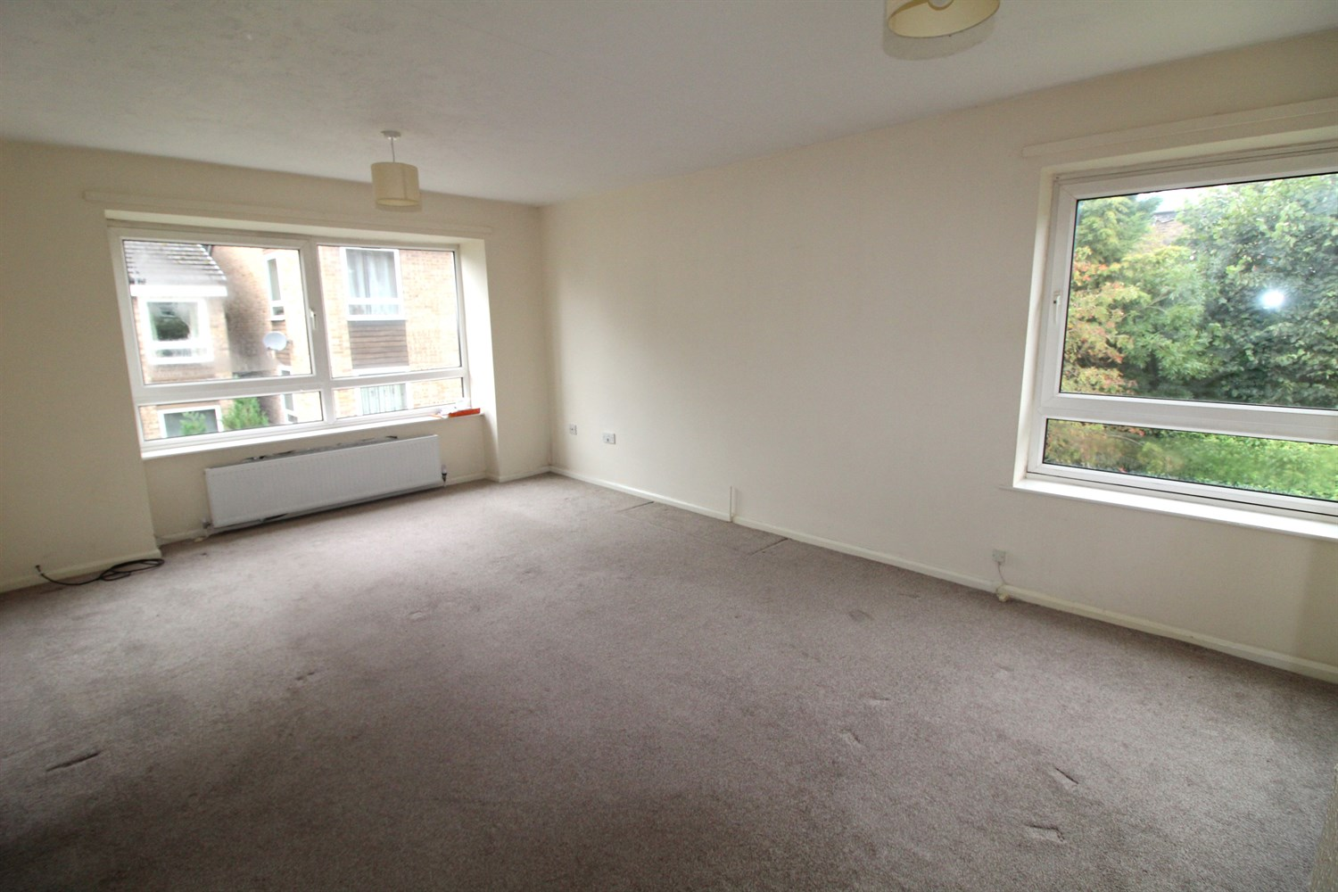

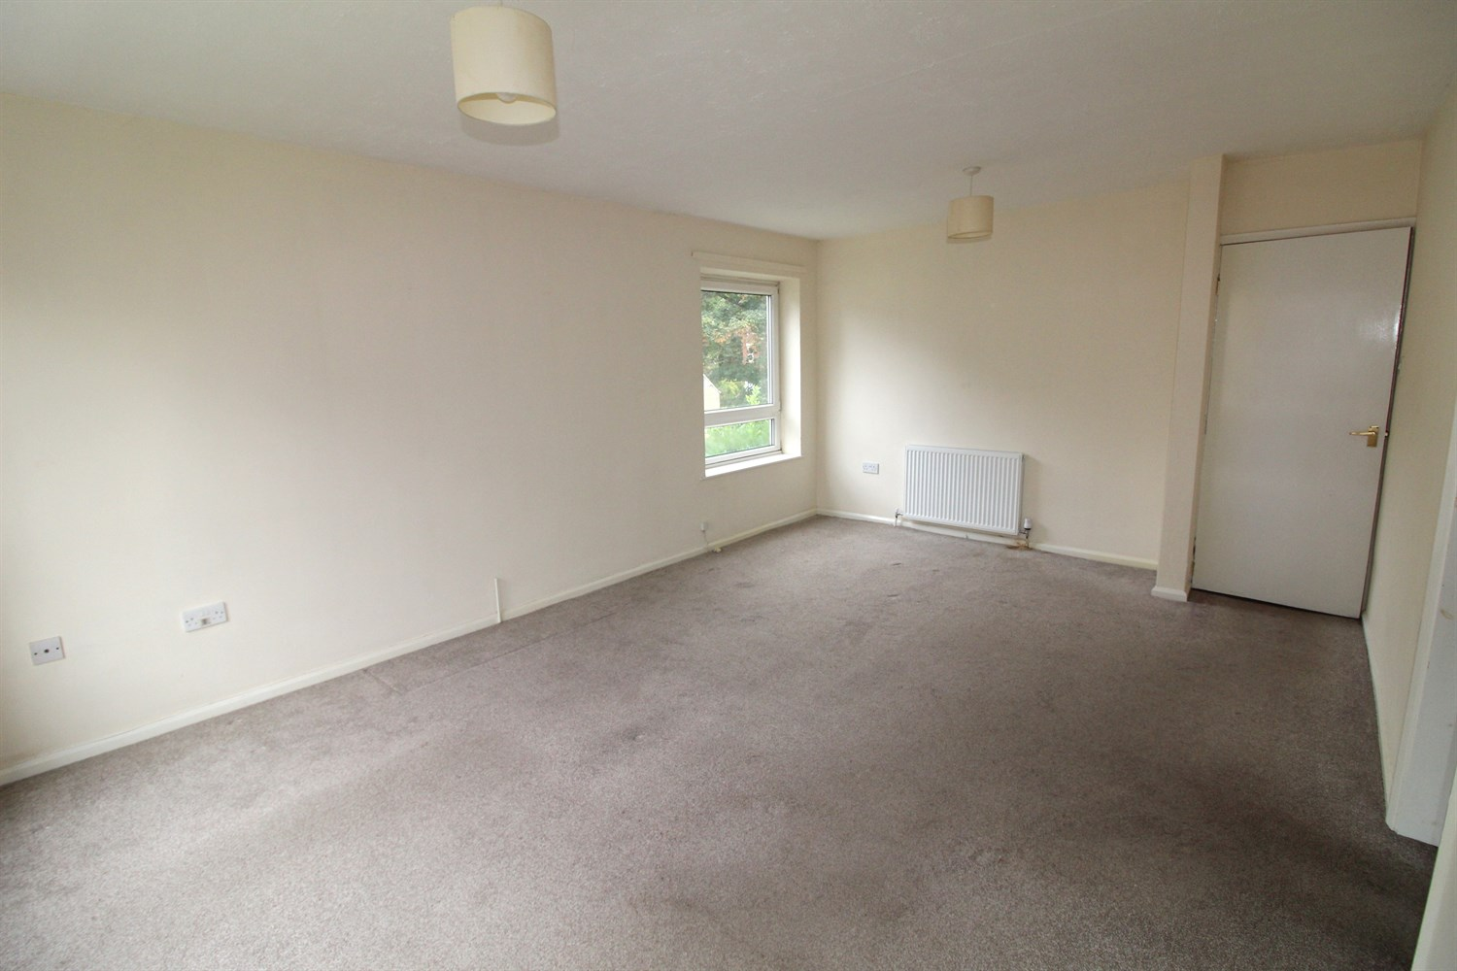

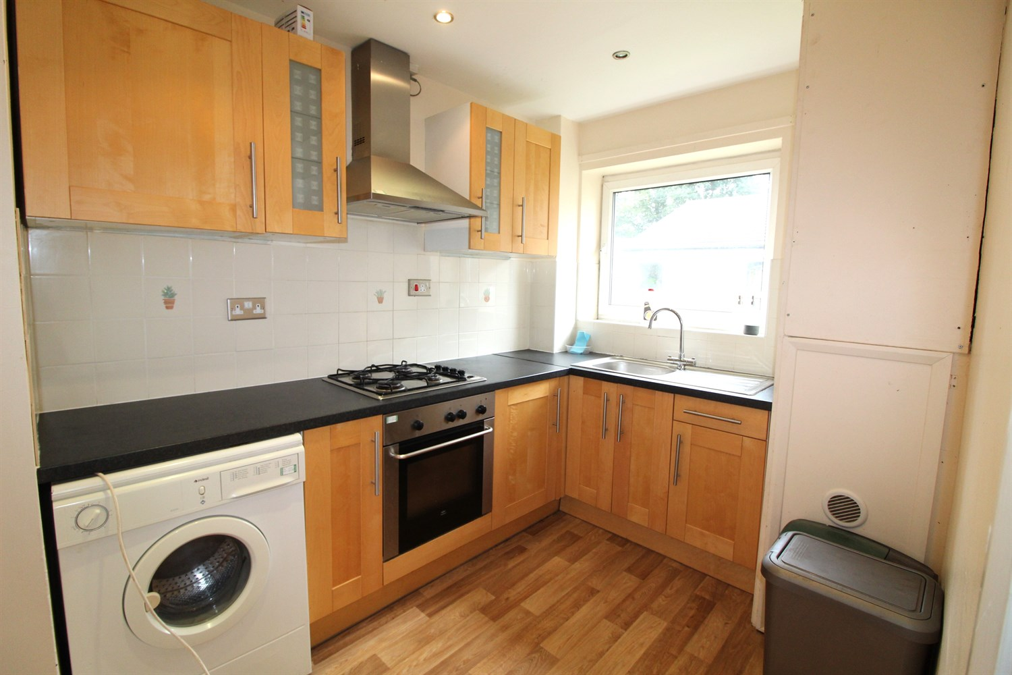

1 Bathroom(s)

1 Reception(s)

1 Bedroom(s)

00

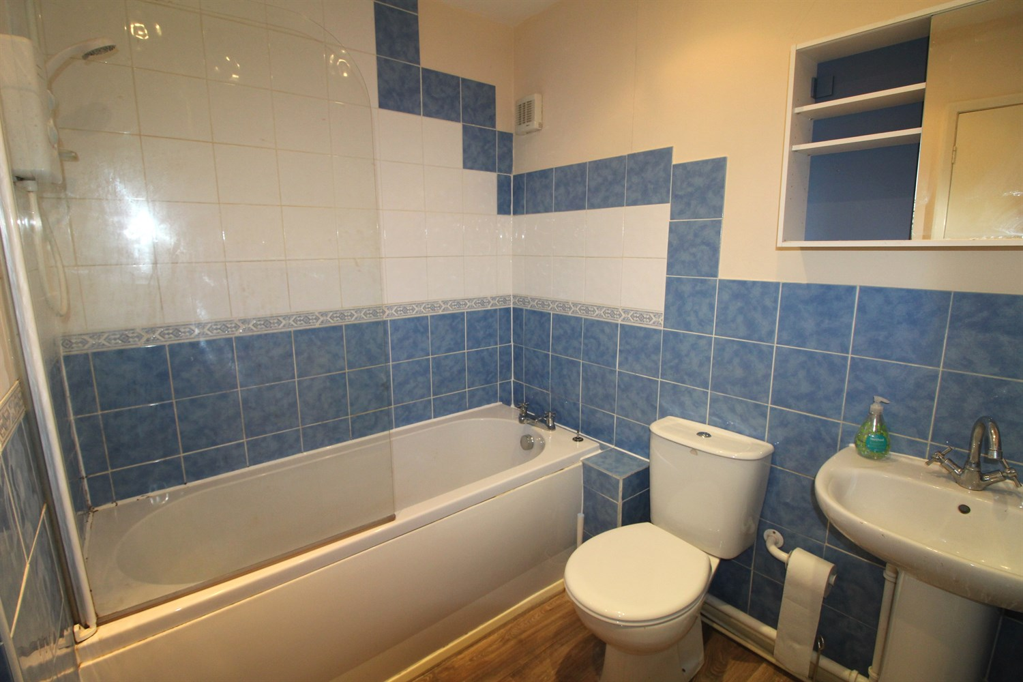

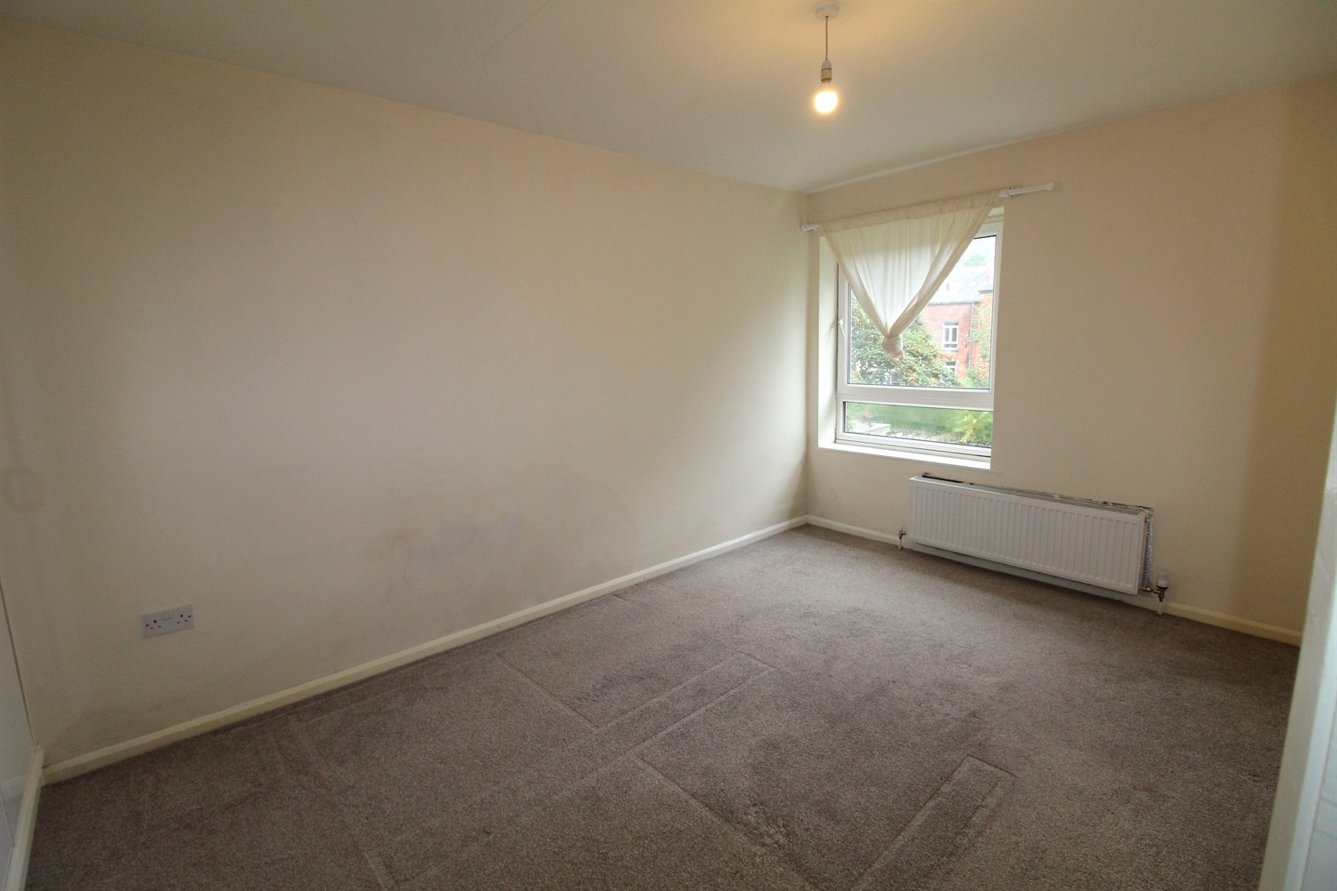

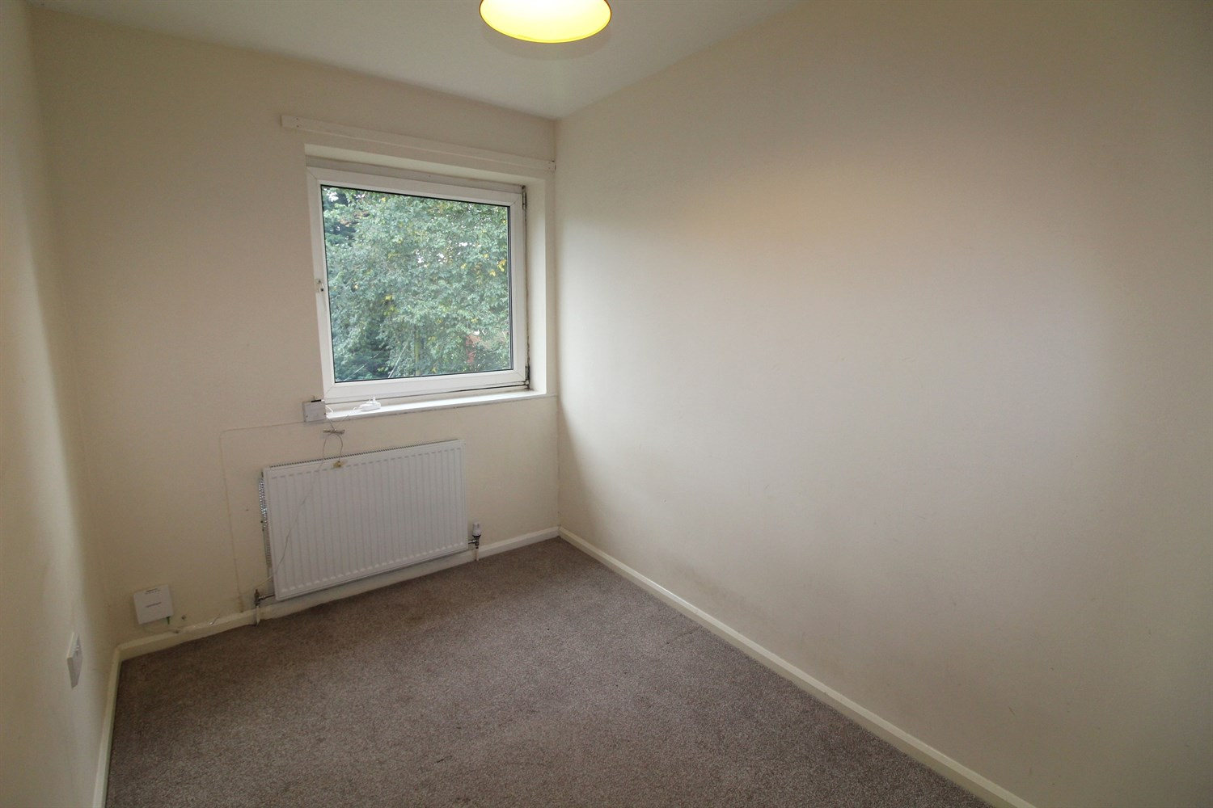

|  |
| --- |
| **Communal entrance**  Communal entrance with letter boxes and stairs to access all floors. |
| **Lounge 3.65m (12') x 5.64m (18'6)**  Spacious living room with a large Upvc window and gas fire radiator. |
| **Kitchen 2.16m (7'1) x 3.05m (10'0)**  Kitchen fitted with a range of wall and base units with work tops over, stainless steel sink with mixer tap and drainer. Electric oven and hob with extractor above. |
| **Bedroom 1 2.75m (9'0) x 4.74m (15'7) Max**  Double bedroom with a double glazed window and gas fired radiator. |
| **Bedroom 2 2.06m (6'9) x 3.81m (12'6)**  Second bedroom with a window and a gas fired radiator. |
| **Bathroom**  Three piece bathroom suite with a bath and over head shower, W/C and hand wash basin. Tiled walls. |
| **Service Charge**  Service Charge £325.00 (Quarterly) |
| **Tenure**  Leasehold - 200 years from 1975 Ground Rent £52.00 (Annual) |

|  |  |
| --- | --- |
| These particulars are intended to give a fair description of the property, but their accuracy cannot be guaranteed, and they do not constitute an offer of contract. Intending purchasers must rely on their own inspection of the property. None of the above appliances/services have been tested by ourselves. We recommend purchasers arrange for a qualified person to check all appliances/services before legal commitment.  **Property Ref:** 3923  **For more information, please contact**  0113 258 1150 **|** [sales@adairpaxton.co.uk](mailto:sales@adairpaxton.co.uk) **|** www.adairpaxton.co.uk |  |