

**Tinshill Lane, LS16**

**£850.00pcm**

**Apartment**

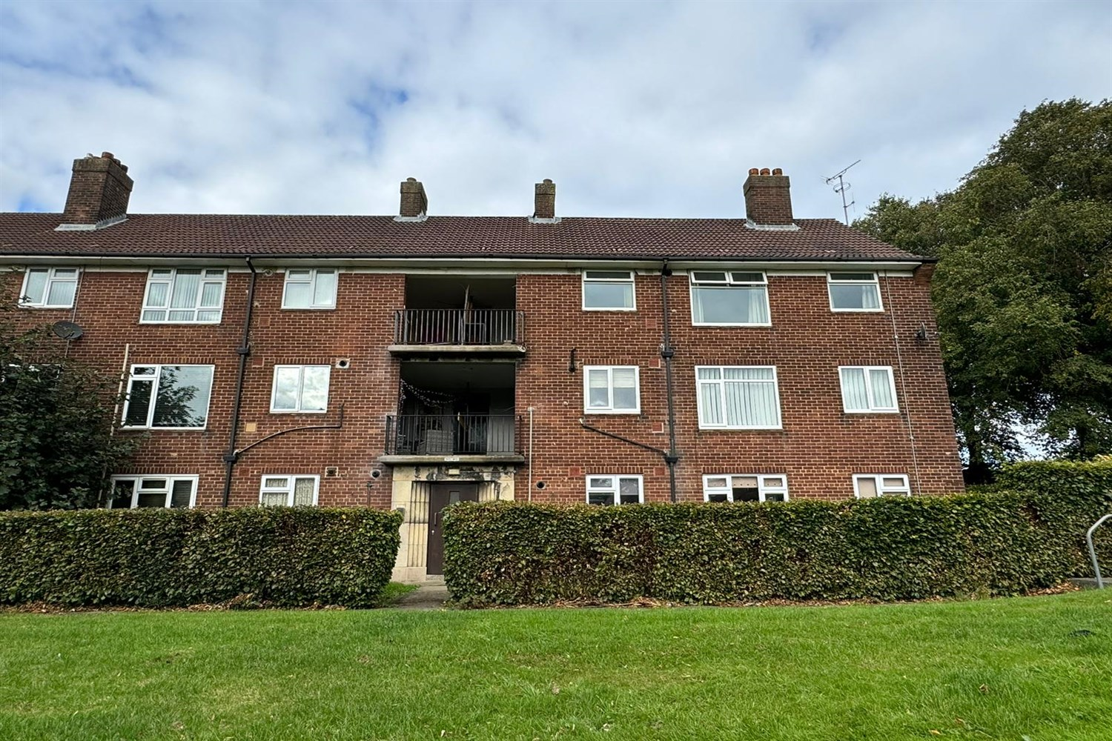

1 Bathroom(s)

1 Reception(s)

2 Bedroom(s)

***AVAILABLE NOW*** WELL PRESENTED *** A spacious TWO DOUBLE BEDROOM APARTMENT CLOSE TO HORSFORTH TRAIN STATION. Lovely spacious sitting room leading into the kitchen, both with open views over Horsforth and beyond. Two double bedrooms, one with fitted cupboard and the other larger than standard double bedrooms. Bathroom, electric shower over the bath. Gas central heating. Available Now, Council tax band A, EPC rating C, deposit £980



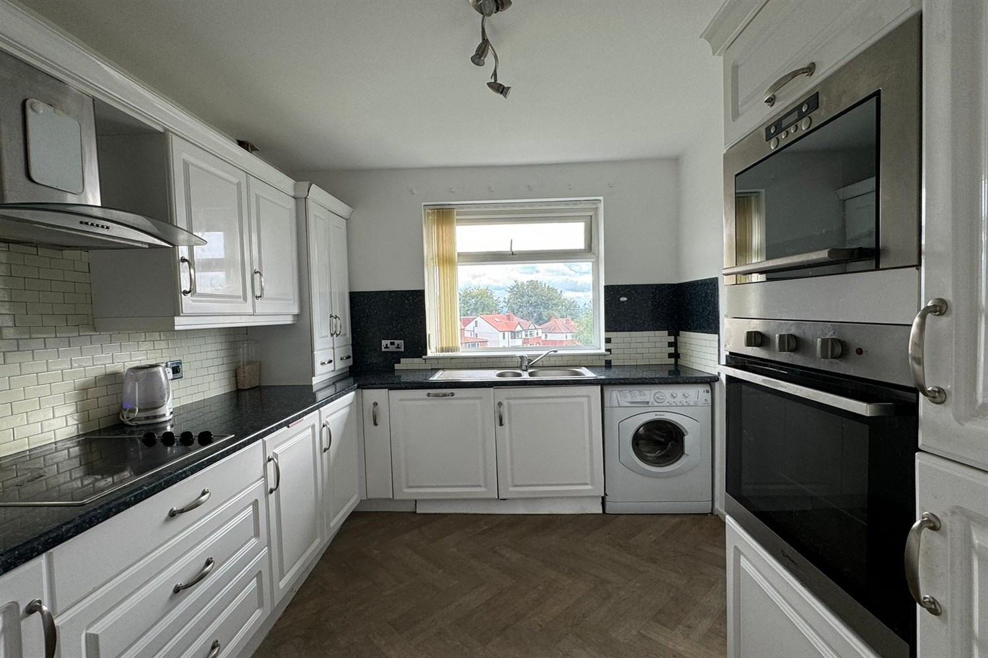

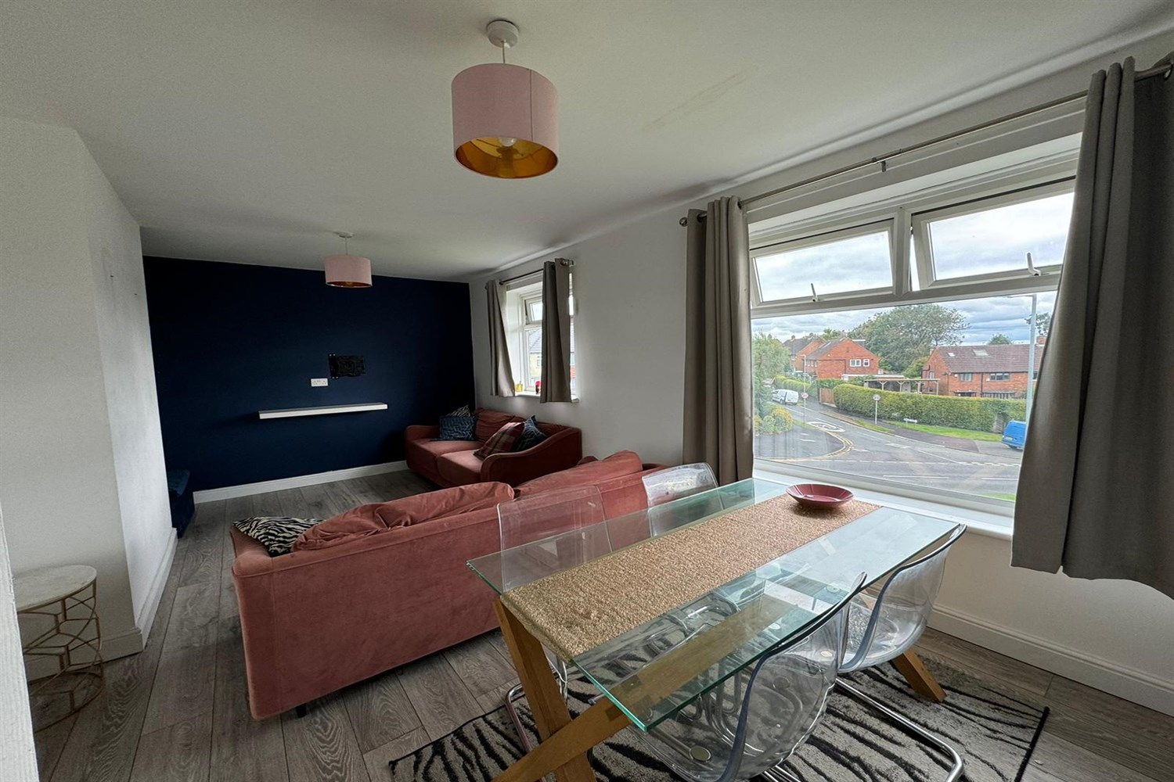

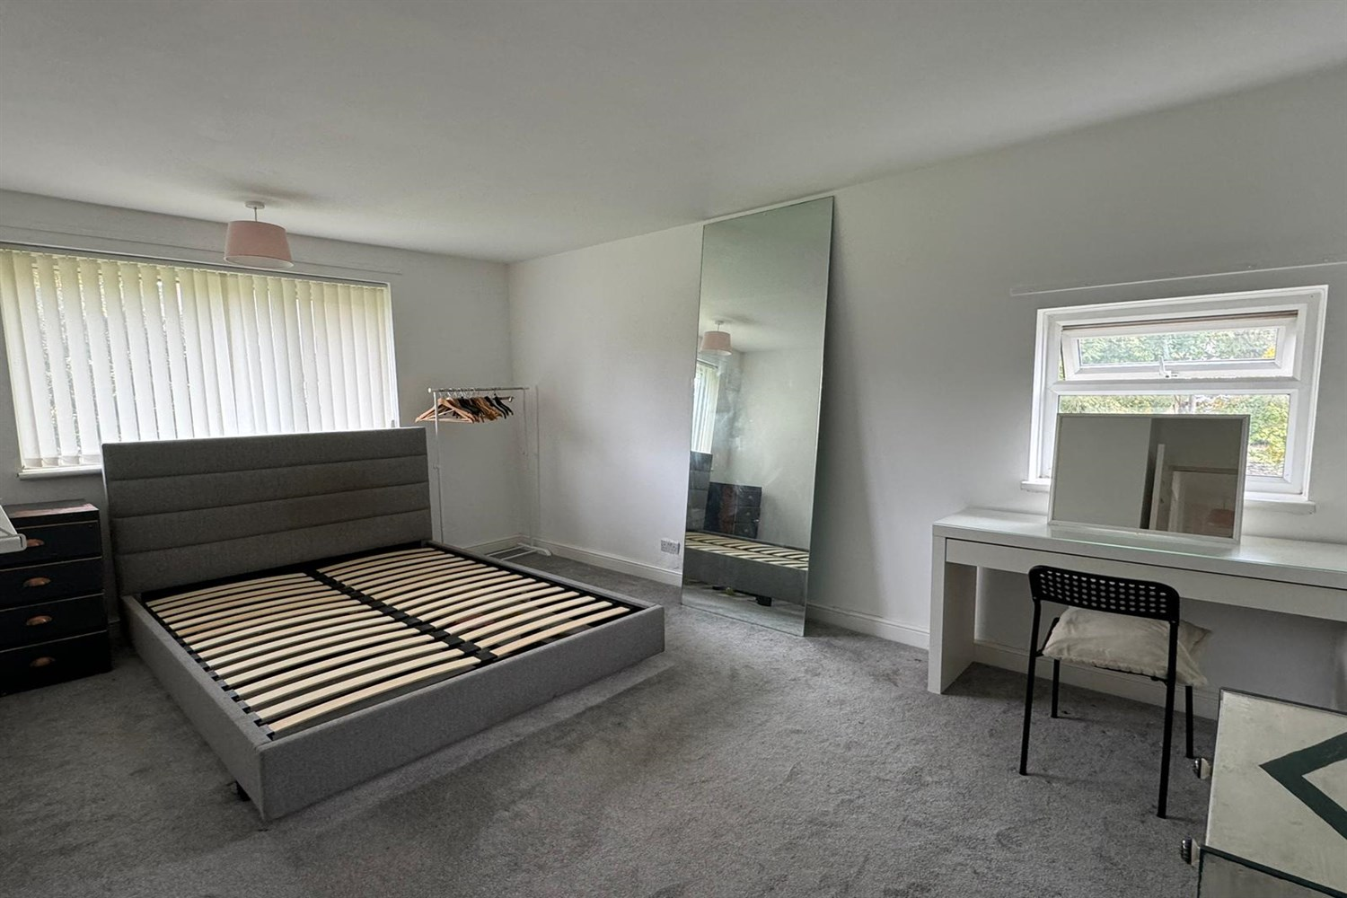

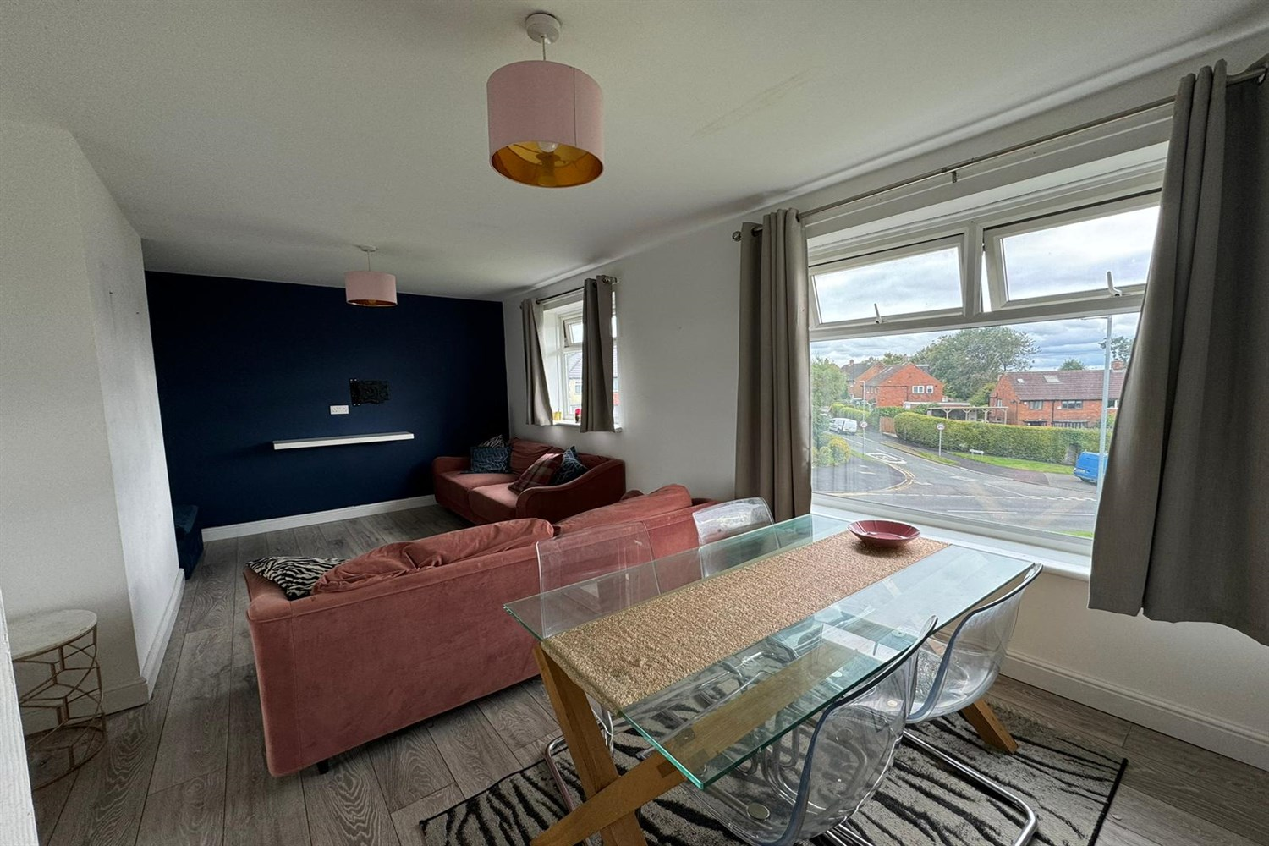

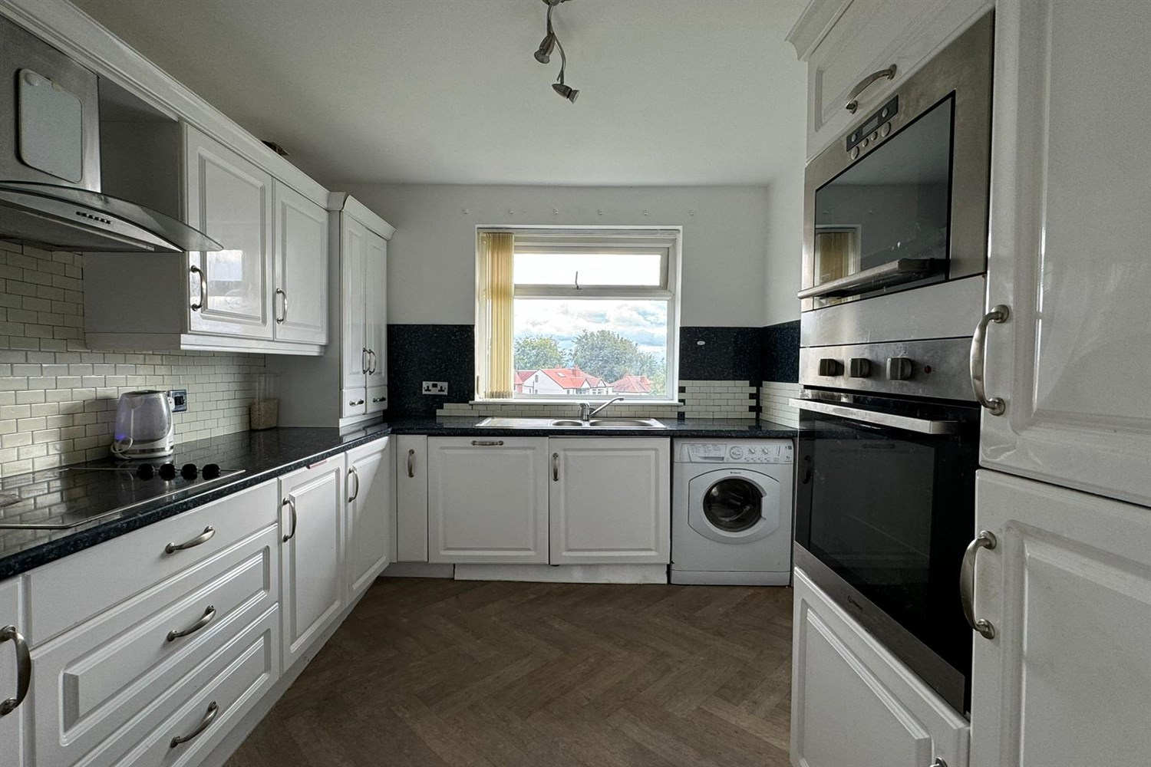

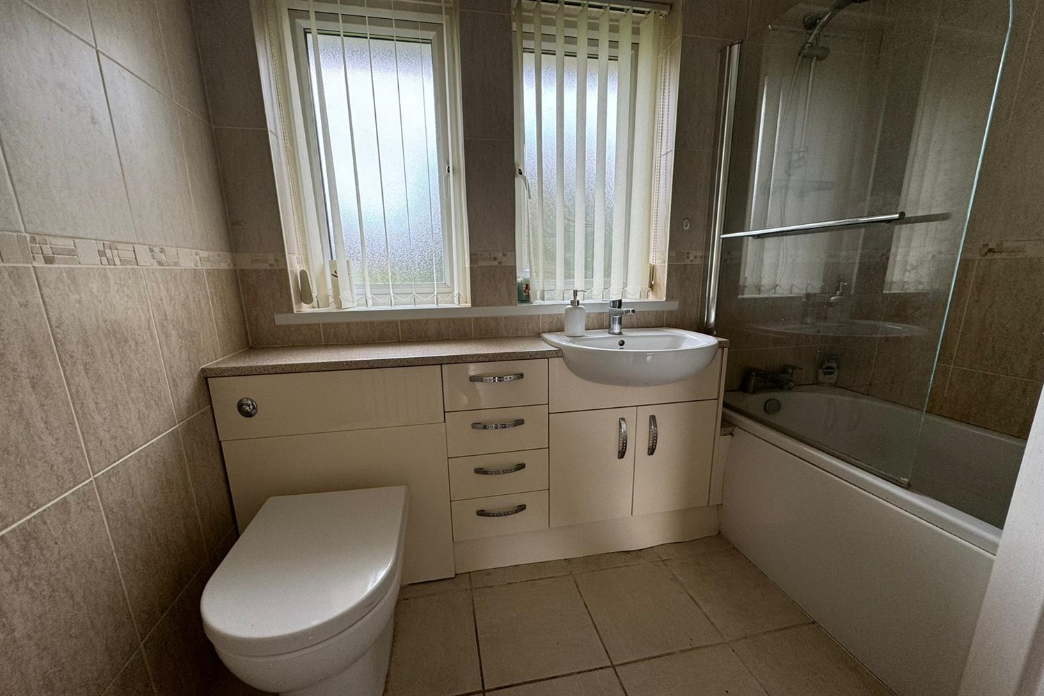



|  |
| --- |
| **Reception 1**  Light and airy lounge with uPVC double glazed windows, Gas central heating. |
| **Kitchen**  Modern kitchen fitted with a range of wall and base units with worktops over, Electric oven and hob extractor over hob. Stainless steel sink with drainer and mixer tap. |
| **Bedroom 1**  Large double bedroom with two uPVC double glazed windows one to the rear and one looking to the side of the property, Gas central heating. |
| **Bedroom 2**  Second double bedroom with window to rear, Gas central heating. |
| **Bathroom**  Modern bathroom compromising of bath with shower over, shower screen, w/c and sink unit. Tiled walls and floor, uPVC double glazed window to rear. |
| **Communal Garden**  Large communal grass area. |
| COUNCIL TAX BAND: A EPC Rating C.  12 Month tenancy. Leasehold property Street Parking  Broadband: Standard 7 Mbps 0.8 Mbps Good Superfast --Not available --Not available Unlikely Ultrafast 1000 Mbps 220 Mbps Mobile availability: Three likely to have good coverage . EE limited coverage. O2 limited. Vodafone limited.  Utilities: Water supplied on standard meters. Gas and Electric mains supplied on standard meters. |

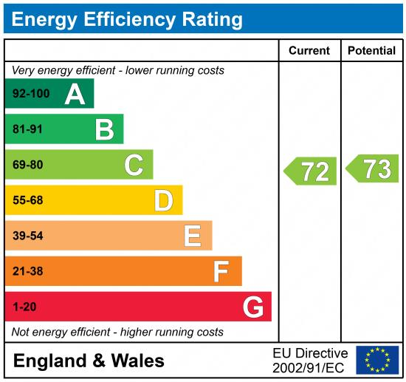

|  |
| --- |
|  |

These particulars are intended to give a fair description of the property, but their accuracy cannot be guaranteed, and they do not constitute an offer of contract. Intending purchasers must rely on their own inspection of the property. None of the above appliances/services have been tested by ourselves. We recommend purchasers arrange for a qualified person to check all appliances/services before legal commitment.

**Property Ref:** 3996

**For more information, please contact**

0113 258 1150 **|** [lettings@adairpaxton.co.uk](mailto:lettings@adairpaxton.co.uk) **|** www.adairpaxton.co.uk