

**Wood Bottom Gardens, Horsforth**

**For Sale £165,000.00**

***50% SHARED OWNERSHIP - THREE BEDROOM SEMI-DETACHED HOUSE IN SOUGHT AFTER LOCATION*** This beautiful home has easy access to local amenities, excellent schools, transport links such as Horsforth train station and The ring road, whilst also offering convenient access to the beautiful country/riverside scenery. This is a fantastic opportunity to get on the property ladder. The property is ready to move into and briefly comprises; Entrance hall, guest WC, living room and kitchen to the ground floor. To the first floor there is a master bedroom, second double bedroom, a third single bedroom and a house bathroom. Externally the property has a driveway offering off street parking and an enclosed lawned south-facing garden to the rear. An early internal viewing is highly recommended to appreciate the accommodation on offer.

**0113 258 1150**

**0800 000 000**

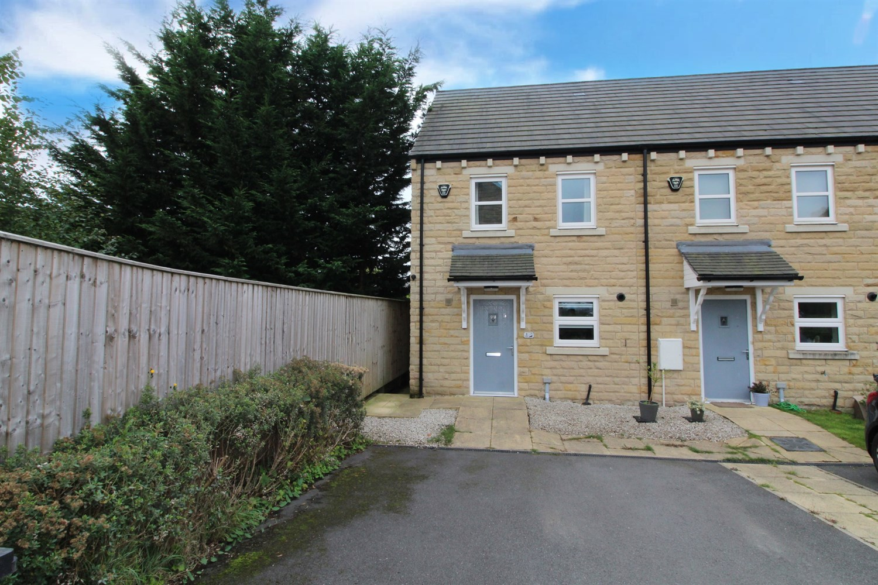



1 Reception(s)

2 Bathroom(s)

3 Bedroom(s)

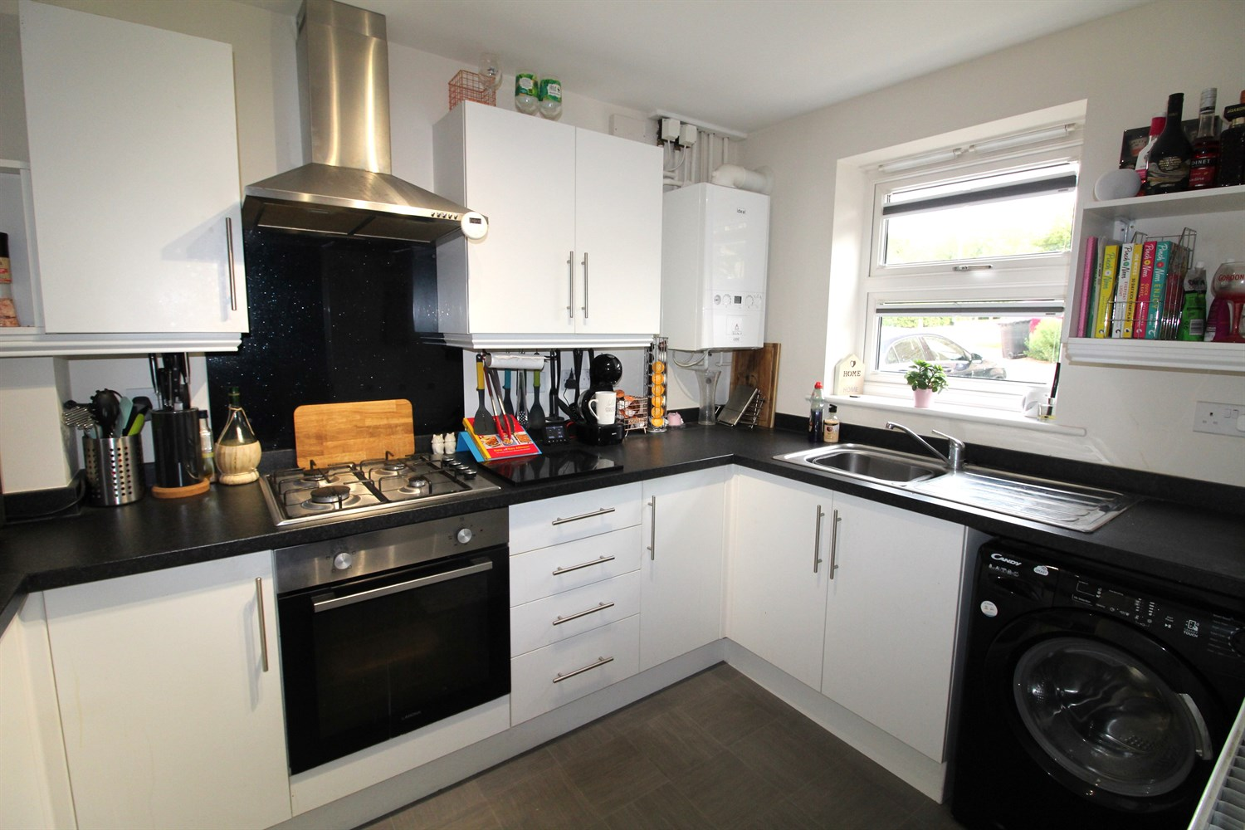

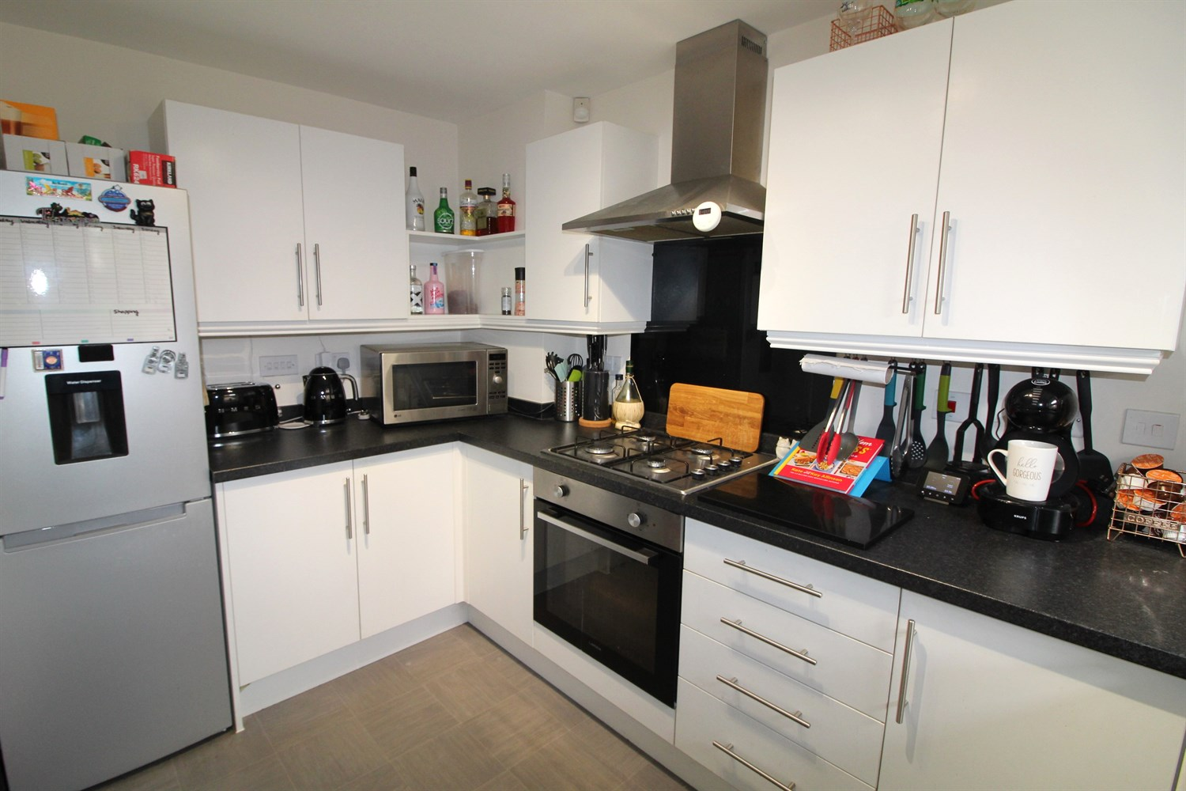

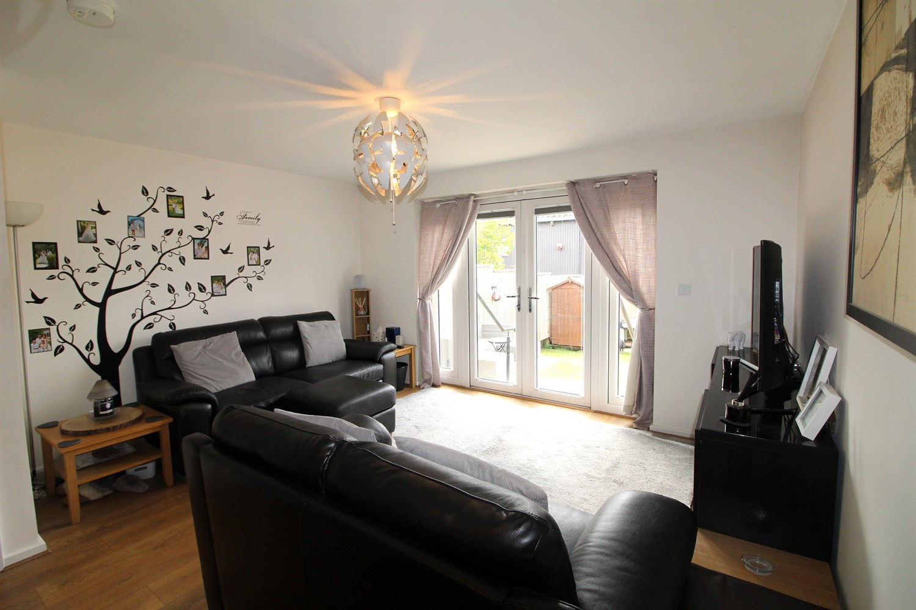

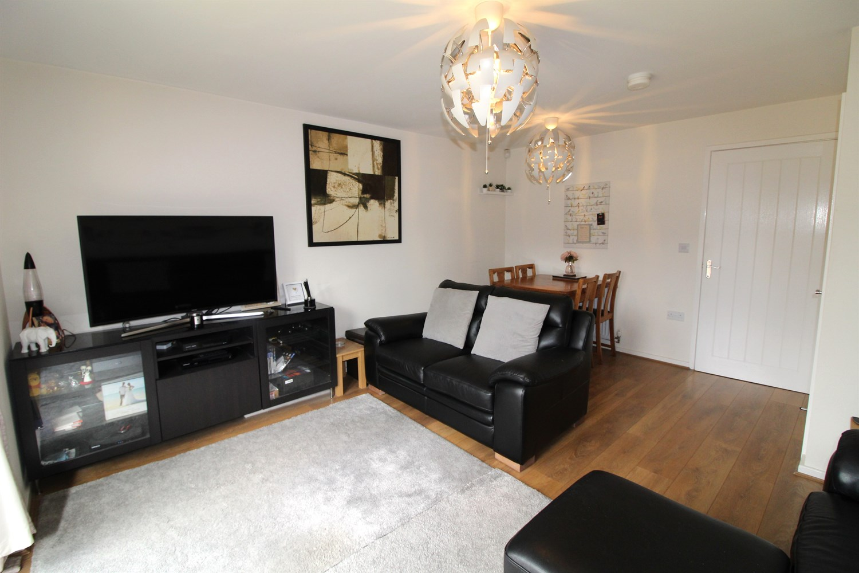

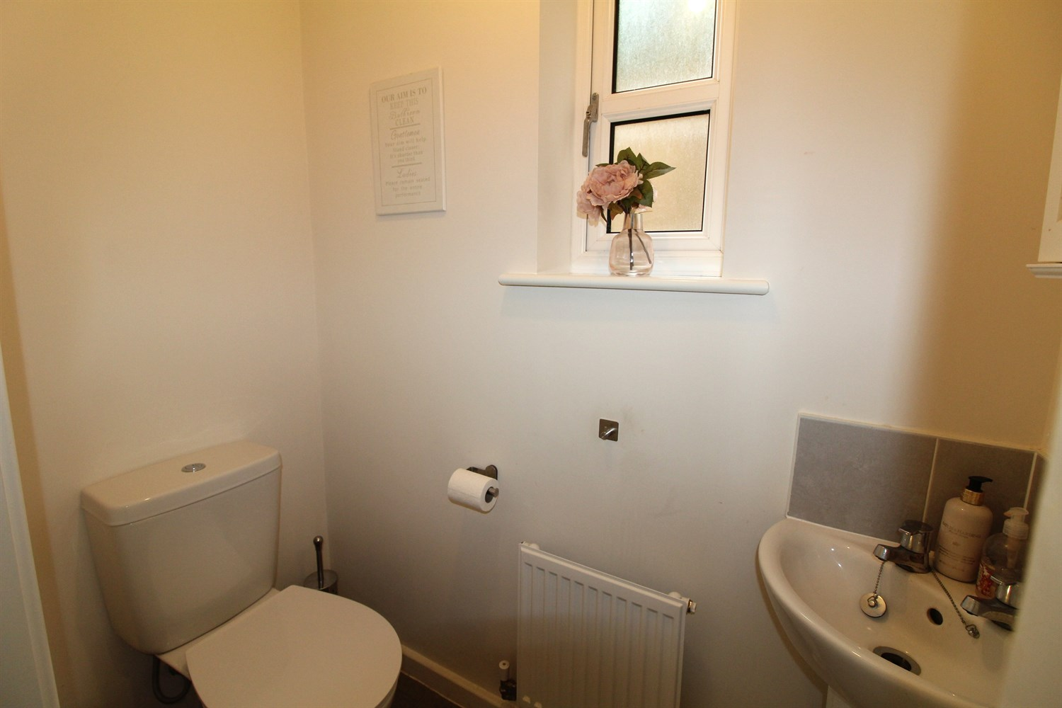

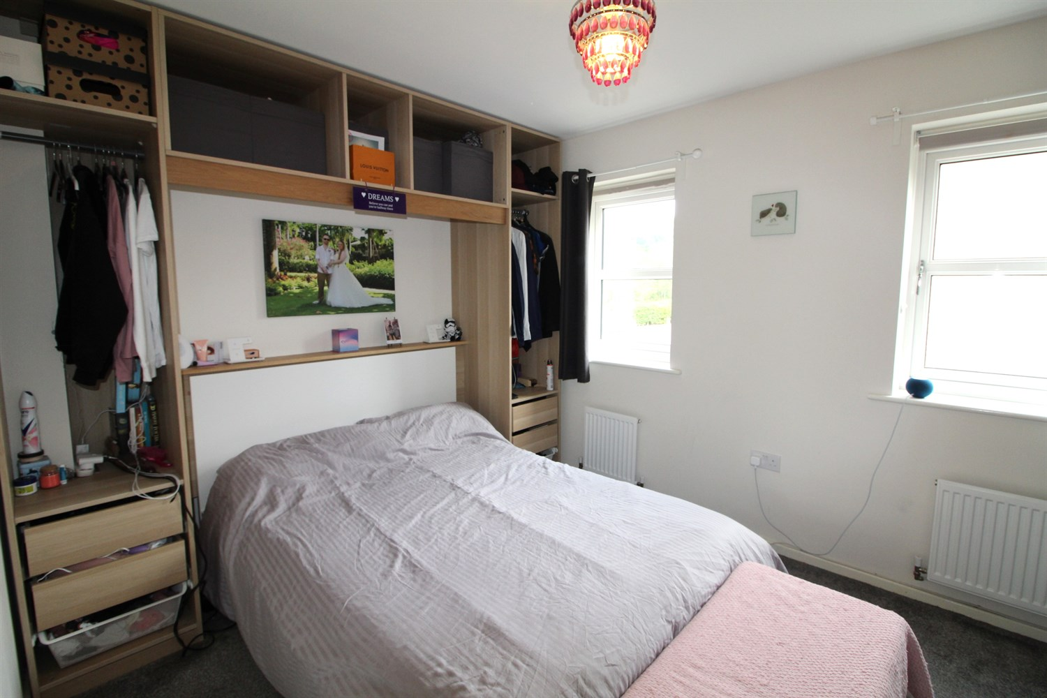

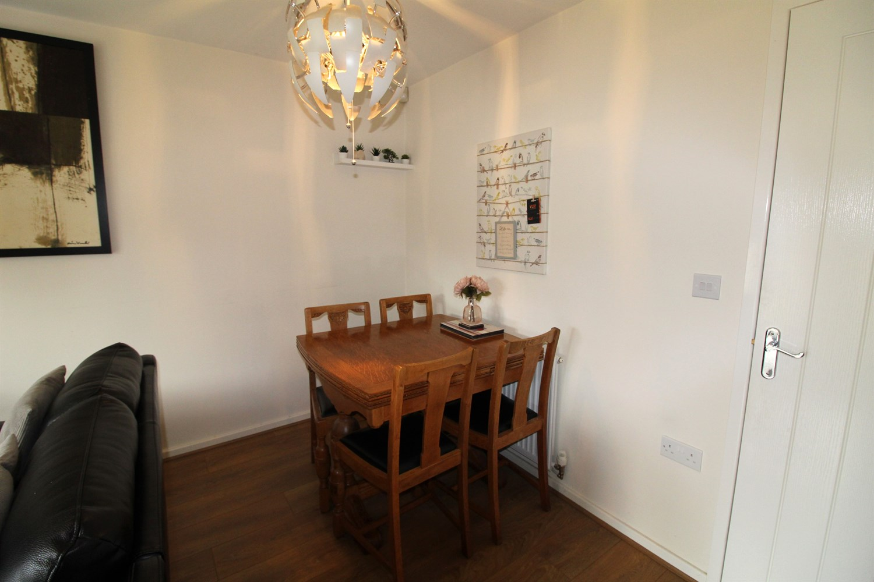

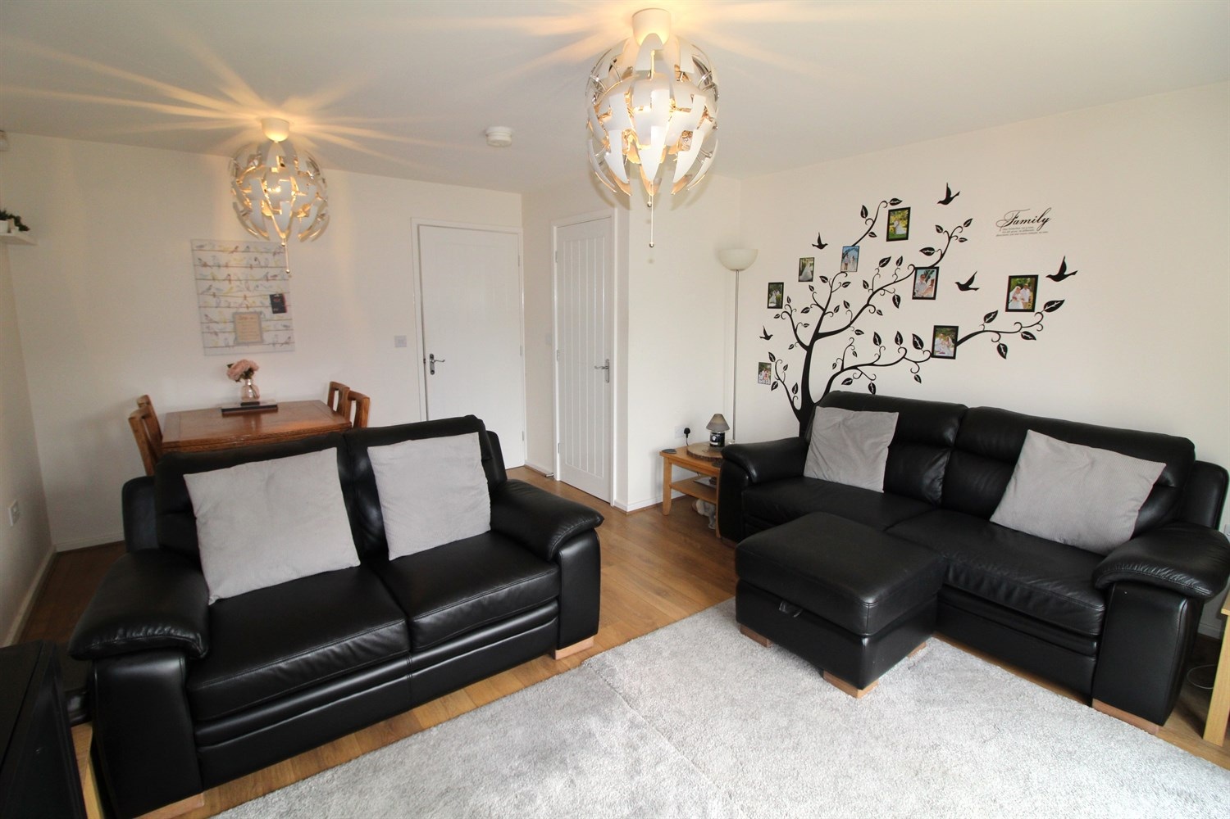

|  |
| --- |
| **Entrance Hall 3.1m (10'2) x 1.05m (3'5)**  Via front entrance door. Stairs to first floor. |
| **Guest WC**  fitted with a two piece suite comprising; WC and wash hand basin. Gas central heating radiator. uPVC double glazed window. |
| **Kitchen 3.1m (10'2) x 2.05m (6'9)**  Fitted with a range of wall, base and drawer units with worktops over. Integrated electric oven with 4-ring gas hob and extractor hood over. Space for fridge/freezer and washing machine. Stainless steel sink with mixer tap and drainer. uPVC double glazed window to front. |
| **Living Room 4.15m (13'7) x 4.69m (15'5)**  Spacious living area with uPVC double glazed patio doors leading to rear garden. Gas central heating radiator. dining area. Storage cupboard. |
| **Bedroom 1 4.2m (13'9) x 2.1m (6'11)**  Double bedroom with uPVC double glazed window to front. Fitted bedroom furniture. Storage cupboard. Gas central heating radiator. |
| **Bedroom 2 3.2m (10'6) x 2.07m (6'9) max**  Second bedroom with uPVC double glazed window to rear. Gas central heating radiator. |
| **Bedroom 3 3.2m (10'6) x 2.07m (6'9)**  Third bedroom with uPVC double glazed window to rear. Gas central heating radiator. |
| **House Bathroom**  Fitted with a three piece suite comprising; bath with shower over, WC and wash hand basin. Tiled walls. |
| **Outside**  To the front of the property is a driveway offering off street parking. To the rear of the property is an enclosed lawned garden with a patio area ideal for entertaining. |
| **Tenure**  Leasehold - 125 years from 2019. |
| **Rent**  Rent of £317.66 to be paid per month for the remaining 50%. |
| **Service Charge**  Service Charge - £45.33 per month. |
| **Agents Note**  Please note, to buy a Shared Ownership property you must meet certain criteria. You have a household income of less than £80,000 You have no ties to any other properties on completion You are unable to buy on the open market |

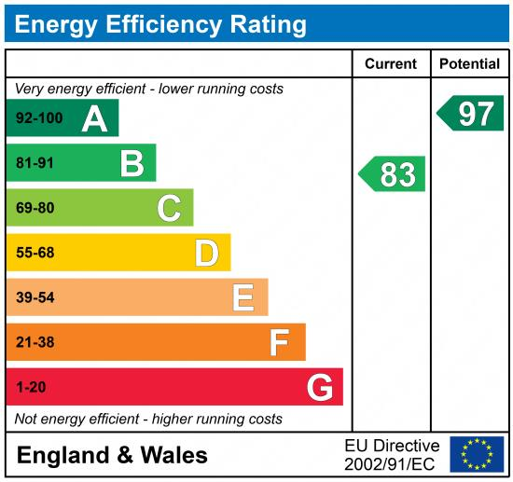

|  |
| --- |
|  |

These particulars are intended to give a fair description of the property, but their accuracy cannot be guaranteed, and they do not constitute an offer of contract. Intending purchasers must rely on their own inspection of the property. None of the above appliances/services have been tested by ourselves. We recommend purchasers arrange for a qualified person to check all appliances/services before legal commitment.

**Property Ref:** 3905

**For more information, please contact**

0113 258 1150 **|** [sales@adairpaxton.co.uk](mailto:sales@adairpaxton.co.uk) **|** www.adairpaxton.co.uk