

**Brackenhurst Drive, Moortown**

**£950.00pcm**

**Apartment**

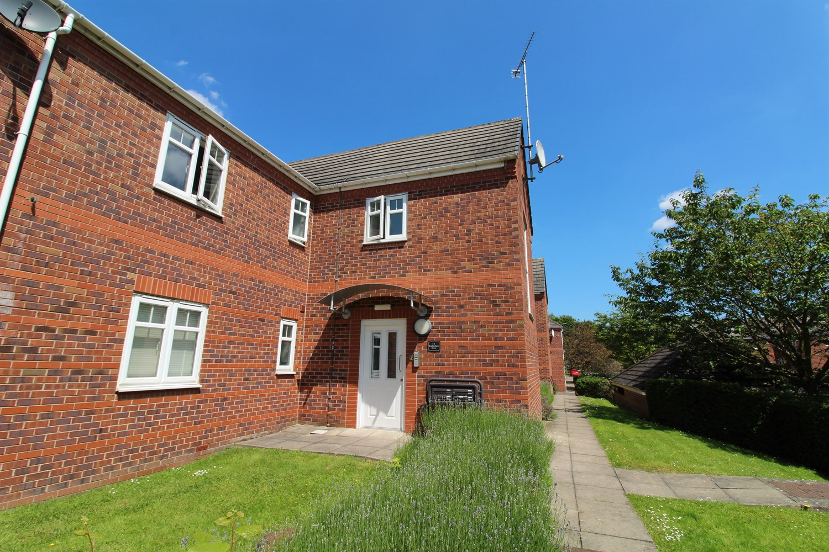

2 Bathroom(s)

1 Reception(s)

2 Bedroom(s)

***GROUND FLOOR TWO BED/TWO BATH APARTMENT IN THIS SOUGHT AFTER LOCATION OF MOORTOWN*** We are delighted to offer this two bedroom apartment, close to all local amenities. Comprising: Communal entrance hall, private entrance hall, open plan lounge/kitchen/diner with Juliette balcony, master bedroom with fitted wardrobes and en-suite shower room, second double bedroom with "Jack and Jill" bathroom and fitted wardrobes. One allocated parking space. The apartment has light neutral decoration throughout. Unfurnished with white goods. Council tax band C, EPC rating C, Available Now. Deposit £1095.



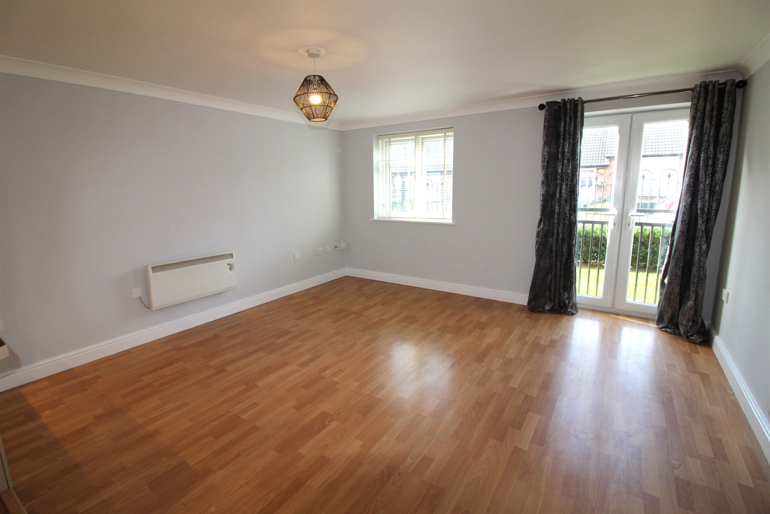

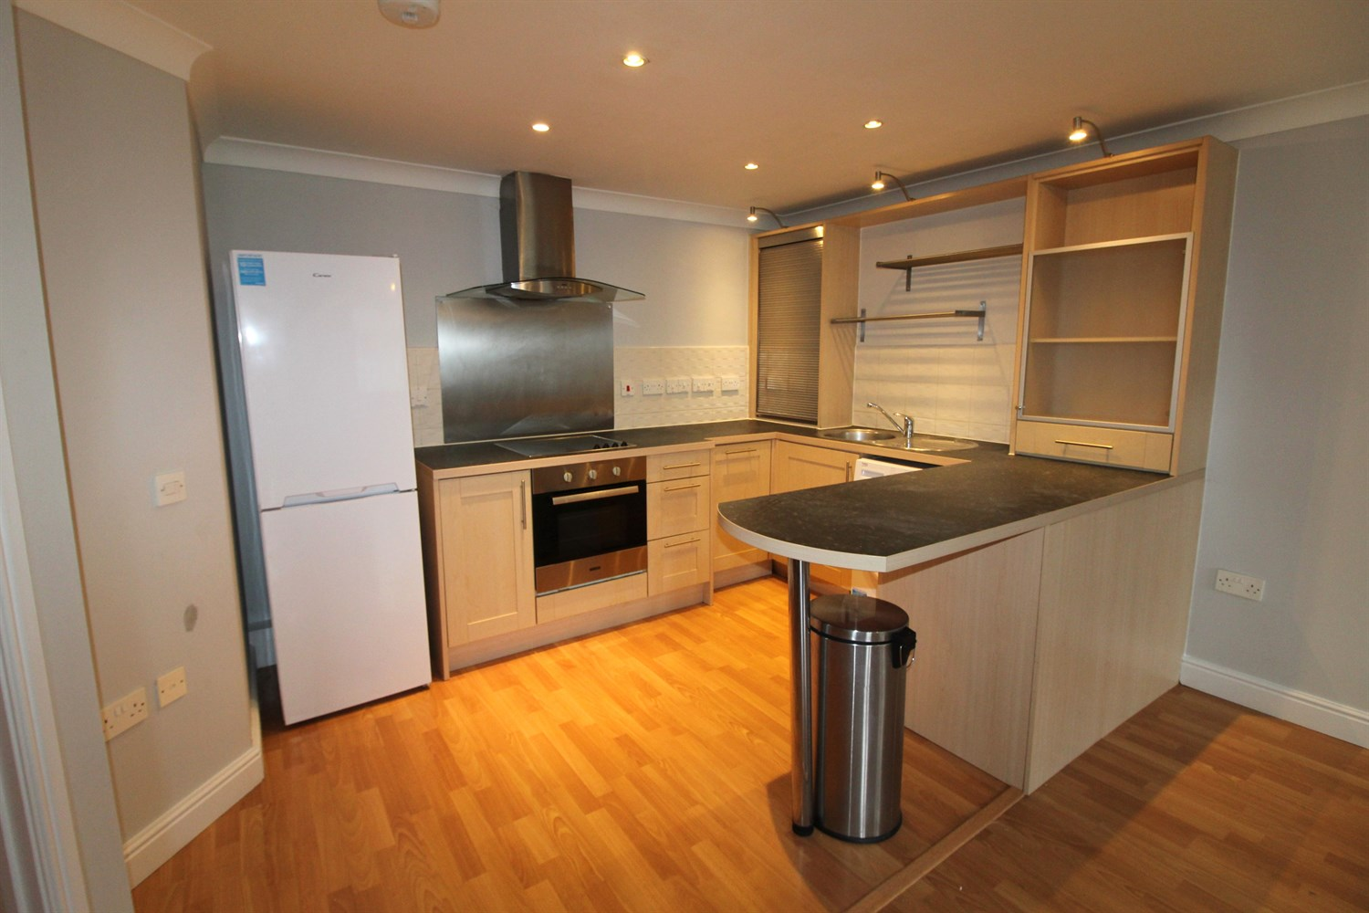

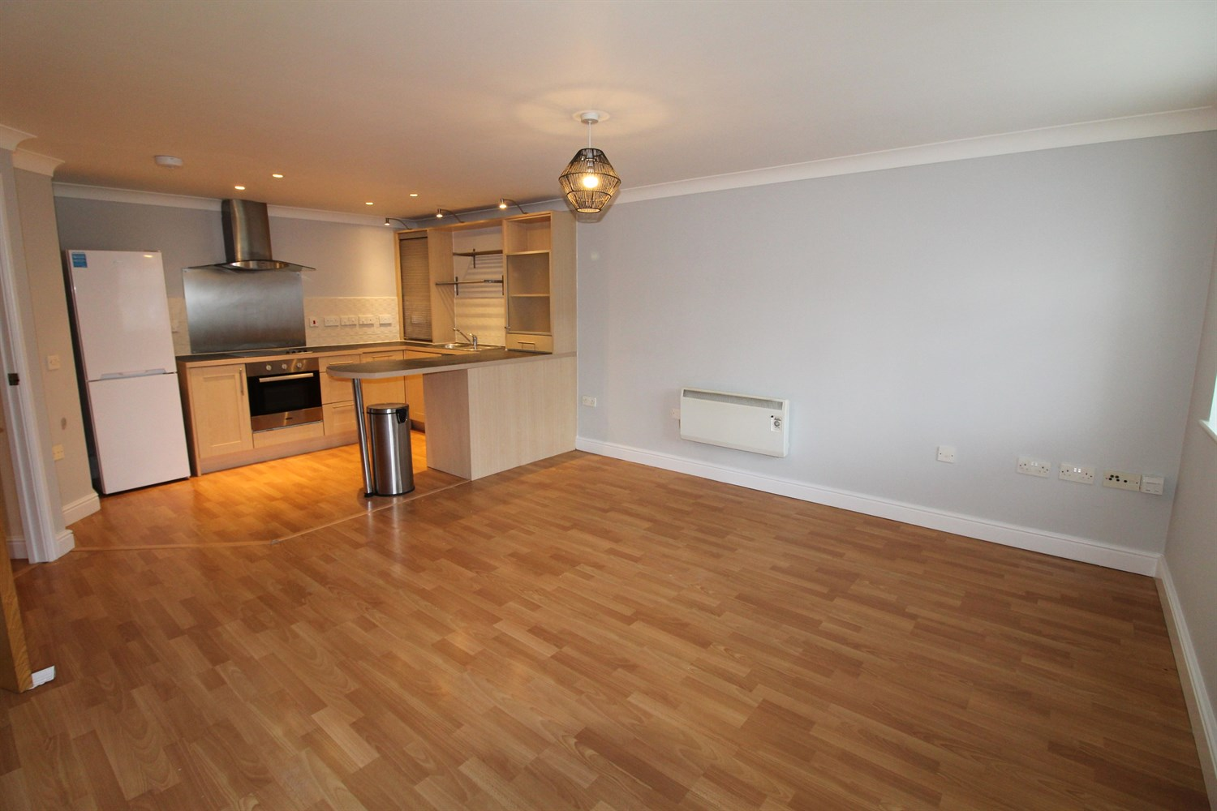

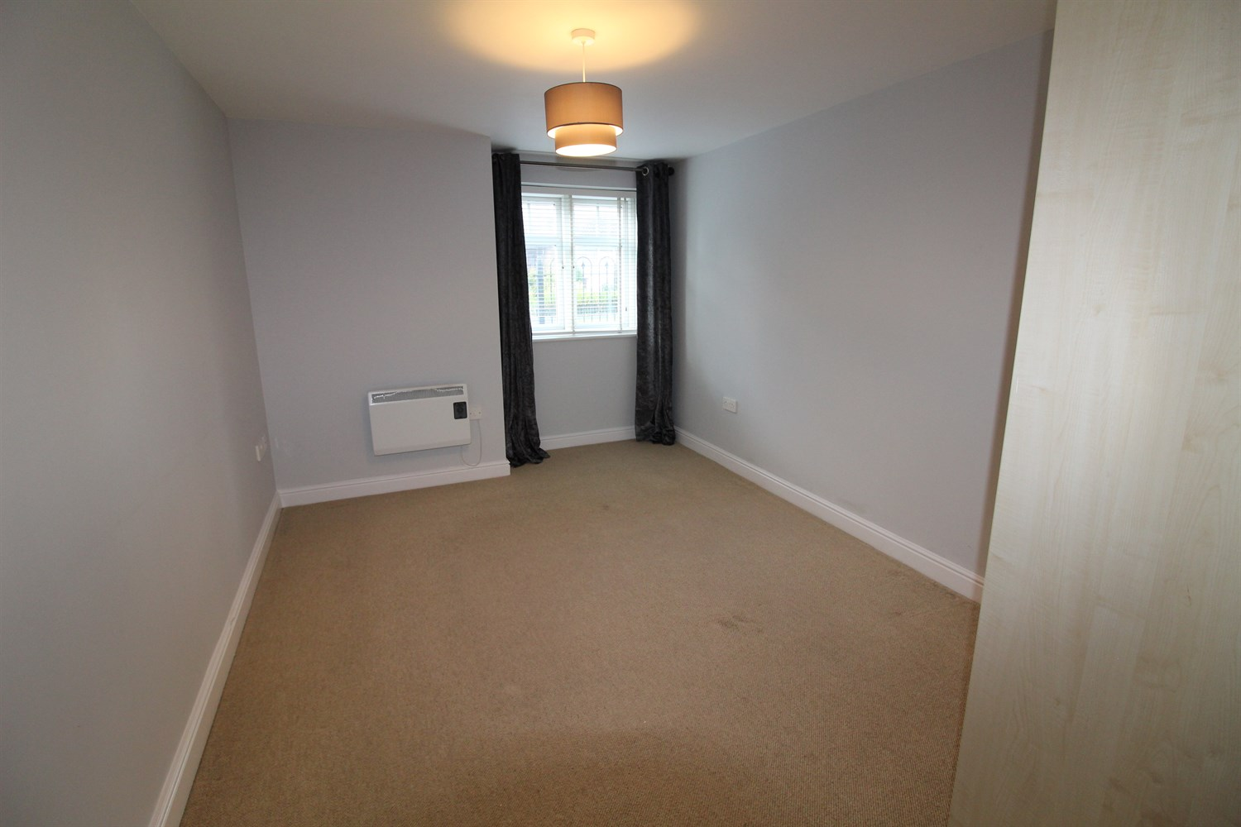

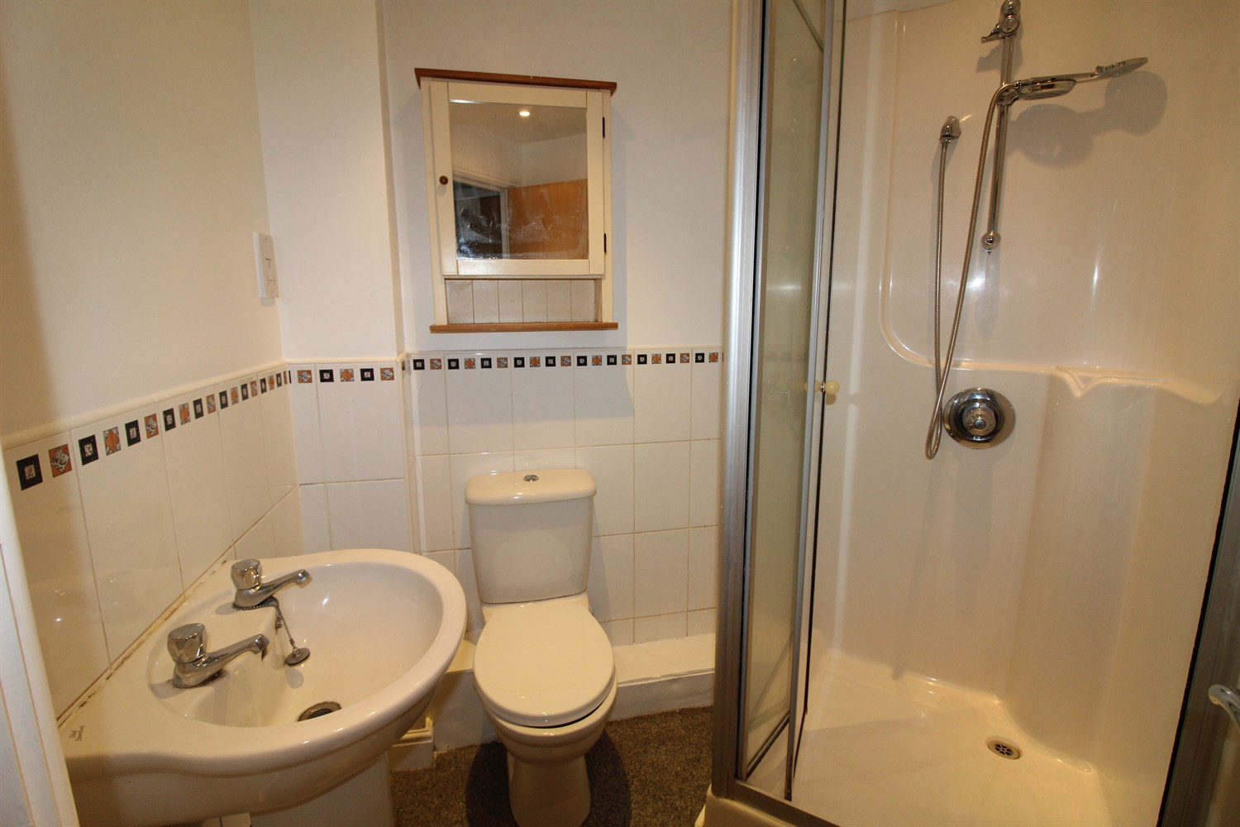

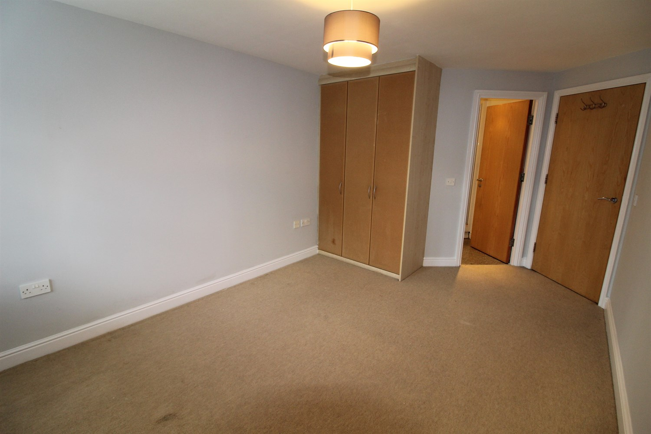



|  |
| --- |
| **Communal Entrance**  Communal Hallway. |
| **Entrance Hall**  Entrance hallway via front entrance door. |
| **Open Plan Living Room/Kitchen**  Contemporary living space with open plan living room/kitchen/diner. uPVC double glazed window to front. uPVC double glazed French doors opening to Juliette balcony. Two wall mounted electric heaters. |
| **Kitchen**  Open plan to the living area, the kitchen is fitted with a range of wall, base and drawer units with work surfaces over and a breakfast bar. Integrated washing machine and dishwasher. Integrated electric oven and hob with extractor hood over. |
| **Bedroom One**  Double bedroom with uPVC double glazed window. Wall mounted electric radiator. Built in wardrobes. |
| **En-Suite Shower Room**  Fitted with a three piece white suite comprising; shower cubicle, WC and wash hand basin. Part tiled walls. |
| **Bedroom Two**  Second double bedroom with uPVC double glazed window. Wall mounted electric radiator. Door leading to "Jack and Jill" bathroom. |
| **Bathroom**  Fitted with a three piece white suite comprising; Bath with hand shower over, W/C and wash hand basin. |
| **Service Charge**  £2192.79 per annum |
| **Tenure**  Leasehold - 999 years from 2003.  Ground rent - £150 per annum |
| **Allocated Parking** |
| 6 Month tenancy only. COUNCIL TAX BAND: C EPC Rating C  Leasehold property Allocated Parking  Broadband: Standard 14 Mbps 1 Mbps Good Superfast 80 Mbps 20 Mbps Good Ultrafast 1000 Mbps 900 Mbps  Mobile availability: EE limited. Three limited. O2 likely to have good coverage. Vodafone limited  Utilities: Water supplied on standard meters. Electric mains supplied on standard meters. Gas mains supplied on standard meters. |

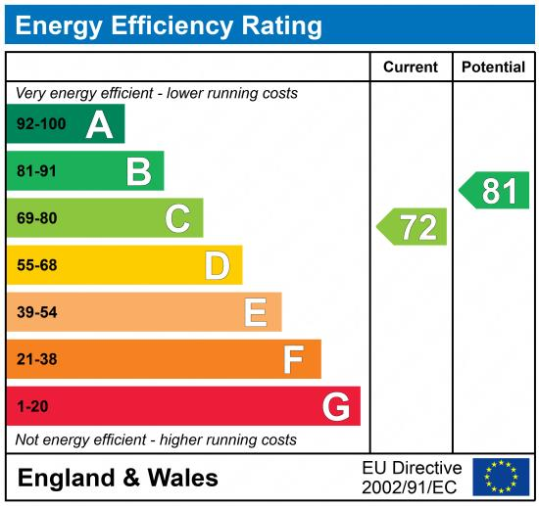

|  |
| --- |
|  |

These particulars are intended to give a fair description of the property, but their accuracy cannot be guaranteed, and they do not constitute an offer of contract. Intending purchasers must rely on their own inspection of the property. None of the above appliances/services have been tested by ourselves. We recommend purchasers arrange for a qualified person to check all appliances/services before legal commitment.

**Property Ref:** 2025

**For more information, please contact**

0113 258 1150 **|** [lettings@adairpaxton.co.uk](mailto:lettings@adairpaxton.co.uk) **|** www.adairpaxton.co.uk