

**Narrowboat Wharf, Leeds**

**£895.00pcm**

**Apartment**

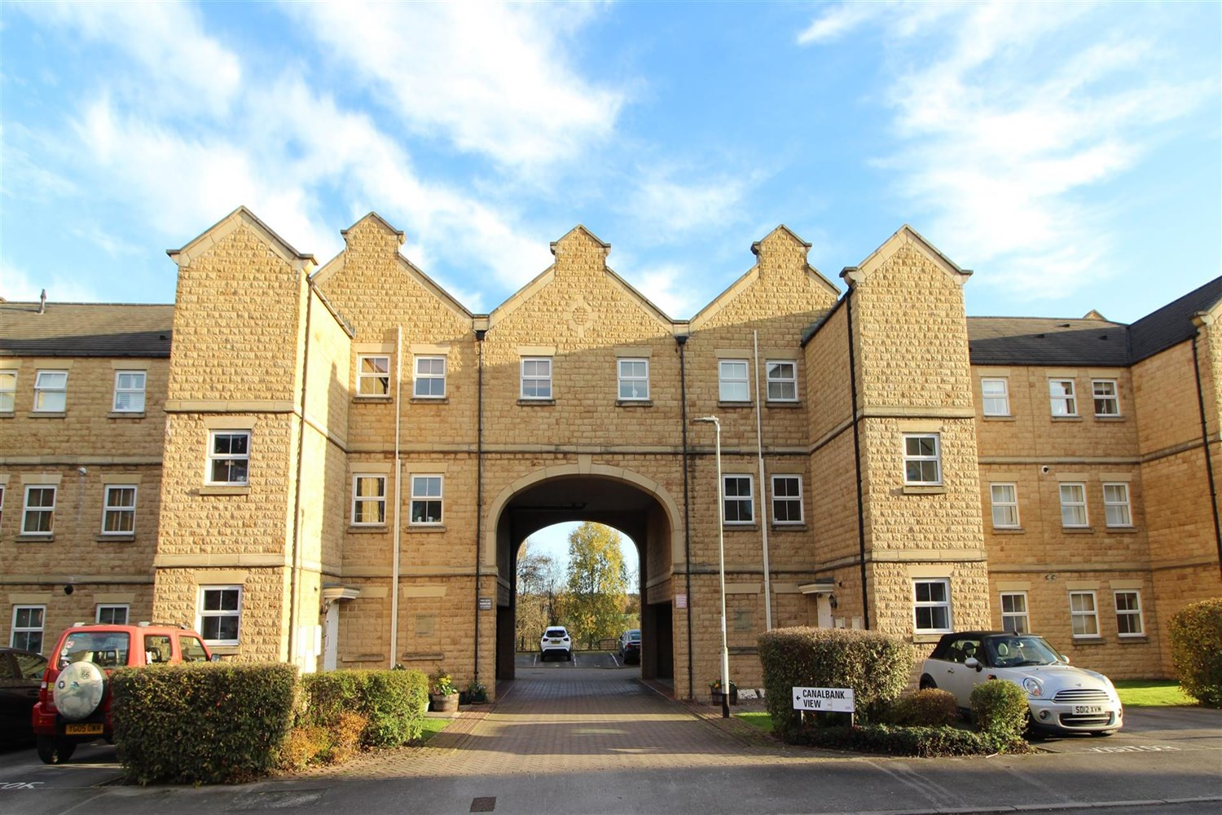

2 Bathroom(s)

1 Reception(s)

2 Bedroom(s)

Adair Paxton are delighted to offer this Two Bedroom/Two Bathroom First Floor Apartment with quality fixtures and fittings throughout. The property benefits from gas central heating and Upvc double glazing. Spacious Lounge and Dining Area with balcony with Kitchen off to include oven/hob/extractor, dishwasher, washer/dryer and fridge/freezer. Double bedroom with outlook and en-suite bathroom, second bedroom and house bathroom. Well maintained grounds and covered car parking space. Furnished. Deposit £1030. Council tax band C, EPC- B Available 28th October.



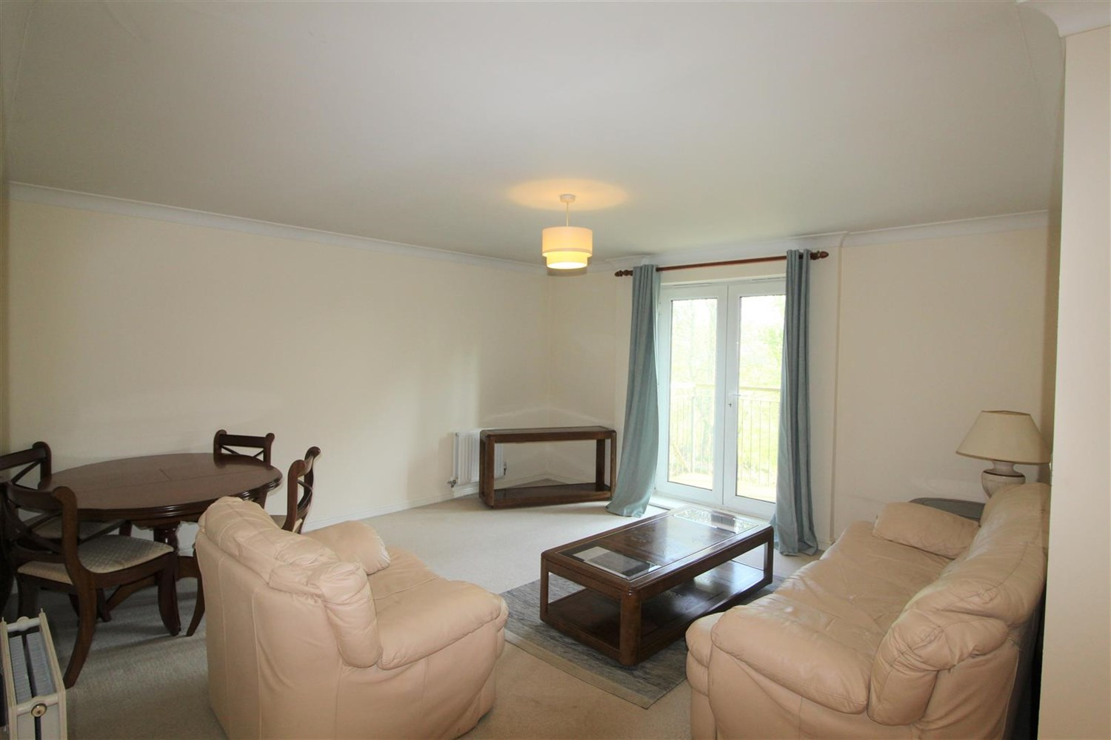

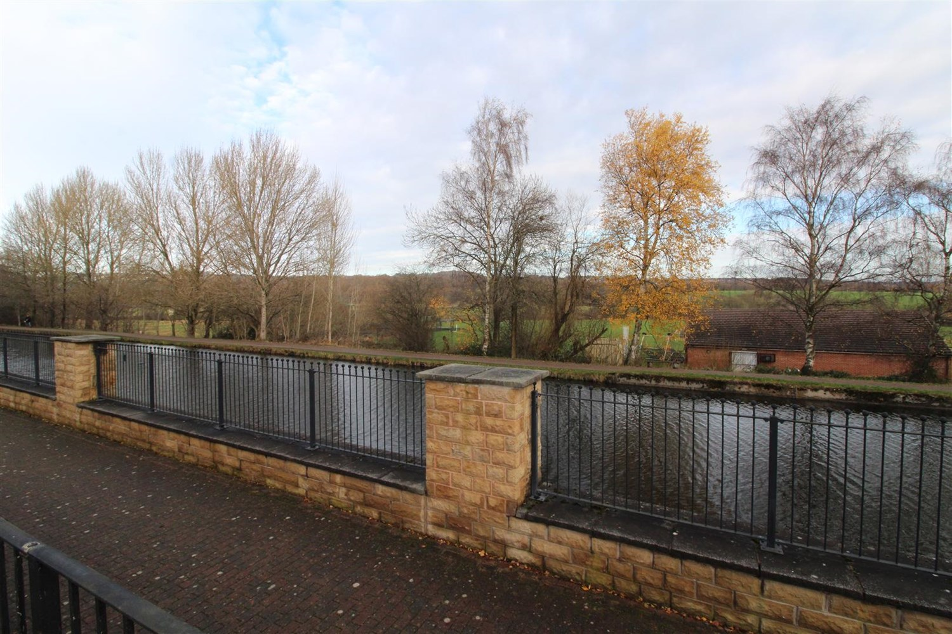

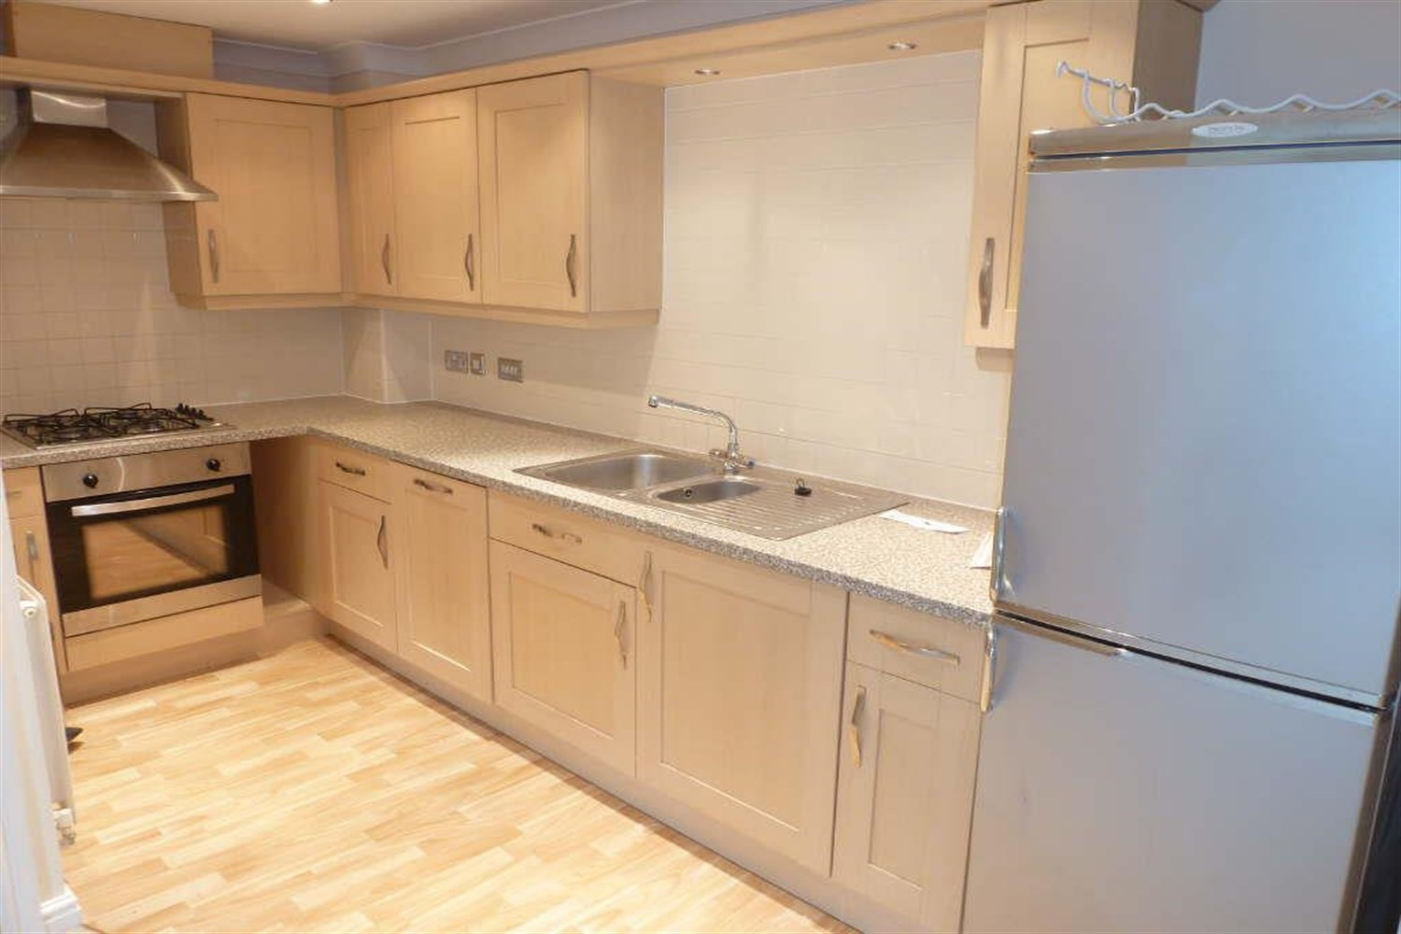

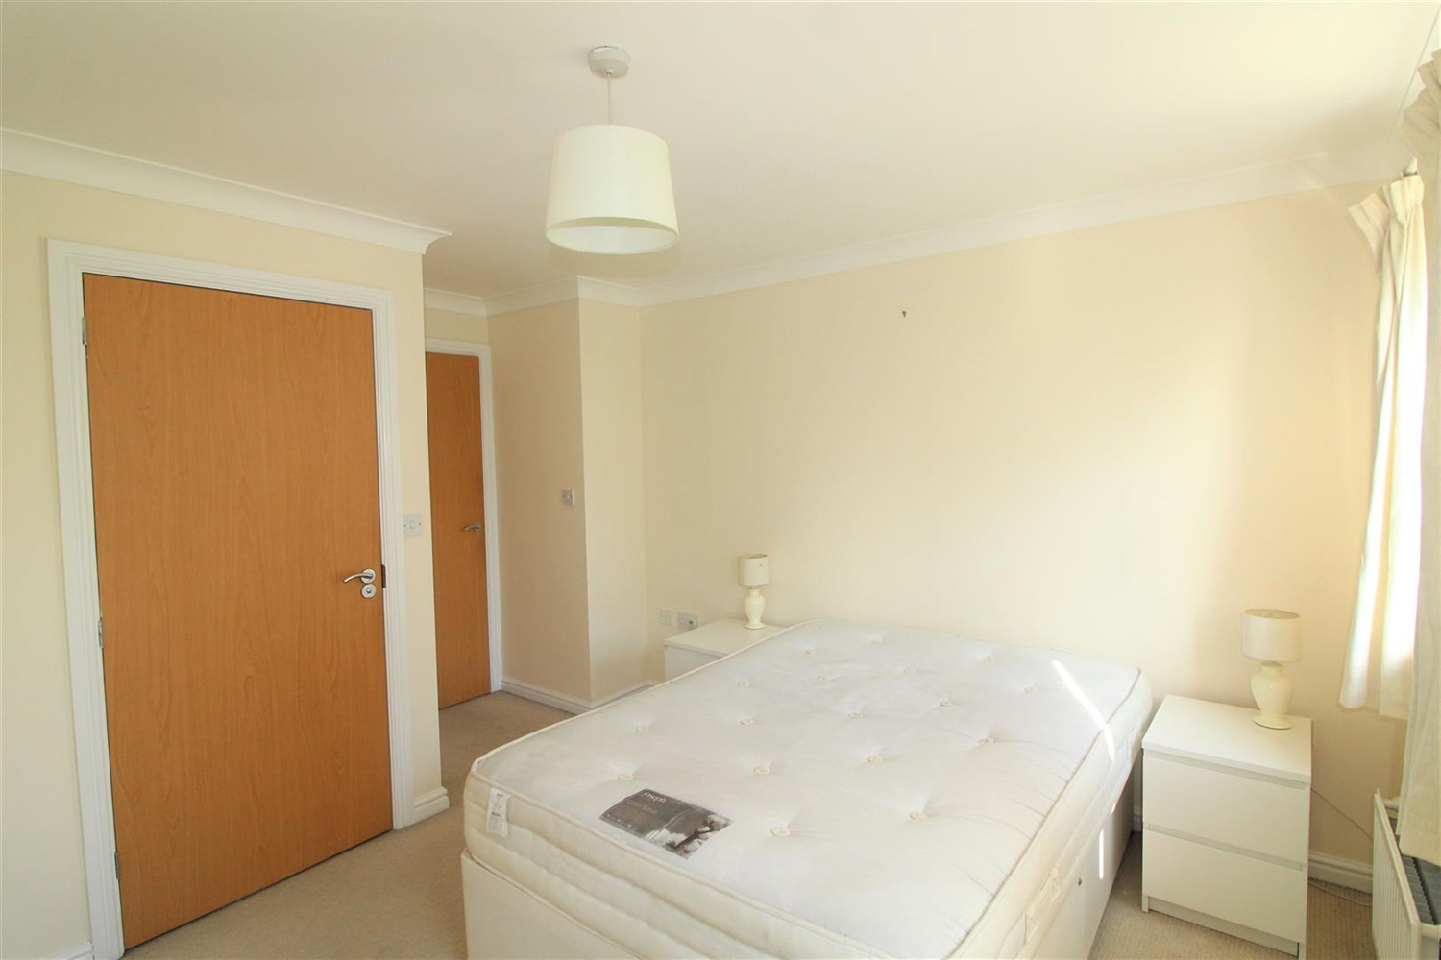

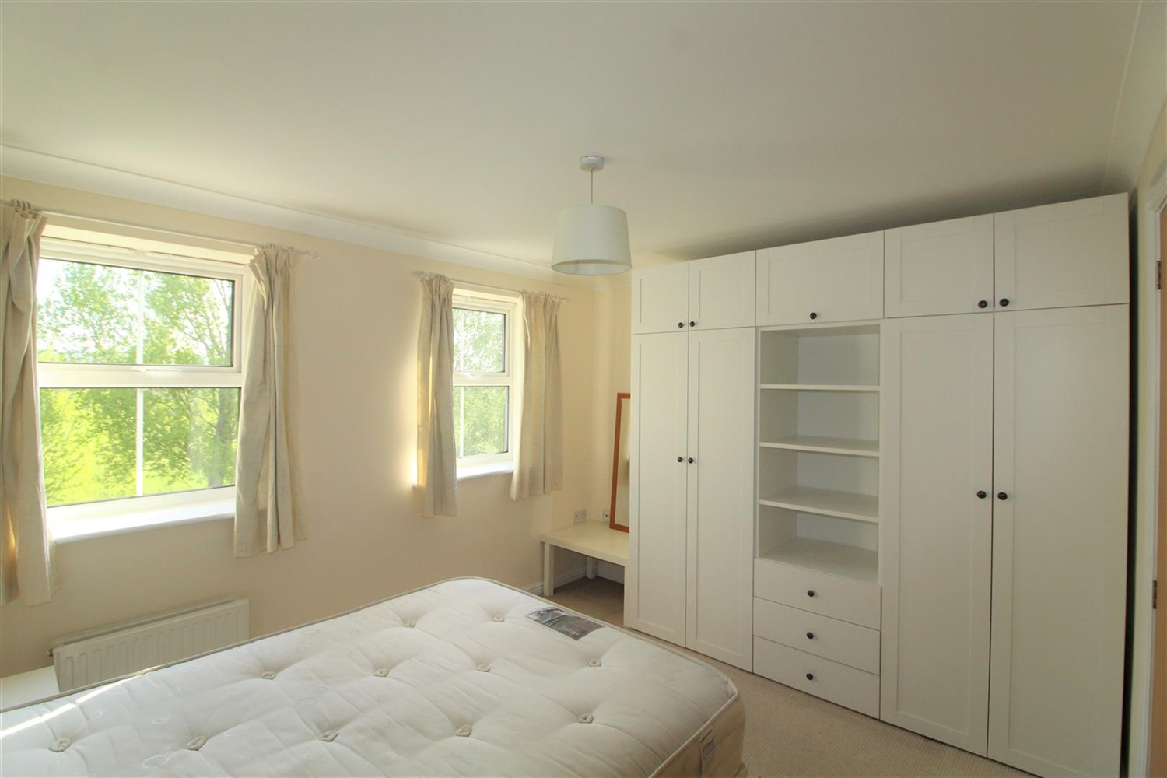

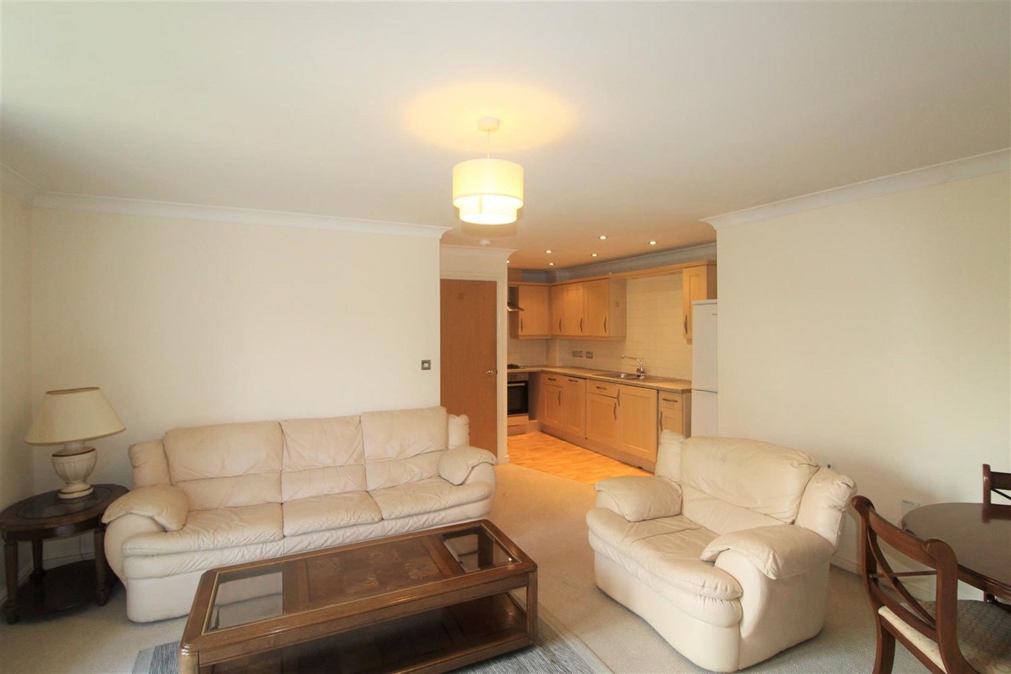



|  |
| --- |
| **Communal entrance**  Via secure intercom entry system. Stairs to first floor. |
| **Private Entrance Hall**  Laminate flooring, two storage cupboards - one housing boiler. |
| **Living room**  A spacious lounge with two double glazed windows to the front. Space for dining table, Two gas central heating radiators. Open plan to the kitchen. |
| **Kitchen**  Open plan to the living room. Fitted with a range of wall and base units, integrated dishwasher, electric oven, gas hob with extractor hood over, laminate flooring. |
| **Bedroom 1**  Double bedroom with double glazed window. Gas central heating radiator. |
| **En-suite**  Fitted with a three piece white suite comprising; shower cubicle, WC and wash hand basin. Part tiled walls. |
| **Bedroom 2**  Second bedroom with double glazed window. Gas central heating radiator. |
| **Bathroom**  Fitted with a three piece suite comprising bath with shower over, wash hand basin, WC. Part tiled walls, heated ladder towel rail. |
| COUNCIL TAX BAND: C EPC Rating B  Leasehold property   Broadband Virgin media only: Standard 5 Mbps 0.6 Mbps Good Superfast 138 Mbps 20 Mbps Good Ultrafast 1000 Mbps 1000 Mbps  Mobile availability: EE Likely Three Limited O2 Limited Vodafone Likely  Utilities: Water supplied on standard meters. Electric mains supplied on standard meters. |

|  |
| --- |
|  |

These particulars are intended to give a fair description of the property, but their accuracy cannot be guaranteed, and they do not constitute an offer of contract. Intending purchasers must rely on their own inspection of the property. None of the above appliances/services have been tested by ourselves. We recommend purchasers arrange for a qualified person to check all appliances/services before legal commitment.

**Property Ref:** 3904

**For more information, please contact**

0113 258 1150 **|** [lettings@adairpaxton.co.uk](mailto:lettings@adairpaxton.co.uk) **|** www.adairpaxton.co.uk