

**Concord Street, LS2**

**£995.00pcm**

**Apartment**

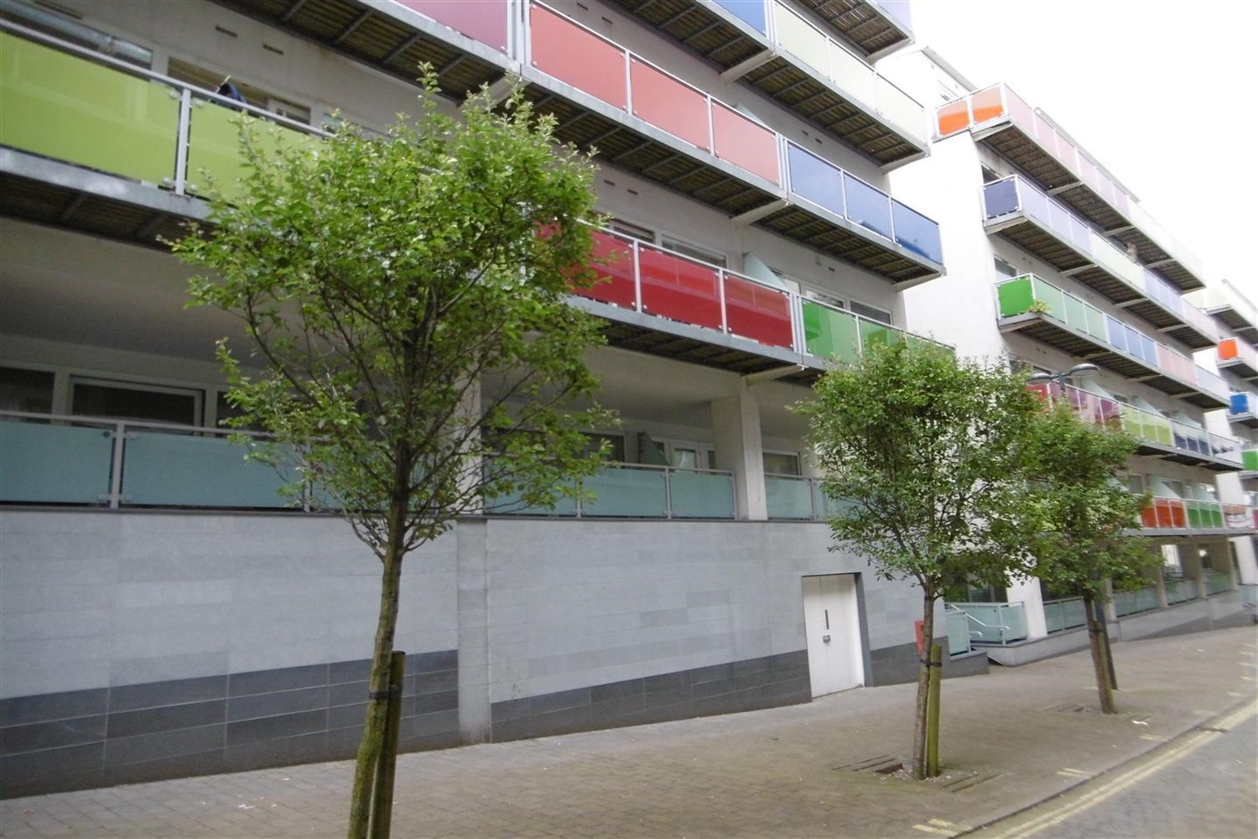

1 Bathroom(s)

1 Reception(s)

0 Bedroom(s)

A well located TWO BEDROOM apartment with SECURE PARKING in the Northern Quarter, offering excellent local amenities, access to the Ring Road and motorway networks. Situated within the popular Concord Street development, this two bedroom apartment is offered to let Furnished and benefits from a secure parking space. Available 15th October. Deposit £1145. Sorry, no pets.



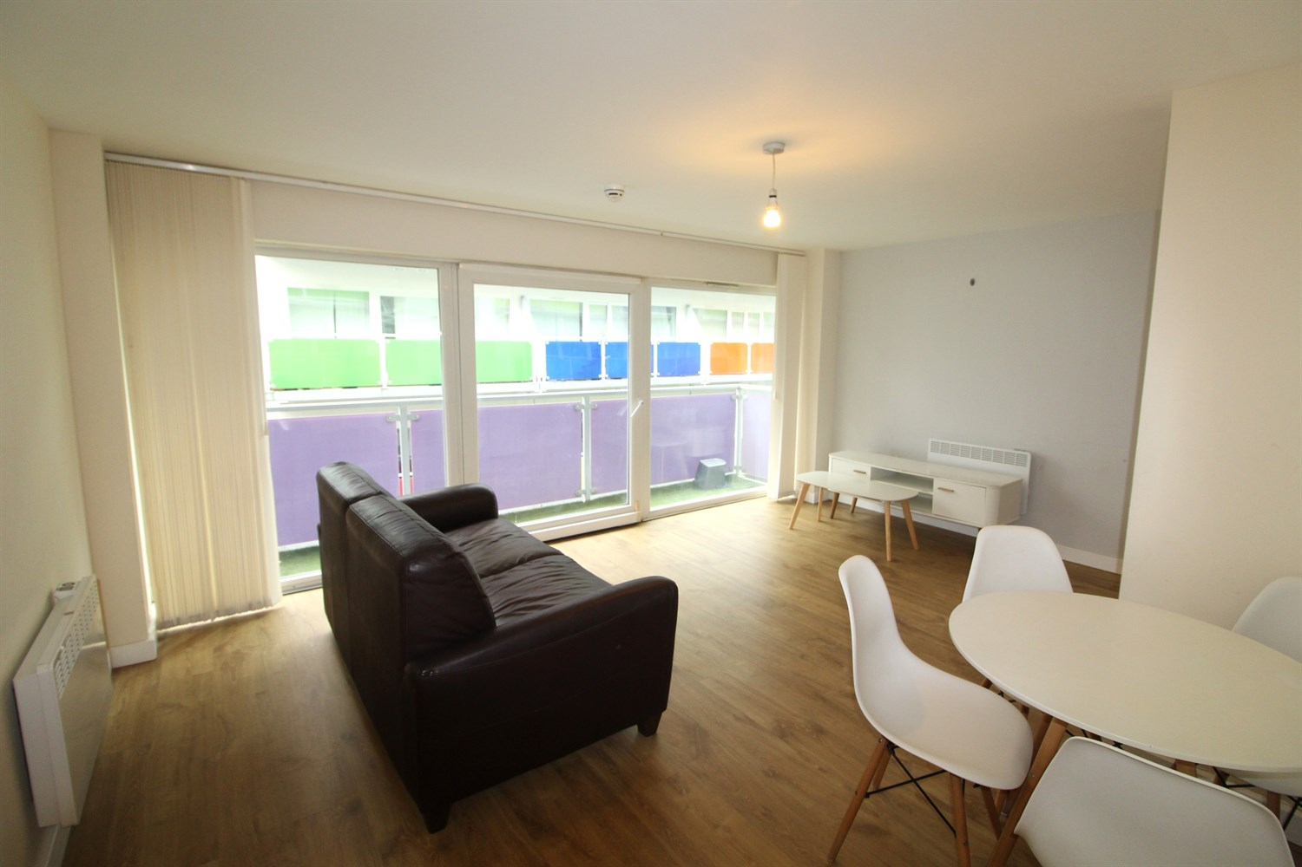

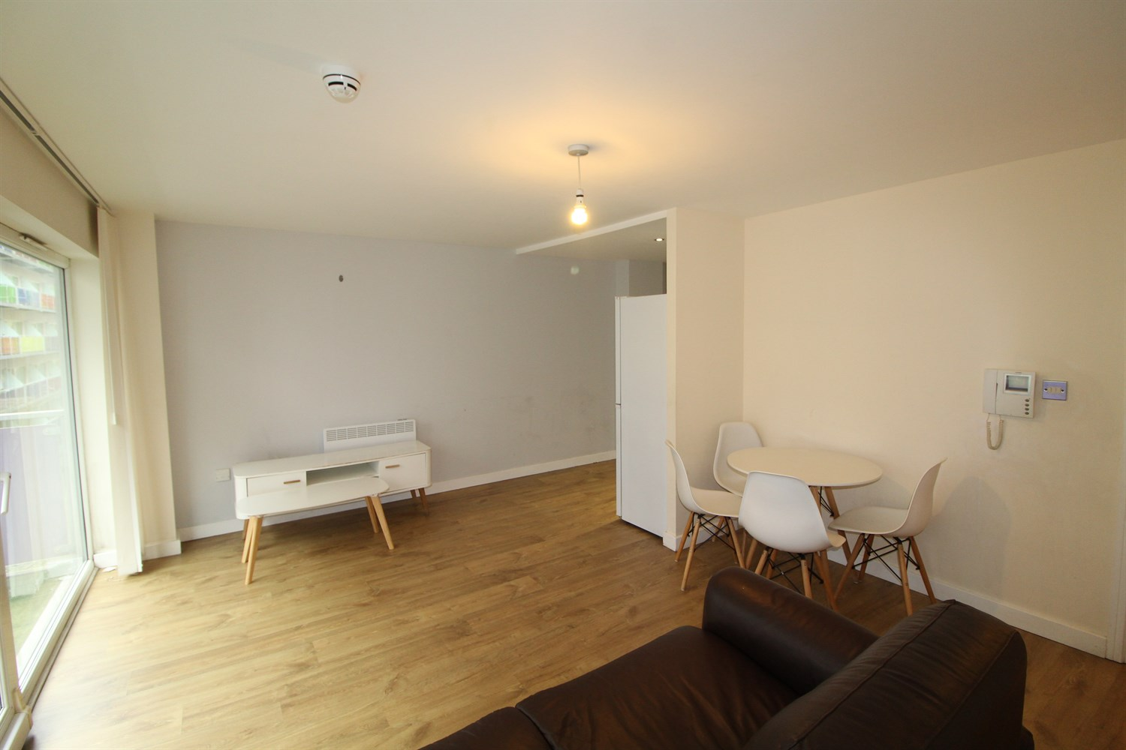

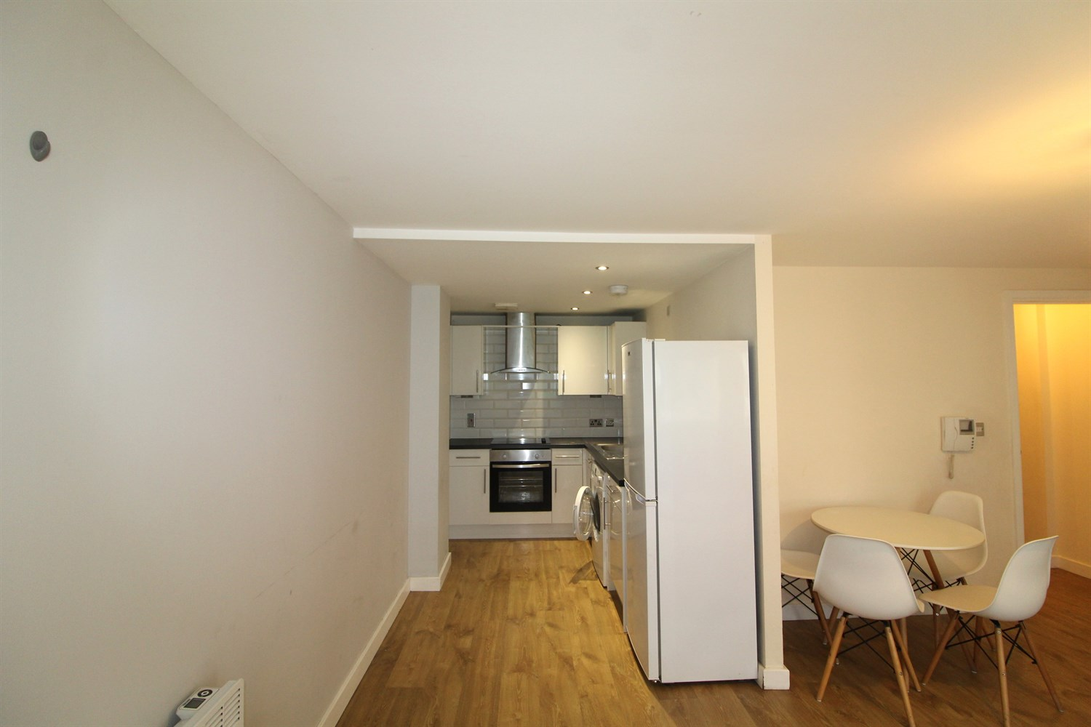

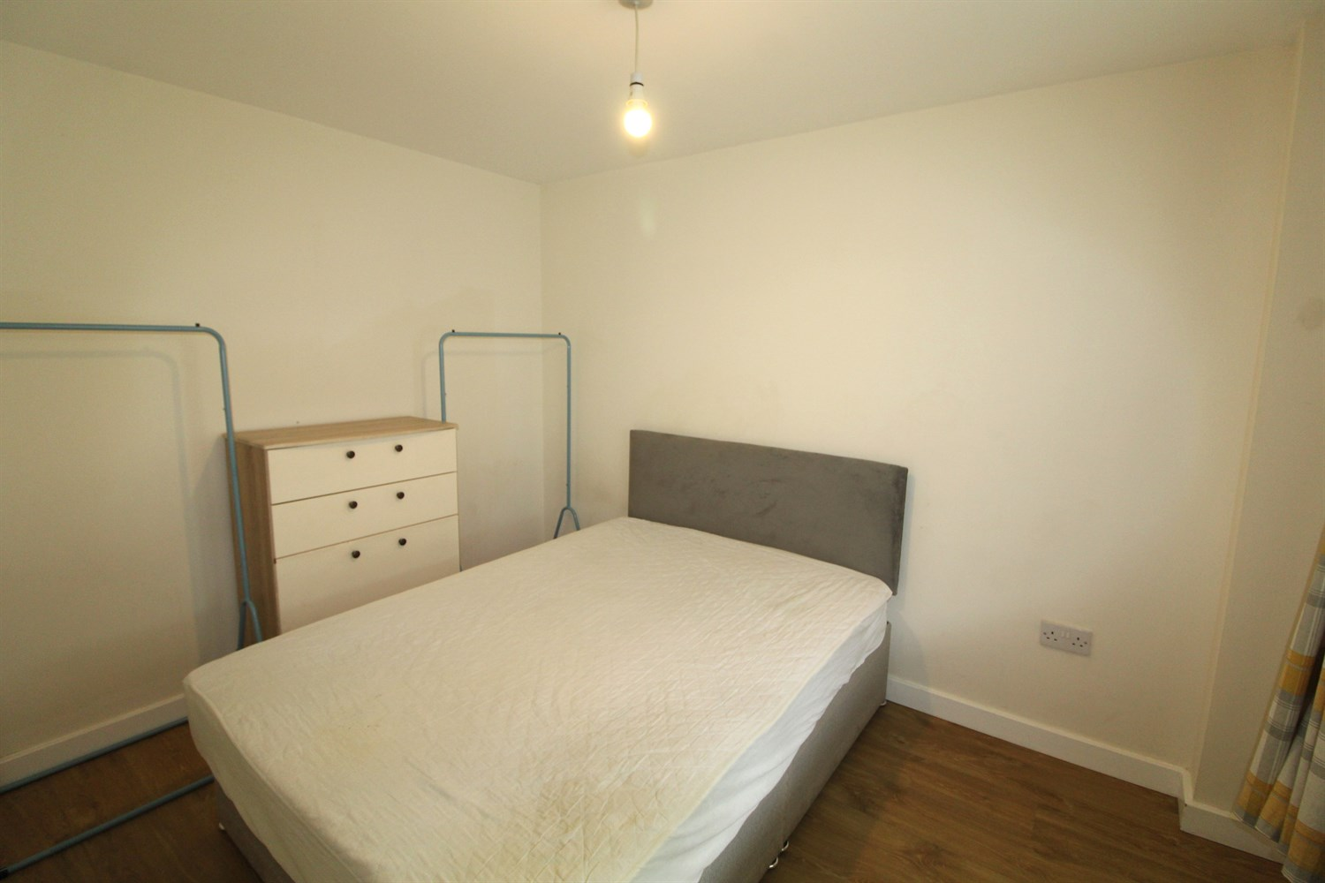

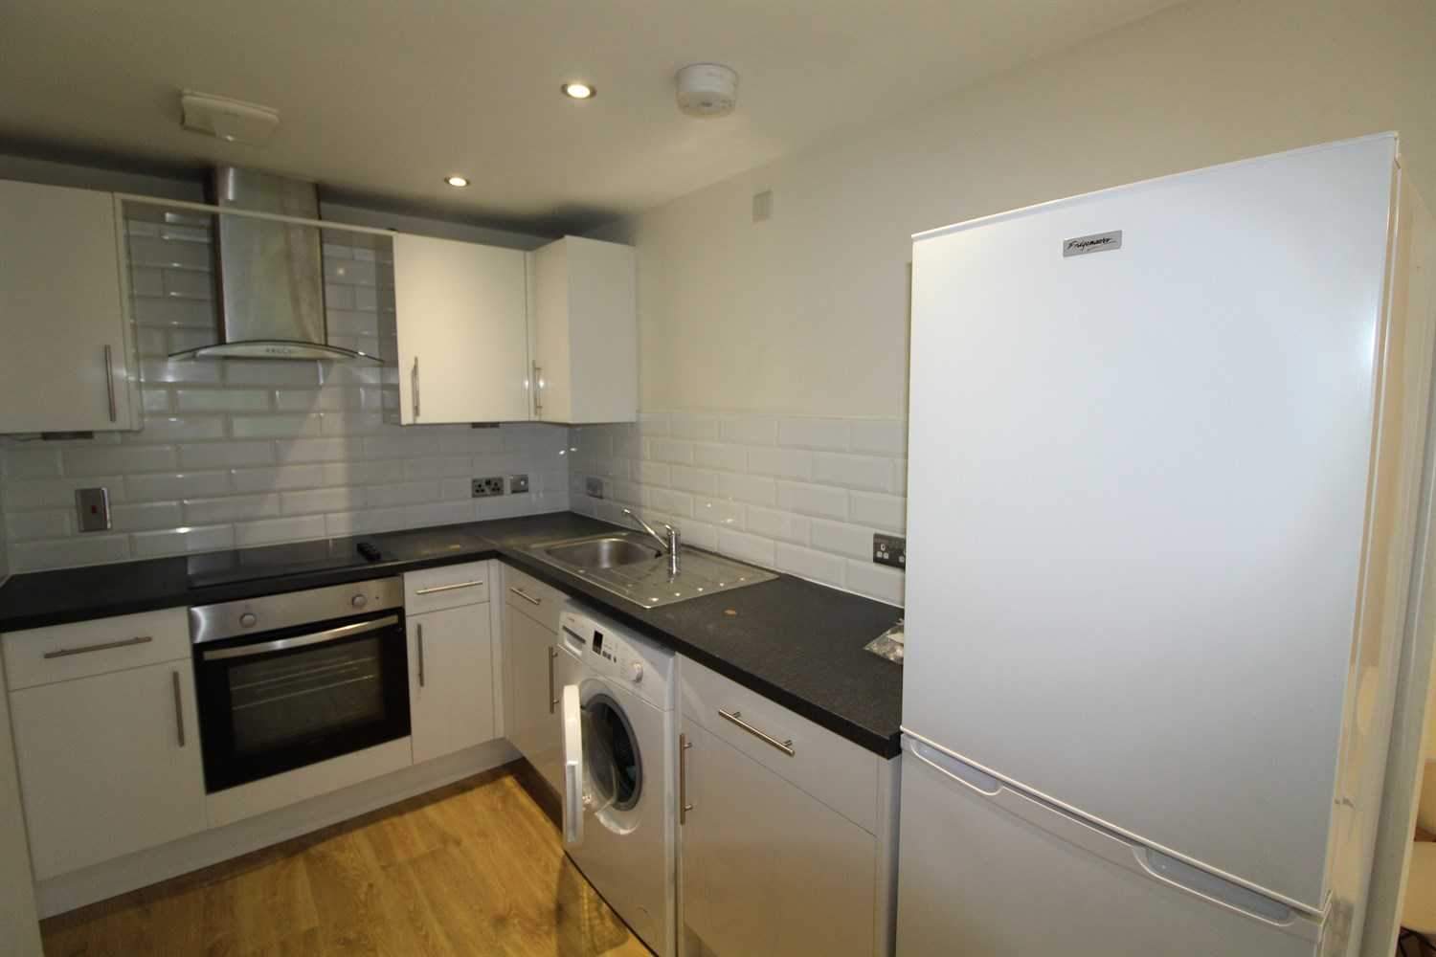



|  |
| --- |
| **Open plan living and kitchen**  Large living space with sliding doors leading on the balcony. kitchen fitted with a range of wall and base units with worktops over, electric oven and hob, washing machine and fridge freezer. Part tiles around units. Intercom system mounted on wall. Underfloor heating. |
| **Bedroom 1**  Double bedroom, with a window to the front and electric wall heater. |
| **Bedroom 2**  Second double bedroom with window to rear and electric wall heater. |
| **Bathroom**  Three piece bathroom suite, walk in shower cubical, hand wash basin and w/c, ceramic floor and walls tiles heated electric towel rail. |
| **Secure Parking**  Secure underground parking. |
| COUNCIL TAX BAND: C EPC Rating C  6 month tenancy.  Leasehold property Parking included  Mobile availability: EE limited coverage. Three likely to have good coverage. O2 likely to have good coverage. Vodafone likely to have good coverage.  Utilities: Water supplied on standard meters. Electric mains supplied on standard meters. |

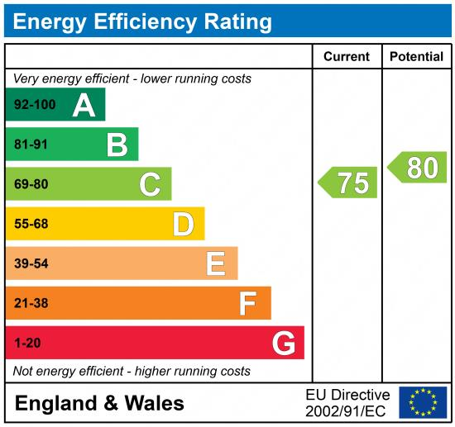

|  |
| --- |
|  |

These particulars are intended to give a fair description of the property, but their accuracy cannot be guaranteed, and they do not constitute an offer of contract. Intending purchasers must rely on their own inspection of the property. None of the above appliances/services have been tested by ourselves. We recommend purchasers arrange for a qualified person to check all appliances/services before legal commitment.

**Property Ref:** 3999

**For more information, please contact**

0113 258 1150 **|** [lettings@adairpaxton.co.uk](mailto:lettings@adairpaxton.co.uk) **|** www.adairpaxton.co.uk