

**Lakeview Court, LS8 2TX**

**£395,000**

**Flat**

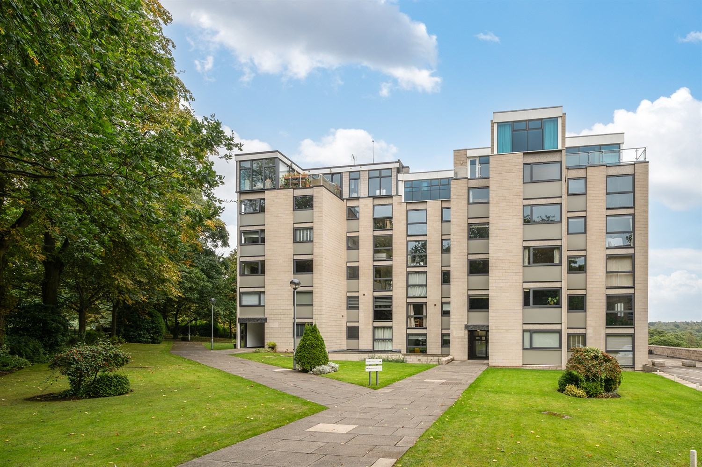

2 Bathroom(s)

1 Reception(s)

2 Bedroom(s)



***STUNNING APARTMENT OVERLOOKING ROUNDHAY PARK, OFFERED WITH NO ONWARD CHAIN*** This delightful apartment simply must be viewed to be appreciated. Properties of this calibre are rare to come to the market and the current vendors have renovated this splendid apartment to an exceptional standard. Offering breathtaking views of the park and situated in this much sought after gated development, the property briefly comprises: communal entrance with stairs and lift access to all floors, private entrance hall, superb open plan living/kitchen/diner with access to the balcony, master bedroom with fabulous en-suite shower room, second double bedroom and house shower room. The property has been well designed with plenty of storage throughout. There are two allocated parking spaces - one in the underground garage which benefits from an electric charging point and a second parking space outside. Situated in well maintained communal gardens, the property enjoys a semi-rural feel, while being on the doorstep of all of the amenities available at Oakwood and Street Lane.

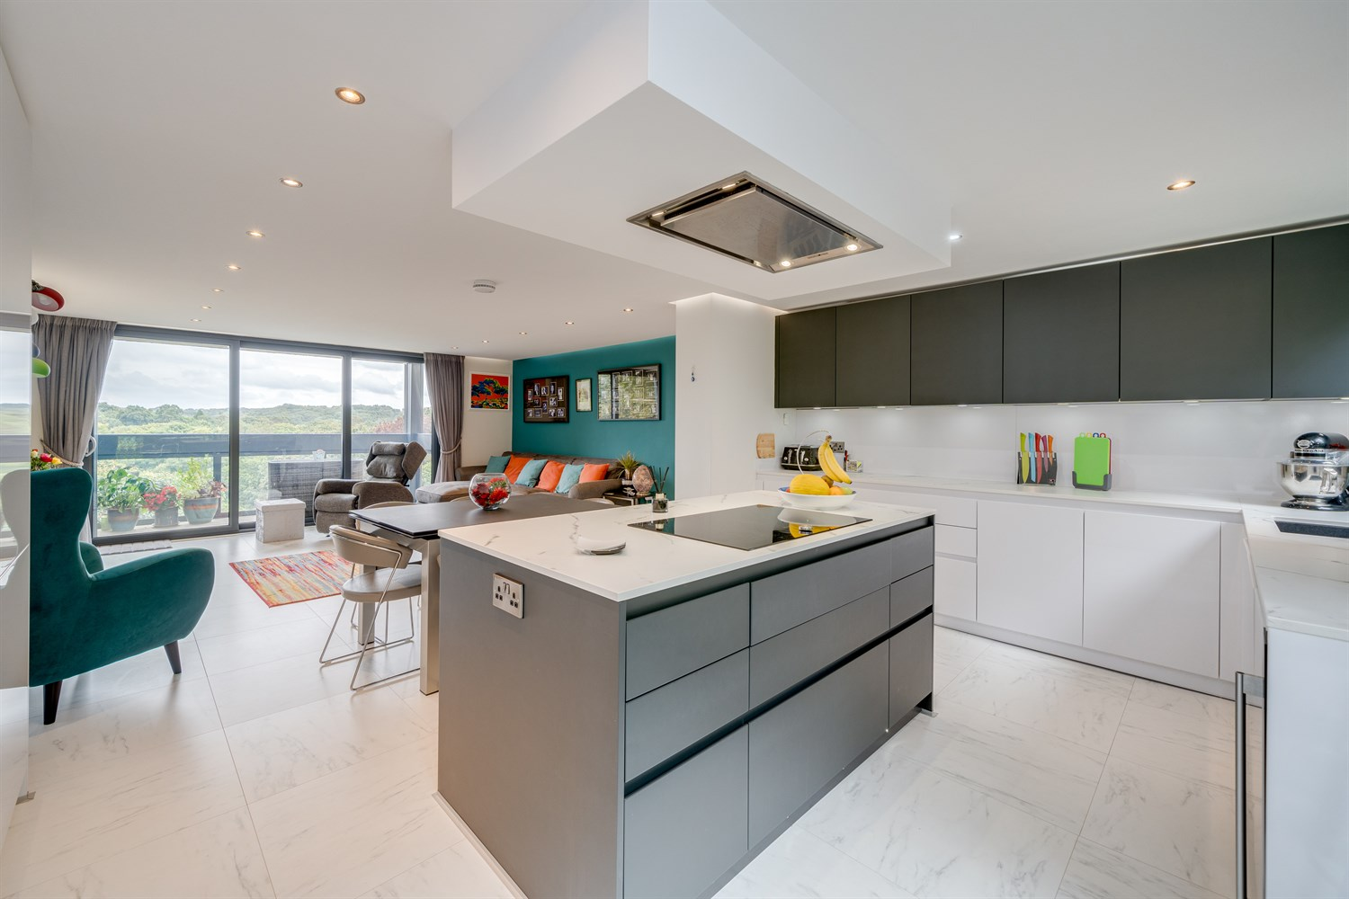

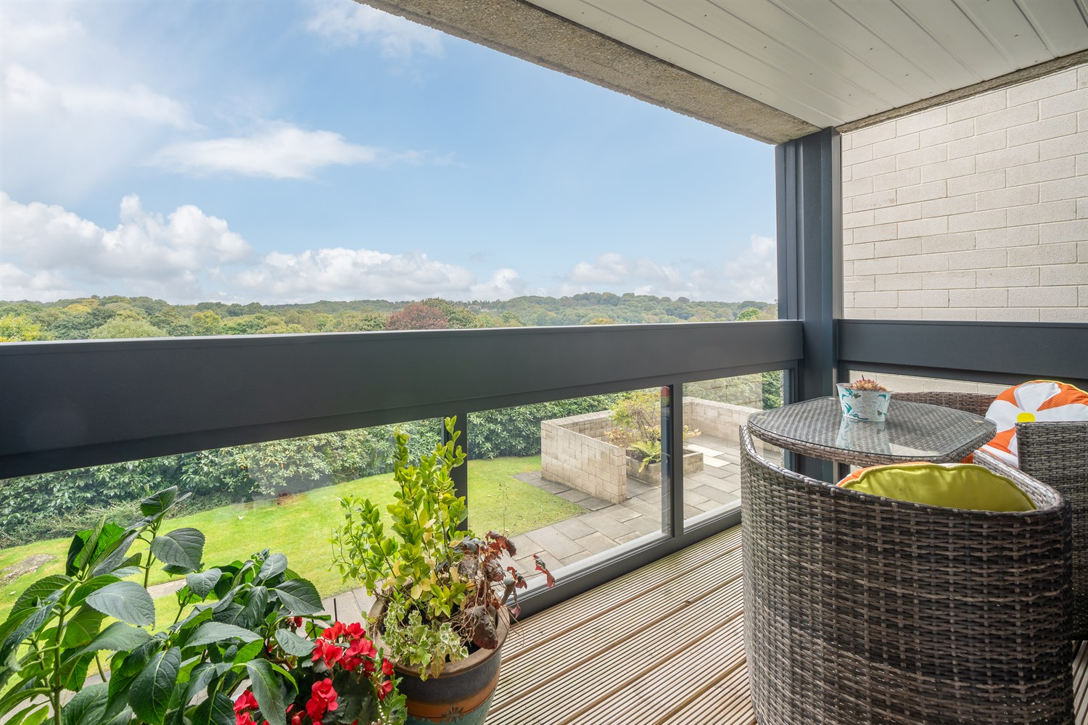

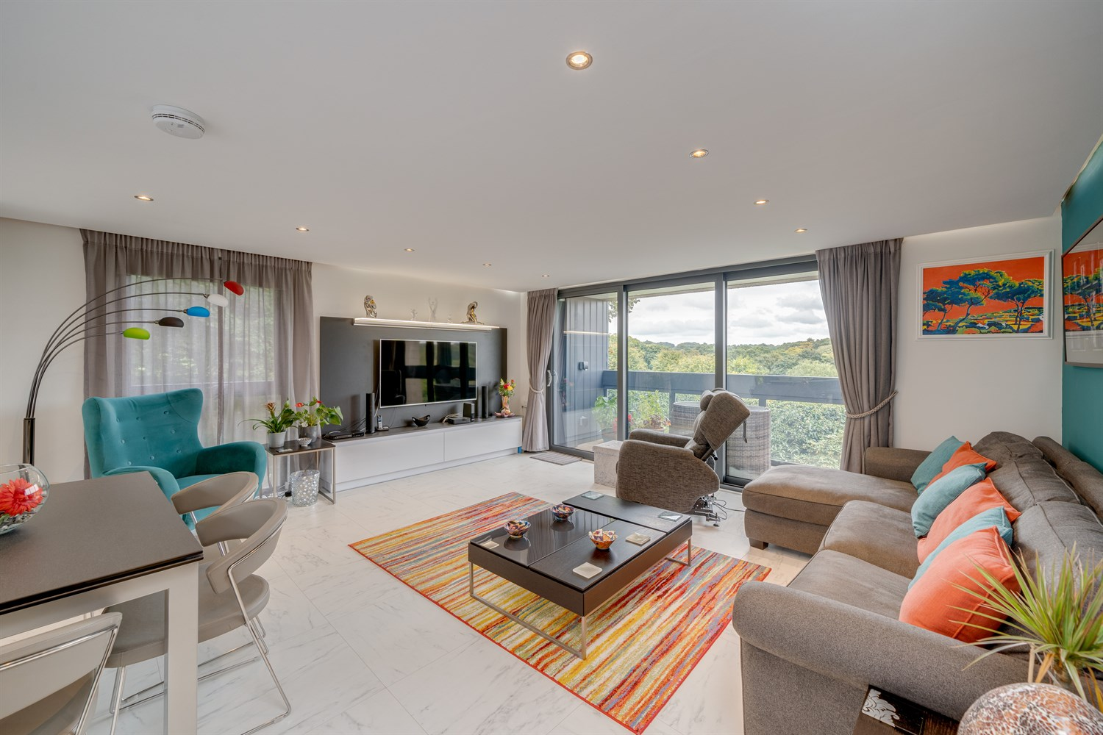

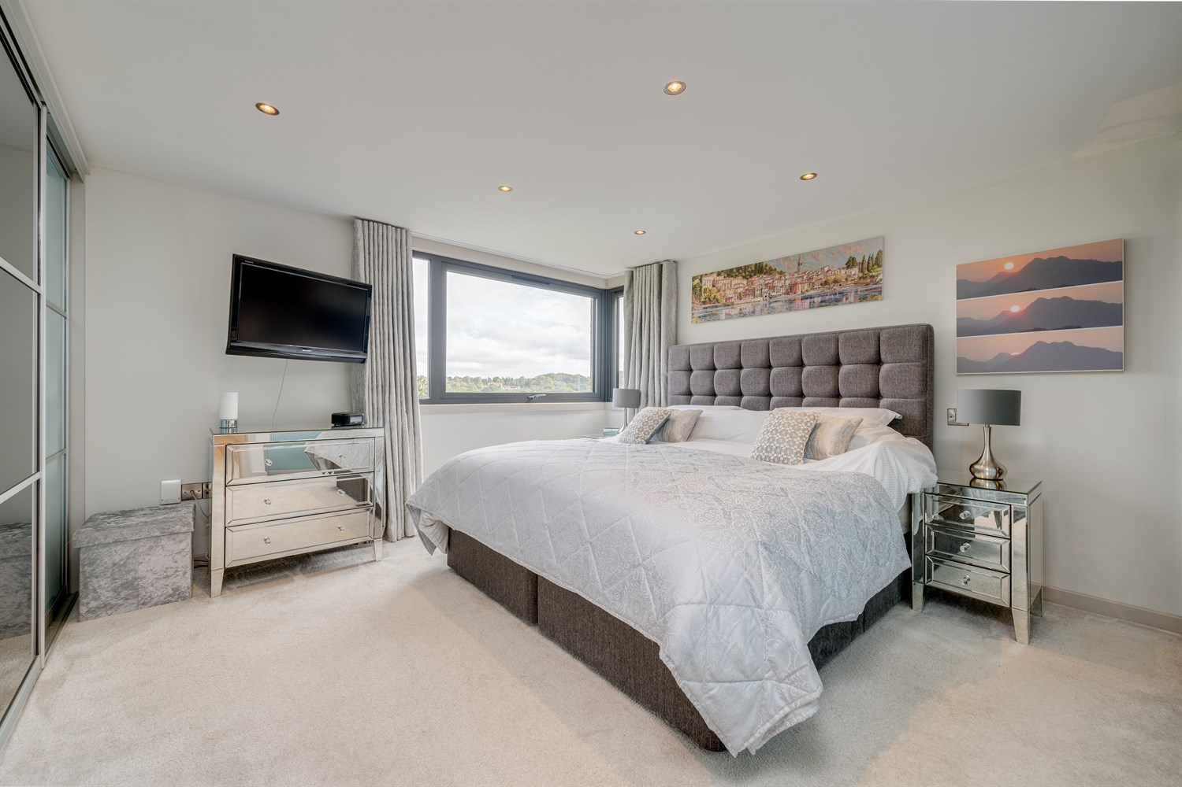

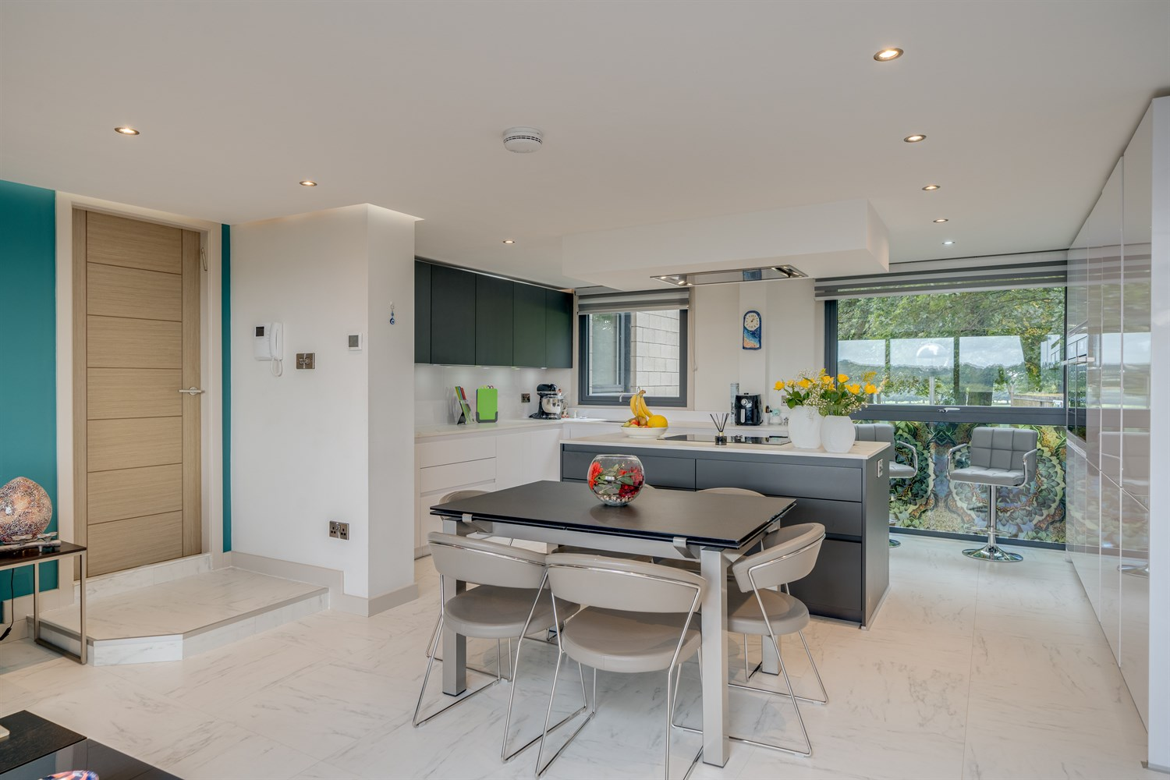

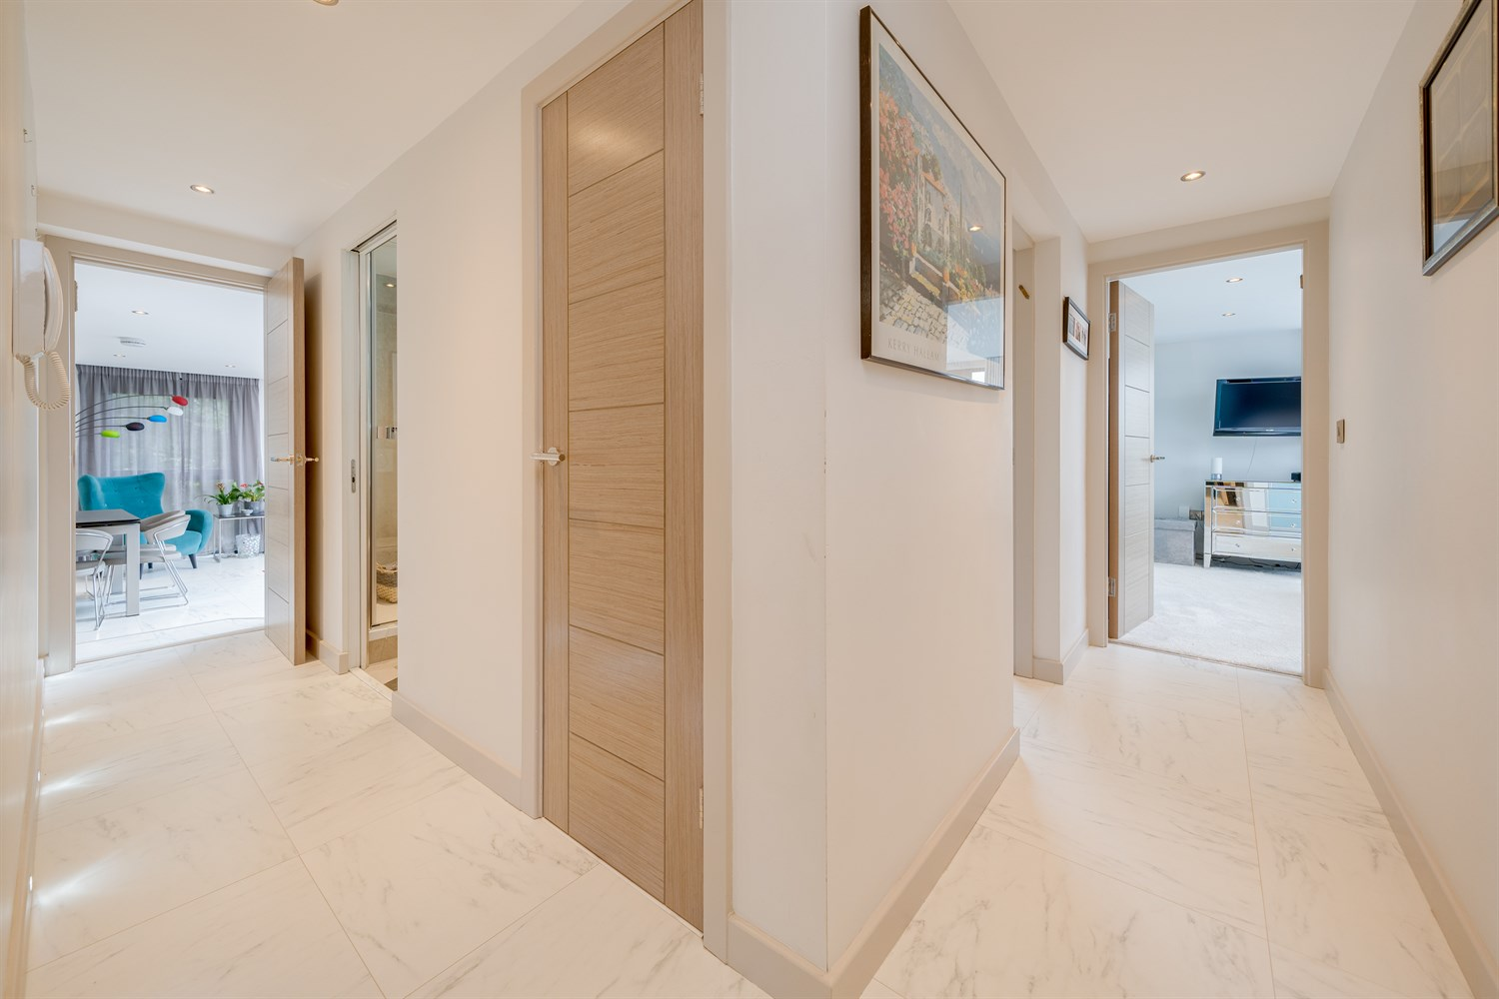



|  |
| --- |
| **Communal entrance**  With video intercom entry system. Stairs and lift access to the first floor apartment. |
| **Private Entrance Hall**  Video intercom. Useful storage cupboard. |
| **Lounge Kitchen Dining Area**  A truly fabulous space with windows to three elevations and access to the balcony which overlooks Roundhay Park. This spacious room has been well designed to incorporate a well designed kitchen, dining area and comfortable living space. The kitchen is fitted with an Arlington Interiors designed kitchen and boasts an extensive range of wall, base and drawer units to utilise every inch of space. Integrated NEFF appliances include: full height fridge and full height freezer, "hide and slide" oven, combination microwave, warming drawer, induction hob and dishwasher. Other appliances include washer/dryer, wine fridge and Quooker boiling tap. Concealed lighting. Zoned underfloor heating. |
| **Balcony**  Direct access from the living room the balcony enjoys stunning views over the communal gardens and park beyond. |
| **Master Bedroom**  A very generous master bedroom with window overlooking the park. An extensive range of fitted wardrobes with sliding doors provide hanging and shelving storage. |
| **En-suite Bathroom**  Impressive en-suite shower room with large walk in wet-room style shower, double wash hand basin set in vanity storage unit, heated towel rail. Fully tiled walls and floor. |
| **Bedroom Two**  Second double bedroom with views over the park. Fitted wardrobes provide hanging and shelving storage. |
| **Shower Room**  Fitted with a three piece suite comprising walk in double shower, WC and wash hand basin. Tiled walls and floor. |
| **Parking**  The property boasts two parking spaces - one in the underground garage which benefits from an electric charging point and a second space outside. Double storage cage within basement. |
| **Communal Gardens And Patio Area**  This gated development enjoys well maintained communal gardens and superb views over Roundhay Park and Soldiers Field. |
| **Service Charge**  Current Service Charge is £3,552.60 per annum and this includes the buildings insurance. |
| **Tenure**  Long leasehold. 945 years remaining. Ground rent £30 per annum. |

|  |
| --- |
|  |

These particulars are intended to give a fair description of the property, but their accuracy cannot be guaranteed, and they do not constitute an offer of contract. Intending purchasers must rely on their own inspection of the property. None of the above appliances/services have been tested by ourselves. We recommend purchasers arrange for a qualified person to check all appliances/services before legal commitment.

**Property Ref:** 3866

**For more information, please contact**

0113 258 1150 **|** [sales@adairpaxton.co.uk](mailto:sales@adairpaxton.co.uk) **|** www.adairpaxton.co.uk