

**0113 258 1150**

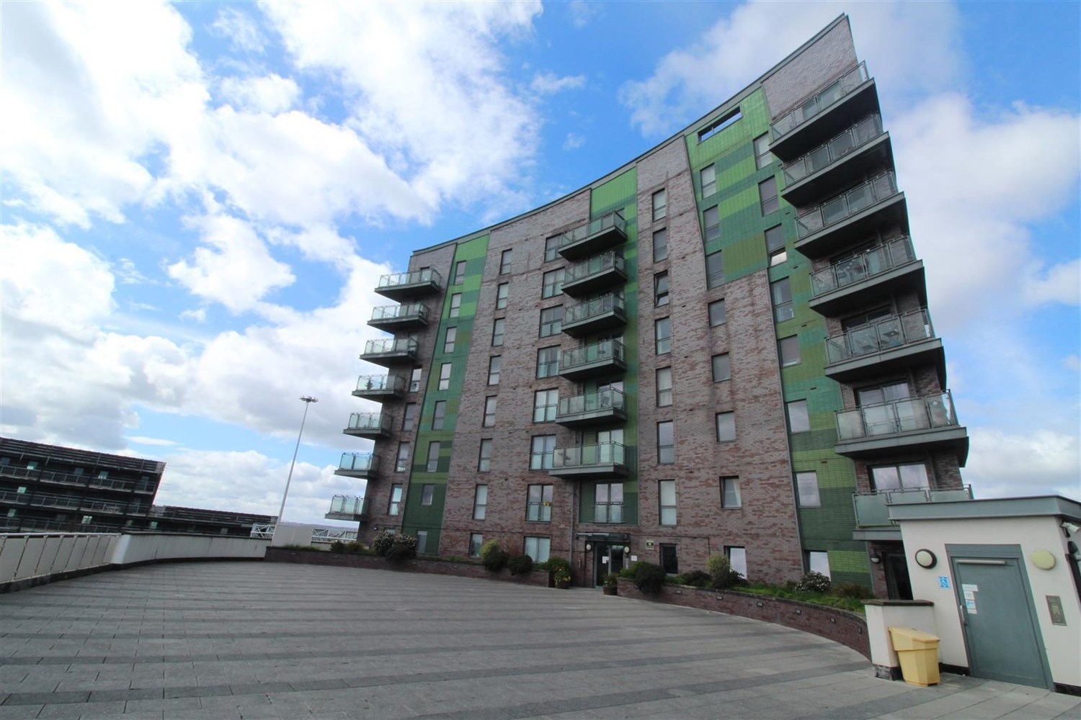



**For Sale £75,000.00**

**409 Echo Central Two, Leeds, LS9 8NQ**

***ONE DOUBLE BEDROOM APARTMENT LOCATED IN THE POPULAR ECHO CENTRAL 2 DEVELOPMENT, CASH BUYERS ONLY***. A short walk from Leeds City Centre to all the amenities on offer as well as being ideally accessible for the motorway network. Briefly comprising; Hallway with Utility/store housing washing machine, double bedroom, modern shower room/WC, Open plan Living/Dining/Kitchen with contemporary units and Juliette balcony. The property is currently tenanted at £650pcm on a periodic tenancy and has an EWS1 B1 Rating in place.

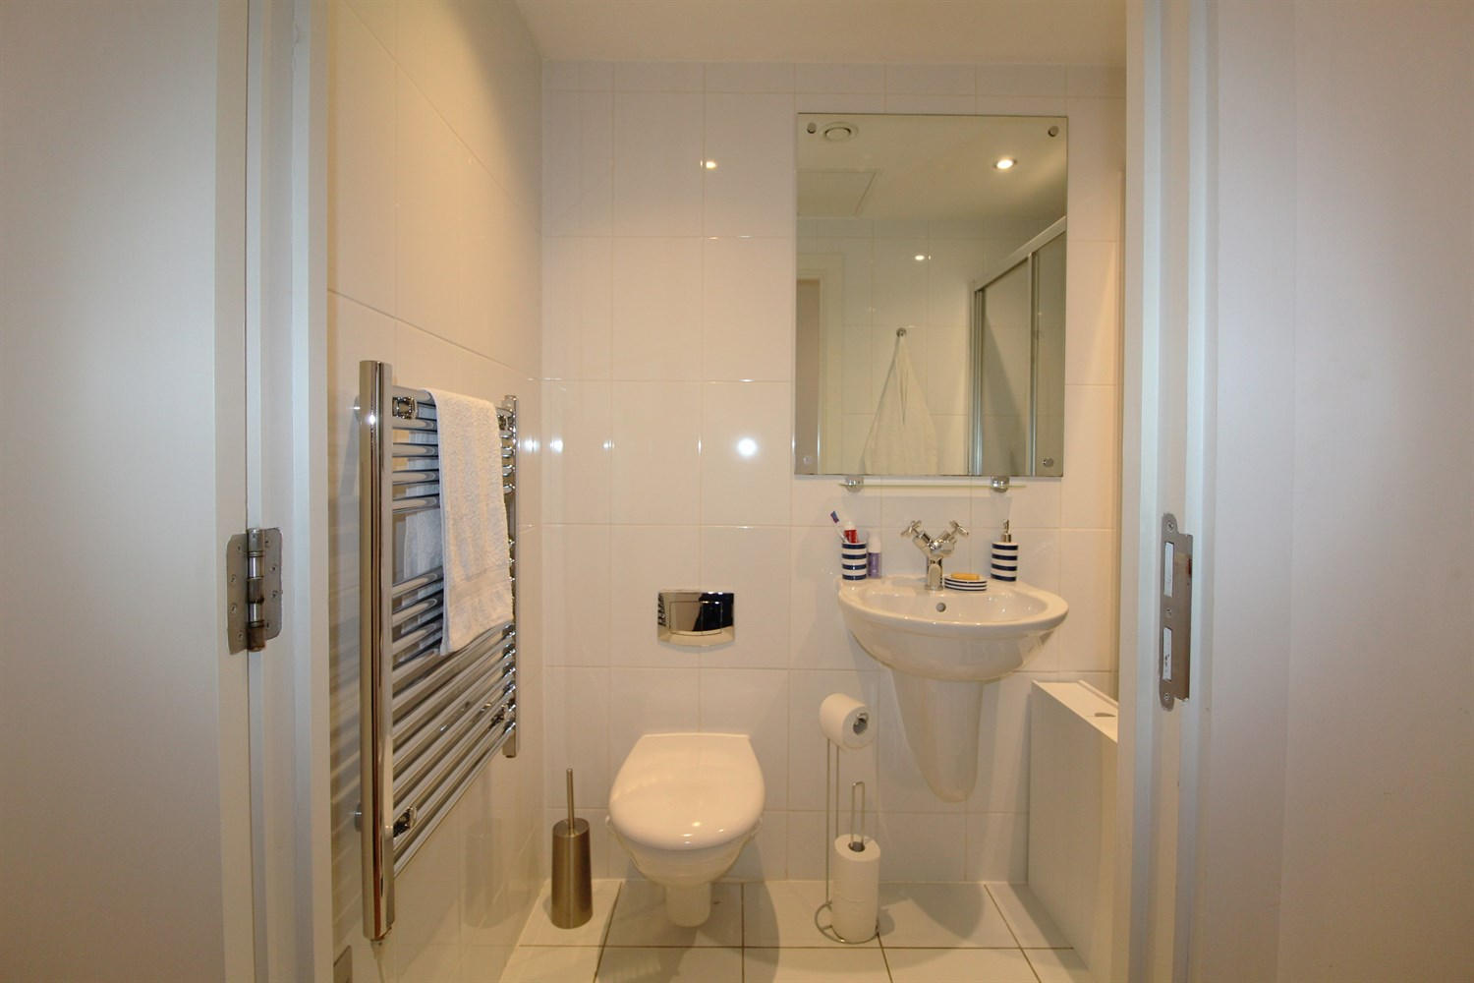

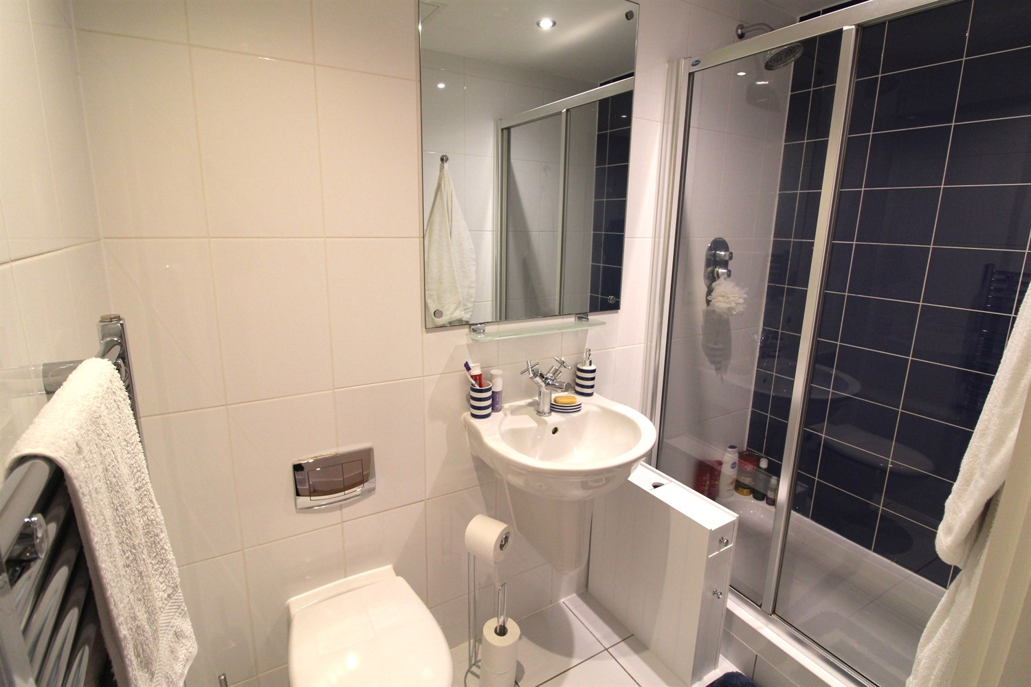

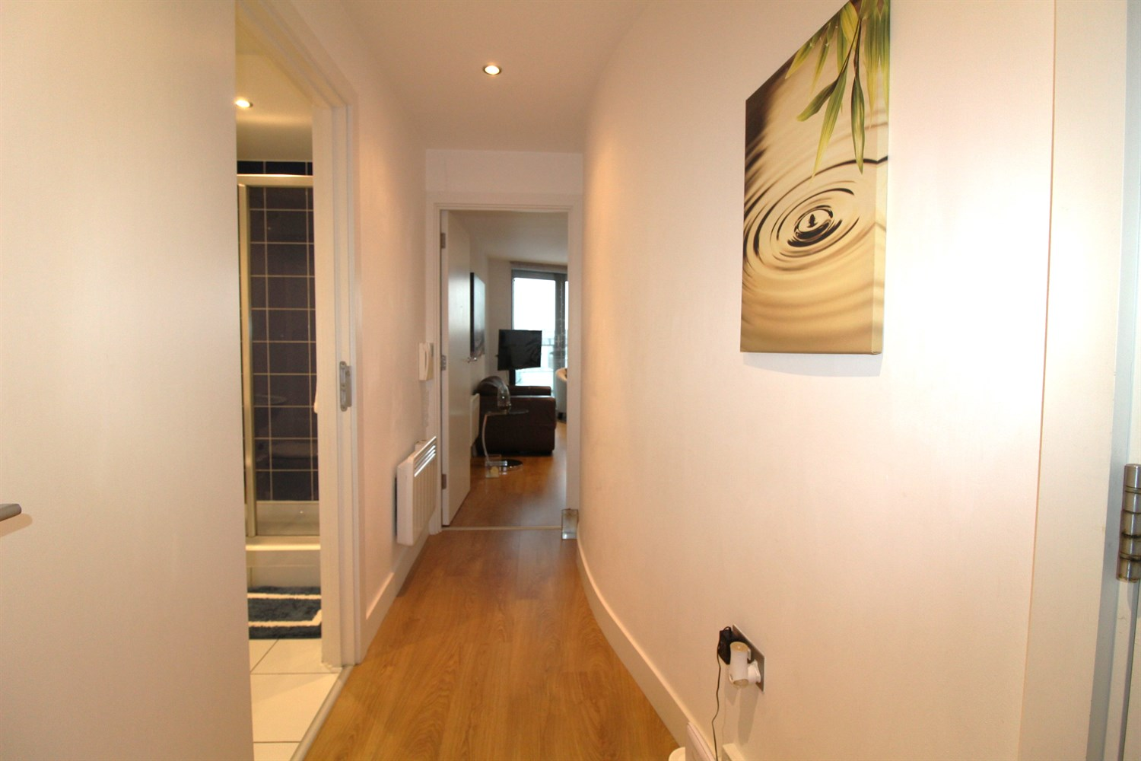

1 Bathroom(s)

1 Reception(s)

1 Bedroom(s)

00

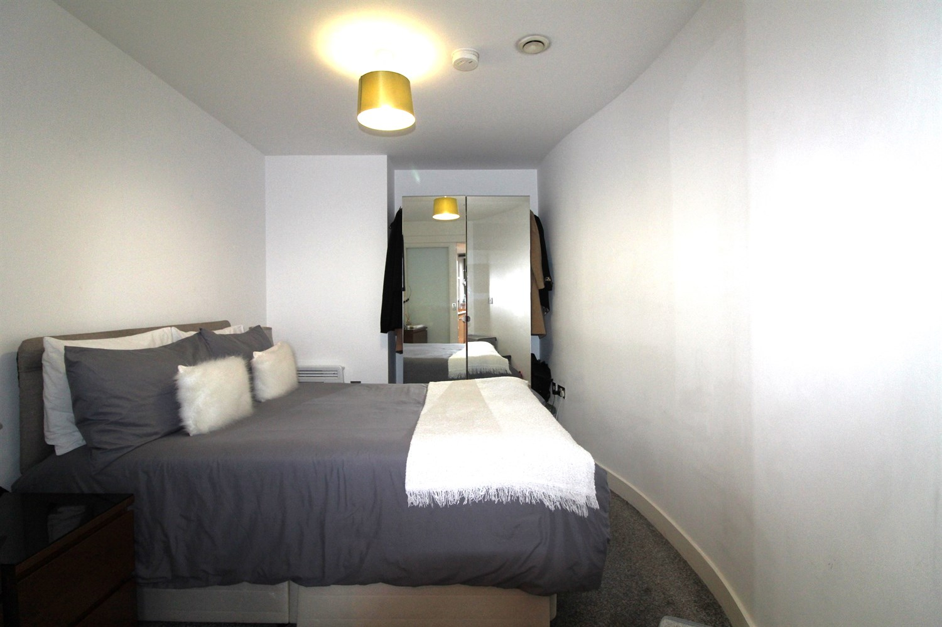

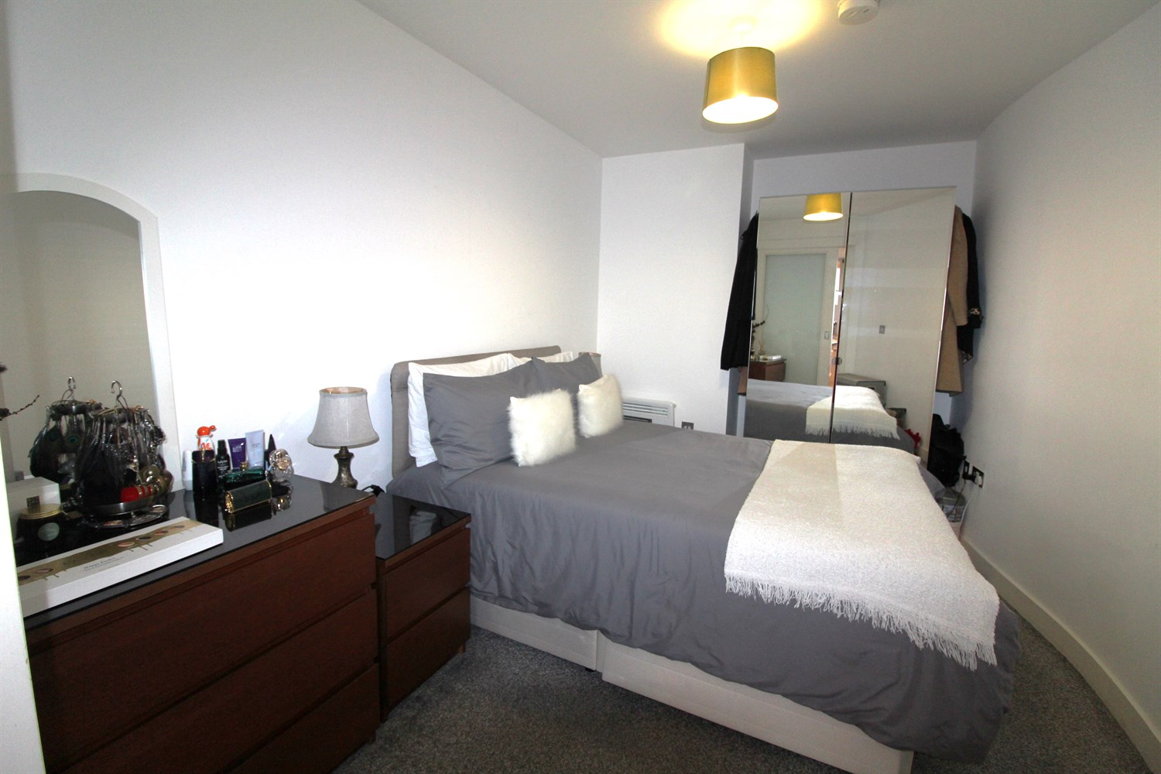

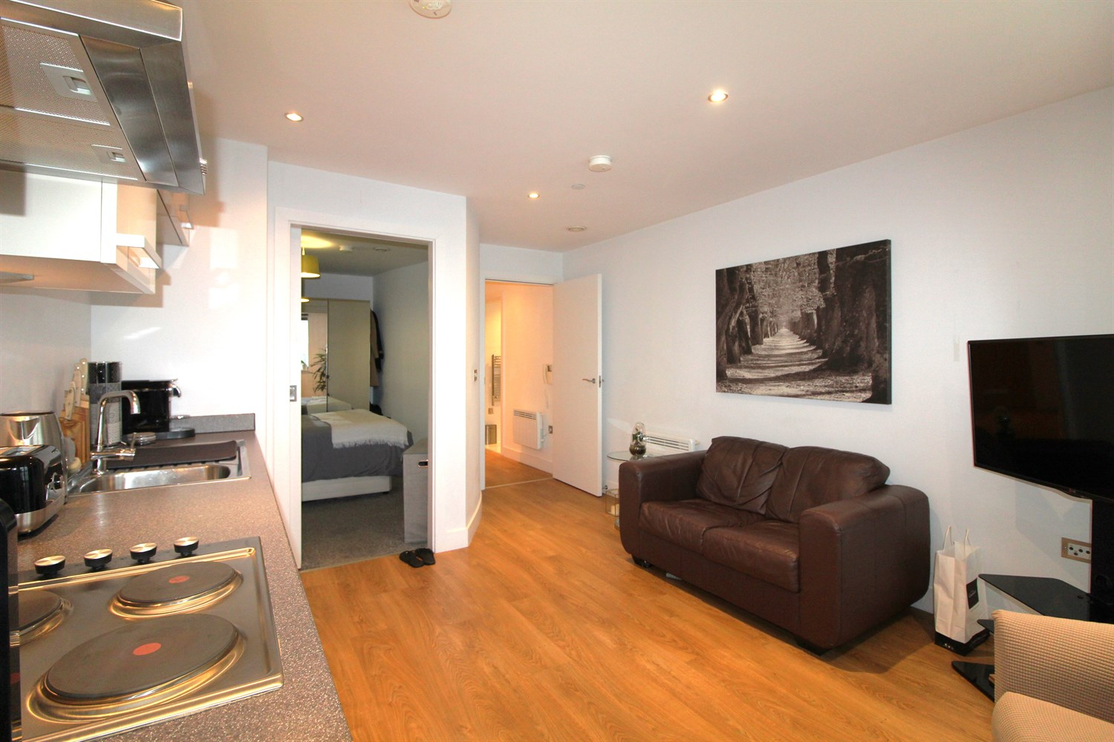

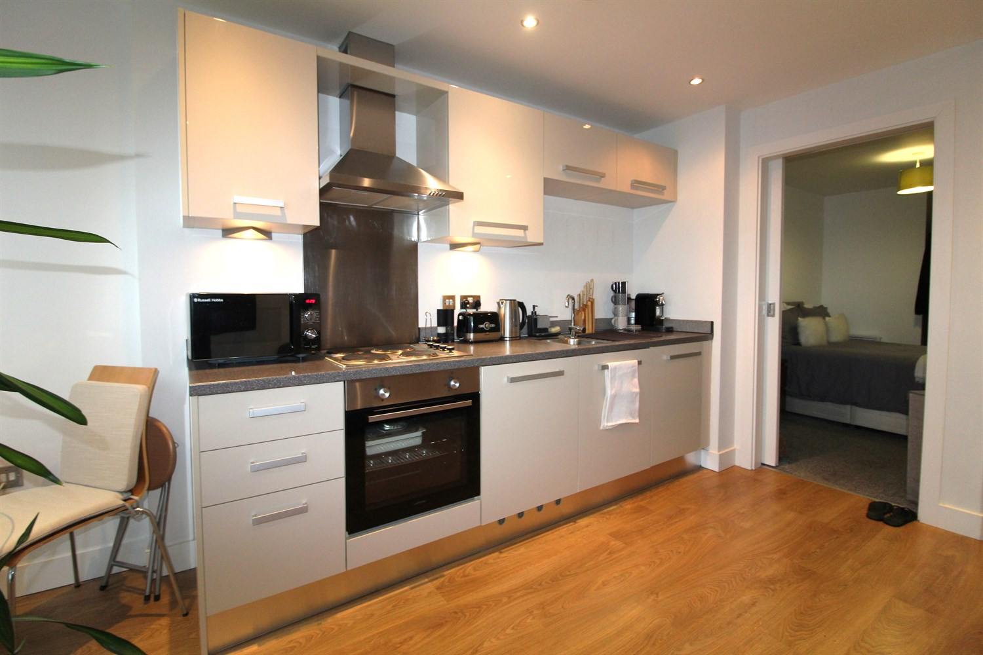

|  |
| --- |
| **Communal Entrance**  Communal entrance with secure intercom entry system. Lift access to all floors. |
| **Open Plan Living/Kitchen**  Open plan to the living room and kitchen fitted with a range of high gloss wall, base and drawer units. Stainless steel sink with mixer tap. Integrated electric oven and hob with extractor hood over. |
| **Bedroom**  A double bedroom with a wall mounted electric heater and sliding door in to the living room. |
| **Bathroom**  Fitted with a modern three piece white suite comprising shower cubicle, wash hand basin and low level WC. Chrome heated ladder towel rail. Tiled floor. Part tiled walls. |
| **Service Charge**  Service charge £703.22 twice yearly. |
| **Tenure**  Ground rent £335.98 per annum.  Lease 150 years from Jan 2007 - 134 years remaining. |

|  |  |
| --- | --- |
| These particulars are intended to give a fair description of the property, but their accuracy cannot be guaranteed, and they do not constitute an offer of contract. Intending purchasers must rely on their own inspection of the property. None of the above appliances/services have been tested by ourselves. We recommend purchasers arrange for a qualified person to check all appliances/services before legal commitment.  **Property Ref:** 207  **For more information, please contact**  0113 258 1150 **|** [sales@adairpaxton.co.uk](mailto:sales@adairpaxton.co.uk) **|** www.adairpaxton.co.uk |  |