

**Brackenhurst Drive, Moortown**

**£1,050.00pcm**

**Apartment**

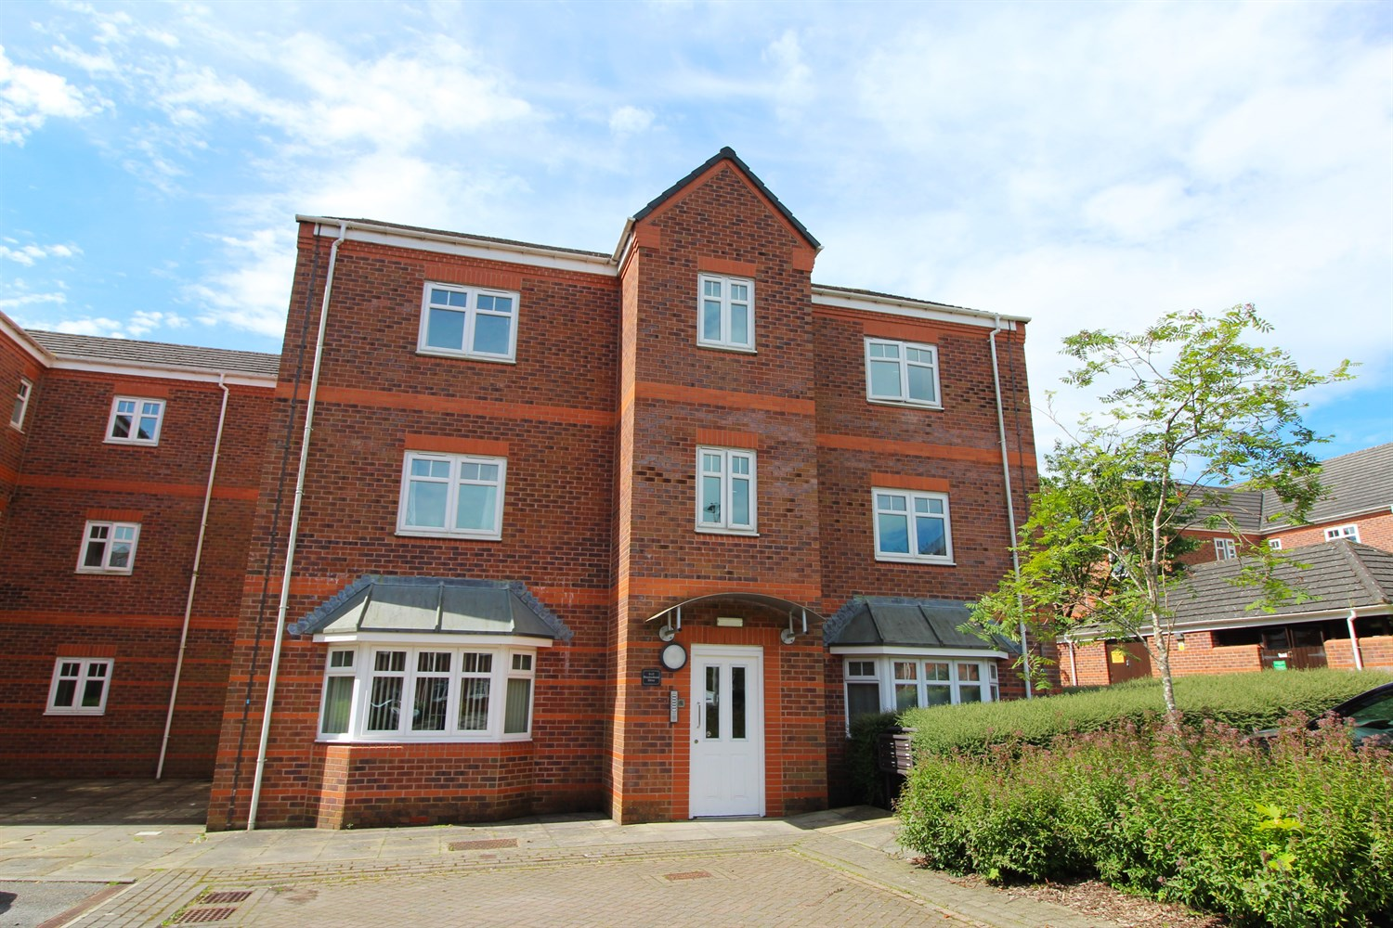

2 Bathroom(s)

1 Reception(s)

2 Bedroom(s)

This spacious two double bedroom, two bathroom apartment situated on the second floor of this modern development. Located in the desirable area of Moortown, close to local amenities and with good transport links into Leeds city centre and Harrogate. The property comprises; entrance hallway, lounge/diner, kitchen, master bedroom with en-suite shower room, second double bedroom and house bathroom. The property benefits from an off street parking space and well maintained communal gardens. Available Now, EPC rating D, council tax band D, deposit £1210.



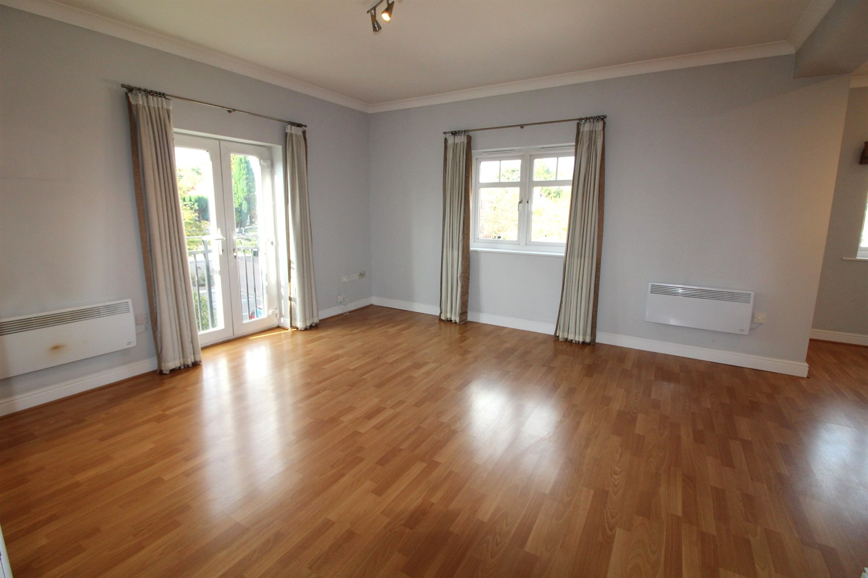

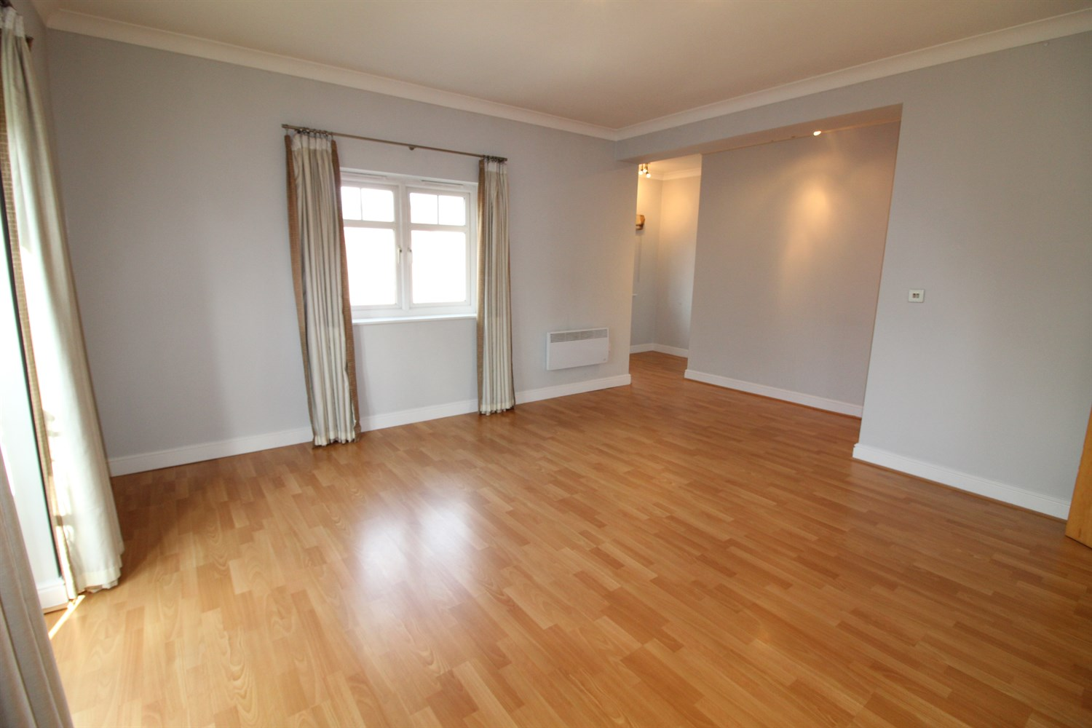

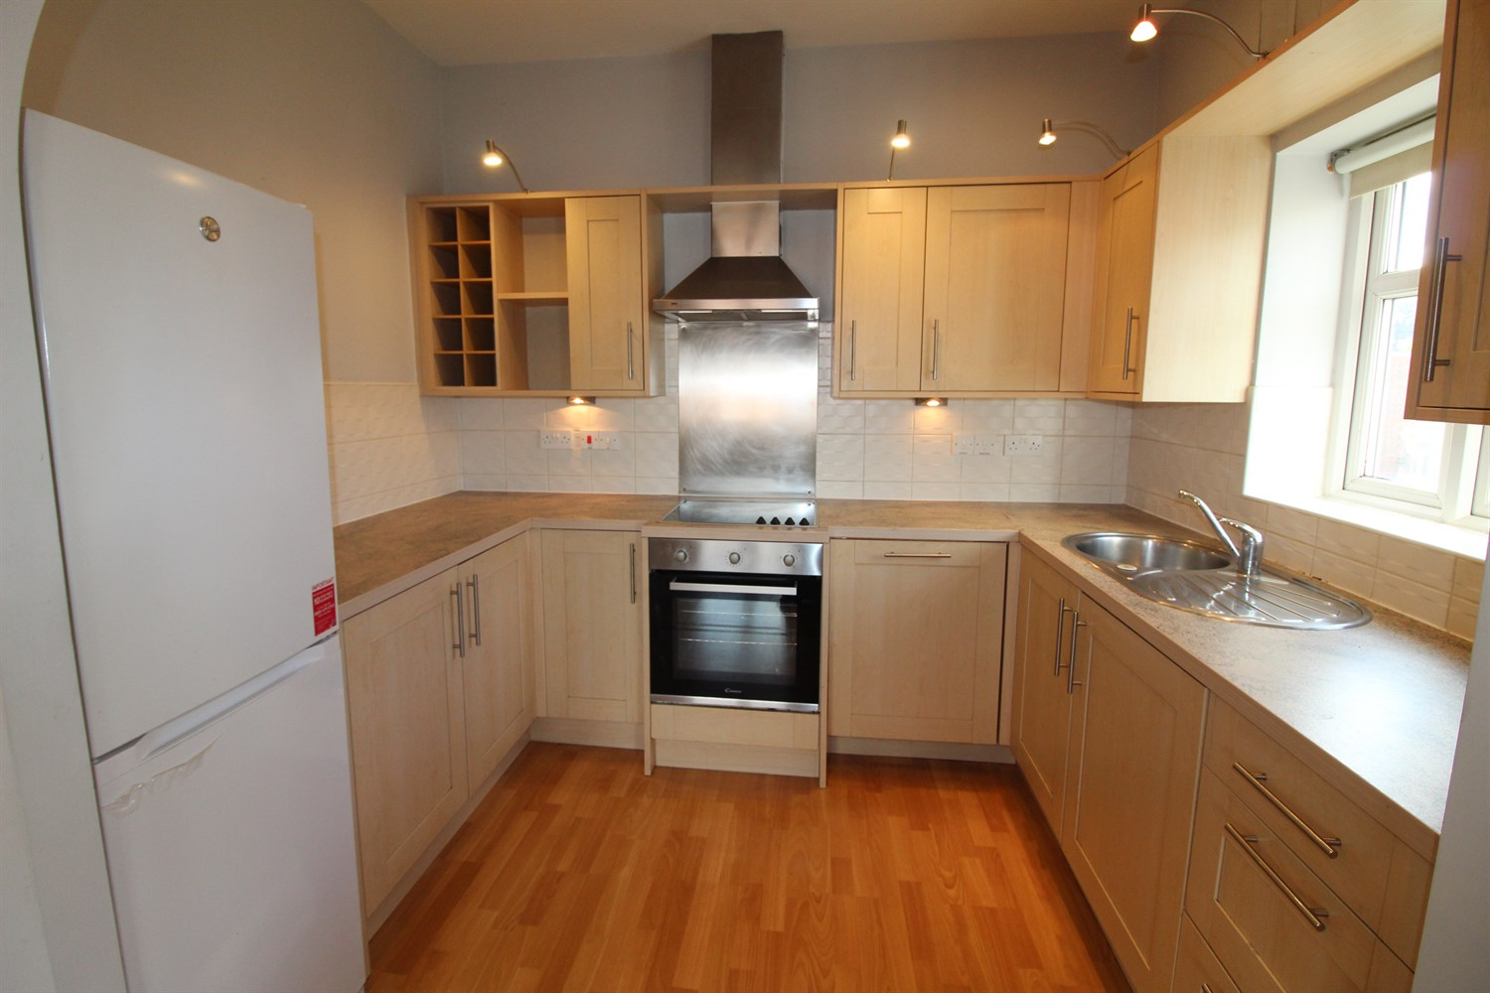

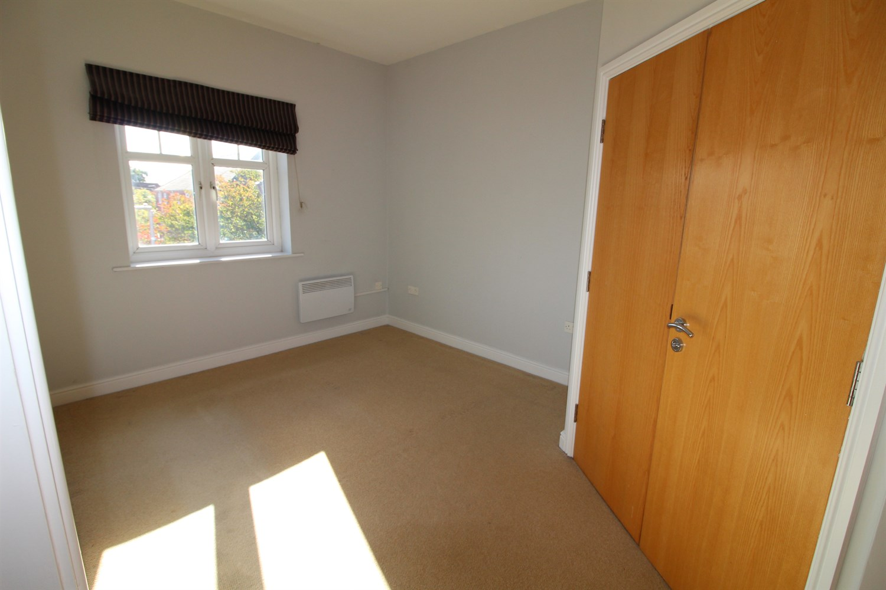

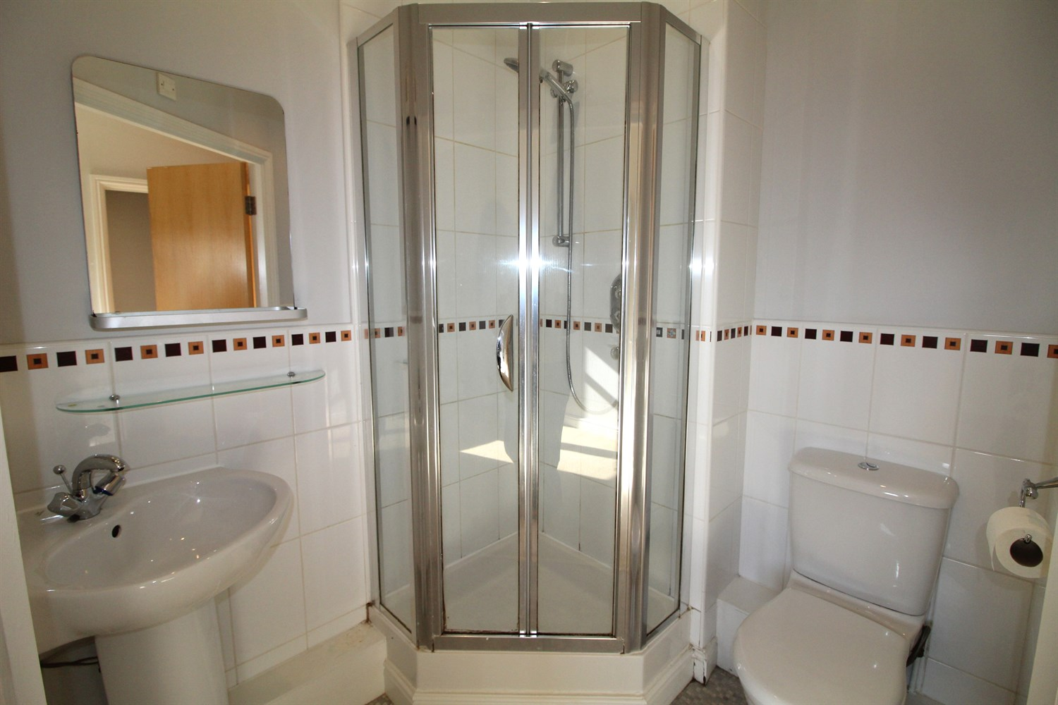

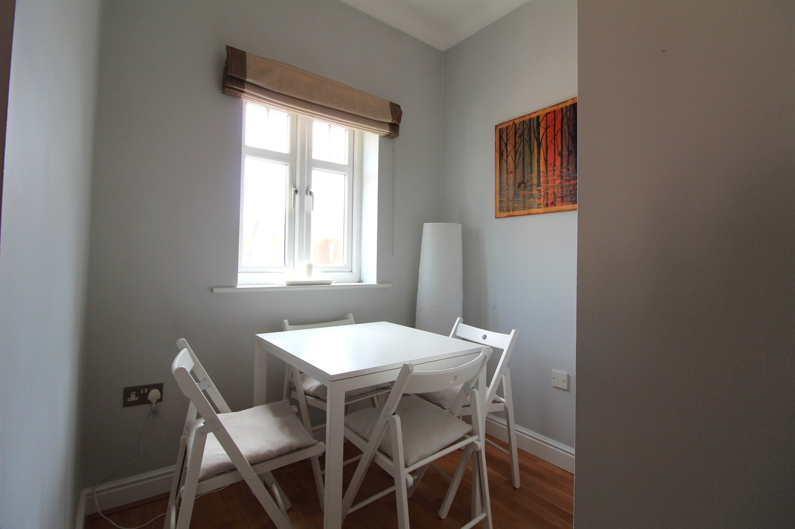



|  |
| --- |
| **Communal entrance**  Communal hallway. Stairs to all floors. |
| **Hallway**  Via front entrance door. Secure entry phone system. |
| **Kitchen**  Fitted with a range of wall, base and drawer units with worktops over. Integrated electric oven with 4-ring hob and extractor hood over. Space for tall fridge and freezer. Inset ceiling spotlights. Double glazed window. |
| **Living/Dining room**  Spacious Light and Airy living area with two double glazed windows. Dining area. uPVC double glazed window. |
| **Bedroom 1**  Double bedroom with uPVC double glazed window. Built in wardrobes. |
| **Bathroom**  Fitted with a three piece white suite comprising; bath with overhead shower, WC, and wash hand basin. Wall mounted electric heater. Tiled walls. |
| **Bedroom 2**  Second double bedroom with uPVC double glazed window. |
| **En-suite**  Fitted with a three piece white suite comprising; shower cubicle, WC, and wash hand basin. Tiled walls. |
| **Allocated Parking** |
| **Tenure**  The ground rent is £150. 999 years from 2004. |
| **Service Charge**  The service charge is currently £1888.89 per annum |
| 6 Month tenancy only. COUNCIL TAX BAND: C EPC Rating C  Leasehold property Allocated Parking  Broadband: Standard 14 Mbps 1 Mbps Good Superfast 80 Mbps 20 Mbps Good Ultrafast 1000 Mbps 900 Mbps  Mobile availability: EE limited. Three limited. O2 likely to have good coverage. Vodafone limited  Utilities: Water supplied on standard meters. Electric mains supplied on standard meters. Gas mains supplied on standard meters. |

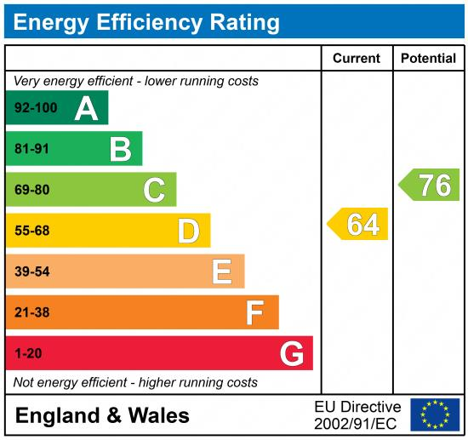

|  |
| --- |
|  |

These particulars are intended to give a fair description of the property, but their accuracy cannot be guaranteed, and they do not constitute an offer of contract. Intending purchasers must rely on their own inspection of the property. None of the above appliances/services have been tested by ourselves. We recommend purchasers arrange for a qualified person to check all appliances/services before legal commitment.

**Property Ref:** 2759

**For more information, please contact**

0113 258 1150 **|** [lettings@adairpaxton.co.uk](mailto:lettings@adairpaxton.co.uk) **|** www.adairpaxton.co.uk