

**Tavistock Mews, LS12**

**£825.00pcm**

**Apartment**

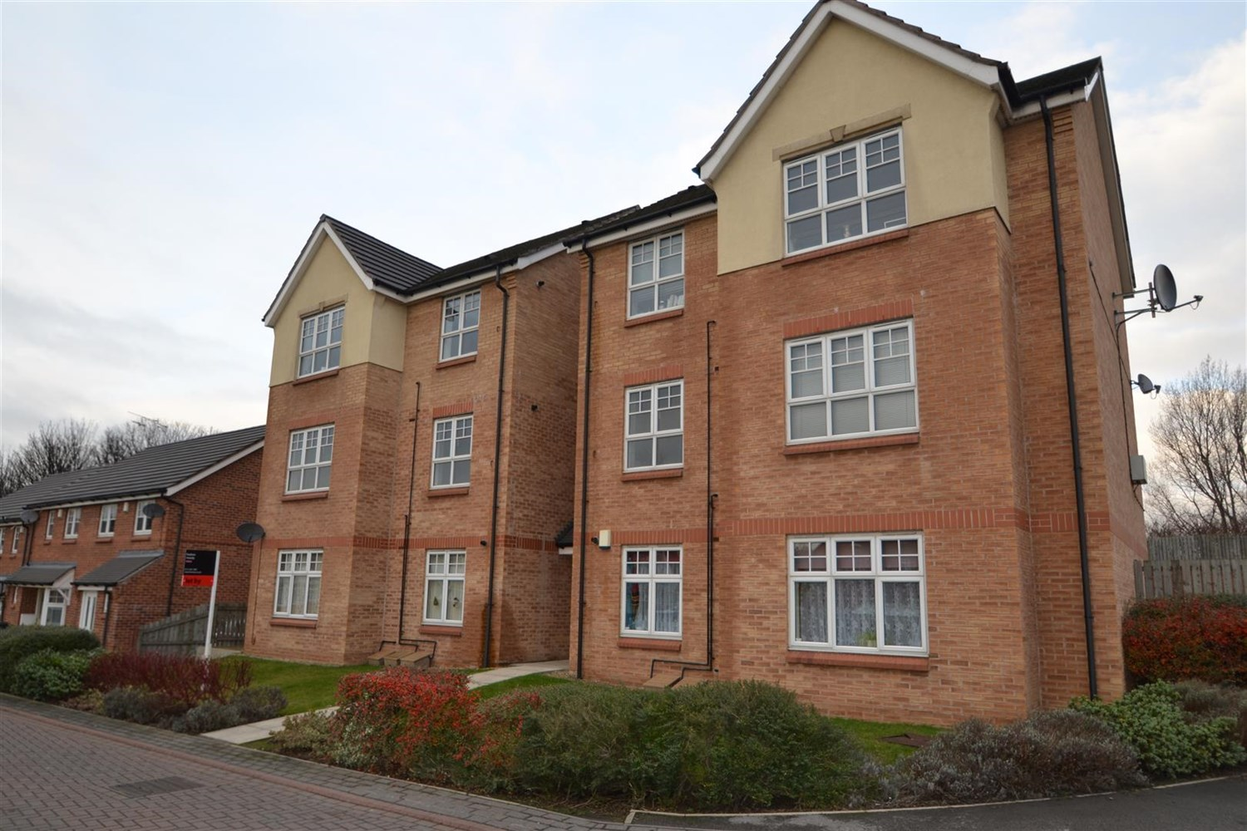

1 Bathroom(s)

1 Reception(s)

1 Bedroom(s)

This well presented two bedroom apartment is situated on the first floor of a modern apartment block. The property has a contemporary finish throughout and and briefly comprises; Specious living room, separate kitchen with white goods included. Two stylish good size bedrooms with amply built in storage and house bathroom. close to all amenities. Ideally located for access to Leeds Ring Road and Armley Gyratory. Unfurnished, available 18th October, EPC rating B, council tax band A, deposit £950.



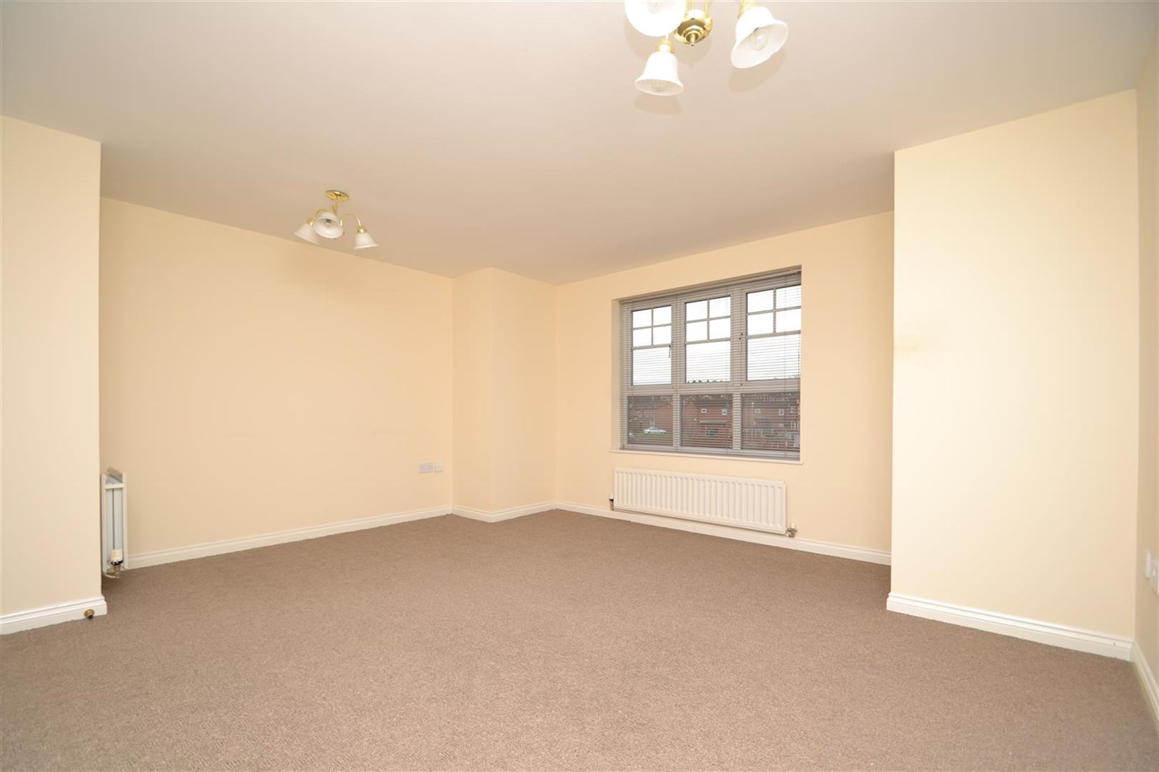

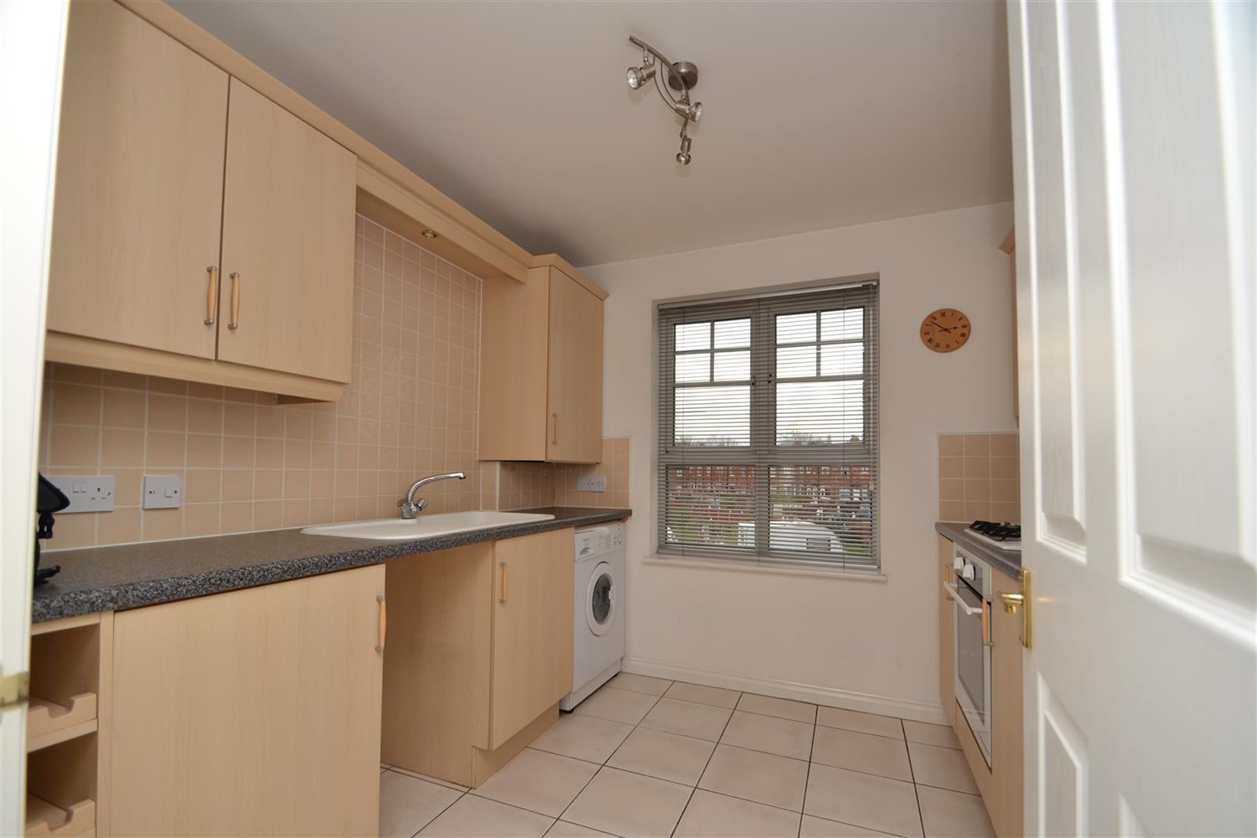

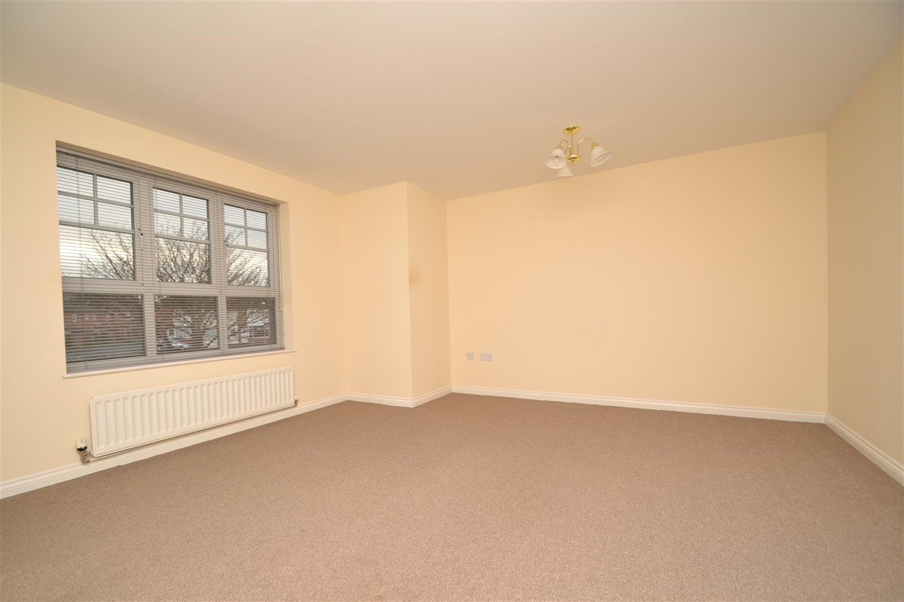

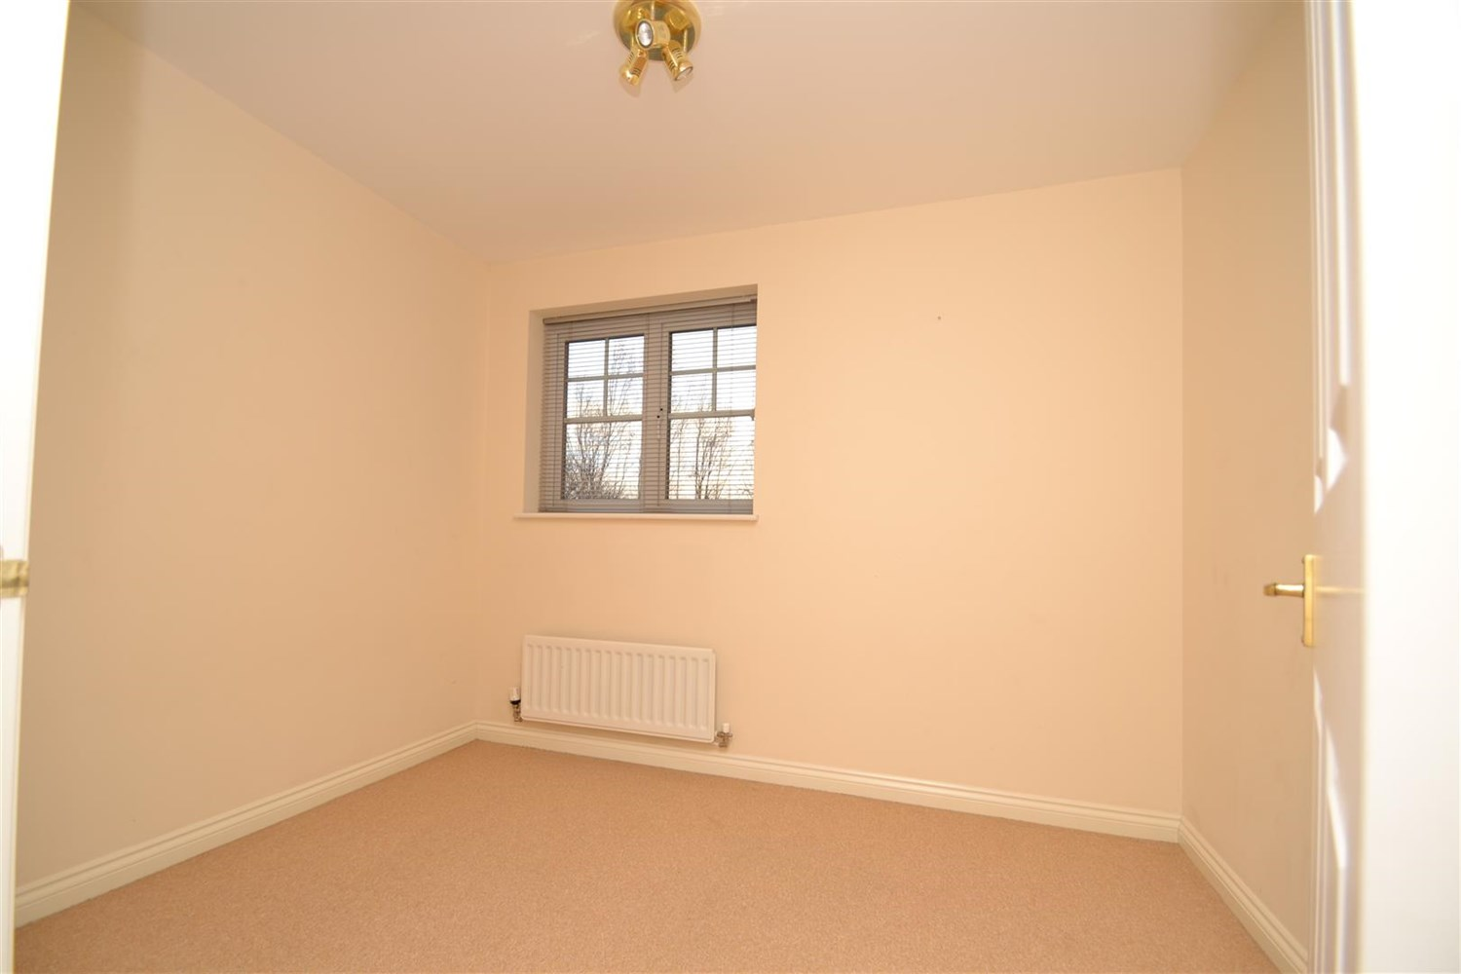

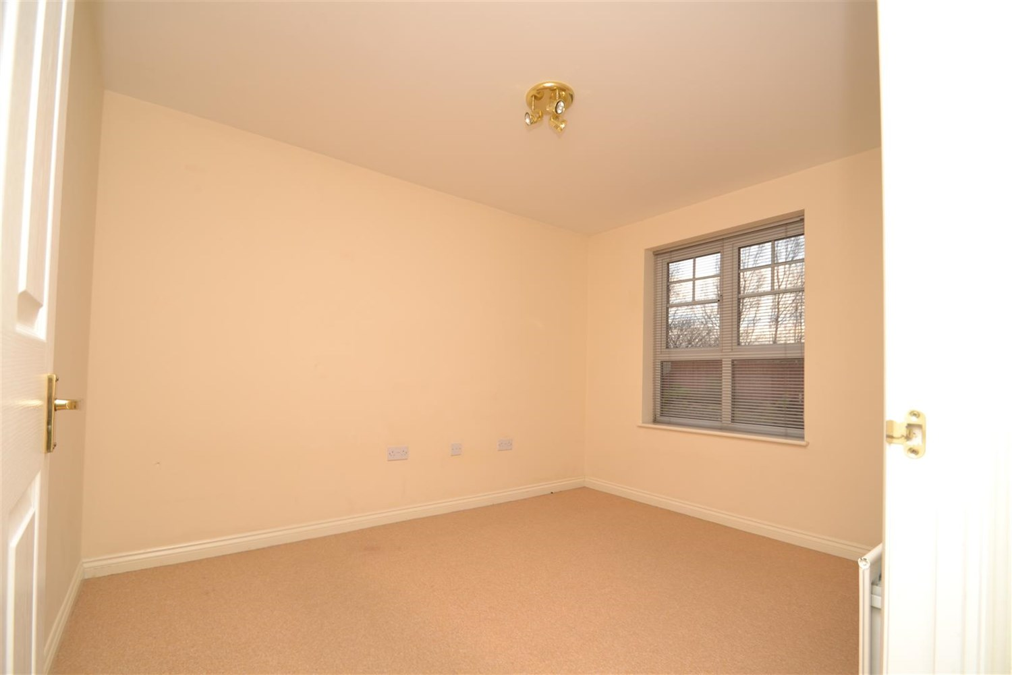



|  |
| --- |
| **Living Room**  Spacious carpeted living room with double glazed window and gas central heating radiator. |
| **Kitchen**  Having tiled flooring and comprising a range of wall and base mounted units, single drainer sink unit with mixer tap, integrated oven, hob and extractor, washing machine and fridge freezer. double glazed window |
| **Bedroom 1**  Carpeted double bedroom, double glazed window and gas central heating radiator. |
| **Bedroom 2**  Carpeted second bedroom with gas central heating radiator and double glazed window. |
| **Bathroom**  Bath with shower over, low flush w.c and hand wash basin, tiled walls, gas central heating radiator. |
| 12 month tenancy  COUNCIL TAX BAND: A EPC Rating B.  Leasehold property. Allocated Parking.  Broadband: Standard 16 Mbps 1 Mbps Good Superfast 86 Mbps 20 Mbps Good Ultrafast 1000 Mbps 1000 Mbps Mobile availability: EE Limited . Three likely . O2 Likely. Vodafone Limited.  Utilities: Water supplied on standard meters. Gas and Electric mains supplied on standard meters. |

|  |
| --- |
|  |

These particulars are intended to give a fair description of the property, but their accuracy cannot be guaranteed, and they do not constitute an offer of contract. Intending purchasers must rely on their own inspection of the property. None of the above appliances/services have been tested by ourselves. We recommend purchasers arrange for a qualified person to check all appliances/services before legal commitment.

**Property Ref:** 3861

**For more information, please contact**

0113 258 1150 **|** [lettings@adairpaxton.co.uk](mailto:lettings@adairpaxton.co.uk) **|** www.adairpaxton.co.uk