

**Rose Avenue, LS18**

**£1,050.00pcm**

**House**

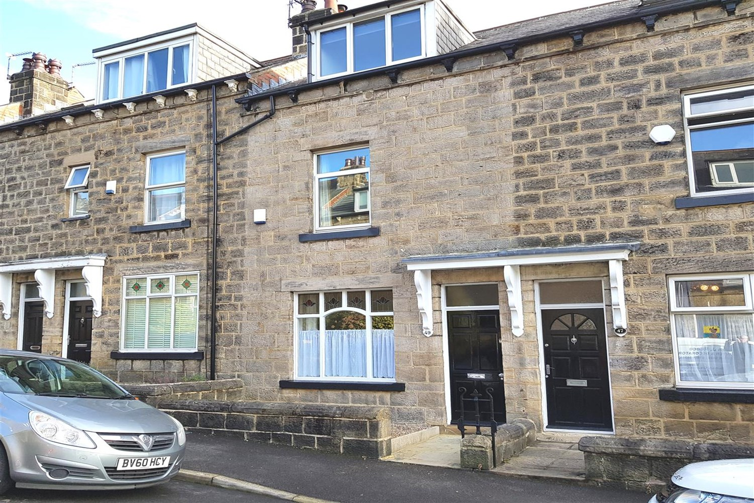

1 Bathroom(s)

1 Reception(s)

2 Bedroom(s)

***BEAUTIFULLY PRESENTED TWO BEDROOM STONE TERRACE HOUSE SET IN THE HEART OF HORSFORTH*** Presented to a great standard throughout this charming property set over three floors is not to be missed. Ideally located for the bars, restaurants and amenities of both New Road Side and Horsforth Town Street, as well as the excellent transport links, including the new Kirkstall Forge train station. This property boasts a superb finish and plenty of character throughout and briefly comprises: lounge with lovely high ceilings and modern fitted kitchen to the ground floor. To the first floor there is a double bedroom and a house bathroom. To the second floor is a second double bedroom. The cellar is also a great feature of this property and provides useful additional storage. Externally there is a low maintenance paved garden to the rear. The property offers ready to move in to accommodation and internal viewing is highly recommended. Unfurnished. Council tax band B EPC rating E. Deposit £1210. Available October 25th. Sorry No Pets.



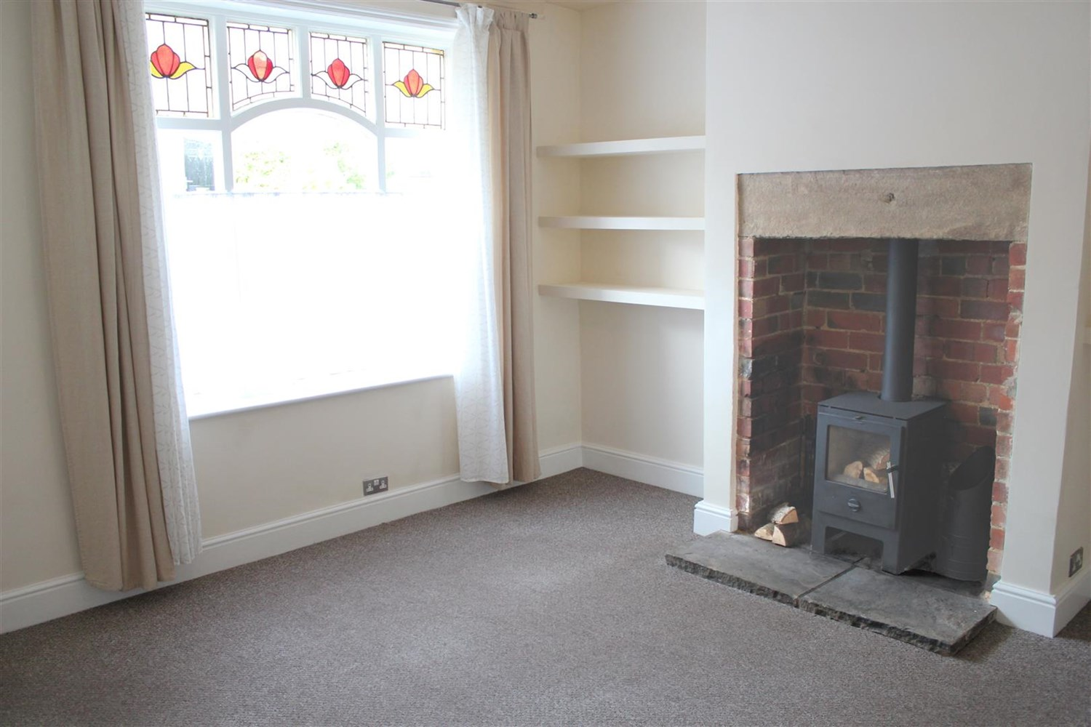

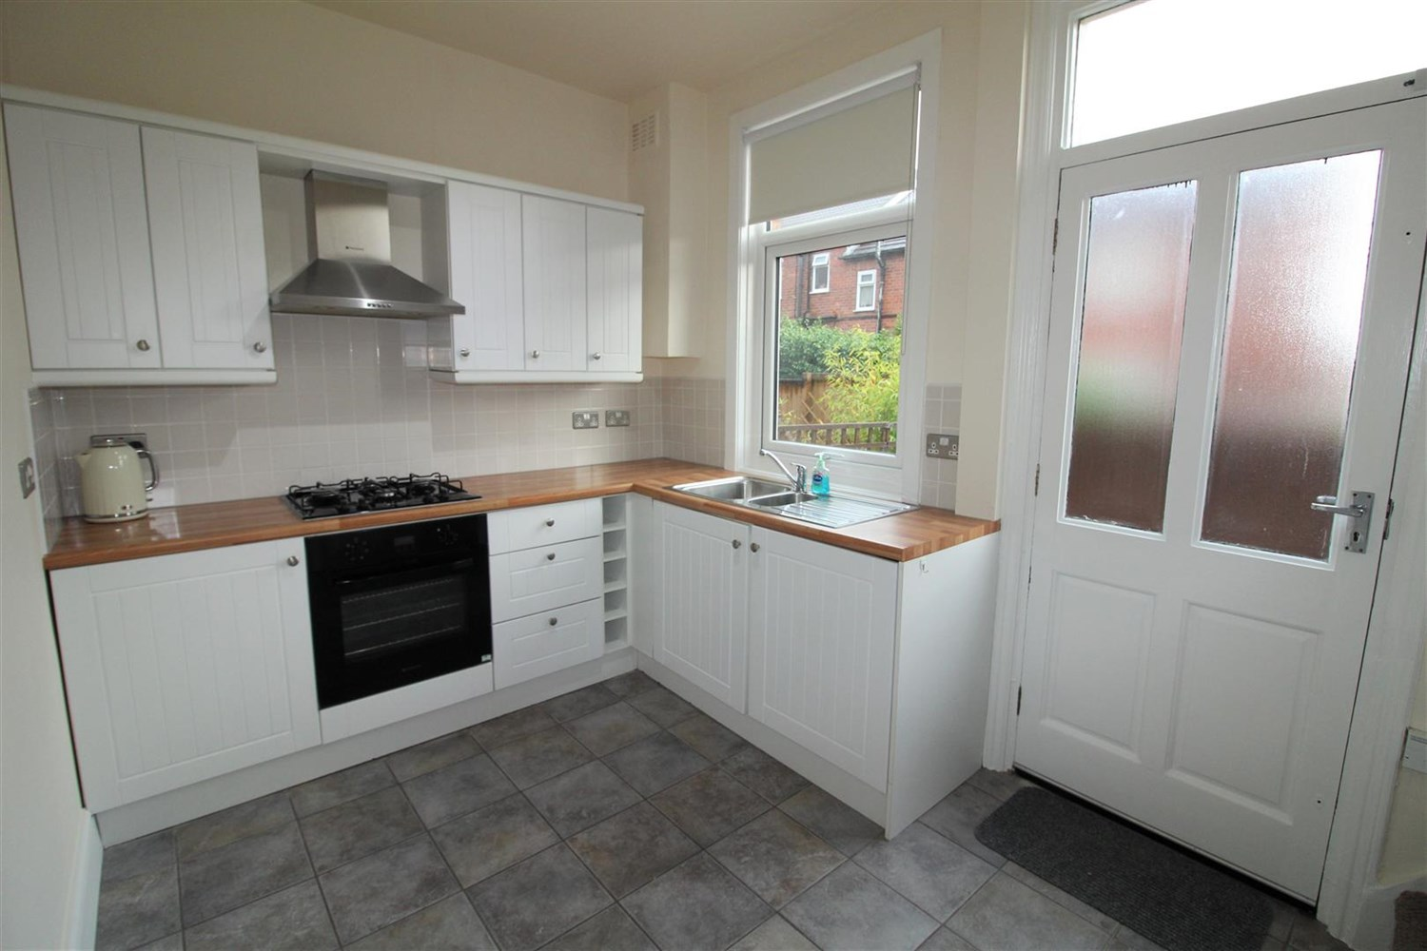

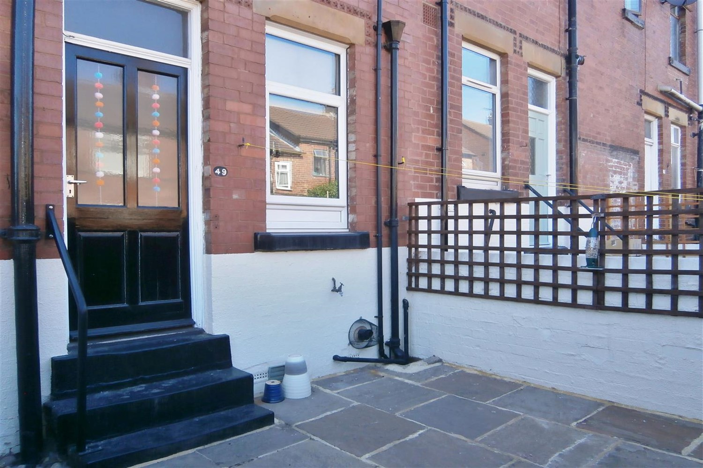

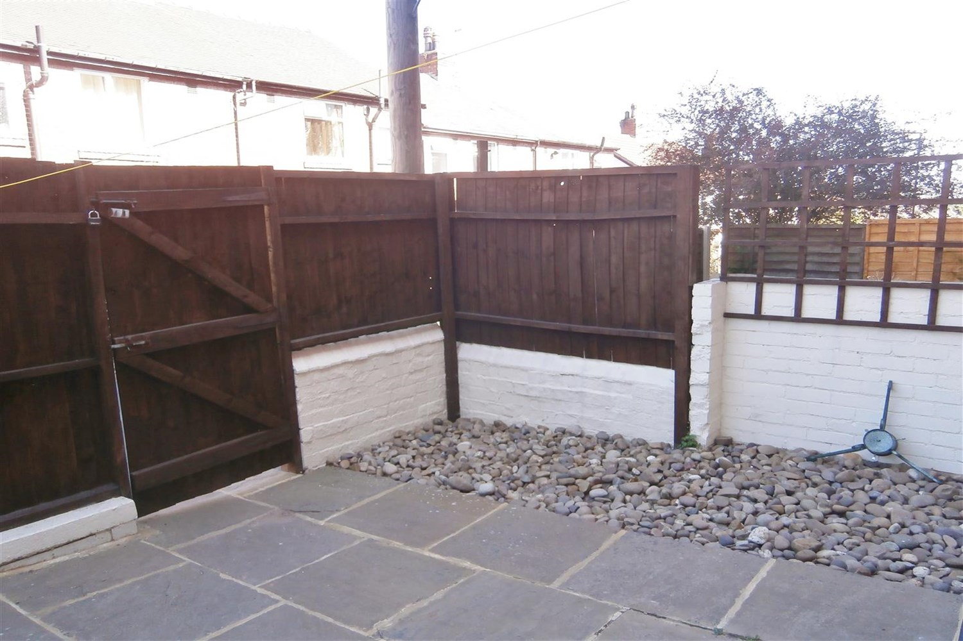

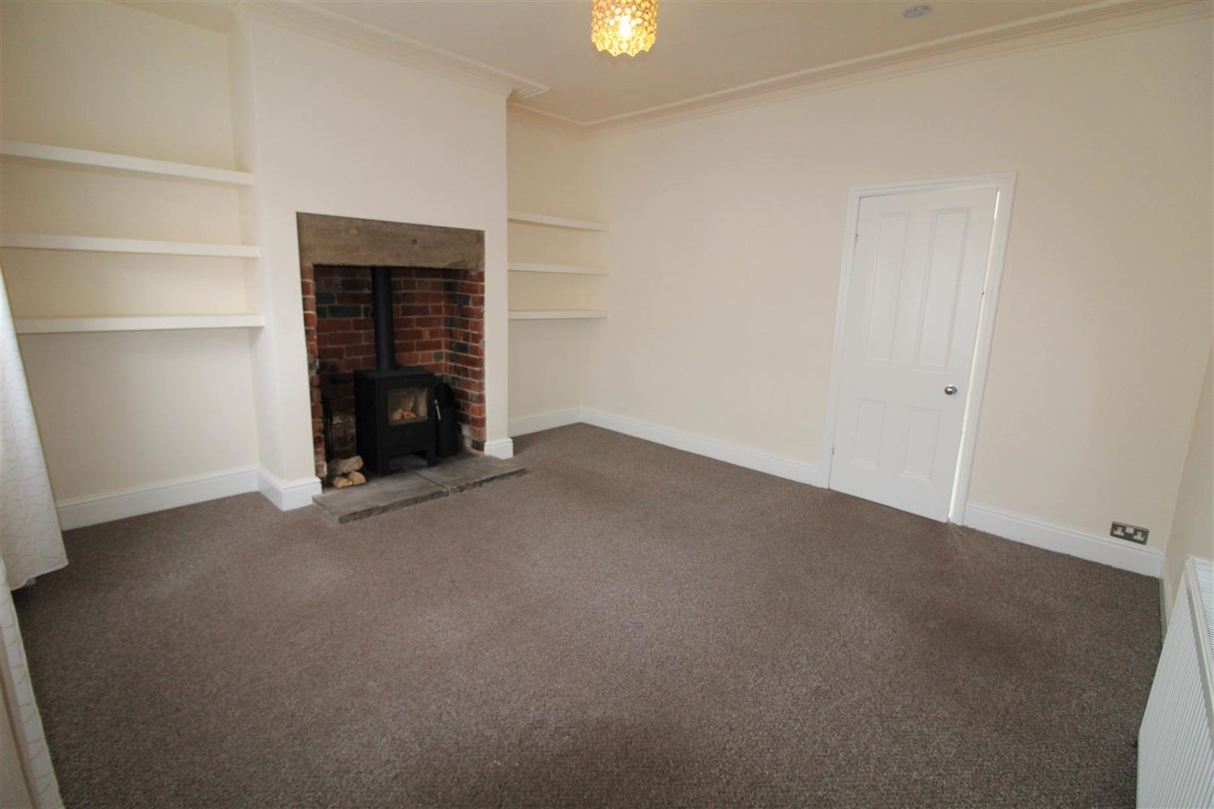

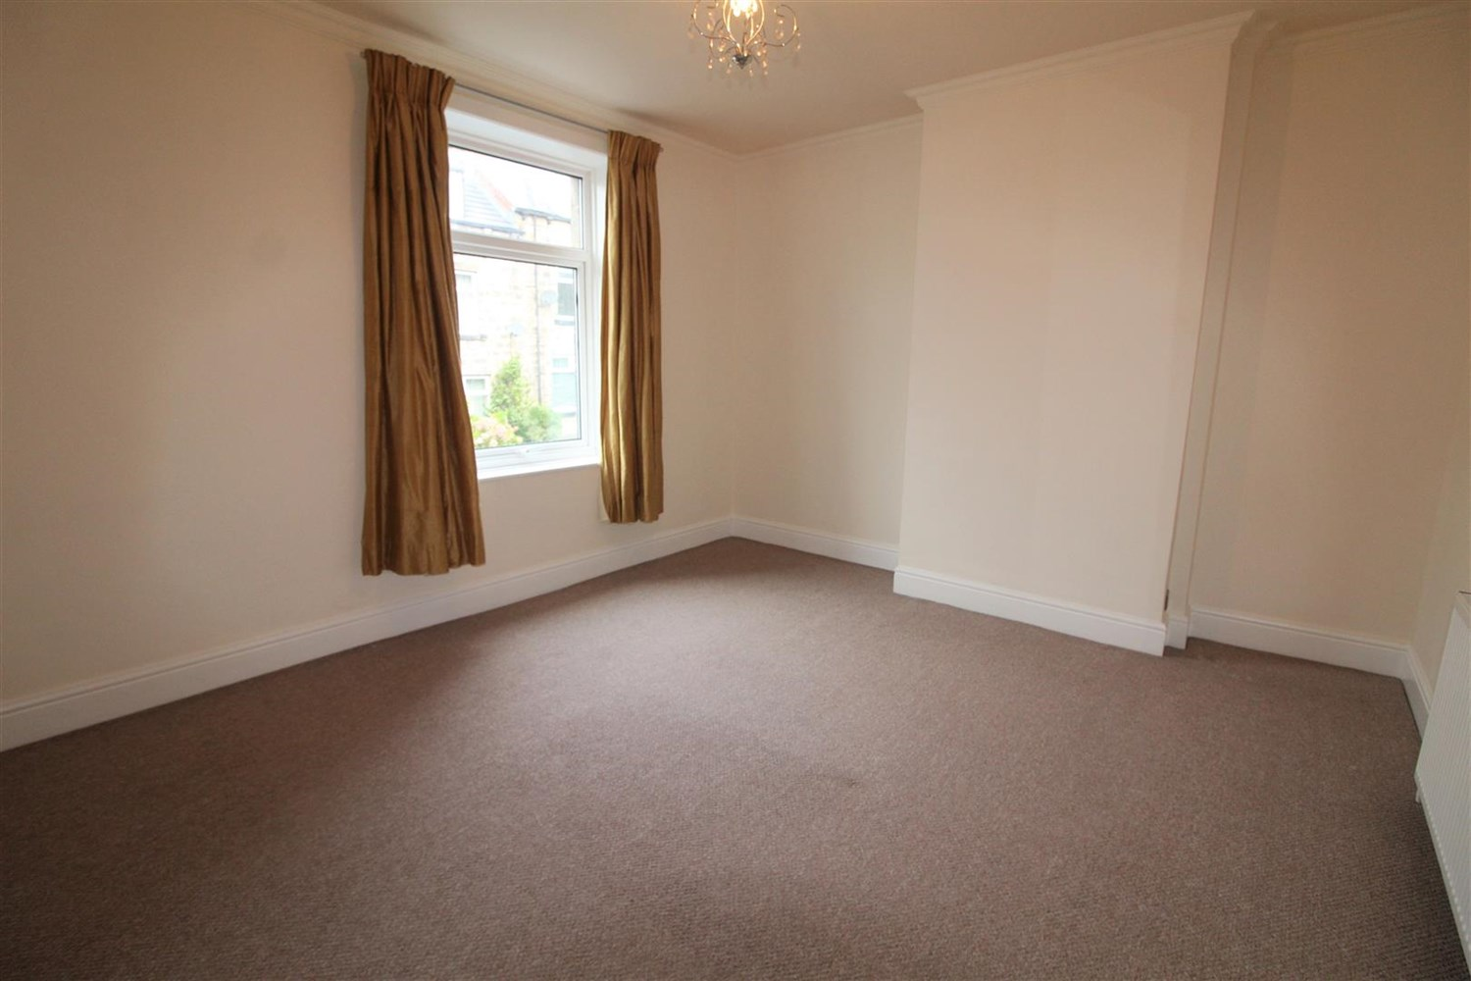



|  |
| --- |
| **Living Room 4.27m (14'0) x 4.11m (13'6)**  Spacious, Light and Airy living area via front entrance door. Feature window to front. Log burning stove set in exposed brick chimney breast. Gas central heating radiator. |
| **Kitchen 2.44m (8'0) x 3.33m (10'11)**  Fitted with a range of wall, base and drawer units with worktops over. 1.5 bowl stainless steel sink with mixer tap and drainer. Integrated electric oven with 4-ring gas hob and extractor hood above. Part tiled walls and tiled floor. uPVC double glazed window to rear. Door to rear. Access to cellar. |
| **Bedroom 1 4.27m (14'0) x 3.78m (12'5)**  Spacious double bedroom with uPVC double glazed window to front. Gas central heating radiator. |
| **Bedroom 2 3.94m (12'11) x 5.11m (16'9)**  Second double bedroom with uPVC double glazed window to front. Gas central heating radiator. |
| **Bathroom**  Fitted with a three piece modern suite comprising; Bath with shower above and glass shower screen, WC and wash hand basin. Tiled floor. Gas central heating radiator. uPVC double glazed window. |
| **Cellar**  Useful storage space. Washing machine and Tumble Dryer. |
| COUNCIL TAX BAND: B EPC Rating E.  12 Month tenancy. Freehold property Street Parking Broadband: Standard 19 Mbps 1 Mbps Good Superfast --Not available --Not available Unlikely Ultrafast 1000 Mbps 220 Mbps Mobile availability: Three likely to have good coverage . EE limited coverage. O2 likely to have good coverage. Vodafone likely to have good coverage.  Utilities: Water supplied on standard meters. Gas and Electric mains supplied on standard meters. |

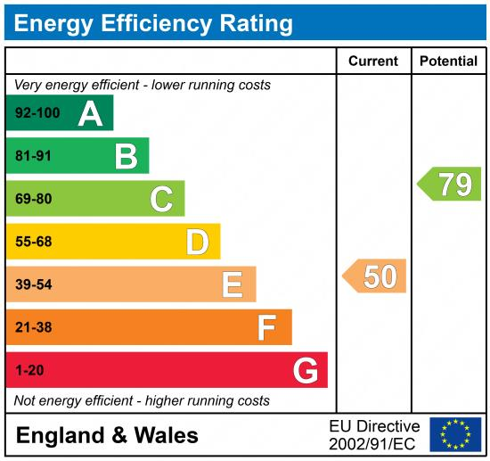

|  |
| --- |
|  |

These particulars are intended to give a fair description of the property, but their accuracy cannot be guaranteed, and they do not constitute an offer of contract. Intending purchasers must rely on their own inspection of the property. None of the above appliances/services have been tested by ourselves. We recommend purchasers arrange for a qualified person to check all appliances/services before legal commitment.

**Property Ref:** 3798

**For more information, please contact**

0113 258 1150 **|** [lettings@adairpaxton.co.uk](mailto:lettings@adairpaxton.co.uk) **|** www.adairpaxton.co.uk