

**Brewery Wharf, Leeds**

**For Sale £295,000.00**

## ***TWO BEDROOM, TWO BATHROOM APARTMENT WITH A SPACIOUS TERRACE OVERLOOKING THE CITY***EWS1 COMPLIANT*** Offered to the market with NO ONWARD CHAIN is this stunning eighth floor apartment, offering delightful views over the city. This property is a MUST SEE! Located in the heart of Brewery Wharf with easy access to shops, bars and restaurants. The apartment also benefits from having a secure underground parking space. The property briefly comprises: Entrance hall, Open plan living room/kitchen, Master bedroom with en-suite shower room, second bedroom and house bathroom. Early internal viewings are highly recommended.

**0113 258 1150**

**0800 000 000**

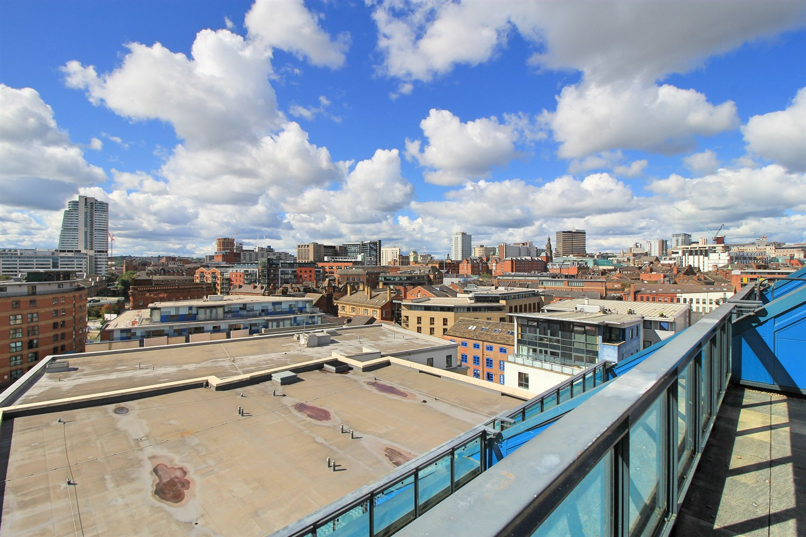

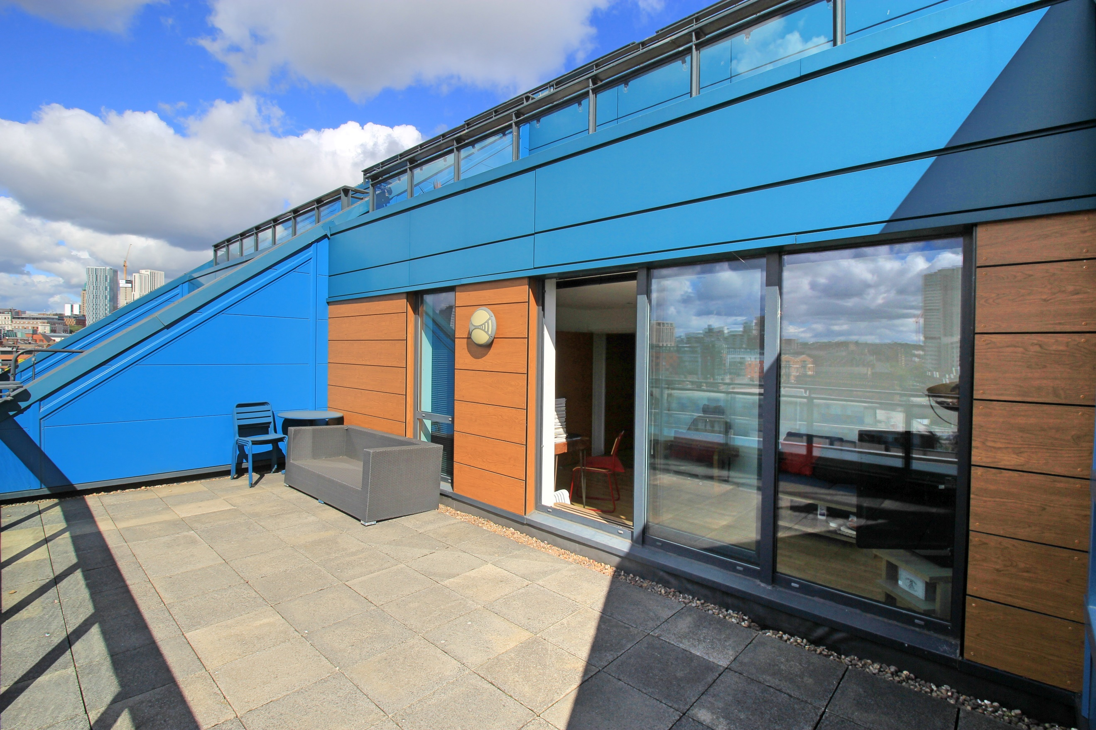

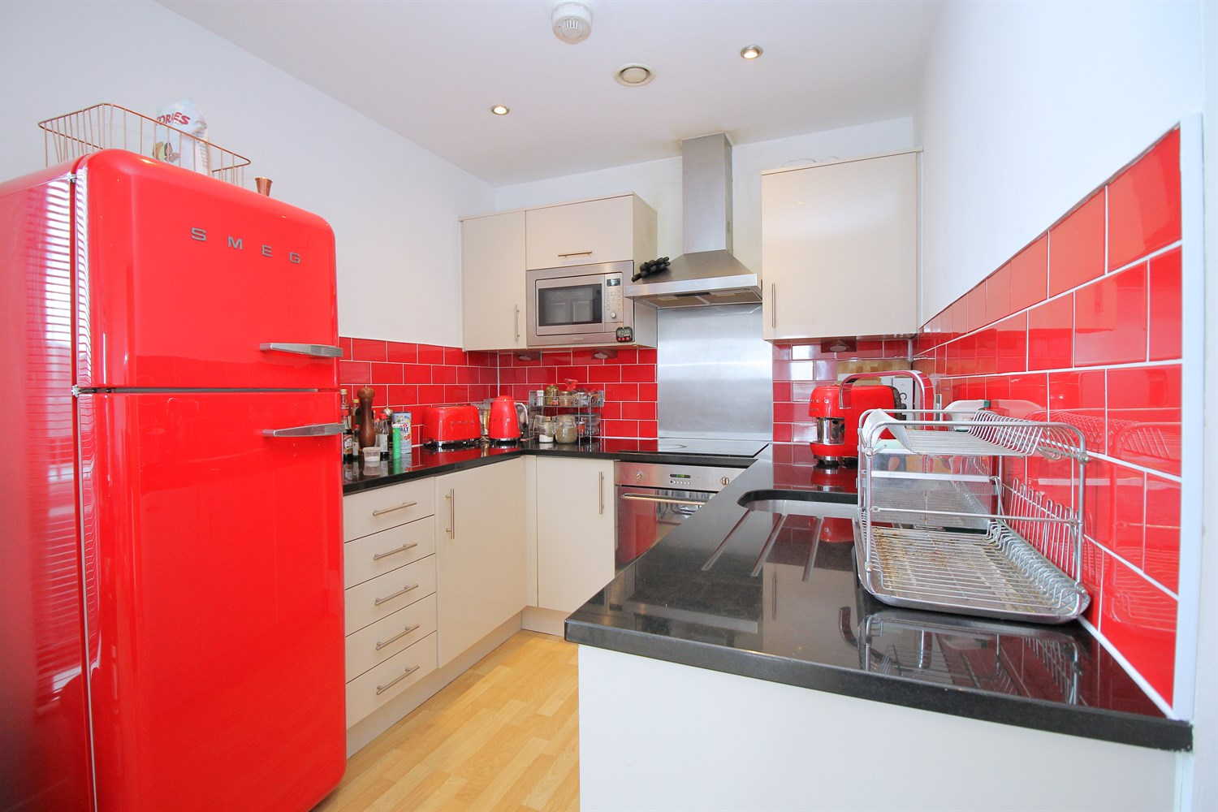

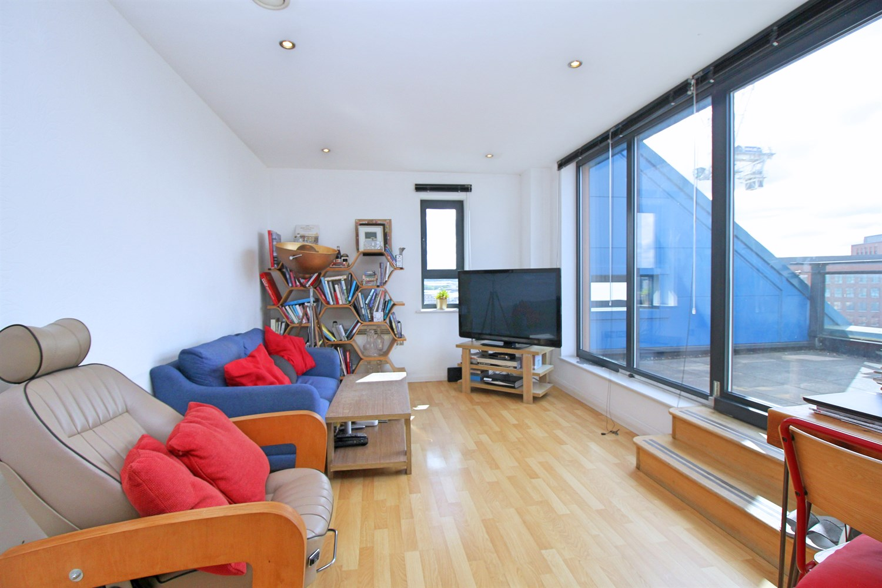

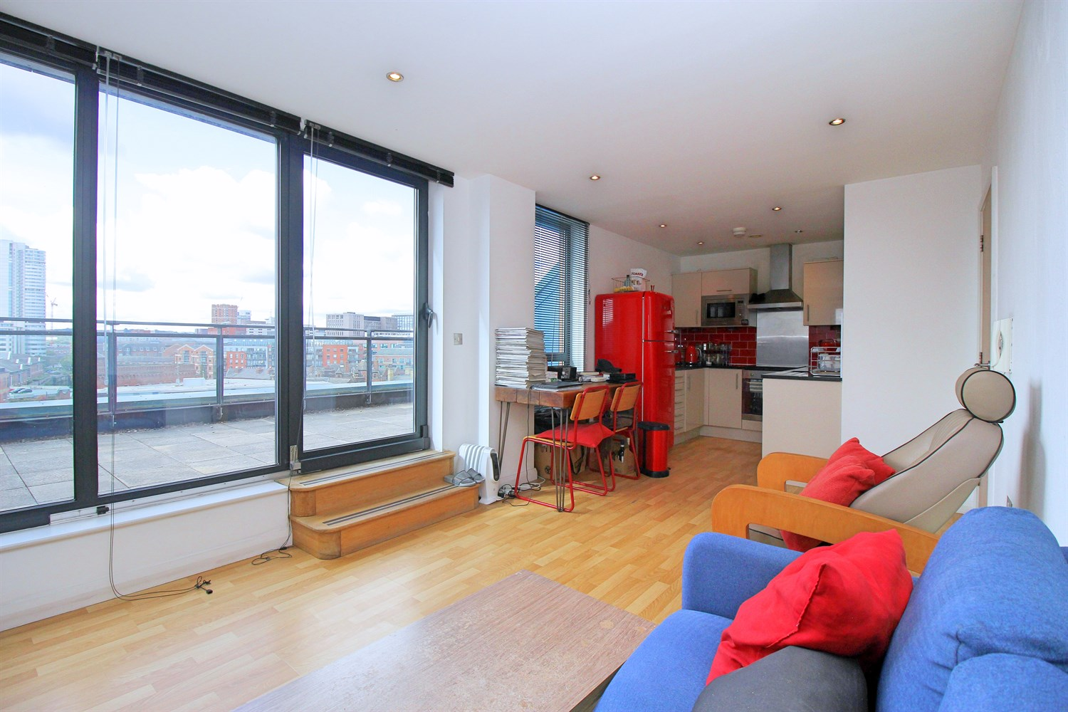

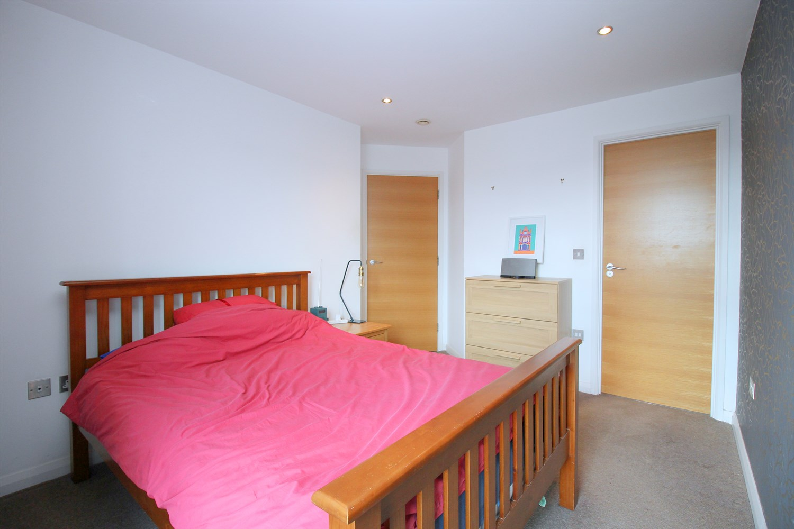

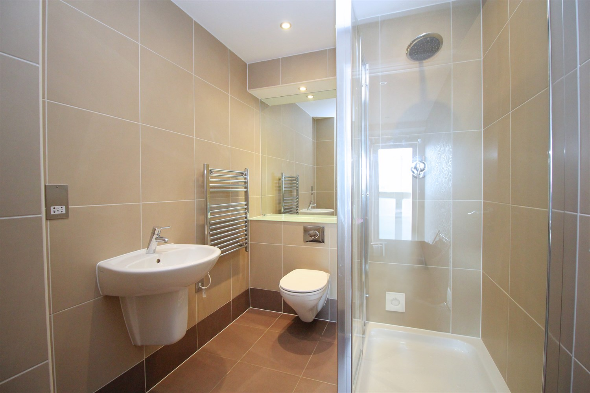

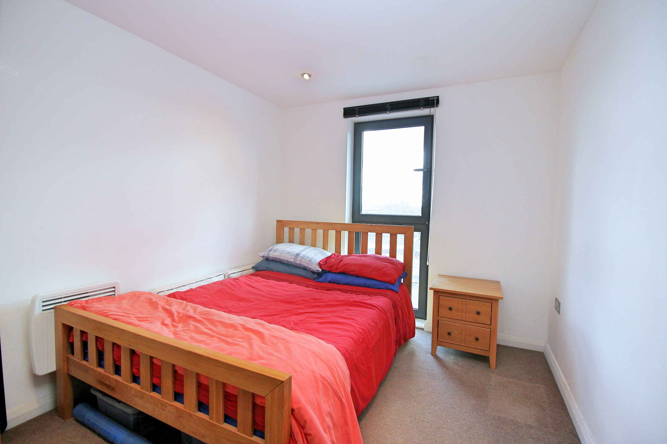

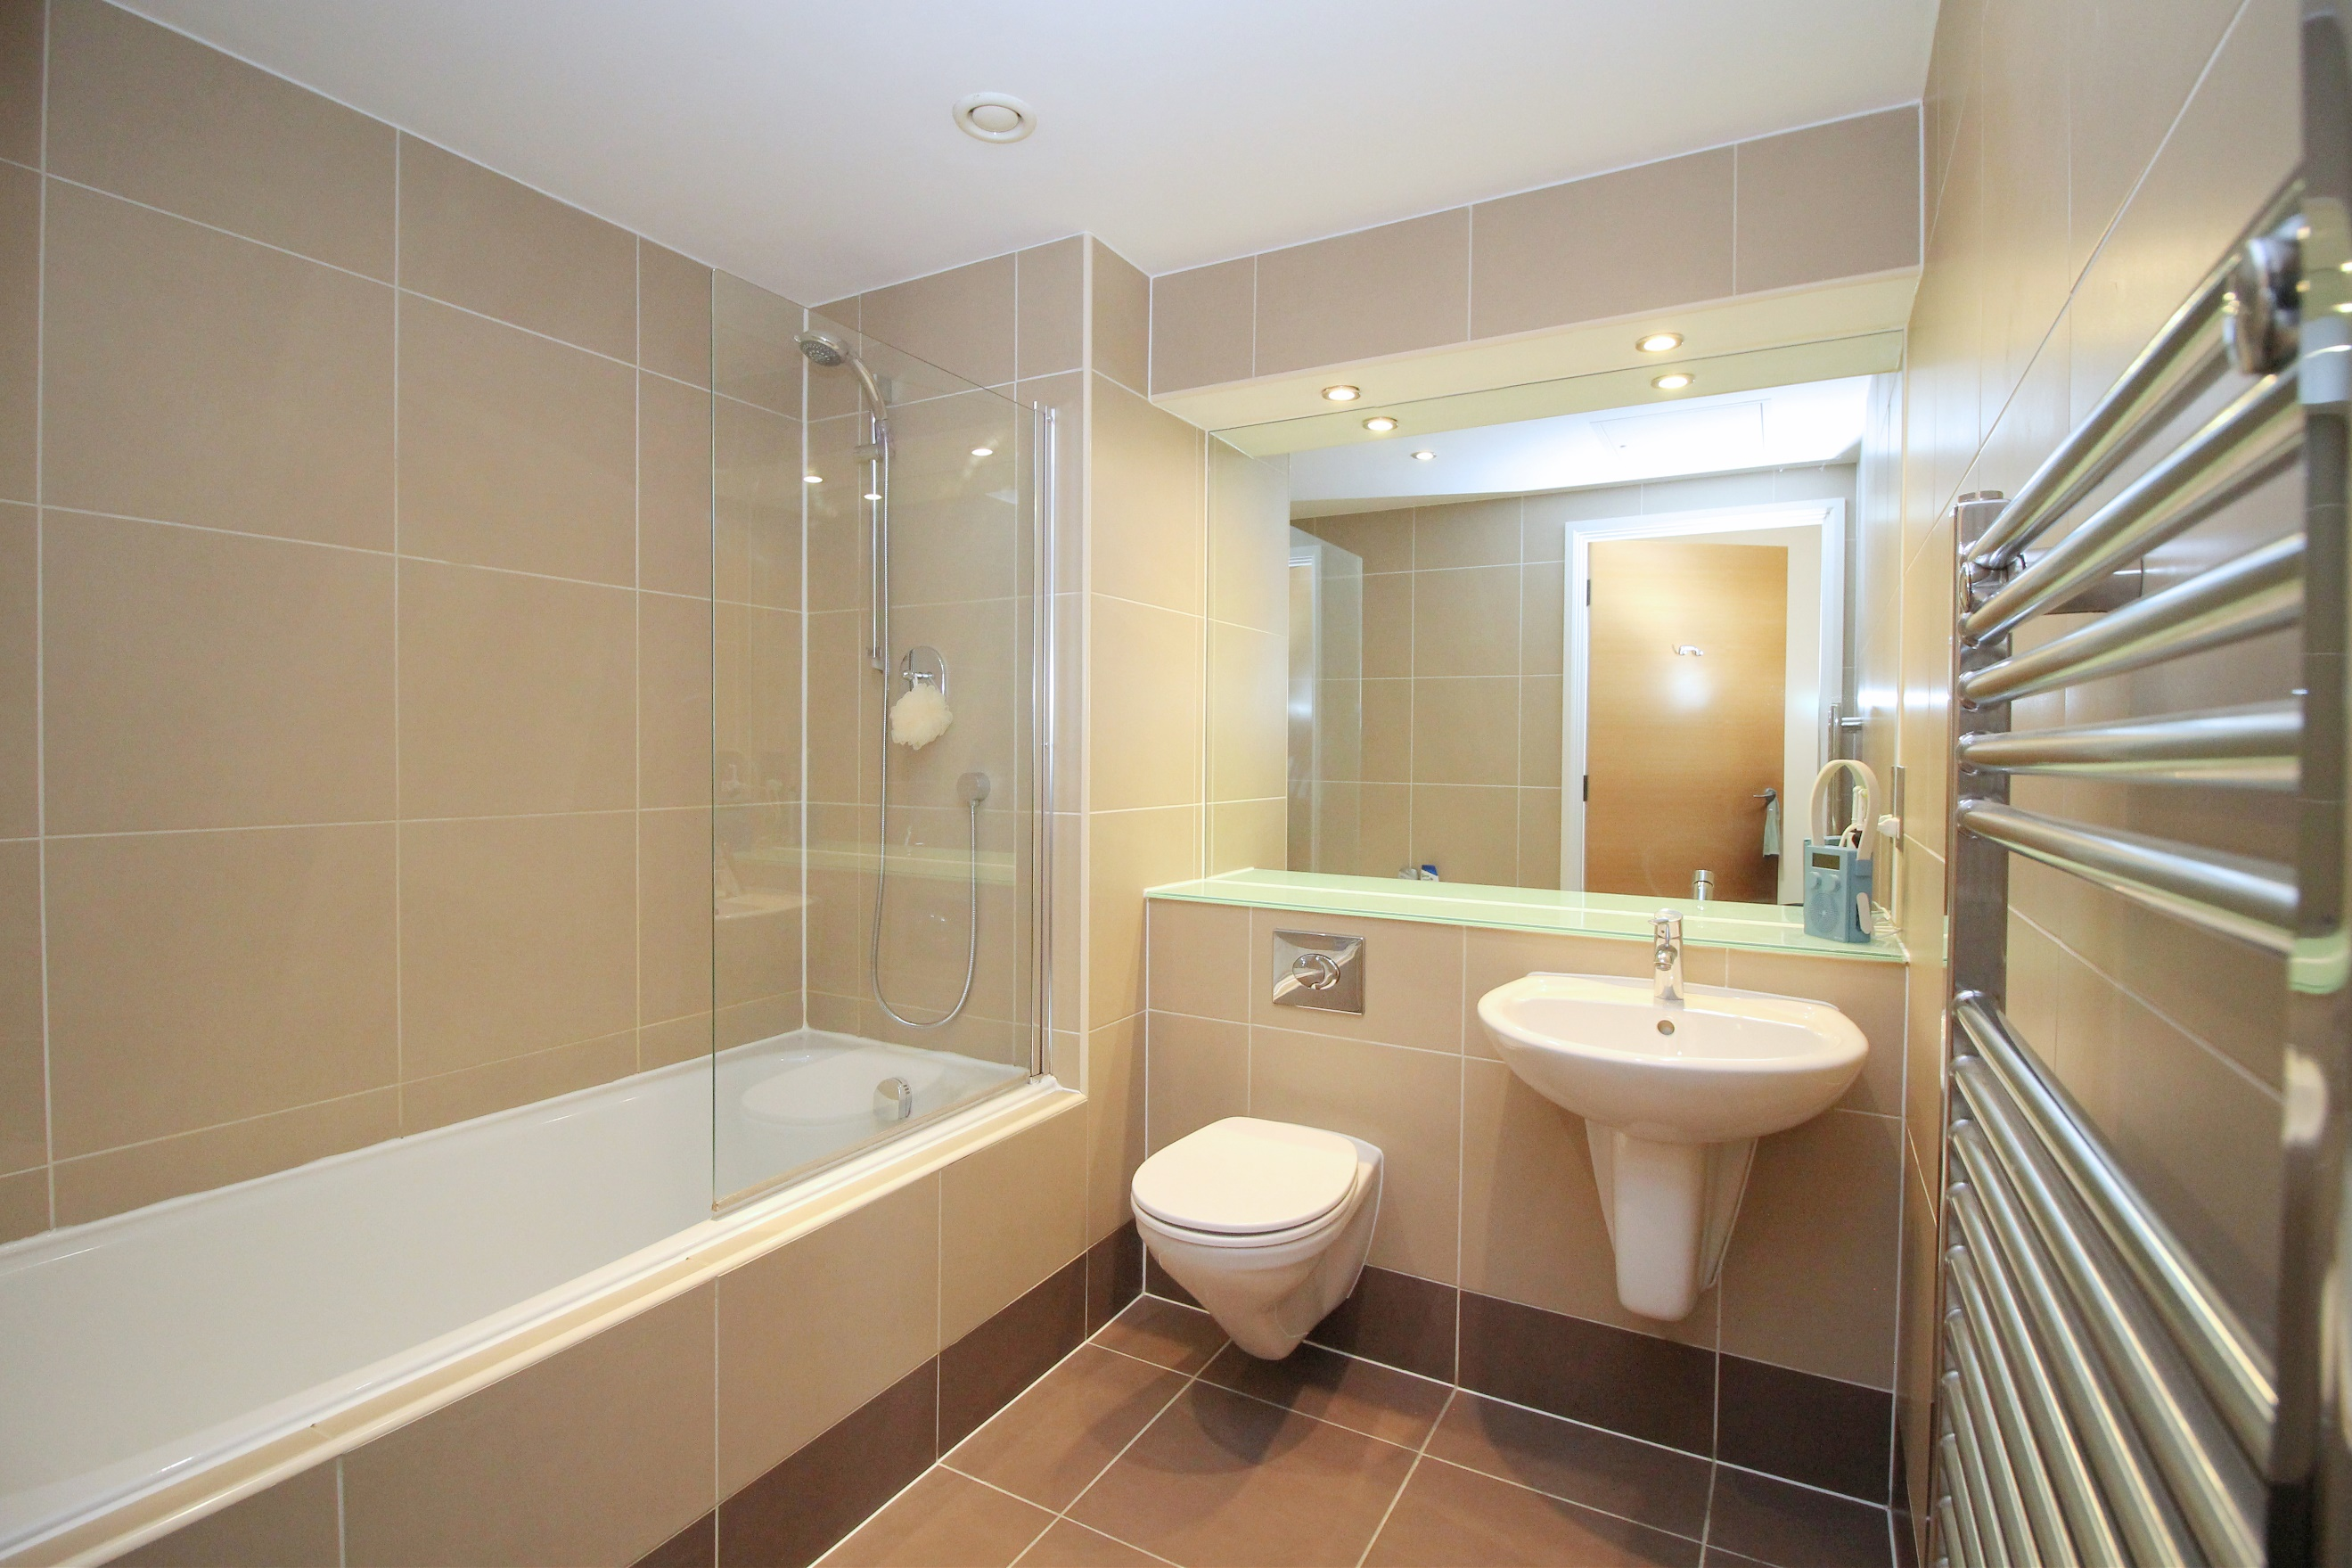

|  |
| --- |
| **Communal entrance**  Communal entrance with telephone entry system, mail boxes and access to all floor via lift and staircase. |
| **Living/Kitchen room**  Open plan living area with wood effect flooring. Wall mounted electric radiator. Sliding door leading out onto the large terrace.  The kitchen is fitted with a range of wall, base and drawer units with worktops over, stainless steel sink with mixer tap and drainer. Integrated oven with 4-ring hob and extractor hood over. Space for a fridge/freezer. Integrated dishwasher. and microwave. Inset ceiling spotlights and tiled walls. |
| **Spacious Terrace**  Large private roof terrace with city views. |
| **Bedroom 1**  A double bedroom with double glazed floor to ceiling window. Wall mounted electric radiator. |
| **En-suite**  En-suite shower room comprising; shower cubicle, wash hand basin and WC and a wall mounted towel radiator. Tiled walls and floor. |
| **Bedroom 2**  A further good sized double room with double glazed floor to ceiling window. Wall mounted electric radiator. |
| **Bathroom**  Three piece white suite comprising; bath with shower above, WC and wash hand basin. Tiled floor and walls. Wall mounted heated towel rail. |
| **Parking**  Secure underground parking with an allocated parking space. |
| **Tenure**  Leasehold - 999 years from 1st January 2006. Ground rent - £428.44 annually. |
| **Service Charge**  Service Charge - £766.83 per quarter.  Car Park Maintenance charge - £25.00 half yearly. |

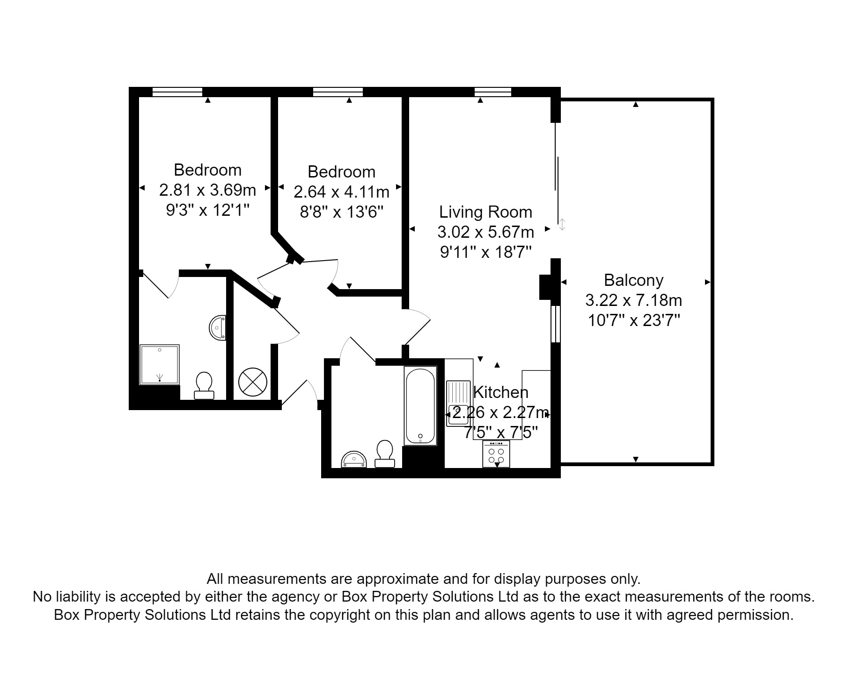

|  |
| --- |
|  |

These particulars are intended to give a fair description of the property, but their accuracy cannot be guaranteed, and they do not constitute an offer of contract. Intending purchasers must rely on their own inspection of the property. None of the above appliances/services have been tested by ourselves. We recommend purchasers arrange for a qualified person to check all appliances/services before legal commitment.

**Property Ref:** 3709

**For more information, please contact**

0113 258 1150 **|** [sales@adairpaxton.co.uk](mailto:sales@adairpaxton.co.uk) **|** www.adairpaxton.co.uk