

**0113 258 1150**

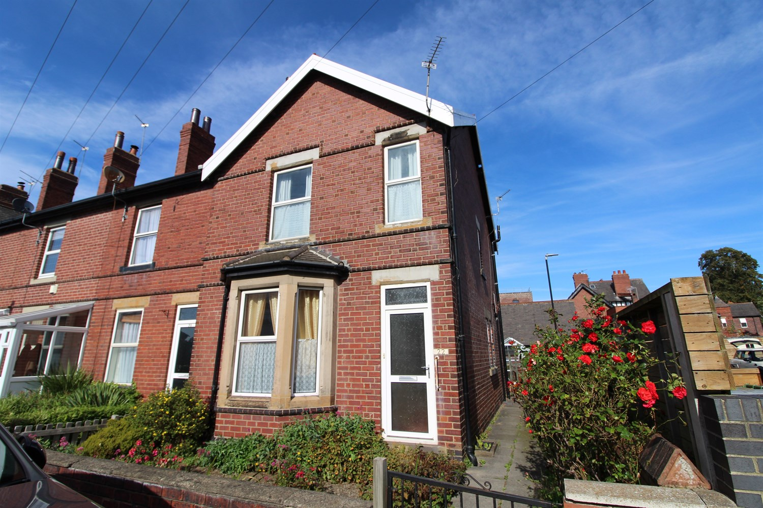



**For Sale £150,000.00**

**22 Smithson Street, Rothwell, LS26 0AQ**

**SPACIOUS TWO BEDROOM END-TERRACE HOUSE with NO ONWARD CHAIN** Located close to the centre of Rothwell, this spacious terrace house is a perfect step up onto the property ladder. The property is now in NEED OF MODERNISATION and briefly comprises; Entrance hall, lounge and spacious kitchen/diner to the ground floor. To the first floor there are two double bedrooms and a house bathroom. Externally the property has an enclosed rear garden and on-street parking.

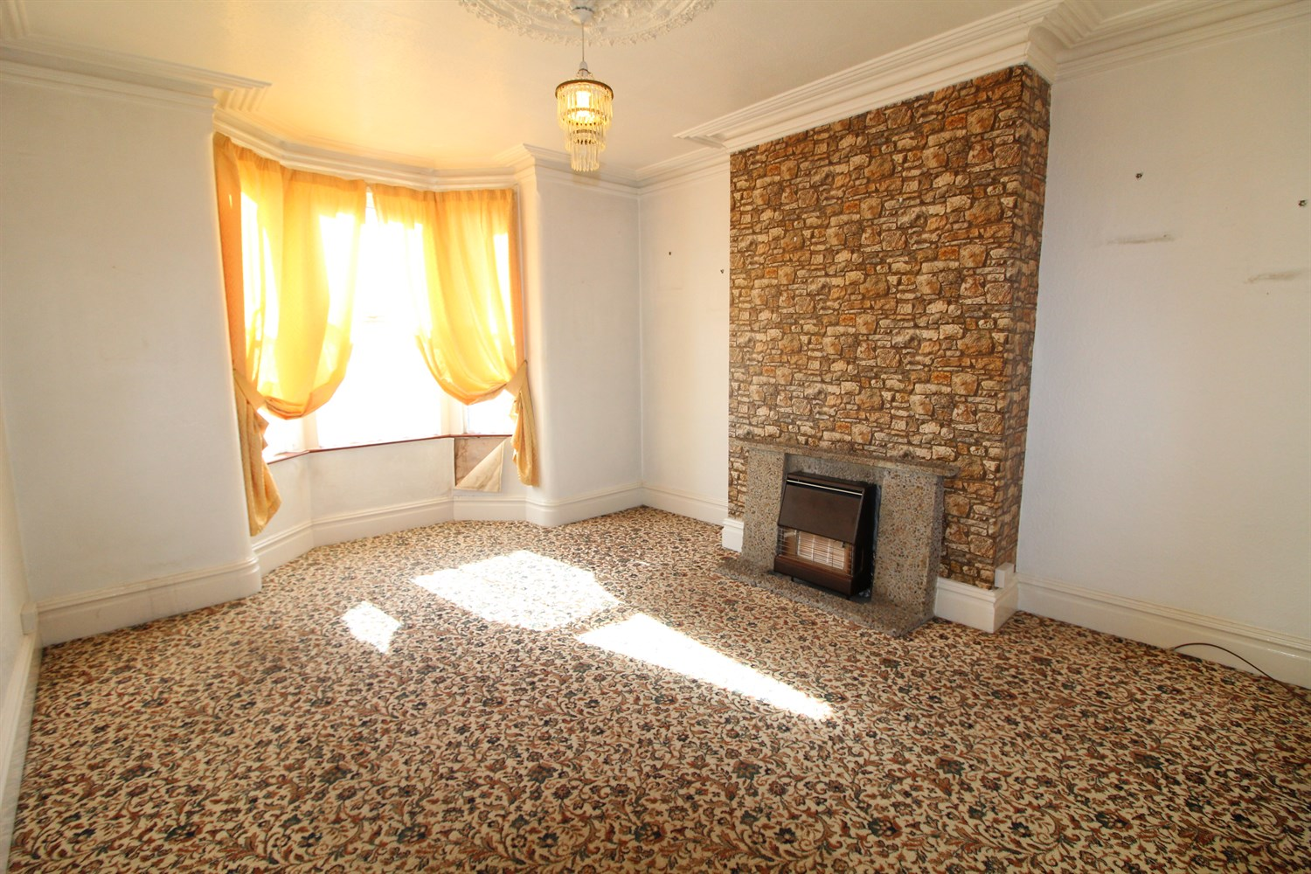

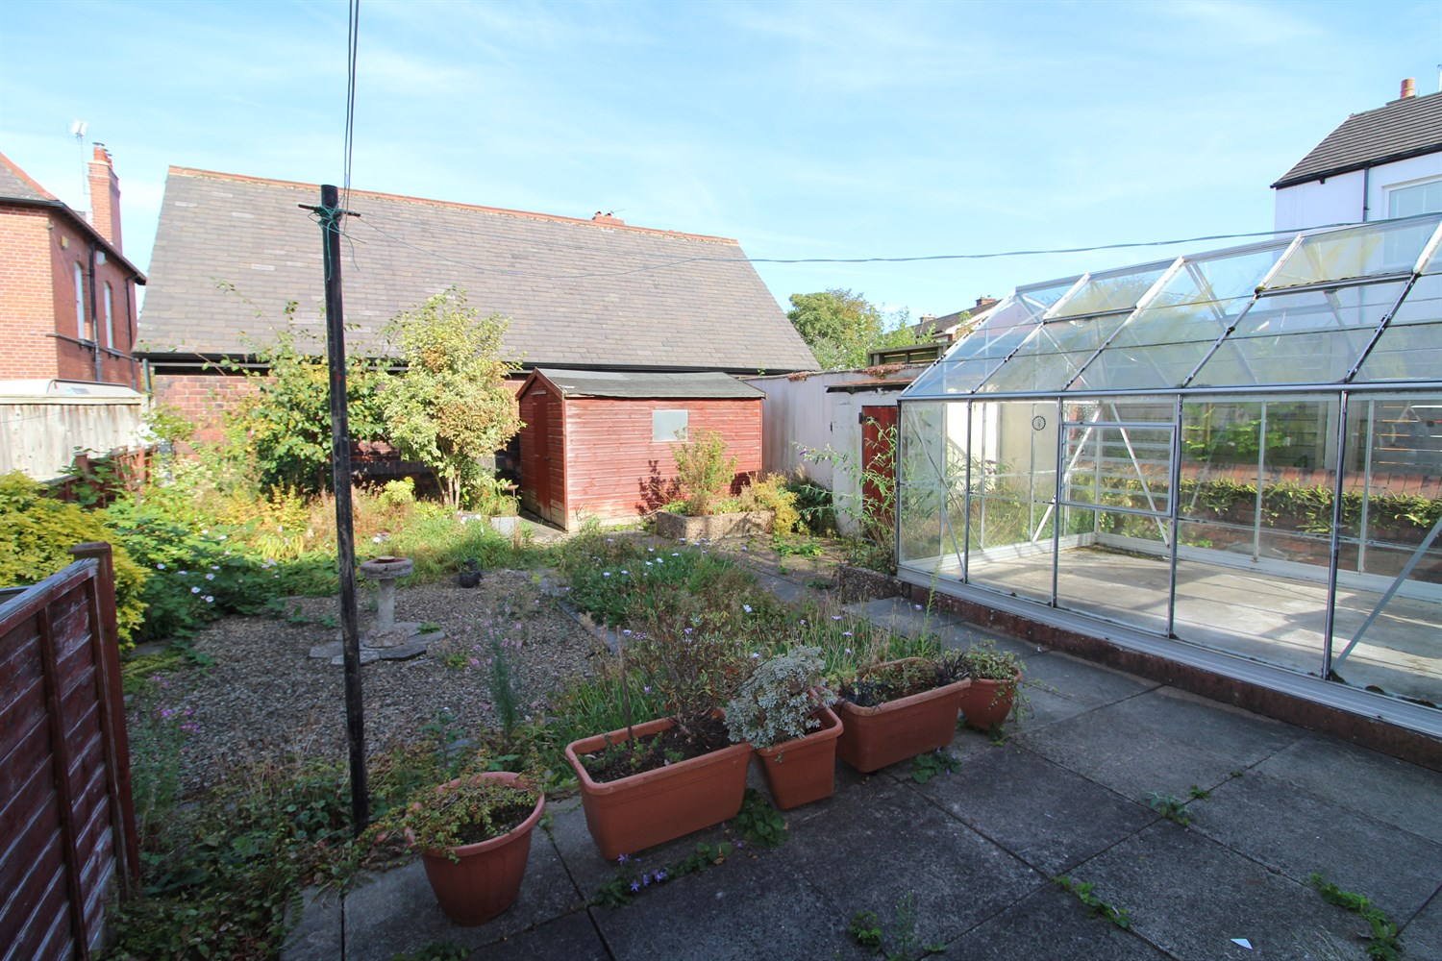

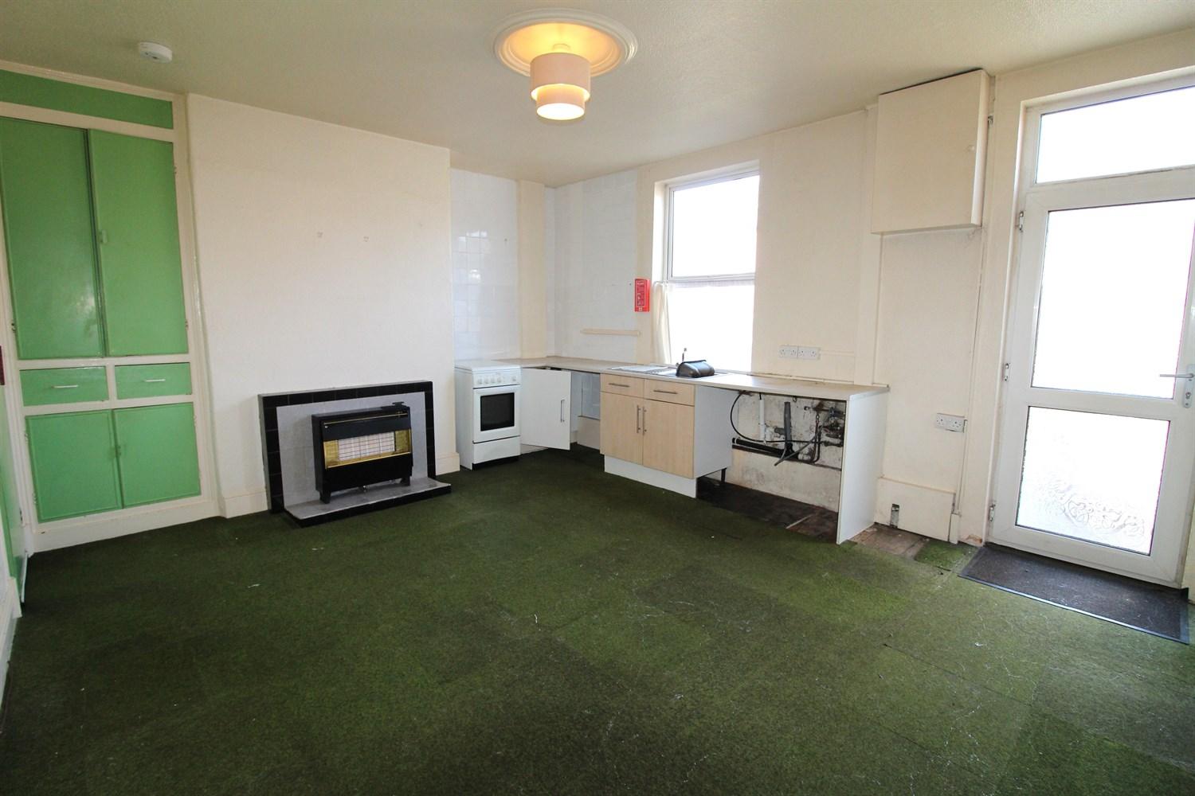

1 Bathroom(s)

1 Reception(s)

2 Bedroom(s)

00

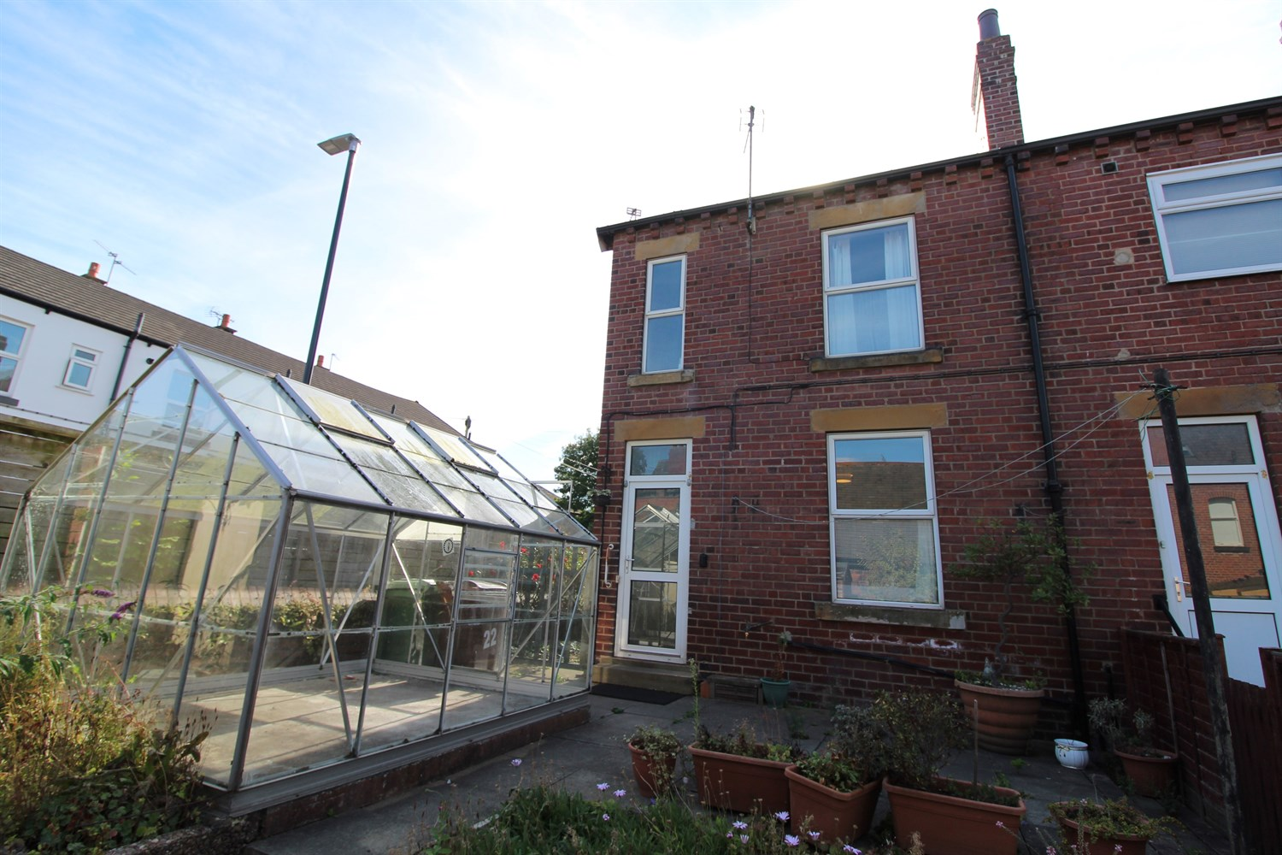

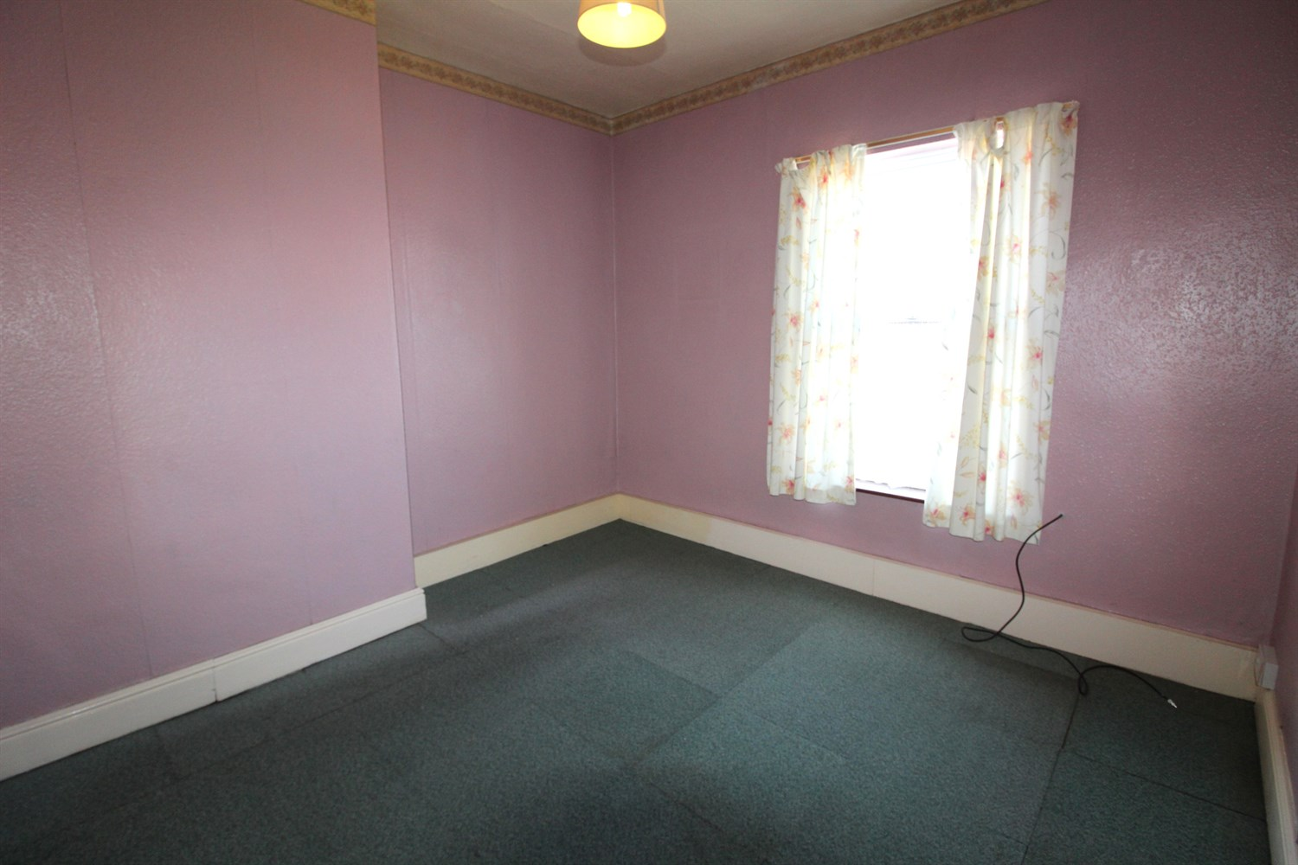

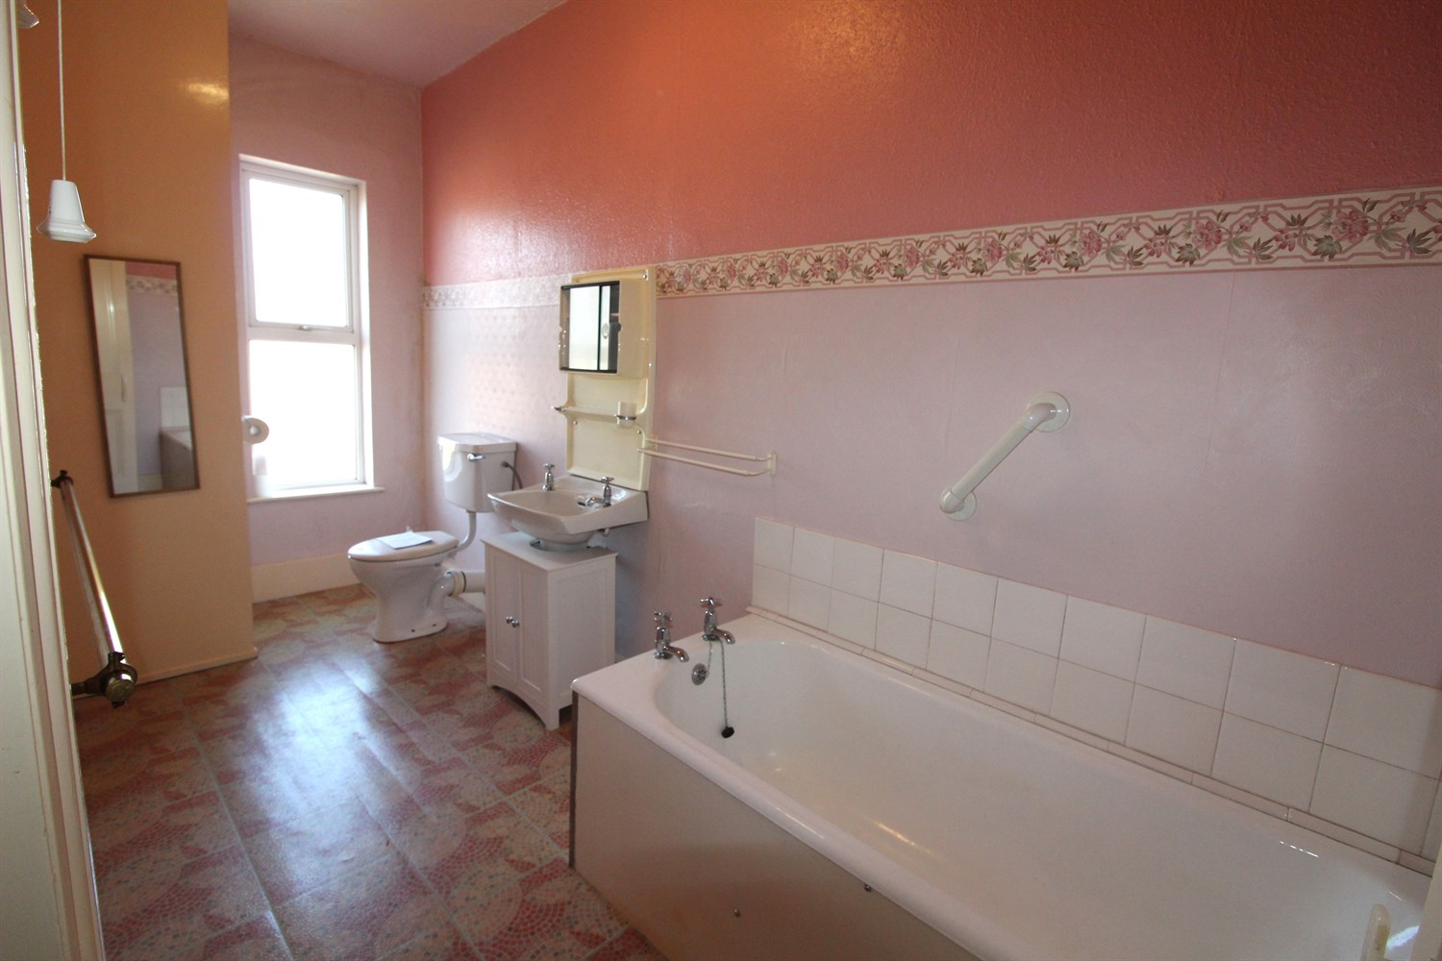

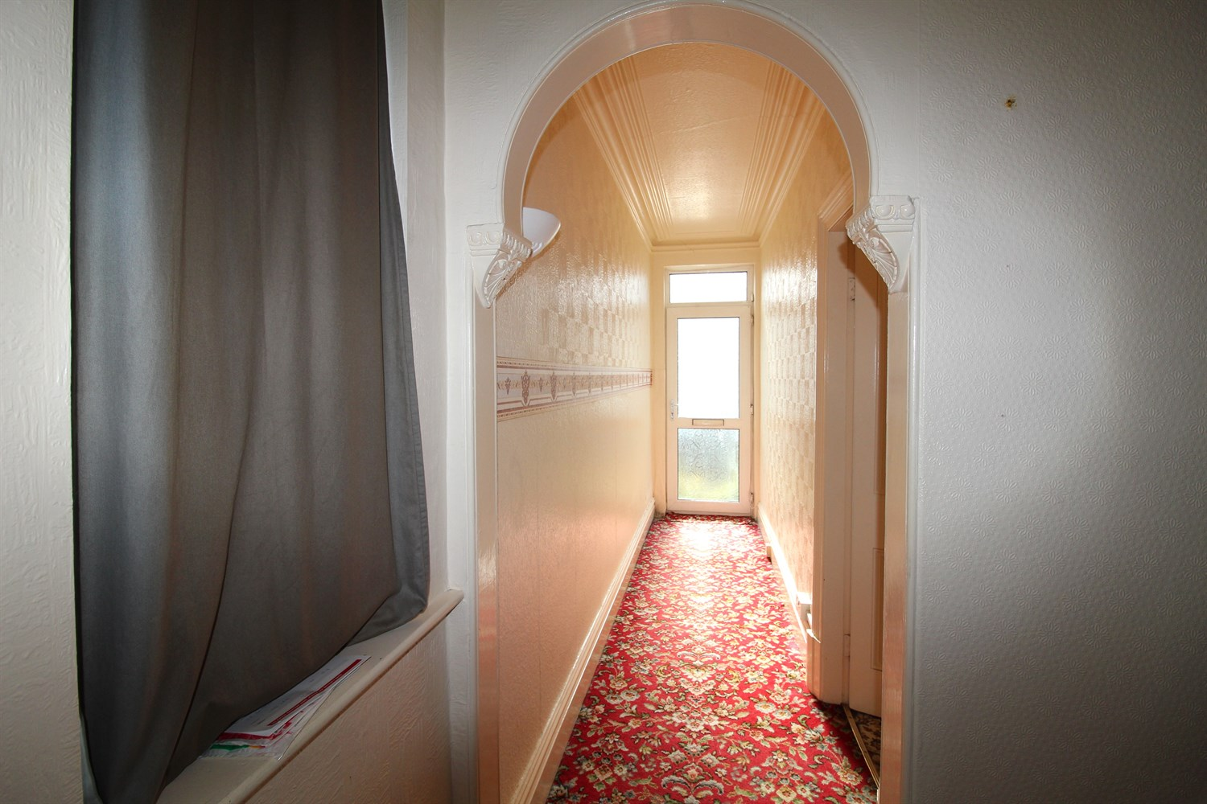

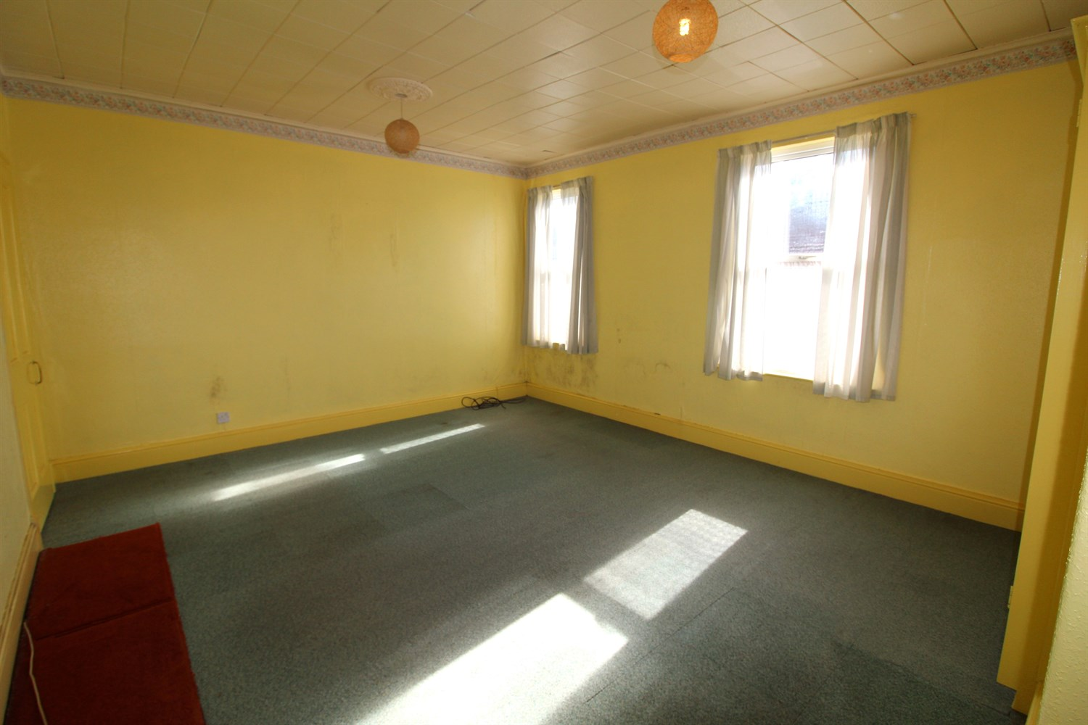

|  |
| --- |
| **Entrance Hall**  Via front entrance door. Window to side. |
| **Lounge 5m (16'5) Into Bay x 3.88m (12'9)**  Spacious living area with uPVC double glazed bay window to front. High ceilings with coving. Gas fire to chimney breast. |
| **Open Plan Kitchen/Diner 5.05m (16'7) x 4.28m (14'1)**  Spacious kitchen/diner with high ceiling and uPVC double glazed window to rear. Gas fire to chimney breast. Stainless steel sink. Space for cooker and plumbed for washing machine. Door leading out to rear garden. Access to basement. |
| **Bedroom 1 5.06m (16'7) max x 4.27m (14'0)**  Double bedroom with double glazed window to front. Walk in cupboard. |
| **Bedroom 2 3.3m (10'10) max x 3.29m (10'10)**  Second double bedroom with double glazed window to rear. |
| **Bathroom**  Fitted with a three piece suite comprising; bath, WC and wash hand basin. Double glazed window to rear. |
| **Outside**  To the front of the property is an enclosed courtyard style garden with borders of plants and shrubs. To the rear is a good sized garden which is mainly paved with borders of plants and flower beds. |

|  |  |
| --- | --- |
| These particulars are intended to give a fair description of the property, but their accuracy cannot be guaranteed, and they do not constitute an offer of contract. Intending purchasers must rely on their own inspection of the property. None of the above appliances/services have been tested by ourselves. We recommend purchasers arrange for a qualified person to check all appliances/services before legal commitment.  **Property Ref:** 3710  **For more information, please contact**  0113 258 1150 **|** [sales@adairpaxton.co.uk](mailto:sales@adairpaxton.co.uk) **|** www.adairpaxton.co.uk |  |