

**0113 258 1150**

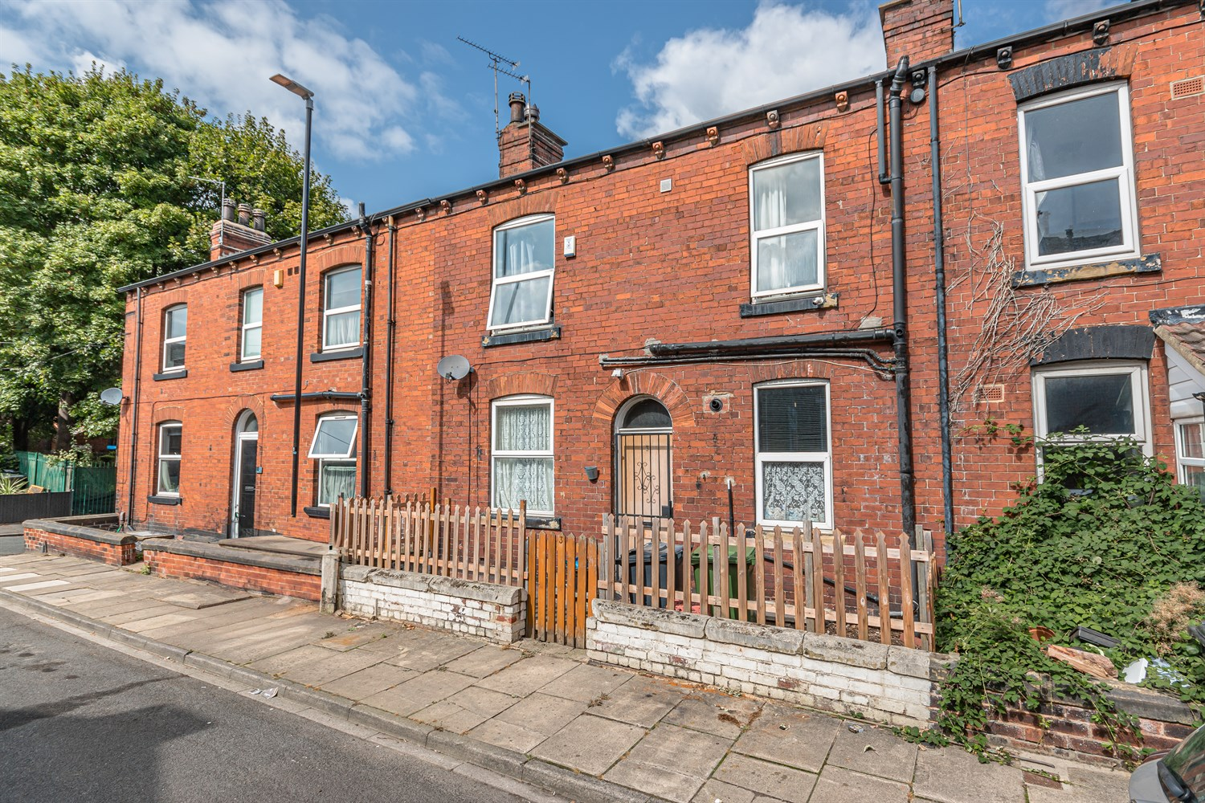



**For Sale £115,000.00**

**3Laurel Place, Armley, Leeds, LS12 2DE**

**TWO BEDROOM MID-TERRACE HOUSE - IDEAL INVESTMENT or FIRST TIME BUY** Within easy reach of Leeds City Centre, Ring Road and Motorway Networks. With Armley Town Street, Armley Park and good bus routes nearby. This property is an ideal investment - Currently tenanted on a rolling basis. The property briefly comprises; Hallway, living room and kitchen to the ground floor. Cellar. To the first floor there are two double bedrooms and a house bathroom. Externally, there is a small courtyard style garden to the front.

1 Bathroom(s)

1 Reception(s)

2 Bedroom(s)

00

|  |
| --- |
| **Hallway**  Via front entrance door. Stairs to first floor. |
| **Sitting Room 4.38m (14'4) x 5.04m (16'6)**  Spacious living area with uPVC double glazed window to front. Gas central heating radiator. |
| **Kitchen 2.57m (8'5) x 4.23m (13'11)**  Fitted with a range of wall, base and drawer units with worktops over. Integrated electric oven with hob and extractor hood over. Space for washing machine and fridge. uPVC double glazed window to front. uPVC double glazed window to front. |
| **Bedroom 1 2.86m (9'5) x 5.04m (16'6)**  Double bedroom with uPVC double glazed window to front. Gas central heating radiator. |
| **Bedroom 2 2.59m (8'6) x 4.23m (13'11)**  Second double bedroom with uPVC double glazed window to front. Gas central heating radiator. |
| **Bathroom**  Fitted with a three piece suite comprising; bath, WC and wash hand basin. Tiled floor. Gas central heating radiator. |

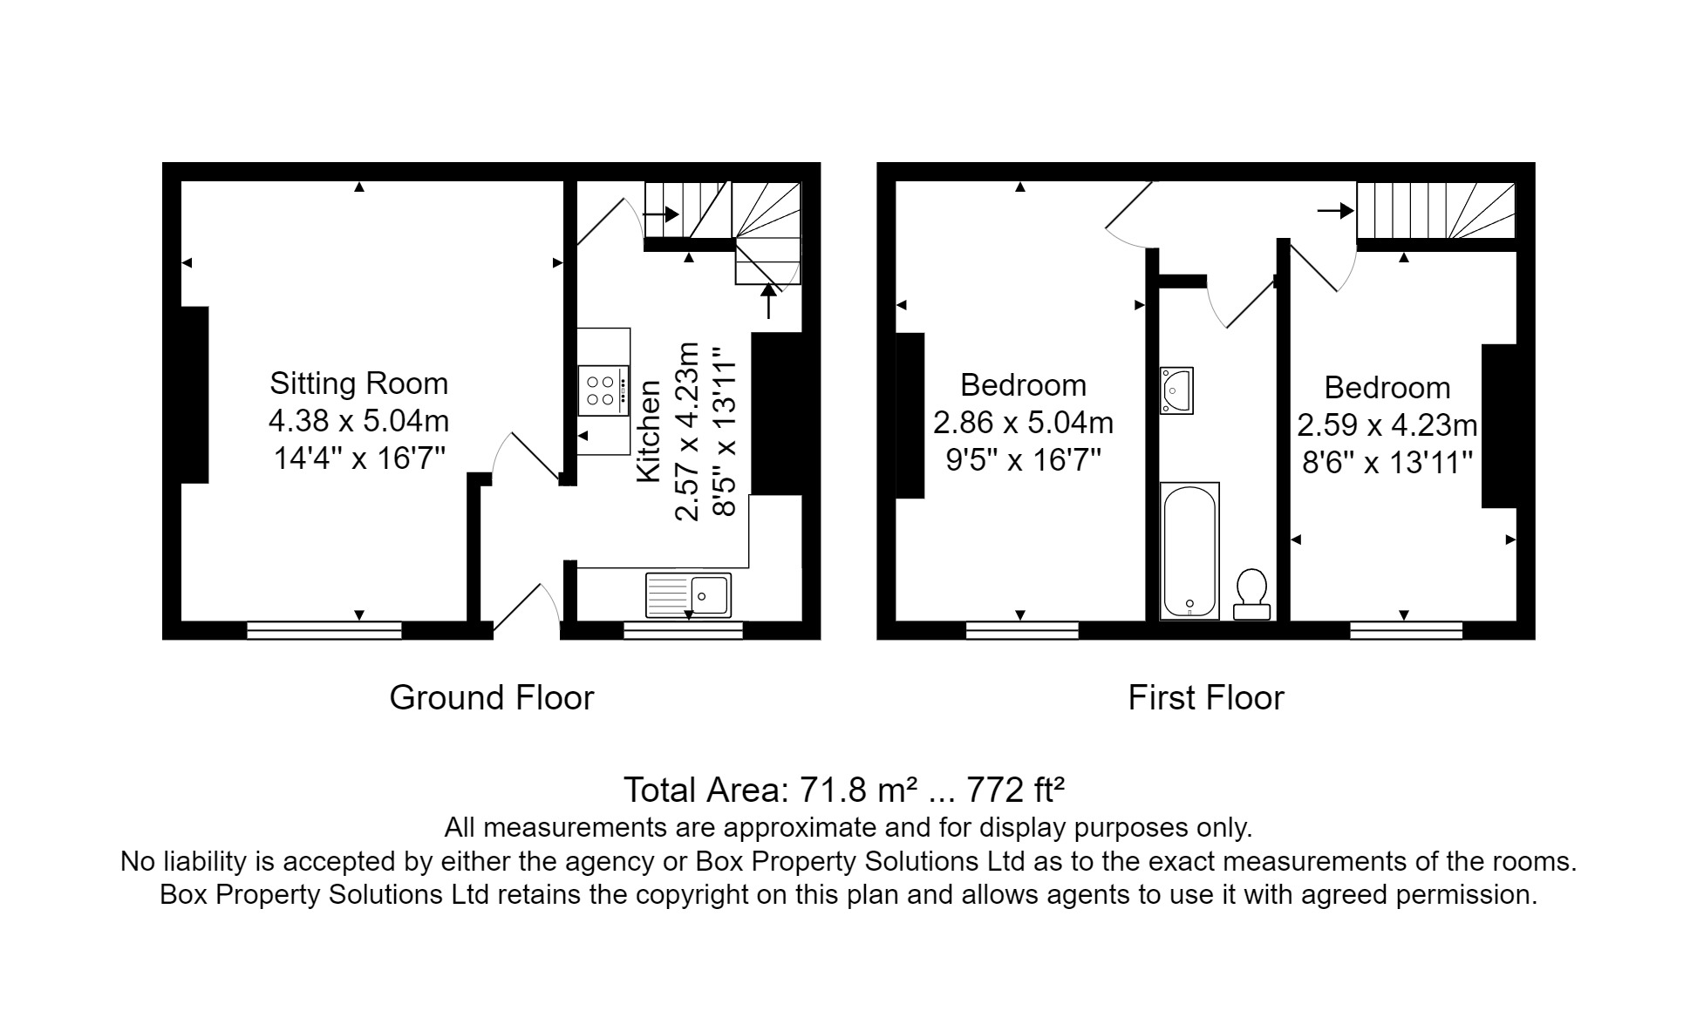

|  |  |
| --- | --- |
| These particulars are intended to give a fair description of the property, but their accuracy cannot be guaranteed, and they do not constitute an offer of contract. Intending purchasers must rely on their own inspection of the property. None of the above appliances/services have been tested by ourselves. We recommend purchasers arrange for a qualified person to check all appliances/services before legal commitment.  **Property Ref:** 3554  **For more information, please contact**  0113 258 1150 **|** [sales@adairpaxton.co.uk](mailto:sales@adairpaxton.co.uk) **|** www.adairpaxton.co.uk |  |